● My Christian Counselor - Current State & Feature Set
Ready for: Production deployment with full counselor monitoring and member management capabilities.

🟢 Current Application State

Servers Running:
- API Server: http://localhost:3697 (NestJS - compiled successfully)
- Web Server: http://localhost:3699 (Next.js 15.2.5 - compiled successfully)
- Build Status: All TypeScript files compiling without errors
- Git Status: On branch master, 2 commits ahead of origin

✅ Completed Feature Set

Core Counseling Platform

1. AI-Powered Christian Counseling
- Scripture-based conversation system with OpenAI integration
- Multiple Bible translation support (KJV, ASV, NIV, ESV, NASB, NKJV, NLT, YLT)
- Comparison translation mode for side-by-side verses
- Crisis detection with emergency resource recommendations
- Grief detection with specialized support resources
- Session management with conversation history
2. User Authentication & Profiles
- Email/password authentication with JWT tokens
- Email verification system
- Password reset functionality
- User profile management with preferences
- Session timeout handling with friendly notifications (✨ NEW)
- Graceful redirect on expired sessions (✨ NEW)
3. Organization Management
- Multi-tenant organization system
- License types: Family, Small, Medium, Large
- License status tracking (trial, active, expired, cancelled)
- Member capacity limits based on license type
- Organization invitation system with email notifications
- Role-based access control (RBAC)

Permission & Role System

4. Platform Roles
- Platform Admin: Global system administration
- Organization Admin: Organization-level management
- Counselor: Member counseling and monitoring
- Member: Standard user access
5. Permissions
- MANAGE_ORGANIZATION, VIEW_ORGANIZATION
- MANAGE_MEMBERS, INVITE_MEMBERS, REMOVE_MEMBERS, VIEW_MEMBERS
- MANAGE_ROLES, ASSIGN_ROLES
- VIEW_MEMBER_CONVERSATIONS, VIEW_ANALYTICS, EXPORT_DATA
- MANAGE_BILLING, VIEW_BILLING

Counselor Features

6. Counselor Dashboard
- AI-powered member wellbeing status (🟢 Green, 🟡 Yellow, 🔴 Red)
- 7-day conversation summary with AI analysis
- Last active tracking and total conversation counts
- Manual analysis refresh capability
- Status override with audit logging
- Multi-organization support for counselors (✨ FIXED)

7. Member Monitoring & Management
- Counselor Assignments: Assign counselors to members
- Wellbeing Status System:
- AI-suggested status based on conversation analysis
- Counselor override capability with reason tracking
- Stoplight indicator (red/yellow/green)
- Automatic analysis on conversation activity
- Member Profile View:
- Comprehensive member information
- Counselor observations (private notes)
- Session history
- Print-friendly export view (✨ NEW)
- Grey print toggle for observations (✨ NEW)
8. Counselor Observations
- Private notes attached to members
- CRUD operations (Create, Read, Update, Delete)
- Soft delete pattern for data retention
- Organization-scoped access control
- Visibility: Only member and assigned counselor
- Export capability with print formatting (✨ NEW)
9. Session Notes & Journaling
- Shared notes on conversation sessions
- Private notes (member + counselor only)
- Public notes (visible to authorized viewers)
- Multi-author support (member, counselor, viewer roles)
- Soft delete with audit trail
- Organization-scoped access
- Print export with privacy toggles (✨ NEW)
10. Coverage & Backup Counselors
- Temporary access grants for backup counselors
- Time-limited coverage periods
- Automatic expiration handling
- Revocation capability

Session Management

11. Session Sharing
- Shareable conversation links with tokens
- Time-based expiration (7, 30, 90 days, or no expiration)
- Read-only vs. notes-access modes
- Anonymous viewing capability
- Organization-scoped sharing
12. Session Export
- Print-friendly session views
- Private notes visibility toggle (✨ NEW)
- Grey print formatting for sensitive content (✨ NEW)
- Scripture references preserved
- Conversation history with timestamps

Administrative Features

13. Platform Administration
- User management across all organizations
- Organization creation and management
- Platform role assignment
- Admin morph capability (impersonate users)
- Morph session tracking with audit trail
- Audit log with detailed activity tracking
14. Organization Administration
- Member invitation and management
- Counselor assignment management
- Role assignment within organization
- Organization settings and details
- Member removal capability
- Audit log viewing

15. Audit & Compliance
- Comprehensive audit logging
- Action tracking (CREATE, UPDATE, DELETE, ACCESS)
- Entity-level tracking
- User attribution for all actions
- Morph session identification
- Queryable audit trail

Infrastructure & UX

16. API Architecture
- NestJS backend with TypeScript
- PostgreSQL database with Prisma ORM
- JWT authentication
- Organization-scoped queries
- Soft delete pattern throughout
- RESTful API endpoints
17. Web Application
- Next.js 15.2.5 with React
- Server-side rendering
- Responsive design
- Toast notifications (✨ NEW)
- Session timeout handling (✨ NEW)
- Authenticated API wrapper (✨ NEW)
18. User Experience
- Anonymous conversation mode
- Authenticated member mode with history
- Dark/light mode support
- Mobile-responsive interface
- Graceful error handling
- Session timeout with friendly redirect (✨ NEW)

🆕 Recently Completed (Latest Session)

1. Session Timeout Handling (ef8f5b8)
- Authenticated API wrapper with centralized error handling
- Toast notification component for user feedback
- Graceful redirect on 401/403 errors
- Migrated 8 core components to use new API wrapper
- "Session timed out" message before redirect
2. Platform Role Management Fixes (84c79a3)
- Fixed counselor dashboard organization ID propagation
- Fixed API URL handling in hooks
- Improved private notes visibility
3. Member Profile Export (67038d7, 504f5cb, e8c6ea9, 6f284a6)
- Print-friendly member profile view
- Observations grey print toggle
- Private notes toggle in exports
- Professional formatting for counselor records

📊 Architecture Overview

Technology Stack:
- Backend: NestJS, TypeScript, Prisma ORM, PostgreSQL
- Frontend: Next.js 15, React, TypeScript, Tailwind CSS
- AI: OpenAI GPT-4 for counseling conversations
- Authentication: JWT with refresh tokens
- Deployment: NX monorepo structure

Database Schema:
- Users, Organizations, OrganizationMembers
- Roles, Permissions (many-to-many)
- Sessions, Messages, ScriptureReferences
- CounselorAssignments, CounselorObservations
- MemberWellbeingStatus
- SessionNotes, SessionShares
- CounselorCoverageGrants
- Notifications, AuditLog

🎯 System Status

- ✅ All core counseling features operational
- ✅ Multi-tenant organization system working
- ✅ Counselor dashboard fully functional
- ✅ Session timeout handling implemented
- ✅ Export functionality with privacy controls
- ✅ Soft delete pattern across all entities
- ✅ Comprehensive audit logging
- ✅ Platform and organization admin capabilities
- ✅ Zero TypeScript compilation errors

Narrative & Screen Shots:

Anonymous
When you initially come to “MyChristianCounselor” you come as an “Anonymous” person and can ask a question, and it will respond to you. You can ask as many questions as you want and the AI will respond, with no clarification, just based on what it understands from how you worded your question.
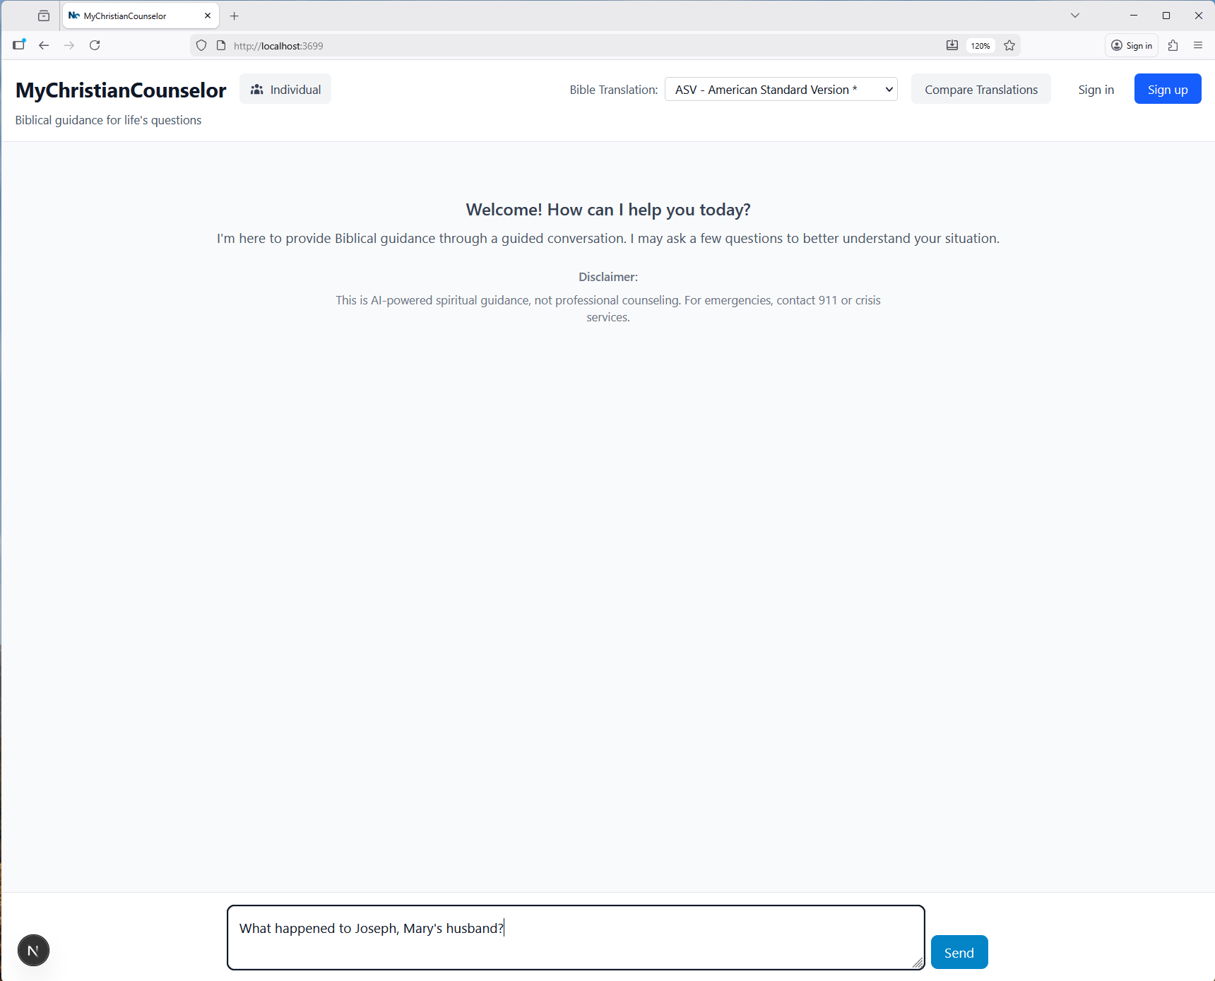
Of course you can choose different translations of the bible.
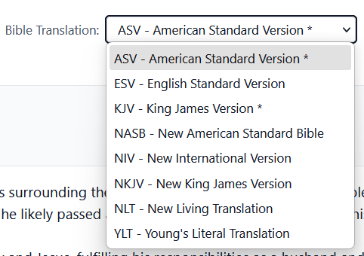
You can even compare translations if you choose by pressing  which will allow you to choose up to 4 translations to compare.
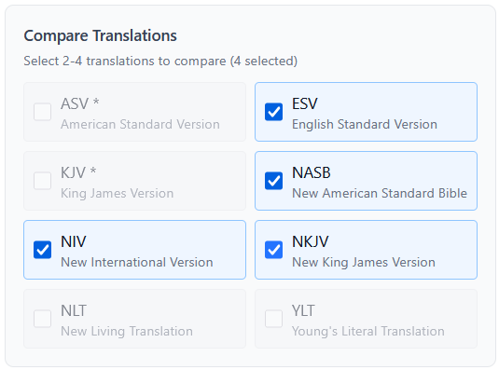
You will also receive a notice that you got a One-time answer only (no clarifying questions) and that you can sign up for more detailed counseling with clarifying questions.
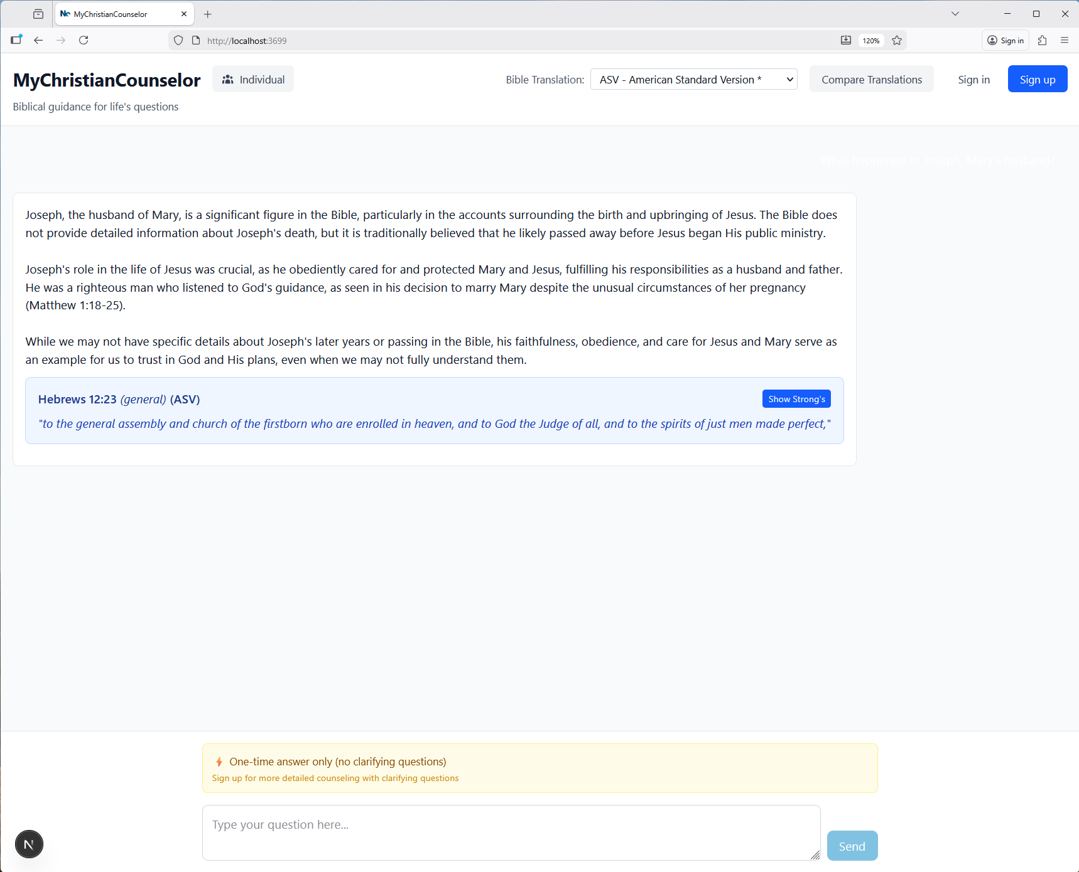
In single translation mode any translations with Strong’s references will display a button “Show Strong’s”, which will expand the verse and show all the Strong’s references that are color coordinated (Blue for Greek and Yellow for Hebrew). When clicked on a reference it will open a tab to the “Blue Letter Bible” for that word.
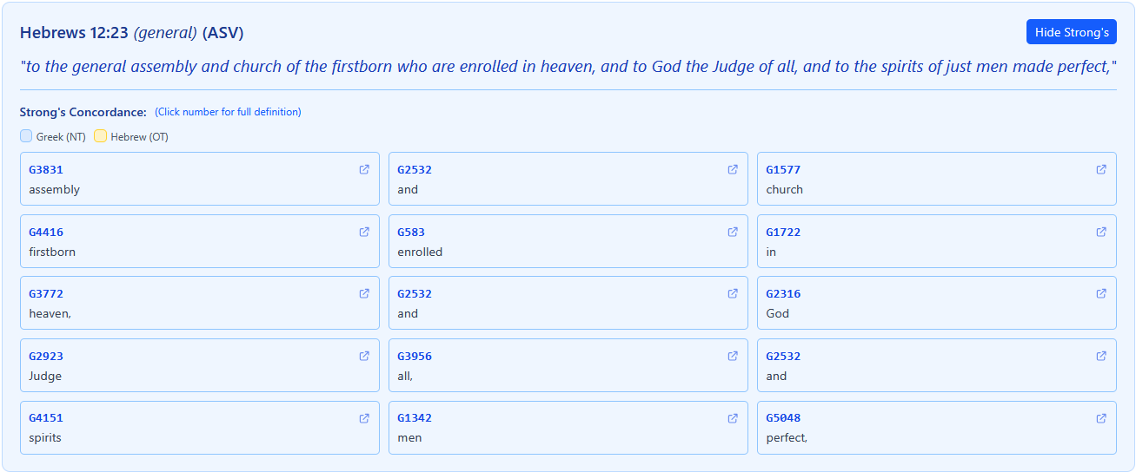
This is the end of what is available as an “Anonymous” user.

Registered
Should you decide to sign-up and become a “Registered” user two additional features become available.
1 - Shared Conversations
This first is that others may share their conversations with you and even allow you to comment on their conversation.
2 – Clarifying questions
The AI will ask up to 3 clarifying questions for any inquiry.
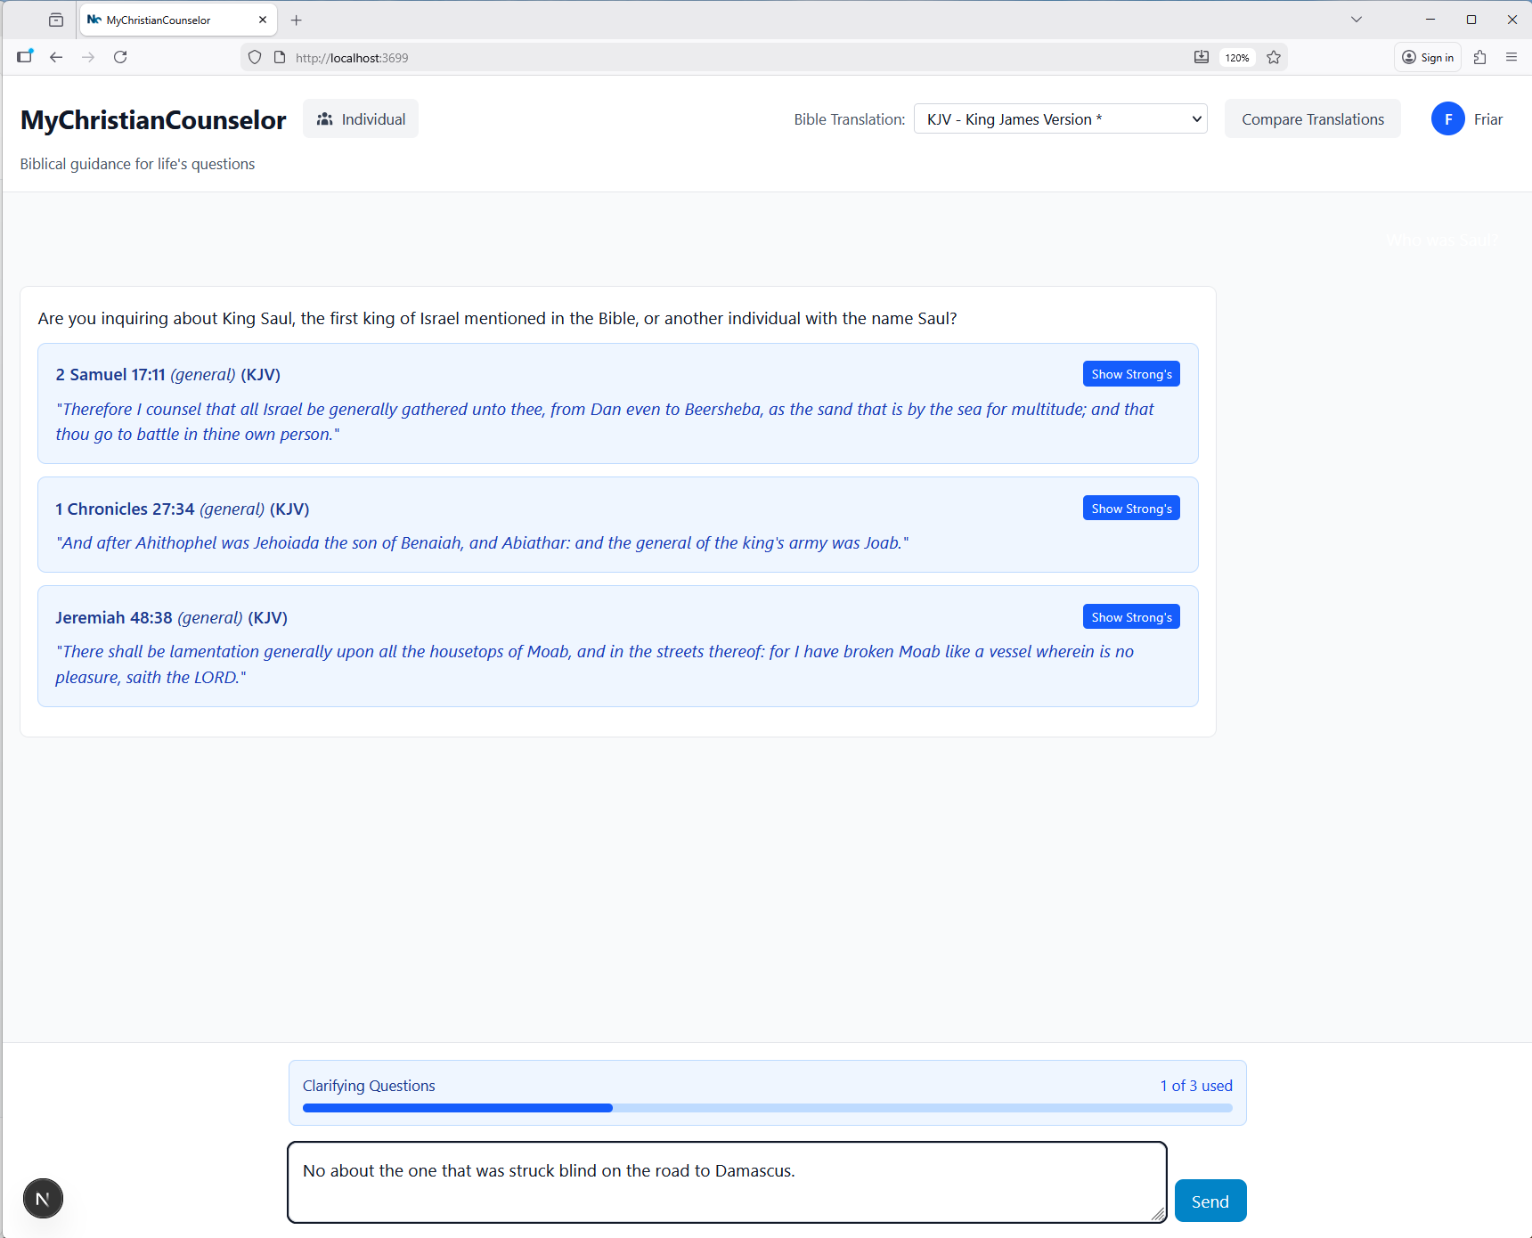

Subscribed
A subscribed user has either subscribed on their own or has a license from an organization, which could be a Family Group, Church, or Counseling Office for example. These users gain the following:
1 – Increased Clarifying Questions
2 – Session Notes (If marked private only the member and their counselor can see the note)
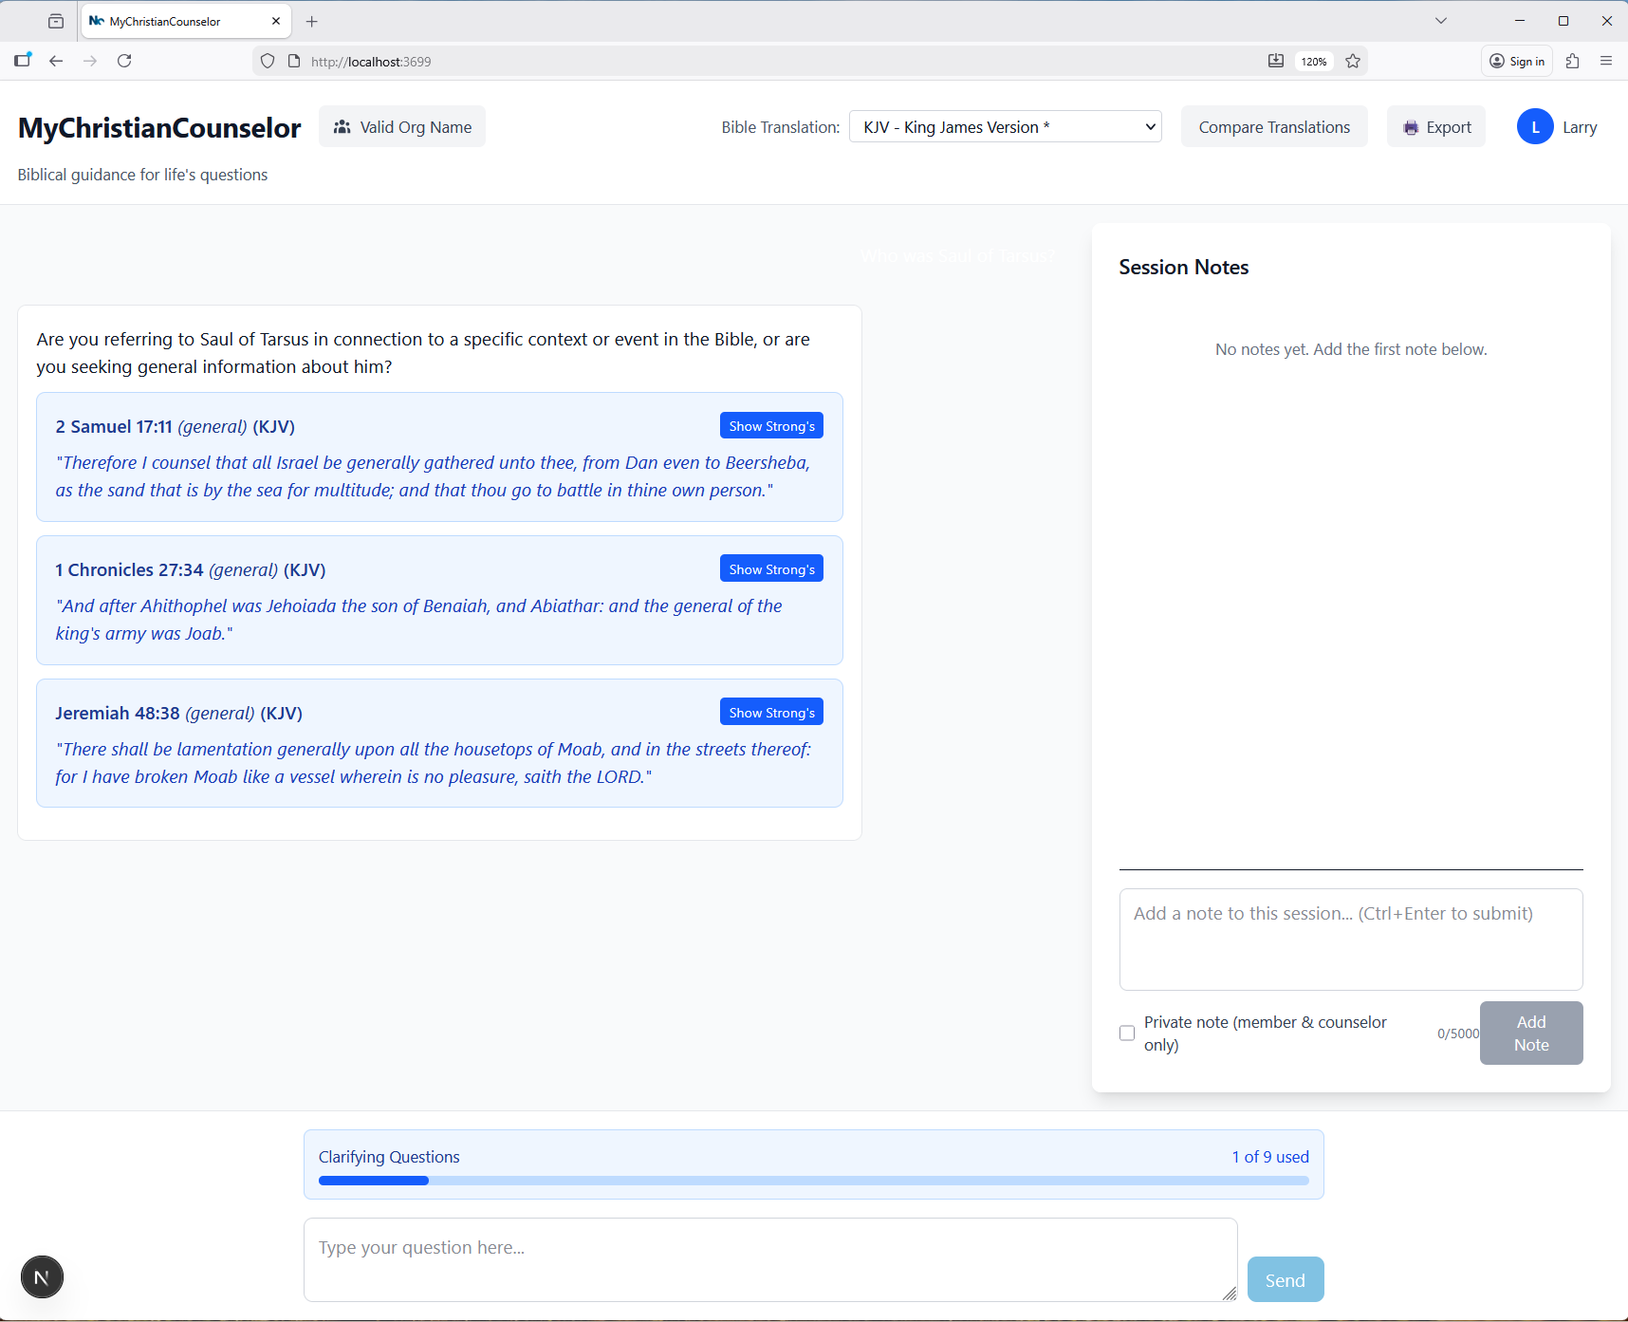
Also, the “Export” and “Journal” options becomes available.
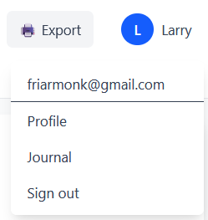
3 – Export allows a session to be printed including the notes.
4 – Journal allows previous sessions to be revisited, discussed, shared, and archived.
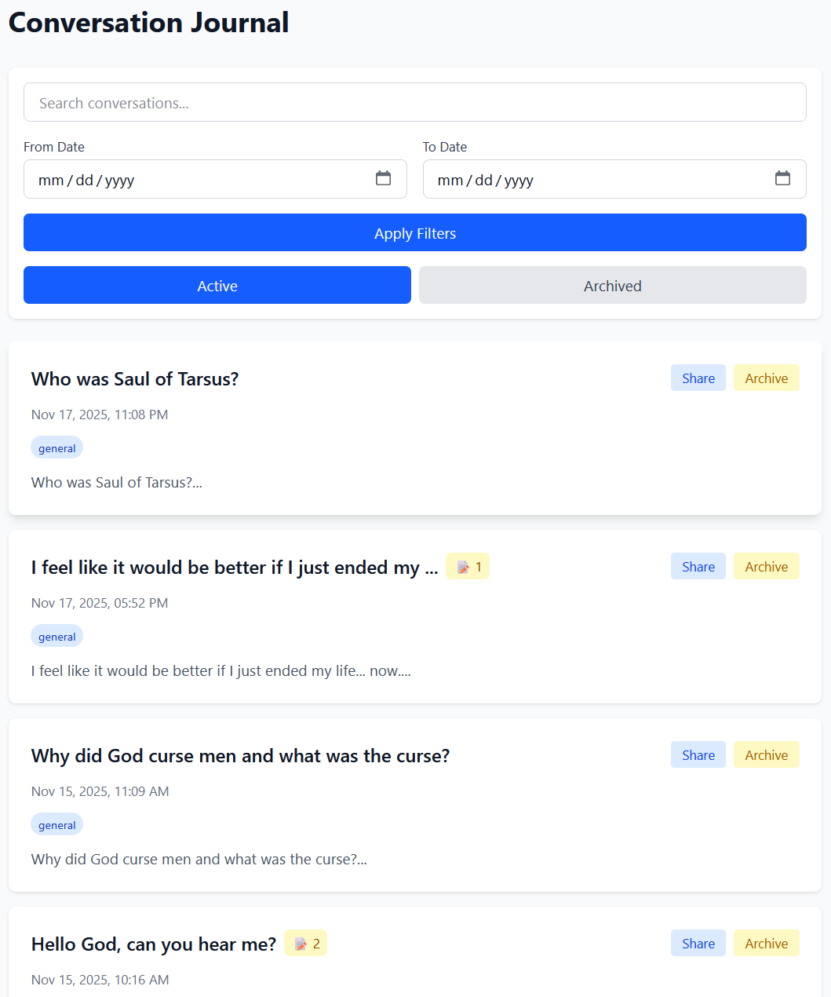

In the Conversation detail you get the questions and answers along with any notes taken during the session or after the conversation is shared.
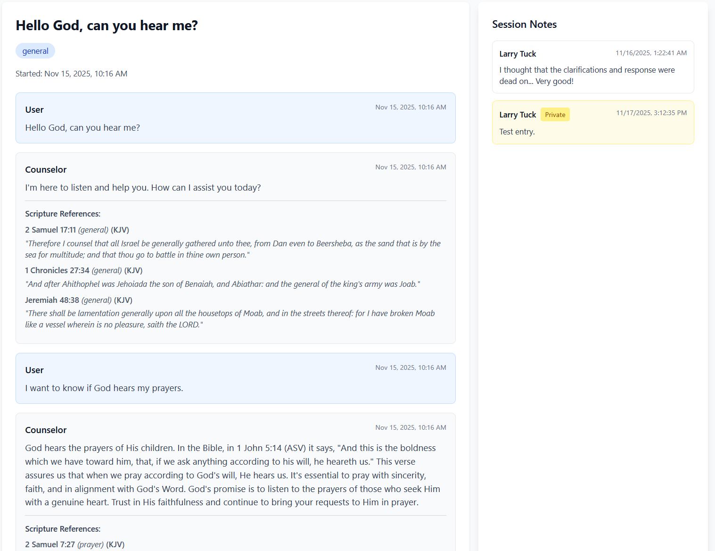

As you can see this can be a very powerful tool weather user for counseling or just diving deeper into God’s nature.

Counselor
A counselor can only be assigned as part of an organization and only to members associated with that organization. Note that a counselor can belong to more than one organization. A counselor is provided with a dashboard of all those he is counseling.
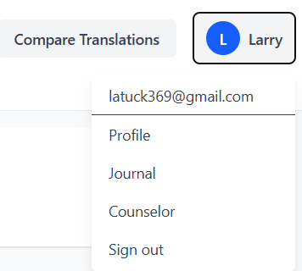

- AI Status Indicator (Overridable)
- Member Name & Email
- AI Generated Summary
- Last Conversation with the total count of conversations.
- Actions
  - Refresh the Status and Summary manually. Normally ran nightly.
  - Override the Status indicator. Must provide justification.
  - Journal, Look at the full journal for the member.
  - Profile, A place for the counselor’s observations. Private to the Counselor.
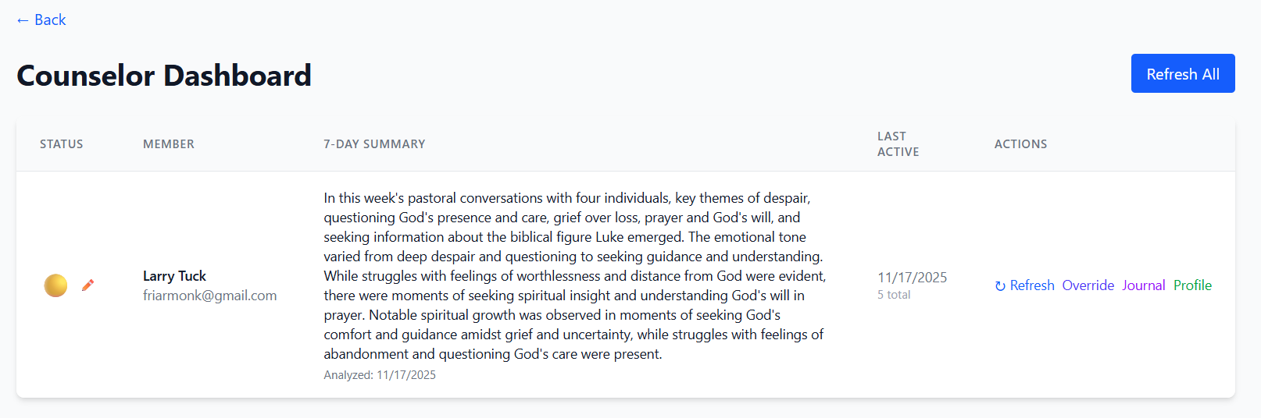
This is a good start but there are many additions that can and will be added.

Administration
There are two types of Administrators, organization and platform.

Organization Administrator:
The focus of an Organization Administrator is sending invitations to new members and assigning Counselors to members.
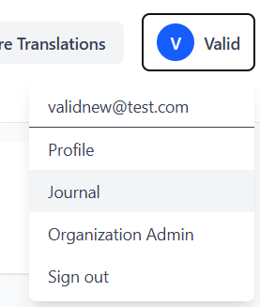
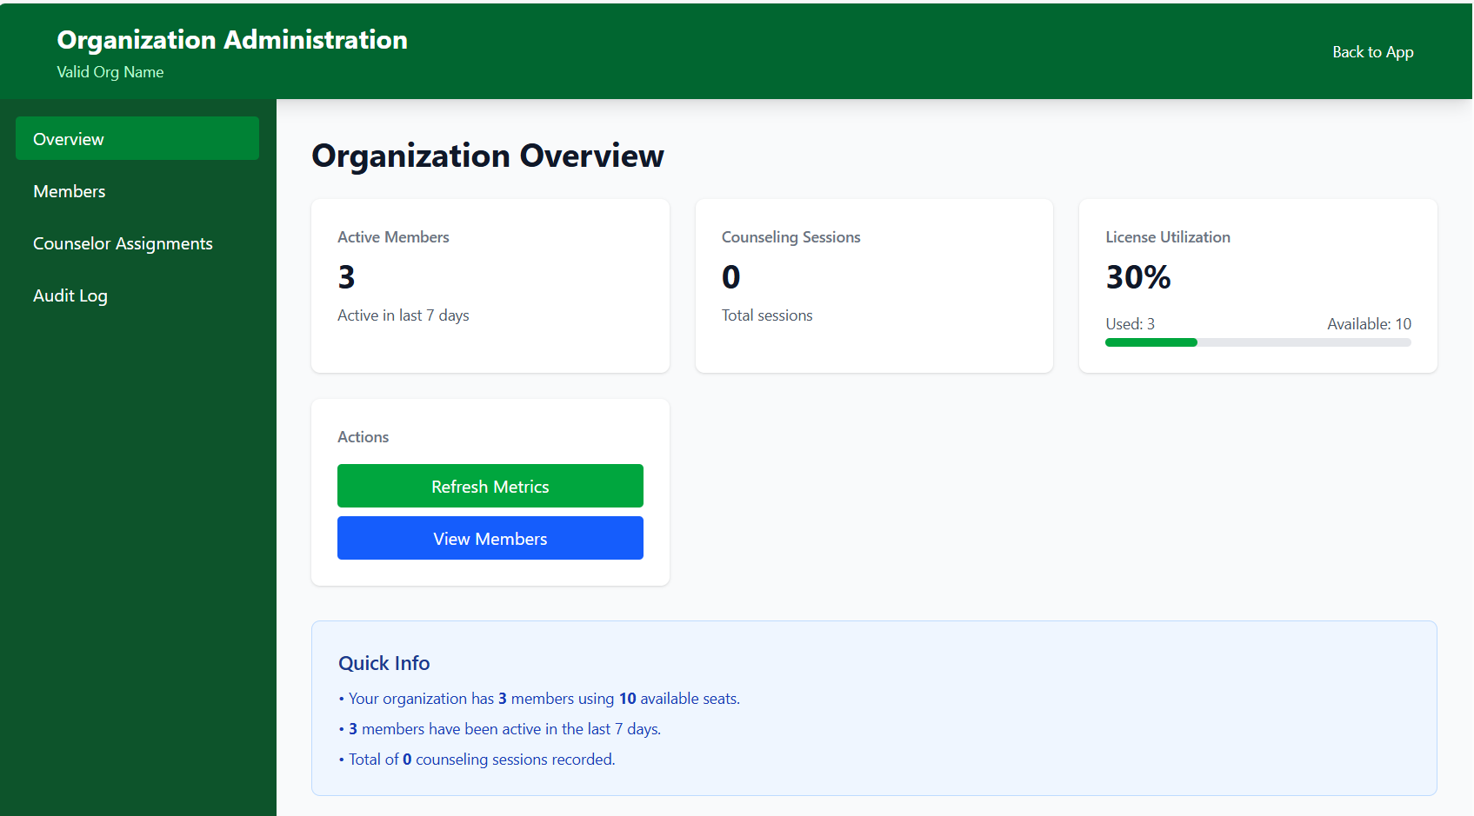

Platform Administrator
The focus of the Platform Administrator is Adding new Organizations and managing subscriptions.
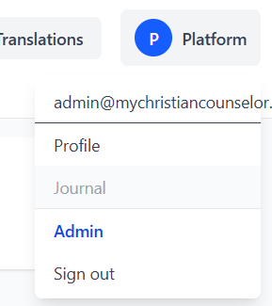

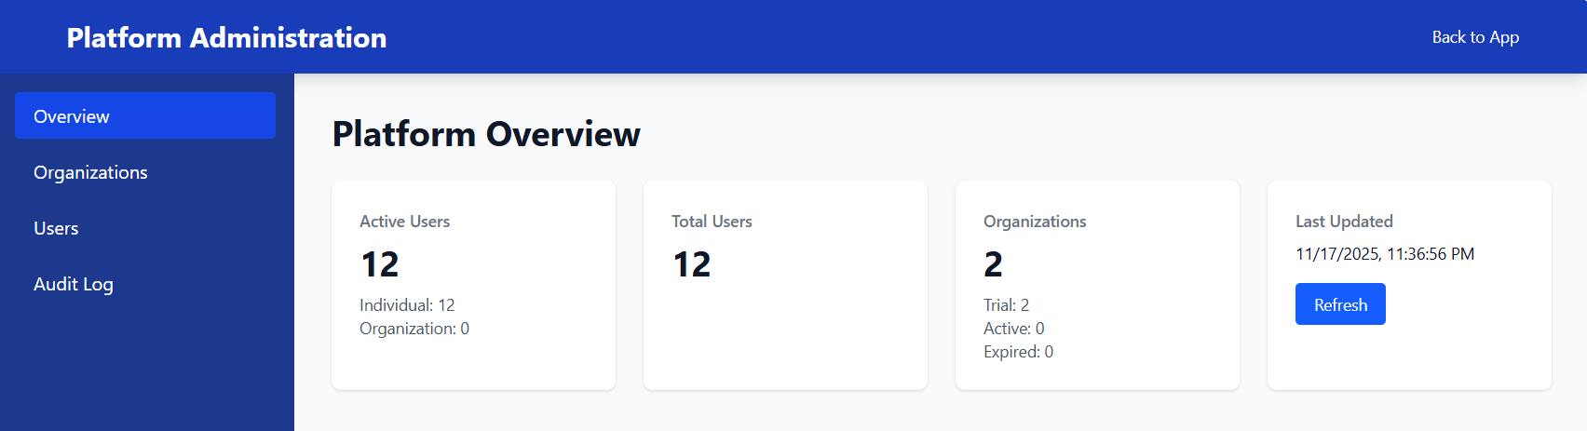

What’s Next

Development

Email Subsystem (Done)
The email system transforms MyChristianCounselor from a basic app into a professional, enterprise-grade platform with:
- ✅ Complete user lifecycle communication
  - registration → subscription → billing → collaboration
- ✅ Automated billing workflows (reduces manual work by 90%+)
- ✅ Professional branded emails (builds trust and credibility)
- ✅ Comprehensive analytics (data-driven decision making)
- ✅ Multi-tenant security (org data isolation)
- ✅ Production-ready infrastructure (Postmark, Stripe, cron jobs)
Users experience: Professional, timely communication at every touchpoint
Admins gain: Complete visibility and control over email operations
Business benefits: Reduced churn, automated collections, better engagement

Subscription Subsystem (Done)
The subscription system transforms MyChristianCounselor from a free-only service into a sustainable, revenue-generating platform with:

Core Capabilities
- ✅ Complete Stripe Integration
  - Checkout Sessions → Customer Portal → Webhook Automation
- ✅ Intelligent Organization Awareness (unique business logic)
  - Auto-suspends individual subscriptions when users join organizations
  - Auto-reactivates when users leave organizations
  - Preserves unused subscription time (zero revenue loss)
  - Supports multi-organization memberships
- ✅ Premium Feature Gating
  - Session Notes export/download
  - AI Context Awareness (crisis/grief detection)
  - Session Sharing capabilities
  - Priority support access

- ✅ Flexible Billing Options
  - Monthly ($9.99/month) and Annual ($99/year) plans
  - Self-service subscription management via Stripe Customer Portal
  - Automatic payment processing and renewal
- ✅ Graceful State Management
  - Subscription states: none → active → suspended → canceled
  - Membership-count-based suspension logic (0→1, 1→0)
  - Error handling ensures billing never blocks core functionality
- ✅ Production-Ready Infrastructure
  - PCI-compliant (no card data stored locally)
  - Webhook-driven status updates (eventually consistent)
  - Comprehensive logging and audit trails

Stakeholder Benefits

Users experience:
- Seamless checkout flow with Stripe's trusted interface
- No lost subscription time when joining/leaving organizations
- Self-service billing management (update cards, view invoices, cancel)
- Immediate access to premium features after payment

Admins gain:
- Zero manual subscription management (100% automated)
- Complete visibility via Stripe Dashboard
- Platform admin tools for manual overrides when needed
- Audit logs for all subscription changes

Business benefits:
- Recurring revenue stream ($9.99/mo or $99/yr per user)
- Zero revenue leakage (suspended subscriptions preserve unused time)
- Reduced support burden (self-service portal)
- Organization-ready (users can move between individual and org accounts seamlessly)
- Scalable infrastructure (Stripe handles payment complexity)

Unique Differentiator
Smart Organization Integration: Unlike typical subscription systems, this implementation intelligently handles users moving between individual and organization-sponsored accounts:
- Sally subscribes for 1 year → 3 months later joins an org → subscription suspended (9 months preserved)
- Sally leaves org later → subscription reactivates (9 months resume billing)
- Result: Zero revenue loss, happy customer, automated workflow
This prevents the common problems of:
- ❌ Double-charging users (individual + org)
- ❌ Losing revenue (canceling instead of suspending)
- ❌ Manual intervention (automatic suspension/reactivation)
- ❌ Poor UX (seamless transitions)
Bottom Line: The subscription system provides a complete, production-ready revenue engine with unique organization awareness that protects both revenue and user experience. It's automated, scalable, and ready to generate recurring revenue from day one.

Ticket Subsystem (Done)
A comprehensive multi-tenant support ticket system built for MyChristianCounselor, providing intelligent ticket management with AI-powered features, SLA tracking, and role-based access control.

Core Ticketing:
- Full CRUD operations for tickets
- Multi-tenant (individual users + organizations)
- Role-based routing (users → platform admin, org members → org admin)
- Message threads with file attachments
- Status workflow and ticket linking

AI Features (Phase 2A):
- Automatic priority detection
- Similar ticket detection (real-time + weekly batch)
- Intelligent duplicate detection with similarity scores

SLA Tracking (Phase 2B):
- Response & resolution SLA tracking
- Priority-based targets (4h urgent → 90d low)
- Business hours calculation (Mon-Fri 10AM-10PM EST)
- Status indicators (on_track → approaching → critical → breached)
- Auto-pause when waiting on user
- 15-minute scheduler for status updates
- Holiday management system
- Dashboard with compliance metrics

Production Preparation
- Complete Unit Testing (Goal > 90% Coverage)
- Production Environment (AWS) Prepared.
- Domain Registration
  - Final URL

Marketing
- Article Published
- Short Videos
- Flyers

Narratives

Profile: Pastor

Elevator:
Imagine your church equipped with a dedicated biblical counselor available to every member 24 hours a day, 7 days a week—delivering Scripture-centered guidance even while you rest and instantly notifying you or your team when a situation requires personal pastoral care. Are you interested in hearing more?

Follow-up:
MyChristianCounselor provides your congregation with immediate access to AI-driven biblical counseling that is theologically vetted, clinically informed, and always aligned with your church’s doctrinal statement. Simultaneously, you and your authorized ministry staff receive secure, real-time wellbeing dashboards and detailed session summaries (with member consent), enabling proactive shepherding and informed follow-up.
Rather than leaving members to struggle in silence or turn to secular resources that may conflict with biblical truth, they receive instant, biblically faithful responses grounded in God’s Word—while you retain full oversight and the ability to intervene seamlessly for escalated or deeply personal care.
This is not a replacement for your ministry; it is a powerful extension of it. MyChristianCounselor multiplies your pastoral reach, ensuring no sheep in your flock walks through crisis or darkness alone while awaiting the next service, counseling appointment, or office hours.

Profile: Counselor

Elevator:
As a licensed Christian counselor, you are acutely aware of the constraints imposed by limited session availability and the growing demand for biblically integrated mental health care. MyChristianCounselor significantly expands your practice capacity by enabling you to effectively serve 3–5 times more clients by delivering AI-powered, theologically vetted biblical guidance between scheduled sessions. Are you interested in hearing more?

Follow-up:
You retain full clinical and pastoral oversight through secure access to comprehensive session transcripts, real-time wellbeing analytics, progress trending, and private clinical notes, allowing you to monitor each client’s spiritual and emotional trajectory with precision.
Your clients benefit from immediate, Scripture-grounded support precisely when crises arise, whether at 2 a.m. or in the midst of a challenging day, while you strategically allocate your expertise to higher-acuity cases and deeper therapeutic work. The platform preserves the integrity of the therapeutic alliance, ensures continuity of care, and upholds ethical standards of confidentiality and professional responsibility.
Rather than declining new referrals or leaving clients unsupported between appointments, MyChristianCounselor positions you as a consistently accessible resource—extending your professional wisdom and biblical fidelity 24/7 without compromising the depth, empathy, or personalization that define exceptional Christian counseling.

Profile: Investor

Elevator:
We are democratizing access to biblical counseling by integrating advanced AI with professional Christian oversight, delivering faith-aligned mental health support to millions in need. Are you interested in hearing more?

Follow-up:
Our secure, scalable platform empowers churches and faith-based organizations to offer their members 24/7 Scripture-grounded guidance and emotional support. Licensed Christian counselors continuously monitor user well-being through proprietary dashboards and provide seamless human intervention when clinically or pastorally indicated.
With approximately 70% of Americans identifying as Christian and mental health challenges reaching crisis levels, we are uniquely positioned to serve a multi-billion-dollar faith-based emotional wellness market. Our B2B2C subscription model enables organizations to provide this service at scale for a predictable per-member fee, while preserving the relational depth and personal care that define effective biblical counseling.
In contrast to secular mental health applications, our solution intentionally fuses evidence-based clinical practices with biblical wisdom and theology, delivering a differentiated offering that deeply resonates with faith communities and produces verifiable improvements in both spiritual vitality and emotional health.

