Systems Analysis and Design

Laboratory 4 — Section A
Role-Based Asset Transaction and Approval Management

1. GitHub Repository & Live Site
GitHub Repository URL: ____________________________________________
Live GitHub Pages URL: ____________________________________________
Fill in after you push this project to GitHub and enable Pages (see README.md, section 2.5).

2. Updated Entity-Relationship Diagram (ERD)
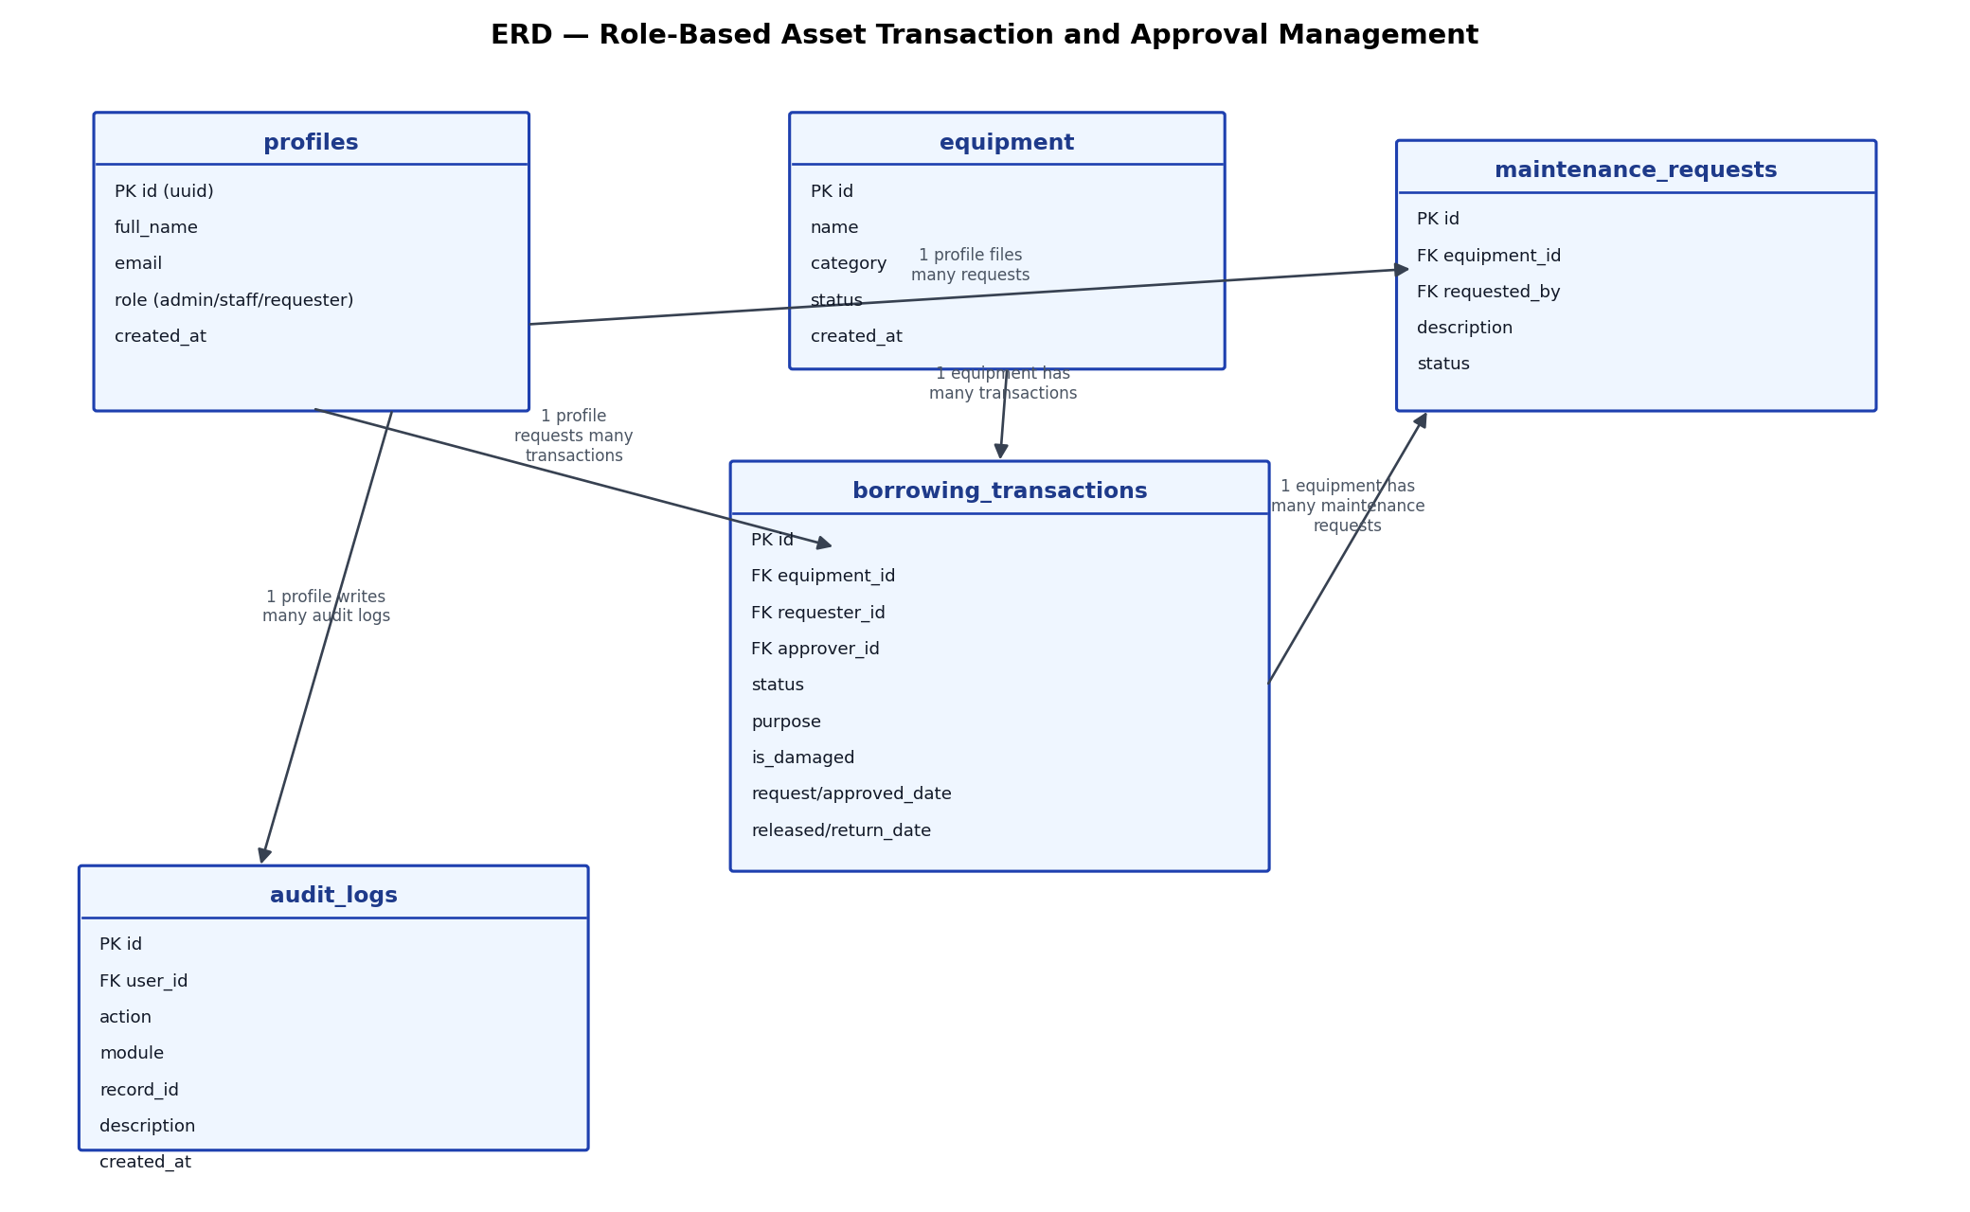

3. Use Case Diagram
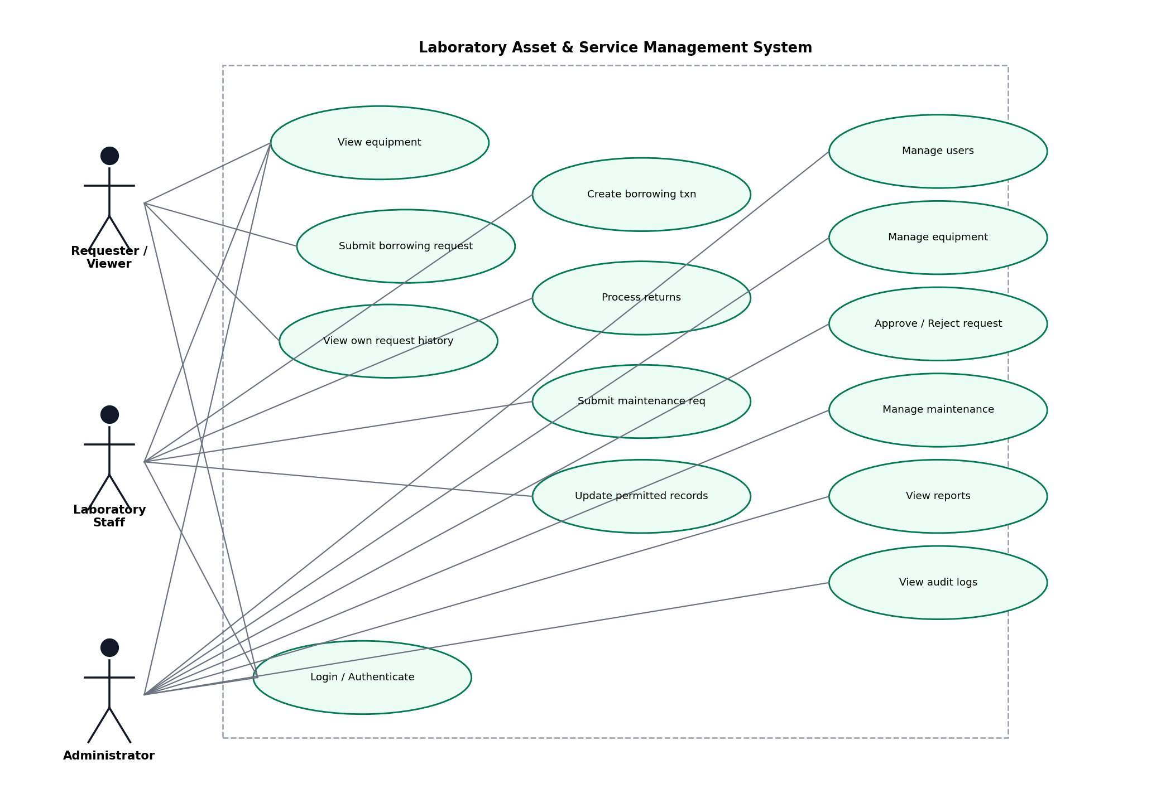

4. Role-Permission Matrix
Function | Administrator | Laboratory Staff | Requester / Viewer
View available equipment | Yes | Yes | Yes
Add / edit / delete equipment | Yes | No | No
Submit borrowing request | Yes | Yes | Yes (own only)
View request history | Yes (all) | Yes (all) | Yes (own only)
Approve / reject request | Yes | No | No
Release approved equipment | Yes | Yes | No
Process returns | Yes | Yes | No
Submit maintenance request | Yes | Yes | No
Resolve maintenance request | Yes | No | No
Manage users / roles | Yes | No | No
View audit logs | Yes | No | No
Enforced at two levels: the interface (nav items and action buttons are hidden/disabled per role) and the database (Row-Level Security policies and trigger checks in supabase/schema.sql), so the rule cannot be bypassed by calling the API directly.

5. Workflow Diagram
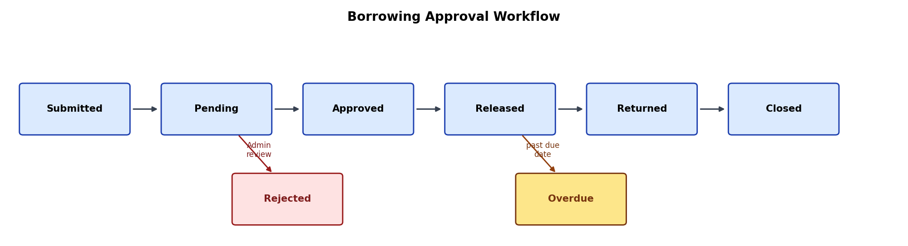
Pending -> Approved -> Released -> Returned -> Closed, with Pending -> Rejected and Released -> Overdue -> Returned as alternate paths.

6. Business Rules
ID | Business Rule | Where Enforced
BR-A4-01 | Only available equipment may be requested. | enforce_new_request() trigger
BR-A4-02 | Staff/Admin cannot approve their own request. | enforce_borrowing_rules() trigger
BR-A4-03 | Only Administrator may approve or reject requests. | enforce_borrowing_rules() trigger + RLS
BR-A4-04 | Only Approved requests may be released. | enforce_borrowing_rules() trigger
BR-A4-05 | Released equipment becomes Borrowed. | enforce_borrowing_rules() trigger
BR-A4-06 | Returned equipment becomes Available unless damaged. | enforce_borrowing_rules() trigger
BR-A4-07 | Rejected requests cannot be released. | Guaranteed by BR-A4-04 precondition
BR-A4-08 | Returned transactions cannot be processed twice. | enforce_borrowing_rules() trigger
BR-A4-09 | Equipment under Maintenance cannot be borrowed. | enforce_new_request() trigger
BR-A4-10 | Sensitive operations must be logged. | log_*_audit() triggers

7. Audit Trail
Table: audit_logs(id, user_id, action, module, record_id, description, created_at).
Populated automatically by SECURITY DEFINER triggers on every sensitive action: request submitted / approved / rejected / released / returned / closed; equipment added / updated / deleted; maintenance opened / resolved; user role changed. Only the Administrator role can read this table, and no role has direct insert/update/delete access to it, so the trail cannot be edited from the application.
Audit-log screenshot (insert after running the app):
[ Insert docs/audit-log-screenshot.png here after testing your deployed instance ]

8. Functional Test Results
Test ID | Scenario | Expected Result | Actual Result | Pass/Fail
TC-A4-01 | Viewer attempts to open Admin page | Access denied.
TC-A4-02 | Staff submits request | Request saved as Pending.
TC-A4-03 | Administrator approves request | Status becomes Approved; audit log created.
TC-A4-04 | Administrator rejects request | Status becomes Rejected.
TC-A4-05 | Attempt to release rejected request | Operation blocked.
TC-A4-06 | Release approved equipment | Equipment becomes Borrowed.
TC-A4-07 | Return released equipment | Equipment returns to appropriate status.
TC-A4-08 | Check audit log after approval | Approval entry is visible.
TC-A4-09 | Staff attempts restricted delete | Operation blocked.
TC-A4-10 | Logout and open protected page | Redirected to login / access denied.
Fill in the Actual Result / Pass-Fail columns after running each scenario on your deployed instance — see docs/test_results.md for the same checklist plus extra rule-specific checks.

