Manual

Swiping Cards to Choose Foods (Main Screen)
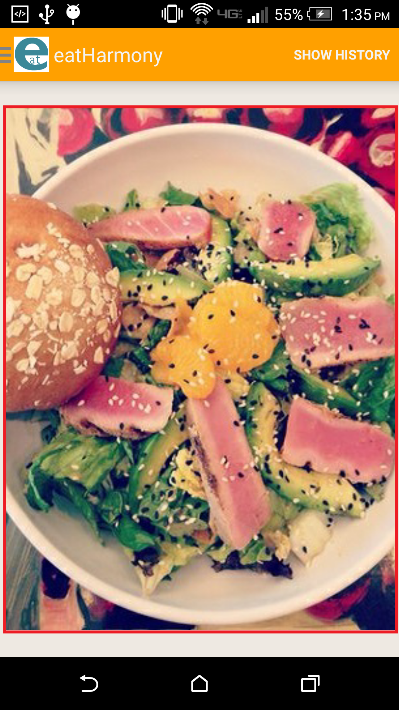
This is the screen that the user sees upon opening the application. The area with the red square around it is what the user interacts with to choose a food.

Swiping Left
A user can swipe left by touching the screen and dragging to the left. This indicates that the user does not like the current food displayed and another food image is shown.

Swiping Right
A user can also swipe right which indicates that the user likes the food displayed and would like more information.

Show History
This will bring up another screen with the history of foods the user has chosen. Further described in “History” section.

Slide Out Menu
Sliding from the left will bring out another menu. Alternatively, the user can tap the eatHarmony icon to bring out the menu. Further described in “Slide Out Menu” section.

Information About the Food
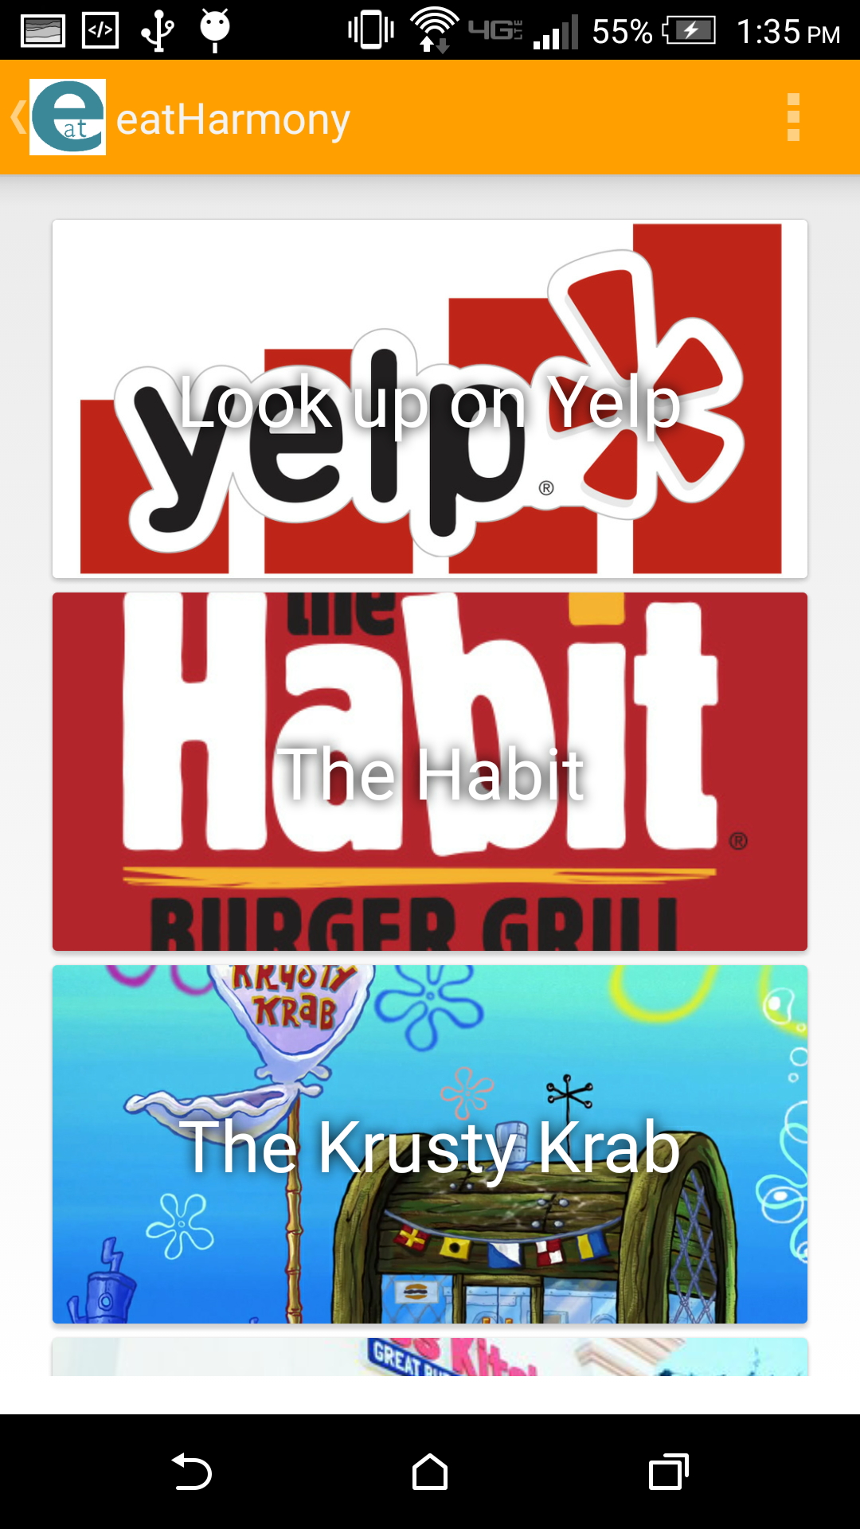
When a user swipes right, it will bring up this screen that presents the user with different actions the user can take by clicking on the appropriate card.

Yelp General Food Type
The first card is a general search of the food that the user selected. For example, if the user selected an image of a pizza, it would bring up the Yelp.com search page of “pizza”.

Yelp Specific Restaurant
The other options are restaurant specific and if clicked, will bring up a specific restaurant's Yelp.com webpage. The user is provided with 5 options to help facilitate choosing.

History
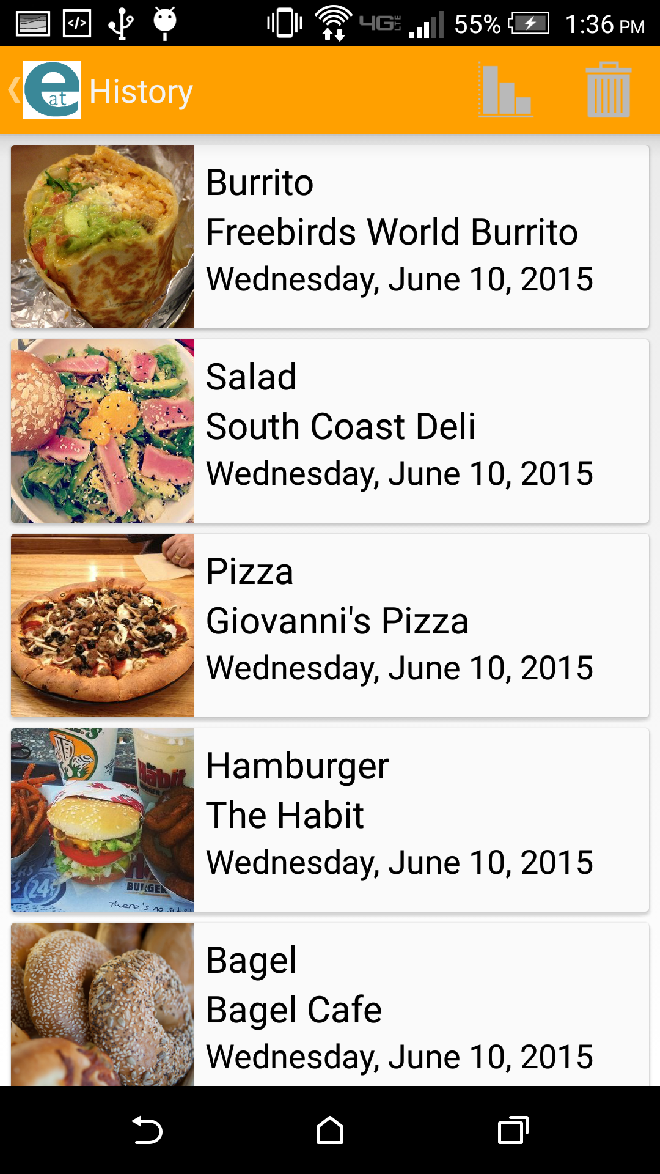
In the top right corner of the main screen in the title bar, there is a history button which brings up this list of cards that shows foods that the user previous choose, the date of choosing, and the restaurant that was chosen.

Deleting History
If the trash bin image in the title bar is pressed by the user, the history will delete itself and no cards will be shown until new foods are chosen from the main screen.

History Graphs
Selected the bar graph icon next to the trash bin will bring up another page with graphs related to the user's history. Further described in “History Graphs” section.

History Graphs
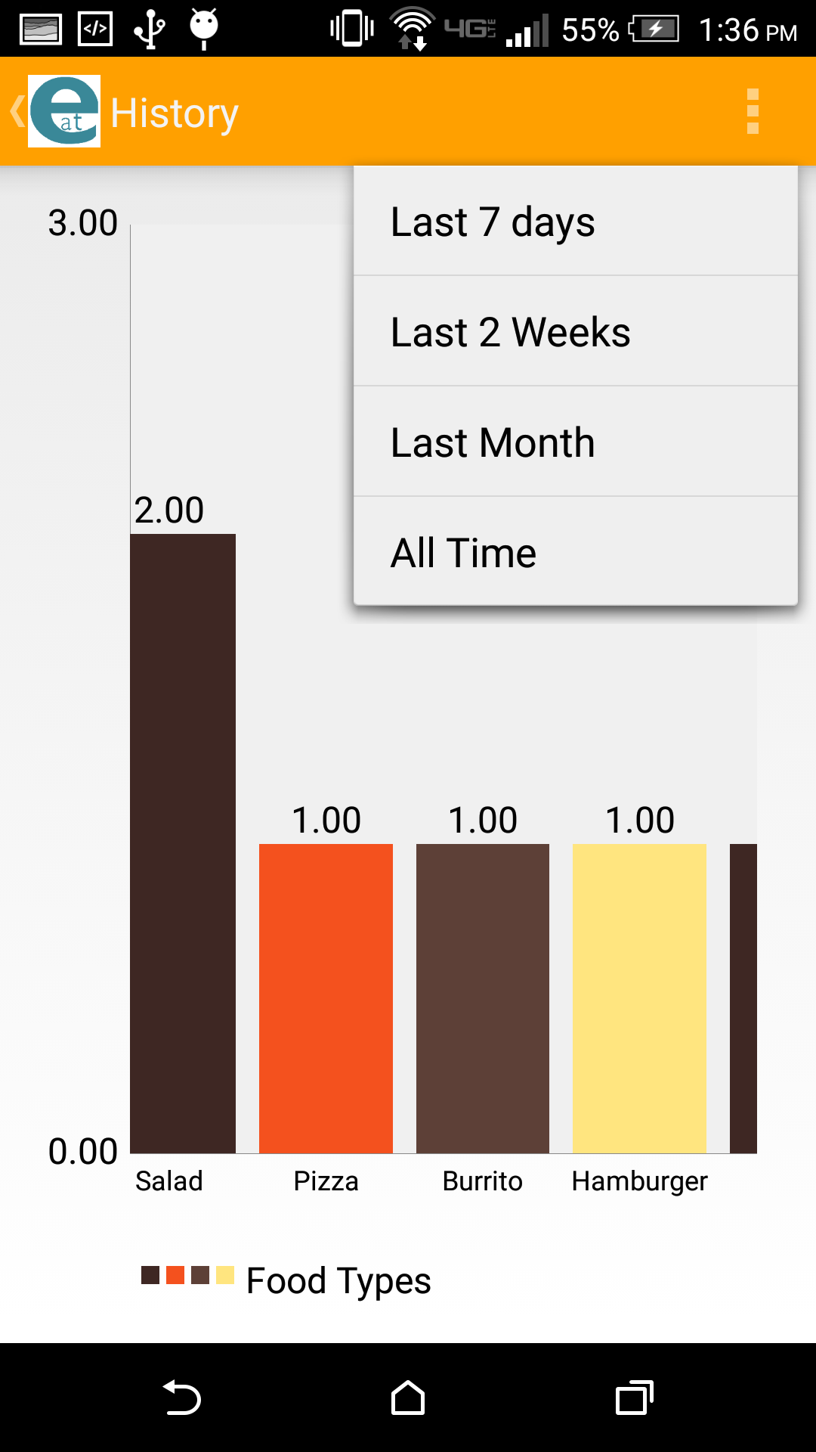
This screen gives a detailed graph about the user's history of food choices. The graphs X-axis represents the different foods and the Y-axis indicates how often that food was ordered. The user can scroll left and right to see the other food choices if they are not shown on screen.

Graph Time Scale
In the title bar, the user can touch the options icon (3 vertical boxes) which will bring up a time scale for the user to choose. The user can see a graph of the history within the past week, 2 weeks, month, or all time since the last history delete.

Slide Out Menu
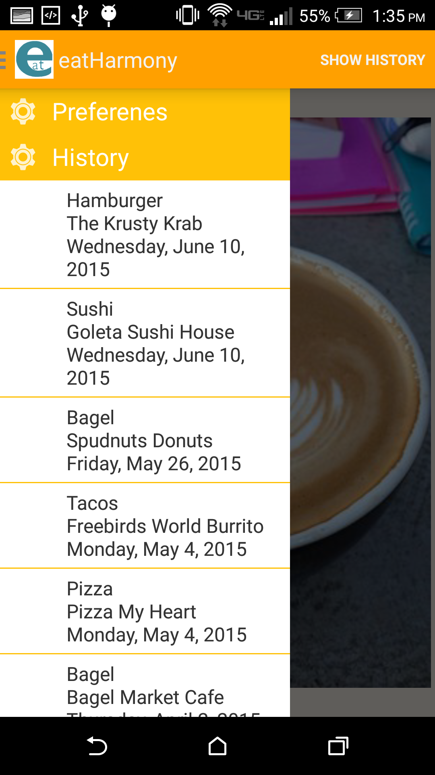
The slide out menu appears if the user drags from the left edge of the screen to the right. Tapping the eatHarmony icon will also display this menu.

Preferences
Touching the preferences option will bring up certain food criteria that the only is only interested in. Further described in “Preferences” section.

History
This is a simple listing of the user's history of foods. Unlike choosing the “Show History” option which brings up a more detailed history, the history listing in the pull out menu is designed for the user to quickly see what they previous ordered.

Preferences
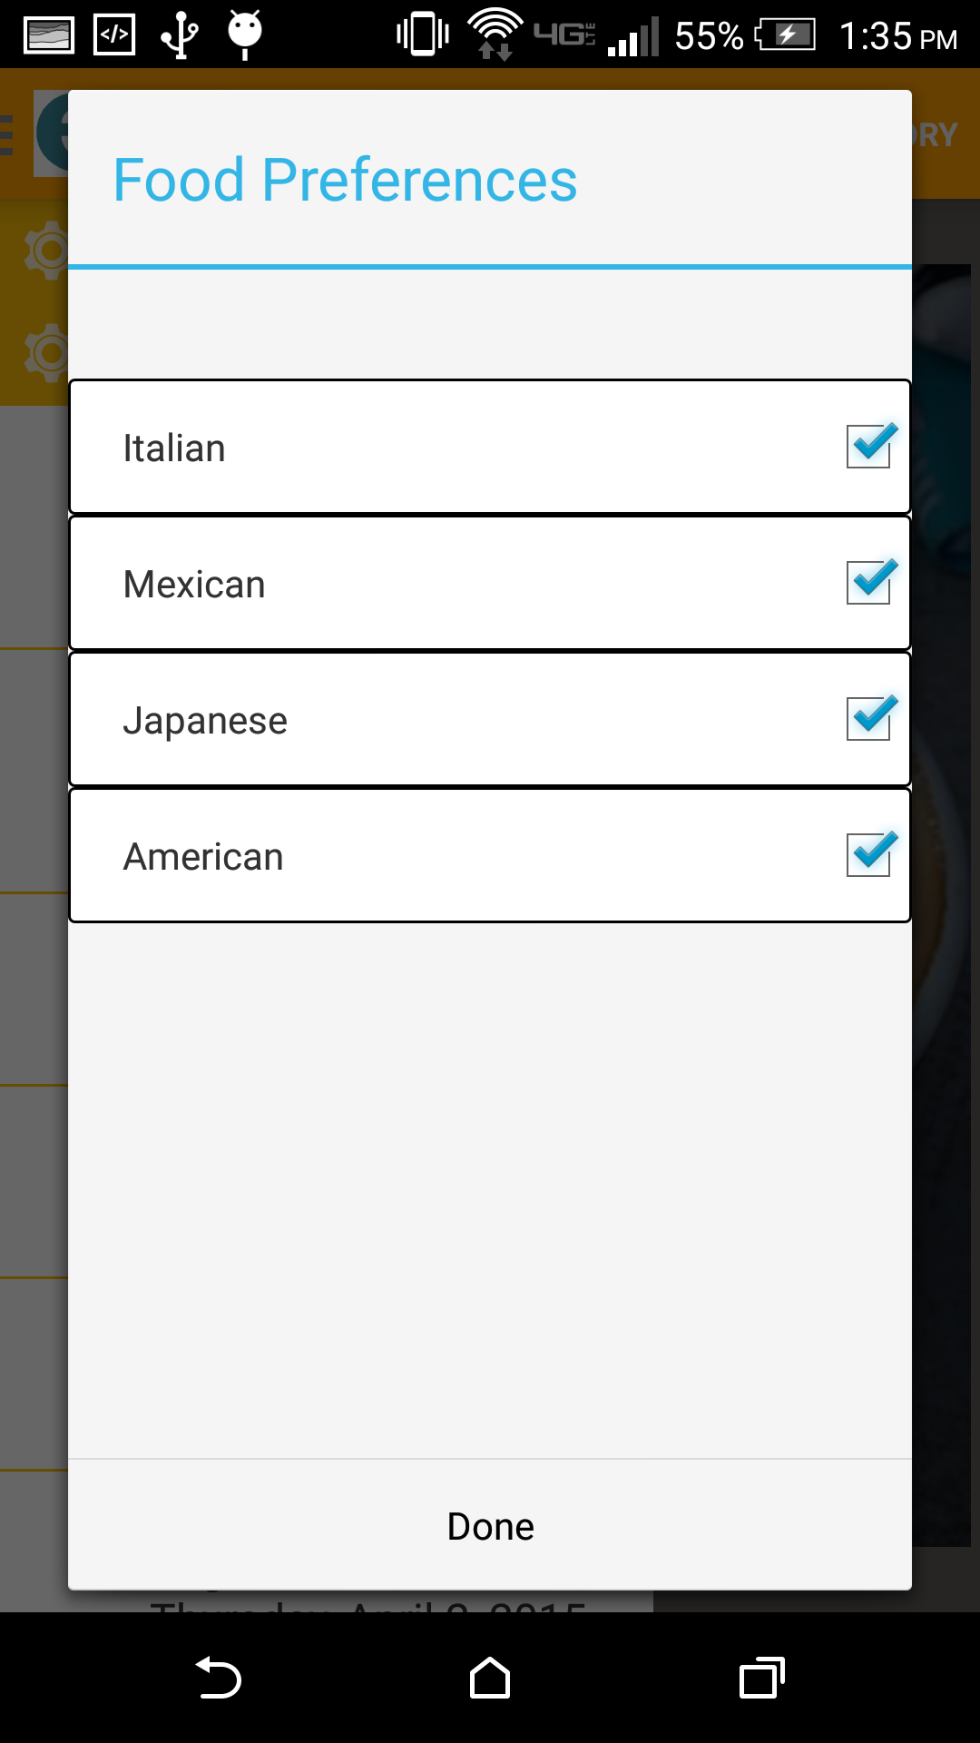
From the slide out menu, choosing the preferences option will bring up this fragment box containing different criteria that the user can choose using the check boxes.

Check Boxes
Foods that are displayed on the main screen are categorized by what kind of food they are. By checking only the boxes that the user wants, it will augment the main screen to only show foods of that category. For example, if “Mexican” and “Italian” are only checked, only foods that fit into that category will be displayed on the main screen.

