# Problem Scenarios

The original idea was inspired by the problem of having too many choices to eat at, and the general lack of decision making ability of a lot of people. This inspired a basic design that just chooses a restaurant for you, and if you really don’t like it you can input a way to choose another restaurant.

As the idea developed, it seemed that was too constricting, maybe you like the type of food but not that particular restaurant. So instead the design would be to choose a specific type of food (not just a category, like Chinese or American, but more specific like a Hamburger), and then from there give a few options of restaurants that would serve you that food.

One problem is with picky eaters. We don’t want them to keep selecting new things because they dislike a whole category of food, like they won’t eat fish. An ability to get rid of certain categories of food that you don’t like was then considered as a solution to this.

A problem that came up later in design is that people often choose based on what they’ve had recently. A common exchange for a couple might go: “Do you want to have pizza?” “No, we had pizza on Tuesday” “No, it was definitely more than a week ago” or similarly. Being able to see a food history including dates you had items selected through the app would make such decisions less ambiguous, and could be quite helpful in the decision making process.

# Design

Our first design was very simplistic, and based off of the second idea and third ideas in our problem scenarios. We decided to start with a splash page with an ability to get to options disabling certain categories. Then would pull up a yelp search of that type of food.

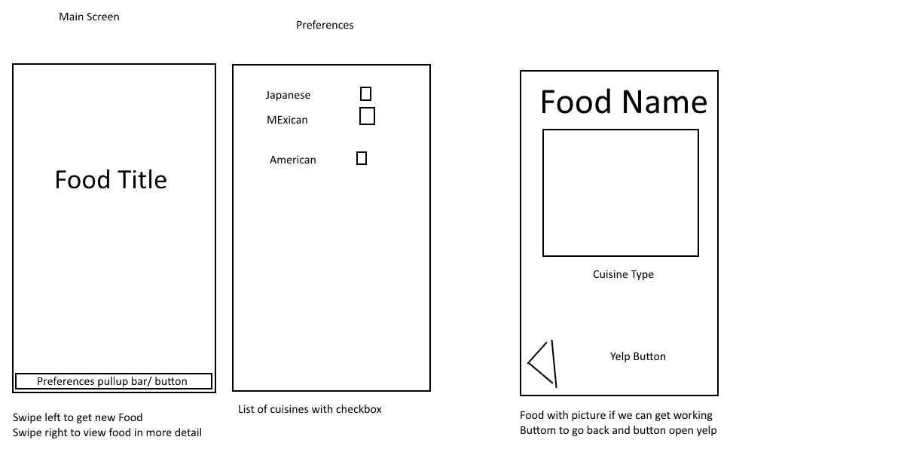

The splash page felt like an extra step in the way of the user, reducing the quickness of getting an option, and also felt unnecessary. In a brainstorming session that included many new problem scenarios and ideas, we first developed a new interface. This is much faster, by opening right to an option. Then you could either choose a new food, or select it which would pull up a list of restaurants and rating rather than making you open yelp immediately. Then you could select a restaurant to open its yelp page for more details.

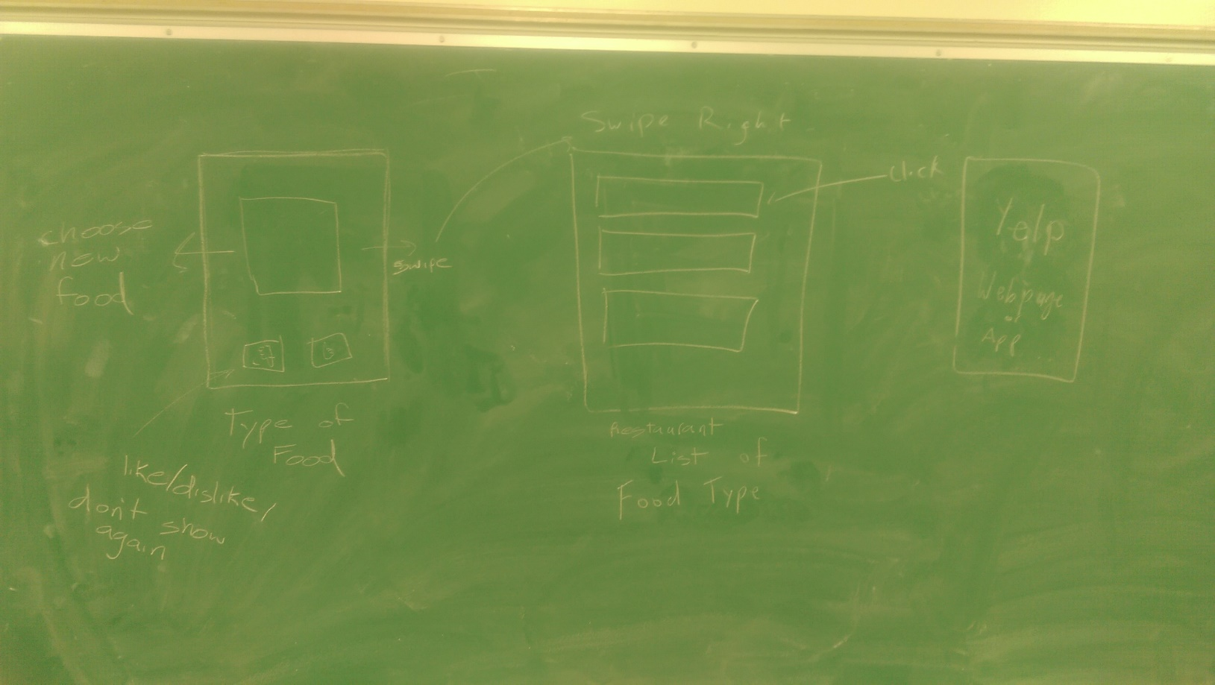

The list of restaurants may be giving too much choice, so we decided to test with users the difference between showing the top 3 results from yelp, the top 5, the whole search, or just a single randomly selected option.

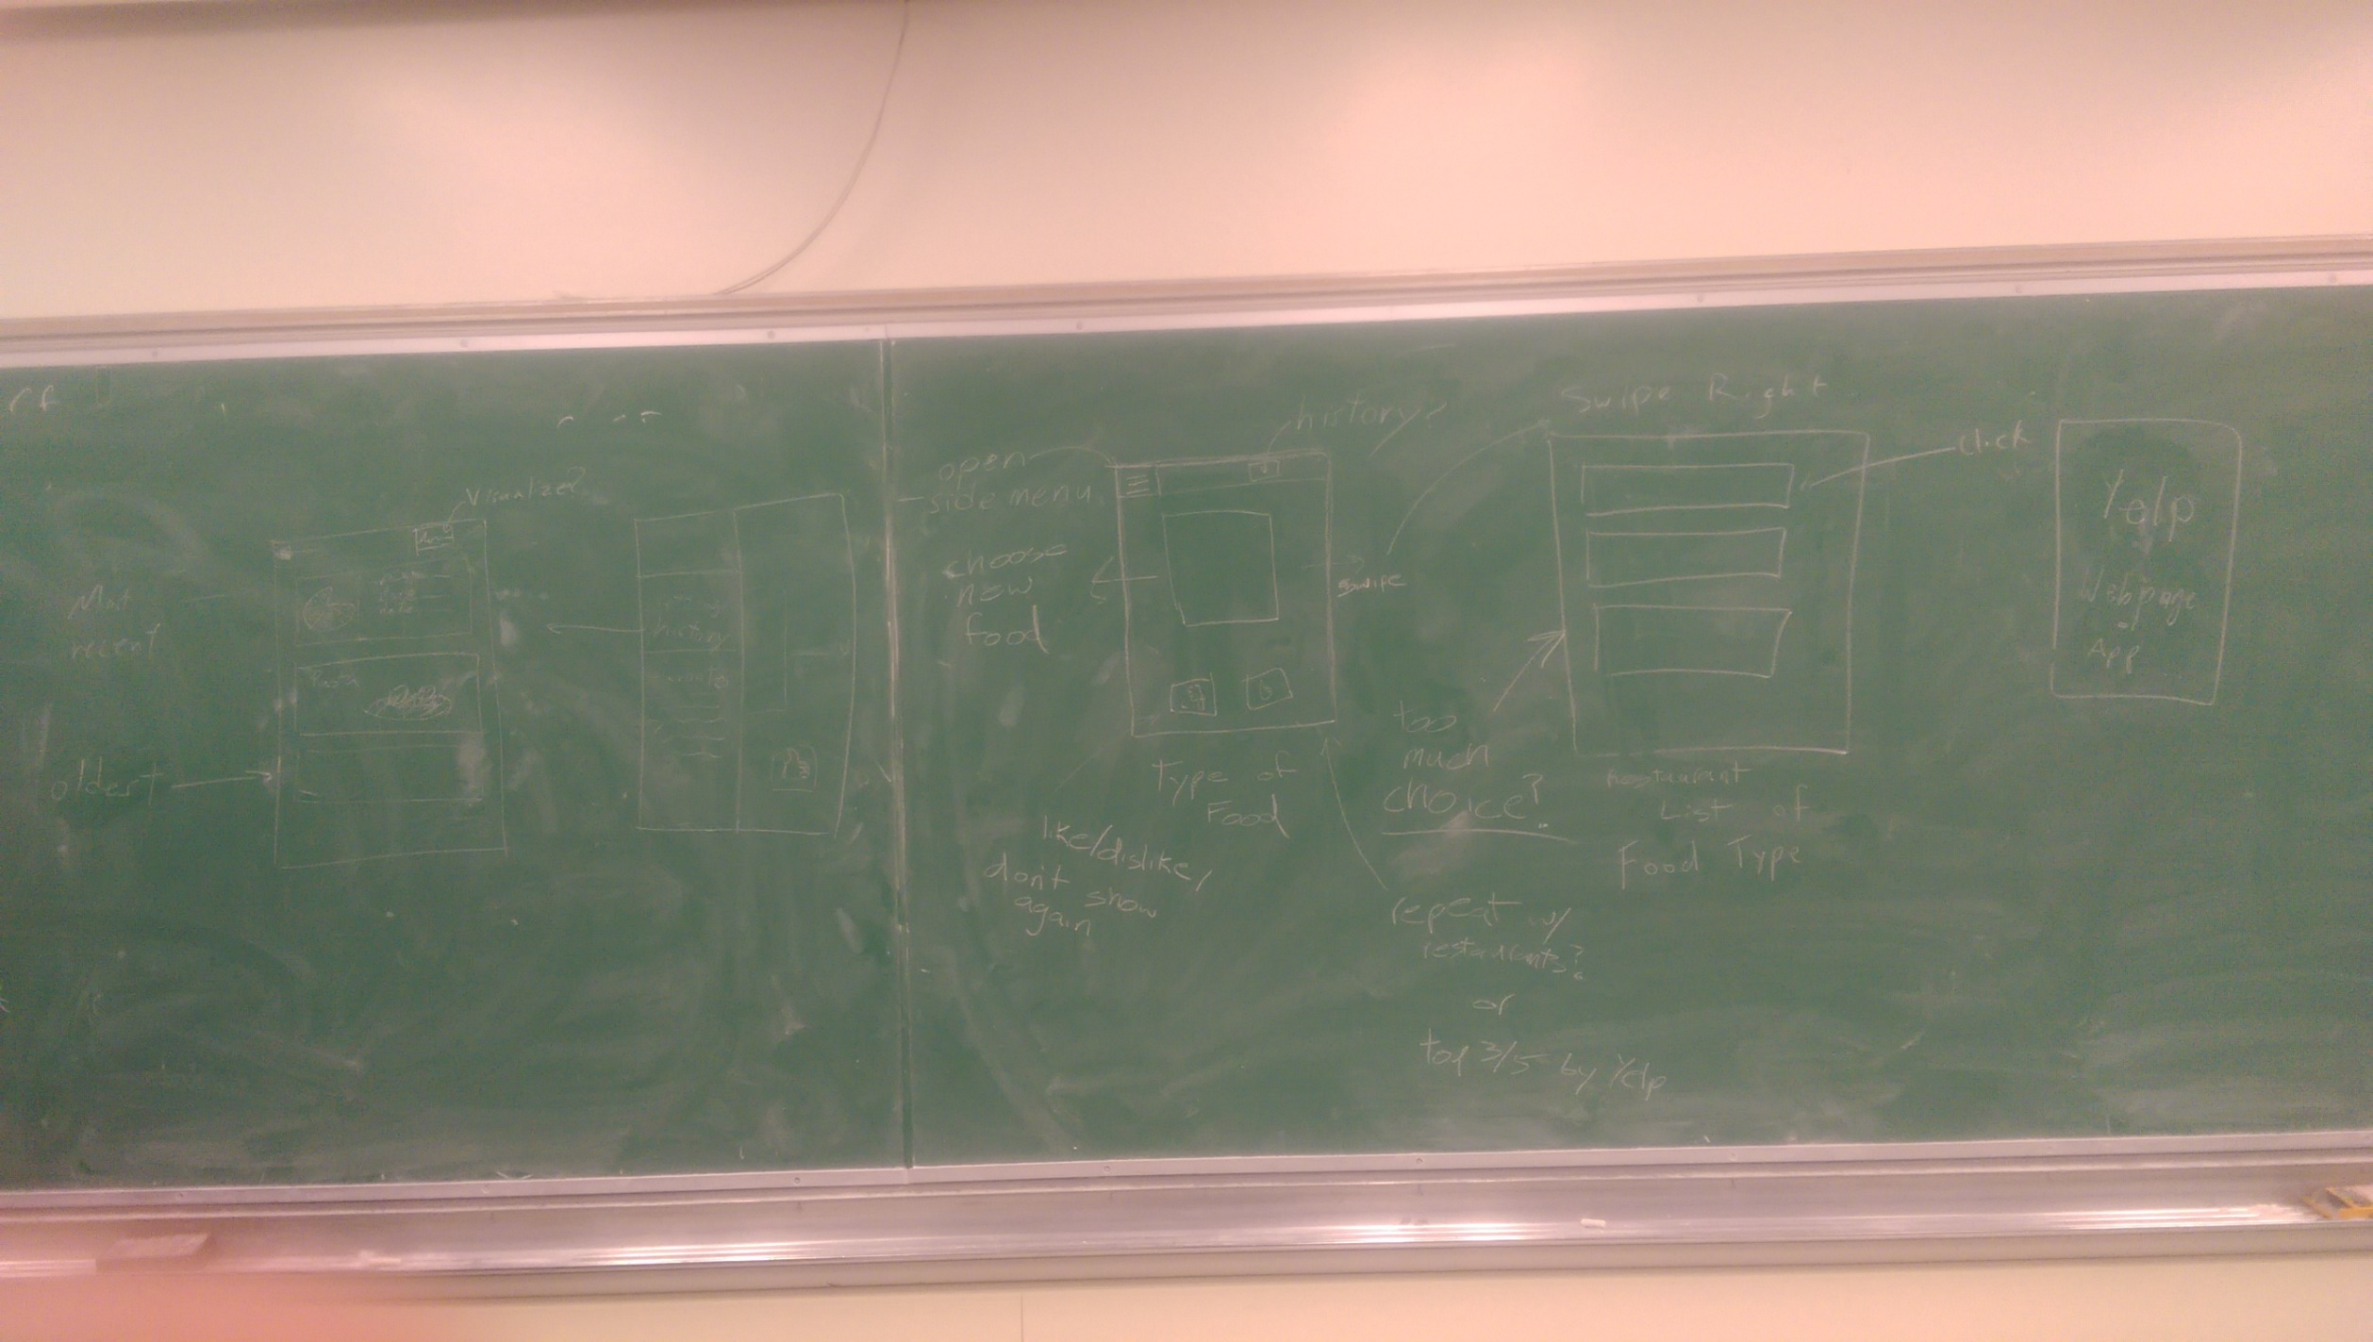

Originally we were just going to have the initial preferences page as a button on the actionbar, or as a swipe up or down, but believe a full android style hamburger menu would work better as we had come up with more problem scenarios, namely about the food history.

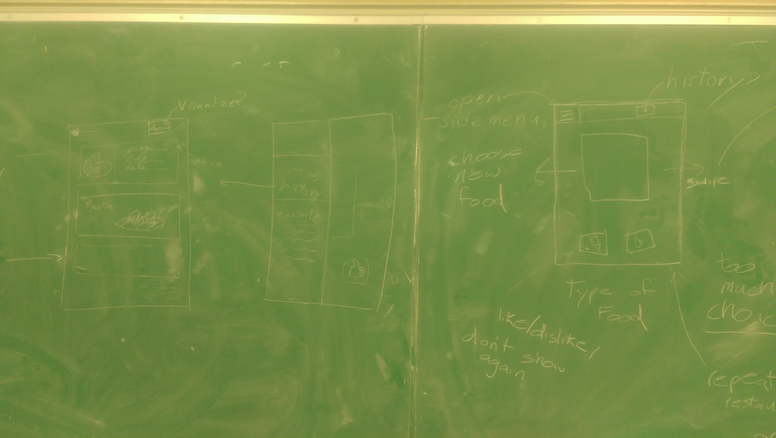

Following the blackboard design, we went on to mock-up more realistic looking designs. Starting with basic paint designs, then moving onto mockups made with hardcoded data in Android studio.

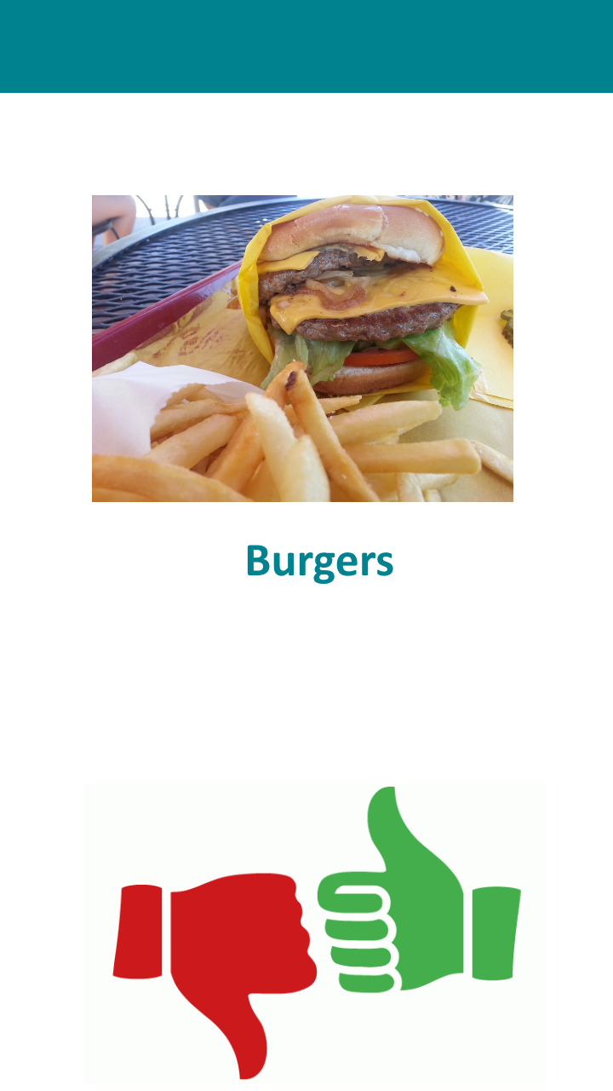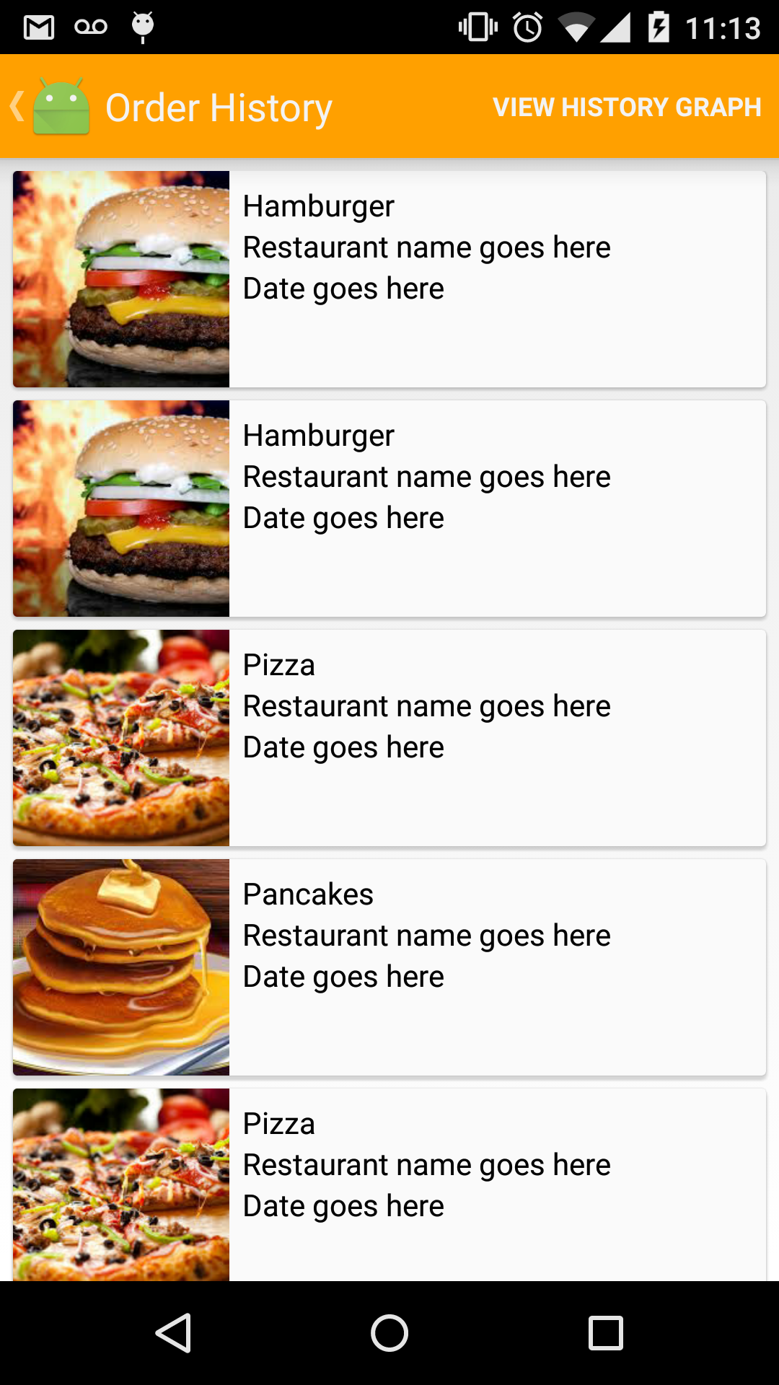

# User Tests

The first test, early on in the design phase was to determine how many restaurant options were too many. To do this, the different members of the group during the next few times they went out to eat with roommates gave varying amounts of options (1, 3, and 5), and timed how long it took to make a decision. Due to the low sample size and the widely varying times between different cases, the results turned out insignificant, but the experience showed that, at least for people familiar with the area, 5 options seemed better as the strong dislikes or “not feeling it” ruled out occasionally ruled out all three options. 1 option was of course the fastest, but had the highest chance of being ruled out, and having to start a new search. The raw, unformatted data is below

5/30: Jon, Kevin, and Krutik. 3 options – 2 minutes

6/2: Jon and Krutik. 1 option at a time – 3 minutes, 4 options declined before deciding

6/3: Jon, Kevin, Krutik, and Quincy. 5 options – 4 minutes

6/5: Jon and Kevin. 3 options – 40 minutes. No options sounded good, did not decide on food till we got hungrier