**KENYATTA UNIVERSITY**



**SNA 390: SCIENTIFIC COMPUTING (CAT II) SEMESTER 2 2023/2024**

|  |  |
| --- | --- |
| **NAMES** | **REG.NO** |
| Beatrice Ndanu | I163/3255/2021 |
| Nancy Waithera | I163/4011/2021 |
| Sharon Njuguna | I163/5813/2021 |
| Purity Rotuno | I163/6112/2021 |

# ACCOUNT PROGRAM DOCUMENTATION

The program starts with displaying a number of options;

1. Deposit
2. Withdraw
3. Check Balance
4. Exit

These options have methods that works together to provide basic functionality for managing the balance of the ACCOUNT, allowing users to deposit, withdraw, and check their balance.

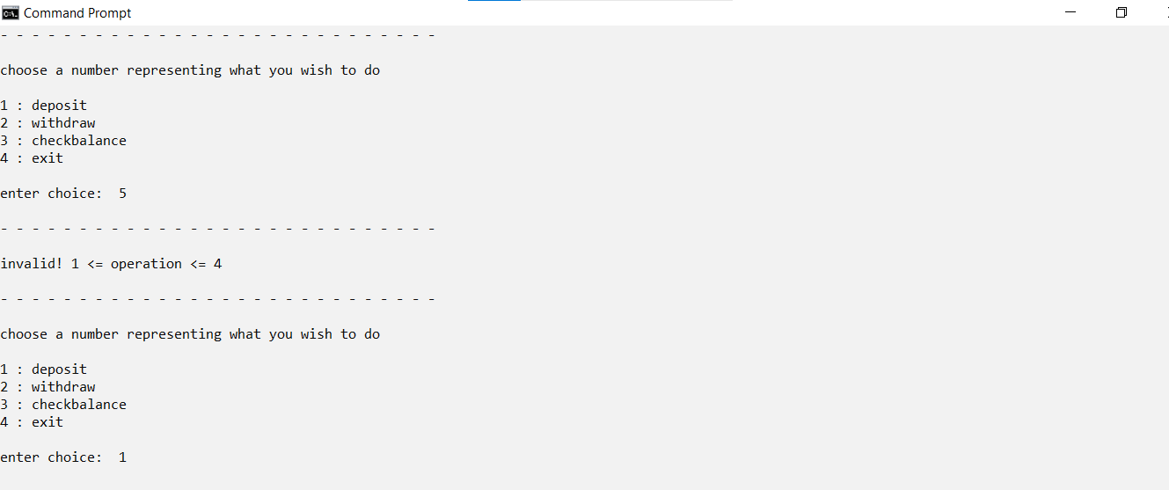

### Deposit Method ()

This method allows a user to deposit money into the ACCOUNT.

It simply adds the specified amount to the current balance of the ACCOUNT and returns the new balance. If you try to deposit an amount greater than 500, 000 or less than 49 it returns “invalid amount! Enter a positive value less than 500, 000 and greater than 49”

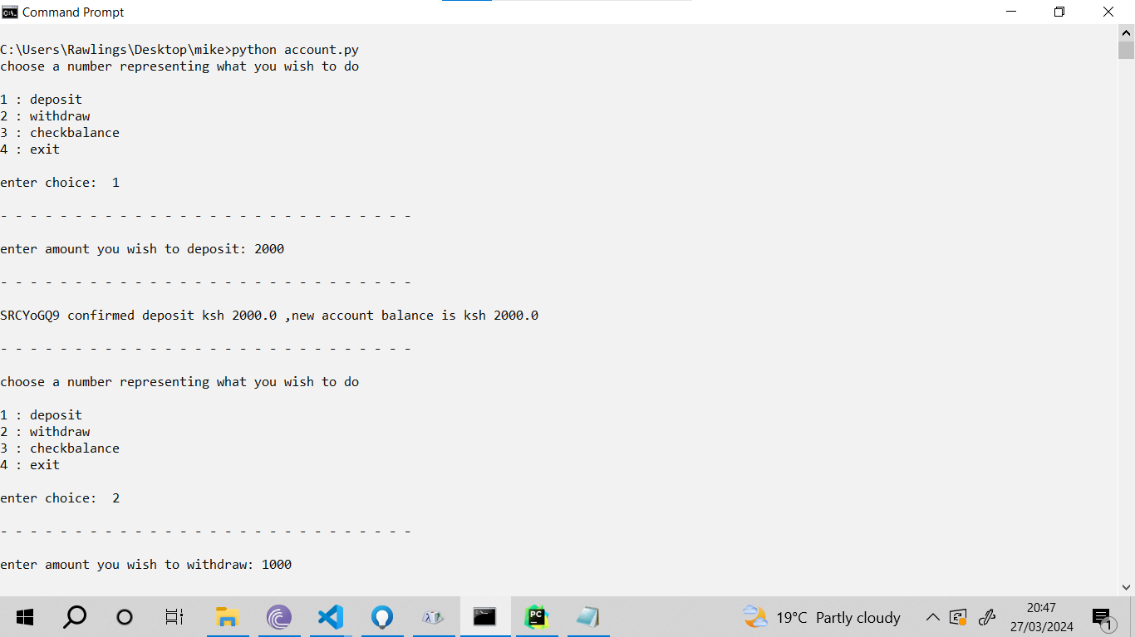

### Withdraw Method ()

This method allows a user to withdraw money from the ACCOUNT

It first checks if the ACCOUNT has sufficient funds to process the withdrawal. If the balance is enough, it deducts the specified amount from the balance plus the transaction cost and returns the amount withdrawn, new balance and the transaction cost. If the balance is insufficient, it returns “Invalid amount” and your current balance to indicate that the withdrawal cannot be processed.

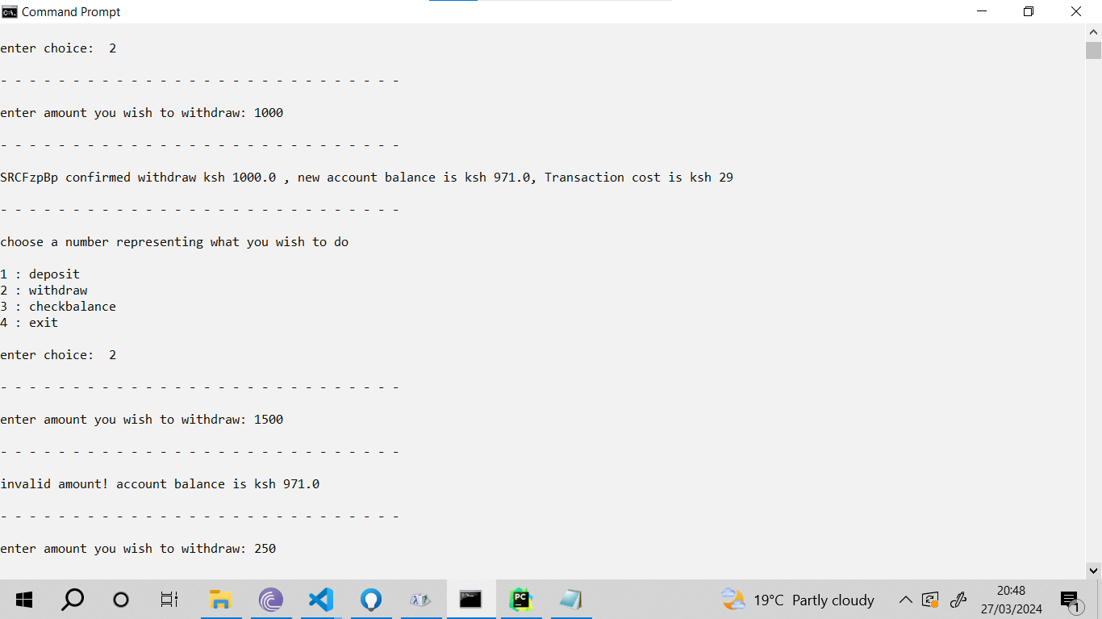

### Check balance Method ()

This method allows a user to check the current balance of the ACCOUNT.

It simply returns the current balance of the ACCOUNT.

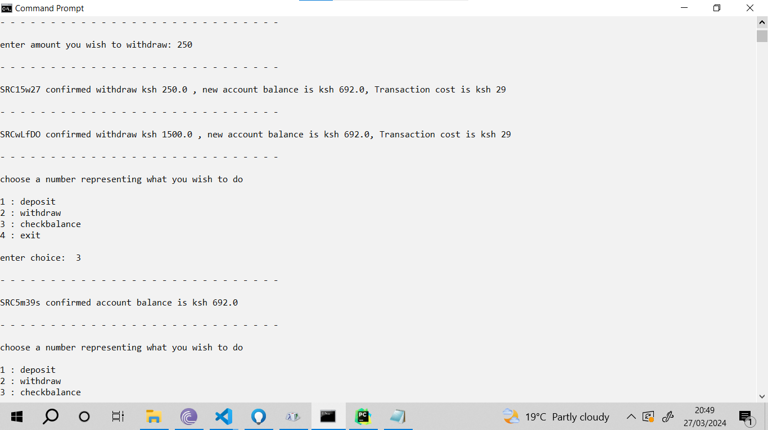

### Code

import random  
import string  
  
def random_string():  
 #concatenation of letters, digits and symbols  
 chars = string.ascii_letters  
 chars += string.digits  
  
 #you can try printing it by removing # below  
 #print(chars)  
  
 #variable initialisation before use  
 random_string = "SRC"  
  
 for i in range(5):  
 random_string += random.choice(chars)   
   
 return random_string  
  
  
def br():  
 print("\n- - - - - - - - - - - - - - - - - - - - - - - - - - - -\n")  
  
def withdraw(balance,random_string):  
 amount = float(input("enter amount you wish to withdraw: "))  
 br()  
  
 if(amount <= 100 and amount > 50):  
 transaction_cost = 11  
 balance = balance - (amount + transaction_cost )  
 elif(amount <= 2500 and amount > 100 ):  
 transaction_cost = 29  
 balance = balance - (amount + transaction_cost )  
 elif(amount <= 3500 and amount > 2500 ):  
 transaction_cost = 53  
 balance = balance - (amount + transaction_cost )  
 elif(amount <= 5000 and amount > 3500 ):  
 transaction_cost = 57  
 balance = balance - (amount + transaction_cost )  
 elif(amount <= 7500 and amount > 5000 ):  
 transaction_cost = 78  
 balance = balance - (amount + transaction_cost )  
 elif(amount <= 10000 and amount > 7500 ):  
 transaction_cost = 90  
 balance = balance - (amount + transaction_cost )  
 elif(amount <= 15000 and amount > 10000 ):  
 transaction_cost = 100  
 balance = balance - (amount + transaction_cost )  
 elif(amount <= 20000 and amount > 15000 ):  
 transaction_cost = 105  
 balance = balance - (amount + transaction_cost )  
 elif(amount <= 250000 and amount > 20000 ):  
 transaction_cost = 108  
 balance = balance - (amount + transaction_cost )  
 else:  
 while(amount < 50 or amount >250,000):  
 print("invalid amount! enter a positive value less 250,000 and greater 49")  
 br()  
 amount = float(input("enter amount to withdraw: "))  
 balance = withdraw(balance,random_string)  
  
 if(balance < 0):  
 balance = balance + amount + transaction_cost  
 print("invalid amount! account balance is ksh {0}" .format(round(balance,2)))  
 br()  
 balance = withdraw(balance,random_string)  
  
 random_string = random_string()  
  
 print("{0} confirmed withdraw ksh {1} , new account balance is ksh {2}, Transaction cost is ksh {3}" .format(random_string, round(amount,2), round(balance,2), round(transaction_cost,2)))  
 br()  
   
 return balance  
  
def check_balance(balance,random_string):  
 random_string = random_string()  
 print("{0} confirmed account balance is ksh {1}" .format(random_string, round(balance,2)))  
 br()  
  
def deposit(balance,random_string):  
 amount = float(input("enter amount you wish to deposit: "))  
 br()  
 while(amount < 50 or amount >500000):  
 print("invalid amount! enter a positive value less 500,000 and greater 49")  
 br()  
 amount = float(input("enter amount you wish to deposit: "))  
   
 balance = balance + amount  
  
 if(balance > 500000):  
 balance = balance - amount  
 print("invalid amount! account balance is ksh {0} , max account balance is ksh 500,000" .format(round(balance,2)))  
 br()  
 balance = deposit(balance,random_string)  
  
 random_string = random_string()  
 print("{0} confirmed deposit ksh {1} ,new account balance is ksh {2}".format(random_string, round(amount,2), round(balance,2)))  
 br()  
 return balance  
  
#start of program  
balance = 0.00  
random_string  
  
operation = ["deposit", "withdraw", "checkbalance", "exit"]  
  
print("choose a number representing what you wish to do\n")  
for i in range(len(operation)):   
 print("{0} : {1}" .format(i+1, operation[i]))  
  
choice = int(input("\nenter choice: "))  
br()   
  
while(choice != len(operation)):  
 if (choice==1): balance = deposit(balance,random_string)  
 elif (choice==2): balance = withdraw(balance,random_string)  
 elif (choice==3): balance = check_balance(balance,random_string)  
 else:  
 print("invalid! 1 <= operation <= 4")  
 br()  
  
 print("choose a number representing what you wish to do\n")  
 for i in range(len(operation)):   
 print("{0} : {1}" .format(i+1, operation[i]))  
 choice = int(input("\nenter choice: "))  
 br()