A Design Document for:

THAT FOUR-LETTER WORD

a romantic heist adventure

**GAME OVERVIEW**

**THE PITCH:**

*THAT FOUR-LETTER WORD* is a top-down heist game in which the player must traverse across various maze-like levels with the ultimate goal of reaching the object of their affection, then escape once all are said and done. As the player completes their objective, they must utilize critical thinking, patience, and quick reflexes to stealthily evade the numerous guard entities that patrol the maze. The game offers a lighthearted narrative, along with a focused heist fantasy, with suspenseful stealthy gameplay being its core value. Wrapped in lightweight graphics, short levels, and minimalist controls, the game is capable of being played on many platforms and contexts—be it a commuter’s mobile phone or a procrastinating college student’s web browser.

**DESIGN ELEMENTS**

**THE NARRATIVE:**

The noble ladies of the land have an admirer, and he is determined to declare his unrequited love. This admirer has had many opportunities to ask for a lady’s hand, yet every time he tries, he would become so nervous that he would accidentally murder the poor maiden instead! No matter; For the land is vast, and he only needs more practice. Strangely enough, his charming reputation does not seem to precede him, for the ladies do everything they could to avoid his visitation. Surely, they would change their mind once their gazes fall upon his magnificent mug. Their guards, on the other hand, might have other ideas…

**THE AESTHETICS:**

* **ARTSTYLE:** The game world is to be composed of clean three-dimensional geometric shapes (i.e. cube, pyramid, spheres, etc.) with single-colored texture. Static objects, such as walls and props, are always textured with solid grey. Dynamic objects, such as *THE ADMIRER*, *THE LOVE INTERESTS*, and enemy entities, are to be textured with bright, distinctive, glowing colors. The glows emitted from these dynamic objects are to be the only light sources within the game world; and as such, their surrounding will be the only part of the game space that is visible to the player. 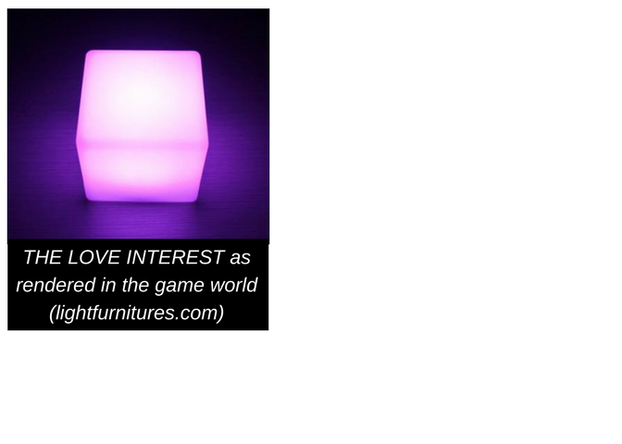

**THE PERSPECTIVE:**

The point of view is a top-down, slightly slanted perspective of the level (not unlike that of RTS or MOBA games). The camera will zoom in or out depending on the size of the level so that the current level will always fill up the entire screen.

**THE LEVELS:**

Levels are rectangular and maze-like, with enemy guard entities scattered throughout. *THE ADMIRER* always spawns in a room with the escape window, and *THE LOVE INTEREST* would be placed at the opposite end of the level. As the difficulty increases, so would the enemy density and level size.

**THE CHARACTERS:**

* 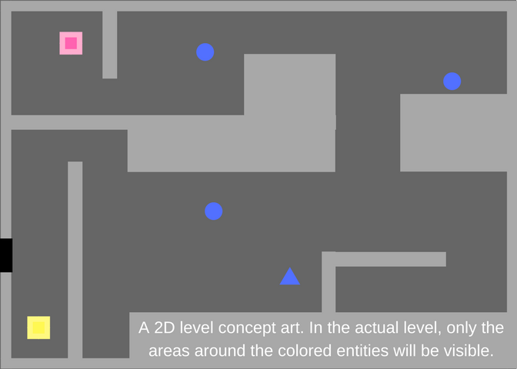**THE ADMIRER:** The sole player-controlled character—*THE ADMIRER* is only capable of four-directional movement, and dons the appearance of a yellow cube by default. He moves faster than a patrolling guard, yet slower than an alert one. Upon touching *THE LOVE INTEREST*, he gains a blood trail that glows and fades after five seconds. *THE ADMIRER* dies upon collision with any enemy entity.
* **THE LOVE-INTERESTS:** Cubes with randomized shades of pink by default; One of them will aimlessly path around each level at a snail’s pace. They would attempt to move away from *THE ADMIRER* when he gets close. Upon collision with him, they would explode into a puddle of blood.

**THE GOALS:**

Each level possesses two goals. Both must be achieved to complete the level.

* **GOAL #1:** *THE ADMIRER* must touch *THE LOVE INTEREST*.
* 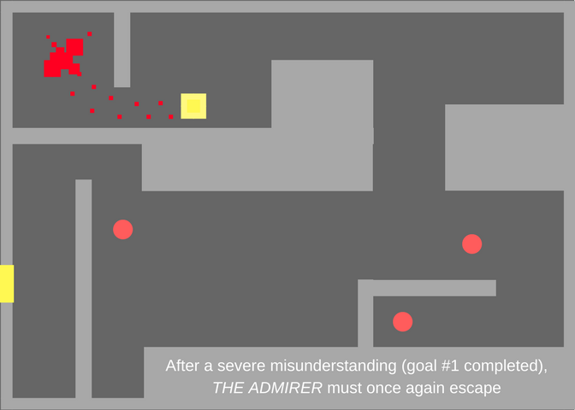**GOAL #2:** *THE ADMIRER* must defenestrate himself through the escape window, which opens after the completion of GOAL #1.

**THE PLAYER EXPERIENCE:**

The flow of the game is simple: The player (in the role of *THE ADMIRER*) spawns in a level. They would then observe the enemy entities, memorize their pathing patterns, as well as using the emitted light to visualize the level layout. The player then uses this knowledge to reach the level’s *LOVE INTEREST* unseen, and repeats the process once again to reach the escape window and complete the level. Of course, the player may become detected during any of the steps above, and must utilize quick thinking to evade pursuit. Satisfaction is gained through the stealthy execution of a plan, or the use of quick reflexes to avoid certain death. In any case, a deliberate, slow-pace, puzzle-solving experience is provided during the planning phase of the level, which in turn is supplement by a suspenseful, patience-driven execution of said plan. Occasionally, exciting chase sequences would occur, forcing the player to abandon all caution and instead exercises fine motor skill to react to the oncoming chaos.

**THE ENEMIES:**

Each enemy entity has a vision field represented by a cone of light within the game world. Wall and props can block this vision.Enemies enter alert mode for 20 seconds upon detecting *THE ADMIRER* or another alerted guard entity*.* If any guard entity detects the blood trail or *THE LOVE INTEREST*’s remains, all enemies would enter alert mode indefinitely.

* **THE GUARDS:** Blue spheres by default. They have a wide, but short-ranged vision.
  + **Patrol mode:** randomly path about the level, turn slowly.
  + **Alert-mode:** turn red and move erratically at double speed. Their vision range is also doubled. If *THE ADMIRER* is detected, fire a burst of three bullets in his direction, then travel in that direction. Guards cannot move while firing.

**THE INTERFACE:**

The gameplay itself cannot be paused, and contains no HUD, save for the Setting button in the top left corner.

* **Main Menu:** For selecting unlocked levels and modifying the game setting.
* **Setting:** For customizing character colors, gender pronounces, and game volume. If called during gameplay, it also provides buttons to restart the level or return to the main menu.

**INSPIRATIONS**

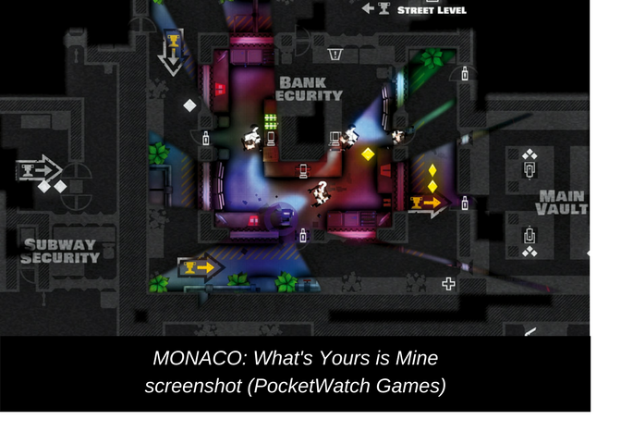This game draws inspiration from others of the same genre. Its rectangular, top-down, low visibility level designs borrow heavily from Pocketwatch Games’ *Monaco: What’s Yours Is Mine.* Additionally, its deliberate, slow-pace puzzle-solving aspect is partially modeled after Klei Entertainment’s *Mark of The Ninja;* Despite the success of the genre in recent years, the market for pure stealth experience remains virtually untapped. Most stealth games, including the ones mentioned above, are still weighted down by unnecessary combat or overpowered escape mechanics. While an exciting heist is not mutually exclusive with combats and cat-n-mouse actions, a wrongly-placed power fantasy would only serve to detract from the tension of a high-strung atmosphere. The most obvious example of this can be seen in *Monaco* where escaping guards required little effort, and hardly any importance is placed on staying unseen. This results in the ruin of any ambience or narrative of a covert operation, and thus removes the value of stealth from a “stealth” game.

**VALUES & TAKEAWAY**

While the narrative of *THAT FOUR-LETTER WORD* offers a message regarding the importance of consent by presenting the player with a satirical perspective of a stalking, narcissistic lunatic that possesses no regard for personal space; its core value of stealth, however, aims to immerse the player in a completely different experience. From the challenge and thrill of staying unseen, to the emotional panic the player would experience when they wonder if a guard would turn toward them or keep walking on, the game’s design values provide a unique, thrilling experience of being an expert burglar, whose uncertain survival often comes down to the perfect execution of a well-thought-out plan, as well as adapting correctly to the chaos when it inevitably falls apart.