Introduction
Passing tests in medical education relies largely on memorizing, retaining, and retrieving copious amounts of information. Memorized information decays over time, first formally conceptualized by Ebbinghaus (1885), and commonly termed as the forgetting curve, with the largest drop in retained knowledge occurring just after acquisition. Arguably one of the most effective methods in breaking the curse of the forgetting curve is spaced repetition or spaced learning, in which learners review information over separate short study sessions separated by either constant or expanding intervals. While the benefit of spaced learning seems uncertain - while Karpicke and Bauernschmidt (2011) argue that relative spacing patterns have no effect on memory retention, argue that retrieval between expanding intervals improves memory retention for information on immunology and reproductive physiology (Dobson, 2012), there is good evidence for superiority of spaced repetition in general over massed repetition (Cepeda et al., 2006).
Custom-made flashcards for a pharmacology course among preclinical medical students wre well received in an Australian cohort, were especially the supplementing the cards with diagrams was positively evaluated (Jape et al., 2021). Similar for cards on anatomy for fist year medical students, where cards were well received, and 76.7% believed that the cards had helped them alleviate anxiety (Rana et al., 2020).
Evidence for decreased mentioning of renal and cardiovascular pharmacology as a difficult topic among first-year students when compared to previous non-Anki cohort, but no improvement in scores (Magro et al., 2024).
has been Among the most popular is Anki: In a cohort of first-year medical students taking an integrated module in anatomy and physiology at the University of Central Florida’s College of Medicine, 70% reported complementing the regular curriculum with Anki cards. Of these, a significant share preferred using cards passed down from other people over self-designed ones (Harris and Chiang 2022).
Using Anki in general, and using Anki to a larger extent, improved scores in United States Medical Licensing Exam (USMLE) Step 1 exam (Lu et al., 2021)
In a small cohort of 12 orthopedic surgery trainees preparing for the Royal Australasian College of Surgeons Orthopedic Principles and Basic Sciences (OPBS) examination, hours spent with Anki were positively correlated with exam scores (Lambers & Talia, 2021).
Number of Anki cards positively correlates with USMLE step 1 scores, with 1700 explaining an increase in 1 point each when controlling for other factors (Deng et al., 2015).
Residents in otolaryngology were provided with questions from „Bailey's Head and Neck Surgery–Otolaryngology Review“ and concluded their „Otolaryngology Trainee Examination“ with score dependent on Anki usage.

Methods
Study design
This study was designed as a prospective cohort study carried out at the medical faculty of Ulm in Baden-Württemberg/Germany.
Medical students at Ulm university enroll in a lecture and a consecutive seminar on clinical pharmacology, which extend over one semester each and both conclude with a written exam. As part of the regular curriculum, Students are assigned to either one of two groups and will be enrolled in the lecture either in the seventh or in the eight semester, and in the seminar in the subsequent semester.
The exams are single best answer exams with 5 options per item and 40 (lecture) or 30 (seminar) test items each. Passing both exams as well as attending the seminar are mandatory part of the curriculum, while lecture attendance is non-mandatory.
At the beginning of the lecture, students were made aware of the Anki flash cards, which were available for download on the course material website for the lecture. Also available were a brief manual for downloading the most up-to-date Anki version and importing, creating, and editing cards, as well as an FAQ.
Anki cards creation and structure
Anki is an open-source flashcard software available for most desktop and mobile platforms. Anki allows users to study material following a spaced repetition algorithm, in which the interval for the next review of a card is determined by the self-rated confidence of correct learner recall. This leads to cards which were difficult to learn being presented again after a short time, and cards which were more easily remembered reoccurring after a longer time period. Content for Anki can be downloaded from a free and user-generated online repository or directly created by end-users themselves.
Anki cards for 226 drugs had been created by institute employees and were based on the 2021 version of the IMPP Arzneistoffliste (IMPP, 2021), which lists key drugs and serves as an official guideline for the pharmaceutical-related questions of the central written German medical licensing examinations.
Cards were organized in distinct decks according to medical fields, with two decks for each field: A basis deck showing the drug name on the front, and on the back either the effect, the mechanism of action, indications, contraindications, or side effects, and a comprehensive knowledge deck, showing the drug name on the front and broader drug information on the back. Information on the back was mostly in the form of bulleted lists or single terms, but comprised of short texts or diagrams when appropriate. Cards were tagged to allow for efficient filtering in Anki, including a tag for those cards considered relevant for the exam concluding the lecture and the seminar.
Other studying materials made available to students were lecture and seminar slides, comprehensive electronic scripts accompanying the lecture, example questions, case tasks and exercises as part of our e-learning repository. Students were free to download other Anki decks or create their own.
Questionnaire
Immediately after both the lecture and seminar exam, students were handed survey questionnaires to assess which learning strategies students employed and considered useful, whether and to what extent they used Anki for exam preparation and their attitude towards Anki, as well as basic demographic information. Students explicitly consented to data processing. The questionnaires comprised 11 items for the cohort of the Seminar in 2022, while all other cohorts were given an extended questionnaire of 22 items for providing comprehensive insights into their Anki-usage. Students usually generate a pseudonymous code to write on their exam response sheet before handing it in. Students could voluntarily submit their code on the questionnaire as well, allowing us to pseudonymously correlate survey questionnaires with exam results.

Results
Out of 920 participants in the exams, 820 (89.91%) returned the survey questionnaire, consented to data processing, and filled in their pseudonymous code to pair survey data with exam scores.
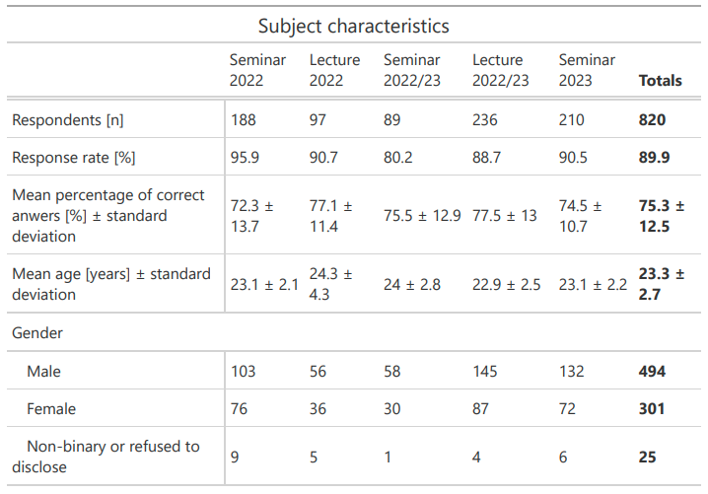
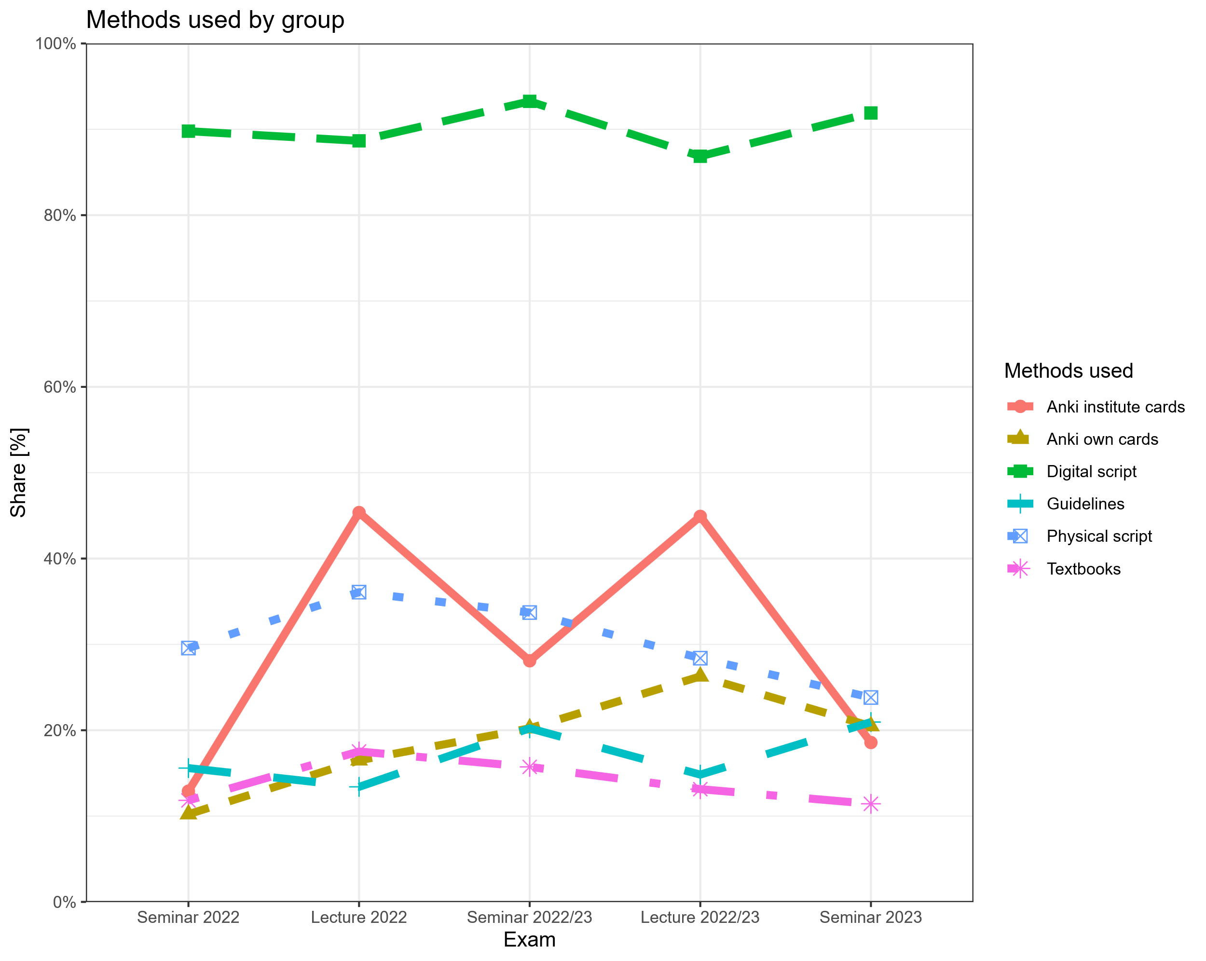
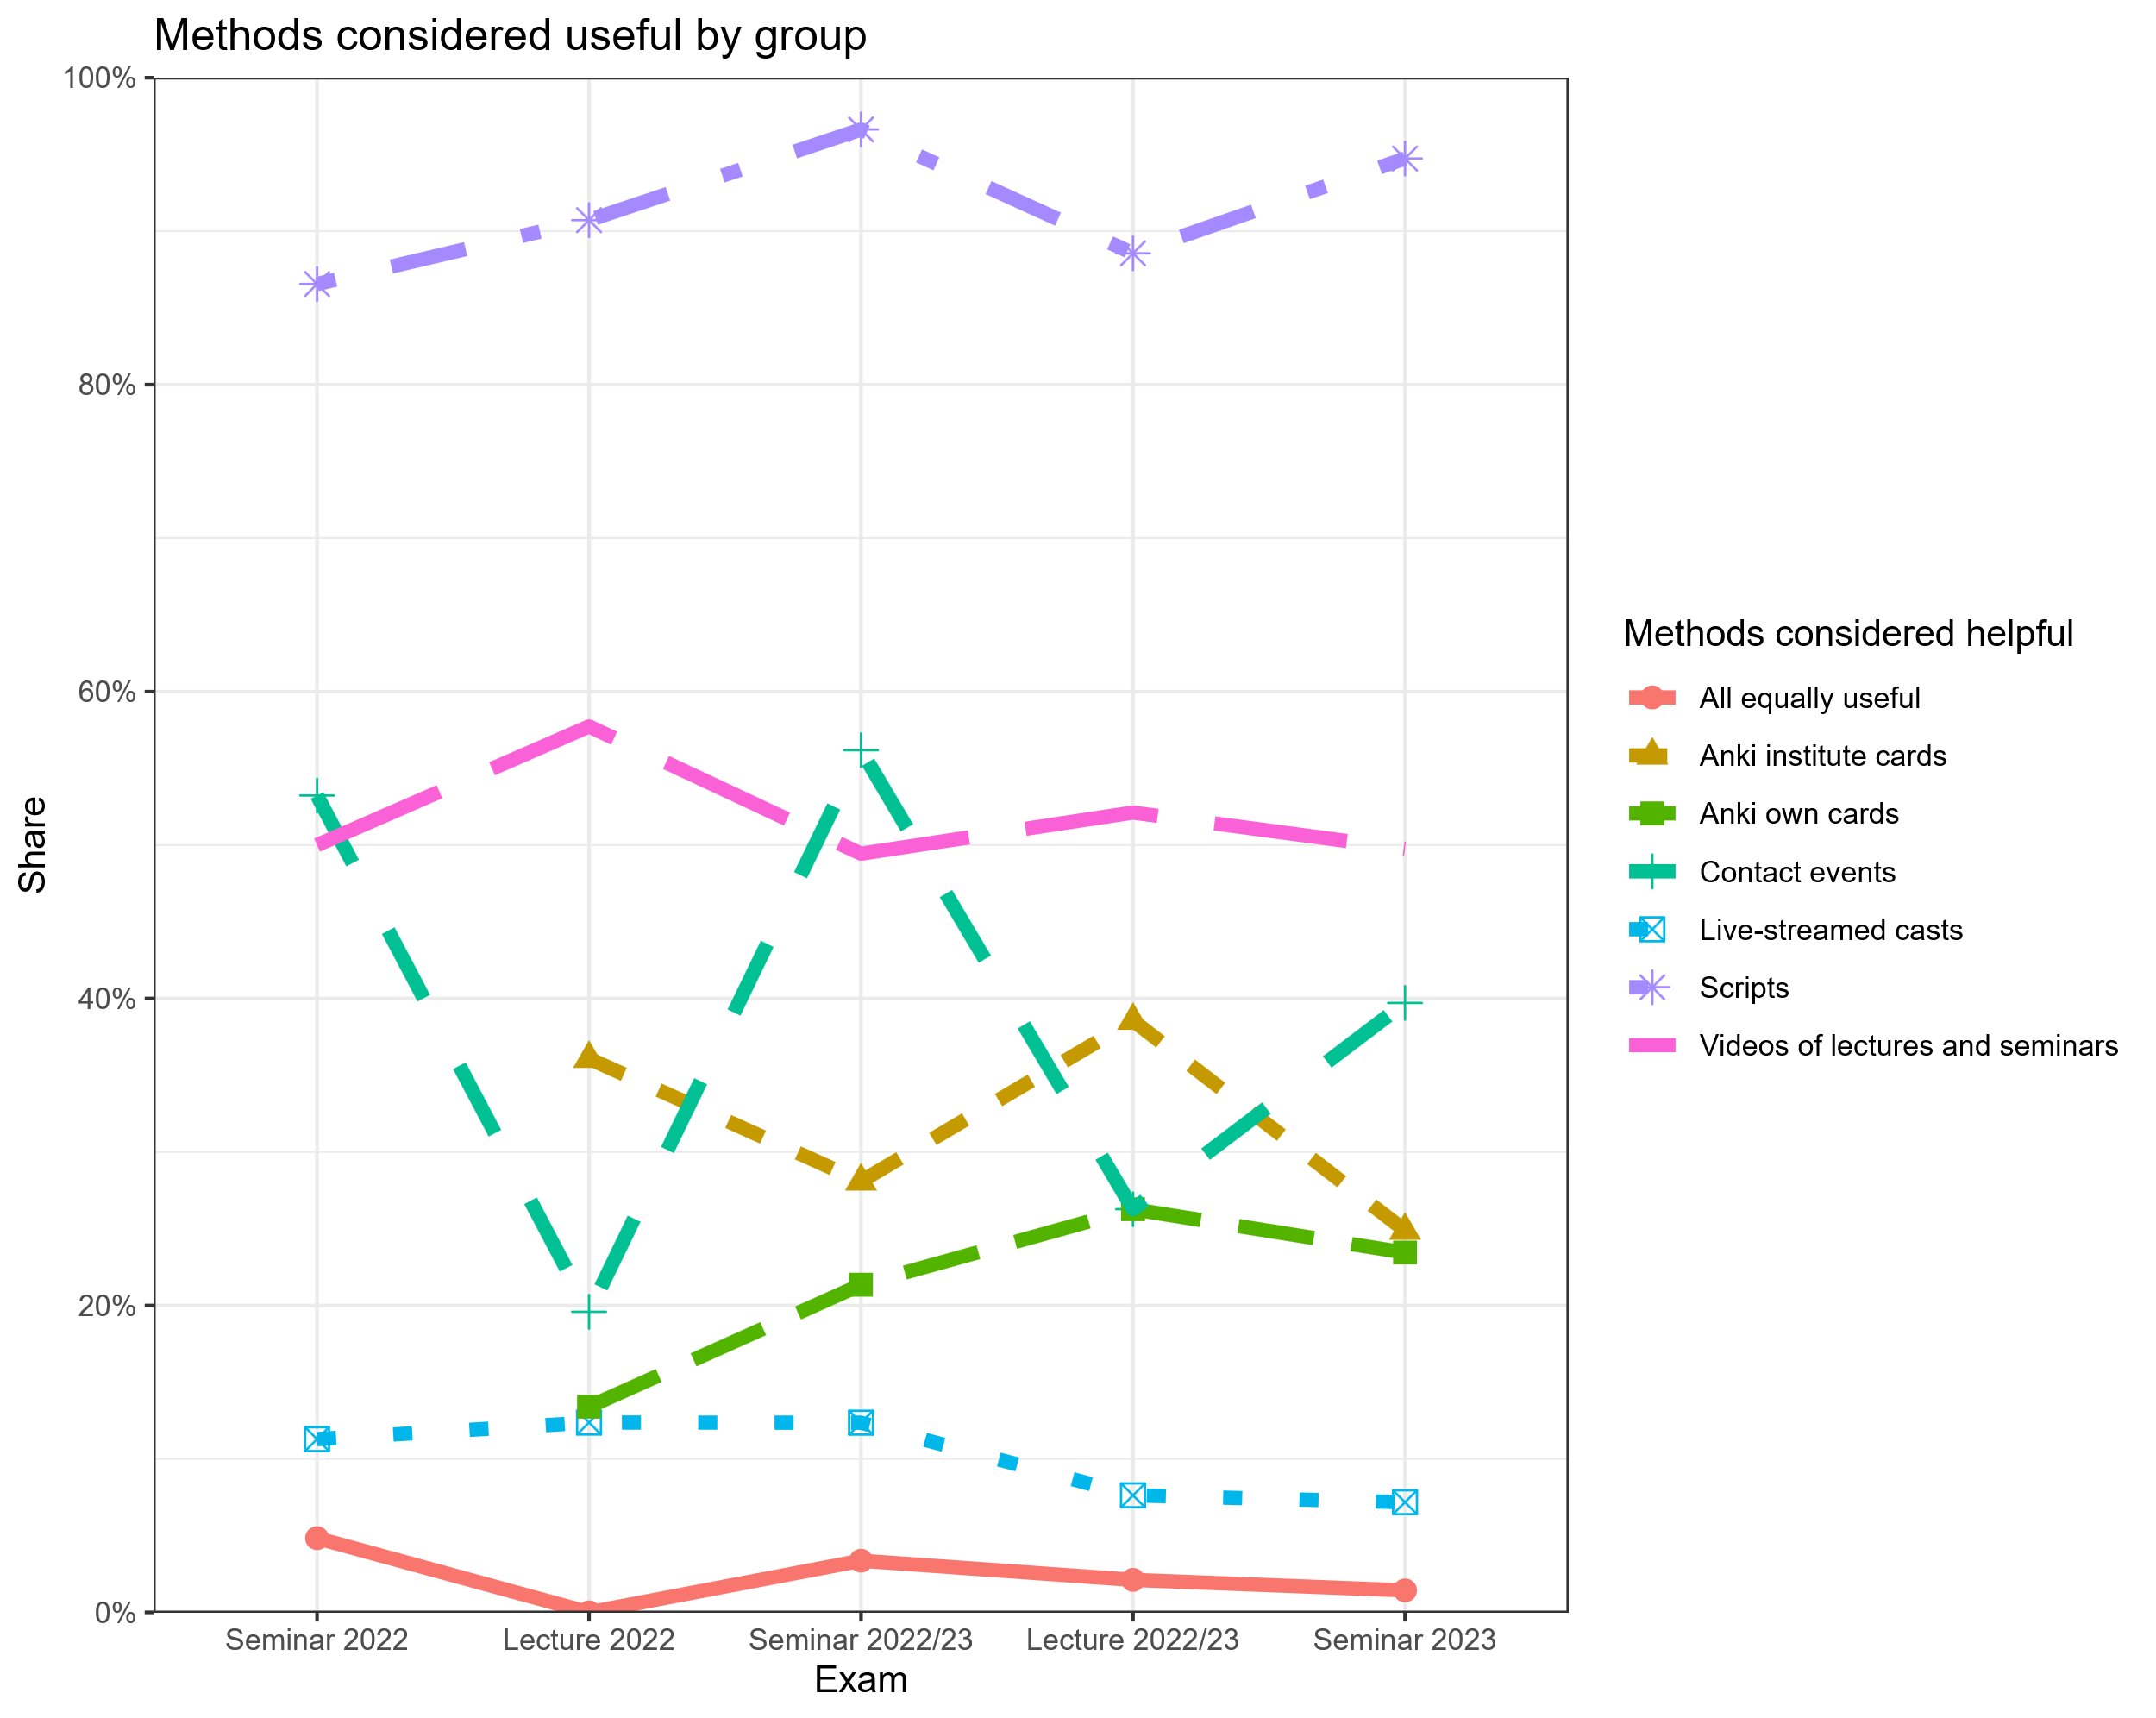

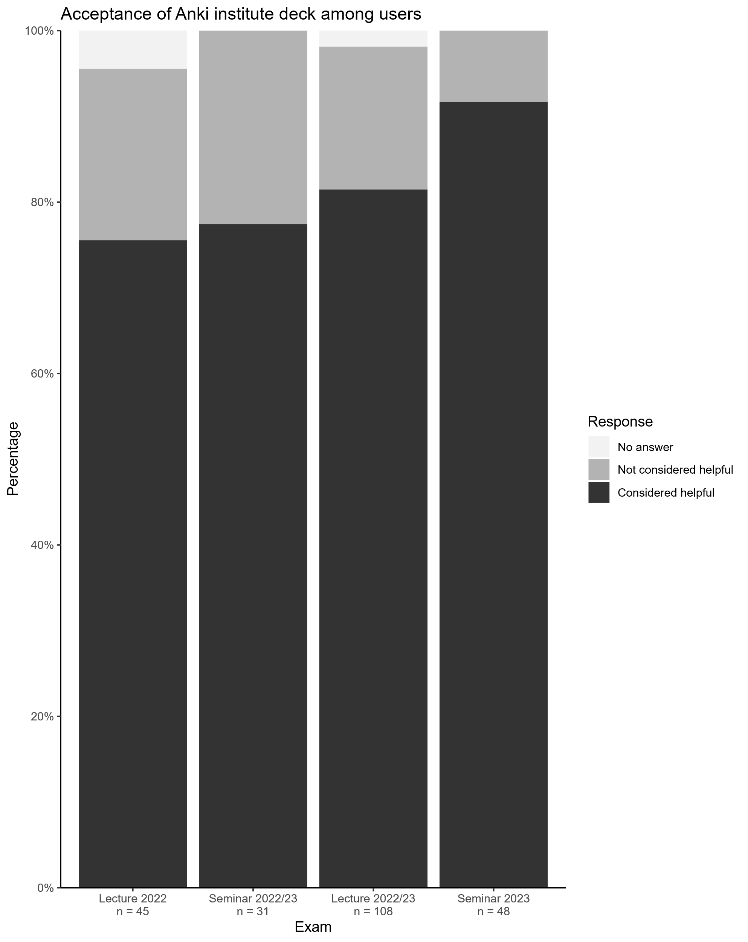

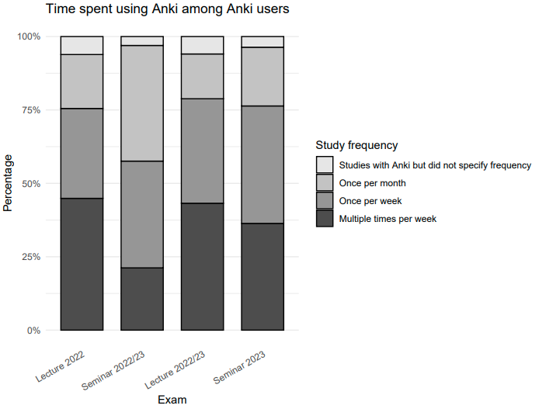

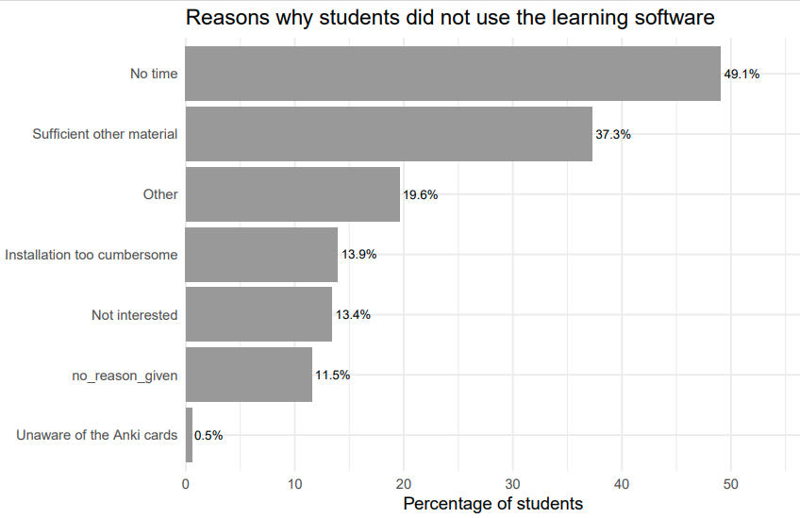

Problem
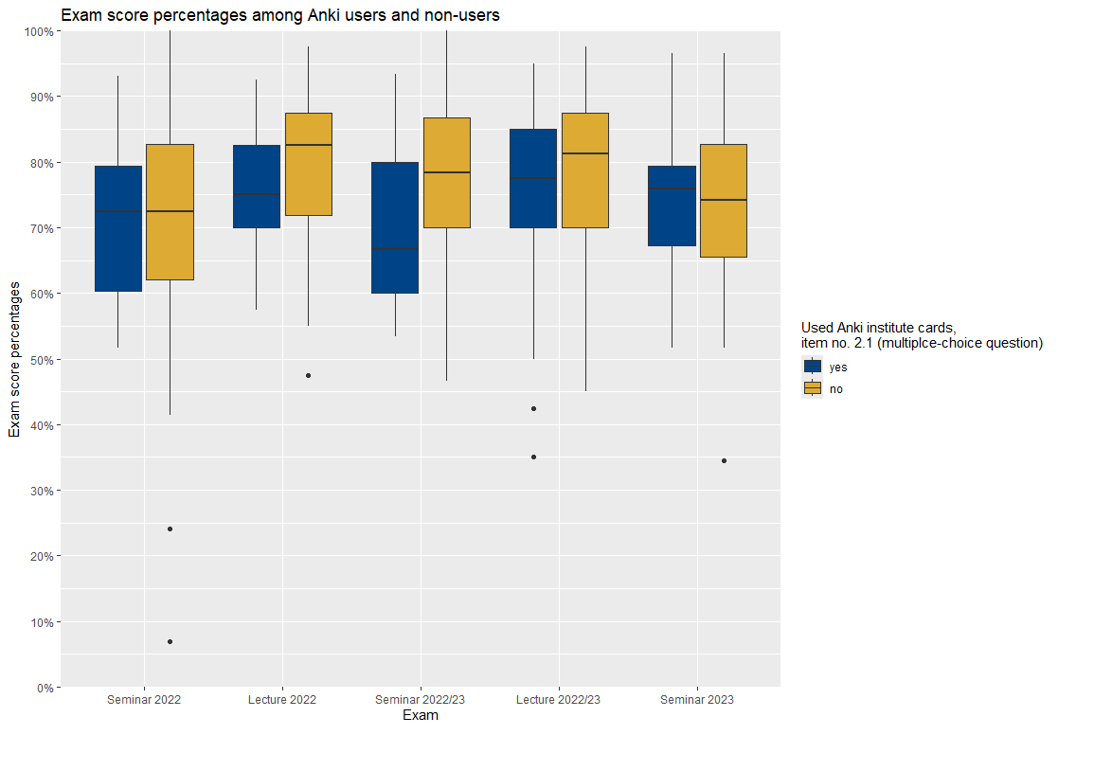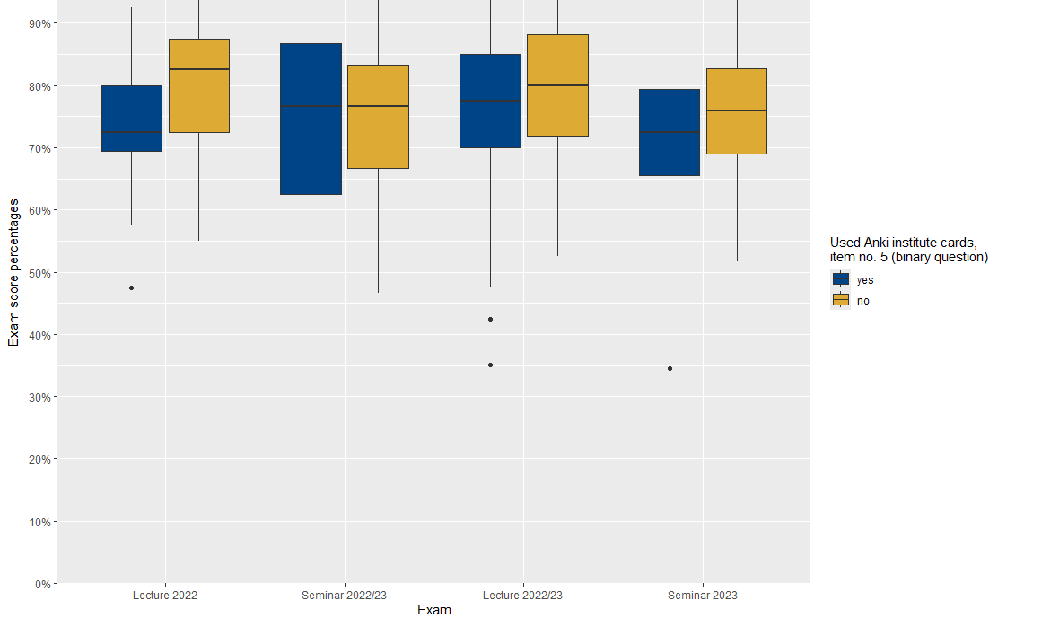
Deviations:
- Seminar 2022/23: yes group (q5) much better than yes group (q2)
Seminar 2023: yes group (q5) much worse than yes group (q2)

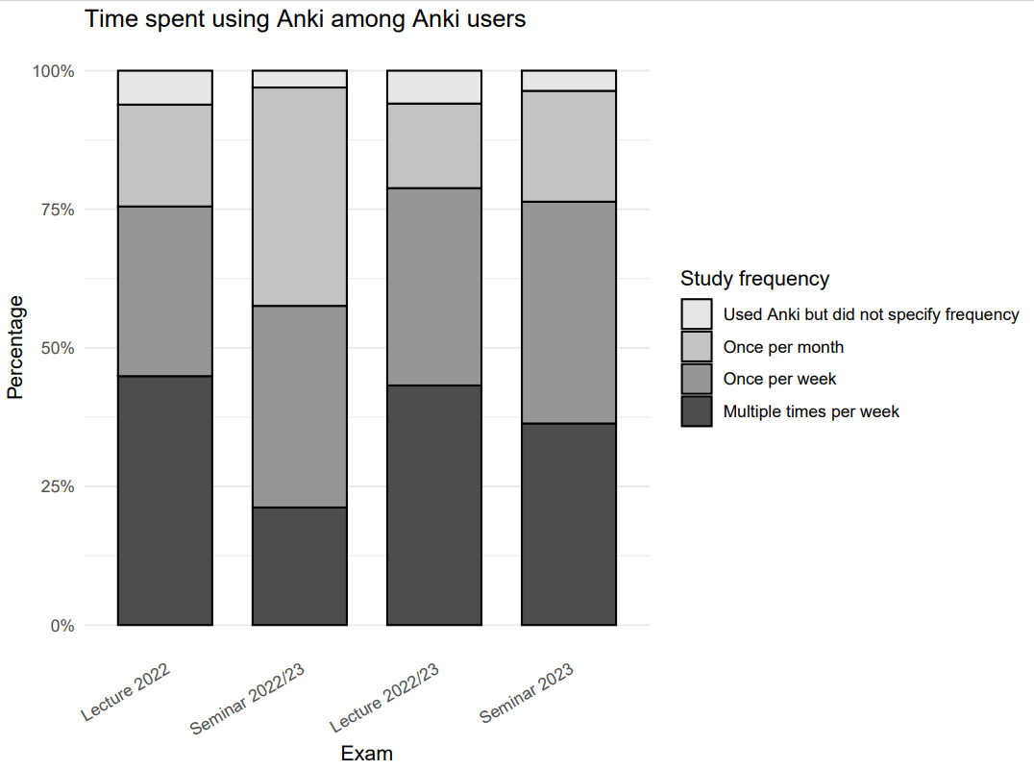

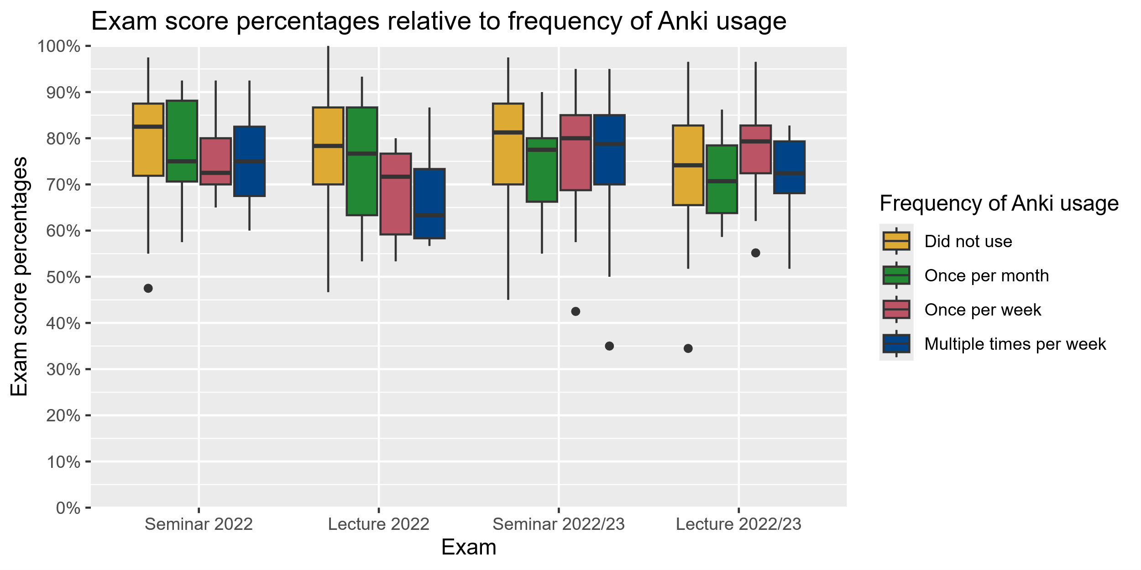

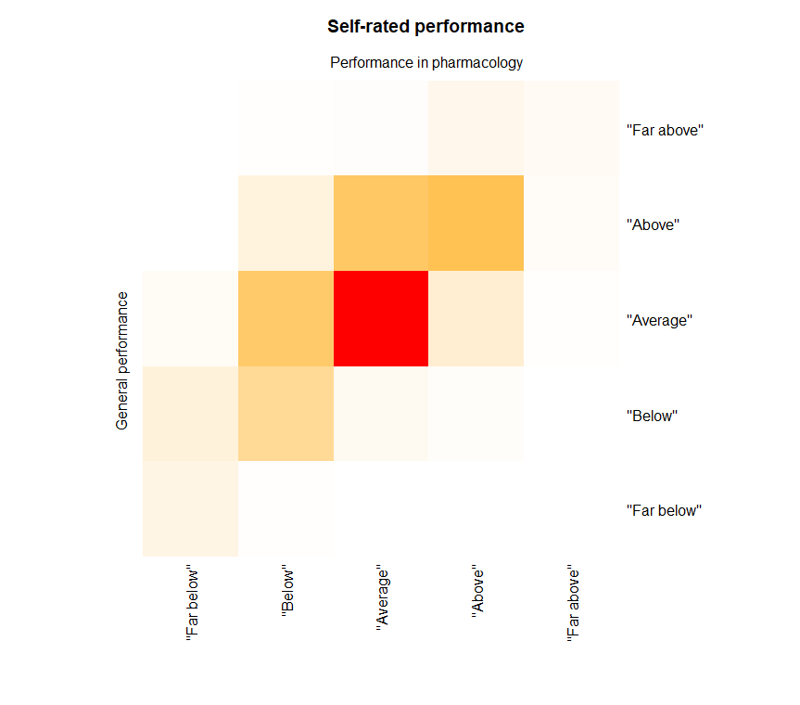
Correaltion self-rated general performance with self-rated pharma performance:
Spearman's ρ = 0.6274989; p < 2.2e-16
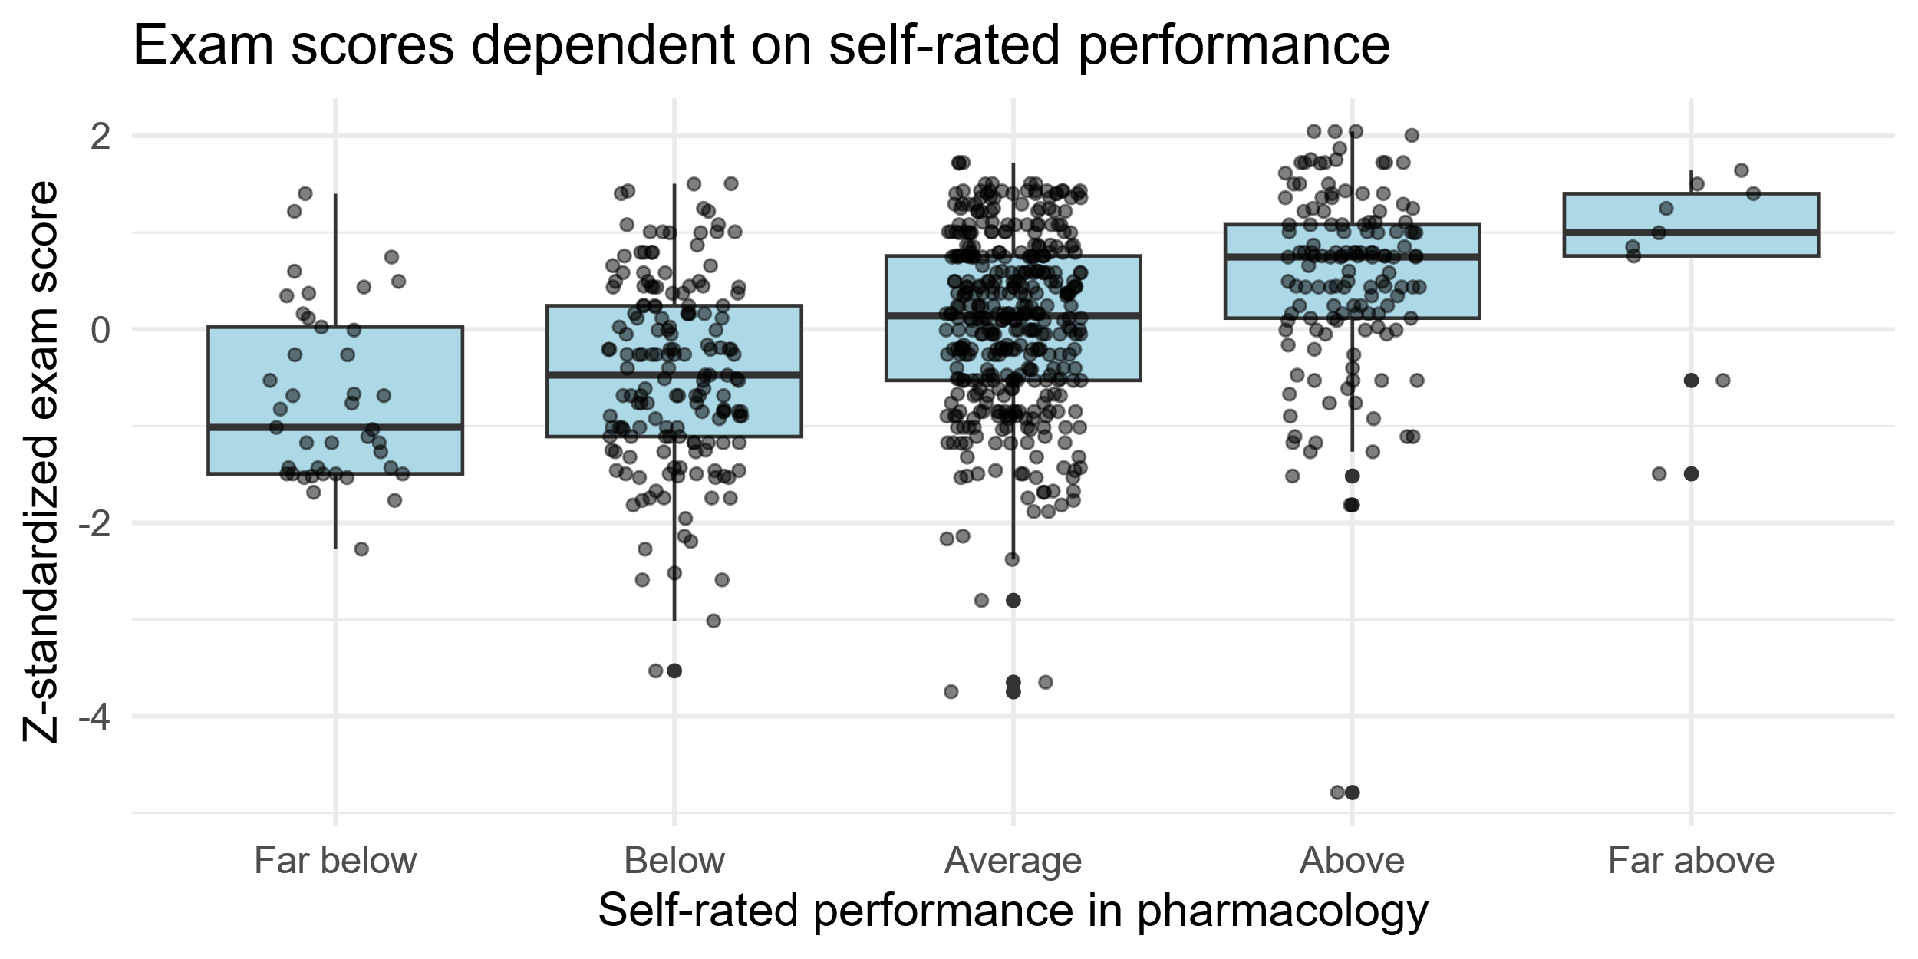

Correlation self rated pharma performance with actual z standardized exam scores:
data: subset_score_performance$performance_pharm and subset_score_performance$z_score
S = 42506238, p-value < 2.2e-16
alternative hypothesis: true rho is not equal to 0
sample estimates:
rho 0.3757005
Correlation self rated general performance with actual z standardized exam scores:
data: subset_score_performance$performance_general and subset_score_performance$z_score
S = 45812246, p-value < 2.2e-16
alternative hypothesis: true rho is not equal to 0
sample estimates:
rho 0.3458337
Correlation self rated general performance with Anki usage
data: survey_data$performance_general and survey_data$used_anki_institute
S = 88690856, p-value = 0.01395
alternative hypothesis: true rho is not equal to 0
sample estimates: rho -0.08755729
Same but Wilcox.test():
data: survey_data$performance_general by survey_data$used_anki_institute
W = 70232, p-value = 0.01405
alternative hypothesis: true location shift is not equal to 0
Correlation self rated pharma performance with Anki usage
data: survey_data$performance_pharm and survey_data$used_anki_institute
S = 86582811, p-value = 0.008124
alternative hypothesis: true rho is not equal to 0
sample estimates: rho -0.0947119
Same but Wilcox.test():
ata: survey_data$performance_pharm by survey_data$used_anki_institute
W = 68819, p-value = 0.008211
alternative hypothesis: true location shift is not equal to 0

lm used Anki with score restricted to sample with responses to performance general
lm(formula = z_score ~ used_anki_institute, data = restricted_subset)
Residuals:
Min 1Q Median 3Q Max
-4.8461 -0.7244 0.1153 0.7245 2.1934
Coefficients:
Estimate Std. Error t value Pr(>|t|)
(Intercept) 0.06784 0.04322 1.570 0.1169
used_anki_institute -0.18947 0.07975 -2.376 0.0178 *
---
Signif. codes: 0 ‘***’ 0.001 ‘**’ 0.01 ‘*’ 0.05 ‘.’ 0.1 ‘ ’ 1
Residual standard error: 0.9941 on 747 degrees of freedom
(39 observations deleted due to missingness)
Multiple R-squared: 0.0075, Adjusted R-squared: 0.006171
F-statistic: 5.645 on 1 and 747 DF, p-value: 0.01776
Anki usage correlated sign. with z-scores
lm(formula = z_score ~ used_anki_institute + performance_general,
data = restricted_subset)

Residuals:
Min 1Q Median 3Q Max
-4.3204 -0.6516 0.1042 0.6926 2.1236

Coefficients:
Estimate Std. Error t value Pr(>|t|)
(Intercept) -1.32416 0.15283 -8.664 <2e-16 ***
used_anki_institute -0.12648 0.07571 -1.671 0.0952 .
performance_general 0.43316 0.04582 9.453 <2e-16 ***
---
Signif. codes: 0 ‘***’ 0.001 ‘**’ 0.01 ‘*’ 0.05 ‘.’ 0.1 ‘ ’ 1

Residual standard error: 0.94 on 746 degrees of freedom
(39 observations deleted due to missingness)
Multiple R-squared: 0.1137, Adjusted R-squared: 0.1113
F-statistic: 47.83 on 2 and 746 DF, p-value: < 2.2e-16
Adjusting for general self-rated performance explains this partially
anova(result_unadjusted_restricted, result_adjusted_restricted)
Analysis of Variance Table

Model 1: z_score ~ used_anki_institute
Model 2: z_score ~ used_anki_institute + performance_general
Res.Df RSS Df Sum of Sq F Pr(>F)
1 747 738.19
2 746 659.23 1 78.96 89.353 < 2.2e-16 ***
---
Signif. codes: 0 ‘***’ 0.001 ‘**’ 0.01 ‘*’ 0.05 ‘.’ 0.1 ‘ ’ 1
model with adjustment significantly superior to model without

Interactions:
- No interactions between Anki usage and anki helpfulness regarding score

Conclusions
Cards should be integrated into the curriculum, especially learning directly after receiving information (directly after lecture). Most preferred using their cards after the lecture (Harris and Chiang 2022).
Majority finds Anki helpul, but no
Time is limited
Enough students knew about anki (only 1% or so did not use Anki because they didn’t know)

Only the bad students used the cards
Interaction with overall grades?
Might have spent the time with other techniques in spaced learning

Noch als Quelle einpflegen:
IMPP. (2021). IMPP-Gegenstandskatalog (IMPP-GK2) für den schriftlichen Teil des Zweiten Abschnitts der Ärztlichen Prüfung (5.1 aktualisierte Auflage). Mainz, Germany. Retrieved August 15, 2025, from Institut für medizinische und pharmazeutische Prüfungsfragen website: https://www.impp.de/pruefungen/allgemein/gegenstandskataloge.html

References
Cepeda, N. J., Pashler, H., Vul, E., Wixted, J. T., & Rohrer, D. (2006). Distributed practice in verbal recall tasks: A review and quantitative synthesis. Psychological Bulletin, 132(3), 354.
Deng, F., Gluckstein, J. A., & Larsen, D. P. (2015). Student-directed retrieval practice is a predictor of medical licensing examination performance. Perspectives on Medical Education, 4(6), 308–313. https://doi.org/10.1007/S40037-015-0220-X
Dobson, J. L. (2012). Effect of uniform versus expanding retrieval practice on the recall of physiology information. Advances in Physiology Education, 36(1), 6–12. https://doi.org/10.1152/advan.00090.2011
Ebbinghaus, H. (1885). Über das gedächtnis: Untersuchungen zur experimentellen psychologie. Duncker & Humblot. https://books.google.de/books?hl=en&lr=&id=-4_XwPeyP68C&oi=fnd&pg=PA1&dq=%C3%9Cber+das+ged%C3%A4chtnis:+untersuchungen+zur+experimentellen+psychologie&ots=FX4B9LoVeC&sig=PJelplqMU2Lijti6eZZbQtSmC0w
Jape, D., Zhou, J., & Bullock, S. (2021). A Spaced-Repetition Approach to Enhance Medical Student Learning and Engagement in Pharmacology. https://www.researchsquare.com/article/rs-625499/latest
Karpicke, J. D., & Bauernschmidt, A. (2011). Spaced retrieval: Absolute spacing enhances learning regardless of relative spacing. Journal of Experimental Psychology: Learning, Memory, and Cognition, 37(5), 1250.
Lambers, A., & Talia, A. J. (2021). Spaced Repetition Learning as a Tool for Orthopedic Surgical Education: A Prospective Cohort Study on a Training Examination. Journal of Surgical Education, 78(1), 134–139. https://doi.org/10.1016/j.jsurg.2020.07.002
Lu, M., Farhat, J. H., & Beck Dallaghan, G. L. (2021). Enhanced Learning and Retention of Medical Knowledge Using the Mobile Flash card Application Anki. Medical Science Educator, 31(6), 1975–1981. https://doi.org/10.1007/s40670-021-01386-9
Magro, J., Oh, S., Košćica, N., & Poles, M. (2024). Anki flashcards: Spaced repetition learning in the undergraduate medical pharmacology curriculum. The Clinical Teacher, e13798. https://doi.org/10.1111/tct.13798
Rana, T., Laoteppitaks, C., Zhang, G., Troutman, G., & Chandra, S. (2020). An Investigation of Anki Flashcards as a Study Tool Among First Year Medical Students Learning Anatomy. The FASEB Journal, 34(S1), 1–1. https://doi.org/10.1096/fasebj.2020.34.s1.09736

Harris, D. M. and M. Chiang (2022). "An analysis of Anki usage and strategy of first-year medical students in a structure and function course." Cureus 14(3).

Karpicke, J. D. and A. Bauernschmidt (2011). "Spaced retrieval: absolute spacing enhances learning regardless of relative spacing." Journal of Experimental Psychology: Learning, Memory, and Cognition 37(5): 1250.

Further content:
- Frau Mauder, Herr Frank, Susanne, Arthur: Arbeitszeit/Karte
- Rechtfertigt kosten/Nutzen-Verhältnis der Kartenerstellung und -verwendung den Nutzen?
- Seminar vs. VL
- Übrige Leistungen
- Deskriptiv: Wie oft verwendet, wie lange, etc.
- Klausurnote vs # Lernmittel
- Korrelationen

