# Introduction

Passing tests in medical education relies largely on memorizing, retaining, and retrieving copious pieces of information. Memorized information decays over time, first formally conceptualized by Ebbinghaus (1885) and commonly termed as the *forgetting curve*, with the largest drop in retained knowledge occurring just after acquisition. Arguably one of the most effective methods in breaking the curse of the forgetting curve is *spaced repetition* or *spaced learning*, in which learners review information over separate short study sessions separated by either constant or expanding intervals. While the benefit of spaced learning seems uncertain - while Karpicke and Bauernschmidt (2011) argue that relative spacing patterns have no effect on memory retention, argue that retrieval between expanding intervals improves memory retention for information on immunology and reproductive physiology (Dobson, 2012), there is good evidence for superiority of spaced repetition in general over massed repetition (Cepeda et al., 2006).

Custom-made flashcards for a pharmacology course among preclinical medical students wre well received in an Australian cohort, were especially the supplementing the cards with diagrams was positively evaluated (Jape et al., 2021). Similar for cards on anatomy for fist year medical students, where cards were well received, and 76.7% believed that the cards had helped them alleviate anxiety (Rana et al., 2020).

Evidence for decreased mentionings of renal and cardiovascular pharmacology as a difficult topic among first-year students when compared to previous non-Anki cohort, but no improvement in scores (Magro et al., 2024).

has been Among the most popular is Anki: In a cohort of first-year medical students taking an integrated module in anatomy and physiology at the University of Central Florida’s College of Medicine, 70% reported complementing the regular curriculum with Anki cards. Of these, a significant share preferred using cards passed down from other people over self-designed ones (Harris and Chiang 2022).

Using Anki in general, and using Anki to a larger extent, improved scores in United States Medical Licensing Exam (USMLE) Step 1 exam (Lu et al., 2021)

In a small cohort of 12 orthopedic surgery traines preparing for the Royal Australasian College of Surgeons Orthopedic Principles and Basic Sciences (OPBS) examination, hours spent with Anki were positively correlated with exam scores (Lambers & Talia, 2021).

Number of Anki cards positively correlates with USMLE step 1 scores, with 1700 explaining an increase in 1 point each when controlling for other factors (Deng et al., 2015).

Residents in otolaryngology were provided with questions from „Bailey's Head and Neck Surgery–Otolaryngology Review“ and concluded their „Otolaryngology Trainee Examination“ with score dependent on Anki usage.

# Methods

Students which had not given consent were excluded, and students who were absent from the exam were excluded.

# Results

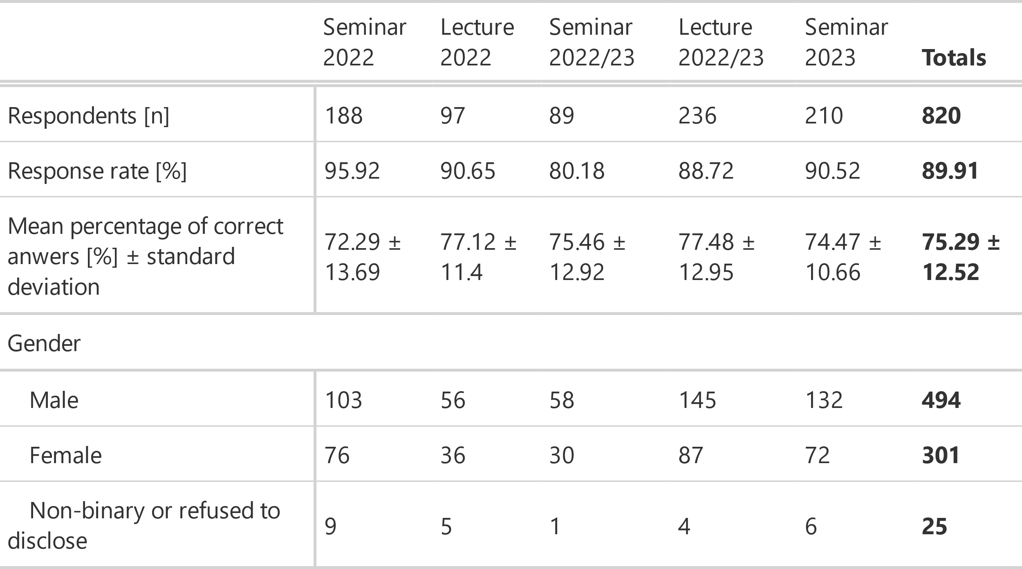

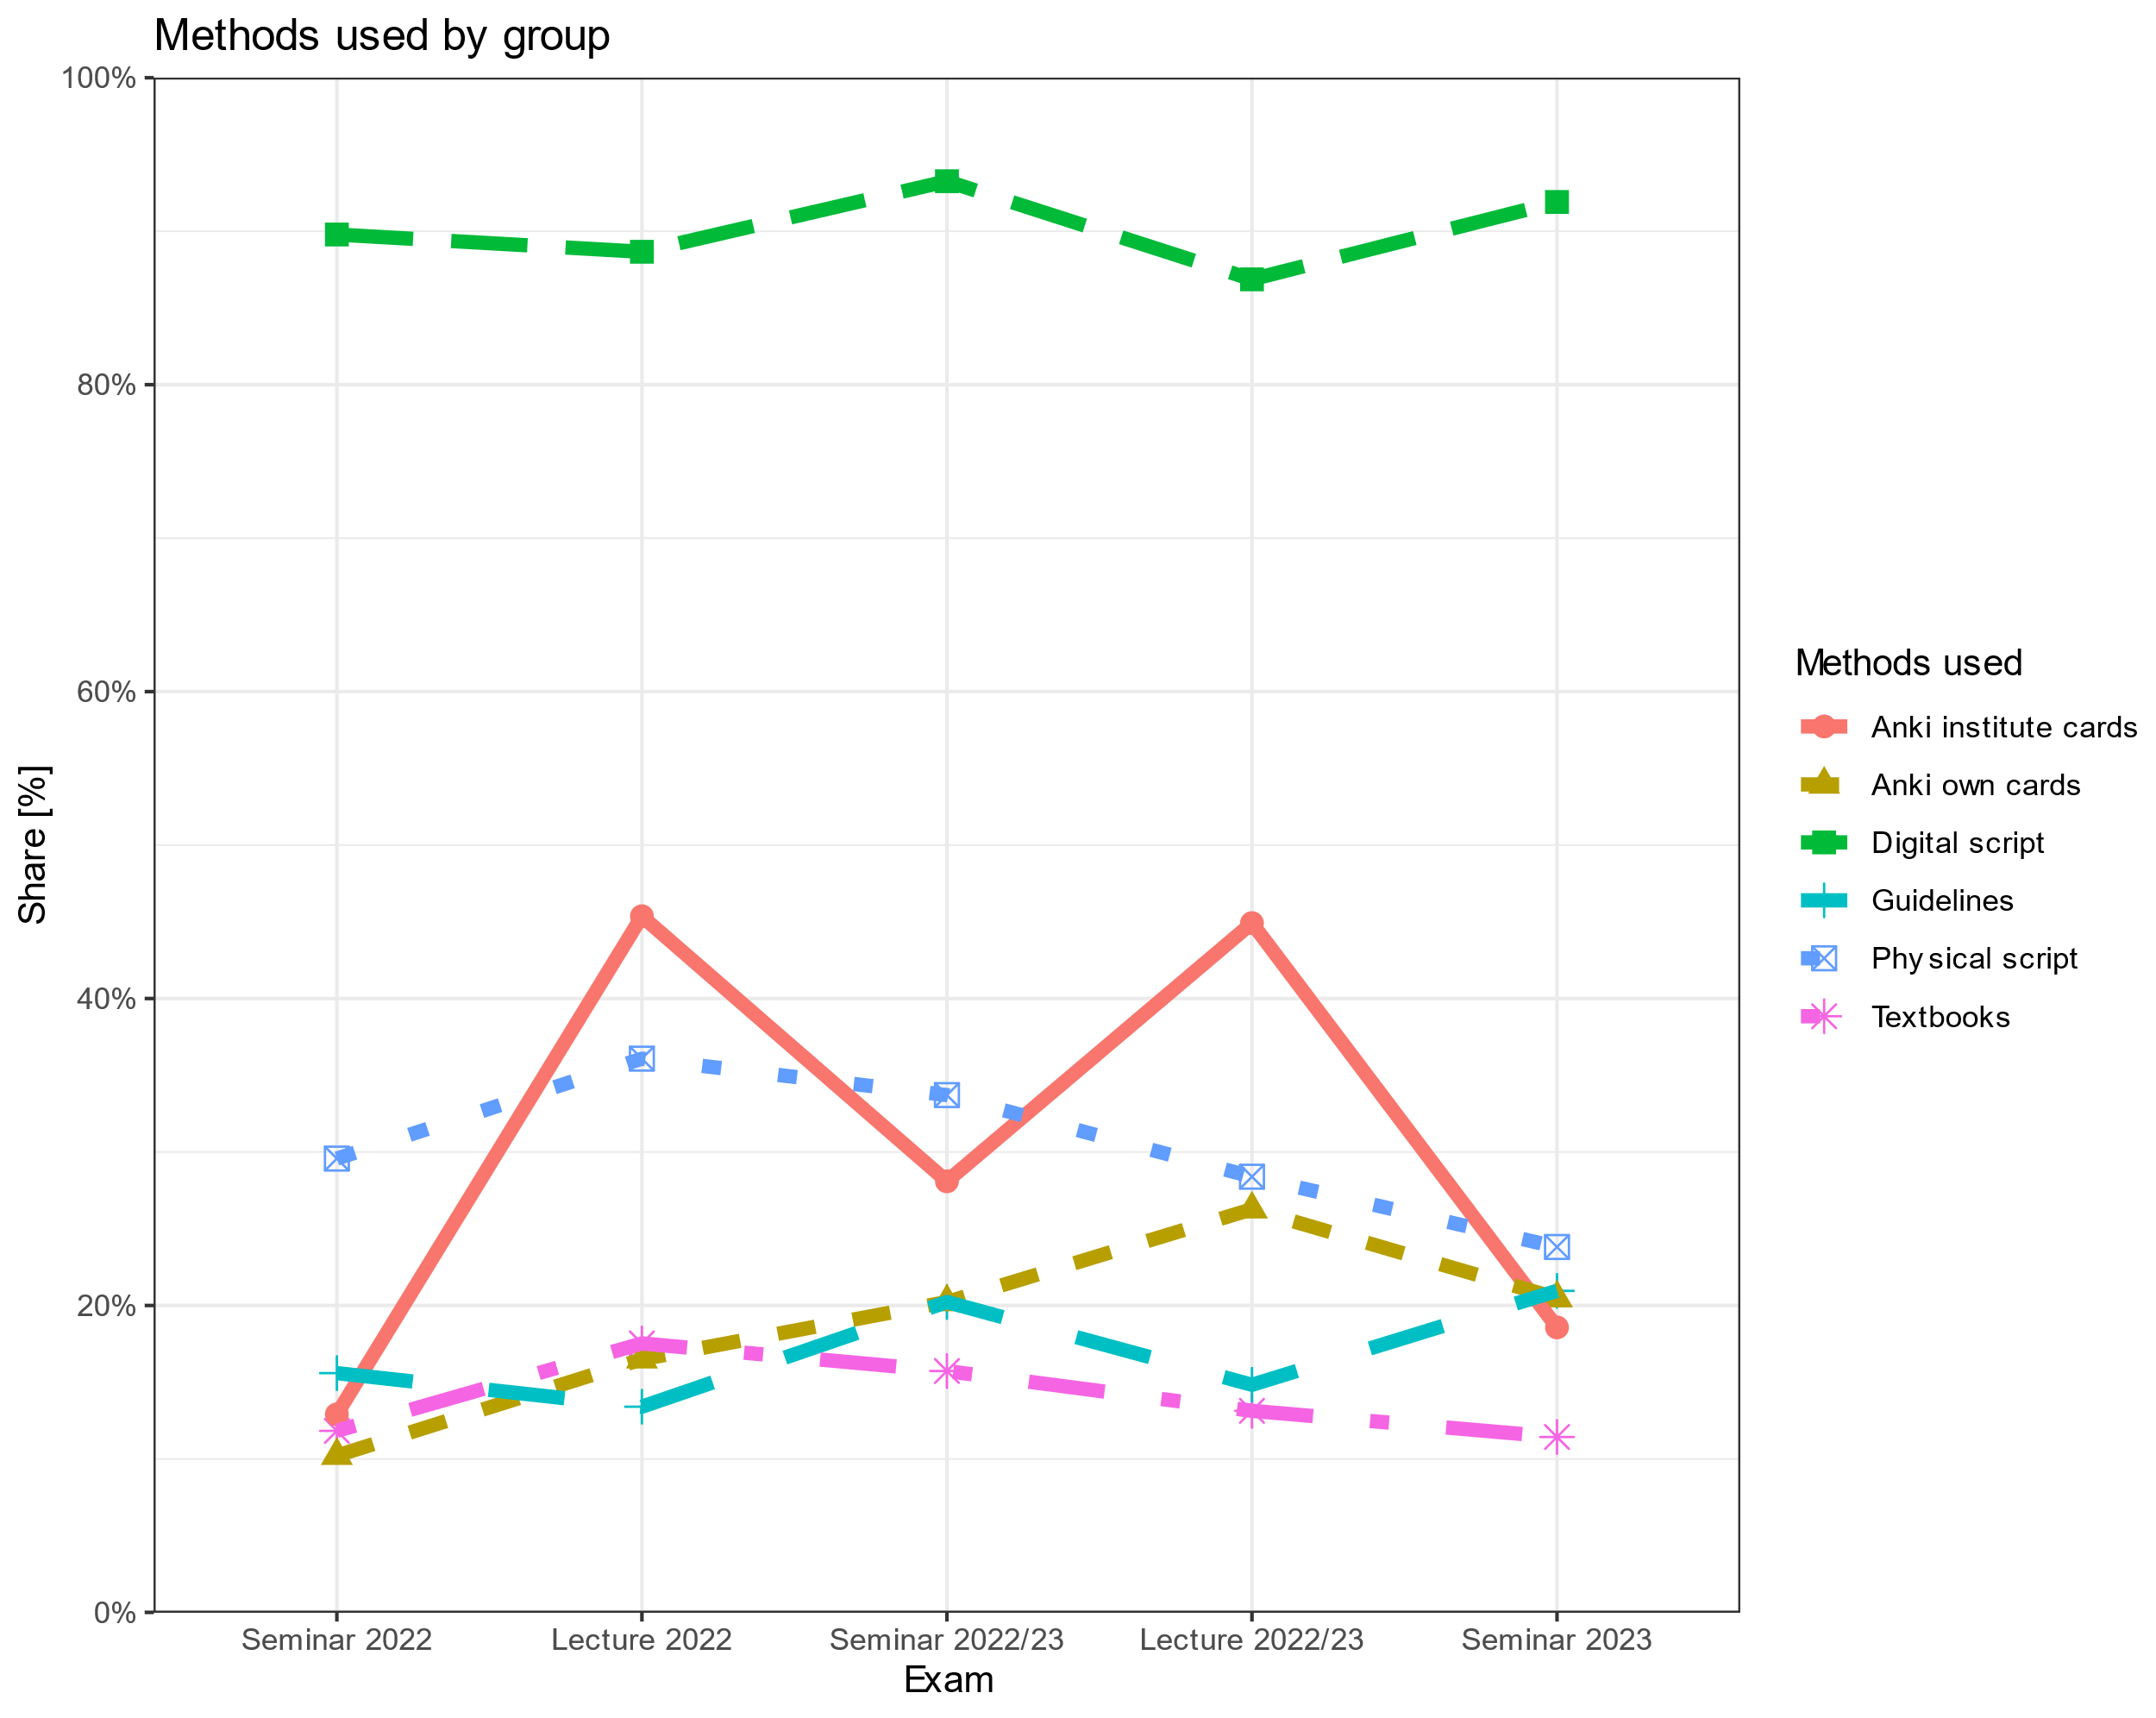

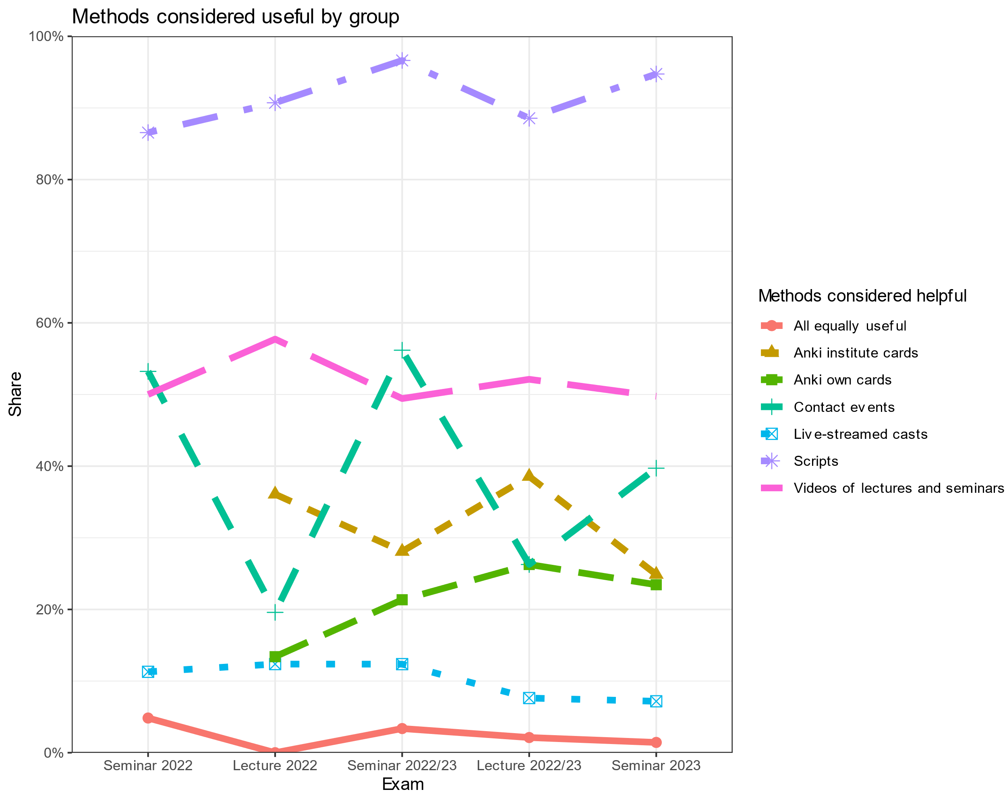

# 

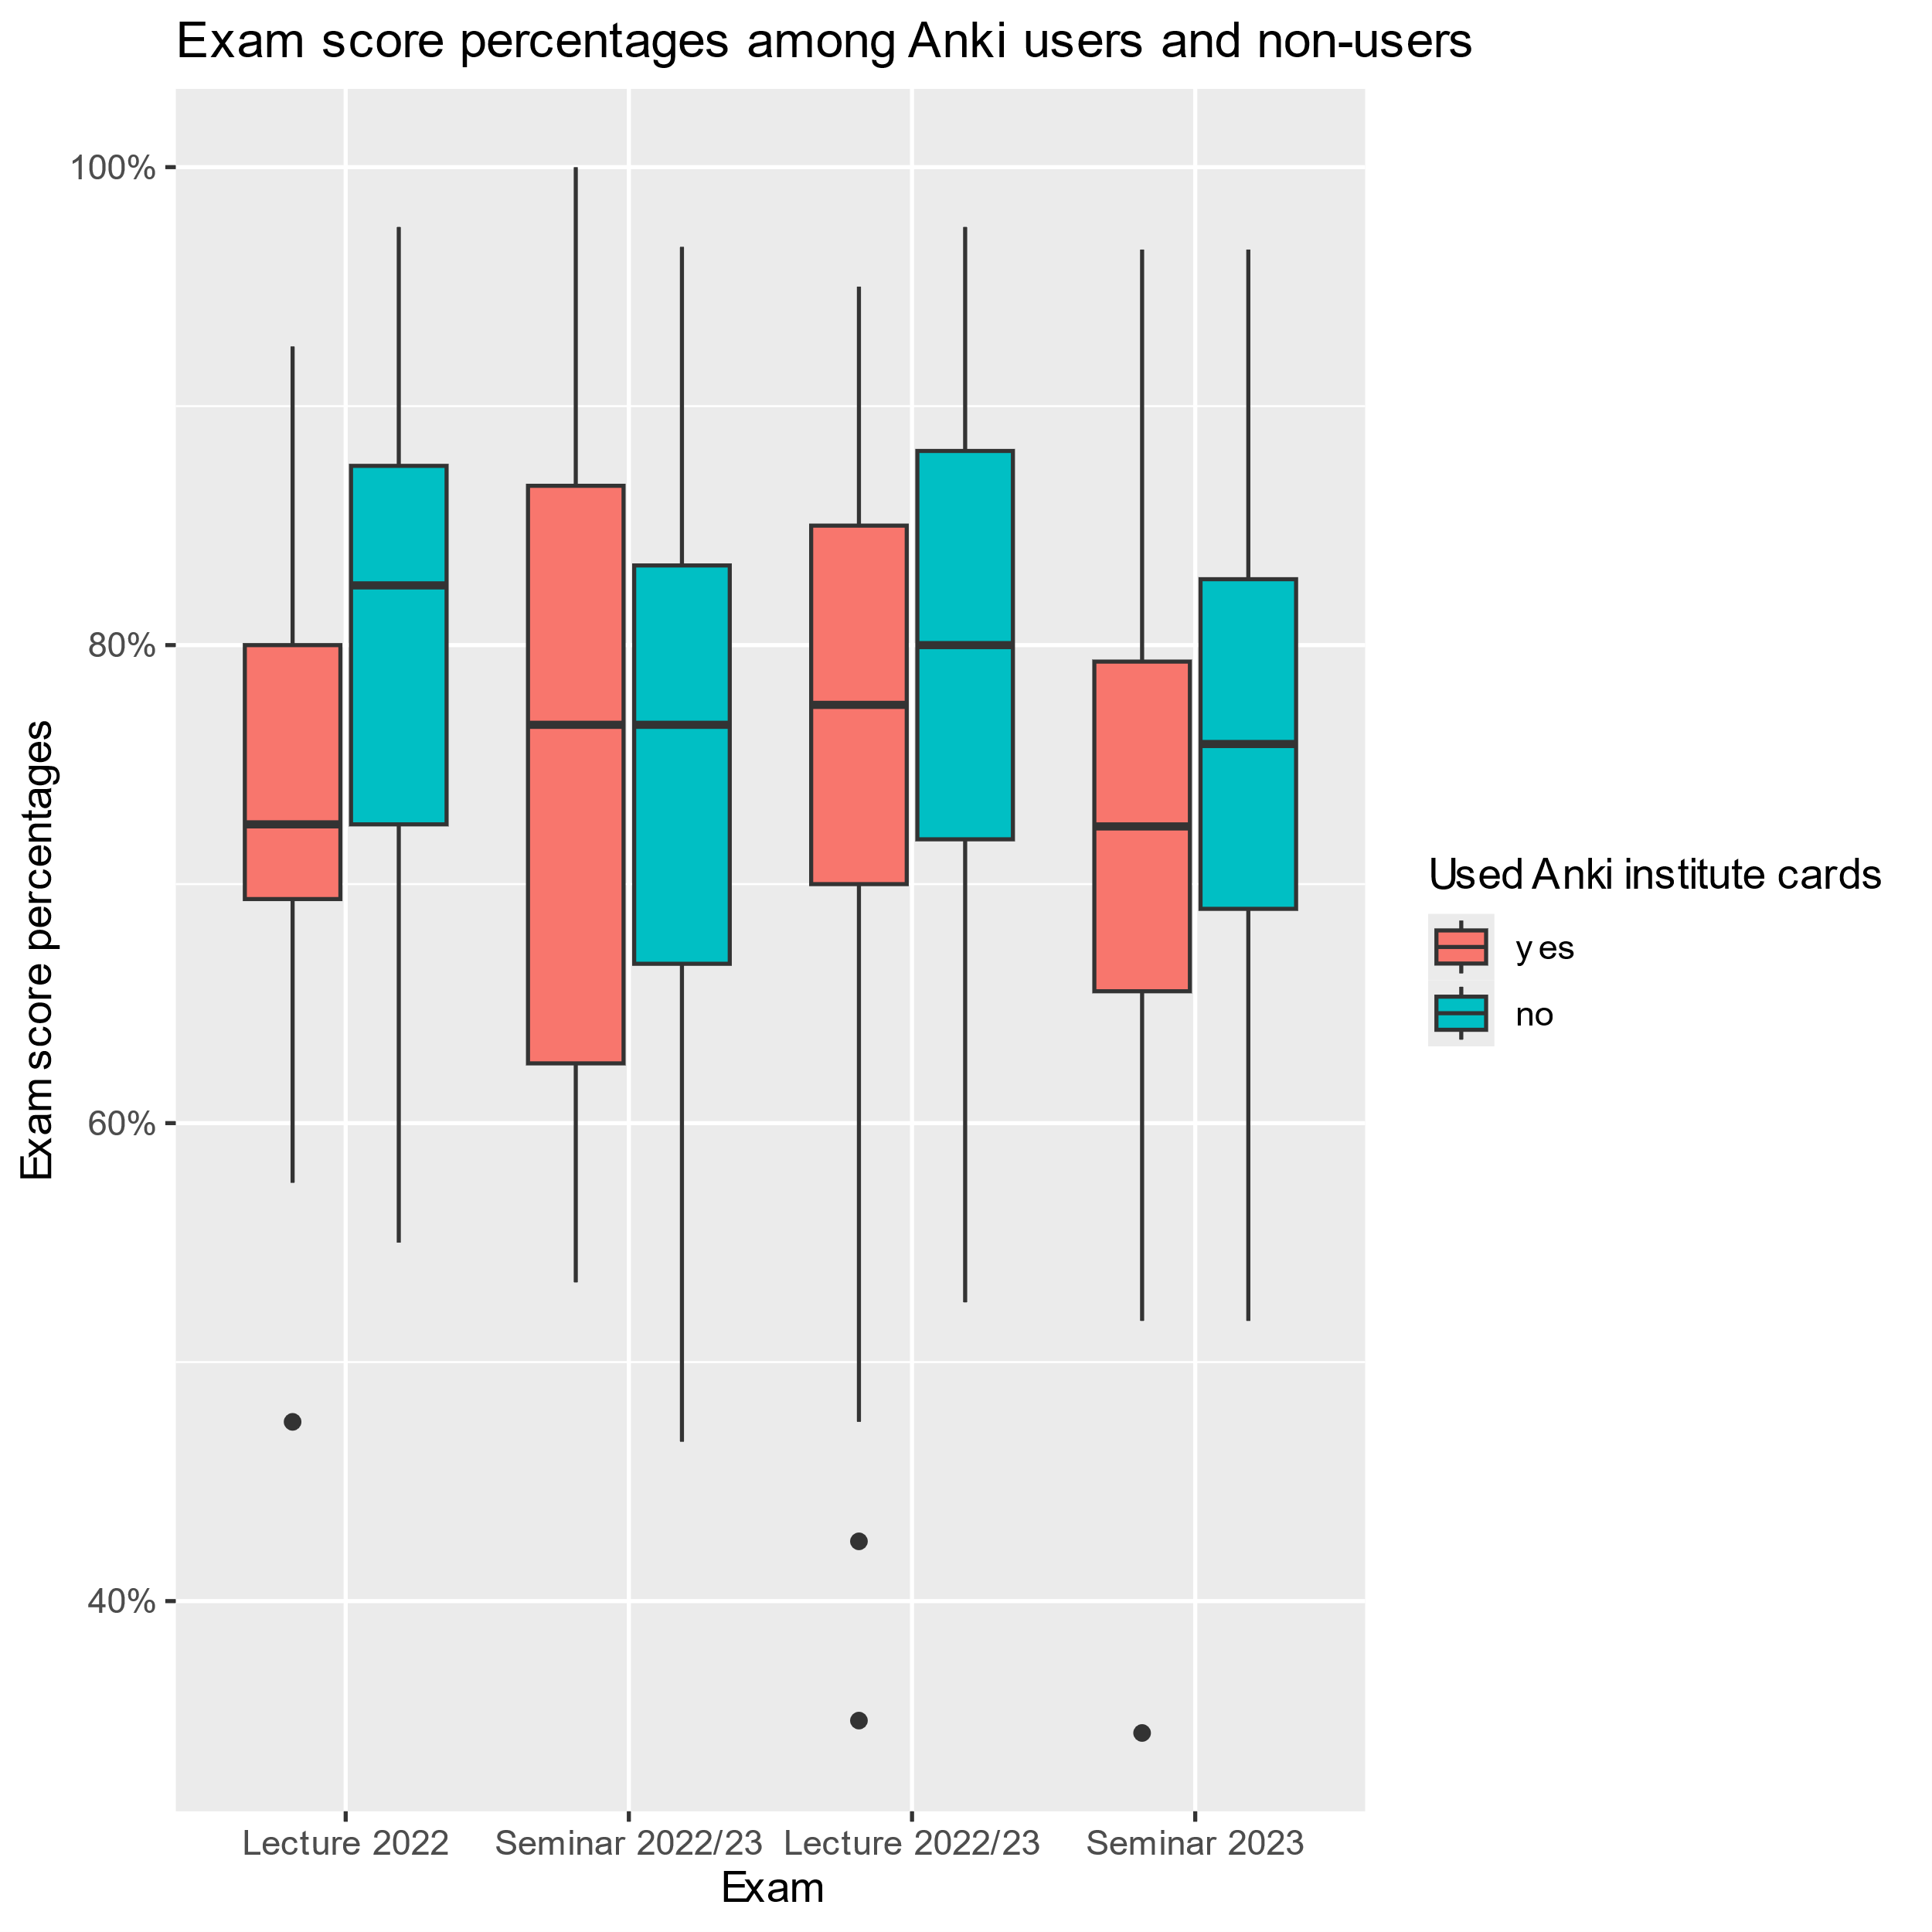

# Conclusions

Cards should be integrated into the curriculum, especially learning directly after receiving information (directly after lecture). Most preferred using their cards after the lecture (Harris and Chiang 2022).

Majority finds Anki helpul, but no

Time is limited

Only the bad students used the cards

Interaction with overall grades?

Might have spent the time with other techniques in spaced learning

# References

Cepeda, N. J., Pashler, H., Vul, E., Wixted, J. T., & Rohrer, D. (2006). Distributed practice in verbal recall tasks: A review and quantitative synthesis. *Psychological Bulletin*, *132*(3), 354.

Deng, F., Gluckstein, J. A., & Larsen, D. P. (2015). Student-directed retrieval practice is a predictor of medical licensing examination performance. *Perspectives on Medical Education*, *4*(6), 308–313. https://doi.org/10.1007/S40037-015-0220-X

Dobson, J. L. (2012). Effect of uniform versus expanding retrieval practice on the recall of physiology information. *Advances in Physiology Education*, *36*(1), 6–12. https://doi.org/10.1152/advan.00090.2011

Ebbinghaus, H. (1885). Über das gedächtnis: Untersuchungen zur experimentellen psychologie. *Duncker & Humblot*. https://books.google.de/books?hl=en&lr=&id=-4_XwPeyP68C&oi=fnd&pg=PA1&dq=%C3%9Cber+das+ged%C3%A4chtnis:+untersuchungen+zur+experimentellen+psychologie&ots=FX4B9LoVeC&sig=PJelplqMU2Lijti6eZZbQtSmC0w

Jape, D., Zhou, J., & Bullock, S. (2021). *A Spaced-Repetition Approach to Enhance Medical Student Learning and Engagement in Pharmacology*. https://www.researchsquare.com/article/rs-625499/latest

Karpicke, J. D., & Bauernschmidt, A. (2011). Spaced retrieval: Absolute spacing enhances learning regardless of relative spacing. *Journal of Experimental Psychology: Learning, Memory, and Cognition*, *37*(5), 1250.

Lambers, A., & Talia, A. J. (2021). Spaced Repetition Learning as a Tool for Orthopedic Surgical Education: A Prospective Cohort Study on a Training Examination. *Journal of Surgical Education*, *78*(1), 134–139. https://doi.org/10.1016/j.jsurg.2020.07.002

Lu, M., Farhat, J. H., & Beck Dallaghan, G. L. (2021). Enhanced Learning and Retention of Medical Knowledge Using the Mobile Flash card Application Anki. *Medical Science Educator*, *31*(6), 1975–1981. https://doi.org/10.1007/s40670-021-01386-9

Magro, J., Oh, S., Košćica, N., & Poles, M. (2024). Anki flashcards: Spaced repetition learning in the undergraduate medical pharmacology curriculum. *The Clinical Teacher*, e13798. https://doi.org/10.1111/tct.13798

Rana, T., Laoteppitaks, C., Zhang, G., Troutman, G., & Chandra, S. (2020). An Investigation of Anki Flashcards as a Study Tool Among First Year Medical Students Learning Anatomy. *The FASEB Journal*, *34*(S1), 1–1. https://doi.org/10.1096/fasebj.2020.34.s1.09736

Harris, D. M. and M. Chiang (2022). "An analysis of Anki usage and strategy of first-year medical students in a structure and function course." Cureus **14**(3).

Karpicke, J. D. and A. Bauernschmidt (2011). "Spaced retrieval: absolute spacing enhances learning regardless of relative spacing." Journal of Experimental Psychology: Learning, Memory, and Cognition **37**(5): 1250.