**Calculation and analysis of financial corporation**

v. 1.0

done by Vladyslav Sliusar

(group A19, Vinnitsa IT-Academy)

Task obtained: 27.09.2019

Pre-defence: 12.10.2019. Teacher1 _______________

Defence 19.10.2019. Teacher2 ___________________

CONTENTS

1. System requirements 3
2. About program “Calculation and analysis of financial corporation” 3
3. User guide 4
4. Programmer instruction 8
5. About the author 10
6. **System requirements**

System requirements which need to save and run the program:

Software requirements: operating system Microsoft DOS or Windows.

Hardware requirements:

* **Processor:** Intel Pentium or faster;
* **RAM:** 640 kB or more;
* **Hard disk space:**5 MB or more;
* **Display resolution:** 800x600 px;

1. **About program “Engineer calculator”**

This program is intended to calculate the main financial indicators of the company. Using the financial statements of the enterprise, the user receives an analysis of the company. Analyzing the data obtained, financiers have the opportunity to draw conclusions about the current state of affairs of the company and make assumptions about its future work.

The peculiarity of the program is that the user saves the previously entered data and can use it at any time. The program is intended both for university students studying finance and for professionals in the field. With its help, experts have the opportunity to increase the efficiency of their work without spending time on calculations, and immediately begin to analyze the company.

This program performs operations:

* calculates the liquidity of the corporation;
* calculates the financial stability of the corporation;
* calculates the profitability of the corporation;
* calculates the business activity of the corporation.

The results of all calculations are displayed.

1. **User guide**

3.1 Run file “financialCalculator.exe”.

3.2 The program will then bring up the main menu with options to add a new company or use an existing one. Choose the type of work that you want to perform and press “Enter” button.

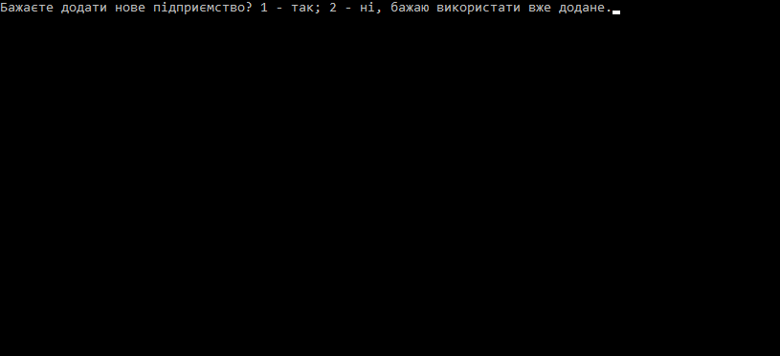

3.3 If you choose to add new company, the program will ask you, how many years you want to analyze. Maximum is 3, minimum is 1.

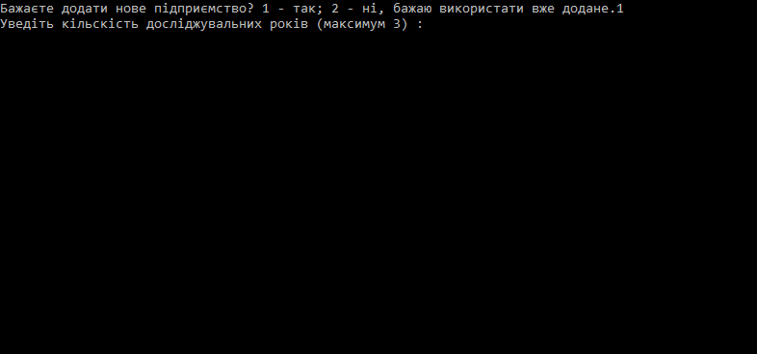

3.4 The next menu prompts you to enter first year of Financial Statements

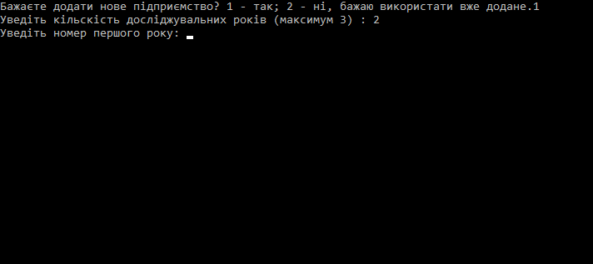

3.5 The next step prompts the user to enter the company’s name in English letters. This name will be used to create the corresponding input file.

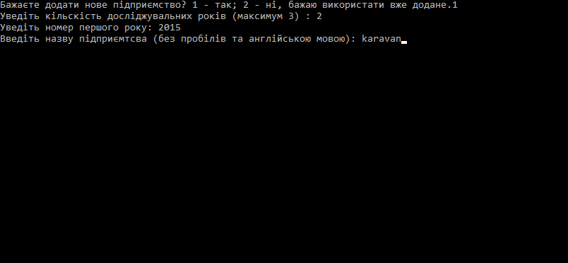

3.6 After clicking "Enter" will open a table where the user have to enter the financial statements of the company. It selects the corresponding row and column, clicks "Enter", enters the corresponding value, and clicks again "Enter". The program accepts only the numeric values to the table. When all the data has been entered, the user clicks "Esc".

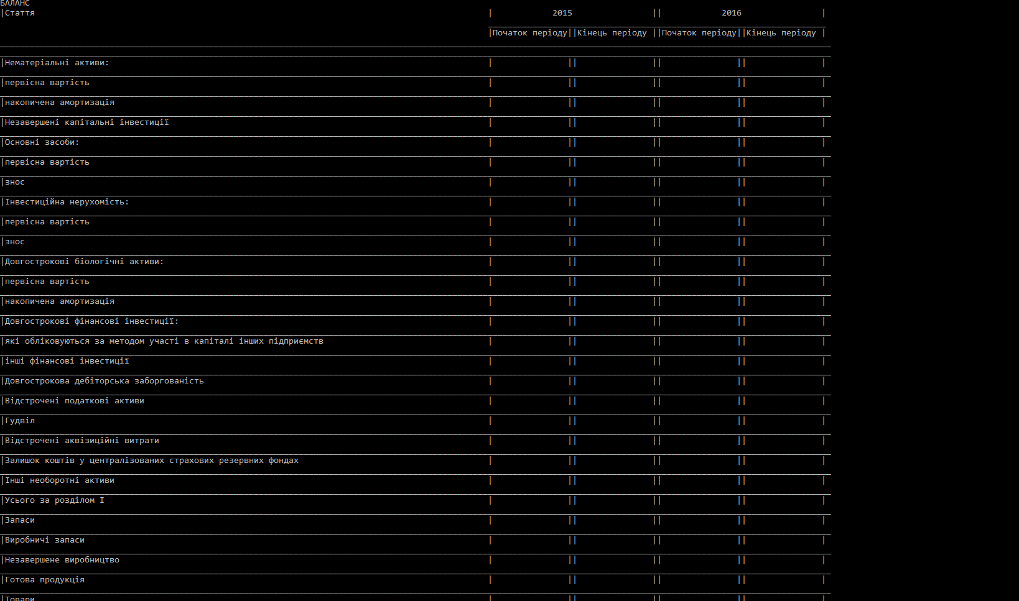

3.7 After entering all the data into the program, the user receives the calculation results in a table

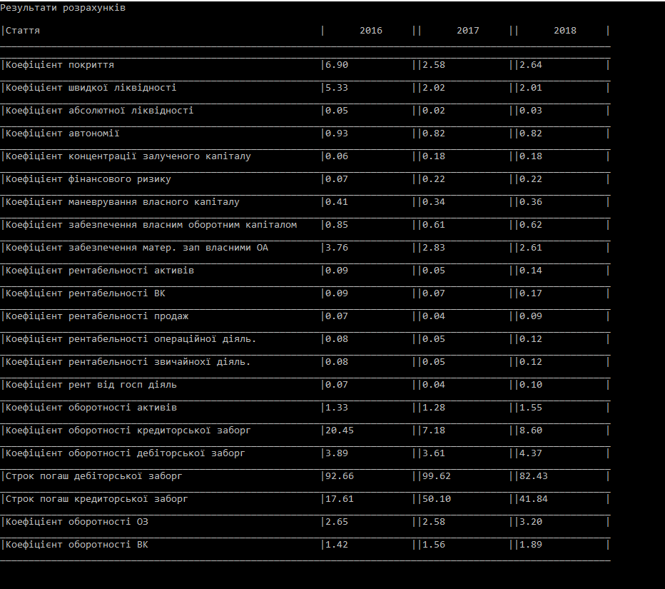

3.8 If a user has chosen to use an existing company in step 3.2. It will receive a list of companies to choose from.

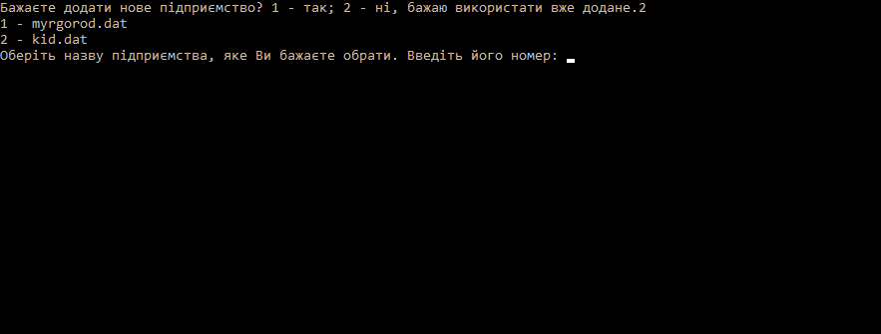

3.9 After selecting the right company, the user receives the result of the calculation of financial indicators.



1. **Programmer instruction**

The project was written on C.

Advantages of C:

1**.** *Highly portable language***:** Programs written on C for one computer can easily run on another computer without any change or by doing a little change.

2. *Easy to understand*: C language code or syntax is very easy to understand. It uses a keyword like “if”, “else”, “switch”, “main”, etc. This kind of keyword we all are using in out day to day life to get some decisions.

3. *Powerful and efficient language*: C is a robust language as it contains many data types and operators to give you a vast platform to perform all kinds of operations.

4. *Quality to extend itself*: C language has its own set of functions in the C library. So, it becomes easy to use these functions. We can add our own functions to the C Standard Library and make code simpler.

5. *Structured programming language*: C is structure-based. It means that the issues or complex problems are divided into smaller blocks or functions. This modular structure helps in easier and simpler testing and maintenance.

6. *Dynamic memory allocation*: C provides dynamic memory allocation that means you are free to allocate memory at run time. Project is a single c-unit which contains all necessary algorithms and functions.

Find and open the file financialCalculator.cbp in folder financialCalculator. For edition, debugging and compiling program code you may use C compilers such as MS Visual Studio, Code Blocks, C++ Builder, Dev C++ and similar.

Program "Engineer Calculator" was created as a multi file project, which consists of source and header files.

main.c – contains main function which starts program running

inputDate.c – source file contains functions which provides input to the application

finCalculations.c – source file contains functions which calculates main financial indicators

outputDate.c – source file contains functions which demonstrate the result of the program

inputDate.h, finCalculations.h, outputDate.h – header files which contains enumeration of functions used that can be called from different places in the program.

**5. About author**

This project was done by Vladyslav Sliusar – Vinnitsya IT-Academy student (group A19, October 2019).