Scientific article one the take-off distance

Article link | remark
https://arc.aiaa.org/doi/pdf/10.2514/1.31352?download=true
https://arc.aiaa.org/doi/abs/10.2514/6.2006-6098
https://www.mdpi.com/2226-4310/12/8/695 | Article about take-off distance even explain by the Nasa , I download the documents in my doc-file: Named : aerospace-12-00695.pdf

Scientific data for simulation link

link | Remark
Beluga XL programme achieves design freeze | Airbus | Beluga data
Airbus BelugaXL | Aircraft Wiki | Fandom | Beluga data
Cessna 172 Specs: Dimensions, Weight, & Performance | Cessna
C-130J Super Hercules | Air & Space Forces Magazine | Lockheed martin military aircraft
MG180389_C-130Brochure_NewPurchase_Final_Web.pdf
Lockhead Hercules.pdf
Dassault Rafale M | Dassault Rafale
https://fly8ma.com/topic/takeoff-and-landing-calculations/ | Website to watch video explaining how to calculate the take-off distance

Link document or simulation website

zq b<; ;

Docu, or simu link | remark
Introduction to Aerospace Flight Vehicles
Decrochage
https://www.eurocontrol.int/what-we-offer
https://aeroadda.com/courses/shock-waves/
Pilot’s Handbook of Aeronautical Knowledge | For aircraft performance data
Aircraft Performance Database
Takeoff Distance Estimator for Aircraft Performance | Simulation website for take-off distance
https://di.univ-blida.dz/jspui/handle/123456789/25672 | Document for take-off distance
https://aircraftinvestigation.info/airplanes/Airbus_A320neo.html#google_vignette | A lot of explanation about aicraft data and even take-off distance

Documents and remark

dhj

Document name | Remark
13_phak_ch11.pdf | Requirement for take-off distance Need to be read
2263.pdf
2371.pdf | Airbus A330 description
a330f_afm.pdf
aerospace-12-00695.pdf | Good article about take-off distance
Lockhead Hercules.pdf | Provide data for simulation of the take-off distance for the aircraft : Lockheed Hercules
MG180389_C-130Brochure_NewPurchase_Final_Web.pdf | Description of the aircraft configuration
Air_Plains_172__180_HP_Performance_9305314D44A0E.pdf | Cessna data info

Questions et reponses posées à l’IA

CHATgpt
“””””””””””””””””””””””””””””””””””””””””””

# Geometry and aircraft data
Sw = None # Wing surface area
bw = None # Wing span
hw = None # Height of the wing above the ground
W = None # Weight
Ra = None # Aspect ratio coefficient
lambda_ = None # Aspect ratio parameter

# Aerodynamic coefficients
Cdo = None # Zero-lift drag coefficient
Cdol = None # Additional drag coefficient term
Cd = None # Drag coefficient
Cl = None # Lift coefficient
Clmax = None # Maximum lift coefficient
e = None # Oswald efficiency coefficient

# Ground and motion parameters
mu = None # Ground friction coefficient
Vlo = None # Lift-off speed
Vhw = None # Reference speed
Vi = None # Initial speed for integration
Vip1 = None # Final speed for integration
g = None # Gravity
rho = None # Air density

# Propulsion parameters
P = None # Piston engine power in BHP
T = None # Jet engine thrust
efficiency = None # Propeller efficiency
T0 = None # Initial thrust or experimental thrust coefficient
T1 = None # Experimental thrust coefficient
T2 = None # Experimental thrust coefficient
A1 = None # Thrust formula coefficient
A2 = None # Thrust formula coefficient
A3 = None # Thrust formula coefficient
A4 = None # Thrust formula coefficient

# Numerical parameter
n = None # Number of iterations

Question: Help transform this in a latext code so I can see my mistake

\acro{Sw}{Surface de l'aile }
\acro{IMHO}{In My Humble Opinion}
\acro{cste}{constant }

“””””””””””””””””””””””””””””””””””””””””””””

def __init__(self, Unit):
"""
Initialize all parameters from dictionary
"""
self.p = dict
self.Unit=Unit

self.CONV = {
"Sw": 0.3048**2, # ft² -> m²
"bw": 0.3048, # ft -> m
"hw": 0.3048, # ft -> m
"W": 4.44822, # lbf -> N
"T0": 4.44822, # lbf -> N
"T1": 4.44822/0.3048, # lbf/ft/s -> N/m/s
"T2": 4.44822/(0.3048**2),
"rho": 515.3788, # slug/ft³ -> kg/m³
"Vhw": 0.3048, # ft/s -> m/s
"Vi": 0.3048, # ft/s -> m/s
"g": 0.3048, # ft/s² -> m/s²
}

# from US to SI
if self.Unit == "US" and new_unit == "SI":
for key, factor in self.CONV.items():
if key in self.p:
self.p[key] = self.p[key]* factor

# from SI to US
elif self.Unit == "SI" and new_unit == "US":
for key, factor in self.CONV.items():
if key in self.p:
self.p[key] = self.p[key] / factor

Question: Improve this for me

“”””””””””””””””””””””””””””””””””””””””””””””””
def Change_Am_SI(self):

self.p['Sw'], self.p['bw'], self.p['W'], self.p['Ra'] = self.p['Sw']*(0.3048**2 ), self.p['bw'] * 0.3048 , self.p['W']* 4.448 , self.p['Ra'] * 0.3048

# self.p['Cdo'], self.p['Cdol'], self.p['e'], self.p['Clmax'], self.p['Cl'],self.p['mu'] = self.p['Cdo'], self.p['Cdol'], self.p['e'], self.p['Clmax'], self.p['Cl'],self.p['mu']

self.p['T0'], self.p['T1'], self.p['T2'] = self.p['T0'] * 4.448, self.p['T1'] * (4.448/0.3048 ), self.p['T2'] *(4.448/0.3048)

self.p['rho'], self.p['alpha'], self.p['alpha_o'], self.p['Vhw'], self.p['g'],self.p['V1'] = self.p['rho'], self.p['alpha'], self.p['alpha_o'], self.p['Vhw'], self.p['g'],self.p['V1']

Question: Give me an efficient way to convert from American unit into Si s am doing now and from Si to American unity

“””””””””””””””””””””””””””””””””””””””””””””””””””

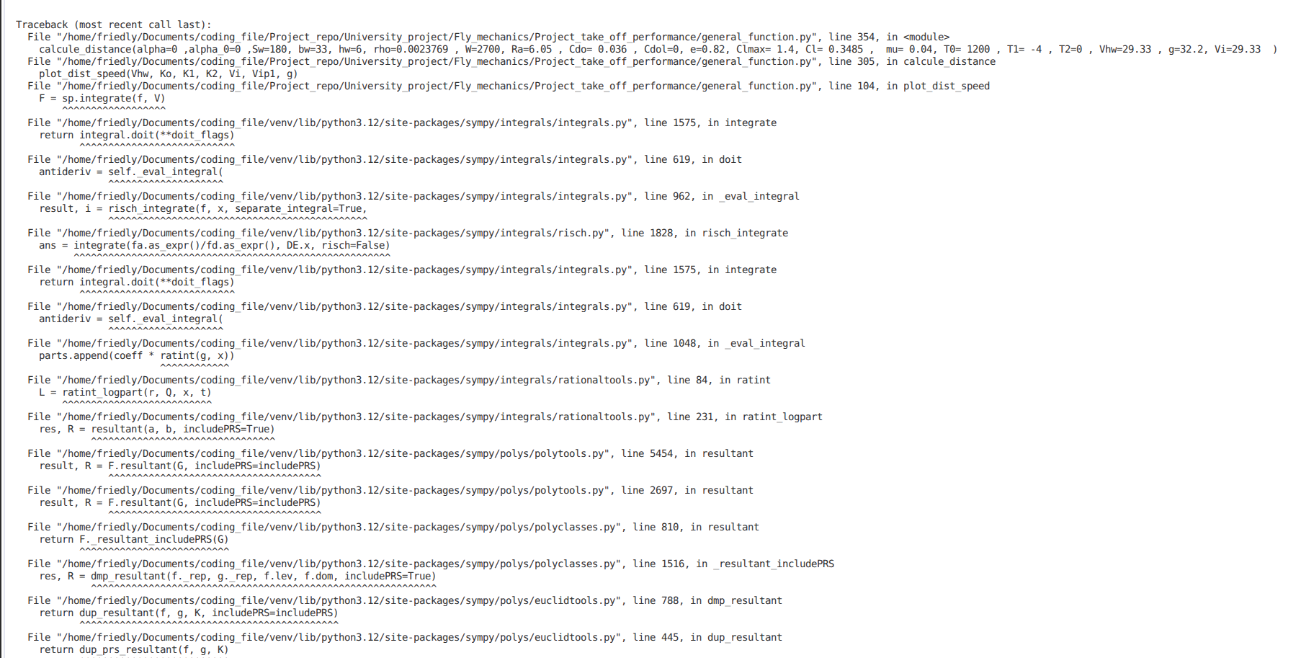

Question: Help me find the mistake
“”””””””””””””””””””””””””””
Question: C-130J Super Hercules Technical Data distance de décollage
AI: Perplexity

Sources : https://www.nlarenas.com/fr/2019/10/hercules-c-130-rompiendo-record/

“”””””””””””””””””””””””””””””””””””””””””””””
def plot_dist_speed(Vhw, koi, k1i, k2i, Vi, Vip1, g):
# Variable symbolique
V = sp.symbols('V')

# Fonction
D = koi + k1i*V + k2i*V**2
f = (-Vhw + V) /D

# Intégrale symbolique
F = sp.integrate(f, V)

# Transformer en fonction numérique
F_num = sp.lambdify(V, F, 'numpy')

# Valeurs pour le tracé
speed = np.linspace(Vi, Vip1, 100)
S = (1/g)* F_num(speed)

# Tracé
plt.figure()
plt.plot(speed, S)
plt.xlabel("Velocity")
plt.ylabel("Distance")
plt.title("Distance as a function of velocity")
plt.grid(True)
plt.show()

Question: Find me the mistake in my code

******************************************************************************************
Question: Look at this data and tell me how to analyse them, talking about the way the have some diagram

Question: Compare the result I have after simulating the different model :

Question: Tell me I already call the value from the disctionnaire tell me how to solve I mean analyse them

Lecture = csv.DictReader( open("sim_data.csv"))
Lp =list(Lecture)
avions = []
Sa1, Sr1, Sc1, S1, Vlo1 = [], [], [], [], []
Sa2, Sr2, Sc2, S2, Vlo2 = [], [], [], [], []
Sa3, Sr3, Sc3, S3, Vlo3 = [], [], [], [], []
Sa4, Sr4, Sc4, S4, Vlo4 = [], [], [], [], []

for i in range (0, len(Lp) ) :
dict = Lp[i] # des element comme la ligne 12 ou 14 du code
avions.append( dict['Avions'])
Sa1.append(dict['Sa1'])
Sa2.append(dict['Sa2'])
Sa3.append(dict['Sa3'])
Sa4.append(dict['Sa4'])
Sr1.append(dict['Sr1'])
Sr2.append(dict['Sr2'])
Sr3.append(dict['Sr3'])
Sr4.append(dict['Sr4'])
Sc1.append(dict['Sc1'])
Sc2.append(dict['Sc2'])
Sc3.append(dict['Sc3'])
Sc4.append(dict['Sc4'])
S1.append(dict['S1'])
S2.append(dict['S2'])
S3.append(dict['S3'])
S4.append(dict['S4'])
Vlo1.append(dict['Vlo1'])
Vlo2.append(dict['Vlo2'])
Vlo3.append(dict['Vlo3'])
Vlo4.append(dict['Vlo4'])
M1, M2, M3, M4 = {}, {}, {}, {}
Var = { "Sa", "Sr", "Sc", "S", "Vlo"}
for var in Var :
if var == "Sa":
M1[var] = Sa1
M2[var] = Sa2
M3[var] = Sa3
M4[var] = Sa4
if var == "Sr":
M1[var] = Sr1
M2[var] = Sr2
M3[var] = Sr3
M4[var] = Sr4
if var == "Sc":
M1[var] = Sc1
M2[var] = Sc2
M3[var] = Sc3
M4[var] = Sc4
if var == "S":
M1[var] = S1
M2[var] = S2
M3[var] = S3
M4[var] = S4
if var == "Vlo":
M1[var] = Vlo1
M2[var] = Vlo2
M3[var] = Vlo3
M4[var] = Vlo4

modeles = {"Model1": M1 , "Model2": M2 , "Model3": M3 , "Model4": M4 }

Question: Tell me I already call the value from the disctionnaire tell me how to solve I mean analyse them
Answer: ( Chatgpt )
for model_name, data in modeles.items():
print(f"\n{model_name}")
for var, value in data.items():
print(f" {var}: {value}")
**************************************************************************************

Question: What do you think about or report

Could you clarify what you mean by “What do you think about or report”?
For example, are you asking:
- My opinion about a specific topic, event, company, person, or idea?
- Whether I should give an opinion versus an objective report?
- A summary/report about something in the news?
- Feedback on a document, article, or report you've written?
If you tell me the subject, I can either:
- give an analysis/opinion,
- provide a neutral report of the facts, or
- do both and clearly separate them.

*******************************************************.

*********************************************************************
Question: tell me where I can find researche paper about takeoff distance
Chatgpt
Si tu cherches des articles scientifiques, voici les sites les plus utilisés par les chercheurs :

Bases de données académiques générales
- Google Scholar (Google Académique)
  - Le moteur de recherche scientifique le plus utilisé.
  - Recherche dans des millions d'articles, thèses, livres et conférences.
- PubMed
  - Référence mondiale pour la médecine, la biologie et les sciences de la santé.
- ResearchGate
  - Réseau social de chercheurs où de nombreux articles sont accessibles gratuitement.
- Semantic Scholar
  - Moteur de recherche utilisant l'IA pour trouver rapidement les articles les plus pertinents.

Accès libre (Open Access)
- Directory of Open Access Journals (DOAJ)
  - Répertoire de revues scientifiques en accès libre.
- arXiv
  - Très utilisé en informatique, mathématiques, physique et intelligence artificielle.
- HAL
  - Archive ouverte française regroupant des publications scientifiques.

Éditeurs scientifiques majeurs
- Elsevier (ScienceDirect)
- Springer Nature
- Wiley Online Library
- IEEE Xplore (informatique, électronique, IA)
- ACM Digital Library (informatique)

Pour trouver gratuitement un article payant
- OpenAlex
- Unpaywall

Recommandation
Pour la plupart des recherches, commence par :
- Google Scholar
- Semantic Scholar
- Puis vérifie si une version gratuite existe via Unpaywall ou HAL.
Si tu me donnes ton domaine (IA, médecine, droit, économie, psychologie, etc.), je peux te recommander les bases de données les plus adaptées.

