Difference Between a Piston Engine and a Turbofan Engine
Feature | Piston Engine | Turbofan Engine
How it works | Pistons move inside cylinders | Air is compressed and pushed through turbines
Propulsion | Turns a propeller | Produces jet thrust with a fan
Aircraft type | Small airplanes | Large jet aircraft
Speed | Slower | Much faster
Fuel efficiency | Better for short, slow flights | Better for long, fast flights
Complexity | Simpler | More complex
Noise | Less noisy | Can be loud but modern ones are quieter

Vocabulary in French
English Word | French Meaning
Aircraft | Avion / aéronef
Engine | Moteur
Piston | Piston
Turbofan | Turboréacteur à double flux
Turbojet | Turboréacteur
Turboprop | Turbopropulseur
Propeller | Hélice
Thrust | Poussée
Fuel | Carburant
Cylinder | Cylindre
Turbine | Turbine
Exhaust gases | Gaz d’échappement
Fan blades | Pales du ventilateur
Takeoff | Décollage
Altitude | Altitude
Passenger jet | Avion de ligne
Cargo plane | Avion cargo
Fuel efficient | Économe en carburant
Powerful | Puissant
Complex | Complexe

Main Types of Aircraft Engines
1. Piston Engine
A piston engine works like a car engine. Fuel burns inside cylinders and moves pistons up and down. The pistons turn a crankshaft, which spins a propeller.

Used for:
- Small airplanes
- Training aircraft
- Private aviation

Advantages:
- Simple
- Less expensive
- Good for short flights

Disadvantages:
- Slower
- Less powerful at high altitude

2. Turboprop Engine
A turboprop uses a gas turbine to spin a propeller.

Used for:
- Regional aircraft
- Cargo planes
- Short runways

Advantages:
- Fuel efficient at medium speeds
- Good for takeoff

Disadvantages:
- Slower than jets
- 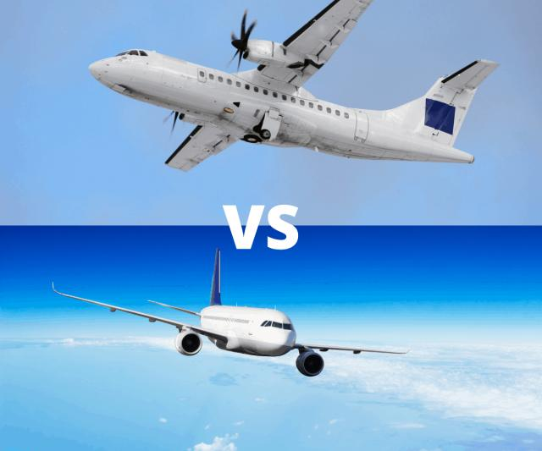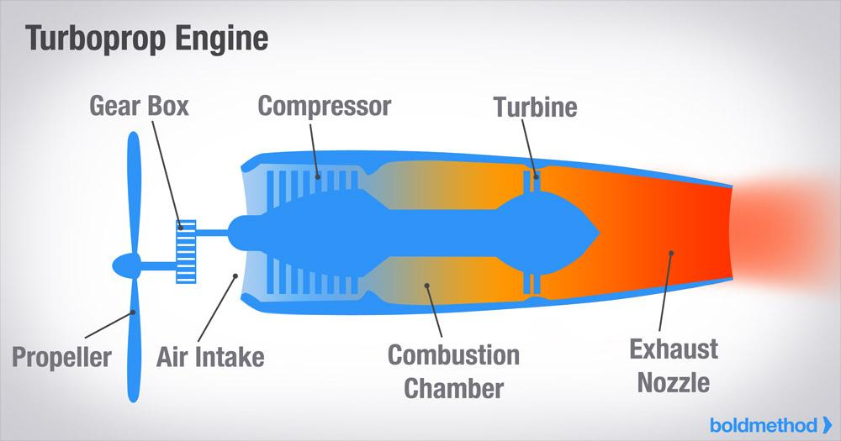

3. Turbojet Engine
A turbojet produces thrust directly from fast exhaust gases.

Used for:
- Older military jets
- Supersonic aircraft
Advantages:
- • Very fast
Disadvantages:
- • Noisy
- • Uses more fuel

4. Turbofan Engine
A turbofan is the most common modern jet engine. It has a large fan in front that moves a lot of air.

Used for:
- Airliners
- Modern passenger jets

Advantages:
- Powerful
- Quieter
- Fuel efficient

Disadvantages:
- Expensive
- Complex
