Battery container simulation on Ansys

Made by Friedly WOLI

- Meshing Part

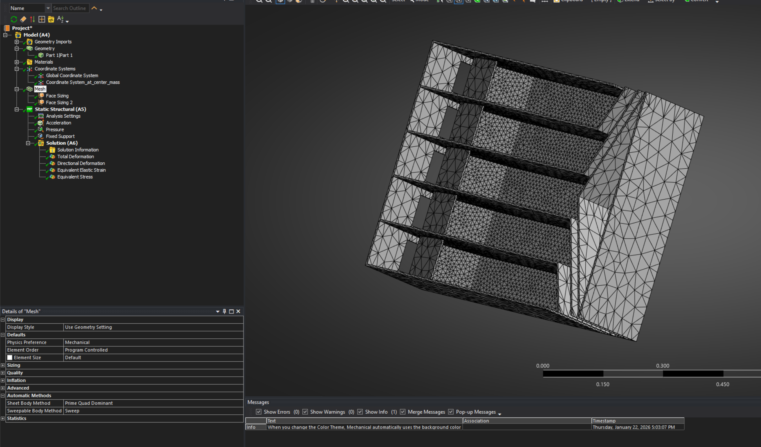Figure 1: Meshing result
- Fixed part

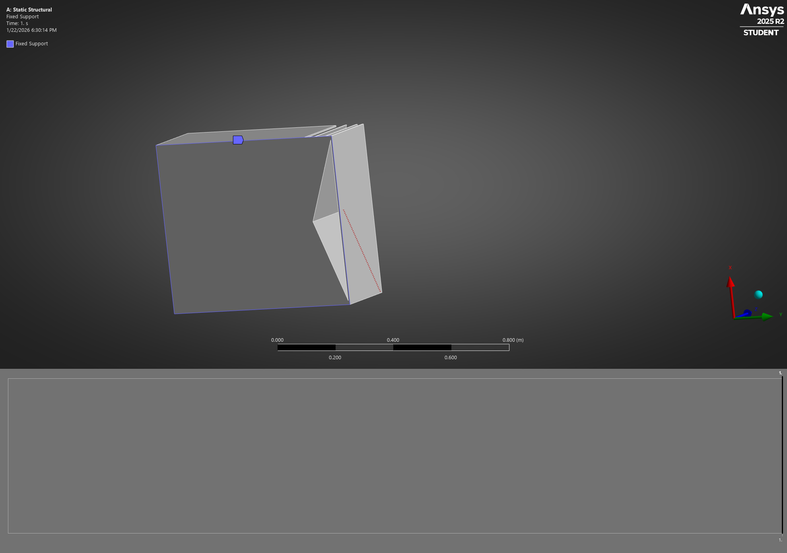Figure 2: fixed support in blue

- Pressure on the bottom surface
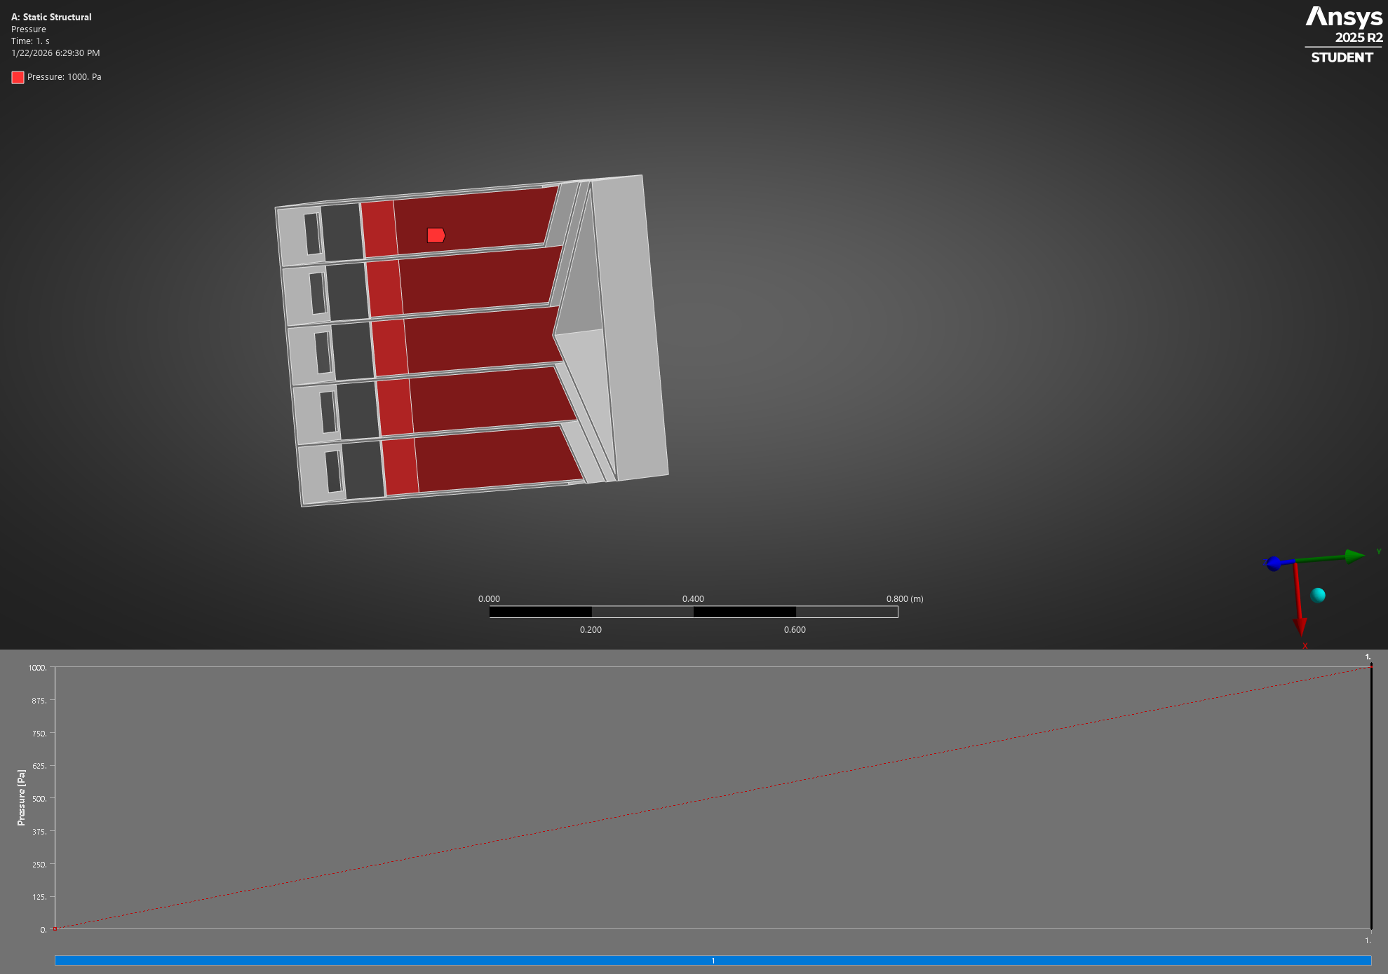Figure 3: Pressure on the bottom surface

Acceleration force

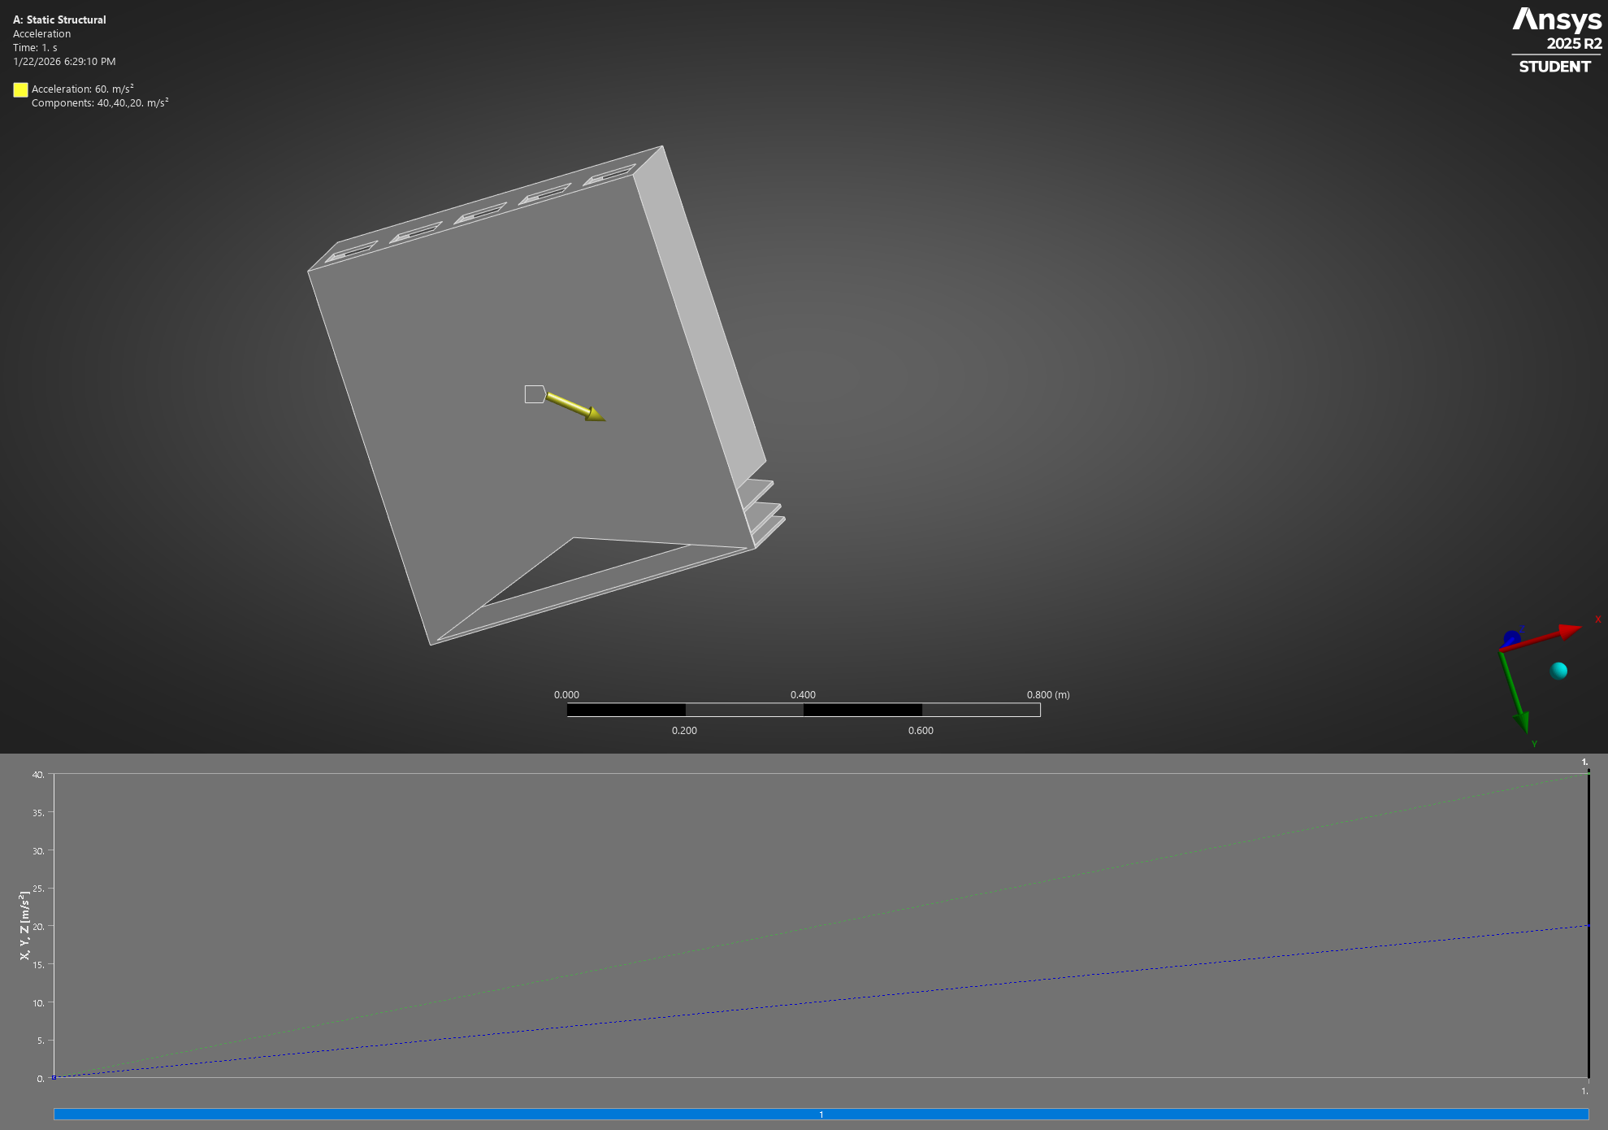Figure 4: Acceleration force

More about acceleration force

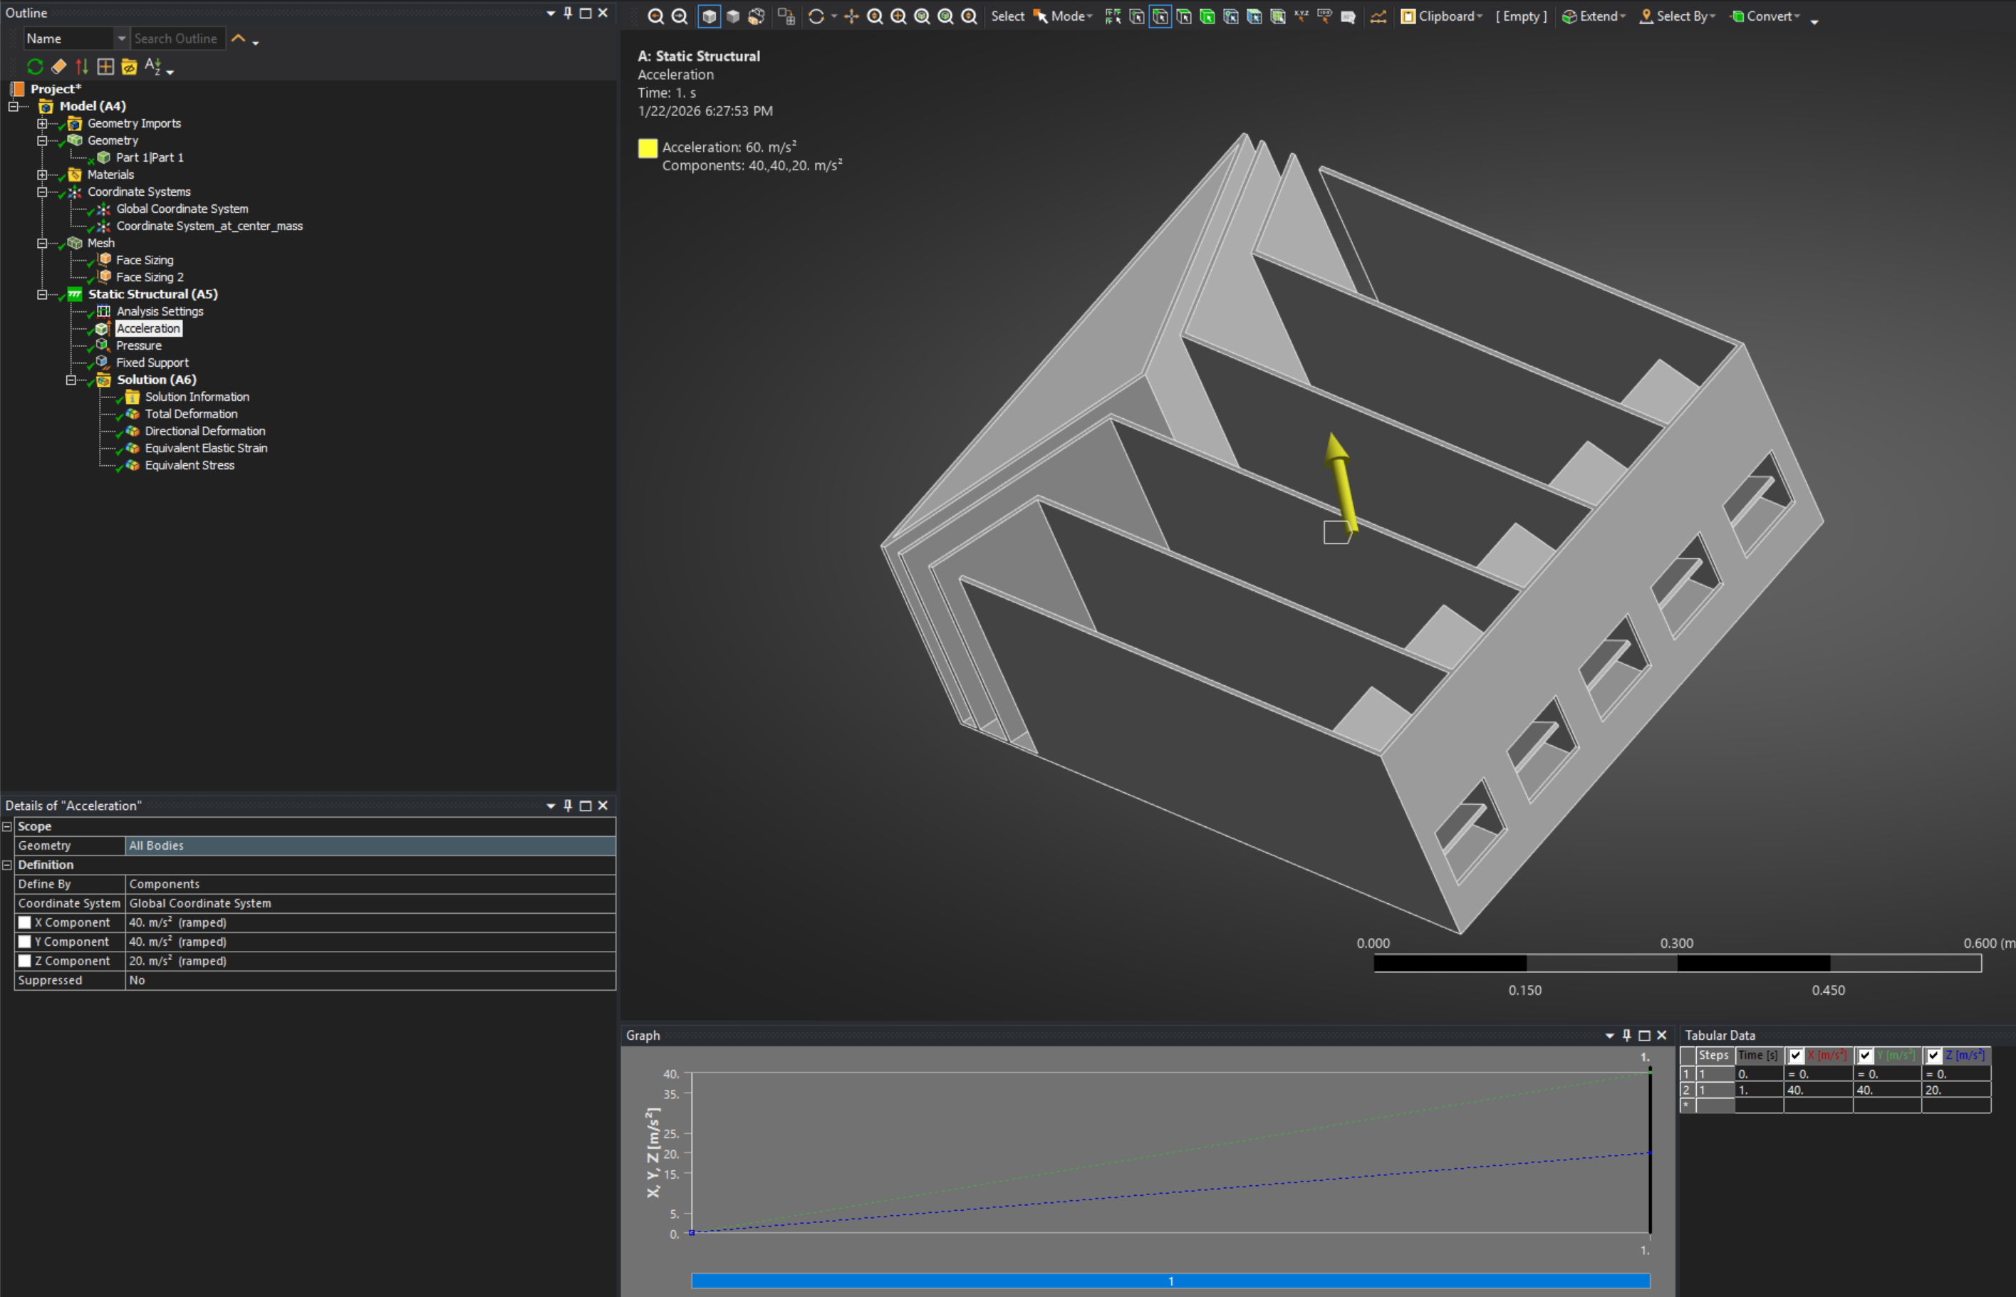Figure 5: Aceleration force

Directional Deformation

Directional deformation 2
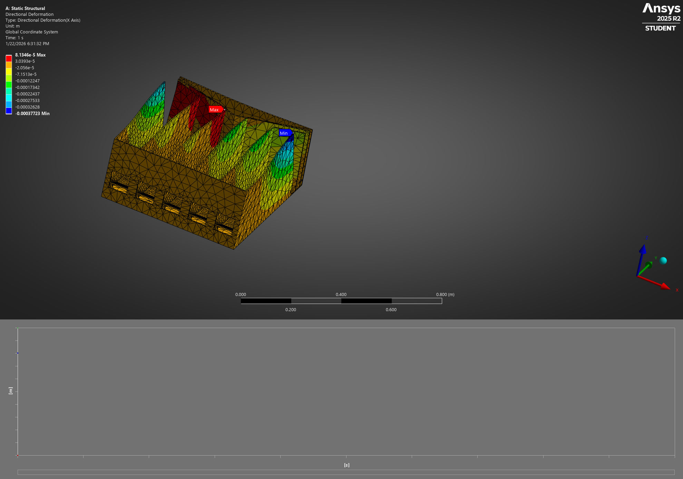Figure 6: directional deformation

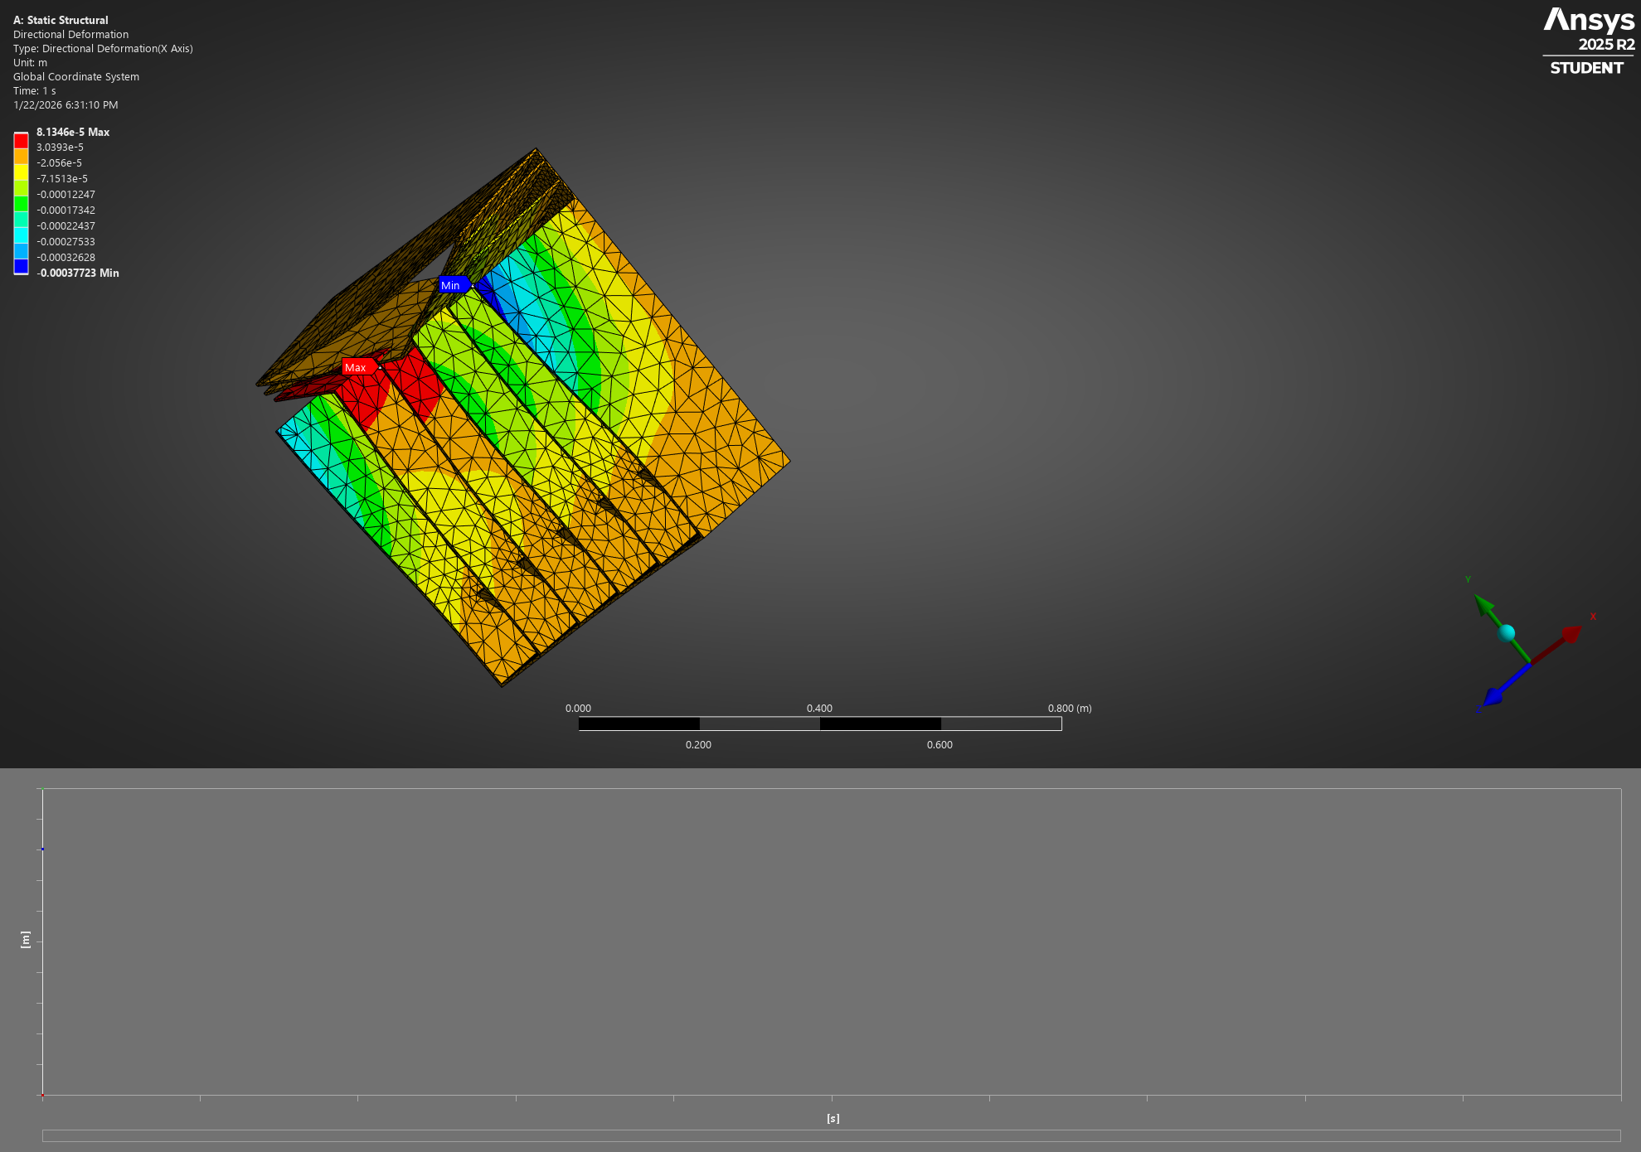Figure 7: directional deformation

- Total deformation

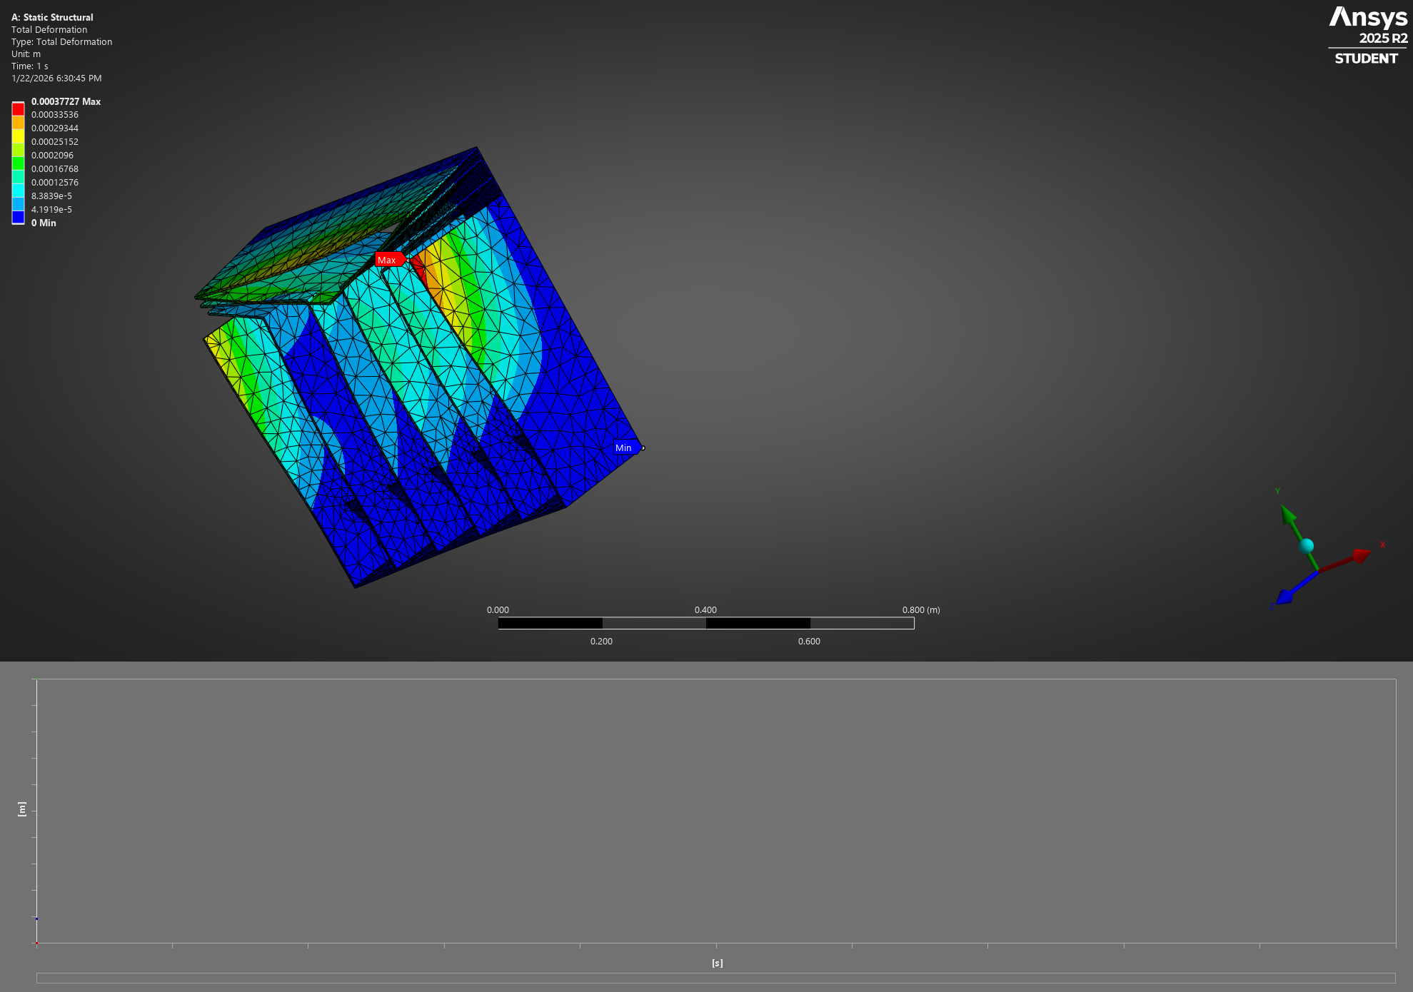Figure 8: Total deformation

Total deformation 2
.

j

Equivalent Stress

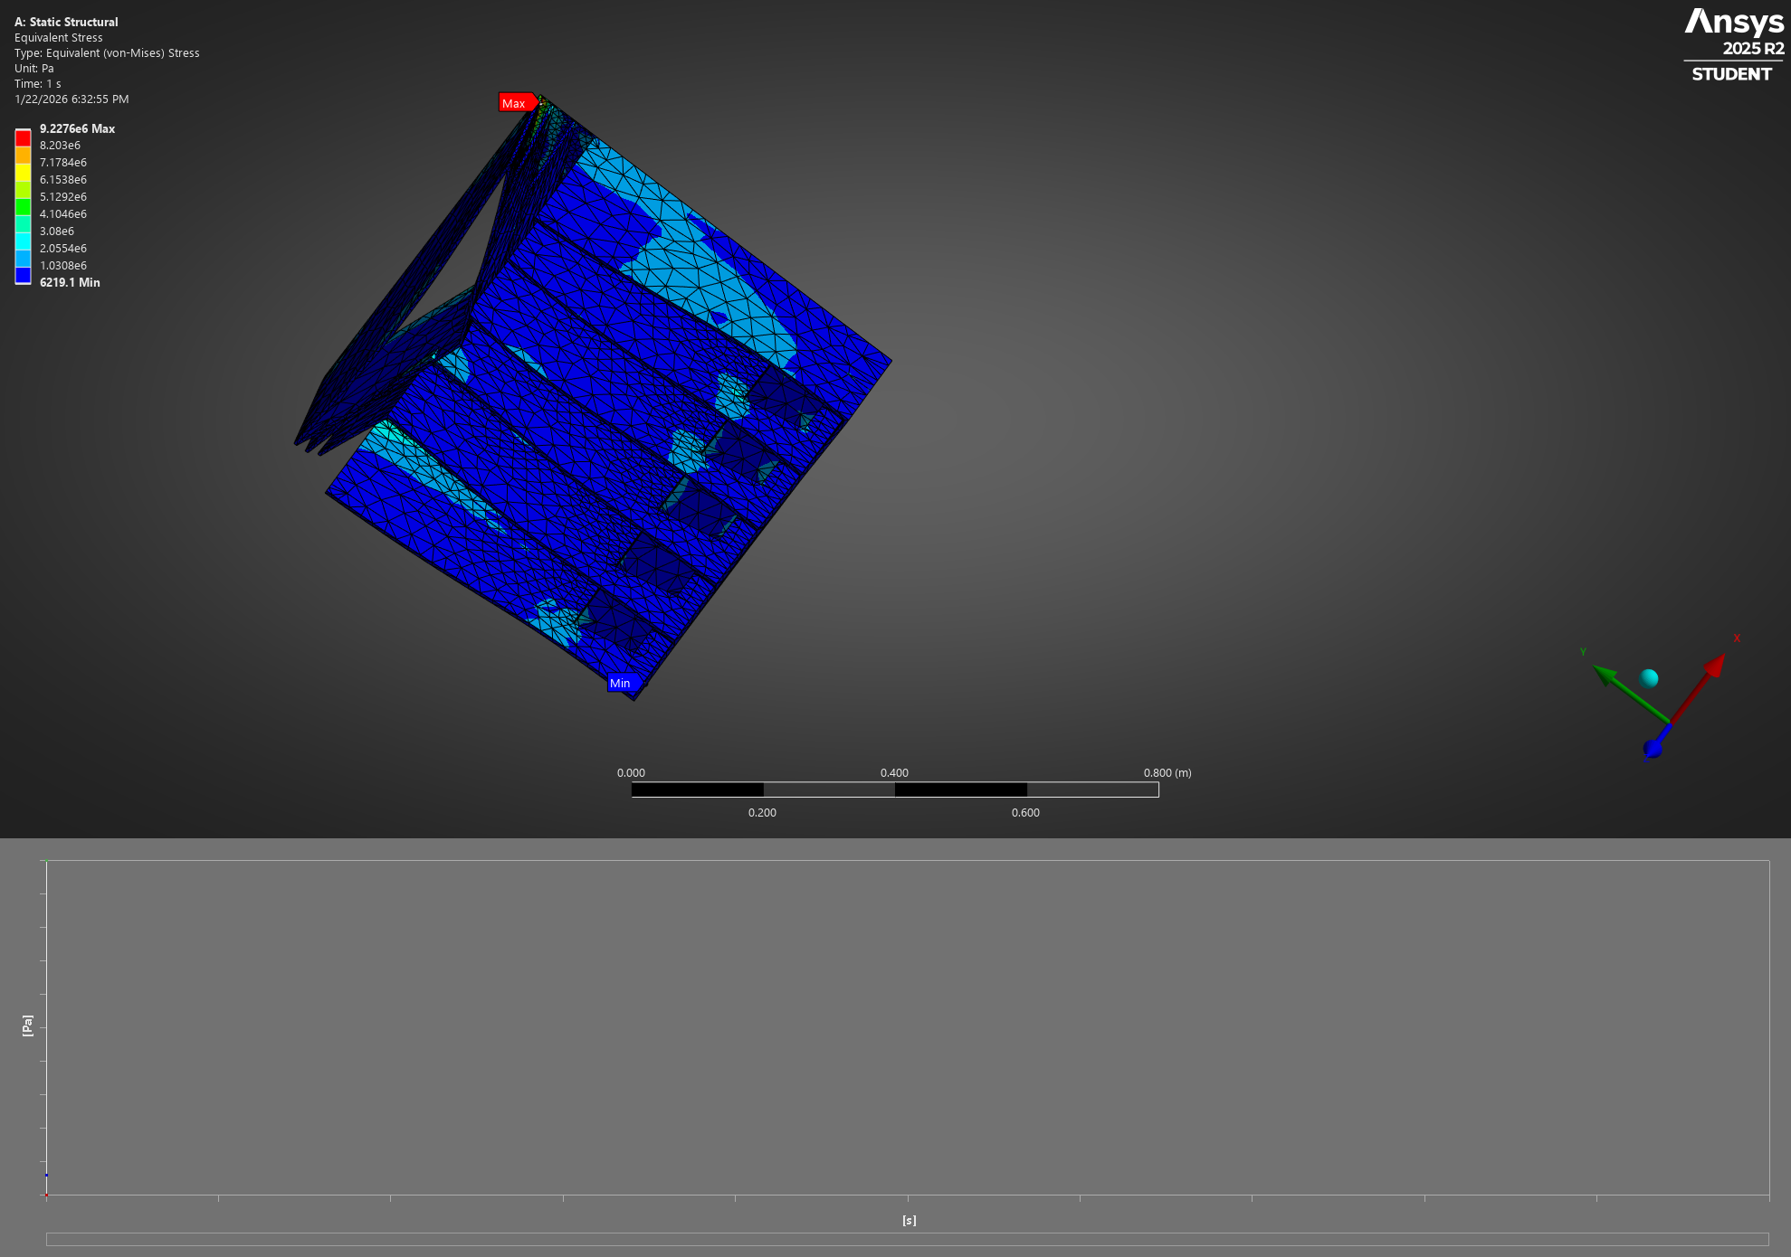Figure 9: Equivalent stress

A) Geometry
The initial geometry (with two pipes on each side) presented computational complexity and caused convergence issues during simulation. Therefore, the geometry was simplified to a single-chamber container design to facilitate robust FEA analysis while maintaining representative loading conditions.
B) Loading and Boundary Conditions
Applied Load:
- A uniform pressure of 1000 Pascal (Pa) is applied to the bottom surface of the container.
Fixed Supports:
To simulate real-world constraints, fixed supports (zero displacement boundary conditions) are applied to four line:
A total acceleration is add based on the rule requirements, for 40g in longitudinal and lateral direction and 20g in vertical direction. I sum up all the vector to have the resulatnte vector acceleration egal to 20 z+40x+40y

C) Meshing Strategy and Technical Constraints

Final Mesh (Bottom Surface Sizing = 0.01 m)
- Number of nodes: Within license limits
- Number of elements: Within license limits
- Status: Successful execution
- Animation saved:
This mesh sizing represents a compromise between solution accuracy and computational constraints, while remaining within the software license restrictions.

D) Total deformation

The total deformation plot shows the magnitude of displacement across the container structure under 1000 Pa pressure loading. Maximum deformation occurs at regions of lowest constraint stiffness.

