Islamic University of Gaza
Electrical and Computer Engineering Department

ENGE 4471 Control Systems

Final Exam
January 14 2002

Name: 1100-1:00
ID# Dr.Basil Hamed

1. a) 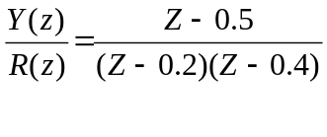 , r(k) is unit step. Determine y(k) for all k ≥ 0,
Assume all initial conditions=0

- For the difference equation ;
y(k+2) + 0.3 y(k+1) + y(k) = r(k+1) + 0.2 r(k) + 0.1 r(k-1) Find Y(z)/R(z).

- In the design of a digital controller (computer) the following input and output sequences were found

D(z)
{e₁(k)} = {1, 0.5, 0,0,0,…………..0}
{e₂(k)} = {2, 3, 2, 2, 2,…………..2} Find the difference equations that would be used by the computer.

2.
A/D
Computer
D/A
P(s)
H(s)
H(s)=1, m(k)=e(k) 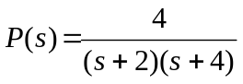

- Using the parallel method determine the state model ( continuous time)

- The open loop discrete state model can be written as
X[(k+1)T] = A₀ (T) X(kT) + B₀ (T) e(kT)

Y(kT) = C₀ X(kT) + D₀ (kT)

Find A₀ ,B₀ ,C₀ , D₀

c) The closed loop discrete state model can be written as

X[(k+1)T] = A_{c} (T) X(kT) + B_{c} (T) r(kT)

Y(kT) = C_{c} X(kT) + D_{c} (kT)

Find A_{c} ,B_{c} ,C_{c} , D_{c}

- For the system in Figure below with 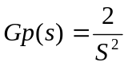 answer the following question
Design a controller (D(s)) such that the dominant closed loop poles have ζ≥ 0.5,
σ≥ 1 and e_{SS}(ramp) =0.

D(s)
Gp(s)

4. Consider 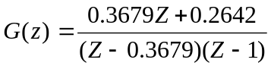

Determine the range of gain K for stability by use of the Jury Stability Test.

K
G(z)

