Islamic University of Gaza
Electrical and Computer Engineering Department

ENGE 4471 Control Systems

Final Exam
January, 7, 2003

Name: 12:00 - 2:30
OPEN BOOK EXAM Dr.Basil Hamed

Answer all the following questions.
1. a) Obtain the inverse z transform of (8 pt.)
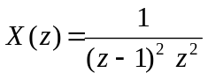
- Obtain the z transform of the curve x(t) shown in the below Fig. Assume that the sampling period is 1 sec. (7 pt.)

- Given 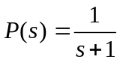; T=0.5, m(0)=1, m(0.5) = 2, m(1) = 3, y(0)=0. (15 pt.)
.find i.) y(t) 0≤ t ≤ 1.5 sec. plot results
ii) y(0.5); y(1); y(1.5) ( this is y(kT) for k=1,2,3 )

P(s)

ZOH
m(t)

- a) Obtain the closed-loop pulse transfer function C (z)/R (z). Also, obtain the
expression for C(s) for the shown Fig . (12 pt.)

  - Find C(z)/R(z) if
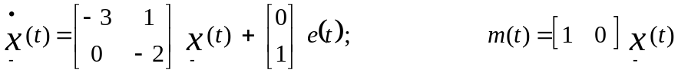

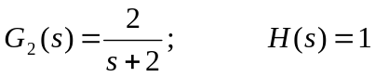 T=0.1 Sec (10 pt.)
c) Find the system type, and the steady-state response for a unit- step input. (8 pt.)

- For the closed-loop system of the following figure, the transfer function of the plant is given by
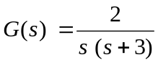
If the closed-loop system is required to satisfy the following design specifications,
% over Shoot ≤ 4.3214
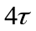 ≤ 2. sec.
Steady- state error for a unit ramp ≤ 0.5
D(s)
G(s)

- Which controllers can be used to solve the problem (P, PD, LEAD, LAG) (10 pt.)

- By emulation design, if possible, two different type digital controllers to satisfy the design specifications. (20 pt.)

4. A digital control system is described by the state equation (10 pt.)

x (k+1) = (0.368 – 0.632 K) x (k) + K r (k)

where r (k) is the input, and x (k) is the state variable. Determine the values
of K for the system to be stable.

