**VIRTUAL TOUR STOPS**

**THE ANNEX: PHOTO SLIDESHOW**

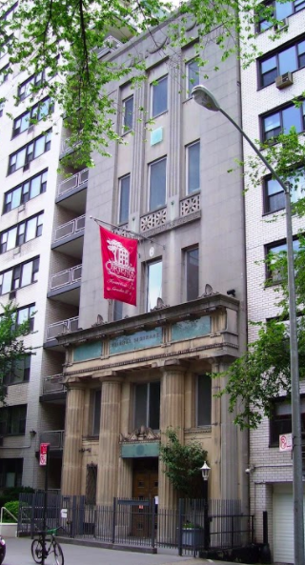

**Photo: Annex 01. Please note we do not have a horizontal photo.**

The Annex is located directly across 15th Street from our historically landmarked Meetinghouse. A dedicated Upper School space, the Annex houses math classrooms and science labs as well as the MacRae Blackbox Theater.

**PHOTO: Annex02 & Annex03**

Traveling through the hallways, you will hear enthusiastic “aha” moments as students work out connections and cause and effect experiments in the chemistry, biology and physics labs—affectionately called the “Cave”.

**PHOTO: Annex 04, 05, 06 07, 08, 09. Repeat below caption for these photos.**

In support of our performing arts program, the Blackbox Theater provides flexible space for smaller productions, including experimental theater and musical performances. For larger musical theater and drama productions and concerts, students may perform in a professional off-campus theater nearby. A few of our most recent productions have included: *Spring Awakening*, *Little Shop of Horrors, Metamorphoses*, *The Skin of our Teeth*, and Friends Seminary’s annual student-written, produced, and performed One Act Play Festival*.*