**Table of Contents**

1. Logo 2
2. Web App Details 2
3. List of Pages 3
4. Version History 4
5. Color and Typography 5
6. Application Wireframes 5
7. Application Screenshots 8



**Description of the Web App:**

1. The Main Game Tracking Page will allow a registered user who is logged in to enter the statistics and data related to 4 games or contests held between two teams during any calendar week.
2. Game statistics and data will be displayed within various HTML elements and ASP.NET server controls contained in the page. All Controls will be appropriately styled and positioned to enhance the overall user experience.
3. During each calendar week, each Game may be assigned a name, a short description, total points scored by both teams combined, the number of spectators and a designated winning team.
4. During each calendar week, each Team will include a name, a short description, total points scored for a weekly game, total points allowed (lost) for a weekly game.
5. After all data is entered for each game and team for each Calendar week, a registered user who is logged in can use a submit button to submit the weekly game and team statistics to be recorded on the database server.
6. Anonymous users are allowed to view any calendar week including Game and Team statistics but will prevented from making any changes unless they are logged in.

**Pages:**

**Home**

The Home Page contains a list of all tracked game data. The data is visible to the general public, but only registered user can update the data.

**Login**

This page is where you log in to the Game tracker website in order to create or update tracking data.

**Register**

This page is where you register yourself as a new user to user all the functionalities of the website. Details including First name, Last name, email id and a password are required to register.

**Edit User Details**

A user can update their personal information on this page.

**Add Game Page**

On this page, you can create new matches. You can enter the two teams, the scores, the game type, stadium the match was held at, the date of the match and also the number of spectators present during the match.

**Edit Game Details and Statistics Page**

On this page, you can edit the details of existing match tracking data.

**Version History**

Link to GitHub Repository:

<Screenshot of Commit history goes here>

**Color and Typography**

<Fonts, colors and color codes used in the website goes here>

**Wireframes**

Main Page:

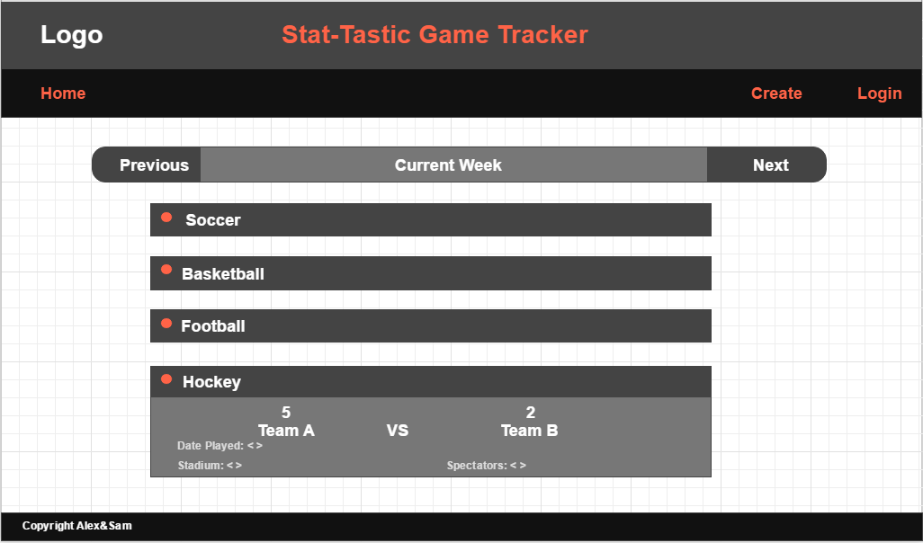

Login Page:

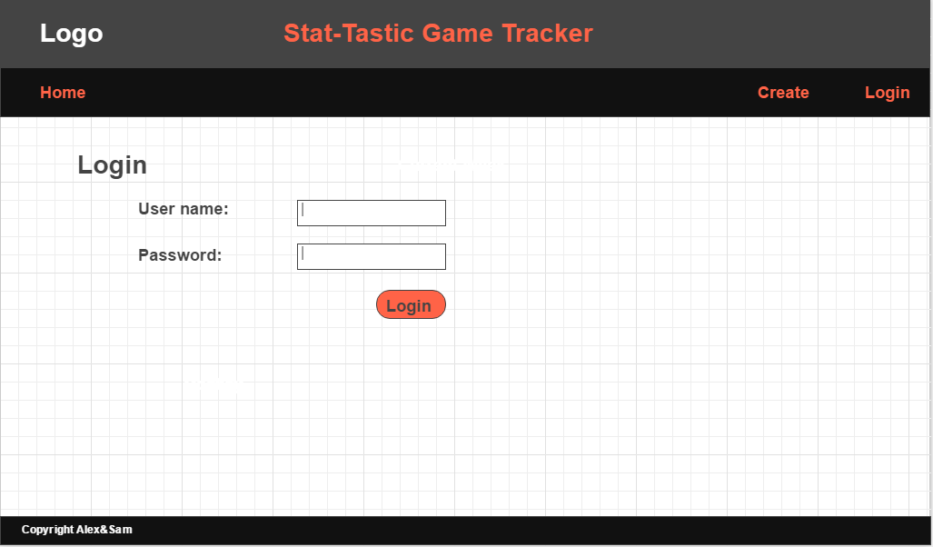

Register Page:

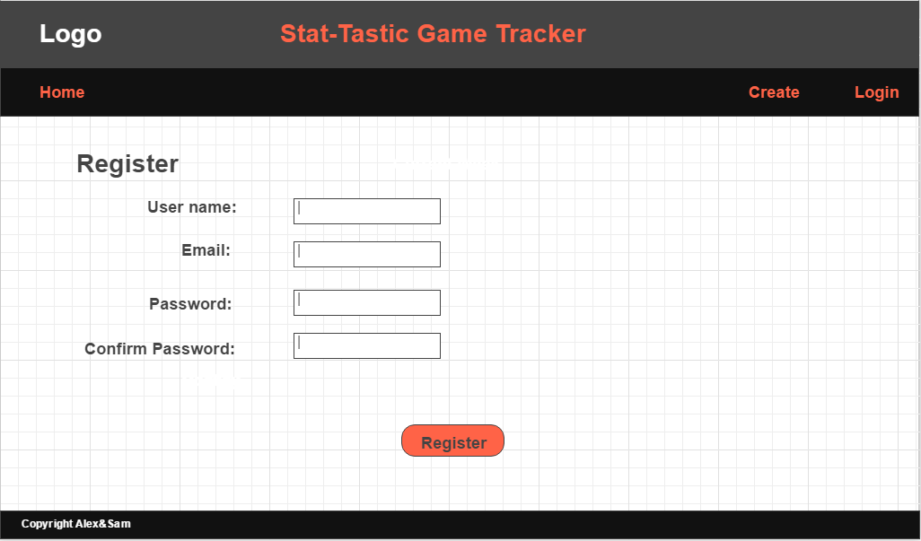

Create Match Page:

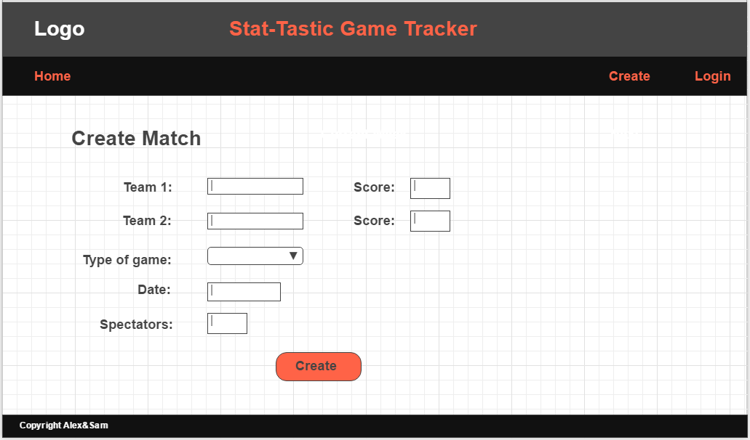

Edit match stats page:

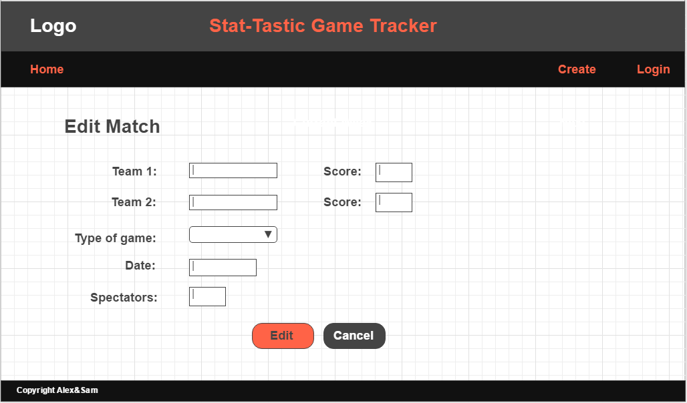

**Screen Shots**

<Website screenshots goes here>