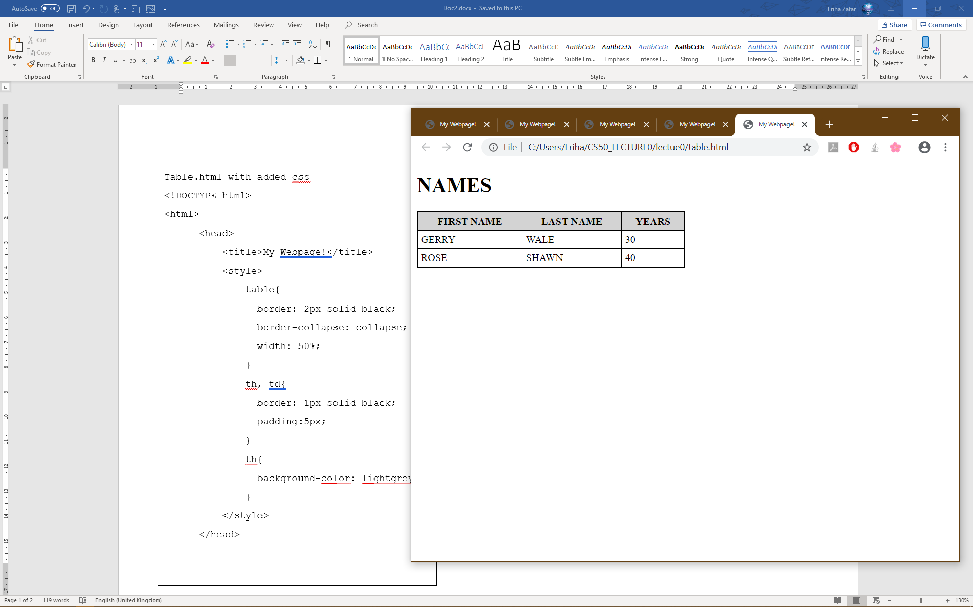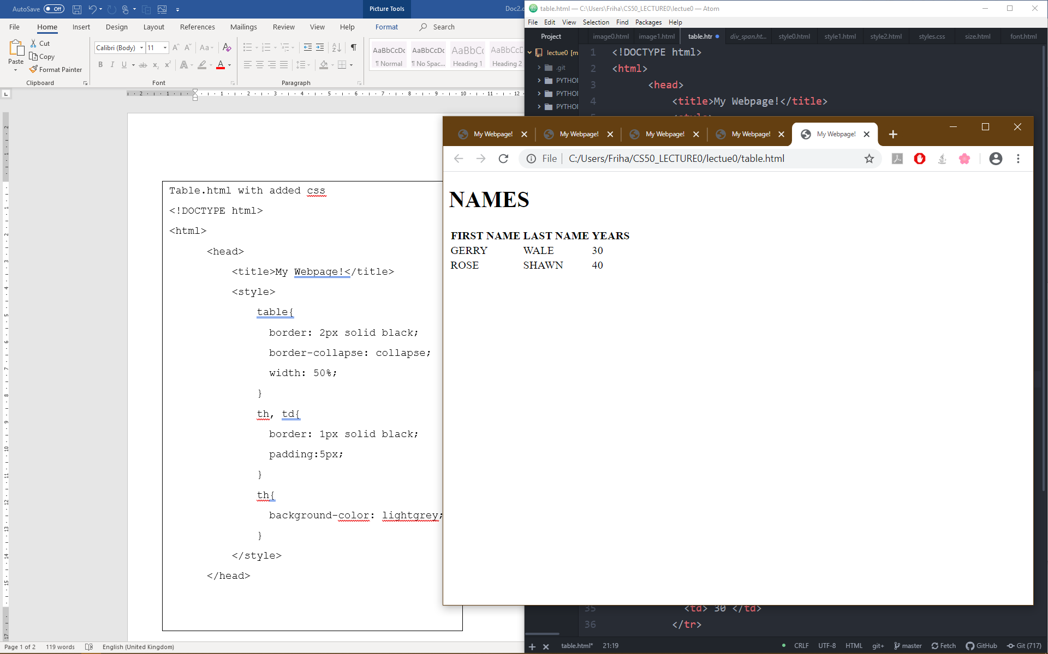

**Table.html with added css**

<!DOCTYPE html>

<html>

<head>

<title>My Webpage!</title>

<style>

table{

border: 2px solid black;

border-collapse: collapse;

width: 50%;

}

th, td{

border: 1px solid black;

padding:5px;

}

th{

background-color: lightgrey;

}

</style>

</head>

STYLE2.HTML

<!DOCTYPE html>

<html>

<head>

<title>My Webpage!</title>

<link rel="stylesheet" href= "styles.css">

</head>

<body>

<h1> Welcome to my page! </h1>

<p> Hello world! This is a paragraph. </p>

<p> another paragraph</p>

</body>

</html>

styles.css

h1{

color : blue;

text-align : center;

font: arial;

}

p{

color: black;

text-align: left;

font: arial;

}

STYLE1.HTML

<!DOCTYPE html>

<html>

<head>

<title>My Webpage!</title>

<style>

h1{

color: blue;

text-align: center;

}

p{

color: red;

text-align:left;

}

</style>

</head>

<body>

<h1>WELCOME TO MY WEBPAGE!</h1>

<p>A paragraph</p>

<p> another paragrpah!</p>

</body>

</html>

**div_span.html**

<!DOCTYPE html>

<html>

<head>

<title>My Webpage!</title>

<style>

#top{

font-size: 36px;

}

#middle{

font-size: 24px;

}

#bottom{

font-size: 12px;

}

.name{

font-weight: bold;

}

</style>

</head>

<body>

<div id="top">

This is the <span class="name">top</span> of my webpage.

</div>

<div id="middle">

This is the <span class="name">middle</span> of my webpage.

</div>

<div id="bottom">

This is the <span class="name">bottom</span> of my webpage.

</div>

</body>

</html>