Risk log
<Name of product>
for
<name of customer>

Document properties

Background
This document it the Risk Log as defined in PRINCE 2. It is intended to identify, analyze and manage risks tangible to the project.

Revision history
Below is the history of the document. The columns show the document version, the version date, a short description of the corresponding version, along with the name of the responsible person.
Table 1: Document history
Revision | Date | Description | Responsible
draft | 2008-11-17 | Initial draft | KS
2008-11-20 | 2008-11-20 | Added Risk actions | KS
2009-02-16 | 2009-02-16 | License | KS

Approvals
<The person signing this document should either be the representative for the Board, or in the case of the project being an external project, the Customer.>
This document requires the following approvals. Signed approval forms are filed in the project files.
Table 2: Approvals.
Name | Title | Signature | Date of issue | Version

Risk data
<The Risk Log is examined before starting the project, before commencing a new stage, as part of the analysis of any major change and before confirming project closure. Every time the Log is reviewed one should check for and add new risks, at the very least at each end stage assessment. The Project Board is responsible for checking external events for external risks. The actual Risk Log should be located on a medium that is readily accessible, available and easy to update.>

Identifier
<A unique identifier to group and sort risks.>

Author
<Who found and submitted the risk.>

Date
<When the risk was identified. When it was reported. When it was last updated.>

Owner
<Assign a Risk Owner who will follow the risk.>

Description
<Describe the risk as thoroughly as needed.>

Category
<Service Design should design categories.>

Impact
<Service Design should design a predefined Impact Model. Example:
- Minimal impact
- Minor impact
- Moderate impact
- Major impact
- Critical impact
- Extraordinary impact. (God help us all.)>

Probability
<Service Design should design a predefined probability model. Example:
- Not likely
- Small chance
- Medium chance
- Probable
- Very probable
- Almost certain>

Risk profile and analysis
<The risk is placed in the matrix by multiplying Impact and Probability. An acceptable risk tolerance must be set. Example: Tolerance = 10. The matrix looks like this:
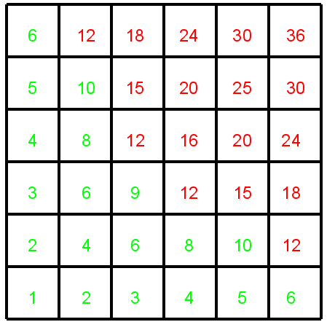Illustration 1: Risk Matrix

If the risk factor number is red actions must be taken in order to reduce the risk to an acceptable level.>

Proximity
<The closeness in time in which the risk is likely to occur.>

Risk response
<Actions that have been or will be taken to counter this risk. Actions can be Prevention, Reduction, Transference, Contingency, Acceptance>

Current status
<Examples: Closed, reducing, increasing, no change, pending.>

