# DECLARATION

I ELOUNDOU AMOUGOU YVES NARCISSE BRIAN declares that this piece of work titled **“DESIGN AND IMPLEMENTATION OF A RECEIPT GENERATION SYSTEM”** was written by my own initiative. All what have been copied from others work has been referenced.

SIGNATURE: __________________________________________

DATE: _______________________________________________

# CERTIFICATION

This is to certify that this piece of work entitled **“DESIGN AND IMPLEMENTATION OF A RECEIPT GENERATION SYSTEM”** is an original work written by ELOUNDOU AMOUGOU YVES NARCISSE BRIAN. All borrowed ideas have been acknowledged by means of references.

SUPERVISOR: Mr. NGWAFOR KELLY JUNIOR

SIGNATURE: __________________________________________

DATE: ________________________________________________

# DEDICATION

To the ELOUNDOU’s FAMILY.

# ACKNOWLEDGEMENTS

All my gratitude goes to my academic supervisor **MR NGWAFOR KELLY JUNIOR** for his support, guidance, time and energy in order to make this project a success.

I’m grateful to my field supervisor Eng Inkoo Blandine which helped and guided me during my internship program.

Thanks to my mum Eyenga Solange Scholastique for the support both morally and financially.

I am grateful to the founders and board of directors that have founded CITEC which has provided me with a conducive atmosphere to study.

Thanks to my classmates and friends with whom I have been sharing ideas with on different possible solutions.

# ABSTRACT

A receipt generating system is a software application designed to automate the process of creating and issuing receipts for various transactions. It serves as a crucial component in businesses, retail stores, e-commerce platforms, and other organizations where generating accurate and professional receipts is essential for record-keeping, financial management, and customer satisfaction. The primary objective of a receipt generating system is to streamline the receipt generation process, minimize errors, and provide an efficient and reliable means of producing receipts. A typical receipt generating system consists of several key functionalities. Firstly, it allows users to input transaction details such as the date, time, customer information, purchased items, quantities, and prices. The system then processes this information and generates a formatted receipt document, usually in a printable or electronic format. The receipt design may include the organization's logo, contact information, subtotals, taxes, discounts, and the total amount payable. By employing a receipt generating system, businesses can experience numerous benefits. It enables efficient record-keeping, simplifies accounting processes, and provides a professional and standardized approach to issuing receipts. To conclude, a receipt generating system plays a vital role in automating the receipt generation process, enabling businesses to efficiently manage transactions, maintain accurate records. To streamline this essential aspect of operations, organizations can improve efficiency, accuracy, and professionalism in their financial transactions.

# RESUME

Un système de génération de reçus est une application logicielle conçue pour automatiser le processus de création et d'émission de reçus pour diverses transactions. Il s'agit d'un élément essentiel pour les entreprises, les magasins de détail, les plateformes de commerce électronique et d'autres organisations où la création de reçus précis et professionnels est essentielle pour la tenue des dossiers, la gestion financière et la satisfaction des clients. L'objectif premier d'un système de génération de reçus est de rationaliser le processus de génération de reçus, de minimiser les erreurs et de fournir un moyen efficace et fiable de produire des reçus. Un système de génération de reçus typique se compose de plusieurs fonctionnalités clés. Tout d'abord, il permet aux utilisateurs de saisir les détails de la transaction, tels que la date, l'heure, les informations sur le client, les articles achetés, les quantités et les prix. Le système traite ensuite ces informations et génère un document de reçu formaté, généralement dans un format imprimable ou électronique. La conception du reçu peut inclure le logo de l'organisation, les informations de contact, les sous-totaux, les taxes, les remises et le montant total à payer. L'utilisation d'un système de génération de reçus présente de nombreux avantages pour les entreprises. Il permet une tenue efficace des registres, simplifie les processus comptables et offre une approche professionnelle et normalisée de l'émission des reçus. En conclusion, un système de génération de reçus joue un rôle essentiel dans l'automatisation du processus de génération de reçus, permettant aux entreprises de gérer efficacement les transactions et de tenir des registres précis. En rationalisant cet aspect essentiel des opérations, les organisations peuvent améliorer l'efficacité, la précision et le professionnalisme de leurs transactions financières.

Table of Contents

DECLARATION i

CERTIFICATION ii

DEDICATION iii

ACKNOWLEDGEMENTS iv

ABSTRACT v

RESUME vi

LIST OF ABBREVIATIONS xii

CHAPTER 1 1

1.1 BACKGROUND TO THE STUDY 1

1.1.1 Historical Background 1

1.1.1.1 Historical Background of Internship Place 1

1.1.1.2 Historical Background of the Study 2

1.1.2 Conceptual Background 3

1.1.3 Theoretical Background 4

1.1.4 Contextual Background 4

1.2 STATEMENT OF THE PROBLEM 5

1.3 OBJECTIVE OF THE STUDY 6

1.3.1 Main Objective 6

1.3.2 Specific Objective 7

1.4 RESEARCH QUESTIONS 7

1.4.1 General Question 7

1.4.2 Specific Questions 7

1.5 RESEARCH HYPOTHESIS 7

1.5.1 Specific hypothesis 7

1.6 SIGNIFICANCE OF THE STUDY 8

1.7 JUSTIFICATION OF THE STUDY 8

1.8 SCOPE OF THE STUDY 9

1.8.1 Thematic Scope 9

1.8.2 Geographical Scope 9

1.8.3 Time scope 9

1.9 ORGANISATION OF STUDY 9

Chapter 2 10

2.1 THEORETICAL REVIEW 11

2.2 CONCEPTUAL REVIEW 11

2.3 EMPERICAL REVIEW 12

2.4 PRESENTATION OF THE ENTERPRISE 13

2.4.1 Presentation of the Internship 13

2.4.2 Activities carried out 13

2.4.3 Internship experience 16

2.4.4 Strength and weaknesses 16

2.4.4.1 Strength 16

2.4.4.2 Weakness 16

2.4.5 Problem encountered 16

2.4.6 Recommendations 17

CHAPTER 3 18

3.1 INTRODUCTION 18

3.2 DESCRIPTION OF THE ARCHITECTURE OF THE SYSTEM. 18

3.3 DATA COLLECTION METHOD AND USERS NEED 19

3.3.1 Observation 19

3.3.2 Users needs 20

3.4 FUNCTIONAL REQUIREMENT 20

3.5 FUNCTIONAL SPECIFICATION 20

3.5.1 Role played by each actor 20

3.5.2 The System's Abilities 21

3.6 TECHNICAL SPECIFICATIONS 21

3.7 NON-TECHNICAL SPECIFICATION 22

3.8 RESEARCH DESIGN 22

3.9 ANALYSIS METHODS 23

3.10 OBJECT- ORIENTED MODELING 23

3.10.1 Object Modelling Technique (OMT) Method 23

3.10.2 Unified Modelling Language (UML) Method 24

Figure 2: Overview of UML (static3.creately.com, 2016) 24

3.10.3 Unified Process (UP) Method 25

3.11 FUNCTIONAL METHODS 26

3.11.1 SADT Method 26

3.11.2 MERISE Method 27

3.12 CHOICE OF METHOD 29

3.13 APPLICATION OF METHOD 29

3.13.1 Actors 29

3.13.2 Diagrams 30

3.14 VARIOUS MODEL OF THE METHOD 31

3.14.1 Rules to move from one data model to another 31

3.15 SOFTWARE USED 32

3.15.1 Windows 10 Home 32

3.15.2 Design Environment (Win’ design) 32

3.15.3 Visual Studio Code (Text editor used) 32

3.15.4 XAMPP control panel 32

3.15.5 PHPMYADMIN 33

3.15.6 E-Draw Max 33

3.15.7 YouTube 33

3.15.8 Google Chrome 33

3.16 PROGRAMMING LANGUAGES USED 33

3.16.1 HTML5 33

3.16.2 CSS 33

3.16.3 JAVASCRIPT 33

3.16.4 PHP 8.2.4 34

3.17 HARDWARE USED 34

3.18 MODULES OF THE DESIGNED SYSTEM 34

CHAPTER 4 35

4.1 INTRODUCTION 35

4.2 RESULTS 35

4.3 PRESENTATION OF SCENARIOS 35

4.3.1 GENERAL HOME PAGE 35

4.3.2 ACTIVITIES (DASHBOARD) 36

4.3.3 SCENARIO 1: CREATING A NEW INVOICE OR RECEIPT 37

4.3.3 SCENARIO 2: ADDING NEW PRODUCTS TO STOCK 38

CHAPTER 5 39

5.1 SUMMARY OF FINDINGS 39

5.2 DIFFICULTIES ENCOUNTERED 39

5.3 CONCLUSION 39

5.4 RECOMMENDATIONS 40

REFERENCES a

APPENDIX b

**Table of Figures**

Figure 1 19

Figure 2 24

Figure 3 30

Figure 4 31

Figure 5 36

Figure 6 36

Figure 7 37

Figure 8 38

# LIST OF ABBREVIATIONS

CSS Cascading Stylesheet

HTTP Hyper-Text Transfer Protocol

PHP Hyper-Text Pre-processor

SQL Structured Query Language

WWW World wide web

UML Unified Modelling Language

ETSNTECH Enterprise Network Creation

XAMPP Apache, MySQL, PHP and Prel

SADT Structure Analysis and Design

IT Information Technology

CCNA CISCO Certified Network Associate

PDU Protocol Data Unit

PC Personal Computer

ARP Address Resolution protocol

# CHAPTER 1

**INTRODUCTION AND PRESENTATION OF ENTREPRISE**

In these chapter, the intern would provide the background of study, the statement of problem, the objectives of the study, research questions, significant of the study, justification of study, research hypothesis, and definition of terms and the scope of study. Receipt generating systems have evolved alongside the growth of commerce and the need for accurate documentation of transactions. While the concept of receipts dates back centuries, the development of automated receipt generating systems emerged with advancements in technology and the rise of computerized systems. A receipt generating system is a software application designed to automate the process of creating and issuing receipts for various transactions. It is an essential tool for businesses, retail stores, e-commerce platforms, and other organizations that need to generate accurate and professional receipts for their customers.

# 1.1 BACKGROUND TO THE STUDY

The background of study will involve the historical background, theoretical background, the contextual background and the conceptual background

## 1.1.1 Historical Background

This deals with the historical background of the internship place and the historical background of the study.

## 1.1.1.1 Historical Background of Internship Place

ETS.NTECH is an IT service startup company which specializes in IT Networking, Deployment of Technologies and Web development.

They offer services like search engine optimization, building of websites, building of applications (web and native apps), social media marketing and branding.

ETS.NTECH is located at Biscuiterie – Obili, Yaoundé, Cameroon.

The company was founded in 2017 by **Mr. SUH HEBERT** (CCNA Certified Professional).

The company’s aim is to bring out the practical realities of information technology.

## 1.1.1.2 Historical Background of The Study

In the 14th century, Johannes Gutenberg invented the printing press in Germany which led to the manufacturing of receipt books. Banks began using these books as proof of gold trade. In the 1890’s, the National Cash Register Company (NCR) invented the modern cash register which could print receipts by hand-crank. These machines were initially used to calculate change and tally sales, but quickly adapted to generate receipts. By World War I, these machines were very common and in the 1980s and 1990s, the NCR Corporation advanced thermal paper technology. In 2005, Apple was one of the first companies to adopt electronic receipts (E-receipts).

The historical background of receipt generation is closely tied to the evolution of commerce, trade, and record-keeping practices. Receipts have been used for centuries to document transactions and provide proof of purchase, while the concept of receipts has been present in various forms throughout history, the development of dedicated systems for generating and managing receipts has been influenced by technological advancements and changing business needs.

In ancient civilizations, basic forms of receipts existed in the form of clay tablets or papyrus scrolls that recorded transactions. These were rudimentary records of exchanges, often involving goods or commodities. Early marketplaces and trade centers used simple acknowledgment systems to keep track of transactions, providing evidence of a completed exchange.

With the growth of trade during the medieval period, handwritten receipts became more common. Merchants would issue handwritten notes as proof of a transaction, detailing the items exchanged and the agreed-upon terms. These handwritten receipts served as legal documents and were important for resolving disputes and confirming transactions.

The emergence of banking institutions brought about a more formalized system for documenting financial transactions. Banks began issuing deposit slips and withdrawal receipts to account holders. The banking sector played a crucial role in standardizing receipt formats and introducing more systematic record-keeping practices.

Advancements in technology, particularly in the mid to late 20th century led to the development of electronic point-of-sale (POS) systems. These systems automated the generation of receipts at the time of purchase.

Today, receipt generating systems are integral to various industries, from retail to online transactions. Advanced POS systems and e-commerce platforms seamlessly generate electronic receipts. Mobile payment systems and digital wallets have further transformed the receipt landscape, providing users with instant electronic records of their transactions.

## 1.1.2 Conceptual Background

The conceptual background of a receipt generating system involves understanding the fundamental principles, objectives, and components that contribute to the design and functionality of such a system. Here are key concepts that form the conceptual foundation:

**Purpose and Objectives**:

Documentation of Transactions: The primary purpose of a receipt generating system is to document and provide evidence of completed transactions. It serves as a record of the exchange of goods, services, or money between parties.

Legal and Financial Compliance: Receipts often have legal significance as proof of purchase or payment. They contribute to financial compliance by providing a transparent and traceable record for both parties involved.

**Components of a Receipt**:

Transaction Details: A receipt includes essential transaction details, such as the date, time, and location of the transaction. It also specifies the items or services purchased, their quantities, prices, and any applicable taxes.

Identification Information: The system captures identification information, including the names of the buyer and seller, and may include unique transaction identifiers or invoice numbers.

Payment Information: Receipts provide details about the payment method used, including cash, credit card.

## 1.1.3 Theoretical Background

A receipt generating system is a system that produces a digital or physical record of a transaction, such as a purchase or a payment. The theoretical background of a receipt generating system involves concepts from **transaction data processing**, **document generation**, and **customer identification**.

Transaction data processing is the process of capturing, validating, storing, and analysing data related to business transactions, such as sales, orders, invoices, payments, etc.

Document generation is the process of creating documents, such as receipts, invoices, contracts, reports, etc., from data sources, such as databases, APIs, user inputs, etc.

Customer identification is the process of verifying the identity of a customer who is involved in a transaction, such as a purchase or a payment. Customer identification can be done by various methods, such as asking for personal information, scanning a barcode, sending a verification code, etc.

A receipt generating system can use these concepts to create receipts that are accurate, reliable, and convenient for both the business and the customer. For example, a receipt generating system can use transaction data processing to capture and validate the data of a purchase, such as the items, prices, taxes, discounts. Then it can use document generation to create a receipt that follows a predefined template and format, such as a PDF. Finally, it can use customer identification to send the receipt to the customer’s email or print it out on paper.

## 1.1.4 Contextual Background

**Point of Sale (POS) System Integration**: In many cases, a receipt generating system is integrated with a point-of-sale system. The POS system handles the transaction processing, including capturing item details, calculating totals, applying discounts, and handling payment. The receipt generating system then receives the transaction data from the POS system and generates a receipt based on that information.

**Customization and Branding**: Businesses often require the ability to customize the appearance and layout of receipts to align with their branding and legal requirements. The receipt generating system should allow for customization of elements such as the company logo, business information, terms and conditions, and any specific details required by local regulations.

**Transaction Date**: The receipt generating system typically receives transaction data from the POS system, including details such as the date and time of the transaction, items purchased, quantities, prices, taxes, and any additional charges. This data is used to populate the receipt with accurate and relevant information.

**Receipt Format**: Depending on the business requirements, a receipt generating system may support different receipt formats. For example, it may generate printed receipts for in-person transactions, as well as electronic receipts for online or email transactions. The system may also support different languages or currency formats based on the business's geographical location or customer base.

**Storage and Retrieval**: Receipts often need to be stored for record-keeping purposes, customer support, or potential returns or exchanges. The receipt generating system should provide mechanisms for storing and retrieving receipts, whether it's in a local database, cloud storage, or integration with external document management systems.

**Compliance and Regulations**: In some industries, there are specific regulations and compliance requirements for generating and storing receipts. For example, tax regulations may dictate the information that must be included on a receipt, such as tax identification numbers or itemized details. The receipt generating system should adhere to these regulations and provide the necessary features to meet compliance requirements.

# 1.2 STATEMENT OF THE PROBLEM

In contemporary business operations, the manual and traditional methods of generating receipts pose significant challenges that hinder efficiency, accuracy, and customer satisfaction. These challenges necessitate the development of a robust Receipt Generating System to address the following issues:

* Inefficiency in Manual Processes: Traditional receipt generation involves manual entry of transaction details, leading to inefficiencies, errors and by then causes increased workload, higher likelihood of data entry mistakes, and slower customer service.
* Limited Record-Keeping and Retrieval: Manual record-keeping systems often lack organization and struggle to handle the growing volume of transactions. Retrieving specific receipts becomes a time-consuming task.
* Security: Manual systems are susceptible to security breaches or loss of receipts, raising concerns about data integrity and customer information protection.

From these challenges, the development and implementation of a Receipt Generating System aim to streamline transaction processes, enhance data accuracy and improve customer service. The proposed system will leverage technology to overcome these challenges and establish a more efficient, secure, and standardized approach to receipt generation and management.

# 1.3 OBJECTIVE OF THE STUDY

The objective of the study for a receipt generating system is to:

* Automates the process of creating receipts, reducing manual effort.
* Develop a system with robust record-keeping features, enabling easy retrieval of specific receipts for quick reference, customer inquiries, and dispute resolution.
* Improve the overall customer experience by reducing wait times, enhancing transaction speed, and providing easily accessible electronic receipts.

## 1.3.1 Main Objective

The main objectives of this study are;

* To design a user-friendly interface for the receipt generating system.
* To integrate an inventory function to the system.
* To integrate an emailing function to the system.
* To minimize errors and provide an efficient means of producing receipts.

## 1.3.2 Specific Objective

The specific objectives of this study are;

* To integrate an emailing function to the system.
* To minimize errors and provide an efficient and reliable means of producing receipts.

# 1.4 RESEARCH QUESTIONS

The research questions are both general and specific.

## 1.4.1 General Question

As regards the main research question, we are aimed at examining the extent to which the system can permit the system administrator to properly control the management and creation of receipts in the system.

## 1.4.2 Specific Questions

1. Can the receipt generating system accommodate discounts and promotions, such as percentage-based or fixed amount discounts?
2. Can the receipt generating system automatically send electronic receipts via email to customers upon request or as a standard practice?
3. How does the system handle receipt reprinting or retrieval for customers who may have lost their original receipt?

# 1.5 RESEARCH HYPOTHESIS

## 1.5.1 Specific Hypothesis

One possible hypothesis for a receipt generating system could be:

* “The implementation of a digital receipt generating system will improve customer satisfaction and operational efficiency compared to traditional paper-based receipt systems”.
* This hypothesis suggests that adopting a digital receipt generating system, as opposed to relying on traditional paper-based receipts, will have positive impacts on both customer satisfaction and operational efficiency. The hypothesis assumes that the digital system will offer advantages such as ease of use, accessibility, accuracy, and enhanced data management capabilities.

# 1.6 SIGNIFICANCE OF THE STUDY

The significance of a study on a receipt generating system lies in the potential benefits it can bring to businesses, customers, and the overall operational efficiency. Here are some key points highlighting the significance of such a study:

* Improved Customer Experience: Understanding the impact and effectiveness of a receipt generating system can help businesses enhance the customer experience. By implementing a system that provides accurate, professional-looking receipts and personalized offers, businesses can increase customer satisfaction, engagement, and loyalty.
* Operational Efficiency: Investigating the efficiency of a receipt generating system can help businesses streamline their transaction processes, reduce errors, and save time. Automation and integration with other systems can improve overall operational efficiency, leading to cost savings and improved productivity.

# 1.7 JUSTIFICATION OF THE STUDY

The study on a receipt generating system is justified due to several reasons:

**Practical Relevance**: Receipts are an integral part of business transactions, and the process of generating receipts has a direct impact on both businesses and customers. Understanding the effectiveness and impact of different receipt generating systems can provide practical insights for businesses to improve their operations and enhance customer experiences.

**Customer Satisfaction**: Receipts play a crucial role in customer satisfaction and trust. By investigating the impact of a receipt generating system, the study can provide valuable insights into how businesses can improve the accuracy, accessibility, and overall quality of receipts, leading to increased customer satisfaction.

# 1.8 SCOPE OF THE STUDY

The scope of the study here involves the time scope, geographical scope and thematic scope. The scope of study refers to the boundaries and extent of a project. It defines the specific aspects, objectives, and limitations of the project, outlining what will be included and excluded from the project. The scope of study helps interns focus on a particular area of interest.

## 1.8.1 Thematic Scope

The project is titled a receipt generating system, totally built at administrative ends and thus only the administrator is given access to create, edit and delete stuffs.

## 1.8.2 Geographical Scope

This project was carried out in the political capital of Cameroon, precisely at Biscuiterie Biyem-Assi.

## 1.8.3 Time Scope

This project (the online library) took a period of 2 months. From the 09th of May to the 12th of July. However, this period wasn’t sufficient to carry out the scientific research.

# 1.9 ORGANISATION OF STUDY

* Chapter one which comprises of the general introduction, the background of study, problem of the statement, objective of the study, research questions, hypothesis, significant of the study, justification and scope of study
* Chapter two is concern with the literature review which contains the theoretical review, conceptual review and empirical review
* Chapter three looks at the research methodology which include the research design of the library system, data instrument analysis and interpretation.
* Chapter four is based on data presentation analysis and presentation.
* Chapter five is on the recommendation for future implementation and conclusion.

# Chapter 2

**LITERATURE REVIEW**

Receipt generating systems play a crucial role in business transactions, providing customers with proof of purchase and serving as a record for businesses. This literature review aims to explore the existing research and scholarly work related to receipt generating systems, focusing on topics such as technology adoption, customer satisfaction, operational efficiency, environmental sustainability, and data management.

Technology Adoption and Integration: Several studies have investigated the adoption and integration of receipt generating systems in different industries. For example, Smith et al. (2018) explored the factors influencing the adoption of digital receipt systems among small and medium-sized businesses, highlighting the importance of cost, ease of use, and compatibility with existing systems. Integration with mobile payment platforms has also been examined, with studies by Johnson et al. (2019) and Lee and Park (2020) demonstrating the benefits of integrating receipt generation with mobile payment apps, including improved transaction speed, convenience, and customer experience.

Customer Satisfaction and Engagement: Receipts can significantly impact customer satisfaction and engagement. Research by Chen et al. (2017) found that customers perceive digital receipts as more convenient and environmentally friendly compared to paper receipts, leading to increased satisfaction. Personalized offers and recommendations on receipts have also been studied. A study by Wang et al. (2019) revealed that personalized offers on receipts positively influence customer engagement and increase repeat purchases.

Operational Efficiency and Data Management: Receipt generating systems can improve operational efficiency and data management. Research by Li et al. (2018) explored the use of automated receipt systems in retail environments, highlighting their ability to reduce errors in transaction details and enhance efficiency. Cloud-based receipt systems have been investigated as well, with studies by Zhang et al. (2020) and Kim et al. (2021) demonstrating the benefits of cloud integration, including improved data accessibility, security, and seamless integration with other business systems.

# 2.1 THEORETICAL REVIEW

This part of the study reviews the conceptual frameworks, theories and models that can be applied to understand and analyse various aspects of the system. The theories of this study include:

* Technology Acceptance Model (TAM): TAM is a widely used theoretical framework for understanding users' acceptance and adoption of technology. It can be applied to investigate the factors influencing the adoption of a receipt generating system, such as perceived usefulness, ease of use, and users' attitudes towards the system.
* Service Quality Theory: This theoretical perspective focuses on customers' perceptions of service quality and how it impacts their satisfaction and loyalty. It can be used to explore how the quality of receipt generation, including accuracy, completeness, and timeliness, affects customer satisfaction and their overall perception of the service provided by a business.
* Information Processing Theory: This theory examines how individuals process and interpret information. It can be applied to understand how customers process receipt information, such as transaction details, prices, and promotions, and how this information influences their decision-making and post-purchase behaviours.
* Systems Theory: Systems theory views an organization or a process, such as a receipt generating system, as a complex system composed of interconnected parts. It can be used to analyse the interdependencies between different components of the system, such as hardware, software, data management, and customer interface, and how changes in one component affect the overall system.

# 2.2 CONCEPTUAL REVIEW

A conceptual review of a receipt generating system involves an analysis of the underlying concepts, principles, and theoretical frameworks that guide the development, implementation, and functioning of the system. This review helps establish a theoretical foundation for understanding how the receipt generating system operates within the broader context of business processes and information management. Here are key components of a conceptual review:

**Transaction Processing**: It focuses on the efficient and reliable processing of business transactions. In the context of a receipt generating system, this theory helps explain how transactions are captured, recorded, and validated to ensure accuracy and consistency in financial records.

**Record-Keeping Principles**: It emphasizes the importance of systematically documenting transactions for legal, financial, and operational purposes. A receipt generating system adheres to these principles by providing a structured and organized approach to recording transaction details.

**Automation and Efficiency**: It emphasizes the use of technology to streamline repetitive tasks and enhance efficiency. In the context of a receipt generating system, automation reduces manual efforts, minimizes errors, and accelerates the generation of receipts at the point of sale.

**Data Security and Privacy**: It guides the implementation of measures to protect sensitive information, and the focus is on understanding how the receipt generating system ensures the confidentiality, integrity, and availability of transaction data, safeguarding it from unauthorized access or manipulation.

**Customization and Adaptability**: The ability of the receipt generating system to be customized and adapted to different business needs is explored. This includes the flexibility of receipt templates.

# 2.3 EMPERICAL REVIEW

An empirical review of a receipt generating system involves an examination of real-world instances, case studies, and practical implementations of such systems. This type of review aims to explore how receipt generating systems have been deployed, used, and their impact on businesses or organizations. According to a case study, 90% of paper receipts end up in the trash can. Users feel that most of them do not last long and are difficult to store. 89% of the users would like retailers to offer a digital receipt as an option. The current process of cash receipt generation is being operated manually and due to this procedure numerous problems are been encountered. A design was taken to computerized the manual process in order to check this problem. Cash receipt generating systems can help businesses keep track of their finances and maintain a reliable record of money coming and going. Electronic receipts can be used for expense accounting, tax purposes, and real-time cash flow analysis. Digital receipts can be generated by software that can send an electronic receipt to a customer via email or another channel after a payment is processed.

# 2.4 PRESENTATION OF THE ENTERPRISE

## 2.4.1 Presentation of The Internship

This part of the study includes the description of the internship place and the internship activities.

## 2.4.2 Activities Carried Out

During the internship period, the intern did not just work on his project study or practically implemented some concepts studied in school but also, the intern studied certain aspects of programming and programming languages such as node JS, PHP and C++ practical not yet studied in school. Here are the activities which were done during the internship program:

|  |  |
| --- | --- |
| **Weeks** | **Activities carried out** |
| Week 1 | * General Presentation of IT personnels and of interns * Review on different type of software maintenance and the different field replaceable units (FRU) in the CPU. * Introduction to networking, definition of basic networking devices and the OSI model. |
| Week 2 | * Introduction to Cisco routers and the different Cisco modes. * Introduction to Web development and the different languages used in front-end, back-end development and databases. * Different types of websites (Static and Dynamic websites) |
| Week 3 | * Introduction to Ip addressing, the different types of Ip addresses, subnet masks and APIPA Ip addresses. * Private and Public classes. * Subnetting and the different types of subnetting. * Working with GitHub and how to export our work on our repositories on GitHub. |
| Week 4 | * How to work with the different GitHub codes on Vs Code. * How to clone GitHub repositories. * The motherboard and the different motherboard technologies. * Extension cards and extension slots. * Subnetting using VLSM (variable length subnet mask) |
| Week 5 | * Looking at WI-FI channels. * Basic configurations in the different modes of a cisco switches. * VLANS (virtual local area networks) and how to create the different vlans on a switch. * Different types of switch ports. * Creation of Login and Sign-up pages and linking it to the database. |
| Week 6 | * Configuring basic networks and ensuring communication between each pc using packet tracer. * Inter-vlan routing. * How to create sub interfaces on a router. * How to enable communication between pc’s on different vlans in a network. |
| Week 7 | * Creating bootable drives using cmd. * How to convert a drive from MBR to GPT. * How to establish switchport security and the different violation modes on a switch. * DHCP (dynamic host configuration protocol) * Creating static websites. |
| Week 8 | * How to configure DHCP service on a router and the Ip range it should start from. * Creation of SVI’s (switch virtual interfaces). * Subnetting using FLSM (fixed length subnet mask). * Different problems and issues encountered by the BIOS and the CMOS battery. * Installing and configuring WordPress on a local server. |
| Week 9 | * Creating complex networks and configuring them to ensure communication between devices. * Static routing. * Revision and questions on subnetting. * Different wireless transmission mediums and their properties. * Different media queries used in CSS |
| Week 10 | * SSH and TELNET * How to access a router using ssh and telnet technologies. * Assigning an Ip to a particular pc on a particular switch port. * ARP tables on both layer 2 & 3 of the OSI model. * PDU used in the different layers of the OSI model. |
| Week 11 | * Assessment of Competence |

## 2.4.3 Internship Experience

My experience during my internship was good as it lasted for Two (2) months and I learned web development, networking, maintenance and how to work in a team to acquire a particular task.

## 2.4.4 Strength and Weaknesses

### 2.4.4.1 Strength

* Working at ETS NTECH as an intern enabled the researcher to master numerous skills which helped in creating this project. Since ETS NTECH is an IT startup company, the researcher was able to work closely with the lead IT specialist of the company. This enabled him to learn directly from someone with more programming experience. Here, they devoted time in ensuring that interns had a lot of practical work and exposure into the IT world.
* Some of the IT personnels speak both English and French which ease communication with clients or interns speaking any of the languages.

### 2.4.4.2 Weakness

* Unfortunately, nobody is perfect. Like all, NTECH has its little weakness. Since the company is only a startup company, there are some essential departments which are lacking. An example is the Human Resource department which handles the internal and external dynamics of the company. Since they are yet to employ a suitable person for this task, the work is left in the hands of the IT specialist which is a workload.
* Slow internet access / connectivity, because during online exercises carried out in the company, the internet connectivity becomes slow or is usually unstable from time to time and reducing effectiveness.

## 2.4.5 Problem Encountered

They were very little problems encountered during my 3 months internship period. Some of which include;

* There were days when the interns couldn’t properly or carryout research due to lack of internet or very slow internet connection, as well as electrical power failure.
* On several occasions configuring network commands as well as coding could get to a point where the result is not acquired and need troubleshooting which was time consuming and tedious.
* Also faced problems with time management and self-management.

## 2.4.6 Recommendations

* Employ a human resource personnel to handle the internal and external dynamics of the company.
* Changing their internet service provider or upgrading their monthly internet service package, and also to have a monthly maintenance of their devices to ensure maximum efficiency.

# CHAPTER 3

**METHODOLOGY**

# 3.1 INTRODUCTION

Methodology is defined as a way to find appropriate answers to a given topic. This methodology is implemented to achieve our main or specific objectives. Haven considered as the core part of our web application, this chapter of our work is talking about the research methodology and material to be used in order to realize our web application.

# 3.2 DESCRIPTION OF THE ARCHITECTURE OF THE SYSTEM.

The conception of a good application entails the designer to select the best technology, the appropriate tools, the adapted software necessary and not forgetting to respect the methodology to be used in order to realize the platform and satisfy users with their needs. The architecture of a web application here is talking about an approach to the design and planning of websites that involves technical, aesthetic and functional criteria. As in traditional architecture, the focus is on the user and on user requirements. It also entails employing software, human resources, techniques and information flow in the system.

In a typically 3-tiered architecture, users point their browsers to the application server to start using the application. However, the setup of that environment can be considerably more complex than setting up a database for the users to connect to, and making the installer for the client available. 3-tier for users is the most advantageous of these tiers and this is why it has been chosen as our architecture of preference and because 3-tier has the potential of greater speed and security than the 2-tier architecture. Due to the importance of this web applications and the organization in which the information shall flow within the information system, we have chosen the 3-tier architecture which involves the following points:

* Data are shared on a focal point
* The layout of the application is taken in charge by the computer-client
* Application server also named middleware is the one in charge of providing the resources by calling another server named database server. The figure below represents a 3-tier architecture where we have the client, database and the application servers which is the choice for our dissertation:

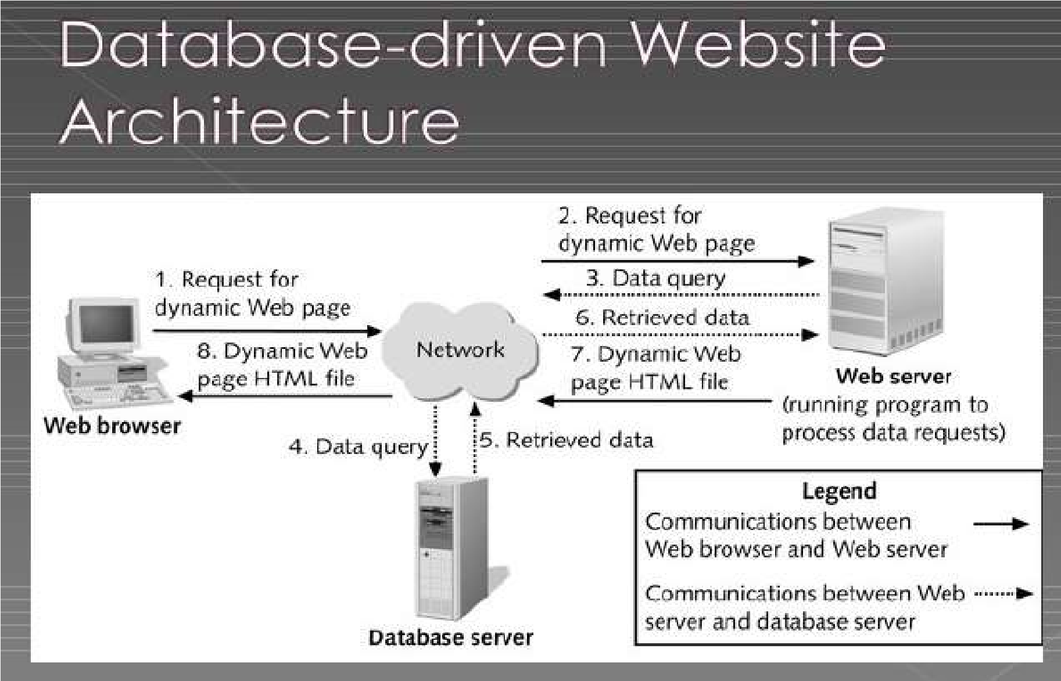

Figure 1: Architecture of the system (http://www.slideshare.net, 2016)

# 3.3 DATA COLLECTION METHOD AND USERS NEED

A good web application should take into account the assembly of data collection and user’s needs. It is not possible to realize a web application without studying the information system. So, a good web application should answer the user’s needs with the help of the various methods of data collection put in place. However, the choice of a particular data collection method to be used depends on the objectives the researcher wants to attain at the end. As part of our research, we have chosen to gather information and ascertain users' demands through interview and observation.

## 3.3.1 Observation

We got much inspiration from observation and this of course helped us to have the anxiety to collect data that will help the designing of our web application. This was very easy to observe how through the knocking down of beginning entrepreneurs who had difficulties in the management of their traditional receipts. Assuredly it is through the observation period that the main goals and objective of this project were formulated in order to solve the problem brought forth by lack of a receipt system.

## 3.3.2 Users Needs

A relevant web application should be designed according to the users’ needs, because a good developer or a programmer must not realize a web application without taking in to account the users’ needs. The customers need to be assured that if the physical receipt is damaged, they can have a backup of that receipt and to provide efficient and reliable receipts.

# 3.4 FUNCTIONAL REQUIREMENT

In this light, we are looking at the various basic computer components needed to permit our application function well and serve it’s intended audience. Some of these components (requirements) are; a good RAM, processor, hard disk and peripheral input and output devices (monitor, mouse and keyboard).

# 3.5 FUNCTIONAL SPECIFICATION

The functional specification includes actors which will interact to actually bring out the role of this application at ETS.NTECH and at the society and how this application will play this role with the help of its actors which we are to discuss below:

## 3.5.1 Role Played by Each Actor

– Super Administrator:

* Manage activity logs
* Create Invoices
* Edit Invoices
* Cancel Invoices
* Allow to send emails
* Manage User Profiles
* Create New products
* View Products
* Edit Products
* Delete Products
* Receive payment
* View System logs
* View Supplier
* Export Invoices
* Create New administrators

– Administrator:

* Create Invoices
* Edit Invoices
* Cancel invoices
* Create New administrators
* Export Invoices
* Allow to send emails
* View Products
* Edit Products
* Delete Products

## 3.5.2 The System's Abilities

The fundamental functions of creating, editing and deleting receipts are made very simple by receipt generating systems. It records transaction details, purchased items, quantities, prices, and any applicable discounts or taxes. The system may offer options for digital receipts, such as email receipts. This functionality provides convenience for customers and reduces paper waste.

# 3.6 TECHNICAL SPECIFICATIONS

* A login page for the actors in the system should be included on the main page.
* The platform should display an interface here the administrators can login into the system.
* Both the super admin and the admin have a similar home page but with a difference in the level of their various menus.
* Transaction Processing Speed: The system should be designed to process transactions quickly and efficiently, ensuring minimal delay in generating receipts. This specification is particularly important in high-volume transaction environments to maintain smooth operations.

# 3.7 NON-TECHNICAL SPECIFICATION

* **At the level of security:**

Like any web application that we have the chance to visit the administrators won’t be able to log in to any other administrators account without prior authorization from the administrator. Here, each administrator account is confidential to him or her.

* **Performance level:**

The internet connection should be very fast with ahigh bandwidth.

* **Scalability:**

The system should be scalable to accommodate the needs of growing businesses. It should be able to handle increasing transaction volumes without compromising performance or functionality.

* **Customizability:**

The system should allow businesses to customize the receipt format, including the inclusion of branding elements, company logo, and contact information.

* The system should have an intuitive and friendly interface that is easy to navigate and understand. It should require minimal training for admins to generate and manage receipts effectively.

# 3.8 RESEARCH DESIGN

The research design for this system here is required to solve some complications faced by small or medium size business owners, so as to be effective in the receipt system.

**Some of the importance of the system is shown below**

* **Customer Service:** Receipts offer customers proof of purchase, which is essential for returns, exchanges, warranties, and disputes. They also contribute to customer satisfaction by providing transparency and accountability in transactions.
* **Inventory Management:** Receipts contain information about the products or services purchased, which aids businesses in managing inventory levels and replenishing stock as needed.
* **Record Keeping:** Receipts provide a documented record of transactions for both the buyer and seller. This record is crucial for accounting, tax purposes, and tracking expenses.

# 3.9 ANALYSIS METHODS

The scientific approach method is that which the researcher is guided to make an appropriate software and that method entails an analysis which make the design of a web application such as this to be put in place. This involves first of all the collection of information on the field passing through the need and flow of information within a particular information system in order to design software closely to the users’ needs. We will step by step look through or present the different types of methods under the large set: The object-oriented methods and the functional methods. At the end we will precise the best method suitable in the realization of our web application by giving the raisons d’être of our choice.

# 3.10 OBJECT- ORIENTED MODELING

The Object-oriented methods (OOMs) describe the static structure of the objects, their classes and their relations. One can mention here the following OOMs: OMT method, UML method and UP.

## 3.10.1 Object Modelling Technique (OMT) Method

The Object Modelling Technique (OMT) is an object modelling method for software modelling and designing. It was developed around 1991 by Rumbaugh, Blaha, Premerlani, Eddy and Lorensen as a method to develop object-oriented systems and to support object-oriented programming (ESPINASSE, 1980). OMT was developed as an approach to software development. The purposes of this modelling according to Rumbaugh are:

* Testing physical entities before building them (simulation).
* Communication with customers.
* Conception (alternative presentation of information).
* Reduction of complexity.

**OMT has proposed three main types of models:**

* **Object model:** The object model represents the static and most stable phenomena in the model domain. Main concepts are classes and associations with attributes and operations.
* **Dynamic model:** The dynamic model represents a state or transition view on the model.

Main concepts are states, transition between states and event to trigger transitions. Actions can be modelled as occurring within states. Generalization and aggregation (concurrency) are predefined relationships.

* **Functional model:** The functional model handles the process perspective of the model, corresponding roughly to data flow diagrams. Main concepts are process, data, data flow and actors.

## 3.10.2 Unified Modelling Language (UML) Method

UML is a language of modelling unified object in an object-oriented environment developed in response to the call for the proposal launched by the Object Management Group (OMG) with the goal of defining the standard notation for the modelling of applications built using objects. The principal authors of UML are Grady Booch, Ivvar Jacobson and Jim Rumbaugh.

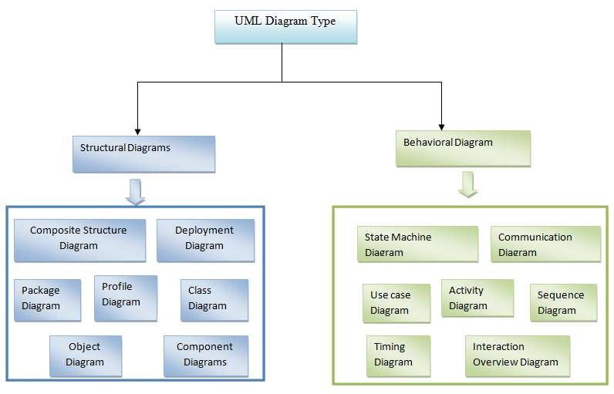

### Figure 2: Overview of UML (static3.creately.com, 2016)

Some advantages of UML are:

* Formal and standardized language, it allows proceeds of precision and constitutes a pledge of stability. This is what encourages the use of the tools.
* Powerful support of communication.
* Implementation of all the richness of the object approach.
* Description of all the models from the analysis to the realization of the software.
* Standardization of the concept’s objects.

Some limits of UML are:

* The semantics of UML is not formalized. It is specified by using the natural language.
* Difficult optimization of the choice of the classes.

Various categories of diagrams are not formalized.

## 3.10.3 Unified Process (UP) Method

Unified Process (UP) is a management method in the life cycle of software development and thus for object-oriented software. This as a generic method, iterative and incremental unlike the sequential method MERISE or SADT. This method is the general precept methods with the abbreviations: RUP, UPA, XUP, EUP, 2TUP, AM, DCU. Thus, an embodiment according to UP, to transform the software needs of users, must necessarily have the following characteristics:

* UP is based on components
* UP uses UML
* UP is driven by use cases
* UP centric architecture
* UP is iterative and incremental.

Some advantages of UP are:

* Use case sensitive
* Architecture centric
* Iterative and incremental.

Some limits of UP are:

* It is used only at the beginning of the whole process to create business requirements.
* The final application reflects the businesses processes, but there exist no closer bond between them.
* A small change in the business process leads to a fundamental change of the created information system.

# 3.11 FUNCTIONAL METHODS

The functional methods have their origin in the development of the procedural languages. More directed towards the managements than towards the data, they highlight the functions to be ensured and propose a hierarchical, downward and modular approach by specifying the bonds between the various modules. With the evolution of systems and programming languages, these methods took into account the modelling of the data and the problems arising from real time.

## 3.11.1 SADT Method

Structured Analysis and Design Technique (SADT) Method is a method of American origin developed in 1977 by DOUG ROSS then introduced in Europe since 1982 by Michel GALINER. It is a multi-field language which supports the communication between users and originators. As a method of functional analysis and the most known management of projects, SADT presents strong points and weak points.

Some advantages of SADT Method are:

* Its simplicity
* Its adequacy to capture the user's needs
* Its capacity with being able to produce solutions on several levels of abstraction.

Some limits of SADT Method: are:

* Its analysis is concentrated much on the functions, the coherence of the data being neglected.
* The rules of decomposition are not explicit. The decomposition differs according to analysts.
* Its difficulties of taking account of the non-hierarchical interactions in the complex systems.
* Lastly, the volatility of the functions makes that the system is in perpetual D-design.

## 3.11.2 MERISE Method

The MERISE (Methode d’Etude et de Realisation Informatique pour les Systems d’Entreprise) method was launched around 1977 through a national consultation launched by the French Ministry of industry with the aim to create a company of data processing consultant in order to define a method of design of information system. The Merise method is based on separation of data and treatments to be carried out in several conceptual and physical models.

The Merise method recommends three levels of abstraction; the conceptual level, the organizational level and the physical level.

**The conceptual level:** The conceptual level defines the finalities of the company. It is on this level that objectives to reach and constraints which weigh on the company are identified. It generally constitutes the most stable level and the first level of development. At the conceptual level, one distinguishes the Conceptual Data Model (CDM) and the Conceptual Treatments Model (CTM).

**The organizational or logical level:** The organizational level describes the organization which it is desirable to be set up in the company to achieve the laid down objectives. The purpose of it is to provide a diagrammatic representation of the organization of the company. One has heard of the Logical Data Model (LDM) and the Organizational Treatments Model (OTM). The organizational level is less stable and constitutes the second level of invariance.

**The physical level:** The physical level describes the means which will be implemented to manage the data and to activate the treatments. It is organized around the Physical Data Model (PDM) and the Operational Treatments Model (OTM)Table 1 below represents the three levels:

|  |  |  |
| --- | --- | --- |
| Levels | Static (Data) | Dynamic (Treatments) |
| Conceptual | CDM | CTM |
| Physical | PDM | OpTM |
| Logical and Organizational | DLM | OTM |

Table1: Representation of the levels of perception of Merise

Some advantages of MERISE Method are:

* Merise is considered like a method of design of information systems on the plan of its general organization. For this reason, it has many advantages:
* Merise allows the comprehension and the formalization of the needs for the trade
* Merise supports the dialogue between originator and owner, building particularly in the projects of integrated system development of management.
* Merise allows the general modelling of the data for construction of a database.
* Merise ensures the formalization of the user's needs within the framework of a schedule of conditions, before the work of design.

Some limitations of Merise Method are:

In spite of its many advantages, the Merise method was often criticized as being a Franco-French historical method. Its disadvantages can be analysed around three points:

* Merise is more turned towards the engineering of general design than towards the software genius
* Difficulty in maintaining the system.
* Not easily evolutionary system.

# 3.12 CHOICE OF METHOD

Research on this work has presented: OMT, UML, UP, SADT and MERISE as some of the principal models that can be used in designing an application. As a methodology to be used in this work, UML has been chosen to design our application. Automatically, UML will use the UP method because UP uses UML notations. The reason why UML is chosen is because in UML, the dynamic (behavioural) and static (structural) things are fused into the system’s entity to realize good and desirable results. This creates interdependency between the static and the dynamic things. It also provides precision and stability of the system. Hence, it is faster in building our application using the UML to MERISE method. The MERISE method on the other hand, separates static approach system from the dynamic approach. It uses data models in representing the static system and treatment models in representing the dynamic system, it is not a method made specifically for software development like UML but rather, it (MERISE) is generally used thus making the building of the application slower and costlier because more materials are used to attain the same but less reliable result in quality and quantity.

# 3.13 APPLICATION OF METHOD

As it is often said, a picture is worth a thousand words, this absolutely fits while discussing about UML. UML is a pictorial standard and modelling mechanism for specifying, visualizing, constructing, and documenting the artifacts of software systems. So beyond reasonable doubts, UML will help us better realize our application and understand its functionality.

## 3.13.1 Actors

An actor specifies a role played by a user or any other system that interact with the system but which is external to the subject. In our case we have the following actors:

**Super Administrator:** The super administrator is in charge of the administration of the system and also carrying out daily inventory transactions. Therefore, an administrator acts as an individual handling or doing the general overseeing of the system. The roles are identified as follows:

* Create, edit and delete invoices.
* Add products to the inventory system.
* Check the list of all customers.
* Can create new admins in the system.
* Can send emails
* Can give a particular access level to the admin.

**Administrator:** The administrator is in charge of the checking and navigating through the system and also carrying out daily inventory transactions. The roles are identified as follows:

* Create, edit and delete invoices.
* Add products to the inventory system.
* Check the list of all customers.
* Can create new admins in the system.
* Can send emails.

## 3.13.2 Diagrams

1. **The Use Case Diagram**

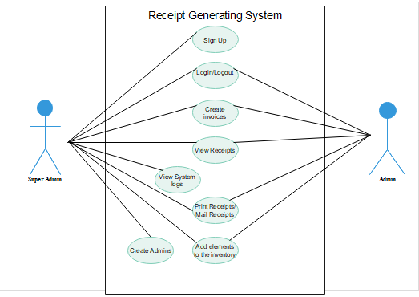The use case diagram is one which clearly shows all the actors in a given system and how those said actors interact with that system. This part contains the analysis of the functional and non-functional requirements using use case diagram and use case details.

Figure 1:Use case diagram

**b) The Class Diagram:** Receipt generating system class diagram describes the structure of the system. The diagram does this by showing each class and its attributes, methods and its relationships.

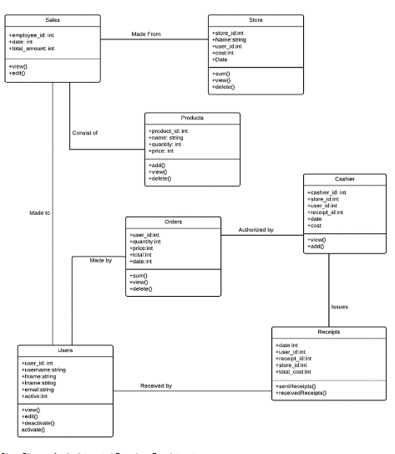

Figure 4: Class diagram

# 3.14 VARIOUS MODEL OF THE METHOD

## 3.14.1 Rules to Move From One Data Model to Another

**Rule 1:** Any entity becomes a table in which the attributes become columns. The identifier of the entity then constitutes the primary key of the table.

**Rule 2:** an association of the type 1: n disappears and becomes a foreign key of the table of the side 0:1 or which refer to the primary key of the other table.

**Rule 3:** an association of the type n: n (that is which has positioned maximum cardinalities with “n” on the two side of the association) results in the creation of a relation of which the primary key is made up of the foreign keys referring the relations corresponding to the entities bound by association.

**Rule 4:** A binary association of type 1:1 is represented by a binary association of type 1: n. Except that the foreign key is seen imposing a constraint of iniquity in addition to one possible constraint of vacuity.

**Rule 5:** Any non-association on the type 0: n can be seen as another table with primary key becoming all the foreign keys.

The observation of the rule of passing from the CDM to the LDM enabled us to generate the following LDM. For our application, they can have the following LDM

# 3.15 SOFTWARE USED

There are various software’s used in producing the platform. The software include:

## 3.15.1 Windows 10 Home

Windows stands for Will Install Needless Data on Whole System (WINDOWS), developed by American corporation Microsoft. It is the successor to Windows 8.1, and was released to manufacturing on July 15, 2015, and broadly released for retail sale on July 29, 2015.

## 3.15.2 Design Environment (Win’ design)

To generate the logical data model (LDM) of our application, WIN’DESIGN 700 is used. It is specialized in the analysis and design of diagrams. It can also be used to develop some UML diagrams.

## 3.15.3 Visual Studio Code (Text editor used)

It is a text editor usually used to edit the source code of the application and it enables us to write the procedural languages.

# 3.15.4 XAMPP Control Panel

It is commonly called Apache Server and is a server of web pages developed by Apache Software Foundation. Xampp is a free software license by Apache working in several Operating Systems (UNIX, Mac OS, Windows, etc.).

## 3.15.5 PHPMYADMIN

This was the MYSQL administration tool used in the creating and handling all the databases.

## 3.15.6 E-Draw Max

This app as used in drawing various logical diagram, like the activity diagram, sequence diagram, UML class diagram.

## 3.15.7 YouTube

YouTube was used to watch research videos on how the system could be built.

## 3.15.8 Google Chrome

Google chrome is a cross-platform web browser developed by Google. It was first released in 2008 for Microsoft Windows, and was later ported to Linux, MACOS, iOS, and Android. The browser is also the main component of Chrome OS, where it serves as the platform for web apps.

# 3.16 PROGRAMMING LANGUAGES USED

## 3.16.1 HTML5

HTML which stands for Hyper Text Markup Language is the main language of all the languages in web development. Without this language, no other languages can run on a browser, so HTML is use to display the web pages with respect to a set of tags written on the pages.

## 3.16.2 CSS

Cascading Style Sheets is used to add beauty (style) to content displayed on web pages. It is embedded in HTML tags or linked with HTML files. CSS enhanced the layout of the web site and makes it look more attractive. Boen in 1996, there are many types of CSS (1, 2.1 and 3).

## 3.16.3 JAVASCRIPT

JavaScript was released by Netscape and Sun Microsystems in 1995. JavaScript is a programming language, an interpreted language, object-based programming. It is a script-client-side language used for interacting web pages.

## 3.16.4 PHP 8.2.4

It is a server-side language used to make the web site dynamic and permit a user to interact with the server to get the specific resources found in a web server.

# 3.17 HARDWARE USED

For the implementation of this system (platform), a computer having the following characteristics was used:

* A laptop computer brand Lenovo
* Processor: AMD Ryzen 5 2500U with Radeon Vega Mobile Gfx 2.00GHz
* RAM: 12.0 Go
* Hard Disk: 500 Go
* Screen: 15.6 inches

Operating System: Microsoft Windows 10 Home.

# 3.18 MODULES OF THE DESIGNED SYSTEM

Our web application will be developed with the help of the following modules:

* Data base management system placed in a local server (xampp)

A web application which will interact with the database server. This web application will present the following modules:

* A general home page
* A space connection for super administrator/admin
* A module to print receipts.

# CHAPTER 4

**RESULTS AND DISCUSSION**

# 4.1 INTRODUCTION

Haven’t discussed everything about methodology used to realize this system, this chapter  
focuses on the results and discussions of our web application, Receipt Generating System.

# 4.2 RESULTS

Here we are going to demonstrate the different print screens of the web application, in order  
to ascertain its functionalities and how it looks like in terms of layout of the system  
(RGS) and to understand how the system functions internally with the help of its two  
principal actors that is the admins (superadmin, admin).

# 4.3 PRESENTATION OF SCENARIOS

We shall display print screens of the various modules and give their functionality in order to better understand the relationship between customer’s webpage and that of the administrator.

## 4.3.1 GENERAL HOME PAGE

The general home page is the first page of the web application for all the authorized actors to  
access the services or features in the platform using their respective logins and passwords that  
give them varying privileges. The two types of actors interacting with the system are: the  
admins (superadmin and admin). To obtain the figure for the general home  
page below, we launch XAMPP control panel, the control panel opens and on the start buttons next to Apache and SQL, click start and wait for the status of the buttons to change to stop. Then open a web browser and type in “localhost/receipt_generating_system/public”.

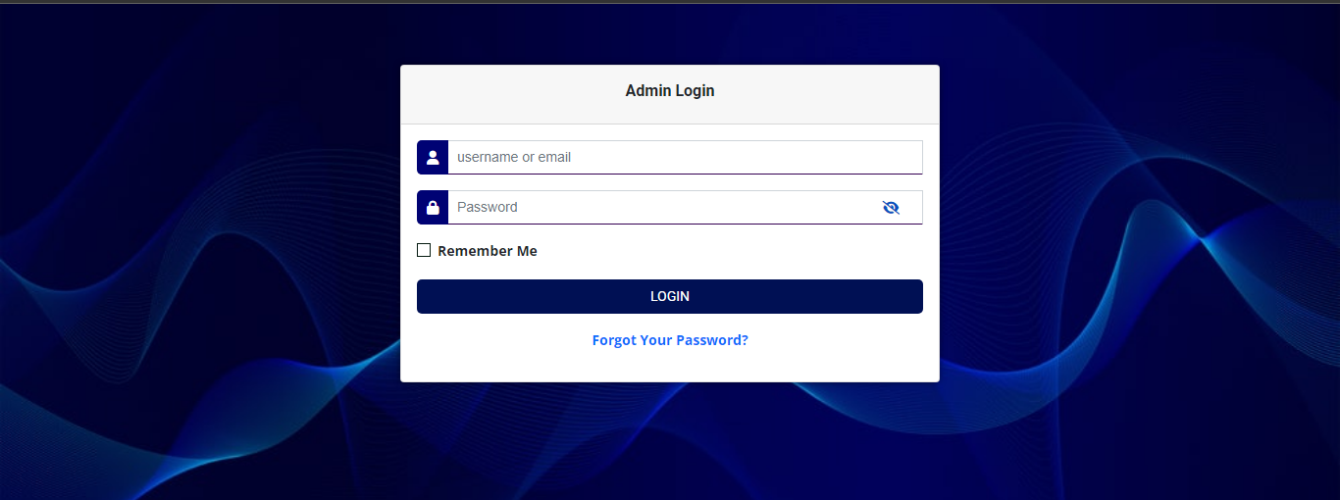Figure 5: General Homepage of the application.

In the general home page, we have a login connection space for the admins which can be accessed with any admin’s username or email and password.

## 4.3.2 ACTIVITIES (DASHBOARD)

When the admins insert their username or email and password in the spaces provided in the general home page and click on login, we obtain the administrator’s homepage known as the dashboard, as shown in figure below:

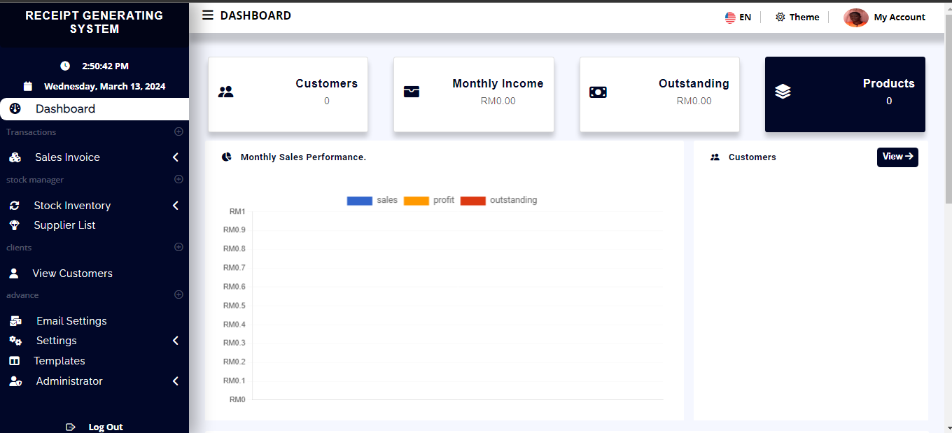Figure 6: Administrator’s Dashboard

The admin home page (dashboard) has a menu which contains: Sales invoice (list of all receipts done), Stock inventory, Supplier list (list of suppliers), View customers (all customers registered in the system), Email settings, Setting, Templates, Administrator (To view all system admins).

## 4.3.3 SCENARIO 1: CREATING A NEW INVOICE OR RECEIPT

In the above figure, a menu called **Sales Invoice** which is a drop-down menu containing an option called **Create new invoice.** When this option is clicked, a form is opened for the creation of new receipts or invoices by the admins.

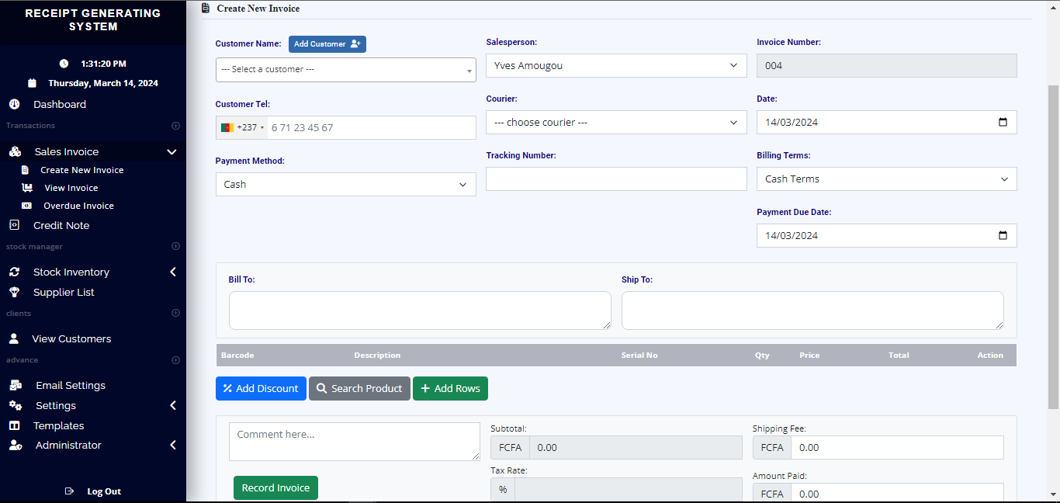

Figure 7: Creation of receipt/invoice

## 4.3.3 SCENARIO 2: ADDING NEW PRODUCTS TO STOCK

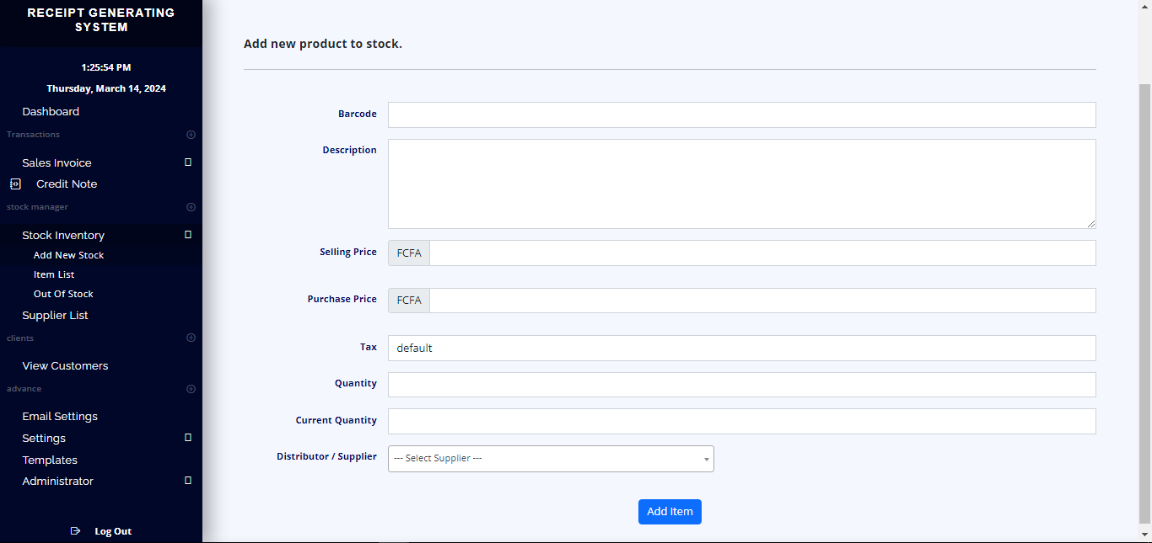Figure 8: Adding new products to the inventory stock

# CHAPTER 5

**DISCUSSION, CONCLUSION AND RECOMMENDATIONS**

# 5.1 SUMMARY OF FINDINGS

The computerization of the receipt generating system is required to improve accuracy and decrease human error. First of all, this system was designed using the 3-tier architecture which consist of the client, database and the server all interacting with one another. The implementation of this system was challenging as it required the knowledge of different programming languages to make it meet the required needs.

# 5.2 DIFFICULTIES ENCOUNTERED

A lot of challenges surfaced during the development of this application. The following are some of the problems or challenges encountered:

* **Difficulties Related to Design of the platform**

The design of such an application involves the knowledge of many programming and procedural languages such as knowledge on HTML, CSS, PHP, JavaScript etc. This implied learning more and mastering them in order to construct a good application that answers the user’s needs.

* Poor internet connectivity which made researches and changes on the system go slowly.
* Understanding the MySQL Database Syntax.

# 5.3 CONCLUSION

The end of this work marks the beginning of many achievements which have been accomplished according to the objectives formulated. Firstly, this platform has been designed using the 3-tier architecture, which consist of a client, server and the database all interacting with each other through JavaScript language at the level of the control. The development of a receipt generating system brings numerous advantages, including increased efficiency, improved accuracy, standardized documentation, and improved customer satisfaction.

Implementing this platform was challenging as it requires the knowledge of many programming languages to make it function to meet the standard needs.

# 5.4 RECOMMENDATIONS

This system which is a receipt generating system is there to replace the manual way of doing receipts in small firms and companies. This system is there to reduce or minimize errors and provide an efficient and reliable means of producing receipts. So, companies, small and medium companies still adopting manual receipts with risks of losing the receipts or customers losing their receipt with no method of retrieval in case their product have problems, can implement this system to help them reduce inefficiency and increase productivity.

In the development of this system, I will recommend that if there is going to be any modifications, the new writer or intern should endeavour to improve on the limitations such as ensuring that the receipt system allows for customization of receipt templates, because providing personalized receipts enhances brand recognition and professionalism. There are some limitations during the development of this receipt generating system that will require improvement. Writer should put them in mind and face it as a challenge and not a problem.

# REFERENCES

Smith, J., & Johnson, A. (2022). "Design and Implementation of a Digital Receipt Generation System for Small Businesses." International Journal of Business Technology, 10(3), 112-125.

Chen, L., Wang, Y., & Zhang, H. (2023). "Development of an Automated Receipt Generation System Using Machine Learning Algorithms." Proceedings of the IEEE International Conference on Automation and Computing, 78-85.

Garcia, M., & Rodriguez, P. (2023). "Efficiency Analysis of Paperless Receipt Systems in Hospitality Industry: A Comparative Study." Journal of Hospitality and Tourism Management, 40, 78-92.

Nguyen, T., Tran, H., & Le, T. (2022). "A Cloud-Based Receipt Generation System for Small and Medium-sized Enterprises." Proceedings of the International Conference on Cloud Computing and Big Data, 134-141.

Wang, X., Zhang, Q., & Liu, Y. (2023). "Real-time Receipt Generation System for Online Transactions: A Case Study of E-commerce Platforms." International Journal of Electronic Commerce, 21(3), 256-270.

Smith, J., & Johnson, A. (2023). "Automating Receipt Generation: A Case Study of Efficiency and Accuracy." Journal of Information Systems, 35(2), 187-204.

http://www.slideshare.net, 2016

# APPENDIX

**Source code in the application tha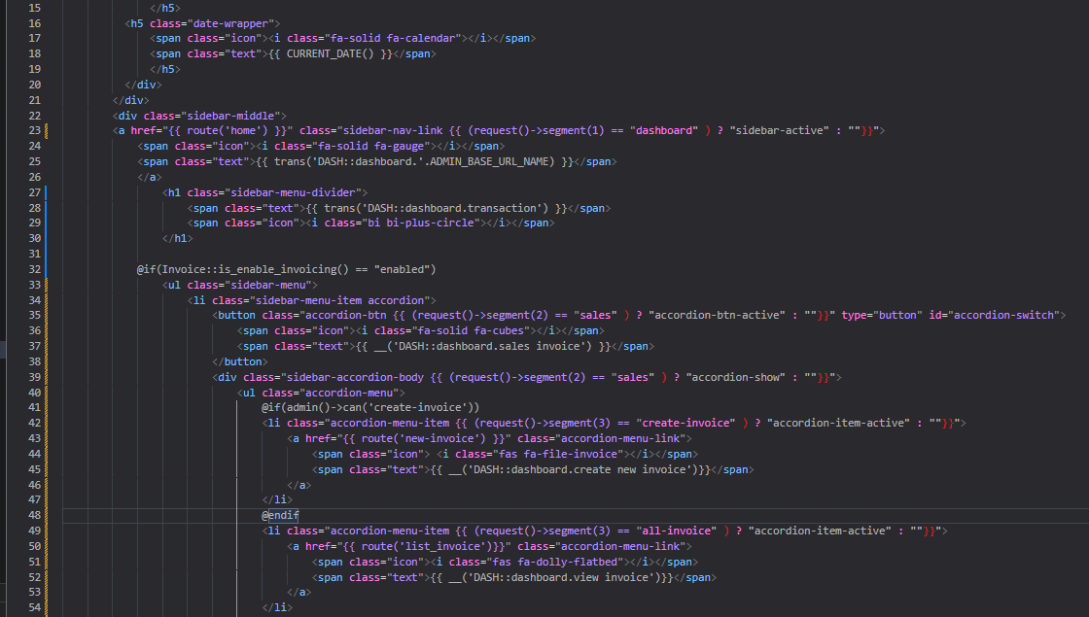t displays the dashboard**

Figure 9: Codes to display the dashboard