1. Press the New button and choose to create a new request, give it a name, a description if you want and save it to a collection.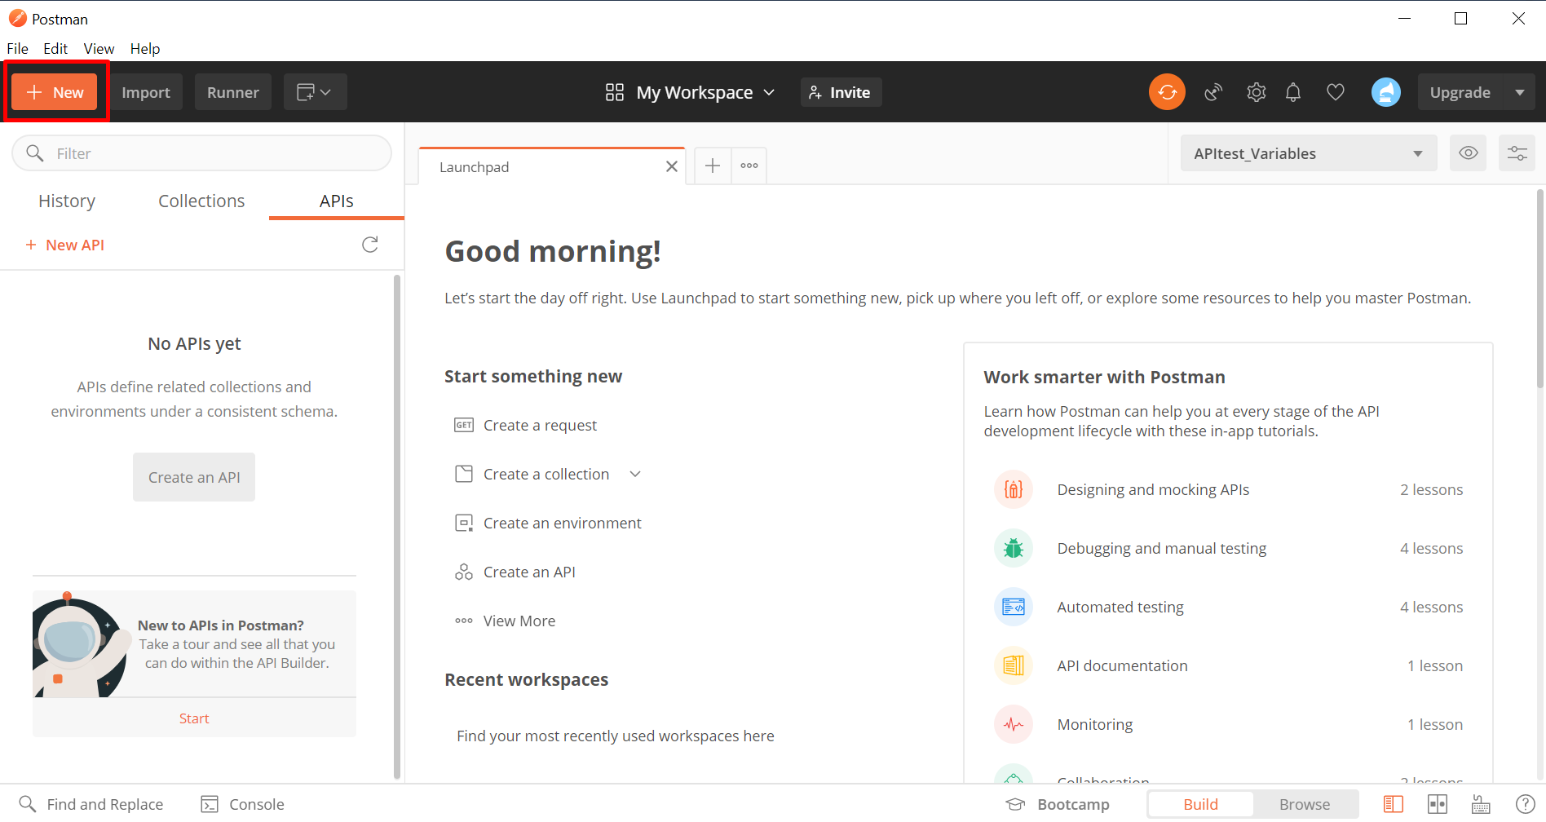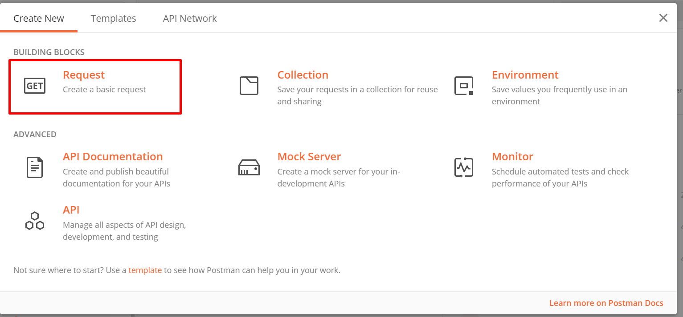
2. Type in <http://loclahost:5488/v1/Foo/Bar> in the URL bar and change “GET” to “POST”. This connects to an endpoint hosted on your local machine at port 5488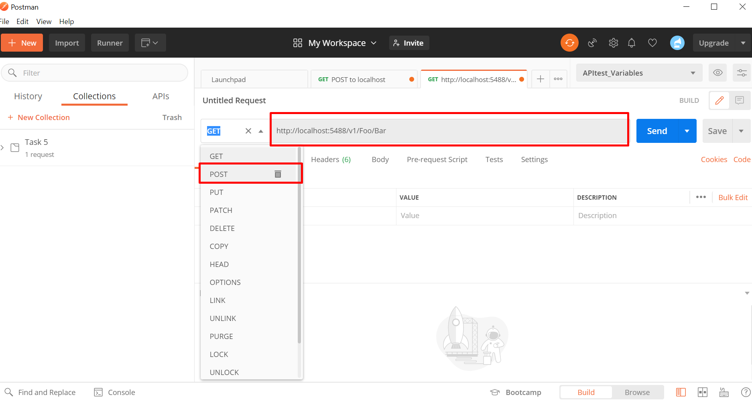
3. Click body and change to “Raw”, then copy-paste the code from the json file we are posting in this task. Afterwards change from “Text” to “json” to signify it is a .json file

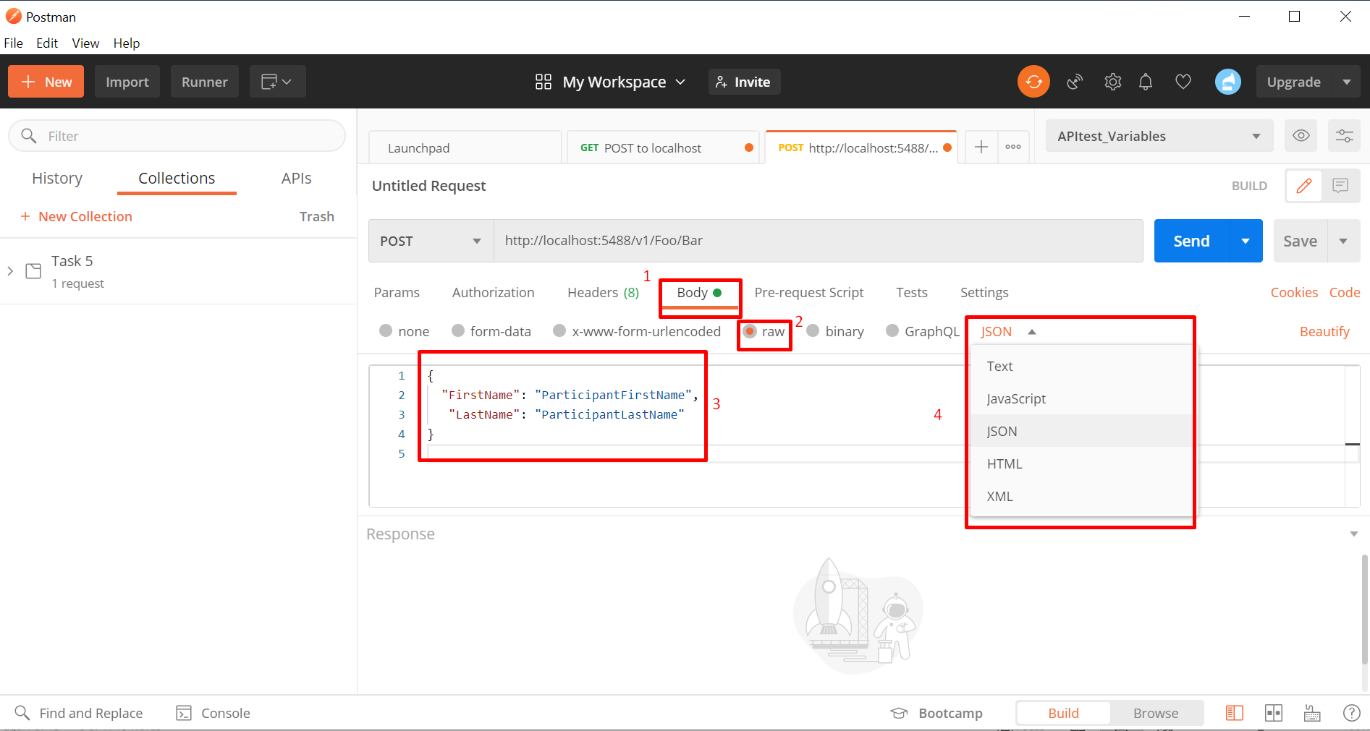

1. Go to the Authorization tab and under Type select “No Auth” for no authentication. (as we assume there is no authentication in this task)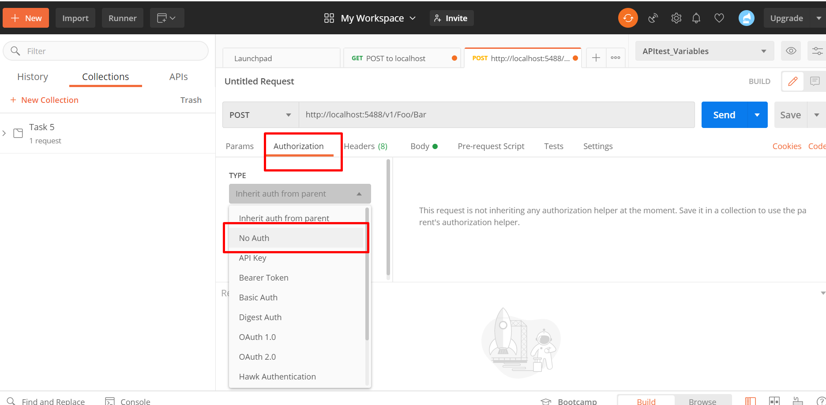
2. Click Send to send the Request.