Software Requirements Specification Template
CptS 322—Software Engineering

The following annotated template shall be used to complete the Software Requirements Specification (SRS) assignment of WSU-TC CptS 322. The instructor must approve any modifications to the overall structure of this document.

Template Usage:
Text contained within angle brackets (‘<’, ‘>’) shall be replaced by your project-specific information and/or details. For example, <Project Name> will be replaced with either ‘Smart Home’ or ‘Sensor Network’.

Italicized text is included to briefly annotate the purpose of each section within this template. This text should not appear in the final version of your submitted SRS.

This cover page is not a part of the final template and should be removed before your SRS is submitted.

Acknowledgements:
Sections of this document are based upon the IEEE Guide to Software Requirements Specification (ANSI/IEEE Std. 830-1984). The SRS templates of Dr. Orest Pilskalns (WSU, Vancover) and Jack Hagemeister (WSU, Pullman) have also be used as guides in developing this template for the WSU-TC Spring 2005 CptS 322 course.

<KIDSTUTOR>

Software Requirements Specification

<Version 1>

<3rd Novemeber,2015>

<AGYEI EUNICE ENO YAA FRIMPONMAA>

Prepared for
WSU-TC CptS 322—Software Engineering Principles I
Instructor: Saleh Hadi, Ph.D.
2015

Revision History

Date | Description | Author | Comments
<date> | <Version 1> | <Your Name> | <First Revision>
3/11/2015 | 1 | Agyei E.E.Y.F

Document Approval

The following Software Requirements Specification has been accepted and approved by the following:
Signature | Printed Name | Title | Date
 | <Your Name> | Lead Software Eng.
 | Ph.D. Hadi Saleh | Instructor, CptS 322

Table of Contents

Revision History ii
Document Approval ii
1. Introduction 1
1.1 Purpose 1
1.2 Scope 1
1.3 Definitions, Acronyms, and Abbreviations 1
1.4 References 1
1.5 Overview 1
2. General Description 2
2.1 Product Perspective 2
2.2 Product Functions 2
2.3 User Characteristics 2
2.4 General Constraints 2
2.5 Assumptions and Dependencies 2
3. Specific Requirements 2
3.1 External Interface Requirements 3
3.1.1 User Interfaces 3
3.1.2 Hardware Interfaces 3
3.1.3 Software Interfaces 3
3.1.4 Communications Interfaces 3
3.2 Functional Requirements 3
3.2.1 <Functional Requirement or Feature #1> 3
3.2.2 <Functional Requirement or Feature #2> 3
3.3 Use Cases 3
3.3.1 Use Case #1 3
3.3.2 Use Case #2 3
3.4 Classes / Objects 3
3.4.1 <Class / Object #1> 3
3.4.2 <Class / Object #2> 3
3.5 Non-Functional Requirements 4
3.5.1 Performance 4
3.5.2 Reliability 4
3.5.3 Availability 4
3.5.4 Security 4
3.5.5 Maintainability 4
3.5.6 Portability 4
3.6 Inverse Requirements 4
3.7 Design Constraints 4
3.8 Logical Database Requirements 4
3.9 Other Requirements 4
4. Analysis Models 4
4.1 Sequence Diagrams 5
4.3 Data Flow Diagrams (DFD) 5
4.2 State-Transition Diagrams (STD) 5
5. Change Management Process 5
A. Appendices 5
A.1 Appendix 1 5
A.2 Appendix 2 5

1. Introduction
This Software Requirements Specification provides a complete description of all the functions and specifications KidsTutor Mobile Application. The expected audience of this document is pre-school kids who will use this application to learn.

Purpose
This document describes the software requirements of KidsTutor mobile application. It is intended for the designer, developer and maintainer of KidsTutor.

Scope
KidsTutor is a software that is designed to run on the mobile platform. It will teach pre-school kids how to pronounce the letters of the English alphabet, count numbers and identify basic Animals.

Aim:
- To teach children in Ghana the pronunciation of the letters of the English alphabet, numbers and basic Animals
Objective:
- To display pictures of the letters of the English alphabet and teach the kids how to pronounce them.
- To display pictures of numbers and teach how to pronounce them
- To display pictures and names of basic Animals and teach how to pronounce them.

1.3 Definitions, Acronyms, and Abbreviations
This subsection should provide the definitions of all terms, acronyms, and abbreviations required to properly interpret the SRS. This information may be provided by reference to one or more appendixes in the SRS or by reference to other documents.

- Pronounce
Say a word, phrase or syllable in a certain way.
- Mobile
Moving or capable of moving readily (especially from place to place).
- Application
Moving or capable of moving readily (especially from place to place)
- App
Application

1.4 References
This subsection should:
(1) Provide a complete list of all documents referenced elsewhere in the SRS, or in a separate, specified document.
(2) Identify each document by title, report number - if applicable - date, and publishing organization.
(3) Specify the sources from which the references can be obtained.
This information may be provided by reference to an appendix or to another document.

1.5 Overview

The remainder of this document is organized into four chapters, the first chapter 2, provides a general description of the project. It lists all the functions performed by the system. Chapter 3 lists specific requirements of the application. Chapter 4 handles analysis models of the application. Chapter 5 lists how changes can be managed.

2. General Description
KidsTutor will run on the mobile platform. Internet connection is needed to download and install the app. The app can be run offline.

2.1 Product Perspective
KidsTutor works independently.

System interfaces
The app will not interface with any software

User interfaces
Logical characteristics of each interface between software and user eg menus

Hardware interfaces
Logical characteristics of each interface between software and hardware components eg. supporting devices

2.2 Product Functions
This software product will allow the users will be able to perform a function by clicking on any of buttons. The action that will be executed is based on the buttons clicked.
This subsection of the SRS should provide a summary of the functions that the software will perform.

2.3 User Characteristics
There is only one user who will interact with the system at a time. The user can perform any of the following function after clicking a button. When a button is clicked, the user can select a letter, number or a shape. Tap on it for it to be pronounced.

2.4 General Constraints
This subsection of the SRS should provide a general description of any other items that will
limit the developer’s options for designing the system. (See the IEEE Guide to SRS for a partial list of possible general constraints).

2.5 Assumptions and Dependencies
This subsection of the SRS should list each of the factors that affect the requirements stated in the SRS. These factors are not design constraints on the software but are, rather, any changes to them that can affect the requirements in the SRS. For example, an assumption might be that a specific operating system will be available on the hardware designated for the software product. If, in fact, the operating system is not available, the SRS would then have to change accordingly.

3. Specific Requirements
This will be the largest and most important section of the SRS. The customer requirements will be embodied within Section 2, but this section will give the D-requirements that are used to guide the project’s software design, implementation, and testing.

Each requirement in this section should be:
- Correct
- Traceable (both forward and backward to prior/future artifacts)
- Unambiguous
- Verifiable (i.e., testable)
- Prioritized (with respect to importance and/or stability)
- Complete
- Consistent
- Uniquely identifiable (usually via numbering like 3.4.5.6)

Attention should be paid to the carefuly organize the requirements presented in this section so that they may easily accessed and understood. Furthermore, this SRS is not the software design document, therefore one should avoid the tendency to over-constrain (and therefore design) the software project within this SRS.

3.1 External Interface Requirements

3.1.1 User Interfaces

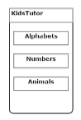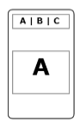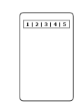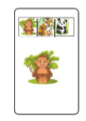

3.1.2 Hardware Interfaces

3.1.3 Software Interfaces

3.1.4 Communications Interfaces

3.2 Functional Requirements
This section describes specific features of the software project. If desired, some requirements may be specified in the use-case format and listed in the Use Cases Section.

3.2.1<Launch app>
3.2.1.1Introduction
User starts the app by tabbing on the launch icon on her phone
3.2.2 Inputs
None
3.2.3 Processing
Launching of app
3.2.4 Output
App opens and displays main page with three (3) buttons thus the alphabet, numbers and animal button
3.2.1.5 Error Handling
Display an error message “App launch failed” if app does not launch.

3.2.2 <Teach Alphabet>
3.2.2.1 Introduction
User taps the alphabet button on the menu to view pictures of the letters of the alphabets on a slider. User taps on an alphabet on the slider to view the alphabet and taps on the alphabet for the pronunciation of it.

3.2.2.2 Inputs
Value carried by the alphabet button.
Value carried by an alphabet on the slider
Value carried by that alphabet picture

3.2.2.3 Processing
Call functions to display picture of alphabet and pronounce it

3.2.2.4 Outputs
Display a picture of the alphabet
Pronunciation it

3.2.2.5 Error Handling
Display an error message “Picture failed to open” if the picture of the alphabet is not displayed.
Display an error message “Sound failed” if that alphabet is not pronounced

Input | Process | Output
User opens app for the first time | Display main pages | Main page
Tap on the Alphabet/ Number/Shape button on the main page | Display Alphabets/Number/ Animals page | Alphabets page/ Numbers page/ Animals page
Tap on the Alphabet/Number/Shape | Pronounce alphabet/number/shape | Sound of alphabet/number/shape

3.2.3 <Teach Numbers>
3.2.3.1 Introduction
User taps the “Number button" on the menu to view pictures of numbers in a slider. User taps on a number on the slider to view the number and then taps on the number for the pronunciation of it.
3.2.3.2 Inputs
Value carried by the Number button.
Value carried by a number on the slider
Value carried by that number picture
3.2.3.3 Processing
Call functions to display picture of number and pronounce it
3.2.3.4 Outputs
Display a picture of the number
Pronunciation it

3.2.3.5 Error Handling
Display an error message “Picture failed to open” if the picture of the number is not displayed.
Display an error message “Sound failed” if number is not pronounced

3.2.4 <Teach Animals>
3.2.4.1 Introduction
User taps the “Animal button” on the main page to view pictures of numbers in a slider. User taps on an animal on the slider to view that animal and then taps on the animal for the pronunciation of it.
3.2.2.2 Inputs
Value carried by the Animal button.
Value carried by an animal on the slider
Value carried by that animal picture
3.2.3.3 Processing
Call functions to display picture of animal and pronounce it

3.2.4.4 Outputs
Display a picture of the animal
Pronunciation it

3.2.5.5 Error Handling
Display an error message “Picture failed to open” if the picture of the animal is not displayed.
Display an error message “Sound failed” if name of animal is not pronounced
…

3.3 Use Cases

3.3.1 Use Case 1

Name | Launch app
Summary | User launches app
Rational | Needed for app to start working
Users | All users
Pre-condition | App must be installed
Basic course of action | User tabs on the launch icon
Alternative path | -
Post condition | Display main page

3.3.2 Use Case 2
…
Name | Teach alphabet
Summary | User tabs on the Alphabet button on the main page to learn alphabet
Rational | Needed if user wants to learn alphabets
Users | All users
Pre-condition | App must have been launched and displayed the main page
Basic course of action | - User tabs on the alphabet button to access the alphabet page  - The alphabet page has a slider.  - User tabs on an alphabet on the slider to display picture of alphabet  - User may tab on the picture of it for its pronunciation
Alternative path | -
Post condition | Display picture of alphabet  Pronounce alphabet

3.3.4 Use Case 4
Name | Teach numbers
Summary | User tabs on the Number button on the main page to learn numbers
Rational | Needed if user wants to learn numbers
Users | All users
Pre-condition | App must have been launched and displayed the main page
Basic course of action | - User tabs on the number button to access the alphabet page  - The number page has a slider.  - User tabs on an number on the slider to display picture of number  - User may tab on the picture of it for its pronunciation
Alternative path | -
Post condition | Display picture of number  Pronounce number

Name | Teach animal
Summary | User tabs on the Animal button on the main page to learn animal
Rational | Needed if user wants to learn animal
Users | All users
Pre-condition | App must have been launched and displayed the main page
Basic course of action | - User tabs on the alphabet button to access the animal page  - The animal page has a slider.  - User tabs on an alphabet on the slider to display picture of animal  - User may tab on the picture of it for its pronunciation
Alternative path | -
Post condition | Display picture of animal  Pronounce animal

3.4.1 <Class / Object #1>

3.4.1.1 Attributes
3.4.1.2 Functions
<Reference to functional requirements and/or use cases>

3.4.2 <Class / Object #2>
…

3.5 Non-Functional Requirements
Non-functional requirements may exist for the following attributes. Often these requirements must be achieved at a system-wide level rather than at a unit level. State the requirements in the following sections in measurable terms (e.g., 95% of transaction shall be processed in less than a second, system downtime may not exceed 1 minute per day, > 30 day MTBF value, etc).

3.5.1 Performance
The response time of the software is 99.9%.
The system is designed to be easy to use. Retention rate is high

3.5.2 Reliability
The system will always be available. It failure rate is less than 0.05%

3.5.3 Availability
The system will be available provide services to its users. Availability is rated 99.9%

3.5.4 Security

3.5.5 Maintainability
The system is designed in such a way that it will be easy to make changes and repair

3.5.6 Portability
The system will be compatible with mobile phones and tablets. It will also be compatible with the Android OS

3.6 Inverse Requirements
State any *useful* inverse requirements.

3.7 Design Constraints
Specify design constrains imposed by other standards, company policies, hardware limitation, etc. that will impact this software project.

3.8 Logical Database Requirements
Will a database be used? If so, what logical requirements exist for data formats, storage capabilities, data retention, data integrity, etc.

3.9 Other Requirements
Catchall section for any additional requirements.

4. Analysis Models
List all analysis models used in developing specific requirements previously given in this SRS. Each model should include an introduction and a narrative description. Furthermore, each model should be traceable the SRS’s requirements.

4.1 Sequence Diagrams

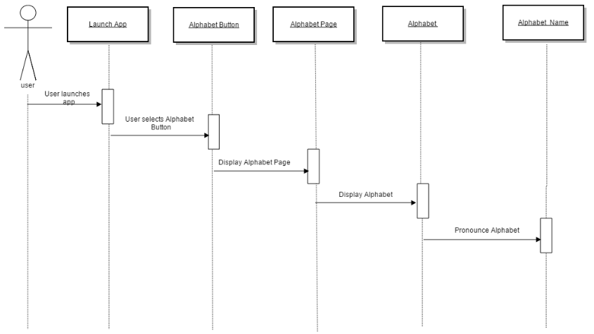
Figure 1 Diagram of choosing the alphabet button

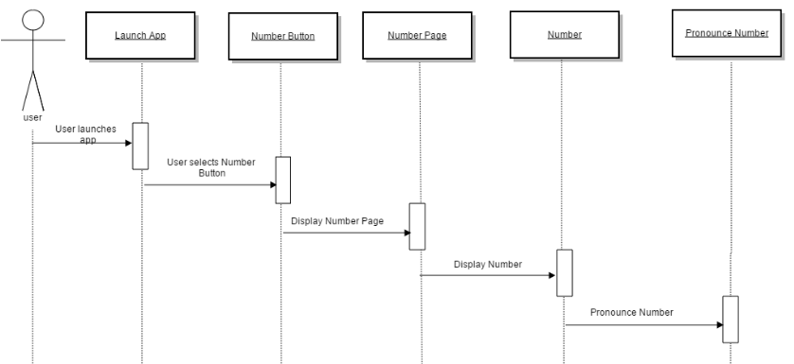

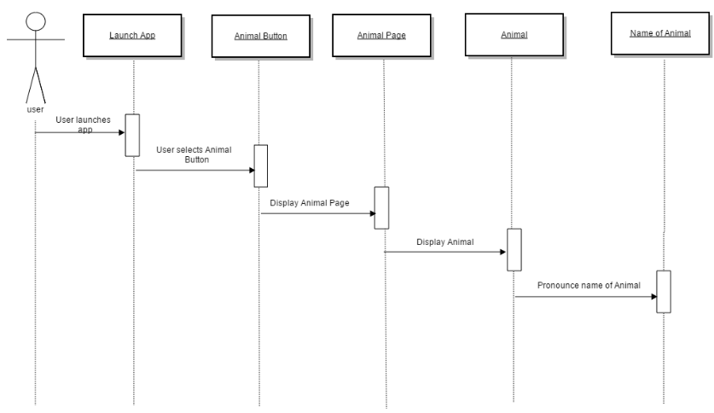

4.3 Data Flow Diagrams (DFD)/use case diagram
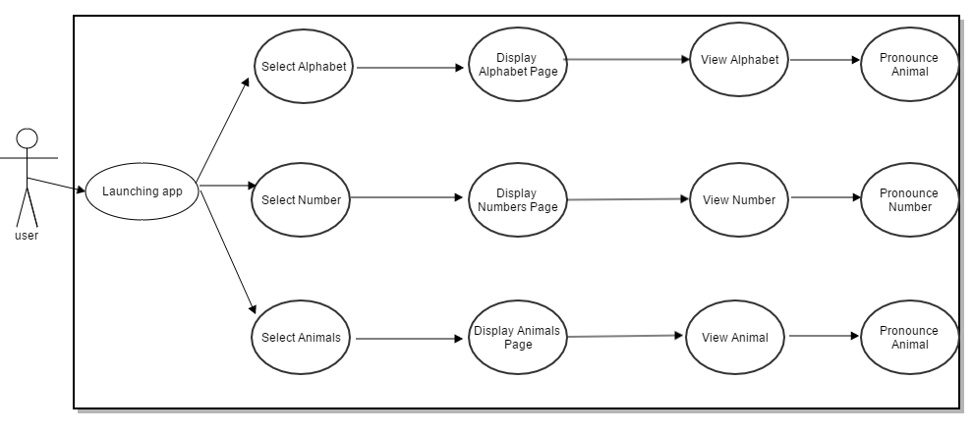

4.2 State-Transition Diagrams (STD)
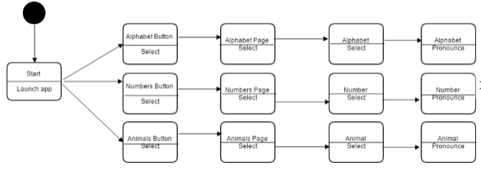

5. Change Management Process
Identify and describe the process that will be used to update the SRS, as needed, when project scope or requirements change. Who can submit changes and by what means, and how will these changes be approved.

A. Appendices
Appendices may be used to provide additional (and hopefully helpful) information. If present, the SRS should explicitly state whether the information contained within an appendix is to be considered as a part of the SRS’s overall set of requirements.

Example Appendices could include (initial) conceptual documents for the software project, marketing materials, minutes of meetings with the customer(s), etc.

A.1 Appendix 1

A.2 Appendix 2

