Assignment 2: 10%
Create Library Mgmt System with Web Flux -Based on Inclass example
Connect with Mongo DB
Implement WebFlux framework with Rest framework
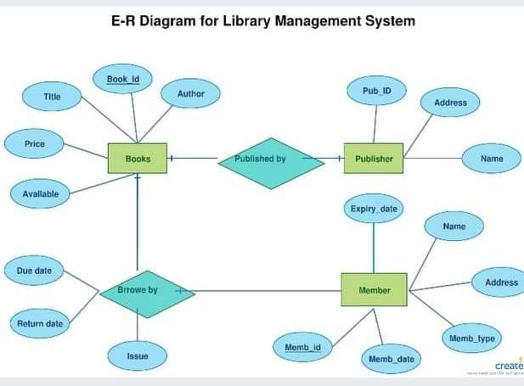

Step 1: Create a new Spring Stater project in eclipse or using spring.io web site named “SpringBootWebFlux_Assign2_YourFullName”.
Choose the following necessary dependencies
- Spring Data Reactive MongoDB
- Spring Reactive Web
- Lombok
- Spring Boot DevTools

Step 2: Create Library Mgmt POJOS – Book Class, Publisher, Member Class.
Create appropriate fields as shown in the ER diagram, along All field’s constructor, getters/setters.

Step 3: Create appropriate repository interfaces for POJOs for Library Mgmt. Application.
For example -:
package com.spring.web.flux;
import org.springframework.data.mongodb.repository.ReactiveMongoRepository;
import org.springframework.stereotype.Repository;
@Repository
public interface EmployeeRepository extends ReactiveMongoRepository<Employee, String>{
}

Step 4 – Add Service Class and write the code for Crud operations.
Operations- Add two operations for CRUD for each Java Class. – books, publisher and member

Step 5 – Add Controller and appropriate code.
Step 6- Open the application.properties file and modify this code as appropriate to your database:
logging.level.org.springframework=ERROR
logging.level.com=TRACE
server.port=8084
spring.data.mongodb.host=localhost
spring.data.mongodb.port=27017
spring.data.mongodb.database=humber
Step 7 – Test with POSTMAN

Submission – zip of the source code – Demo your work before you leave!

