Software Requirements Specification

for

Hail-a-Tryc

Version 4.0 approved

Prepared by Abling, Altea Mae M.

Dator, Frinces Myles T.

Romero, Jovelyn O.

Manuel S. Enverga University Foundation

May 21, 2024

Table of Contents

Table of Contents 1

Revision History 1

1. Introduction 2

1.1 Purpose 2

1.2 Document Conventions 2

1.3 Intended Audience and Reading Suggestions 2

1.4 Project Scope 3

1.5 References 3

2. Overall Description 3

2.1 Product Perspective 3

2.2 Product Features 4

2.3 User Classes and Characteristics 4

2.4 Operating Environment 5

2.5 Design and Implementation Constraints 5

2.6 User Documentation 5

2.7 Assumptions and Dependencies 6

3. System Features 6

3.1 Book Online 6

3.2 Book Offline 8

3.3 Book Shared Ride 9

3.4 Accept Booking 10

3.5 Rate User/Driver 11

3.6 Review Application 13

3.7 Contact User/Driver 14

3.8 Cancel Ride 15

3.9 Waiting Timer 17

3.10 Locate User/Driver 18

4. External Interface Requirements 21

4.1 User Interfaces 21

4.2 Hardware Interfaces 22

4.3 Software Interfaces 23

4.4 Communications Interfaces 23

5. Other Nonfunctional Requirements 24

5.1 Performance Requirements 24

5.2 Safety Requirements 24

5.3 Security Requirements 24

5.4 Software Quality Attributes 24

6. Other Requirements 24

Appendix A: Glossary 25

Appendix B: Analysis Models 25

Appendix C: Issues List 28

Revision History

|  |  |  |  |
| --- | --- | --- | --- |
| **Name** | **Date** | **Reason For Changes** | **Version** |
|  | 11-16-2023 | Purpose, References, Reading Suggestions, Project Scope | Ver. 1.0 |
|  | 11-23-2023 | Introduction , Product Features, Offline Feature, Algorithm, Cancel Feature, Waiting Timer Feature | Ver. 2.0 |
|  | 11-30-2023 | Sign-In | Ver. 3.0 |
|  | 05-10-2024 | Interview, Admin Interface, Remove Color Coding, Algorithm, Revenue, Internet Problem | Ver.4.0 |

# Introduction

## Purpose

The purpose of this Software Requirements Specification (SRS) document is to comprehensively outline the software specifications for "Hail-A-Tryc,". This document aims to identify and define the essential features and functionalities to be implemented within the system. It also specifies the scope of the product that this SRS covers, including whether it pertains to the entire system or specific subsystems.    
   
The primary goal of the researchers is to address the issue of overpricing, which has become increasingly prevalent in Lucena City. According to [1], Tricycle drivers may be raising the rates in certain areas due to increase in oil prices, limited number of passengers, and high number of vehicles that may hinder their daily operations. This is like what's happening in Zamboanga City, where tricycle drivers are charging very high fares.  As reported by similar concerns raised in Zamboanga City [2]. The Land Transportation Office Davao Region also reported that students are commonly victims of overcharging by some tricycle drivers. They stated that students couldn’t even get avail of student discounts. [3].

The researchers also aim to create a system that provides convenient and flexible transportation and delivery services to cater to the needs of the individuals within Lucena City using tricycles as the primary mode of transportation. The system offers four main functionalities: pasakay, paarkila, pabili, and padala. Pasakay involves passengers requesting rides to their desired destinations reducing the hassle of waiting for public transportation. Paarkila allows customers to rent tricycles for personal use over a specified period. Pabili involves tricycle drivers purchasing goods on behalf of customers, such as groceries or food from local stores and delivering them to the customers' locations. Padala offers delivery services using tricycles, allowing customers to entrust tricycle drivers with delivering documents, packages, or other items to specified locations within Lucena City. The application requires internet connectivity for seamless operation and aims to provide easier and cheaper transportation options for commuters in Lucena City.

Tricycle drivers may also benefit from the app as [4] found that drivers of a ride hailing app usually work another job meaning, they could use the app as a part time job instead of a full-time job. This is because tricycle drivers don’t have to operate the whole day just to find passengers, they could just wait for a call from the app.

Interviews conducted within Lucena City implies that most drivers and commuters responded favorably to the app. 7 out of 10 tricycle drivers expressed interest in the app and acknowledged its features and how it may improve their productivity. 3 drivers, however, expressed concerns due to their lack of familiarity with new technologies and their limited access to gadgets. Despite this, most feedback highlights a trust in the app's ability to meet relevant demands in the tricycle driver community. 8 out of 10 commuters expressed interest in the app's potential benefits, particularly in resolving problems related to everyday travel. However, 2 expressed concern about problems with internet connectivity. Despite these reservations, most respondents considered the app a useful way to meet their everyday needs, indicating that it can successfully serve the needs of commuters.

## Estimated Revenue

|  |
| --- |
| **ADVERTISEMENTS:**  The app will generate profit from banner advertisements. The profit per advertisement will be calculated using the CPM (Cost per Mille or Cost per Thousand Impressions) model [5]. Here is the calculation:  So, if the campaign cost is ₱50,000, and the ad has 100,000 impressions, the advertiser will pay ₱500 for every 1,000 views of their ad. (₱0.5 per impression) |
| **BOOKED RIDES:**  The researchers aim to profit from booked rides, the app will generate a profit of ₱5 for every successful ride booked by user. Here is the estimated profit breakdown:  ₱5 (per ride) x 30 (tricycles) x 10 (number of rides per tricycle) = **₱1,500 daily profit**  ₱1500 x 30 (average number of days in a month) x 12 (months) = **₱540,000 annual profit**   * Pasakay charges passengers based on the distance traveled, making it easy to predict costs for simple point-to-point rides. * Pabili which involves the driver purchasing items on behalf of the passenger, incorporates not only the distance traveled and the number of items to reflect the additional effort and time commitment required from the driver. * Padala, which involves delivering items charges based on both distance and the number of items to account for the handling and transportation effort. * Paarkila's pricing is based on the duration of rental in terms of days and hours, providing a flexible and cost-effective solution for passengers who need a tricycle for an extended period. This pricing ensures that each service compensates the drivers fairly for their time and effort while offering passengers transparent and reasonable rates for the services provided. |
| MEMBERSHIPS:  The app offers monthly, quarterly, semi-annual, and annual memberships. This is only an option for users. By subscribing to any of these memberships, users gain benefits such as priority service, discounts, and exclusive promotions.   * Monthly Membership - ₱ 60 * Quarterly Membership - ₱ 160 * Semi-Annual Membership – ₱ 299 * Annual Membership - ₱ 550 |

Overall, the app earns money through various services, such as providing rides, purchasing and delivering items, or renting out tricycles. Each service generates its own revenue, along with income from banner advertisements and membership fees.

## Document Conventions

The Document Conventions followed for the “Hail-A-Tryc" Application SRS involve the use of a clear and professional font style to enhance readability and comprehension. Consistent section headings and subheadings have been employed to facilitate easy navigation and understanding of the various components and requirements outlined in the document. Priority levels have been assigned to each requirement statement individually, ensuring that each requirement's relative importance is highlighted within the SRS. Furthermore, the SRS maintains a standardized approach to terminology and language usage, promoting consistency and clarity in communication. The document also includes a traceability matrix to establish a clear link between high-level requirements and their corresponding detailed requirements, allowing stakeholders to track the implementation and fulfillment of each requirement throughout the development process. These conventions are designed to ensure a systematic and comprehensive understanding of the software requirements, facilitating effective communication and collaboration among all stakeholders involved in the app's development.

|  |  |
| --- | --- |
| SRS | Software Requirements System |
| API | Application Programming Interface |
| HTTP | Hypertext Transfer Protocol |
| FAQ | Frequently Asked Questions |

## Intended Audience and Reading Suggestions

The potential audiences for this document are the design and development team of Hail-A-Tryc in order to specify software designs. The test team utilizes this software specification requirements document to define test scenarios according to the mentioned re requirements. Furthermore, project managers, quality managers, and acquirers use this SRS document for reviewing purposes

The researchers suggest that the design and development team should start with understanding the project scope to grasp the application’s purpose, primary users, and benefits. Move on to the Product Perspective and Overall Description to comprehend how the app fits into the broader system and key components. Move forward to User Functionality, Driver Functionality, and Admin Functionality to understand the specific features users and tricycle drivers will interact with. next is the Product Features for a detailed overview and pay attention to design and implementation constraints before exploring the Software Requirements Specification to gather detailed requirements. Finally, review Document Conventions for a clear understanding of the document structure and priorities.

For the test team, the researcher suggests beginning with a comprehensive understanding of the project scope to set the context for testing activities. Proceed to the Product Features and User Functionality sections to define test scenarios and ensure that all features are thoroughly tested. Next is Software Requirements Specification to align test scenarios with detailed requirements. Pay attention to Design and Implementation Constraints to identify potential testing challenges. Consider revisiting Document Conventions for a structured approach to testing documentation.

The researchers suggest that the project manager should start with the Project Scope to understand the project’s overall objectives and constraints. Move on to the Product Perspective and Overall Description for an overview of the application. Focus on the Design and Implementation Constraints to assess potential project risks. Next is the Software Requirement Specification to align projects with detailed requirements. Revisit the Intended Audience and Reading Suggestions section for a strategic overview of the entire document and guide team members accordingly.

Quality managers should begin by understanding the Project Scope to ensure quality assurance efforts with overall project goals. Explore Product Features and User Functionality to ensure a high-quality user experience. Focus on the Software Requirement Specification to define quality benchmarks based on detailed requirements. Pay attention to Design and Implementation Constraints to identify areas requiring rigorous quality assurance.

Acquirers should start by gaining insights from the Project Scope to align their expectations with the application’s purpose. Explore the Product Perspective and Overall Description for a comprehensive understanding of the application’s role. Next is Product Features to assess if the application meets their requirements. Review the Software Requirements Specification to ensure alignment with their expectations

## Scope and Limitation

The primary users of the "Hail-A-Tryc" application are the residents, particularly the tricycle drivers and commuters of Lucena City. The app is not intended for use outside of Lucena City, although future expansions or modifications may consider extending the service area, subject to further research and feasibility studies.

The Local Government of Lucena has implemented a green and yellow coding scheme to the tricycles of Lucena city to lessen traffic. Under this scheme, green tricycles are designated for mornings, while yellow ones are for the afternoon and evening [6]. To comply with the city’s coding scheme, “Hail-A-Tryc" will operate with 15 yellow tricycles and 15 green tricycles. The drivers affiliated with the app will have uniforms to distinguish themselves as part of our service

To distribute the work more evenly among all drivers, ensuring that no one gets too many rides just because they are always nearby, the system will implement the Modified Incremental Kuhn-Munkres Algorithm. The algorithm is modified by incorporating the number of rides completed by each driver into the cost calculation. The cost calculation consists of how far the driver is and how many rides they’ve already done. This adjustment will ensure that drivers who have already completed many rides are less likely to be selected for new rides even if they are close to passengers. The algorithm picks the match with the lowest cost and assigns the passenger to that passenger. Overall, it will help the system to have equal and fair distribution for every driver [7].

To ensure that each service is priced fairly according to the specific demands and requirements of the task. Pasakay charges passengers based on the distance traveled. Pabili which involves the driver purchasing items on behalf of the passenger, charges not only the distance traveled but also the waiting time and the number of items to reflect the additional effort and time commitment required from the driver. Padala, which involves delivering items, charges based on the distance and the number of items to account for the handling and transportation effort. Lastly, Paarkila's pricing is based on the duration of rental in terms of days and hours, providing a flexible and cost-effective solution for passengers who need a tricycle for an extended period. This pricing ensures that each service compensates the drivers fairly for their time and effort while offering passengers transparent and reasonable rates for the services provided.

## References

[1] F. S. De Jesus and W. C. Villanueva, “Effects of Environmental Regulations among Tricycle Operators and Drivers Association (TODA) in Cabanatuan City: Its Implication to the New Normal,” *OAlib*, vol. 09, no. 07, pp. 1–15, Jan. 2022, doi: 10.4236/oalib.1108915.

[2] “Complaints rise vs Zambo City trike drivers over high fare | Inquirer News,” *INQUIRER.net*, Aug. 17, 2022. https://newsinfo.inquirer.net/1647930/complaints-mount-vs-zambo-trike-drivers-over-high-fare

[3] Krizzy S. Daugdaug and Krizzy S. Daugdaug, “LTO-11 official: Students, most common victims of overcharging by tricycles,” *SunStar Publishing Inc.*, Nov. 09, 2022. <https://www.sunstar.com.ph/davao/local-news/lto-11-official-students-most-common-victims-of-overcharging-by-tricycles>

[4] J. V. Hall and A. B. Krueger, “An Analysis of the Labor Market for Uber’s Driver-Partners in the United States,” *National Bureau of Economic Research*, Nov. 2016, doi: 10.3386/w22843.

[5] “In-App mobile ads: How to make money with mobile apps | Pangle Resources,” *Pangle*, Apr. 26, 2022. <https://www.pangleglobal.com/resource/make-money-with-in-app-mobile-apps>

[6] V. A. P. by J. Lucero, “The number coding scheme: Lucena’s traffic solution,” *The Cicerone*, Dec. 14, 2017. <https://theciceroneblog.wordpress.com/2017/12/14/the-number-coding-scheme-lucenas-traffic-solution/?fbclid=IwZXh0bgNhZW0CMTAAAR3f0UKwG0YxTaKSCJJbiokKUfoM6_zY_6qyW3oKDrRG-ZMyOilz23oulH8_aem_AW8doJApGw9xsAdRrRsUPGtUxr2xkekvD6yiczYFJd4_ySDjYMQaz7W9GPgYNsqu_plSniSGpv-AHO_4uFP2eoah>[7] “Using real-world patterns to improve matching in theory and practice,” *Grab Tech*, 2021. <https://engineering.grab.com/using-real-world-patterns-to-improve-matching?fbclid=IwZXh0bgNhZW0CMTAAAR3m32L09ip5TNR6yDh29SUYj-I83L0TuiCwuWUJcqkcxq5P_CQzMQSOvi8_aem_AcdJVq20HI4yxtSDnNxqTEUb5b7mtGnGFjrRZ9sifrzQpeye8z7w7AAwxcmu2RVBCryEazA6C07fpmAbbkNHyUod> (accessed May 19, 2024).

[8] Jekki Pascual, ABS-CBN News, “PH internet getting faster as investments ramp up: Ookla,” *ABS-CBN News*, Dec. 20, 2023. [Online]. Available: <https://news.abs-cbn.com/business/04/27/23/ph-internet-getting-faster-as-investments-ramp-up-ookla>

# Overall Description

## Product Perspective

*The HAIL-A-TRYC application that specifically caters to tricycle transportation serves as a specialized platform for users to book tricycle rides conveniently. Tricycles are a common mode of transportation in various regions, especially in areas where roads may be narrower or inaccessible to larger vehicles. This specialized application focuses on providing a dedicated service for tricycle transportation, catering to the unique needs and requirements of both users and tricycle drivers.*

*Given the context of the application's focus on tricycle transportation, the major components of the system and their interactions include:*

* *User Interface: The interface allows users to input their location, destination, and any specific requirements for their tricycle ride.*
* *Driver Interface: This component enables registered tricycle drivers to view incoming ride requests, accept or decline them, and communicate with users as needed.*
* *Admin Interface: This component manages interactions with the database, storing user and driver information, ride history, and other relevant data.*
* *Database: This component handles the storage, retrieval, and manipulation of data related to users and drivers.*

## Product Features

**User Functionality:**

* Pasakay
  + *Cancel Pasakay*
  + *Contact Driver*
  + *Locate Driver*
  + *Trip Waiting Timer*
* Paarkila
  + *Cancel Schedule*
  + *Contact Driver*
* Pabili
  + *Cancel Pabili*
  + *Contact Driver*
  + *Locate Driver*
  + *Trip Waiting Timer*
* Padala
  + *Cancel Padala*
  + *Contact Driver*

**Driver Functionality:**

* Accept Pasakay, Paarkila, Pabili, Padala Request
  + *Contact User*
  + *Locate User*
  + *Trip Waiting Timer*
* Reject Pasakay, Paarkila, Pabili, Padala Request
* Rate User
* Review App

***Admin Functionality***

* *Manage Users*
  + *Add user*
  + *Delete user*
  + *Edit user*
* *Manage Drivers* 
  + *Add drivers*
  + *Delete drivers*
  + *Edit drivers*
* *Manage the updates within the application*
  + *Update Fare Rates, Additional Fee*

## User Classes and Characteristics

Users of the system should be able to:

Book

* Pasakay
* Paarkila
* Pabili
* *Padala*

Communication

* Contact driver
* Rate driver
* Track waiting time
* Locate driver

Review and Feedback

* Leave a review for the application

Drivers should have the following functionalities

Accept/Decline a Pasakay, Paarkila, Pabili, Padala

* Contact rider
* Rate user
* Track waiting time
* Locate user

## Operating Environment

*The Hail-A-Tryc app is compatible with the following operating systems and their respective versions:*

* ***Android*** – *The app supports Android OS versions 6.0 (Marshmallow) and above, ensuring compatibility with a wide range of Android devices commonly used by users.*
* ***iOS*** – *The app supports iOS versions 11 and above, ensuring compatibility with a variety of Apple devices, including iPhones and iPads.*

*The app is optimized to utilize the features and capabilities provided by these operating systems, ensuring a smooth and consistent user experience across different devices.*

## Design and Implementation Constraints

In the implementation of "Hail-A-Tryc," a ride-hailing app built on the Flutter framework, several design and implementation constraints must be considered. The app's cross-platform nature limits design choices to what Flutter offers, requiring optimization for various devices and performance levels. Given its heavy reliance on network connectivity and remote servers, network and server failure can impact the app's functionality.

## User Documentation

Providing these user documentation components in user-friendly formats and adhering to industry standards, the Hail-A-Tryc app aims to facilitate seamless user experiences and ensure that users can easily access the necessary information and support to make the most of the app's functionalities.

**Online Help System (FAQs Feature)** – Integrated within the app, our interactive online help system grants users instant access to a knowledge base, FAQs, and troubleshooting tips. This system, accessible through the app's interface, provides context-sensitive support based on the user.

## Assumptions and Dependencies

*Assumptions*

* ***Third-Party Integration*** – *Assuming seamless integration with third-party services, such as mapping, without encountering significant technical challenges or service disruptions.*
* ***Network Connectivity*** – *Assuming reliable and stable internet connectivity for users and drivers to access the application's features and functionalities without interruptions.*
* ***User Adoption*** – *Assuming a positive user response and adoption of the app, leading to a sufficient user base and regular usage to sustain the service.*

*Dependencies*

* ***Mapping Services*** – *The app depends on external mapping services for accurate location tracking, route optimization, and navigation. Any changes or disruptions in these services may directly impact the app's functionality.*
* ***Local Storage Capabilities*** – *The app's functionality is dependent on the local storage capabilities of users' and drivers' devices. This dependency allows the app to operate online and store essential data locally, enabling users and drivers to access necessary information and complete essential tasks even when internet connectivity is unavailable.*
* ***Mobile Device Compatibility*** – *The app's functionality is dependent on the compatibility and performance of various mobile devices and operating systems. Ensuring compatibility with a wide range of devices is essential for reaching a broader user base.*

# System Features

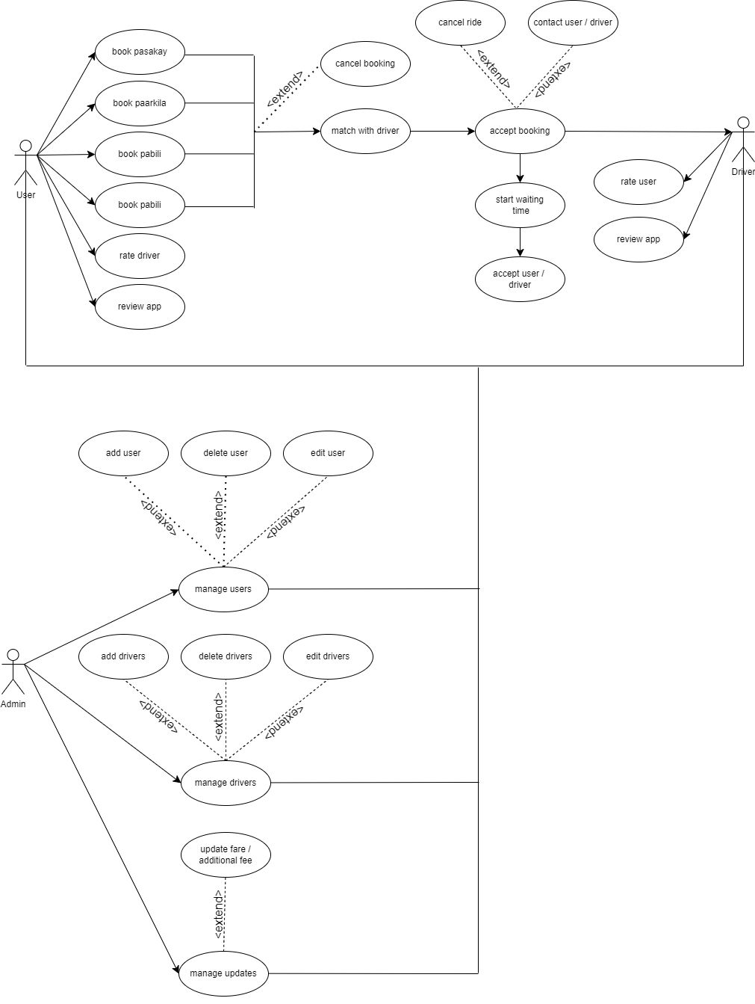

## Pasakay

|  |  |  |  |
| --- | --- | --- | --- |
| *3.2.1* | *Description* | *Allows the user to book a ride for a specific destination.* | |
| *Priority* | *High Priority* | |
| *3.2.2* | *Stimulus* | *User fills out the necessary form and clicks the "book" button.* | |
| *Response* | *The user will be matched with a driver and will have the option to cancel the ride.* | |
| *3.2.3* | *Functional*  *Requirements* | *REQ-1* | *User must choose the “pasakay” tab on the front page.* |
| *REQ-2* | *User must fill out the form provided.* |
| *REQ-3* | *User must click the “book” button.* |
| *3.2.4* | *Error / Invalid*  *Input* | *Stimulus 1* | *The user forgets to fill up some parts of the form.* |
| *Response* | *The app won’t proceed, and a driver won’t be matched to the user.* |

## Paarkila

|  |  |  |  |
| --- | --- | --- | --- |
| *3.2.1* | *Description* | *Allows customers to rent tricycles for personal use over a specified period.* | |
| *Priority* | *High Priority* | |
| *3.2.2* | *Stimulus* | *User fills out the necessary form and clicks the "book" button.* | |
| *Response* | *The user will be matched with a driver and will have the option to cancel the ride.* | |
| *3.2.3* | *Functional*  *Requirements* | *REQ-1* | *User must choose the “parkila” tab on the front page.* |
| *REQ-2* | *User must fill out the form provided.* |
| *REQ-3* | *User must click the “book” button.* |
| *3.2.4* | *Error / Invalid*  *Input* | *Stimulus 1* | *The user forgets to fill up some parts of the form.* |
| *Response* | *The app won’t proceed, and a driver won’t be matched to the user.* |

## Pabili

|  |  |  |  |
| --- | --- | --- | --- |
| *3.3.1* | *Description* | *Allows the user to request the purchase and delivery of items.* | |
| *Priority* | *High Priority* | |
| *3.3.2* | *Stimulus* | *User fills out the necessary form and clicks the "book" button.* | |
| *Response* | *The user will be matched with a driver who will purchase and deliver the items.* | |
| *3.3.3* | *Functional*  *Requirements* | *REQ-1* | *User must choose the “pabili” tab on the front page.* |
| *REQ-2* | *User must fill out the form provided.* |
| *REQ-3* | *User must click the “book” button.* |
| *3.3.4* | *Error / Invalid*  *Input* | Stimulus 1 | The user forgets to fill up some parts of the form. |
| *Response* | *The app won’t proceed, and a driver won’t be matched to the user.* |

## Padala

|  |  |  |  |
| --- | --- | --- | --- |
| *3.4.1* | *Description* | *Allows the user to send items to a specific destination* | |
| *Priority* | *High Priority* | |
| *3.4.2* | *Stimulus* | *User fills out the necessary form and clicks the "book" button.* | |
| *Response* | *The user will be matched with a driver who will deliver the items.* | |
| *3.4.3* | *Functional*  *Requirements* | *REQ-1* | *User must choose the “padala” tab on the front page.* |
| *REQ-2* | *User must fill out the form provided.* |
| *REQ-3* | *User must click the “book” button.* |
| *3.4.4* | *Error / Invalid*  *Input* | *Stimulus 1* | The user forgets to fill up some parts of the form. |
| *Response* | *The app won’t proceed, and a driver won’t be matched to the user.* |

## Accept Booking

|  |  |  |  |
| --- | --- | --- | --- |
| *3.5.1* | *Description* | *Allows a driver to accept a ride booking from a user.* | |
| *Priority* | *High Priority* | |
| *3.5.2* | *Stimulus* | *User books a ride.* | |
| *Response* | *Drivers are notified of the new booking and have the option to accept or reject the ride.* | |
| *3.5.3* | *Functional*  *Requirements* | *REQ-1* | *User must successfully book a ride.* |
| *REQ-2* | *Driver must accept the ride request.* |
| *3.5.4* | *Error / Invalid*  *Input* | *Stimulus* | *Driver is unavailable or rejects the ride request.* |
| *Response* | *The app won’t proceed, and a driver won’t be matched to the user.* |

## Rate User/Driver

|  |  |  |  |
| --- | --- | --- | --- |
| *3.6.1* | *Description* | *Allows users and drivers to rate each other after completing a ride.* | |
| *Priority* | *High Priority* | |
| *3.6.2* | *Stimulus* | *Booked ride is completed successfully.* | |
| *Response* | *A "rate user/driver" popup window will automatically appear.* | |
| *3.6.3* | *Functional*  *Requirements* | *REQ-1* | *User must successfully book a ride.* |
| *REQ-2* | *Driver must accept the ride request.* |
| *REQ-3* | *Booked ride must be completed.* |
| *3.6.4* | *Error / Invalid*  *Input* | *Stimulus 1* | *User cancels the ride.* |
| *Stimulus 2* | *Driver is unavailable or rejects the ride request.* |
| *Response* | *A "rate user/driver" popup window will not appear.* |

## Review Application

|  |  |  |  |
| --- | --- | --- | --- |
| 3.7.1 | Description | Allows users and drivers to provide reviews of the app. | |
| Priority | Medium Priority | |
| 3.7.2 | Stimulus | *User/Driver leaves a review of the app.* | |
| Response | The review will be displayed on the “Reviews” page in table form. | |
| 3.7.3 | Functional  Requirements | REQ-1 | *User/Driver must choose the “Reviews” tab on the left side of the page.* |
| REQ-2 | User/Driver must click the "+" button located on the lower right to leave a review. |
| REQ-3 | User/Driver must provide a review consisting of at least 1 to 100 words and then click the "submit" button. |
| 3.7.4 | Error / Invalid  Input | *Stimulus* | *User/Driver enters more than 100 words.* |
| *Response* | *“Submit” button cannot be clicked.* |

## Contact User/Driver

|  |  |  |  |
| --- | --- | --- | --- |
| *3.8.1* | *Description* | *Allows users and drivers to contact each other.* | |
| *Priority* | *Medium Priority* | |
| *3.8.2* | *Stimulus* | *User books a ride and Driver accepts the ride request.* | |
| *Response* | *A pop-up will appear, containing a "Contact" button, enabling them to contact each other.* | |
| *3.8.3* | *Functional*  *Requirements* | *REQ-1* | *User must successfully book a ride.* |
| *REQ-2* | *Driver must accept the ride request.* |
| *3.8.4* | *Error / Invalid*  *Input* | *Stimulus* | *Driver isn’t matched to a user.* |
| *Response* | *A pop-up with the "Contact" button will not appear.* |

## Cancel Ride

|  |  |  |  |
| --- | --- | --- | --- |
| *3.9.1* | *Description* | *Allows users and drivers to cancel a booked ride.* | |
| *Priority* | *Medium Priority* | |
| *3.9.2* | *Stimulus 1* | *User books a ride and ride request is pending (online booking and ride sharing only).* | |
| *Stimulus 2* | *User books a ride and Driver accepts the ride request.* | |
| *Response* | *A pop-up will appear, containing a "Cancel" button, enabling them to cancel the ride.* | |
| *3.9.3* | *Functional*  *Requirements* | *REQ-1* | *User must successfully book a ride.* |
| *REQ-2* | *Driver may have accepted the ride request, or ride request is still pending.* |
| *3.9.4* | *Error / Invalid*  *Input* | *Stimulus* | *The user forgets to fill up some parts of the form. (online booking and ride sharing only)* |
| *Response* | *A pop-up with the "Cancel" button will not appear.* |

## Waiting Timer

|  |  |  |  |
| --- | --- | --- | --- |
| *3.10.1* | *Description* | *Allows users and drivers to track the waiting time, and extended waiting time results in an additional charge.* | |
| *Priority* | *High Priority* | |
| *3.10.2* | *Stimulus* | *User successfully books a ride and is matched with a driver.* | |
| *Response* | *A pop-up will appear, containing the waiting timer, enabling them to track the time.* | |
| *3.10.3* | *Functional*  *Requirements* | *REQ-1* | *User must successfully book a ride.* |
| *REQ-2* | *Driver must accept the ride request.* |
| *REQ-3* | *User must be matched with a driver.* |
| *REQ-4* | *Driver must be at the “current location” of the user.* |
| *3.10.4* | *Error / Invalid*  *Input* | *Stimulus* | *User/Driver cancels the ride.* |
| *Response* | *A pop-up with the waiting timer will not appear.* |

## Locate User/Driver

|  |  |  |  |
| --- | --- | --- | --- |
| *3.11.1* | *Description* | *Allows users and drivers to locate each other.* | |
| *Priority* | *Medium Priority* | |
| *3.11.2* | *Stimulus* | *User successfully books a ride and is matched with a driver.* | |
| *Response* | *A pop-up will appear, containing the “Locate User/Driver” button, enabling them to track the one another.* | |
| *3.11.3* | *Functional*  *Requirements* | *REQ-1* | *User must successfully book a ride.* |
| *REQ-2* | *Driver must accept the ride request.* |
| *REQ-3* | *User must be matched with a driver.* |
| *REQ-4* | *Driver must be at the “current location” of the user.* |
| *3.11.4* | *Error / Invalid*  *Input* | *Stimulus* | *User/Driver cancels the ride.* |
| *Response* | *A pop-up with the “Locate User/Driver” button will not appear.* |

# External Interface Requirements

## User Interfaces

The user interfaces for the Hail-a-Tryc app are designed to provide a visually appealing and user-friendly experience. Here are the app's user interface:

**Screen Images:**

* User Screen Images
* Driver Screen Images
* *Admin Screen Images*

**GUI Standards and Product Family Styles:**

* **Font Style** – The app uses the "**Agbalumo**" font style to create a bolder look for headlines and titles, while "**Abril Fatface**" is used for subtitles. “**Alike Angula**r” is used for simple text and other contents of the app.
* **Color Scheme** – The color scheme is chosen to create a vibrant and eye-catching look, inspired by the colors of the Philippine flag.
  + **International Klein Blue (0032A0)** – A deep blue color
  + **Creative Red (BF0D3E)** – A vibrant red color.
  + **Sunglow (FED141)** – A medium light shade of yellow color.
  + **White and Black** – The classic colors.
* **Logo**



**Standard Buttons and Functions:**

The app uses standard buttons and functions for ease of use and navigation, including:

* **Booking Forms** (User) – Users can input their ride details and preferences in these forms.
* **Book Button** (User) – This button allows users to confirm their booking after providing the necessary information.
* **Cancel Button** (User and Driver) – Both users and drivers have the option to cancel a booking if needed.
* **Contact Button** (User and Driver) – Users and drivers can access contact information or support through this button.
* **Locate Button** (User and Driver) – The Locate Button helps users and drivers determine their current location.
* **Accept/Reject Button** (Driver) – Drivers can use this button to either accept or reject incoming ride requests, ensuring quick and efficient responses to booking requests.

## Hardware Interfaces

Hail-a-Tryc is a mobile application accessible for download on iOS devices through the Apple App Store and on Android devices through the Google Play Store. The app operates by gathering data from user inputs and button selections within the application. These interactions with the software are essential for it to perform effectively on their respective devices, enabling a seamless and responsive user experience.

## Software Interfaces

|  |  |  |  |
| --- | --- | --- | --- |
| **Category** | **Software / IDE / Programming Language** | **Specifications** | **Purpose** |
| Prototype Design | Figma | Figma 2024 version 116.17.12 | Figma will be used to create a prototype and UI/UX design of the system. |
| System Development | Visual Studio Code IDE  **Frontend:**  Flutter framework  Dart Programming Language  **Backend:**  **Supabase**  **Database** | Visual Studio Code IDE version 1.88 pt 2023  Flutter 3.19.0  Dart 3.5.0-136.0.dev  Supabase Database version 2.43.2 | VS Code supports Dart using Flutter Framework and firebase for database.  Supabase is an open-source Firebase alternative. It provides a real-time database and authentication, which will be used to store and manage the relevant information for the application.  With this, the IDE can be used to construct the proposed web app. |

## Communications Interfaces

*The app facilitates communication between the user and the driver. The chat box becomes available only when a ride is booked.*

# Other Nonfunctional Requirements

## Performance Requirements

*The user who has at least 25Mbits internet connection speed, shall be able to enter a page of the system in less than 1 second.  As recorded in the Philippines for mobile data, Users with an internet connection speed of at least 25.63 Mbps, should experience rapid page loading within a fraction of a second, as indicated by Ookla's data [8].*

*The system shall be able to respond to more than one hundred users simultaneously.*

*The system shall be able to keep user information of more than one hundred users.*  
   
*The app must ensure fast response times for user requests to deliver a smooth and efficient experience. When a user requests a ride, the app should provide a response within 3 seconds or less, on average, to keep users engaged and satisfied. Quick response times enhance the usability of the app and ensure users can find and book rides without delays. The faster response times also support the app's reliability, ensuring that users can quickly connect with drivers and reach their destinations on time.*

## Safety Requirements

The application must have a solid plan for dealing with catastrophic database failures to protect user data and ensure uninterrupted service. In case of major issues like a severe disk crash or hardware failure, the app should be able to recover the data from regular backups and reconstruct the most recent state by reapplying confirmed transactions. This process should maintain service without compromising the safety and integrity of user data. It should also be tested regularly to ensure it works as intended.

## Security Requirements

The application must ensure that it fully aligns with local data protection regulations such as the Data Privacy Act of the Philippines, respecting the privacy of user data. This means that all user data is handled with care and in compliance with the law. Hail-A-Tryc provides clear information to users about how their data is used, and they have the right to access, correct, or remove their data.

## Software Quality Attributes

* ***ADAPTABILITY*** – *The mobile application should be adaptable to constantly changing business needs and user requirements.*
* ***AVAILABILITY*** – *The mobile application must be available 24/7 to accommodate users’ needs.*
* ***CORRECTNESS*** – *The mobile application must provide an updated map and accurate fare rates.*
* ***FLEXIBILITY*** – *The mobile application should be flexible in tracking the time and effort required to introduce new features or change existing ones.*
* ***INTEROPERABILITY*** – *The mobile application must operate smoothly and consistently on both iOS and Android operating systems to provide a seamless user experience across the two major platforms.*
* ***MAINTAINABILITY*** – *The developers should be able to easily update, fix, and enhance the application.*
* ***PORTABILITY*** – *The mobile application must ensure that the application works well on iOS and Android with consistent user experience.*
* ***RELIABILITY*** – *The mobile application should connect users with drivers and provide accurate estimated arrival times and fare rates.*
* ***REUSABILITY*** – *The mobile application must enable developers to reuse code and features in various parts of the application.*
* ***ROBUSTNESS*** – *The mobile application should handle unexpected situations like network disconnections or device errors.*
* ***TESTABILITY*** – *The mobile application must be easily testable to identify and fix issues during development and maintenance.*
* ***USABILITY*** – *The mobile application must ensure that users can easily request a ride and navigate through the app.* .

# Other Requirements

* **Database requirement** – The database should be able to handle large amounts of data since it collects data from all the tricycle drivers of a city/province, and all the ride history.
* **Internationalization requirements –** The app must have good scalability to be available for use in other locations.
* **Legal requirements –** The app must comply with all laws and regulations, including data privacy laws and transportation laws.
* **Reuse objectives** – The app may be able to be reusable for other projects requiring similar parts.

Appendix A: Glossary

* ***Figma*** *– Figma is a software that enables real-time collaboration for building interactive user interface prototypes.*
* ***SRS*** *– Acronym for Software Requirements Specification that is used to describe what the software will do and how it will be expected to perform.*
* ***Supabase*** *– An open-source Firebase alternative providing backend features such as data storage, authentication, real-time capabilities, customization, and community support.*
* ***Visual Studio Code –*** *A programming environment or integrated development environment (IDE) that supports various extensions including flutter and dart.*
* ***Dart*** *– Is an object-oriented programming language that supports concepts like classes, objects, inheritance, and polymorphism, allowing developers to structure their code in a modular and organized manner.*
* ***Flutter*** *– Is a UI framework for creating native mobile apps. It allows developers to build a mobile app using a single codebase while helping quickly build iOS and Android apps.*
* ***HTTPS*** *– Is the secure version of HTTP, which is the primary protocol used to send data between a web browser and a website. HTTPS is encrypted in order to increase security of data transfer.*

Appendix B: Analysis Models

Context Model

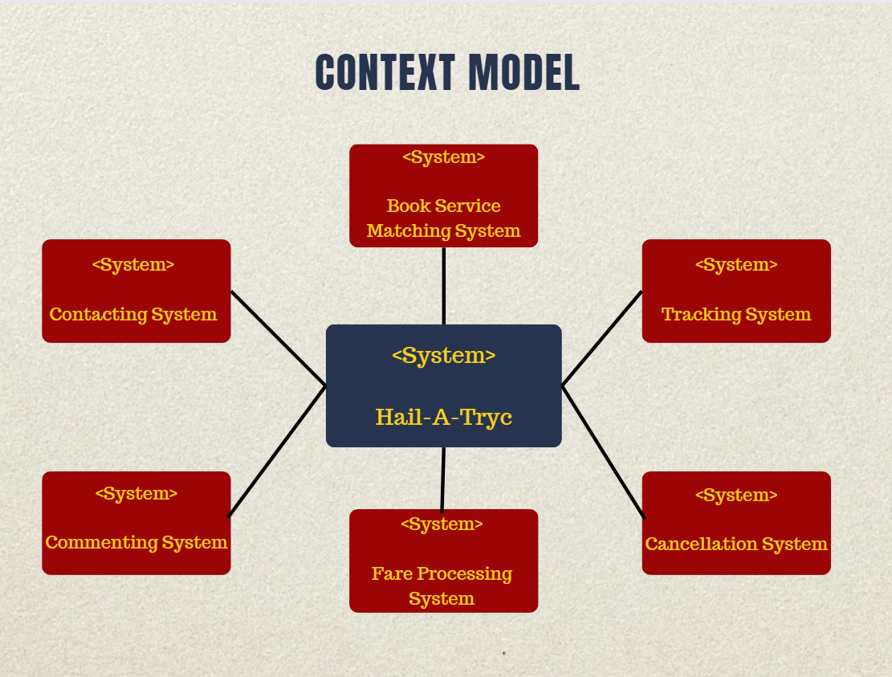

Database Model

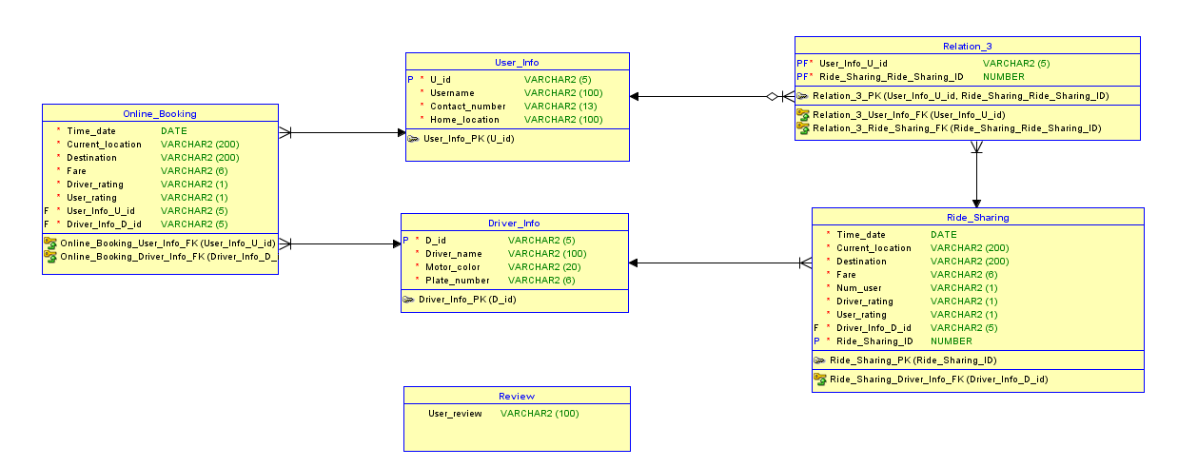

Process Model

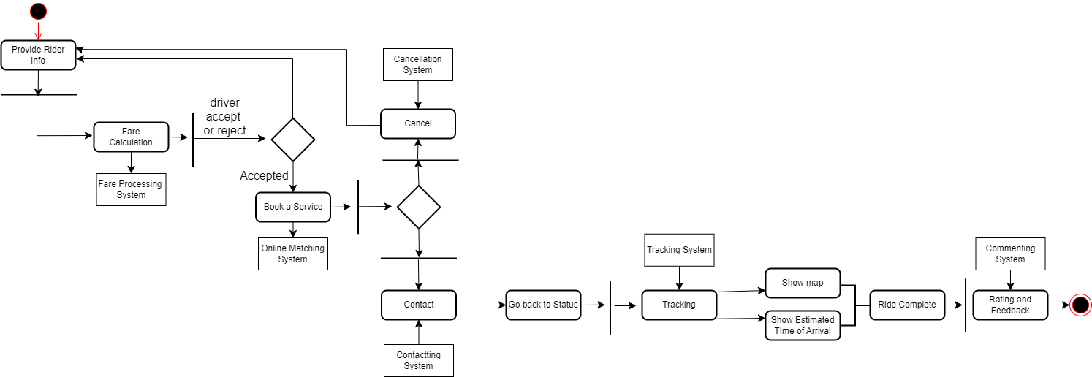

Case Model



Class Diagram

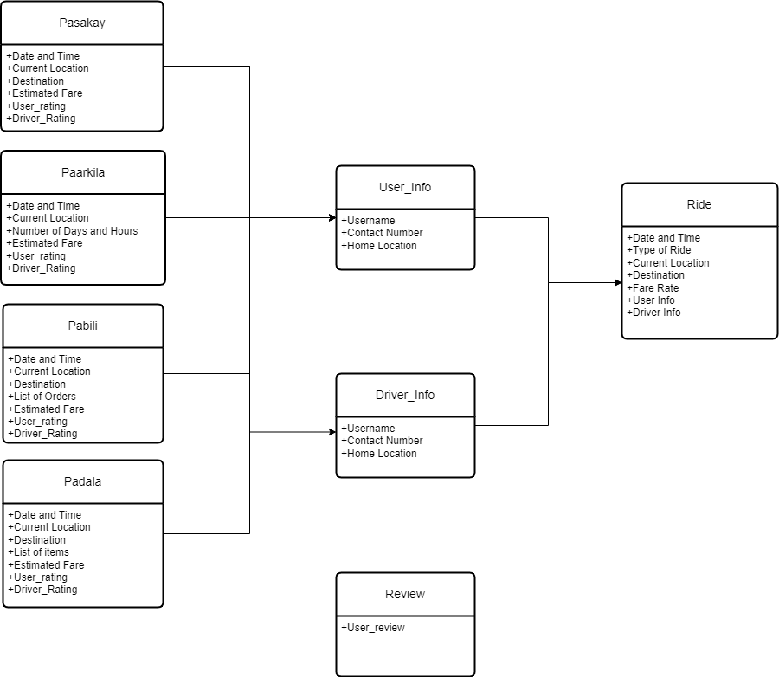

Appendix C: Issues List

This is the dynamic list of the open requirements issues that remain to be resolved:

* The application should be able to ask the user to answer unfilled parts of the form before proceeding with the ride.
* The application should be able to handle cancellation of rides properly without it being a hassle to both user and driver.
* The application should be able to prevent the use of ride sharing in areas where there are not enough users
* The app should be able to give reasonable fare calculations that will benefit both user and driver.