PRD: Module Outputs in Reports & Analytics
Prototype: Reports & Analytics, Today vs After change
Product: Frinks Edge
Status: In review
Date: 20 October 2026
Owner: Tanay Deo
Related: FP-528 (open epic: Analytics & Reports menu). Earlier Reports work: FP-3715 (Raw Images column, Download popup), FP-3622 (Cycle Complete column), FP-3727 (Write to DB custom key)
Code checked: 20 October 2026 — 34 repos at their latest default-branch commit (list in Appendix B)
————————————————————

1. Summary
- Reports & Analytics gets a Module Outputs button. It opens a setup window for the selected instance, listing every capture (grouped by variant) and every value its modules report.
- The person ticks the values they want and can rename each one, for example "Detected text" to "Serial No.".
- After saving, a new Module Outputs column shows the ticked values on each capture's row as Name: value lines, such as Screw count: 4 or Slot 1 class: Good.
- Values come from the results Edge already stores with every cycle, so past cycles show them too. Changing the setup changes what every cycle shows, straight away, with no redeploy.
- Values are offered for object detection, image classification, OCR, code reader, segmentation, bead inspection, colour detection, shape extractor, single-capture dimensions and orientation & tilt check. Only what each module outputs is shown: no winning class and no default text.
- The column is searchable with the existing Search box and exported to Excel as one "Module Outputs" column.
- Saving the setup needs the existing Update permission on Analytics & Reports. Everyone who can view Reports sees the column.

2. Why we are making this
- Today: Reports & Analytics shows only Pass or Fail for each cycle and each capture. To see why a capture failed (how many screws were found, which class a slot got, what serial number or code was read), someone has to open View JSON. It shows raw ids, one cycle at a time. The Class Name and Class Count columns show object counts only, show nothing for image classification, and never show read text or codes. The only workaround is one Write to DB rule per value. That gives one value per cycle (not per capture), and only for cycles run after the rule was made. Quality engineers, plant admins and support teams are affected.
- Evidence: customer request, and parity with competing inspection systems that show tool results next to each part.
- After: someone sets up once, per instance, which module values to show. A "Module Outputs" column then shows them as readable pairs, such as "Screw count: 4" or "Serial No.: SN-48213", for each capture of every cycle, on screen and in the Excel export.

3. Goals and non-goals
Goals
- G1. Inside Reports & Analytics, choose which values each capture's modules show, and what each value is called.
- G2. Show the chosen values as name: value pairs in a new "Module Outputs" column, per capture, for every cycle, including cycles stored before the setup.
- G3. Cover every module type that outputs a value.
- G4. The column works with the existing Search box and appears in the Excel export.
Non-goals
- New search or filter controls for module values. The existing Search box is enough.
- Fast Mode lines (Minute-wise), which store no per-capture results.
- Values a module does not output today: the winning class of single-class segmentation, the default text of conditional classification, bead width in pixels, per-caliper widths.
- Any change to how OK or NG is decided, or to PLC and dashboard keys.

4. Key concepts
- Module output: one value a module reports for a capture, shown as a pair such as "Screw count: 4".
- Module Outputs setup: the per-instance choice of which module outputs show in Reports, and the name each one shows under.
- Auto name: the name a value gets from the module's own names (class, search area, OCR label, bead, colour, shape or dimension name) until someone renames it.

5. Impact map
The parts this changes. Parts checked and not affected are listed at the very end.
Part | What will happen | User stories
Reports & Analytics (edge-reports-analytics) | New Module Outputs button and setup window; new Module Outputs column on each capture row; new Edit Table option; new Excel column; the column is searchable | US1, US2, US4, US5, US8
Edge access & audit (edge-access-audit) | Saving the setup needs Update on Analytics & Reports, checked by the report server; every save is written to the audit log | US7
Object Detection (mod-odc) | Each ticked output class offers its count and result | US3, US9
Image Classification (mod-classification) | Each search area offers its predicted class, confidence and result | US3, US9
OCR (mod-ocr) | Offers all detected text in reading order; in Read & Match, each label's text and result | US3, US9
Code Reader (mod-code-reader) | Offers the decoded code and its result | US3, US9
Segmentation (mod-segmentation) | Each ticked class offers its region count; also the classes found and the result | US3, US9
Bead Inspection (mod-bead-inspection) | Offers the bead result, caliper pass %, incorrect calipers, and per-bead result, gaps and width fails | US3, US9
Colour Detection (mod-color-detection) | Each colour offers its coverage % and result | US3, US9
Shape Extractor (mod-shape-extractor) | Each shape offers its measurements in px and its fit; each single-capture dimension offers its value, expected range and result | US3, US9
Orientation & Tilt (mod-orientation) | Offers the tilt angle, allowed range and result | US3, US9
Tracker (mod-tracker) | Not offered: the tracker produces no result on Edge today | US3
Matting (mod-matting) | Not offered: its mask count is of little use in a report | US3
Instance upload on Edge (edge-instance-details) | A re-upload keeps the setup; removed captures, modules and classes drop out of it; deleting the instance deletes it | US6, US11
Edit Module Configurations (edge-emc) | Edits keep the setup; the values offered follow the current module settings | US6
Cycles and result storage (edge-inferencing-customization) | No change: Edge keeps storing every module's result for every capture, which is what the column reads | US9
Python engine (engine-workflow) | No change: results are produced and sent exactly as today | US9
Result module (mod-result) | No change: OK and NG are decided exactly as today | US9
Actions (edge-actions) | Write to DB rules that copy values into Additional Info columns keep working | US8
Deployments (edge-deployment) | Fast Mode deployments get no Module Outputs, as they store no per-capture results | US8
Health Monitoring (edge-health) | No new per-cycle data, so storage cleanup is unchanged | US8
Backup and migration (edge-backup-migration) | The saved setup is created on upgrade and survives every later upgrade | US11
Release and upgrades (edge-release-upgrade) | Ships in the scripts bundle as a normal release, with one database addition | US10

6. User stories and acceptance criteria

US1 — Open the Module Outputs setup
As a quality engineer, I want one place in Reports to choose which module values to show, so that I don't have to open View JSON for every cycle.
- Kind: Feature
- Parts: edge-reports-analytics
- Teams: SDE
- Covers: C2, C5, C10, C13
- Today: Reports has Edit Table, Download, Filter and Refresh buttons. Module values can only be read in View JSON, as raw ids, one cycle at a time.
- Prototype: Setup window
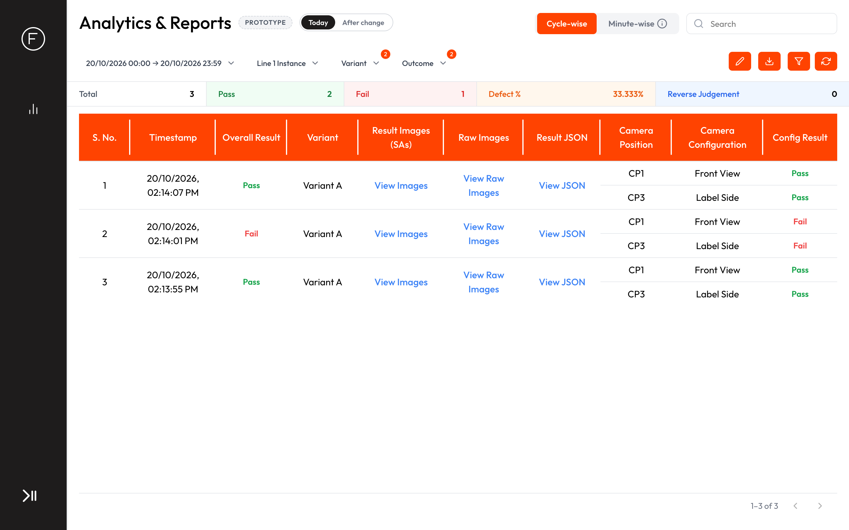
Today: no way to choose module values
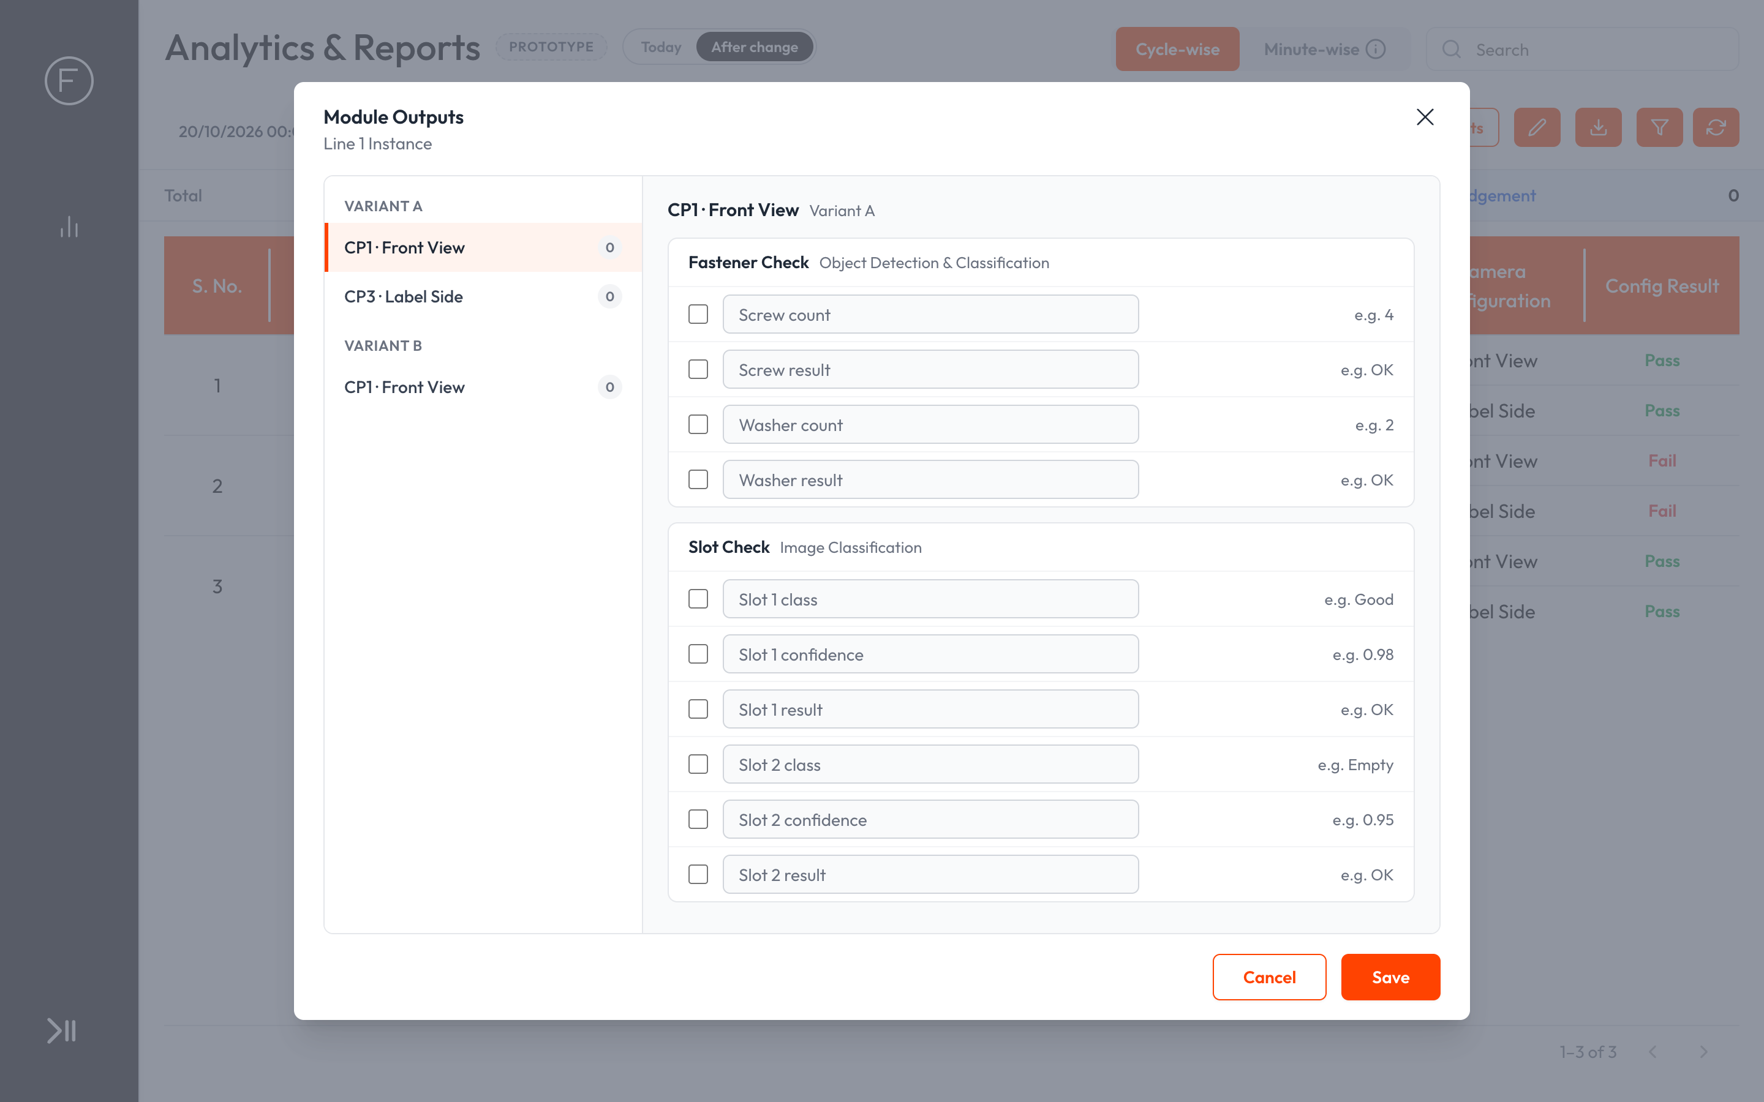
After: the Module Outputs window, first time, nothing ticked
- AC1.1 On the Cycle-wise tab, a "Module Outputs" button sits to the left of the Edit Table, Download, Filter and Refresh buttons. It is not shown on the Minute-wise tab.
- AC1.2 The button is disabled until an instance is selected, with the hover text "Select an instance first".
- AC1.3 Clicking it opens the "Module Outputs" window for the selected instance, with the instance name under the title. On the left, every capture of the instance is listed under its variant as "<capture position> · <capture name>", each with a count of its ticked values. On the right, the selected capture's modules are shown, one card each with the module name and type, listing every value that module offers (US3).
- AC1.4 Only modules that offer values are listed. A capture whose modules offer none shows "No module outputs for this capture".
- AC1.5 The setup can be opened and saved whether the instance is deployed, running or stopped. Saved changes show in Reports at once, with no redeploy.
- AC1.6 If the setup cannot be loaded, the window shows "Module Outputs could not be loaded (RPT-MOUT-002)", and the table keeps working without the Module Outputs column.

US2 — Choose and name the values
As a quality engineer, I want to tick the values I care about and give them names my team knows, so that the report reads like our own checklist.
- Kind: Feature
- Parts: edge-reports-analytics
- Teams: SDE
- Covers: C2, C3, C4, C5, C13
- Today: Nothing to choose or name.
- Prototype: Setup with a renamed value
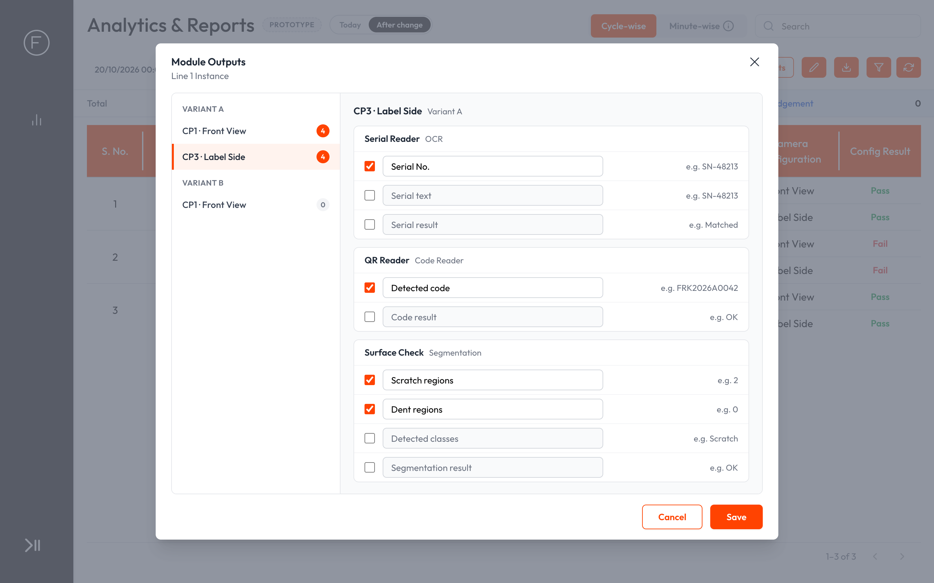
After: three values ticked, Detected text renamed to Serial No.
- AC2.1 The first time the setup is opened for an instance, nothing is ticked, and the table has no Module Outputs column.
- AC2.2 Each value has a tick box, a name field filled with its auto name, and an example value.
- AC2.3 Auto names are built from the module's own names, as listed in US3. While a value has not been renamed, its name follows the current class, search area, label, bead, colour, shape or dimension name on the box.
- AC2.4 A name can be edited. Clearing it brings back the auto name. Names are up to 40 characters and must be unique within a capture. A duplicate shows "Name already used in this capture" under the field, and Save stays disabled until it is fixed.
- AC2.5 Save stores the setup, closes the window, shows "Module Outputs saved", and the table updates at once. Cancel or the close (×) button discards unsaved changes.
- AC2.6 If saving fails, the window stays open with the person's choices and shows "Module Outputs could not be saved (RPT-MOUT-001)". The setup saved earlier is unchanged.
- AC2.7 When two people change the setup at the same time, the last save wins.
- AC2.8 The setup belongs to the instance and is shared by everyone on the box: anyone who opens Reports for that instance sees the same column. Two instances of the same project keep separate setups.

US3 — Values each module offers
As a quality engineer, I want each module to offer the values it actually outputs, under clear names, so that I can read why a capture passed or failed.
- Kind: Feature
- Parts: mod-odc, mod-classification, mod-ocr, mod-code-reader, mod-segmentation, mod-bead-inspection, mod-color-detection, mod-shape-extractor, mod-orientation, mod-tracker, mod-matting
- Teams: SDE
- Covers: C2, C12
- Today: These values sit inside each cycle's stored result, keyed by ids, and are visible only in View JSON. Class Count shows object counts only.
- Prototype: Other module types
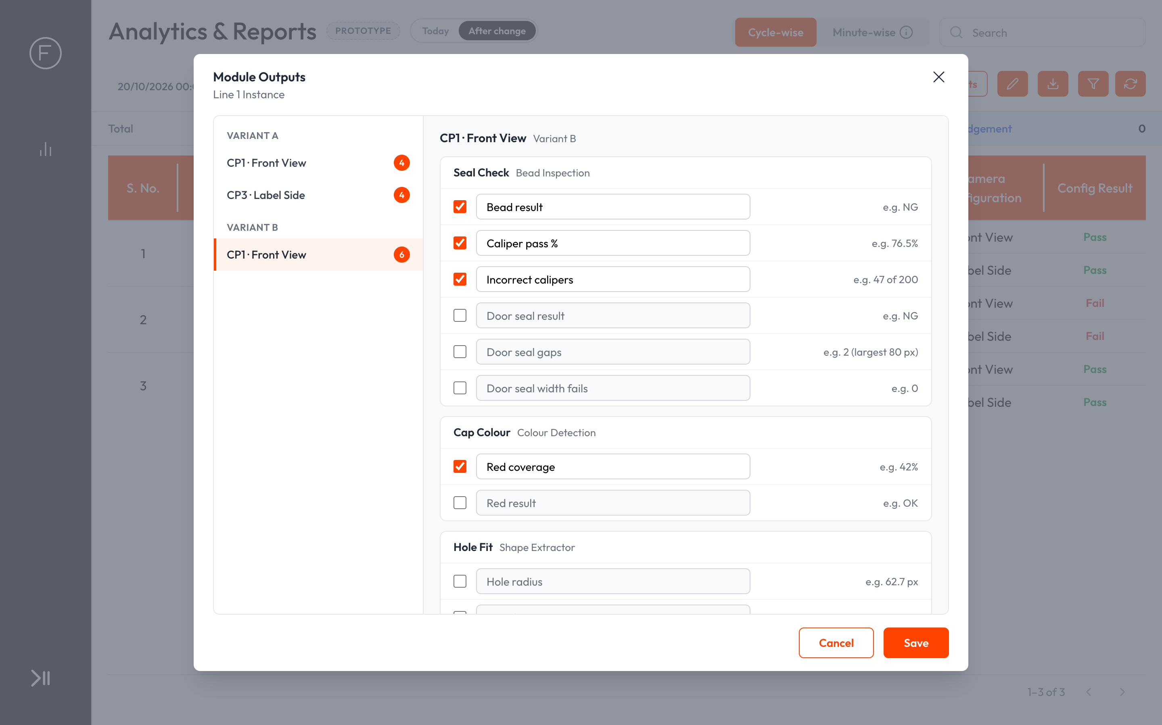
After: bead and colour values offered for a capture
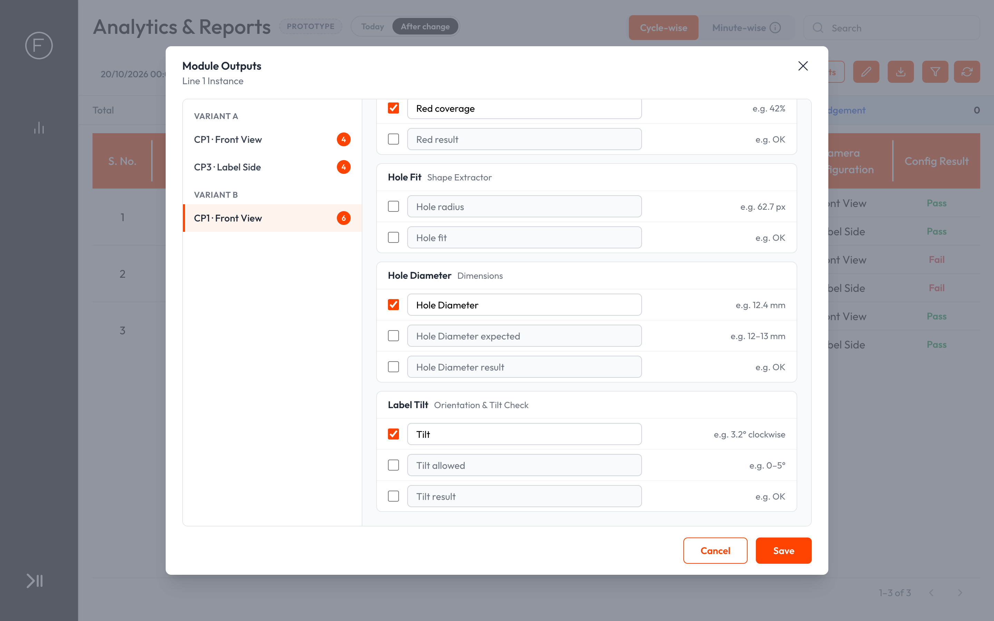
After: shape, dimension and tilt values for the same capture
- AC3.1 Object Detection & Classification offers, for each class ticked in the module's outputs: "<Class> count" (number found) and "<Class> result" (OK or NG). Classes not ticked in the module's outputs are not offered, because they are not judged or stored.
- AC3.2 Image Classification offers, for each search area: "<Search area> class" (predicted class name), "<Search area> confidence" (0 to 1) and "<Search area> result" (OK or NG). When no class wins in conditional mode, the class shows "—".
- AC3.3 OCR offers "Detected text": all text read, in reading order (top to bottom, then left to right), with a space between pieces. In Read & Match it also offers, for each label, "<Label> text" (the text matched to that label) and "<Label> result" (Matched or Not matched).
- AC3.4 Code Reader offers "Detected code" (the decoded text) and "Code result" (OK or NG).
- AC3.5 Segmentation offers, for each class ticked in the module's outputs: "<Class> regions" (number of separate regions found). It also offers "Detected classes" (names of the classes with at least one region, comma-separated) and "Segmentation result" (OK or NG). No winning class and no default text are shown.
- AC3.6 Bead Inspection offers "Bead result" (OK or NG), "Caliper pass %" and "Incorrect calipers" (for example "47 of 200"). For each bead it offers "<Bead> result" (OK, or NG with "gap" or "width" as the reason), "<Bead> gaps" (count and largest gap in px) and "<Bead> width fails" (number of calipers failing the width check).
- AC3.7 Colour Detection offers, for each colour: "<Colour> coverage" (percentage of the region) and "<Colour> result" (OK or NG).
- AC3.8 Shape Extractor offers, for each shape, the measurements its shape type gives, in px, named "<Shape> <measurement>" (for example radius, area and perimeter for a circle; length and angle for a line), and "<Shape> fit" (OK or Failed).
- AC3.9 Each dimension measured within one capture offers "<Dimension>" (measured value with its unit), "<Dimension> expected" (the rule, for example "12–13 mm") and "<Dimension> result" (OK or NG), under the capture it belongs to.
- AC3.10 Orientation & Tilt Check offers "Tilt" (signed degrees with direction, for example "3.2° clockwise"), "Tilt allowed" (the range) and "Tilt result" (OK or NG).
- AC3.11 Tracker, Matting, Orientator, Masking, Search Area Allocator, the master image and dimensions measured across captures offer no values and are not listed in the setup.
- AC3.12 Numbers show with up to 2 decimals, in the module's own unit (px, mm, %, °). Results show as "OK" or "NG".

US4 — See Module Outputs in the table
As a quality engineer, I want each capture's chosen values on its row, so that I can see at a glance why a cycle failed or which part it was.
- Kind: Feature
- Parts: edge-reports-analytics
- Teams: SDE
- Covers: C5, C6, C12, C16
- Today: Each capture row shows only Camera Position, Camera Configuration and Config Result (Pass or Fail). Class Name and Class Count show object counts only.
- Prototype: Table with Module Outputs
Today: capture rows show only Pass or Fail
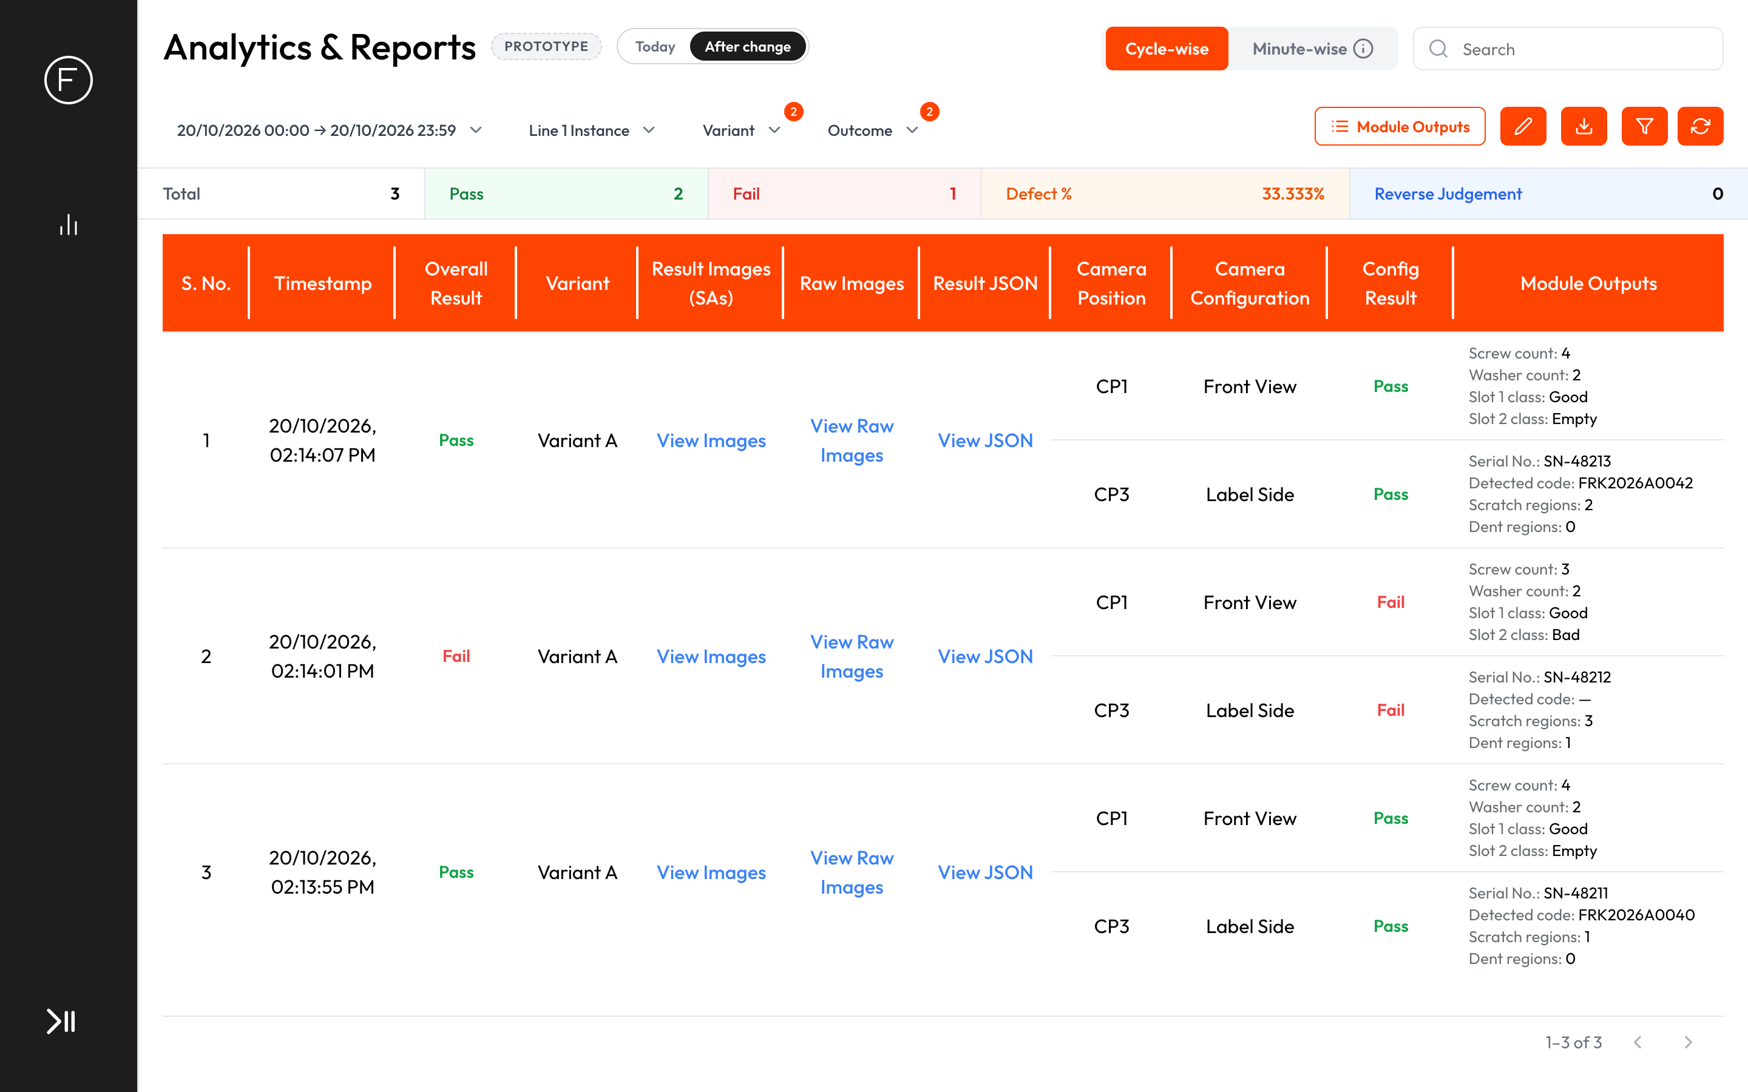
After: the Module Outputs column with each capture's values
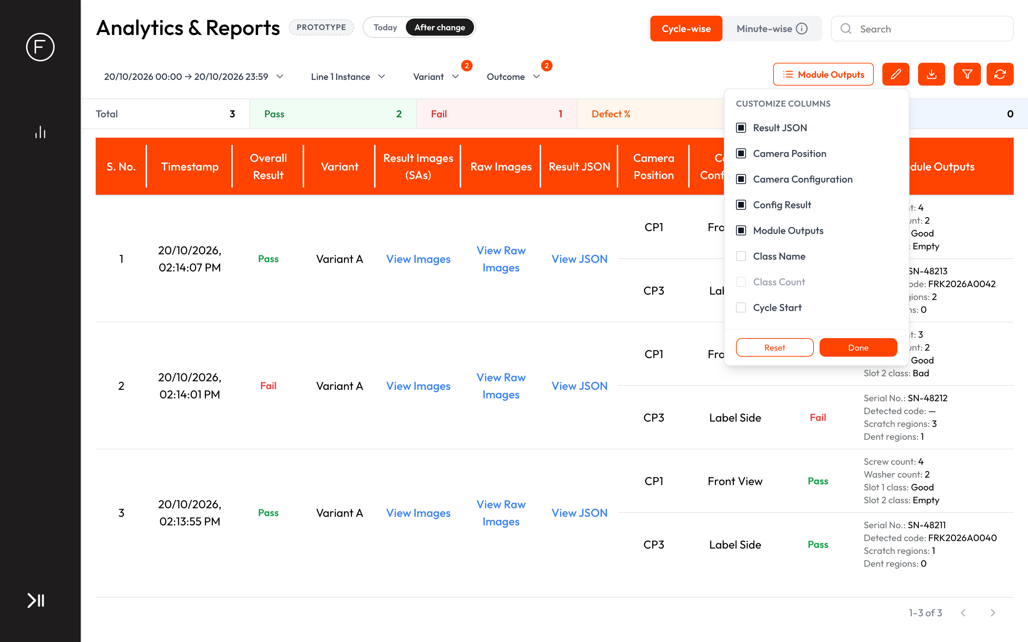
After: Module Outputs in Edit Table, after Config Result
- AC4.1 After the first save, a "Module Outputs" column appears as the last per-capture column, after Config Result, and Camera Position and Camera Configuration are turned on with it.
- AC4.2 Each capture row shows its ticked values, one per line, as "Name: value", in the order of the setup (module order, then value order).
- AC4.3 Values are read from the results already stored with each cycle. Cycles stored before the setup, and before this release, show values too. Changing the setup changes what every cycle shows.
- AC4.4 For a capture triggered more than once in a cycle, the values come from the latest attempt, the same attempt Config Result shows.
- AC4.5 A value with nothing found (no text read, no code decoded) shows "—"; a count of zero shows "0". A module that did not run on that image (its search area was not found) shows "Not run" for its values. A capture with nothing ticked shows "N/A". A stored result that lacks the value (for example one saved by an older Edge version) shows "—", never an error.
- AC4.6 Once set up, Edit Table lists "Module Outputs" after Config Result. Unticking it hides the column. While it is ticked, Camera Position and Camera Configuration cannot be turned off, as with Config Result today. Edit Table choices stay shared for the whole box, as today.
- AC4.7 The existing Search box also matches text in the Module Outputs column, the same way it matches the other visible columns on the page. No new search or filter controls are added.
- AC4.8 Text read from parts (OCR text, codes) is shown exactly as read, as plain text, never as a link or formatted content.

US5 — Module Outputs in the Excel export
As a quality engineer, I want the same values in the Excel, so that I can share and analyse them outside Edge.
- Kind: Feature
- Parts: edge-reports-analytics
- Teams: SDE
- Covers: C8, C12, C16
- Today: The Excel has Class Name and Class Count columns only. Image classification rows come out blank, and read text and codes are never exported.
- AC5.1 When the column is visible, "Report (Excel Sheet)" gets a "Module Outputs" column after Config Result, with one cell per capture row holding the same "Name: value" lines as the screen, separated by line breaks.
- AC5.2 When the column is hidden in Edit Table, it is not exported, as with every other column today.
- AC5.3 Values are written as text. A value that starts with =, +, - or @ is never treated as a formula.
- AC5.4 Export limits and filters are unchanged: up to 100,000 cycles still export with the column on, and the time, instance, variant, outcome, class and additional-info filters apply.

US6 — The setup follows the instance
As a plant admin, I want the setup to survive instance updates and Edge-side edits, so that I set it up once.
- Kind: Feature
- Parts: edge-instance-details, edge-emc
- Teams: SDE
- Covers: C3, C11
- Today: No setup exists.
- AC6.1 Re-uploading the instance from Vision keeps the setup, including renamed values.
- AC6.2 Captures, modules, classes, search areas or labels removed by a re-upload drop out of the setup, and their values stop showing. New ones appear unticked.
- AC6.3 Saving changes in Edit Module Configurations (for example switching OCR between Read and Read & Match, or changing ground truth or thresholds) keeps the setup. The values offered follow the current module settings, and a ticked value that is no longer offered (for example a label's values after switching to Read) drops out.
- AC6.4 Deleting the instance deletes its setup.

US7 — Who can do this
As a plant admin, I want only trusted people to change what Reports show, so that the shared view stays reliable.
- Kind: Rules
- Parts: edge-access-audit, edge-reports-analytics
- Teams: SDE
- Covers: C1, C16
- AC7.1 No role or permission changes. Saving the setup needs the existing Update level on Analytics & Reports, the same as Mark and Comment. Administrator always can.
- AC7.2 Without Update, the Module Outputs button is disabled, with the hover text "Needs Update permission on Analytics & Reports". The column is still shown to everyone who can view Reports.
- AC7.3 The report server refuses a save without Update, with the existing "Update on Analytics and Reports" message, even if the request does not come from the screen.
- AC7.4 With Roles & Permissions switched off on the box, everyone can change the setup, as with Mark and Comment today.
- AC7.5 Each save is written to the audit log as "Module Outputs updated", with the user, time and instance (shown as "Guest" when Roles & Permissions is off).
- AC7.6 Viewing and exporting Module Outputs follow today's rules for viewing and exporting reports, which are open to everyone.

US8 — Reports & Analytics keeps working as today
As a quality engineer, I want everything I use in Reports today to stay as it is.
- Kind: Keeps working
- Parts: edge-reports-analytics, edge-actions, edge-deployment, edge-health
- Teams: SDE
- Covers: C9, C12
- AC8.1 Every existing column, including Class Name, Class Count, Config Result and the Additional Info columns, shows the same values as before.
- AC8.2 View Images, View Raw Images, View JSON, Mark (Reverse Judgement) and Comment work as before.
- AC8.3 Write to DB rules that copy module values into Additional Info columns keep working alongside Module Outputs.
- AC8.4 The Minute-wise tab and Fast Mode deployments are unchanged. Module Outputs is not offered there, because Fast Mode stores no per-capture results.
- AC8.5 Filters, the Download popup ("Report (Excel Sheet)" and "Images Only") and its size checks work as before.
- AC8.6 Storage cleanup keeps deleting the oldest results as today. Module Outputs stores no extra data per cycle, so nothing new needs cleaning up.

US9 — Inspection results keep working as today
As an integrator, I want inspection, verdicts and PLC signals untouched, so that the line runs exactly as before.
- Kind: Keeps working
- Parts: edge-inferencing-customization, engine-workflow, mod-result, mod-odc, mod-classification, mod-ocr, mod-code-reader, mod-segmentation, mod-bead-inspection, mod-color-detection, mod-shape-extractor, mod-orientation
- Teams: SDE
- Covers: C8, C9
- AC9.1 OK and NG for every capture and cycle, PLC writes and dashboard keys are unchanged.
- AC9.2 Edge keeps storing each module's full result for every capture of every cycle, exactly as today. This is the data the column reads.
- AC9.3 Cycle time and per-image processing are unchanged. Module Outputs does its work only when Reports are viewed or exported.

US10 — Platform requirements
As a Frinks support engineer, I want to know what ships and how, so that the release goes out like any other.
- Kind: Platform
- Parts: edge-release-upgrade, edge-reports-analytics
- Teams: SDE
- Covers: C13, C17, C18
- AC10.1 Node Docker image: no change. No new libraries are needed; the Excel export already has one.
- AC10.2 Python Docker image: no change. The engine is not touched.
- AC10.3 Scripts bundle: changes. It carries the Reports app (screen and server) and the Edge database addition that holds the setup.
- AC10.4 Installer: no change. Database additions already run on every install and update.
- AC10.5 New error codes: RPT-MOUT-001 "Module Outputs could not be saved" and RPT-MOUT-002 "Module Outputs could not be loaded". The report server logs them and the window shows them. They are not added to the Health page.
- AC10.6 The Edge manual's Analytics & Reports section describes the Module Outputs button, the setup window, the column and the Excel column, with new screenshots. Release note: "Reports & Analytics can now show chosen module values, such as counts, classes, read text and codes, in a new Module Outputs column, for past and new cycles."

US11 — Migration requirements
As a Frinks support engineer, I want upgrades to keep every box's data and setup, so that no plant loses its reports or has to set them up again.
- Kind: Migration
- Parts: edge-backup-migration, edge-instance-details
- Teams: SDE
- Covers: C6, C7, C15
- AC11.1 Existing data: after the upgrade every instance starts with no setup and no column. Once set up, cycles stored before the upgrade show their values. No stored result is changed or moved.
- AC11.2 The saved setup survives restarts and every later Edge upgrade. The database update replayed at each upgrade must not erase or reset it.
- AC11.3 An older Edge with a new instance: nothing changes, because the instance package is not touched. The new Edge with an older instance: Module Outputs works, and values missing from older stored results show "—".
- AC11.4 Edge boxes in the field get it as a normal release with no data migration. It works offline, and timestamps are unchanged.

7. Out of scope
- New search or filter controls for module values.
- Values modules do not output today: the single-class segmentation winner, conditional classification default text, bead width in px, per-caliper widths.
- Dimensions measured across captures. They are never saved with the cycle today, so a follow-up must store them first.
- Tracker counts. The tracker produces no result on Edge today, so it needs its own fix first.
- Matting mask counts.
- Copying a setup from one variant or instance to another.
- Module Outputs on the Live Dashboard, PLC or Minute-wise reports.

8. Open questions
# | Question | Owner | Needed by
Q1 | Success targets for section 9 (how many boxes set it up, how far View JSON use should drop). | Tanay Deo | Before approval

9. How we'll know it worked
Measure | Target
Edge boxes on this release with Module Outputs set up for at least one instance (from the audit log) | Q1
Support requests that need someone to read View JSON for a customer | Q1
Customer requests for module values in reports still open after release | None open

Appendix A — Coverage
Not applicable:
- C14 — N/A: no change to datasets, annotation, training, evaluation or model selection; values come from results the line already produces.
Coverage check:
Result: PASS, 1 warning
- 11 user stories (6 feature, 1 rules, 2 keeps working, 1 platform, 1 migration), 67 ACs, 23 touched parts, 1 open question.
- Checklist: 17 items covered by stories, 1 N/A, 0 open.
- Warning kept on purpose: AC8.4 contains "Fast", which is the product name "Fast Mode", not a vague word.
- Every punchlist item I1–I67 in notes.md maps to exactly one AC.

Appendix B — Code references
For the ticket skill and developers. Paths are relative to each repo.
- Reports & Analytics: frinksedge-report-frontend: src/modules/analytics/index.jsx:1201-1646 — toolbar, Edit Table dropdown (1431-1518), column locks (1123-1180), session save (689-719), browser-side Search (773-925), Write to DB columns (476-494); src/modules/analytics/columns.js:2-144 — columns, defaults, new-column restore; src/modules/analytics/ResultTable.jsx:186-319 — per-cycle and per-capture cells, Class Name/Count; src/modules/analytics/DownloadModal.jsx, downloadRequest.js:29-64 — export columns.
- Reports server: frinksedge-report: src/features/analysis/analysis.service.ts:458-501 — folds a capture's module rows into one (drops module id); src/features/analysis/analysis.repository.ts:174-251, 397-425, 492-605 — class filter, View JSON, name lookups (captures, variants, classes, search areas, modules); src/features/session/session.service.ts:5-21 — box-wide saved view (app_config type report_analytics); src/features/download/excel/excel.service.ts:573-597, 977-1009 — Excel headers, class columns, dropped empty cycles; src/features/download/download.service.ts:235, 450-469 — 100,000-cycle limit, old result shapes; src/shared/error/error.internal-codes.ts:1-49 — RPT codes.
- Access & audit: frinksedge-deployment-backend: src/rbac/catalogue.ts:219-231, 244-279 — rep R/U and role templates; frinksedge-report: src/features/analysis/analysis.module.ts:25-34, src/shared/auth/auth.service.ts:66-83, require-permission.ts:15-19, auth.errors.ts:21 — Update check; src/shared/audit/audit.service.ts:10-13, 48-59 — audit codes; frinksedge-report-frontend: src/core/auth/AuthContext.jsx:60-70 — can().
- Stored results: frinksedge-inferencing-backend: src/result-flusher/result-flush.service.ts:75-97 — one row per capture × module, capture outcome; src/shared/dto/dto.base.ts:14-17, src/shared/dto/dtos/parser.dto.ts:118-142, 241-307, 404-440 — fields kept per module; src/cycle/cycle-manager.service.ts:569-579 — repeat captures (sequence).
- Module results: vip-inference-python: scripts/assembly/resultProcess/assembly.py:180-396 (ODC), classification.py:118-459 (IC), ocr.py:962-1071 (OCR), codeReader.py:124-239 (code reader), segmentation.py:145-208 (segmentation), beadInspection.py:571-726 (bead), color.py:49-225 (colour), shape.py:354-388 (shape), dimension.py:618-636 (dimensions), orientation.py:190-214 (tilt), tracker.py:81-124 (tracker); scripts/assembly/modules/resultModule.py:786-795, 911-918 — tracker skipped, module skipped when its search area is invalid.
- Names on the box: frinksedge-deployment-backend dump.sql tables variants, capture_position, camera_configs, modules, class, search_area_config.output_name, ocr_config.info[].labelName, bead_inspection_config.name, shape_extractor_config.name.
- Instance upload: frinksedge-deployment-backend: src/service/instance.ts:908-950, 1411-1469, 1856-1869, 2230-2267, 2610-2693 — dropped captures, label merge, id-keeping upsert, delete, per-instance module settings reconcile (module_class_roi_config precedent).
- Database and upgrades: frinksedge-deployment-backend: dump.sql:2823-2869 (per-instance × module table precedent), dump.sql:2969-2974 (repeat-capture delete replayed at every update); frinksedge-installer-electron: src/main.js:265, 387, 512 — dump replay with --force; release-manager-backend: src/services/edgeSchemaRegistry.ts:11-13, 169-182 — schema registration on new tables.
- Health cleanup: frinksedge-health: src/service/storageMonitor.ts:164-200, 595-686.
Repos checked: frinksedge-report @ 5fe5390 (15 Oct 2026), frinksedge-report-frontend @ 9893a19 (13 Oct 2026), frinksedge-inferencing-backend @ eddd8e5 (19 Oct 2026), frinksedge-deployment-backend @ 009fc11 (19 Oct 2026), frinksedge-deployment-frontend @ 7e92de34 (19 Oct 2026), frinksedge-health @ e8ef112 (15 Oct 2026), vip-inference-python @ 93451d1 (15 Oct 2026), frinksvision-backend @ eda944f (14 Oct 2026), frinksvision-frontend @ 110a23c (19 Oct 2026), Python-inference-docker @ 62e22bd (29 May 2026), release-manager-backend @ b8016f7 (22 Sep 2026), and the other 23 repos in the skill's list, all up to date on 20 Oct 2026.

Changelog
- 20 October 2026 — Draft started (Tanay Deo)
- 20 October 2026 — Prototype live on GitHub Pages; sent to the PM for review (Tanay Deo)
- 20 October 2026 — First full draft: 11 user stories after two decision rounds (setup in Reports, all module types, Update permission, one Excel column, past cycles shown, output values only, Tracker out, latest attempt) (Tanay Deo)

Checked, not affected
- vision-access, vision-auto-annotation, vision-captures-cameras, vision-datasets-annotations, vision-instance-creation, vision-model-evaluation, vision-model-training, vision-projects, vision-recipe-tree, vision-training-sets-recommender, vision-variants: Edge-only feature; every name it needs is already on the box after upload, and the instance package does not change.
- mod-input-master-image, mod-search-area, mod-masking: no values of their own; their names are only used as labels.
- edge-plc-read, edge-plc-write, edge-plc-setup, edge-internal-actions, edge-dashboard-builder, edge-live-dashboard: rules, keys and dashboards are untouched.
- edge-camera-capture, edge-model-loading-variant-change, edge-storage-image-saving: capture, model loading and saved images are untouched.
- engine-runtime-packaging, edge-installer, edge-encryption-keys, edge-networking, edge-system-time: no new libraries, steps, keys, ports or time logic; the Reports app keeps its ports.

