>> Entry #1
Monday, March 25th, 2030
That’s it! Our planet is saved! I, AXëlle Müüske, with all my team, found a new chemical element that I called “Zycron” (Zy¹¹⁹). It was hidden deep down in our beloved Earth, but thanks to our newest deep-mining technologies, we were able to explore Earth’s core where we found an abondance of this new material.
What’s so great about Zycron is that it can react with hydrogen, with this simple reaction I discovered :


Zy_{(s)} + H_{(l)} → ZyH_{(g)}
Thermal energy provided by the reaction, a lot of energy that is!
(Ɛ_{n} ~ 1 MJ/mol)

Ɛ_{n}

Note : Indeed, the reaction needs liquid hydrogen, but I don’t think it will be an issue
>> Entry #2
Monday, November 5th, 2031
I knew my discovery would be revolutionary! As I planned, Zycron is an abundant and, most importantly, a green source of energy. Now it’s used almost everywhere in the world, climate change is already a forgotten issue !
I waited winter to write this entry because I wanted to see how using Zycron is so efficient, even in periods of high energy requirements that are winters for example. Well of course, it appears to be efficient, I’m such a genius !
>> Entry #3
crap carp crap crap……………..
Don’t worry

WHY DID WE DISCOVER
ZYCRON ????
Everything’s fine haha !!!

>> Entry #4
Tuesday, January 1st, 2042
Well hum… maybe I’m not such a genius…
Maybe I really doomed Earth 😓 ?
Look, here’s the issue : we discovered an INTERESTING property about Zycron by analyzing… the ozone layer.
Well just look at this following reaction :
ZyH_{(g)} + O_{3 (g)} → Zy_{(s)} + O_{2 (g)} + H₂O_{(g)} (💀)
⚠ see, that’s the issue ⚠
As one beginner chemist could understand, the death (💀) reaction is destroying the ozone layer that is literally necessary for us to survive on this god damned planet
let’s not add that it’s not very professional 😒

Hopefully this reaction is a very slow process?
I don’t know, us scientists have been procrastinating on this topic because, quote, “oh no we’re doomed what’s the point ??” sob sob…
We’re such cowards…
>> Entry #5
Friday, March 14th, 2042
RESEARCH REPORT – EXPERIMENT 1F2
- Topic : of experiment : thermodynamic constant K⁰ of the (💀) reaction
- Observations : The constant increases at a very high rate, and is anyway really high at atmospheric temperature (as well in the thermosphere layer)
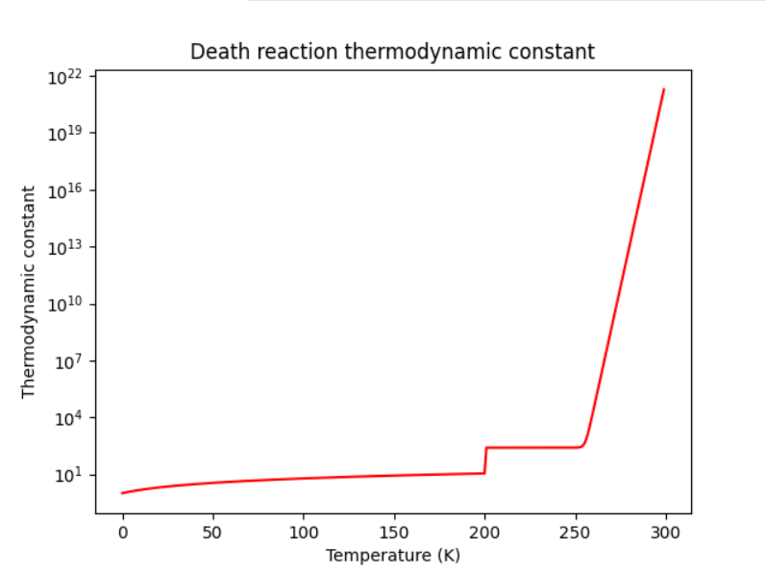

!!!

- CONCLUSION : ⚠ CRITICAL ⚠
  - IF EXPERIMENTS ARE VALID, EARTH MAY BE DOOMED IN LESS THAN A DECENY !!! STOP ZYCRON USAGE NOW !!
>> Entry #6
Tuesday, June 28th, 2044
I, AXëlle Müüske, now acknowledge that Zycron already destroyed enough of the ozone layer in order to doom humanity, and that I am the one who initiated all of this.
Soon, our bodies will be overwhelmed by UV radiation or other nice gifts the sun will throw at us that we were protected from back when Zycron never was discovered. It might not affect this generation, but surely, by the next one or the one after, it will be the end…
This statement of honesty and guilt is important, because all my [coward] colleagues keep doing the same experiments over and over, hoping that they will obtain some reassuring result, because they’re too afraid for accepting their fate. Because I am the one who caused all this bullshit, I never was like them. It’s been a while I’m fighting against the people that are literally supposed to be on my side – my “colleagues”. The scientific community’s becoming crazy, they keep trying to hide our fate to citizens. They even refuse “bad” experiments results; I think they are the ones who corrupted my data from experiment 498. That’s why there’s no record of my next experiments in this journal, I keep them safe elsewhere.
I must convince our community to accept the reality of things, and most importantly, we have to share these facts to governments, so they’ll finally stop to use this cursed Zycron !!
Of course, I’m trying all my best to stop this auto destruction of our species, but without any help I’m useless! How can the person who discovered and worked so hard to implement Zycron all over the world could convince, ALONE, that it’s actually so dangerous it could cause massive extinction ??
I’m… alone. It’s hopeless.
------------------------------------------------------------------------------
>> initializing…
>> AXelle@Home cd data
>> AXelle@Home/data open ./Entry_7.dec
>> error : encrypted file detected - Aborted
>> AXelle@Home/data decrypt.exe ./Entry_7.dec
>> encrypted file – do you want to enter the decryption key (y/n) ? – y
>> decryption key : ***************
>> File being decrypted…………… Success
>> Output : ./decrypt/Entry_7.txt
>> AXelle@Home/data cat ./decrypt/Entry_7.txt

>> Entry #7
Wednesday, April 24th, 2052
Well, working for the government is really starting to get obnoxious here. At last, I (with the scientific community’s help) succeeded in ensuring that every country stops using Zy¹¹⁹, at least that’s what I thought. Some bastards keep murdering the planet, for instance Doonalde Troompp, current president of the USA. Of course, tension rose very fast and now, I think a 3rd World War might happen, everyone is losing control of themselves because of how much we’re fucked.
This entry, and many of the following ones, contrary to the others, will be very well secured from any non-authorized reader. It could be very inconvenient if an enemy successfully reads these notes, especially if I’m hired in secret operations for the government. For this reason, I will now write very sensitive data in an “enciphered language” of my own.
Here’s the translation table for you authorized folks :
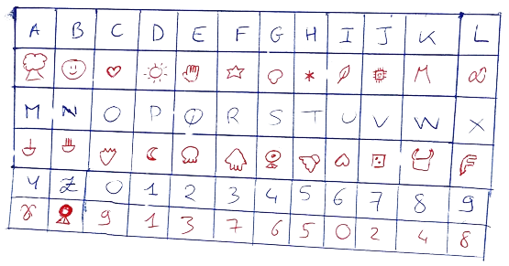

Table 1 – Decipher table
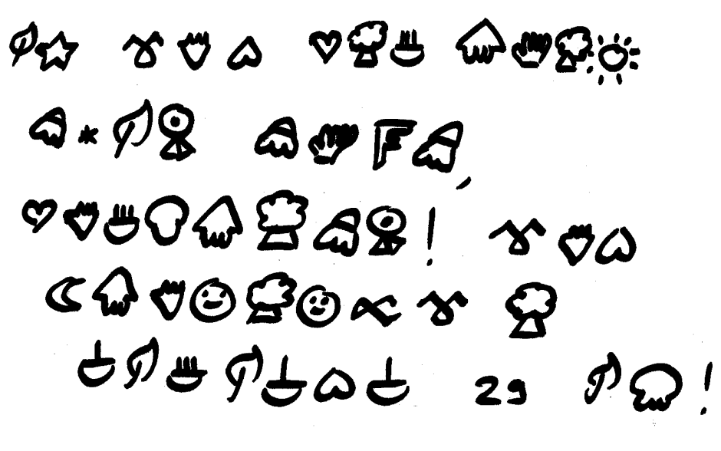
>> Entry #8
Tuesday, May 1st, 2068
The WWIII is indeed occurring, since 2052. Opponents keep attacking us because they want to keep using Zycron, regardless the consequences, because they want to be economically more influent that the other countries that use renewable energy. We figured that a frontal violent response would not solve the conflict, so we’re rather trying to .
What we searched for years is a chemical element that can react with in order to  it, but without endangering Earth, nor human lives (as a secondary objective).
At last, and after many experiments ensuring the safety of the process, we chose the following reaction to be appropriate :
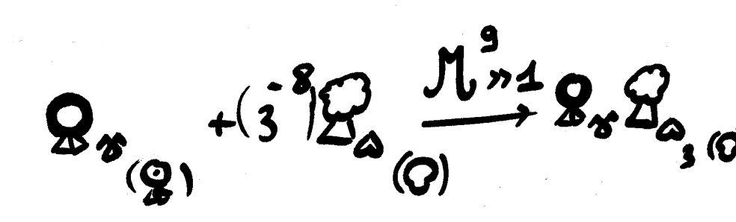

You may think this process will be very expensive, but just look at how few  we need ! The next step is to craft a  of
 , and throw it on opponents !
The war will end soon…

>> Entry #9
Thursday, January 4th, 2080
Hello everyone, it’s been a long time ! Quite some things happened since the last entry. First things first, our project to end the war obviously worked (because it was my idea so of course it was great). After getting rid of this issue, I was immediately committed to another project. Even though I’m starting to get old, my contribution to science was seemingly not about to conclude. Now that everyone accepted that Earth is doomed, we must find a “backup plan”, a way to flee our issues (as humanity always does). Project’s name’s “CONQUEST”, the goal is to find another planet to live on, most likely out of our solar system.
Actually, it’s been many years that I’m on the project, but the thing is, I’m too tired for this. Fortunately, my daughter, EXolotl, also joined the project and is ready to follow my steps. She’s in charge of this journal from now on, and I’m sure she will succeed at finding our redemption, after all she has my blood, so she is at least as great as I am. Before ending this entry, I must express, once again, how I’m sorry for all the trouble I caused to humanity. My last wish is that, somehow, humanity can survive my mistakes…
------------------------------------------------------------------------------
>> initializing…
>> EXolotl@Home decryptv4.exe ./data/Entry_10.dec
>> file encrypted – enter decryption key (y/n) ? - y
>> decryption key : ******************************
>> Success – output @ “./data/Entry_10.txt”
>> EXolotl@Home cat data/Entry_10.txt

>> ENTRY #10, I guess ?
Saturday, 20th May, 2102
Okay so hello, it’s my first entry in my mom's journal, 18 years after the last one because the team on the "CONQUEST" project is struggling so much that it's hard to notice any actual progress on this hopeless thing. Yeah, I'm kind of salty on this stupid idea initiated by my mom but hey, at least she tried something to repair her mistakes.
Anyway, this CONQUEST thing is a forgotten goal for the Müüske family, 'cause since about 2 years, I work on a project that should really save humanity : the “REPLACE” project. The idea is really simple : rather than searching for an ideal world to live on in outer space, that may not even exist in the first place, we're creating it from scratch ! It will be a virtual world, a sort of metaverse in which YOU, as a being, will be living in. It seems kind of crazy, but at the time I'm writing this entry, the metaverse is already created ! For now, this project is kept confidential, we think the government would not appreciate this and would try to stop us, because they really believe in their stupid CONQUEST thing. Although NEW HOME, the metaverse, is almost ready to be published. We just need to find how to make this world "real", how can people really enter this world ? We need a little more time...
-----------------------------------------------------------------------------------
>> initializing
>> EXolotl@Home decryptv4.exe ./data/Entry_11.dec
>> file encrypted – enter decryption key (y/n) ? - y
>> decryption key : ******************************
>> warning : this file is written in an enciphered font. Proceed to the translation (y/n) ? – y
Decrypting Entry_11.dec …………
Launching AXelle_decipher.exe …………
Translating Entry_11.out …………
>> Please authenticate yourself as a valid reader of this file
Username : EX0l0tl
>> User recognized - Success – output @ “./data/Entry_11.txt”
>> EXolotl@Home cat data/Entry_11.txt

>> ENTRY #11
July, 2102 ~ May, 2105
This entry sums up how we were to make the metaverse a “real” world.

-- Experiment 7 observations --

goal : find what's the very culmination of our being.

main hypothesis : SOUL seems to be a good candidate // Don't know if it has some physical existence.

next step : find if the SOUL can be physically called.

-- Experiment 34 observations --

goal : observe physically the SOUL.

main hypothesis : psychologists suggest that SOUL manifests when you can express your true self with no restrictions, that being physical restrictions or society pressure....

strategy : we'll observe the brain activity during sleep, we think dreams to be very appropriate for freeing someone to any "restrictions".

results : after many experiments, it seems that lucid dreams cause the highest brain activity peak to be observed.

-- Experiment 69 observations --

goal : access someone's SOUL to implement its conscience outside of its body.

strategy : retrieve "data" from the brain during a lucid dream

results : SUCCESS ! A subject was transferred into a robot and reinjected successfully in its body afterwards.

sidenotes :

- When the SOUL is out of its body, the body keeps sleeping. We don't know what happens if a SOUL is extracted from the receptacle while the true body is destroyed.

- the SOUL can be extracted from the receptacle at any time, exactly like how you can extract it from the true body while lucid dreaming.

- The SOUL is seemingly “attached” to its body. Indeed, when extracting the SOUL from a receptacle, it returns to the body whether it’s far from the receptacle or not. This may be an issue for implementing the metaverse as a genuine substitution of the real world…

- Fortunately, the person transferred into a receptacle keeps recollections of its time living outside of its body. The “person” is the SOUL, not the brain inside its body.

CONCLUSIONS : These experiments were very, very, interesting. We seemingly found a way to make NEW HOME a real world...

-- Experiments 75 to 84 observations --

subject : conversion of the SOUL into computer data

observations : We tried to connect the brain to a computer and tried to extract the SOUL while the subject was lucid dreaming. Many failures occurred. Many deaths occurred.

Failure log :

- The SOUL extraction is not very stable. A small inconsistency of extraction rate caused many SOULS data to be corrupted. Though, the SOUL directly suffers from this data corruption, and SHATTERS. Breaking a SOUL means a person’s death.
[Deaths : 8]
Sidenote : we observe the death of the body immediately after a SOUL shatters

- Insufficient storage to store the SOUL’s data. At last, an extraction succeeded thanks to at least 50 Terabytes of storage capacity. When no more storage is left, the SOUL’s data gets corrupted and the SOUL shatters.
[Deaths : 25]

- Some interns let a SOUL’s data store on computer’s RAM, so the data was erased when the computer turned off. As a result, the SOUL shattered. SOUL’S EXTRACTION IS IN FACT A TRANSFER : A SOUL CANNOT BE COPIED, NOR CAN WE “EXTRACT DATA” OUT OF IT. THE SOUL ITSELF IS THE DATA THAT IS STORED ON THE COMPUTER.
[Deaths : 3]
Sidenote : this explains why data corruption breaks the SOUL, because it’s actually the SOUL that gets corrupted.

-- Experiment 90 --

subject : DESTROY THE BODY, LET THE SOUL BE OUR ONLY GATE TO THIS WORLD

EXolotl authorized to experiment on the last thing that keeps us in new real world : our physical body. We did what’s right for our redemption.

A subject’s SOUL was extracted into a computer, then we destroyed its physical body. This was a success.

The subject could live in the metaverse without any issue, but then we tried to transfer the SOUL into a real-world robot. This was not a success. The SOUL shattered.

It seems that when the body is destroyed, the SOUL should stay in the place it was FOREVER, otherwise it shatters.

At the time I’m writing this entry, the metaverse is fully operational and will be released very soon. We encountered some ethical issues with these experiments, but knowing how humanity is doomed in any case, the lives that were lost just don’t matter. It’s a necessary step to repair all AXëlle’s bullshit.
I hired some scientists to do the work, because meanwhile I’m still working with the government on the CONQUEST project, it’s my cover. I don’t know how, but AXëlle really had a good reputation inside the scientific administration, so much that all the Müüske family can pretend to any researcher job. It’s pretty easy to hide my true feelings about CONQUEST…

------------------------------------------------------------------------------
>> initializing
>> EXolotl@Home decryptv4.exe ./data/Entry_12.dec
>> file encrypted – enter decryption key (y/n) ? - y
>> decryption key : ******************************
>> Success – output @ “./data/Entry_12.txt”
>> EXolotl@Home cat data/Entry_12.txt

>> ENTRY #12
Saturday, 15th August 2116
The metaverse is a success. Many people trust this way of redemption, and now our terminals, the gates between our world and the metaverse, spread all around the world, are carrying many SOULS in their storage. Honestly, this situation, while being an accomplishment of what I worked on for all these years, is still very oppressing. I can feel the weight of all these SOULS that are gathered in such a vulnerable place that are our metaverse terminals. Of course, we protected the SOULS from being shattered if a terminal ceases to function properly (the data is transferred to the closest terminal, which usually works so long that the bodies the SOULS are attached to are alive), but we’re still kind of vulnerable to cyberattacks.
For the moment, the only thing cybercriminals managed to do is to kick (a few) people out of the metaverse, which again, is not usually an issue so long that the kicked-out person’s body is still alive. Regardless, this shows the potential danger of living inside this world, and how chaotic it could become when all the bodies attached to the SOULS will be destroyed by all the radiations threw on these. If a massive cyberattack happens then, I may feel as guilty as AXëlle felt back when she discovered the dangers of Zycron.
Obviously, all our research is focused on this peculiar issue, but for now there’s not any significant progress. A team is charged of making this issue as less known as possible among the meta-population (population of the metaverse), and they seem to do a great work since nobody’s really freaking out right now.
------------------------------------------------------------------------------
>> initializing
>> EXolotl@Home decryptv4.exe ./data/Entry_13.dec
>> file encrypted – enter decryption key (y/n) ? - y
>> decryption key : ******************************
>> Success – output @ “./data/Entry_13.txt”
>> EXolotl@Home cat data/Entry_13.txt

>> ENTRY #13
Sunday, May 1st , 2117
We just had a massive cyber-attack by none other than our government !! These fuckers just couldn’t bear that our project is more successful than their damned CONQUEST thing, so they just straight up decided to hack many of our terminals, the GODDAMN STORARE OF ALL THE SOULS !! Fortunately, they are not aware of all the terminals that exist, so we were able to store most of the SOULS on the few safe terminals we’re left with, but this caused the metaverse to be very glitchy or even corrupted. We currently don’t know how they attacked the metaverse, but it’s probably some sort of massive cyberattack…
Monday, May 2nd, 2117
Ok so after analyzing further reports and data, it seems that not so many terminals were attacked, and it was indeed a cyberattack. They seemingly just intended to freak the meta-population out, which worked very well! We observe a lot of freed storage capacity compared to yesterday, which most certainly means many SOULS leaved the database.
Funnily enough, the administration communicated to all the people working with the government (including myself, who works at the CONQUEST department for the record) about their involvement in this attack, in case it wasn’t already SO obvious.
Still, we’re not giving up. The metaverse will come back.
------------------------------------------------------------------------------
>> initializing
>> Xhara@Home decryptv4.exe ./data/Entry_14.dec
>> file encrypted – enter decryption key (y/n) ? - y
>> decryption key : **********
>> Success – output @ “./data/Entry_14.txt”
>> Xhara@Home cat data/Entry_14.txt

>> Final Entry
2122
This time this is χhara speaking. My mom was too oppressed by the recent events to continue to update this journal. She asked me to keep tracks of what’s happening as she did, and as grandma did, but I think it’s best for the Müüske family to finish this once and for all. Still, I think that all the future people reading these lines have the right to understand all of what happened and will happen next.
After the hackmageddon, people really gave up this world. All the people who worked on this project received many insults and criticism, my mom being excluded from this since she was, and still is, undercover. Regardless, she took it all personally, and really struggles to bear all of this.
Some people took the leadership among those who stayed in the metaverse, and now we’re the “UNDERDOGS”. We keep upgrading the metaverse, especially regarding cyberattacks, in order to make a comeback when it will be the time. For now, we must hide from the government, even more than before.
As for myself, I was offered the same jobs as my mom back at her time, the Müüske family reputation still being so good. It’s helpful to have people as myself, for the UNDERDOGS, to keep surveilling the government, but unfortunately the CONQUEST department is usually not very aware of what’s prepared against the metaverse. At least I can ensure all the UNDERDOGS that they fight for a great cause, since I know how CONQUEST still is and always will be a failure.
I can’t know what will happen in the following years, but it will surely determine If humanity can have its (not so deserved) redemption or not. Obviously, I’m convinced that the metaverse is the only way to go, but it’s sadly not most of people’s mindset right now…
I hope that any person reading all these entries now has a better understanding of what are the events that lead to this current situation, and I hope that the world they’re living in by their time is better and more peaceful.
Best wishes, χhara Müüske
Note to self : If everything goes as planned, I should make all this journal accessible for everyone when the metaverse can finally exist publicly.

NIKOLAS CAT MISSION REPORT

ENTRY 1 – September 2103
Finally, I integrated the research team for SOUL investigation. It’s been 5 years since I started working on the metaverse along side EXolotl MÜÜSKE, but as a basic computer-science engineer. Only the people EXolotl trusts the most can help her with SOUL experiments, and now I’m one of this people.
What they don’t know is that, for all this time, I’m an undercover agent of the government. My goal isn’t to sabotage the project or anything, but to collect as many data as possible to reveal it when the time is right. EXolotl really wants to keep all the process to understand SOUL very confidential because it reaches the limits of morality, indeed a lot of innocent people died during experiments.
I’m still a rookie in the team so I’ll don’t have access to all the database, but I’ll just wait patiently, and it’ll be fine…

ENTRY 2 – December 2104
I collected all the data shared between all scientist of the team, but the most interesting data is hidden between password-protected directories. I have some hacking skills, but I can’t just throw a brute-force attack otherwise I would be instantly kicked of the research team. I need to find these passwords without going for any cyber-attack.
For now, I found only one password : the one for Jeff Brainoz private directory on its personal computer : “ihatenikolas” (thanks man ).
I keep searching for other passwords but for instance, this Jeff keeps surveilling me, I don’t know when I did something suspicious before his eyes, but this dude won’t let me breath. It’s getting harder to fulfill my true mission…

