>> Entrée n°1
Lundi 25 mars 2030
Ça y’est, notre planète est enfin sauvée ! Grâce à moi, AXëlle Müüske, et l’aide de toute mon équipe, un nouvel élément chimique a enfin été découvert, je l’appelle le « zycron » (Zy¹¹⁹). Cet élément est caché dans les profondeurs de notre chère Terre, mais grâce aux toutes dernières technologies de forage, nous sommes capables d’explorer le centre de la Terre où le zycron prolifère en abondance !
Ce qui est génial avec le zycron, c’est qu’il peut réagir avec l’hydrogène avec cette simple réaction chimique que j’ai découvert :


Zy_{(s)} + H_{(l)} → ZyH_{(g)}
Ɛ_{n}
Energie thermique produite par la réaction
(Ɛ_{n} ~ 1 MJ/mol, c’est beaucoup)

Note : la réaction nécessite de disposer d’hydrogène liquide, mais je ne pense pas que ce sera un problème pour l’usage que nous pourrons faire du zycron…
>> Entrée n°3
Lundi 5 novembre 2031
Je savais que ma découverte serait révolutionnaire ! Comme attendu, le zycron se trouve en abondance et, encore mieux, pourra être utilisé comme source écoresponsable d’énergie. A présent, il est utilisé presque partout dans le monde, le réchauffement climatique est une problématique révolu !
J’ai attendu l’hiver pour écrire cette entrée parce que je voulais constater l’efficacité spectaculaire du zycron en période de forte dépendance énergétique. Eh bien je n’ai pas été déçu du spectacle, je suis vraiment géniale n’empêche !
>> Entrée n°3
merde merde merde merde merde……………..
T’en fais pas…

POURQUOI AVONS-NOUS D֤ÉCOUVERT CE FOUTU ZYCRON !!
Tout va biieeeen haha!

>> Entrée n°4
Mardi 1er janvier 2042
Eh bien euh… je ne suis peut-être pas si géniale que ça…
Peut-être que j’ai condamné la Terre 😓 ?

Ecoutez, voici le problème : nous avons découvert une propriété INTERESSANTE sur le zycron en analysant… la couche d’ozone.
Regardez juste la réaction ci-dessous :
ZyH_{(g)} + O_{3 (g)} → Zy_{(s)} + O_{2 (g)} + H₂O_{(g)} (💀)
⚠ vous voyez, c’est ça le problème ⚠
Même un novice en chimie comprend ici que la réaction de la mort (💀) détruit notre couche d’ozone qui est littéralement nécessaire à la survie de notre putain d’espèce
Mieux vaut ne pas ajouter ça, ce n’est pas très professionnel 😒

Espérons que la réaction est un processus très lent ?
Je ne sais pas. Nous, les scientifiques, avons procrastinés sur ce sujet parce que, je cite, « oh non nous sommes tous condamnés à quoi bon ?? » snif snif…
Nous sommes vraiment des lâches…
>> Entrée n°5
Vendredi 14 mars 2042
RAPPORT DE RECHERCHE – EXPERIENCE 1F2
- Sujet de l’expérience : constante thermodynamique K⁰ de la réaction de la mort (💀)
- Observations : La constante augmente à très forte vitesse, étant de base très élevée à température ambiante (aussi bien qu’à la thermosphère)
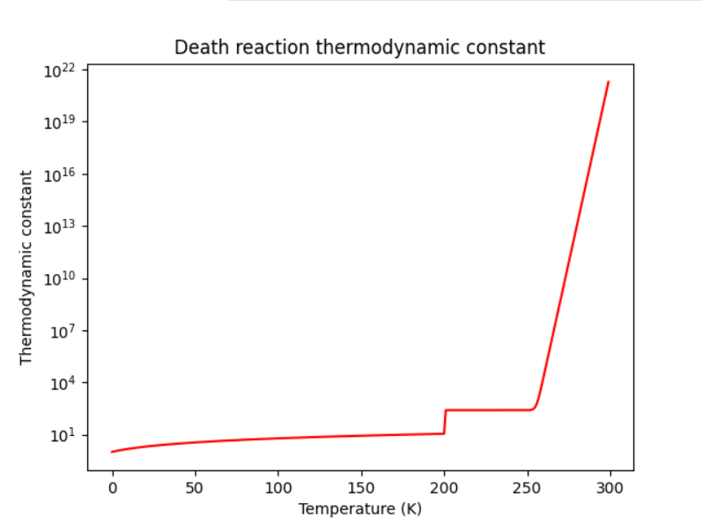

!!!

- CONCLUSION : ⚠ ETAT CRITIQUE ⚠
  - SI ON EN CROIT LES EXPERIENCES, LA TERRE SERA INHOSPITALIERE DANS MOINS D’UNE DECENIE !!! IL FAUT STOPPER L’UTILISATION DU ZYCRON MAINTENANT !!
>> Entrée n°6
Mardi 28 juin 2044
Je soussigné AXëlle Müüske, reconnais qu’à l’heure actuelle, le zycron a déjà détruit assez de la couche d’ozone pour condamner l’humanité, et que je suis celle qui a initié cela
Bientôt, nos corps ne sauront plus endurer les radiations UV et autres joyeusetés envoyées par le soleil pour lesquelles nous étions protégés à l’époque où nous n’avions pas encore découvert ce maudit zycron. Cela n’affectera pas nécessairement notre génération, mais assurément, la prochaine n’y survivra pas.
Ce moment d’+honnêteté et de culpabilité est important, car tous mes [lâches] collègues continuent de faire les même expériences encore et encore, en espérant obtenir des résultats rassurants, parce qu’ils ont trop peur d’accepter leur sort. Parce que je suis celle qui a causé toute cette merde, je n’ai jamais été comme eux. Ça fait un sacré moment que je me bats contre des gens qui sont littéralement censés être dans mon camp – mes « collègues ». La communauté scientifique a perdu la raison, elle continue de cacher notre destins aux citoyens. Ils vont même jusqu’à refuser de « mauvais » résultats d’expérience (aka des résultats inquiétants) ; je pense que c’est eux qui ont corrompu les données de l’expérience 498. C’est pourquoi il n’y a aucune trace de mes expériences suivantes dans ce journal, je les garde en sécurité autre part.
Je dois convaincre la communauté d’accepter la réalité des choses, et ensuite, nous devons partager ces faits aux gouvernements, de sorte qu’ils arrêtent enfin d’utiliser ce foutu zycron !!
Bien sûr, j’essaye autant que possible d’arrêter cette autodestruction de notre espèce, mais sans aide c’est inutile ! Comment la personne qui a découvert et travaillé si dur à implémenter le zycron partout sur Terre pourrait raisonnablement convaincre SEULE que c’est en fait tellement dangereux que ça pourrait causer une extinction de masse ??
Je suis seule… c’est sans espoir.
------------------------------------------------------------------------------
>> initializing…
>> AXelle@Home cd data
>> AXelle@Home/data open ./Entry_7.dec
>> error : encrypted file detected - Aborted
>> AXelle@Home/data decrypt.exe ./Entry_7.dec
>> encrypted file – do you want to enter the decryption key (y/n) ? – y
>> decryption key : ***************
>> File being decrypted…………… Success
>> Output : ./decrypt/Entry_7.txt
>> AXelle@Home/data cat ./decrypt/Entry_7.txt

>> Entry #7
Wednesday, April 24th, 2052
Well, working for the government is really starting to get obnoxious here. At last, I (with the scientific community’s help) succeeded in ensuring that every country stops using Zy¹¹⁹, at least that’s what I thought. Some bastards keep murdering the planet, for instance Doonalde Troompp, current president of the USA. Of course, tension rose very fast and now, I think a 3rd World War might happen, everyone is losing control of themselves because of how much we’re fucked.
This entry, and many of the following ones, contrary to the others, will be very well secured from any non-authorized reader. It could be very inconvenient if an enemy successfully reads these notes, especially if I’m hired in secret operations for the government. For this reason, I will now write very sensitive data in an “enciphered language” of my own.
Here’s the translation table for you authorized folks :
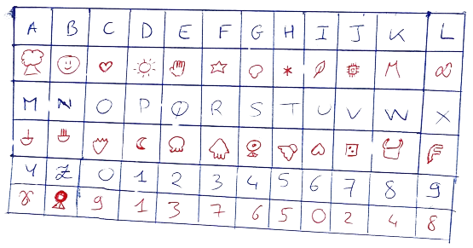

Table 1 – Decipher table
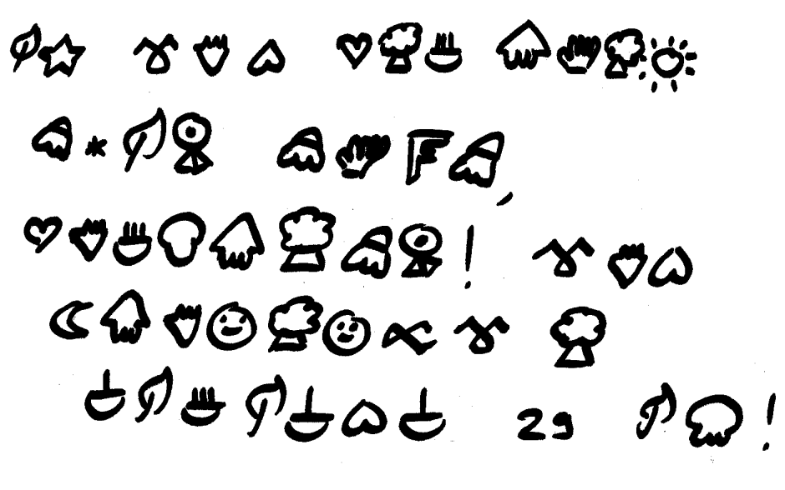
>> Entry #8
Tuesday, May 1st, 2068
The WWIII is indeed occurring, since 2052. Opponents keep attacking us because they want to keep using Zycron, regardless the consequences, because they want to be economically more influent that the other countries that use renewable energy. We figured that a frontal violent response would not solve the conflict, so we’re rather trying to .
What we searched for years is a chemical element that can react with in order to  it, but without endangering Earth, nor human lives (as a secondary objective).
At last, and after many experiments ensuring the safety of the process, we chose the following reaction to be appropriate :
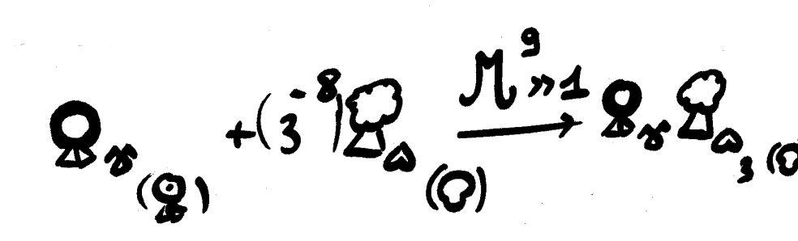

You may think this process will be very expensive, but just look at how few  we need ! The next step is to craft a  of
 , and throw it on opponents !
The war will end soon…

>> Entry #9
Thursday, January 4th, 2080
Hello everyone, it’s been a long time ! Quite some things happened since the last entry. First things first, our project to end the war obviously worked (because it was my idea so of course it was great). After getting rid of this issue, I was immediately committed to another project. Even though I’m starting to get old, my contribution to science was seemingly not about to conclude. Now that everyone accepted that Earth is doomed, we must find a “backup plan”, a way to flee our issues (as humanity always does). Project’s name’s “CONQUEST”, the goal is to find another planet to live on, most likely out of our solar system.
Actually, it’s been many years that I’m on the project, but the thing is, I’m too tired for this. Fortunately, my daughter, EXolotl, also joined the project and is ready to follow my steps. She’s in charge of this journal from now on, and I’m sure she will succeed at finding our redemption, after all she has my blood, so she is at least as great as I am. Before ending this entry, I must express, once again, how I’m sorry for all the trouble I caused to humanity. My last wish is that, somehow, humanity can survive my mistakes…
------------------------------------------------------------------------------
>> initializing…
>> EXolotl@Home decryptv4.exe ./data/Entry_10.dec
>> file encrypted – enter decryption key (y/n) ? - y
>> decryption key : ******************************
>> Success – output @ “./data/Entry_10.txt”
>> EXolotl@Home cat data/Entry_10.txt

>> ENTRY #10, I guess ?
Saturday, 20th May, 2102
Okay so hello, it’s my first entry in my mom's journal, 18 years after the last one because the team on the "CONQUEST" project is struggling so much that it's hard to notice any actual progress on this hopeless thing. Yeah, I'm kind of salty on this stupid idea initiated by my mom but hey, at least she tried something to repair her mistakes.
Anyway, this CONQUEST thing is a forgotten goal for the Müüske family, 'cause since about 2 years, I work on a project that should really save humanity : the “REPLACE” project. The idea is really simple : rather than searching for an ideal world to live on in outer space, that may not even exist in the first place, we're creating it from scratch ! It will be a virtual world, a sort of metaverse in which YOU, as a being, will be living in. It seems kind of crazy, but at the time I'm writing this entry, the metaverse is already created ! For now, this project is kept confidential, we think the government would not appreciate this and would try to stop us, because they really believe in their stupid CONQUEST thing. Although NEW HOME, the metaverse, is almost ready to be published. We just need to find how to make this world "real", how can people really enter this world ? We need a little more time...
-----------------------------------------------------------------------------------
>> initializing
>> EXolotl@Home decryptv4.exe ./data/Entry_11.dec
>> file encrypted – enter decryption key (y/n) ? - y
>> decryption key : ******************************
>> warning : this file is written in an enciphered font. Proceed to the translation (y/n) ? – y
Decrypting Entry_11.dec …………
Launching AXelle_decipher.exe …………
Translating Entry_11.out …………
>> Please authenticate yourself as a valid reader of this file
Username : EX0l0tl
>> User recognized - Success – output @ “./data/Entry_11.txt”
>> EXolotl@Home cat data/Entry_11.txt

>> ENTRY #11
July, 2102 ~ May, 2105
This entry sums up how we were to make the metaverse a “real” world.

-- Experiment 7 observations --

goal : find what's the very culmination of our being.

main hypothesis : SOUL seems to be a good candidate // Don't know if it has some physical existence.

next step : find if the SOUL can be physically called.

-- Experiment 34 observations --

goal : observe physically the SOUL.

main hypothesis : psychologists suggest that SOUL manifests when you can express your true self with no restrictions, that being physical restrictions or society pressure....

strategy : we'll observe the brain activity during sleep, we think dreams to be very appropriate for freeing someone to any "restrictions".

results : after many experiments, it seems that lucid dreams cause the highest brain activity peak to be observed.

-- Experiment 69 observations --

goal : access someone's SOUL to implement its conscience outside of its body.

strategy : retrieve "data" from the brain during a lucid dream

results : SUCCESS ! A subject was transferred into a robot and reinjected successfully in its body afterwards.

sidenotes :

- When the SOUL is out of its body, the body keeps sleeping. We don't know what happens if a SOUL is extracted from the receptacle while the true body is destroyed.

- the SOUL can be extracted from the receptacle at any time, exactly like how you can extract it from the true body while lucid dreaming.

- The SOUL is seemingly “attached” to its body. Indeed, when extracting the SOUL from a receptacle, it returns to the body whether it’s far from the receptacle or not. This may be an issue for implementing the metaverse as a genuine substitution of the real world…

- Fortunately, the person transferred into a receptacle keeps recollections of its time living outside of its body. The “person” is the SOUL, not the brain inside its body.

CONCLUSIONS : These experiments were very, very, interesting. We seemingly found a way to make NEW HOME a real world...

-- Experiments 75 to 84 observations --

subject : conversion of the SOUL into computer data

observations : We tried to connect the brain to a computer and tried to extract the SOUL while the subject was lucid dreaming. Many failures occurred. Many deaths occurred.

Failure log :

- The SOUL extraction is not very stable. A small inconsistency of extraction rate caused many SOULS data to be corrupted. Though, the SOUL directly suffers from this data corruption, and SHATTERS. Breaking a SOUL means a person’s death.
[Deaths : 8]
Sidenote : we observe the death of the body immediately after a SOUL shatters

- Insufficient storage to store the SOUL’s data. At last, an extraction succeeded thanks to at least 50 Terabytes of storage capacity. When no more storage is left, the SOUL’s data gets corrupted and the SOUL shatters.
[Deaths : 25]

- Some interns let a SOUL’s data store on computer’s RAM, so the data was erased when the computer turned off. As a result, the SOUL shattered. SOUL’S EXTRACTION IS IN FACT A TRANSFER : A SOUL CANNOT BE COPIED, NOR CAN WE “EXTRACT DATA” OUT OF IT. THE SOUL ITSELF IS THE DATA THAT IS STORED ON THE COMPUTER.
[Deaths : 3]
Sidenote : this explains why data corruption breaks the SOUL, because it’s actually the SOUL that gets corrupted.

-- Experiment 90 --

subject : DESTROY THE BODY, LET THE SOUL BE OUR ONLY GATE TO THIS WORLD

EXolotl authorized to experiment on the last thing that keeps us in new real world : our physical body. We did what’s right for our redemption.

A subject’s SOUL was extracted into a computer, then we destroyed its physical body. This was a success.

The subject could live in the metaverse without any issue, but then we tried to transfer the SOUL into a real-world robot. This was not a success. The SOUL shattered.

It seems that when the body is destroyed, the SOUL should stay in the place it was FOREVER, otherwise it shatters.

At the time I’m writing this entry, the metaverse is fully operational and will be released very soon. We encountered some ethical issues with these experiments, but knowing how humanity is doomed in any case, the lives that were lost just don’t matter. It’s a necessary step to repair all AXëlle’s bullshit.
I hired some scientists to do the work, because meanwhile I’m still working with the government on the CONQUEST project, it’s my cover. I don’t know how, but AXëlle really had a good reputation inside the scientific administration, so much that all the Müüske family can pretend to any researcher job. It’s pretty easy to hide my true feelings about CONQUEST…

------------------------------------------------------------------------------
>> initializing
>> EXolotl@Home decryptv4.exe ./data/Entry_12.dec
>> file encrypted – enter decryption key (y/n) ? - y
>> decryption key : ******************************
>> Success – output @ “./data/Entry_12.txt”
>> EXolotl@Home cat data/Entry_12.txt

>> ENTRY #12
Saturday, 15th August 2116
The metaverse is a success. Many people trust this way of redemption, and now our terminals, the gates between our world and the metaverse, spread all around the world, are carrying many SOULS in their storage. Honestly, this situation, while being an accomplishment of what I worked on for all these years, is still very oppressing. I can feel the weight of all these SOULS that are gathered in such a vulnerable place that are our metaverse terminals. Of course, we protected the SOULS from being shattered if a terminal ceases to function properly (the data is transferred to the closest terminal, which usually works so long that the bodies the SOULS are attached to are alive), but we’re still kind of vulnerable to cyberattacks.
For the moment, the only thing cybercriminals managed to do is to kick (a few) people out of the metaverse, which again, is not usually an issue so long that the kicked-out person’s body is still alive. Regardless, this shows the potential danger of living inside this world, and how chaotic it could become when all the bodies attached to the SOULS will be destroyed by all the radiations threw on these. If a massive cyberattack happens then, I may feel as guilty as AXëlle felt back when she discovered the dangers of Zycron.
Obviously, all our research is focused on this peculiar issue, but for now there’s not any significant progress. A team is charged of making this issue as less known as possible among the meta-population (population of the metaverse), and they seem to do a great work since nobody’s really freaking out right now.
------------------------------------------------------------------------------
>> initializing
>> EXolotl@Home decryptv4.exe ./data/Entry_13.dec
>> file encrypted – enter decryption key (y/n) ? - y
>> decryption key : ******************************
>> Success – output @ “./data/Entry_13.txt”
>> EXolotl@Home cat data/Entry_13.txt

>> ENTRY #13
Sunday, May 1st , 2117
We just had a massive cyber-attack by none other than our government !! These fuckers just couldn’t bear that our project is more successful than their damned CONQUEST thing, so they just straight up decided to hack many of our terminals, the GODDAMN STORARE OF ALL THE SOULS !! Fortunately, they are not aware of all the terminals that exist, so we were able to store most of the SOULS on the few safe terminals we’re left with, but this caused the metaverse to be very glitchy or even corrupted. We currently don’t know how they attacked the metaverse, but it’s probably some sort of massive cyberattack…
Monday, May 2nd, 2117
Ok so after analyzing further reports and data, it seems that not so many terminals were attacked, and it was indeed a cyberattack. They seemingly just intended to freak the meta-population out, which worked very well! We observe a lot of freed storage capacity compared to yesterday, which most certainly means many SOULS leaved the database.
Funnily enough, the administration communicated to all the people working with the government (including myself, who works at the CONQUEST department for the record) about their involvement in this attack, in case it wasn’t already SO obvious.
Still, we’re not giving up. The metaverse will come back.
------------------------------------------------------------------------------
>> initializing
>> Xhara@Home decryptv4.exe ./data/Entry_14.dec
>> file encrypted – enter decryption key (y/n) ? - y
>> decryption key : **********
>> Success – output @ “./data/Entry_14.txt”
>> Xhara@Home cat data/Entry_14.txt

>> Final Entry
2122
This time this is χhara speaking. My mom was too oppressed by the recent events to continue to update this journal. She asked me to keep tracks of what’s happening as she did, and as grandma did, but I think it’s best for the Müüske family to finish this once and for all. Still, I think that all the future people reading these lines have the right to understand all of what happened and will happen next.
After the hackmageddon, people really gave up this world. All the people who worked on this project received many insults and criticism, my mom being excluded from this since she was, and still is, undercover. Regardless, she took it all personally, and really struggles to bear all of this.
Some people took the leadership among those who stayed in the metaverse, and now we’re the “UNDERDOGS”. We keep upgrading the metaverse, especially regarding cyberattacks, in order to make a comeback when it will be the time. For now, we must hide from the government, even more than before.
As for myself, I was offered the same jobs as my mom back at her time, the Müüske family reputation still being so good. It’s helpful to have people as myself, for the UNDERDOGS, to keep surveilling the government, but unfortunately the CONQUEST department is usually not very aware of what’s prepared against the metaverse. At least I can ensure all the UNDERDOGS that they fight for a great cause, since I know how CONQUEST still is and always will be a failure.
I can’t know what will happen in the following years, but it will surely determine If humanity can have its (not so deserved) redemption or not. Obviously, I’m convinced that the metaverse is the only way to go, but it’s sadly not most of people’s mindset right now…
I hope that any person reading all these entries now has a better understanding of what are the events that lead to this current situation, and I hope that the world they’re living in by their time is better and more peaceful.
Best wishes, χhara Müüske
Note to self : If everything goes as planned, I should make all this journal accessible for everyone when the metaverse can finally exist publicly.

