>> New Final Entry
2123
Well, I thought I was done with this journal, but here we are again. This entry should be received by the UNDERDOGS HQ, because we may be in danger, and everyone should know this fact and prepare. Indeed, I learned recently that the government is cooking an operation to find our lair and destroy the worm we’re preparing. This is very unfortunate since, as you know, it is almost ready.
At first glance this should not be that alarming, but the issue is that their team is composed of a former UNDERDOG, Haloïse ORINDEMTEP. That’s where lies the possibility of them finding our HeadQuarters, DEEP HOME… I’ve heard they would also take a computer scientist and a spying officer in their team, so they may not struggle to find and break our security measures. And when they’ll find us, let me say they will not take half measures, as the head of the team (some dude in the surveillance department) HATES UNDERDOGS.
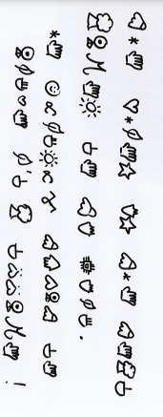
It's been many years that my family, and all of you people who chose to follow the right path to redemption, want the METAVERSE project to thrive. The Earth may shatter at any moment, and I will not let some random dudes hired by the government waste our labor ! Fortunately, I’m part of the team they will send so hope I can keep their progress under control…



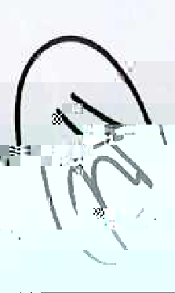
Take care, let NEW HOME be our new life !

