**Aplikasi Profil Desa**



|  |  |
| --- | --- |
| **Beny Tampubolon** | **11317034** |
| **Friska Sianturi** | **11317027** |
| **Syvia Sihombing** | **11317025** |

**Tahun Ajaran 2018/2019**

1. Login

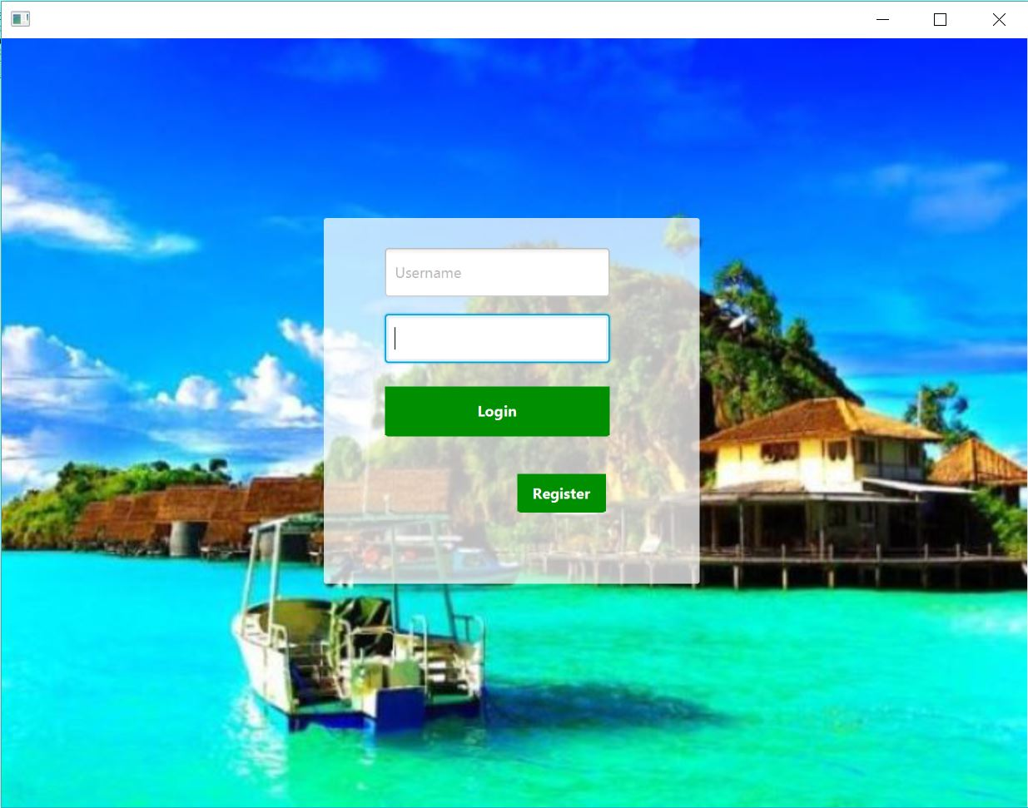

1. Register

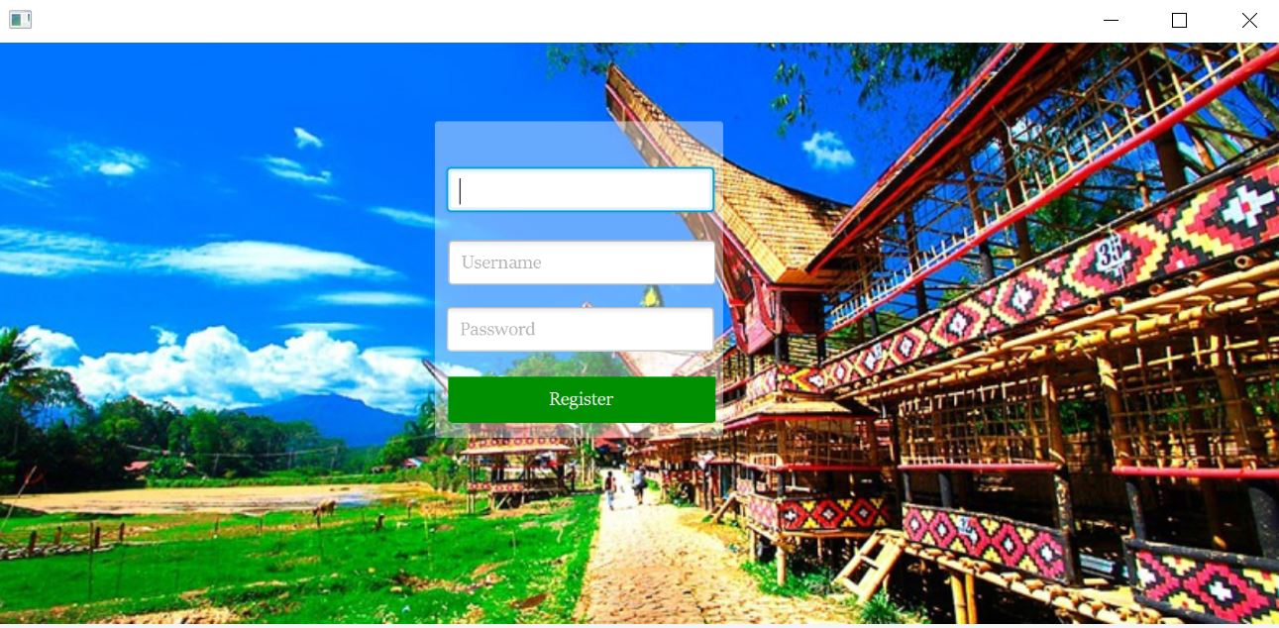

1. Beranda Admin

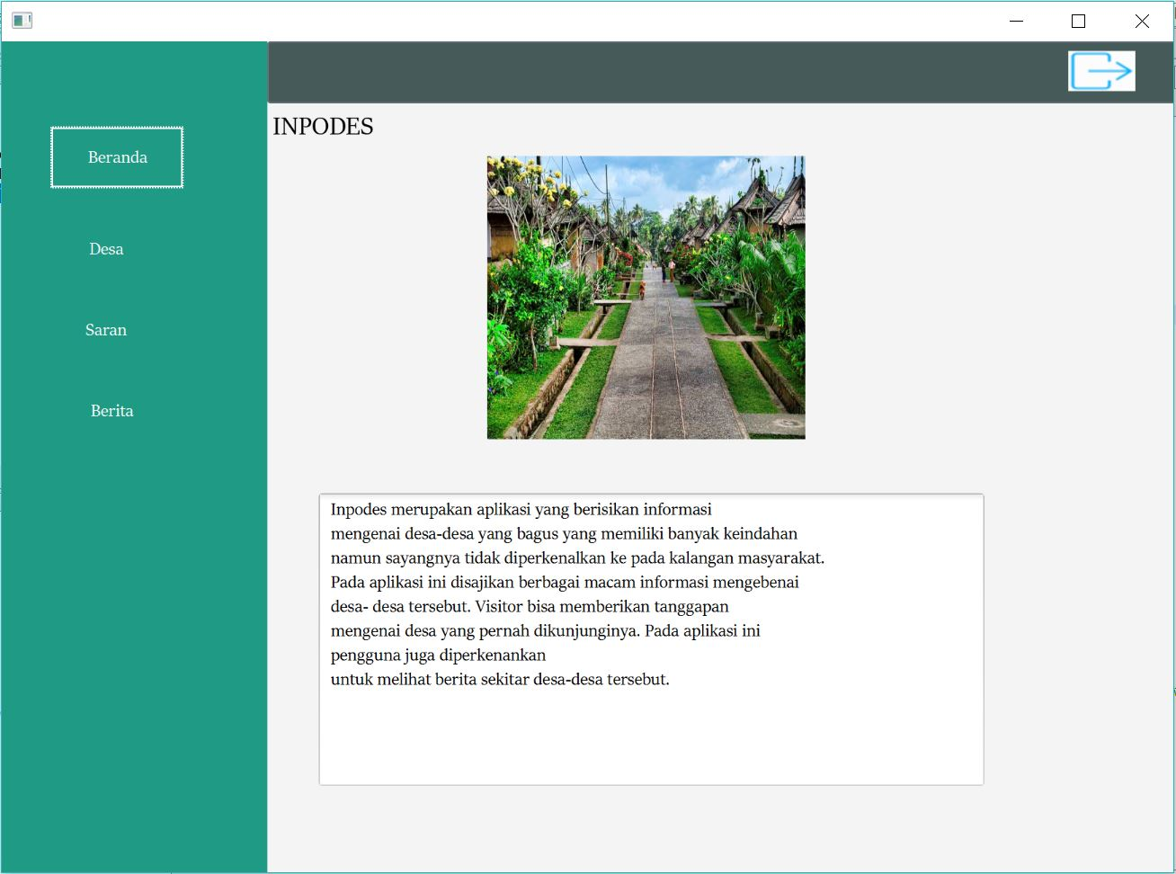

1. Beranda User

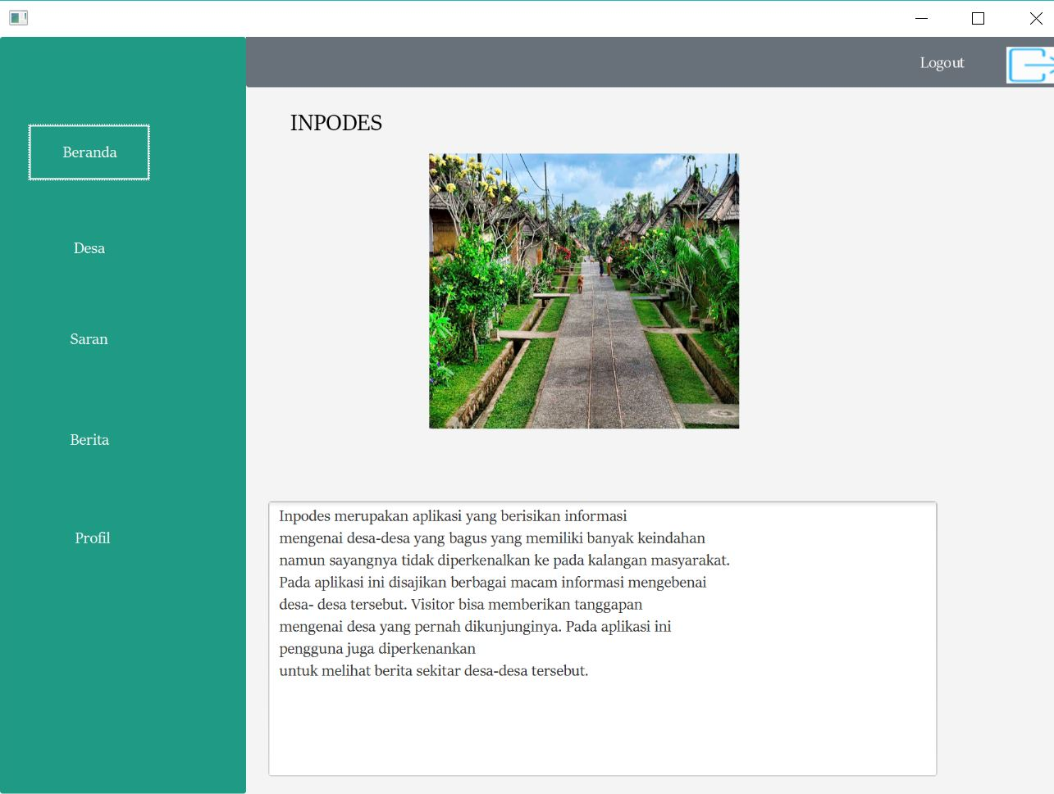

1. Page Desa Admin

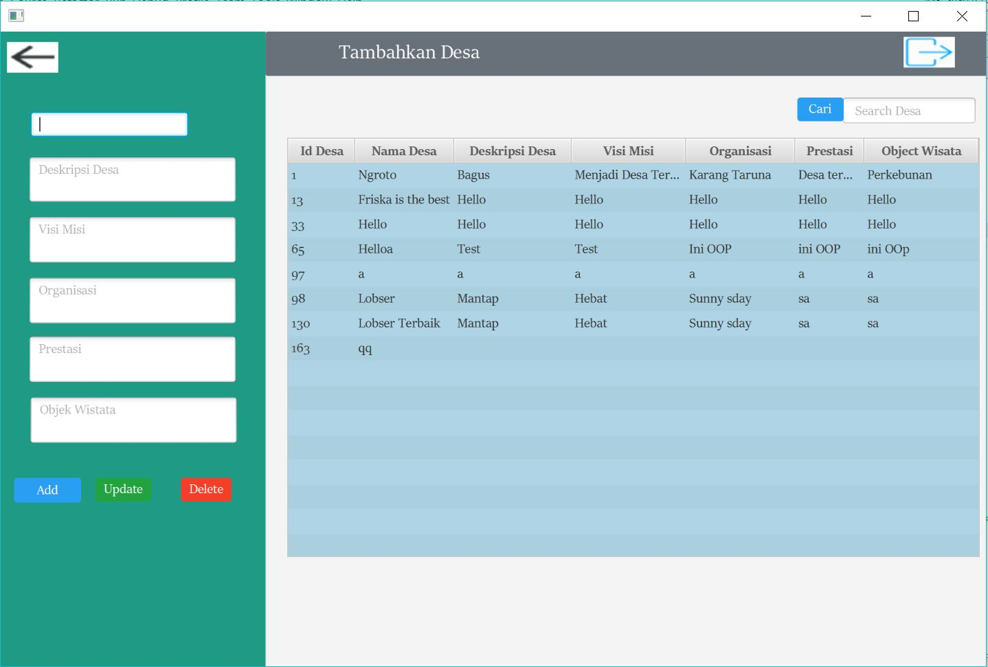

1. Page Desa Guest

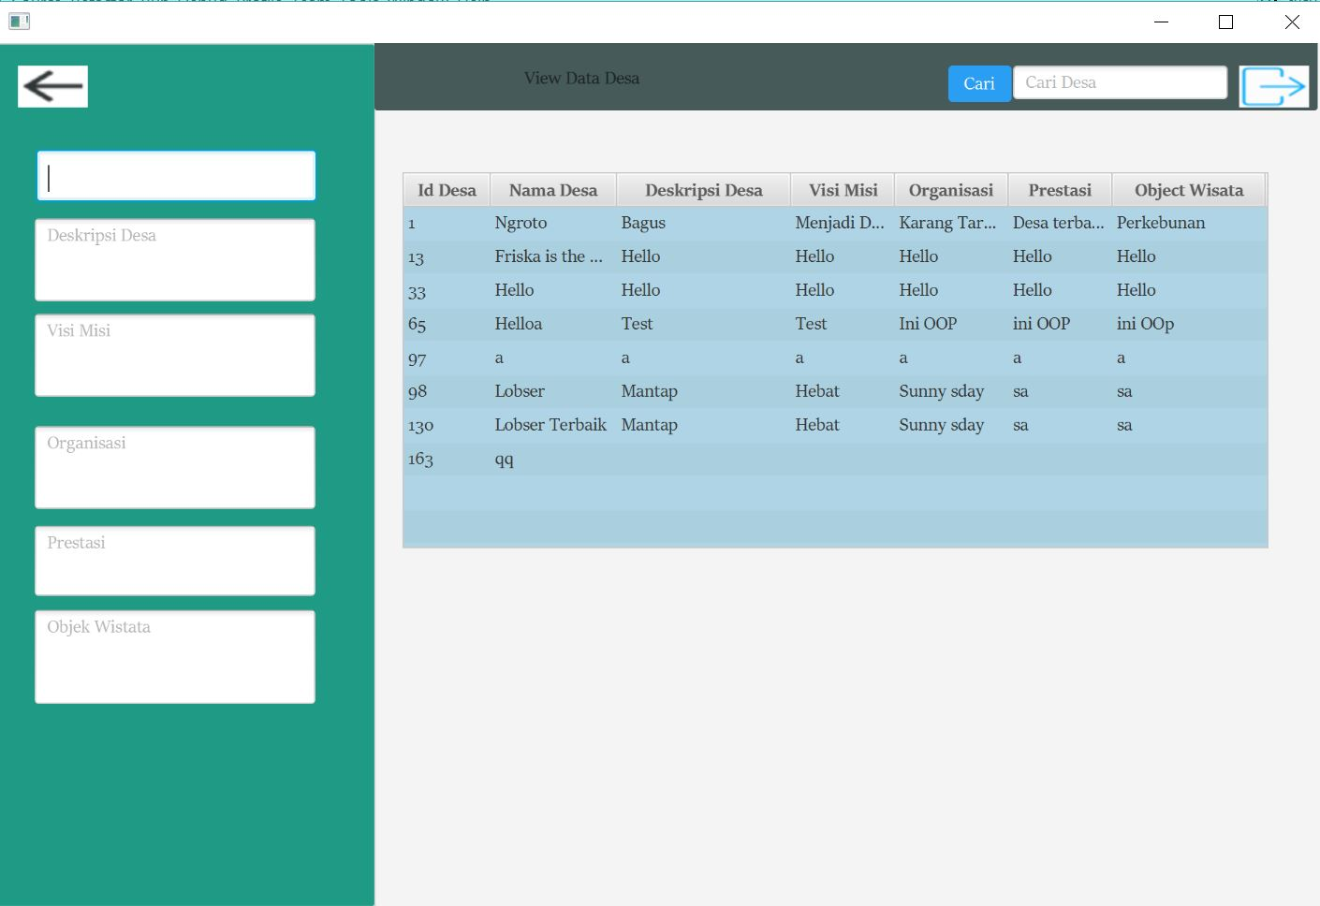

1. Page Berita Admin

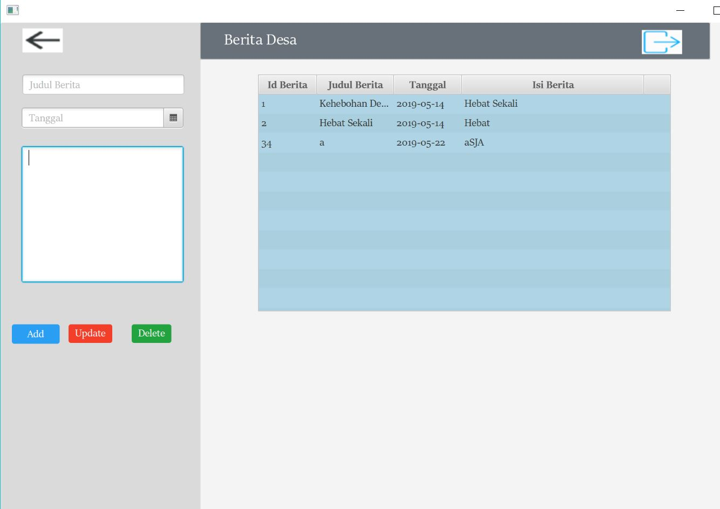

1. Page Berita Guest

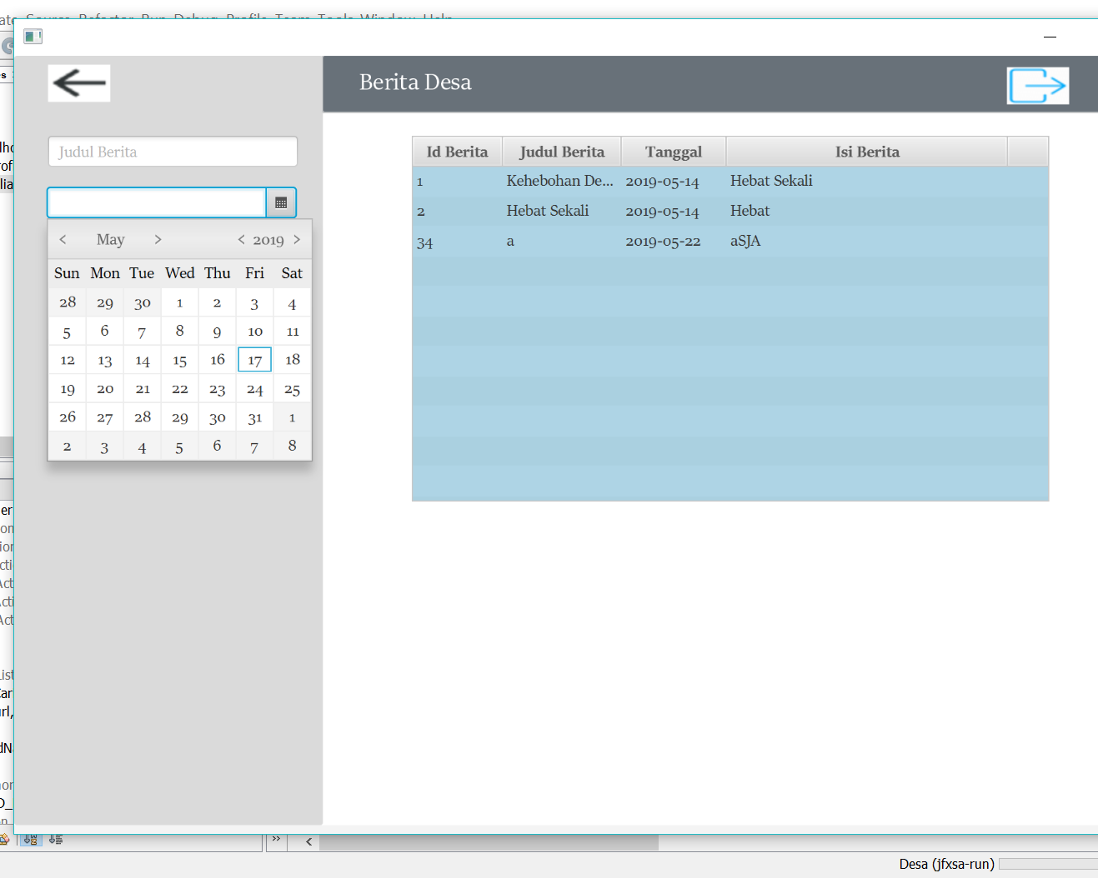

1. Page Saran Admin

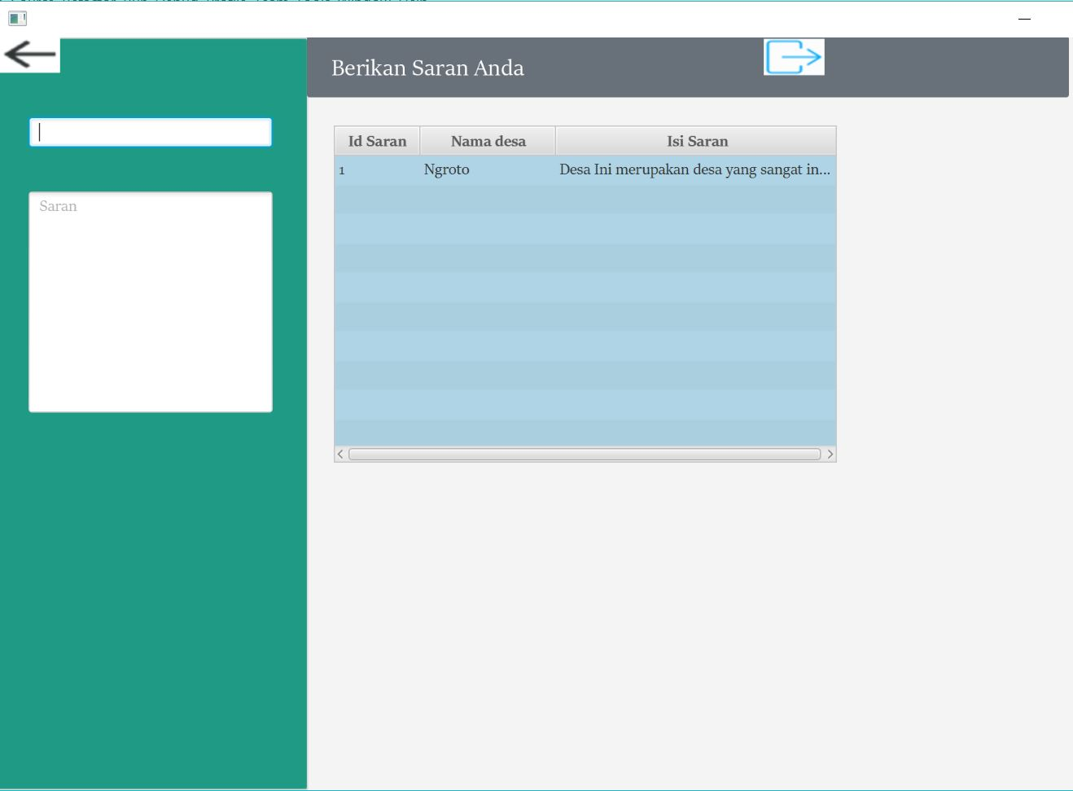

1. Page Saran guest

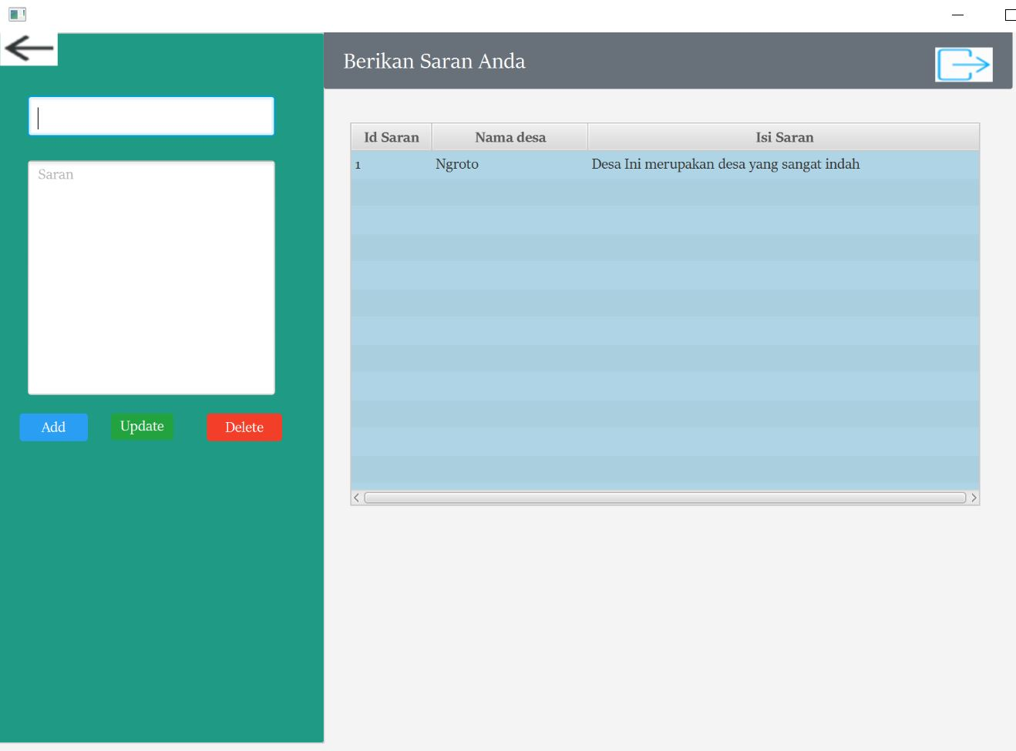

1. Page Searching Desa

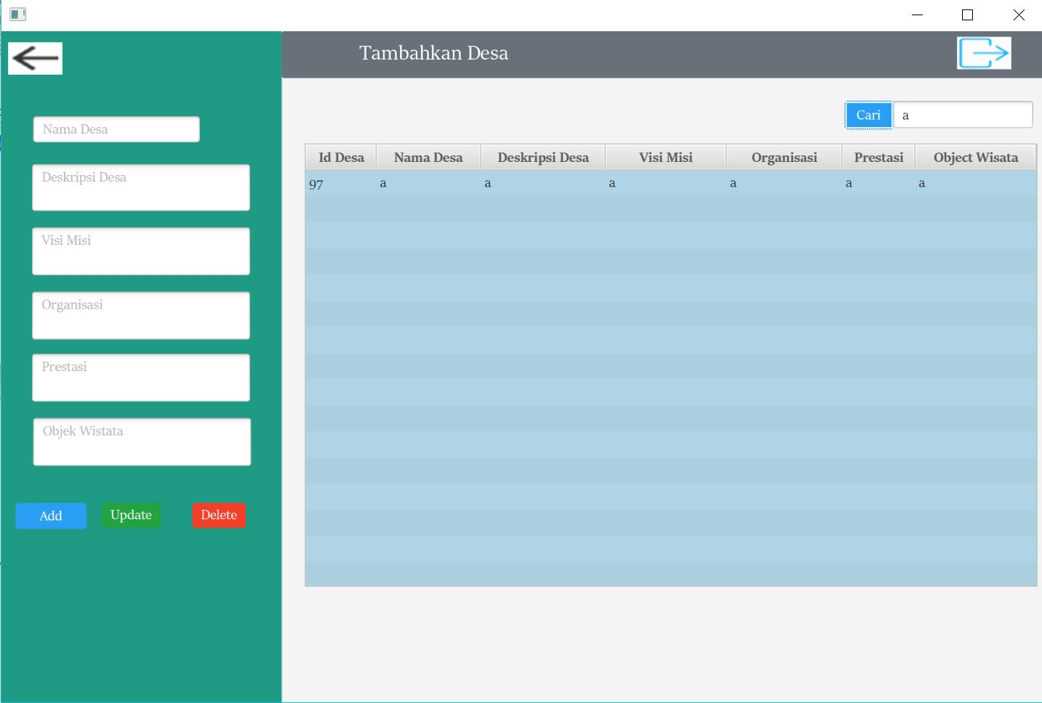

1. Page Update Profil