Offline Gesture Recognition Application
Version 1
Software Design Plan (SDP)
Document status: Draft. Based on the approved System Architecture Design (SAD).

At a glance
Platform | Cross-platform desktop application for Windows, macOS, and Linux
Technology | Python, PySide6 (GUI), OpenCV (camera capture and image processing)
Function | Real-time recognition of ten predefined hand gestures from a local camera
Operation | Fully offline; frames and recognition data stay in memory
Architecture | Modular, single-process, multithreaded

This document translates the System Architecture Design into a component-level design. Figures are identified as SDP-01 to SDP-05.

1. Introduction

1.1 Purpose
This Software Design Plan (SDP) defines the software design for Version 1 of the Offline Gesture Recognition Application. It translates the System Architecture Design into a component-level design, specifying module interfaces, internal responsibilities, data structures, processing logic, concurrency, error handling, and testing requirements.

1.2 Scope
The application is a cross-platform desktop application developed in Python using PySide6 for the graphical user interface and OpenCV for camera capture and image processing. It recognizes ten predefined hand gestures in real time using locally available pretrained models and a hybrid recognition approach combining geometric rules, temporal state machines, and machine-learning classifiers.
The application supports Windows, macOS, and Linux and must operate without network access. Camera frames and transient recognition data are processed in memory and are not persistently stored or transmitted.

1.3 Design Constraints
The design shall adhere to the following constraints:
- The application shall use a modular, single-process, multithreaded architecture.
- GUI operations shall execute exclusively on the Qt main thread.
- Camera capture and computationally intensive vision processing shall execute in worker threads.
- Recognition models and runtime dependencies shall be available locally.
- A bounded latest-frame-wins buffer shall prioritize processing current camera frames.
- The default recognition confidence threshold shall be 0.7.
- The static prayer pose and dynamic clap motion shall produce the same external gesture label.
- Configuration and diagnostic logging shall exclude camera frames and sensitive user data.

2. Software Design Overview
The software is divided into presentation, application coordination, camera acquisition, vision processing, tracking and feature extraction, gesture recognition, recognition decision management, configuration, logging, and domain modules.
Each module shall expose a defined interface and minimize dependencies on other modules' internal implementations. Shared data structures shall be defined in the Domain Module. The Application Controller shall coordinate module lifecycles and data exchange without implementing vision algorithms or gesture-specific recognition logic.

2.1 Design Structure
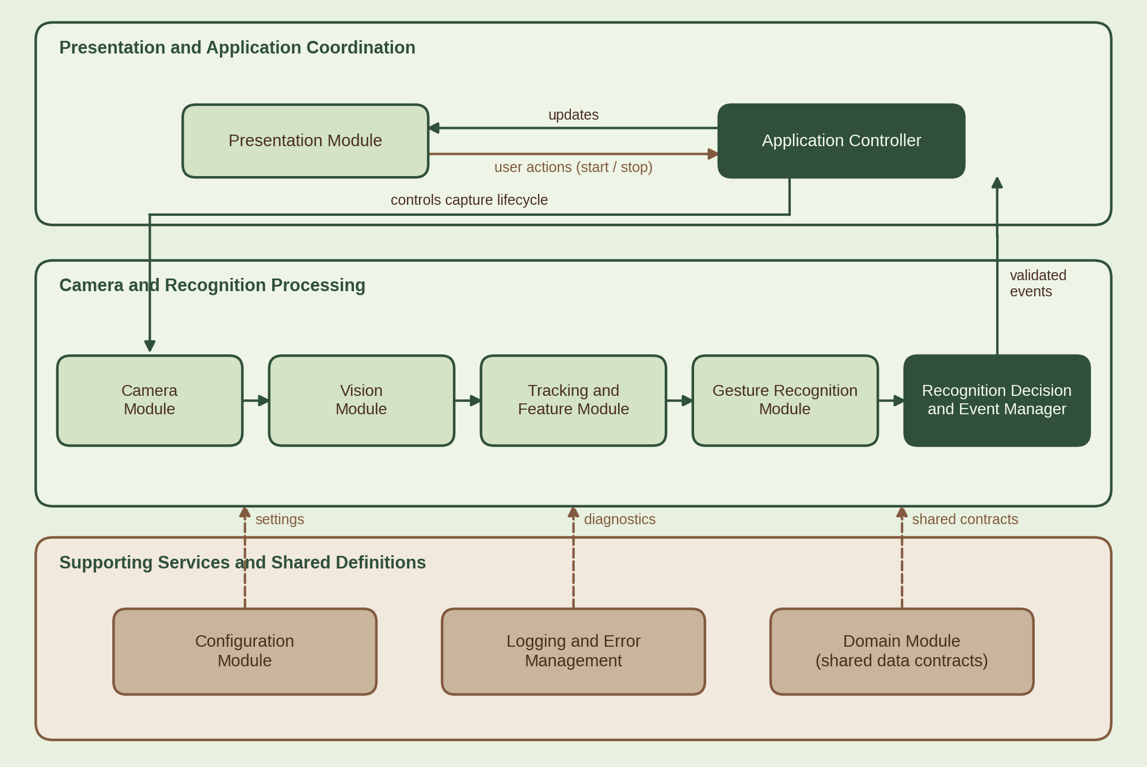
Figure SDP-01: Software module decomposition: ten modules in three logical areas.

2.2 Design Principles
The implementation shall follow separation of concerns, interface-based communication, replaceable recognition strategies, explicit application states, bounded buffering, and deterministic resource cleanup. Recognition algorithms shall remain independent of GUI widgets and camera-specific APIs. Thread communication shall use Qt signals and slots or equivalent thread-safe mechanisms supported by the selected runtime.

3. Module Design

3.1 Presentation Module
The Presentation Module shall implement the desktop interface using PySide6. It shall display the live camera preview, hand bounding boxes, recognized gesture labels, and the following performance and recognition indicators:
- Last Gesture
- Current Gesture
- Confidence
- Camera FPS
- Processing FPS
Recognized hands shall be displayed with green bounding boxes and associated gesture labels. Hands without an active recognized gesture shall be displayed with grey bounding boxes.
The module shall emit user actions, such as application start and stop requests, to the Application Controller. It shall receive recognition results, camera status, and performance updates through thread-safe signals or slots. It shall not perform inference, direct camera capture, or other computationally intensive operations.

3.2 Application Controller Module
The Application Controller shall coordinate initialization, execution, state transitions, and shutdown. It shall initialize configuration and recognition services, load local models, create and start worker threads, and connect component interfaces.
The controller shall receive validated recognition events and publish updates to the Presentation Module. It shall also coordinate recovery from component failures and ensure that camera and worker resources are released during shutdown.
The controller shall maintain the application lifecycle states:
State | Meaning
Initializing | Configuration and required resources are being prepared.
Ready | Required components are initialized and available.
Running | Camera capture and recognition are active.
Error | A component failure requires recovery or user notification.
Stopping | Workers and resources are being shut down.
Stopped | Execution has terminated and resources have been released.
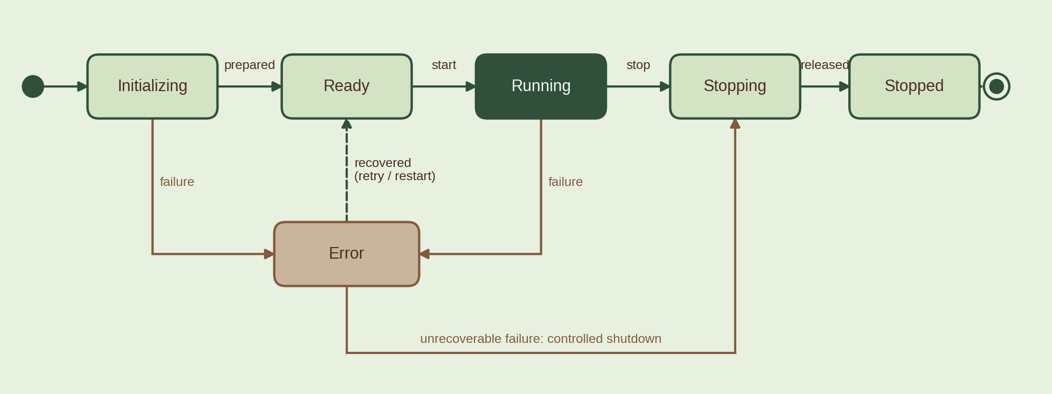
Figure SDP-02: Application lifecycle state machine, including error recovery and controlled shutdown.

3.3 Camera Module
The Camera Module shall encapsulate OpenCV camera access. It shall initialize the selected camera, acquire frames, assign capture timestamps, and report capture status or device errors.
Frames shall be passed to a bounded buffer that retains the newest available frame when processing falls behind. The buffer shall prevent unbounded memory growth and minimize recognition latency.
The module interface shall support camera initialization, frame acquisition, status reporting, and resource release. Camera device selection and retry policies shall be finalized during implementation.

3.4 Vision Module
The Vision Module shall perform hand detection and landmark extraction using a locally available pretrained model. It shall preprocess frames as required by the selected model and return detected hands with their landmark coordinates and associated detection confidence.
The module shall validate inference outputs and report model-loading or inference failures through defined error interfaces. It shall not determine the final externally recognized gesture label.

3.5 Tracking and Feature Module
The Tracking and Feature Module shall maintain the information required to interpret successive frames. Its responsibilities include:
- Associating hand detections across frames.
- Deriving finger-pose and hand-orientation features.
- Maintaining bounded motion history with timestamps.
- Calculating directional displacement and movement features.
- Computing relative spatial relationships between two hands.
- Handling missing detections and resetting invalid tracking state.
Feature outputs shall be represented using normalized coordinates or other model-independent structures where practical. Tracking identifiers and temporal history shall remain transient and shall not be written to persistent storage.

3.6 Gesture Recognition Module
The Gesture Recognition Module shall expose a stable interface for evaluating gesture candidates. It shall contain three logical recognition strategies.
Static Pose Recognizer. Uses geometric features and, where appropriate, classifiers to identify static hand configurations, including Peace Sign, Close Hand, and Open Hand.
Temporal Movement Recognizer. Uses timestamped feature history and state machines to identify Swipe Left, Swipe Right, and the four directional wave gestures involving one or two raised fingers.
Two-Hand Recognizer. Evaluates the spatial relationship and temporal interaction of two hands to detect the prayer pose or clap motion. Both patterns shall map to the single external label Join Both Hands in a Clap/Prayer Gesture.
The exact classifier, pretrained landmark model, geometric thresholds, and temporal parameters shall be selected and validated during implementation.
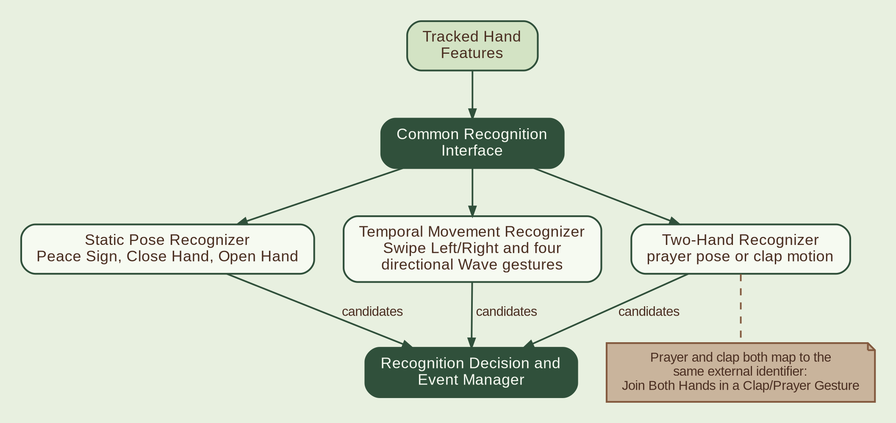
Figure SDP-03: Hybrid gesture recognition strategies. Prayer and clap patterns produce the same external identifier.

3.7 Recognition Decision and Event Manager
This module shall validate candidate recognition results and control the emission of application-level gesture events. Its responsibilities shall include:
- Enforcing the configured confidence threshold, defaulting to 0.7.
- Applying gesture-specific temporal or geometric validation criteria.
- Resolving conflicting candidates according to a defined recognition policy.
- Suppressing duplicate events for sustained gestures.
- Managing gesture re-arming and cooldown state where required.
- Emitting validated recognition events to the Application Controller.
Recognition shall trigger as soon as the applicable gesture criteria are satisfied with sufficient confidence. Additional temporal validation shall be applied only where required by the gesture definition. Static poses and dynamic movements shall use appropriate, potentially different validation rules.
The manager shall distinguish between an ongoing recognized gesture and a newly emitted recognition event to prevent continuous frame-by-frame detection from repeatedly triggering the same event.

3.8 Configuration Module
The Configuration Module shall load and validate local application settings and provide them through a defined configuration interface.
Settings shall include the default confidence threshold of 0.7 and any subsequently defined camera, performance, or recognition parameters. Invalid or missing values shall be handled through documented defaults or explicit configuration errors.
Configuration changes shall be validated before being applied to active components. The format, storage location, and exact settings schema shall be determined during implementation.

3.9 Logging and Error Management Module
This module shall provide consistent diagnostic logging and error reporting. Log entries may include timestamps, component identifiers, severity levels, error categories, and recovery actions.
The module shall exclude camera frames, raw landmark data, and sensitive user information. Logging shall not block the GUI or delay real-time processing.
Recoverable errors shall be reported to the Application Controller for retry or component recovery. Unrecoverable errors shall result in an appropriate user-facing message and controlled resource cleanup.

3.10 Domain Module
The Domain Module shall define shared data contracts, gesture identifiers, application states, recognition results, tracking structures, and error types.
It shall remain independent of GUI widgets and concrete camera or model implementations. Shared contracts shall establish consistent communication between modules and support isolated unit testing.

4. Data Design

4.1 Core Data Structures
The following logical structures shall be defined in the Domain Module. Exact Python types and field representations shall be finalized during implementation.
Data structure | Principal contents
FrameData | Image frame, capture timestamp, frame sequence identifier
HandDetection | Hand landmarks, detection confidence, tracking identifier
HandFeatures | Finger-pose features, orientation, normalized position
MotionHistory | Timestamped feature samples and tracking state
GestureCandidate | Gesture identifier, confidence score, recognition metadata
RecognitionResult | Validated gesture identifier, confidence, event status, timestamp
ApplicationStatus | Lifecycle state, camera status, processing status
PerformanceMetrics | Camera FPS, processing FPS, relevant processing timings
ErrorRecord | Component, error category, diagnostic message, recovery status
AppConfiguration | Confidence threshold and validated runtime settings

Frame and recognition structures shall be transient. Configuration and permitted diagnostic logs may be stored locally, subject to the privacy requirements.

4.2 Gesture Identifier Design
A centralized enumeration or equivalent identifier definition shall represent the ten external gesture labels. Internal recognition strategies shall map their results to these identifiers before emitting externally visible recognition events.
The prayer pose and clap motion shall share one external identifier. Internal metadata may distinguish the detected pattern when necessary, provided this distinction does not change the externally visible gesture label.

4.3 Data Validation
Interfaces shall validate required fields, confidence ranges, timestamps, landmark dimensions, and tracking consistency. Invalid or incomplete inference outputs shall be rejected or handled safely without terminating the application. Confidence values shall be normalized to a documented range before threshold comparison.

5. Processing and Concurrency Design

5.1 Worker Allocation
The Qt main thread shall handle GUI rendering, input events, and display-state updates. Worker threads shall handle camera acquisition and vision processing, with additional separation where required by profiling and the selected model runtime.
The design shall avoid direct manipulation of GUI objects from worker threads. Inter-thread communication shall use signals, slots, thread-safe queues, or equivalent mechanisms with explicit ownership rules.

5.2 Frame Processing Pipeline
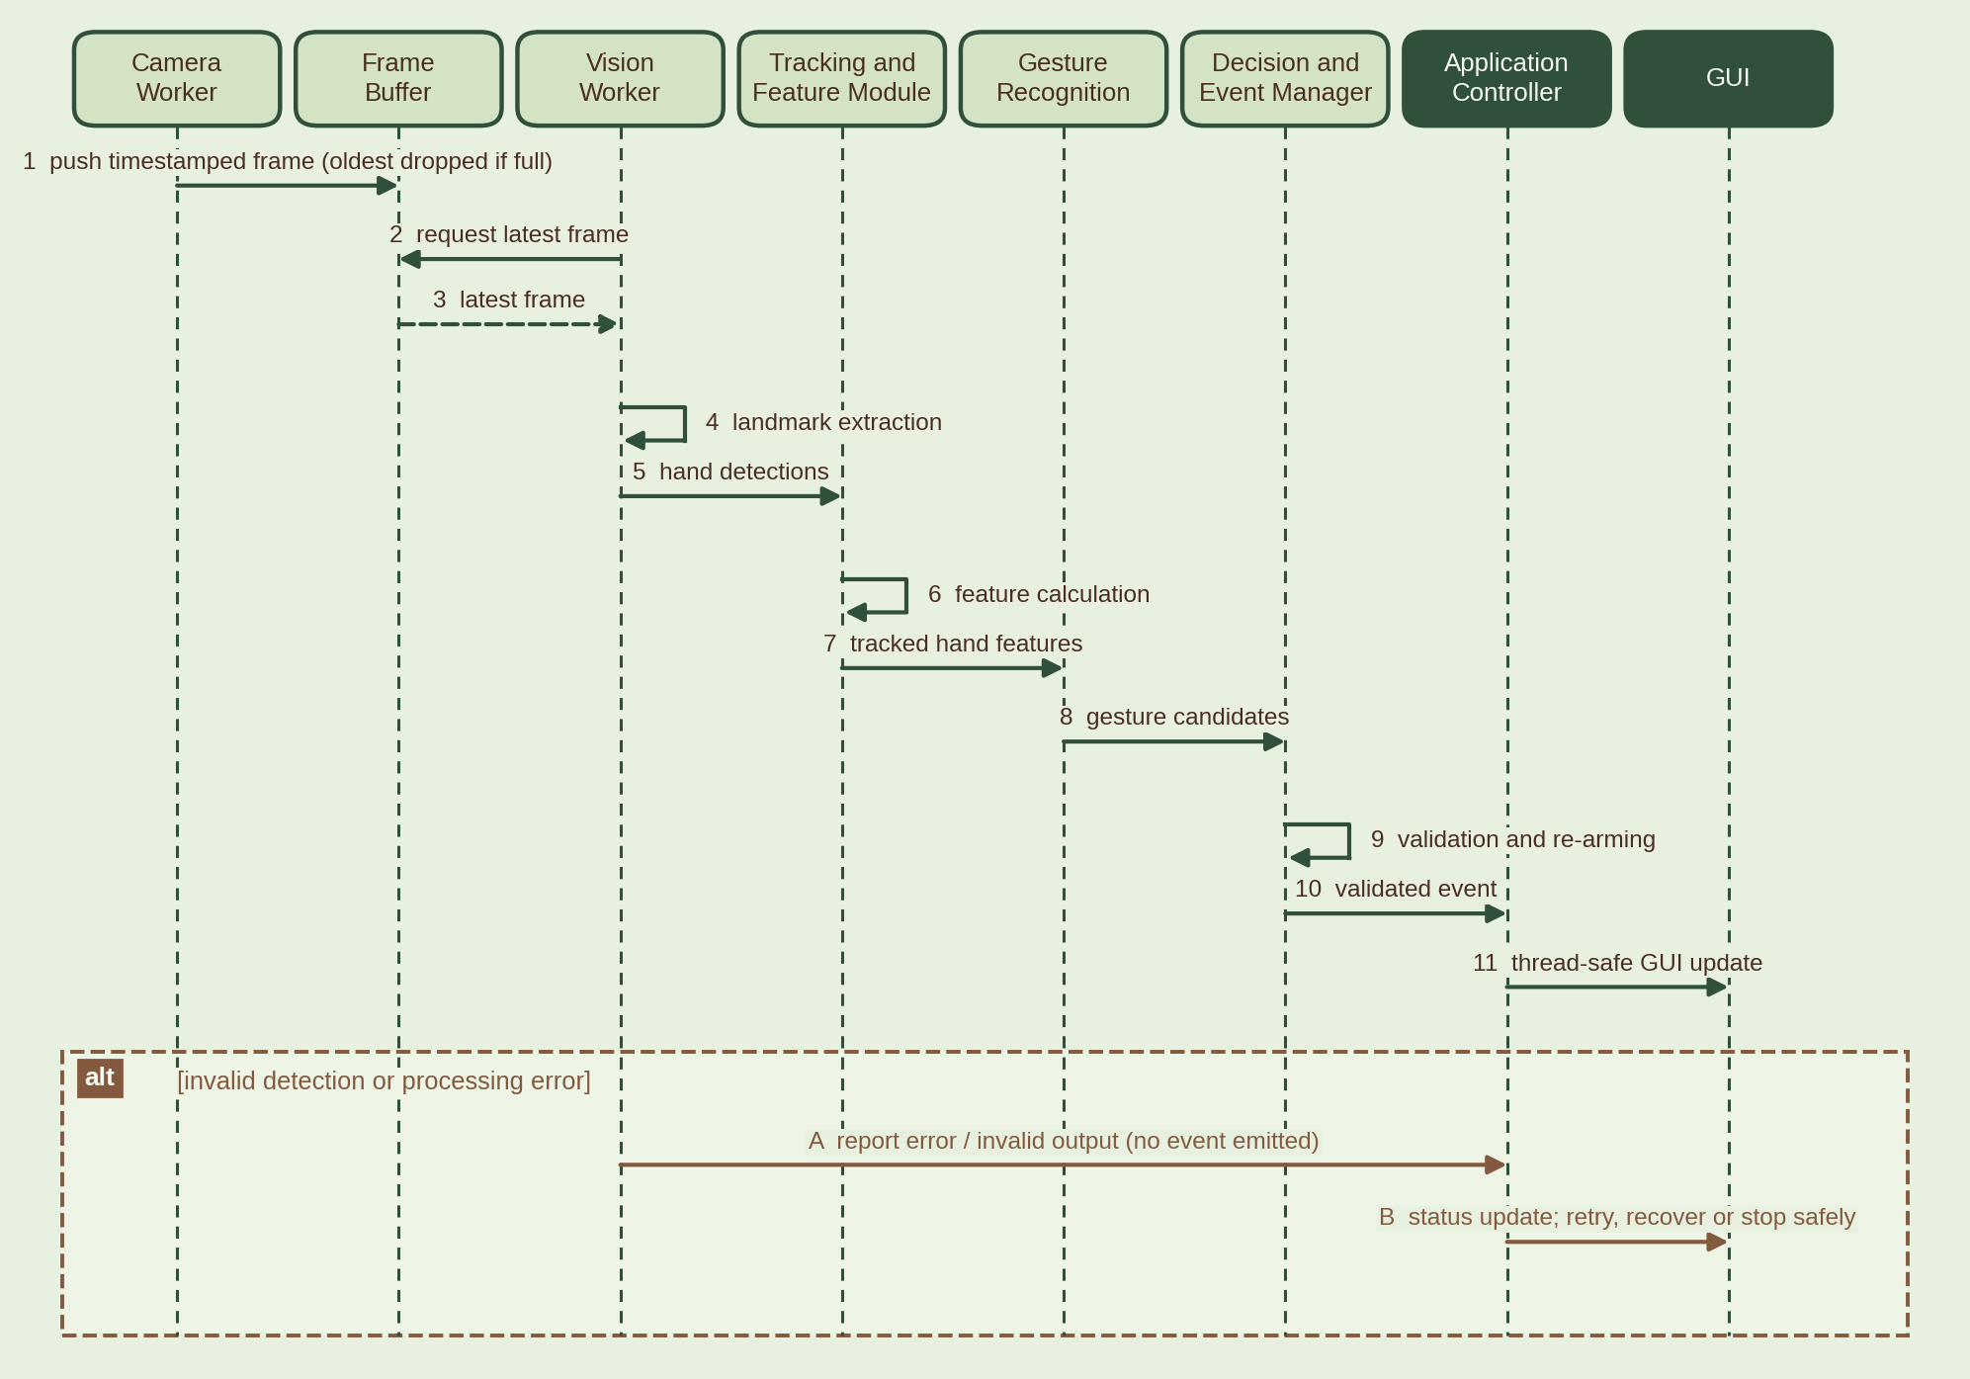
Figure SDP-04: Camera-to-GUI processing sequence, with the alternate path for invalid detections or processing errors.

5.3 Buffering and Performance
The frame buffer shall be bounded. When full, obsolete frames shall be discarded in favor of the latest available frame. Processing metrics shall use timestamps and completed-frame counts to calculate camera FPS and processing FPS consistently.
The implementation shall measure frame acquisition, inference, and end-to-end recognition latency during testing. Numeric performance targets shall be established through prototyping rather than assumed at design time.

5.4 Synchronization and Resource Ownership
Each worker shall own and release the resources it initializes unless ownership is explicitly transferred. Shared state shall be minimized. Access to mutable tracking history and recognition state shall be confined to the owning processing context or protected through suitable synchronization.
Shutdown shall stop new frame acquisition, signal workers to terminate, wait for their completion, and release camera and model resources safely. Blocking waits on the GUI thread shall be limited to controlled shutdown operations.

6. Recognition Logic Design

6.1 Recognition Evaluation
For each processed frame, the recognition pipeline shall generate hand features and evaluate applicable recognition strategies. Each strategy shall return zero or more candidates containing an external gesture identifier, confidence score, and required validation metadata.
The Recognition Decision and Event Manager shall reject candidates that fail confidence or gesture-specific validation criteria. If multiple candidates qualify, a deterministic conflict-resolution policy shall select the applicable result or reject ambiguous candidates.

6.2 Static Gestures
Static pose recognition shall evaluate the current hand configuration using geometric rules and classifiers where appropriate. Pose stability and confidence requirements shall be determined through empirical testing.

6.3 Directional Movements
Directional movement recognition shall evaluate timestamped feature history rather than isolated frames. State machines shall track gesture initiation, direction, completion, and reset conditions. Motion history shall be bounded, and stale or interrupted tracking data shall not be treated as valid movement evidence.

6.4 Two-Hand Gesture
The Two-Hand Recognizer shall determine whether the detected hands satisfy the criteria for the prayer pose or clap motion. The internal recognition path may differ between static contact-like configurations and dynamic hand convergence. Both paths shall return the same external gesture identifier.

6.5 Event Re-Arming
After emitting a recognition event, the manager shall apply the appropriate duplicate-suppression and re-arming policy. A sustained static pose shall not repeatedly emit the same event on every frame. A subsequent valid occurrence shall be permitted after the defined release, cooldown, or state-reset condition is satisfied.
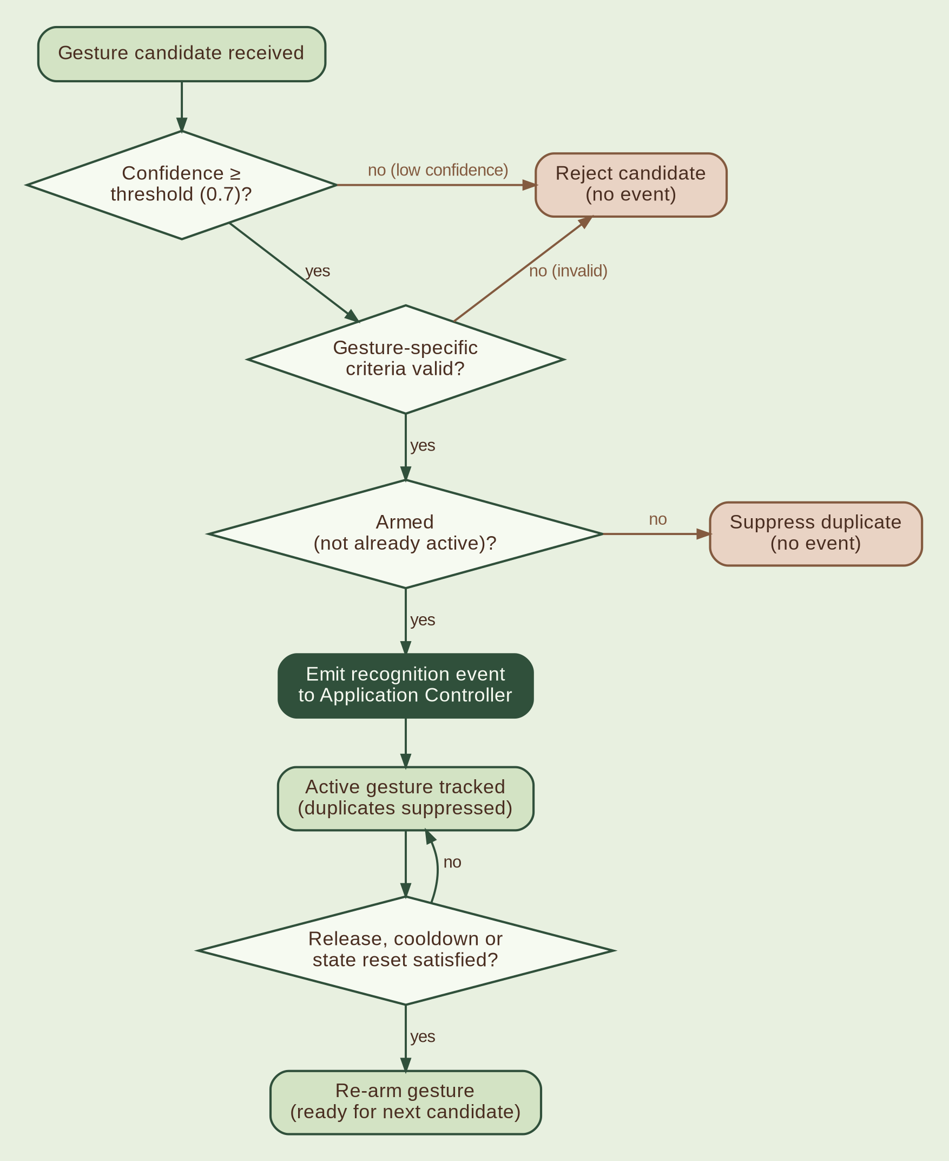
Figure SDP-05: Recognition validation and event re-arming. Rejection and suppression paths are shown in tan.

7. Interface Design

7.1 Internal Interfaces
The following logical interfaces shall separate module responsibilities:
Interface | Purpose
Camera Interface | Initialize camera, acquire frames, report status, release resources
Vision Interface | Detect hands and extract landmarks from a frame
Feature Interface | Produce tracked hands and derived pose, motion, and spatial features
Recognition Interface | Evaluate features and return gesture candidates
Decision Interface | Validate candidates and emit recognition events
Configuration Interface | Provide validated settings to consuming modules
Logging Interface | Record diagnostic events and error information
Controller-to-GUI Interface | Publish preview, recognition, lifecycle, and performance updates

Concrete method signatures, signal definitions, and data-transfer formats shall be specified in the implementation design.

7.2 External Interfaces
The application shall use the local camera through supported operating-system and OpenCV interfaces. It shall not depend on external web services, cloud inference APIs, remote databases, or network-based model repositories during runtime.
User interaction shall occur through the PySide6 desktop interface. Installation and packaging shall supply the required runtime dependencies and model files locally.

8. Error Handling and Recovery Design
Errors shall be detected at component boundaries and translated into defined application error categories.
Failure condition | Required response
Camera unavailable | Report the error and allow safe retry or shutdown
Camera capture interruption | Report status and attempt recovery where appropriate
Model-loading failure | Prevent recognition startup and notify the user
Inference exception | Record a sanitized diagnostic entry and recover or stop safely
Invalid configuration | Apply a documented safe default or report a configuration error
Worker-thread failure | Notify the controller and coordinate recovery or shutdown
Invalid recognition output | Reject the output without emitting a recognition event
GUI communication failure | Preserve thread safety and report the failure
Shutdown interruption | Attempt bounded cleanup and release owned resources

Recovery operations shall not create duplicate workers, leave the camera open, or allow invalid recognition state to persist. Logging failures shall not cause uncontrolled application termination.

9. Security and Privacy Design
The application shall enforce offline runtime operation through its dependency and deployment design. All recognition inference shall execute locally.
Camera frames, landmarks, motion histories, and recognition intermediates shall remain in memory and shall not be written to files, databases, or logs. No telemetry or external transmission shall be implemented.
Local configuration and diagnostic logs shall be restricted to necessary operational information. Dependencies and pretrained model files shall be packaged or installed through a controlled development and deployment process. The implementation shall be reviewed to ensure that third-party libraries do not introduce unintentional network access or sensitive-data persistence.

10. Testing Design

10.1 Unit Testing
Unit tests shall validate geometric feature calculations, landmark validation, motion state machines, two-hand spatial calculations, confidence enforcement, duplicate suppression, event re-arming, configuration validation, and application state transitions.

10.2 Integration Testing
Integration tests shall verify camera-frame delivery, vision-to-feature data flow, recognition strategy integration, decision-manager event publication, controller coordination, and thread-safe GUI updates.
Where physical hardware is unnecessary, camera frames and model outputs may be replaced with controlled test inputs. Test fixtures shall avoid persistent storage of sensitive camera data.

10.3 System and Platform Testing
System tests shall verify end-to-end recognition, camera access, startup and shutdown, error recovery, performance indicators, and packaging on Windows, macOS, and Linux.
Recognition tests shall cover all ten external gesture labels under varied hand positions, orientations, lighting conditions, movement speeds, and detection interruptions. Prayer poses and clap motions shall both produce the same required external label.

10.4 Concurrency and Failure Testing
Tests shall cover dropped frames, processing overload, concurrent shutdown, worker exceptions, repeated camera failures, model-loading errors, and recovery from missing hand detections. The GUI shall remain responsive during normal processing and recoverable failures.

10.5 Performance and Acceptance Testing
Performance evaluation shall measure camera FPS, processing FPS, end-to-end latency, resource usage, and recognition accuracy. Acceptance thresholds shall be established through prototyping and documented separately before release.

11. Implementation and Deployment Considerations
Implementation shall proceed by establishing domain contracts and configuration, implementing camera acquisition and vision processing, integrating tracking and recognition strategies, adding decision and event management, and connecting the GUI and operational error handling.
Deployment shall include compatible Python runtime dependencies, PySide6, OpenCV, the selected pretrained models, and required model assets. Packaging shall be verified independently on each supported operating system. Runtime startup shall not require downloading dependencies or models.
The precise model selection, classifier implementation, temporal thresholds, camera selection policy, concurrency configuration, packaging mechanism, and quantitative performance targets remain subject to prototyping and validation.

12. Design Traceability
The following table links the major architectural requirements to their corresponding software design elements.
Requirement | Design element | Verification
Ten predefined gestures | Gesture Recognition Module and Domain Module | Gesture-level unit and system tests
Prayer and clap share one label | Two-Hand Recognizer and centralized identifiers | Two-hand integration tests
Default confidence threshold of 0.7 | Configuration Module and Decision Manager | Configuration and decision tests
Immediate triggering after valid detection | Decision Manager | Event latency and trigger-policy tests
Offline execution | Local model assets and runtime dependencies | Network-isolation testing
Responsive GUI | Main-thread presentation and worker processing | Concurrency and responsiveness tests
Bounded processing latency | Latest-frame-wins buffer | Processing-load tests
No persistent camera data | In-memory processing and restricted logging | Privacy and storage inspection
Cross-platform support | Camera abstraction and deployment configuration | Platform-specific system tests
Duplicate event suppression | Decision Manager and re-arming state | Recognition state-machine tests

13. Conclusion
This Software Design Plan defines the component-level design and operational behavior of Version 1 of the Offline Gesture Recognition Application. It establishes the module boundaries, data contracts, recognition workflow, threading model, event validation policy, error handling, privacy controls, and testing approach required to implement the approved architecture.
The design preserves the separation between the GUI, camera acquisition, vision processing, gesture recognition, and event management. Implementation-specific parameters shall be finalized through prototyping and verified against documented functional, performance, cross-platform, and privacy requirements.

