For this project, I decided to create a photography and craft business manager program that relates to our side business. This makes the project more personal and motivates me to complete each section of the code based on what I have envisioned.

I imagined and planned this program from a business manager's perspective, where I can manage customer information, orders and order details, photography services, and custom products. The program allows me to create, modify, and delete information as necessary.

I initially started planning with this flow in mind:
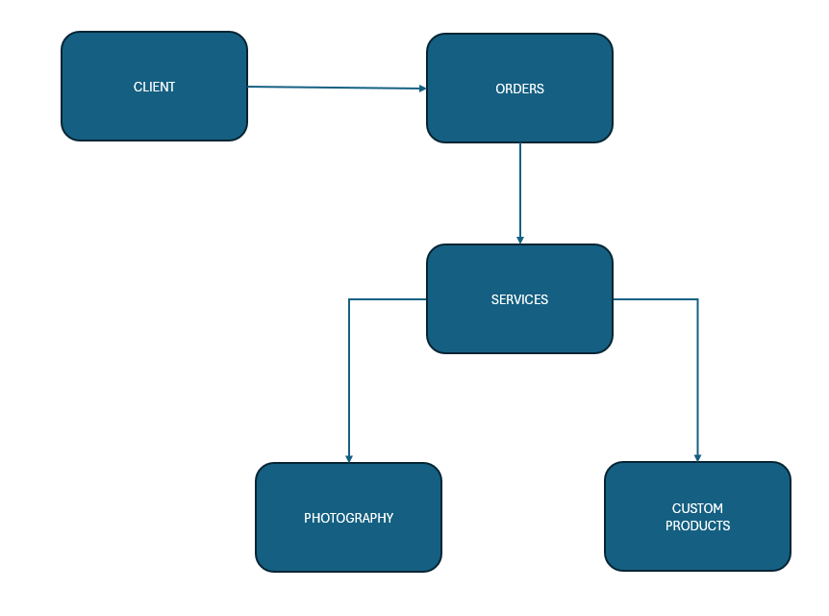
Flow Chart 1: Base Structure of the Overall Project

DATABASE PLANNING:
I then began planning the attributes needed to create each database in Excel:
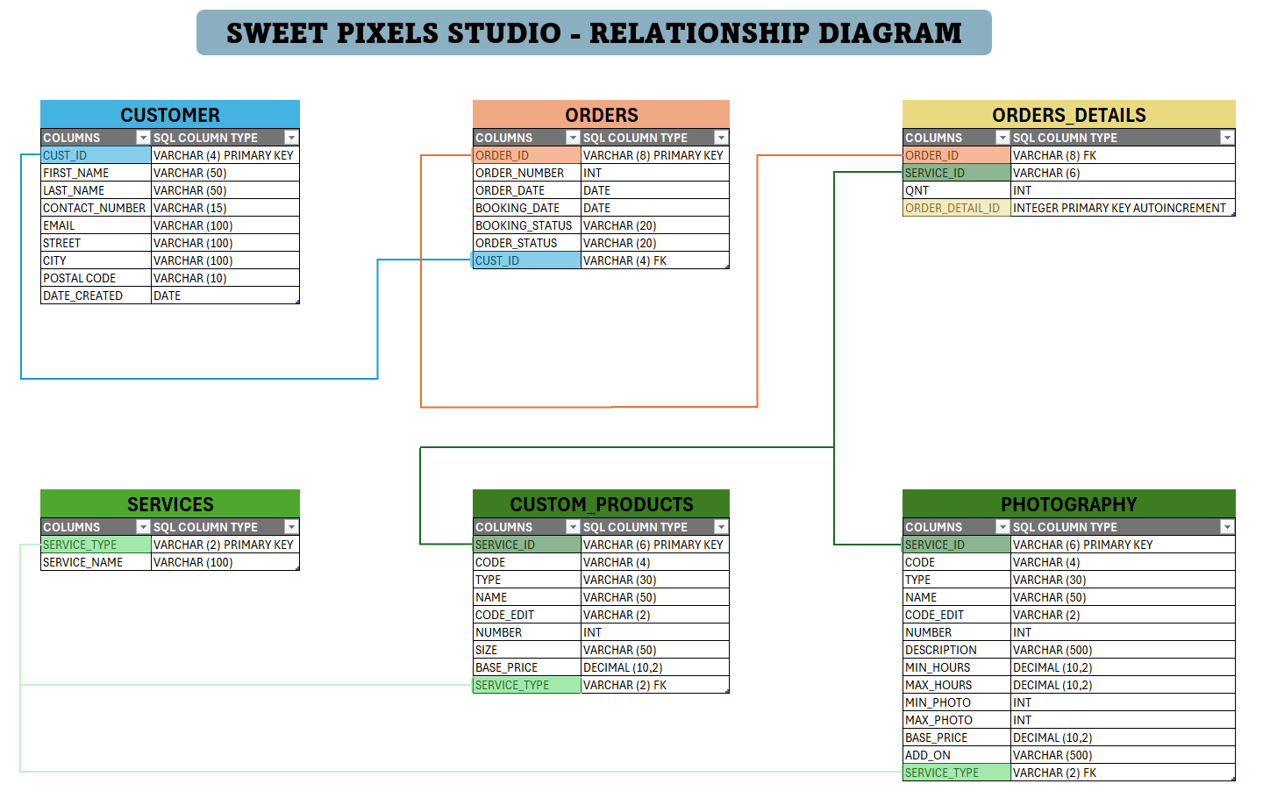
Flow Chart 2: The flow chart above represents my initial plan, but the design changed as I progressed through the project.

As I began planning the database, I realized that it would be easier and make more sense to use MySQL and design the tables with fewer columns. I could utilize features such as AUTO_INCREMENT in MySQL and use Python to navigate and manage the database through code.

At this point, I used ChatGPT to make sure I understood the possibilities and limitations I might encounter. After confirming my ideas and deciding what I wanted to accomplish, I built the SQL code needed for the database. AI also helped me create sample data for the database and reminded me of the correct syntax for certain SQL statements.

I did not encounter any major issues while building the database, and I was able to complete it relatively quickly. However, I did spend time redesigning or rebuilding some of the tables a few times to achieve the structure I wanted.

PYTHON DEVELOPMENT:
Once I finished creating the initial data in MySQL, I started building the Python program with this flow in mind:
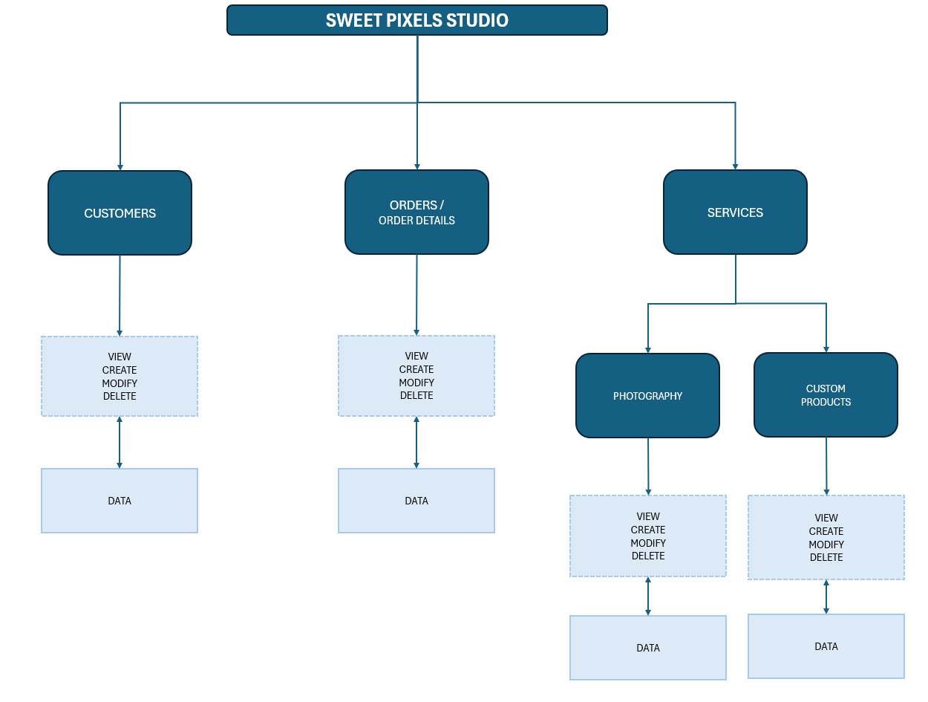
Flow Chart 3: Overall View of Python’s flow

I started with sweet_pixels_studio.py as the main menu, followed by the Customers, Orders, and Services menus.
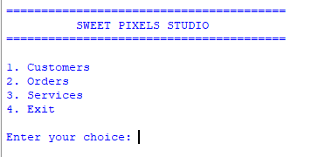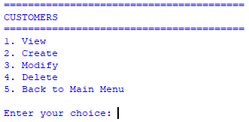
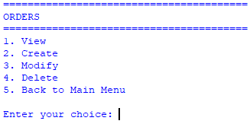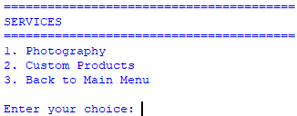
Menu View Samples (Console): sweet_pixels_studio.py, customers.py, orders.py and services.py

One major obstacle I encountered was getting MySQL to connect properly to my Python program. I asked ChatGPT to explain the error and guide me through the steps needed to resolve it so I could continue with my project. I believe the issue occurred because I was using a different computer from the one I normally use for my class exercises. Overall, it was a relatively quick fix with the help of AI.
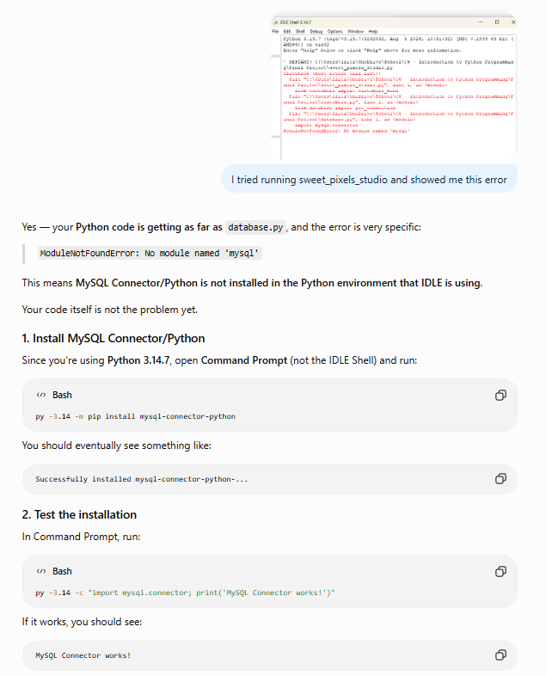
AI assist Example 1: SQL and Python connection error encountered

I gradually added functionality to each selection in the menus. I used AI assistance when I encountered difficulties, such as creating classes, making sure the MySQL database was updated when adding, modifying, or deleting information, and detecting and correcting errors, especially typing and syntax errors.

USE OF AI:
As I worked on the project, I became more comfortable using AI while also learning about its capabilities and limitations. AI has become a useful study buddy for me and has helped me understand concepts more quickly.
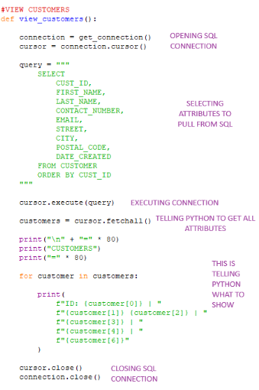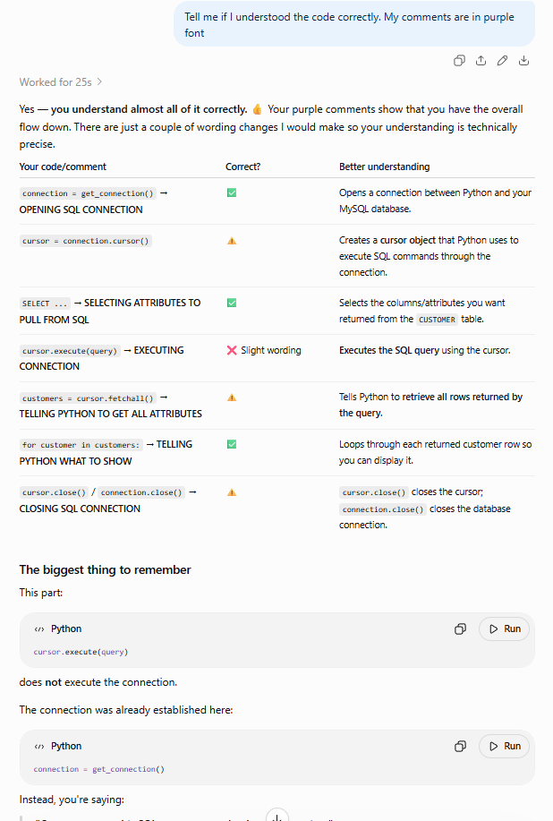
AI use screenshot sample 1

I mainly use AI to confirm my understanding when tracing code that was generated with its assistance. I prefer to work this way because it allows me to learn how the code is written and become more familiar with programming concepts and terminology. I find it more helpful when AI corrects me when I am wrong and explains why my answer or approach is incorrect. Through these conversations, I have also learned more appropriate programming terms and expanded my vocabulary.

AI is not perfect all the time, so I still need to review, test, and correct the code. I see the process as a learning experience where I use AI as a tool while remaining responsible for understanding and testing the final result.

TESTING AND FINAL RESULT:
During testing, I added validations along the way. So far, the options under the main menu, Customers, Orders, and Services are working.

For this project, I left the Photography and Custom Products menus available, but their Create, Modify, and Delete functions display the message:

“Sorry, CREATE/MODIFY/DELETE option is not yet available. Coming soon.”

I made this decision because I wanted to focus my remaining time on completing the other parts of the program rather than repeating the same CRUD process that I had already implemented for the other database tables.

Overall, I am satisfied with the results, and the program is doing what I intended it to do.

The most exciting part for me was asking ChatGPT to help me create a GUI (Graphical User Interface). Since I did not have enough experience to code the GUI completely from scratch, I asked ChatGPT to build the initial GUI code and then used AI prompts to make modifications.

I was surprised by how quickly the GUI came together and how well it turned out. I still made modifications based on how I wanted the program to look and function. There is still room for some aesthetic improvements, but overall, it is functional and working as intended.

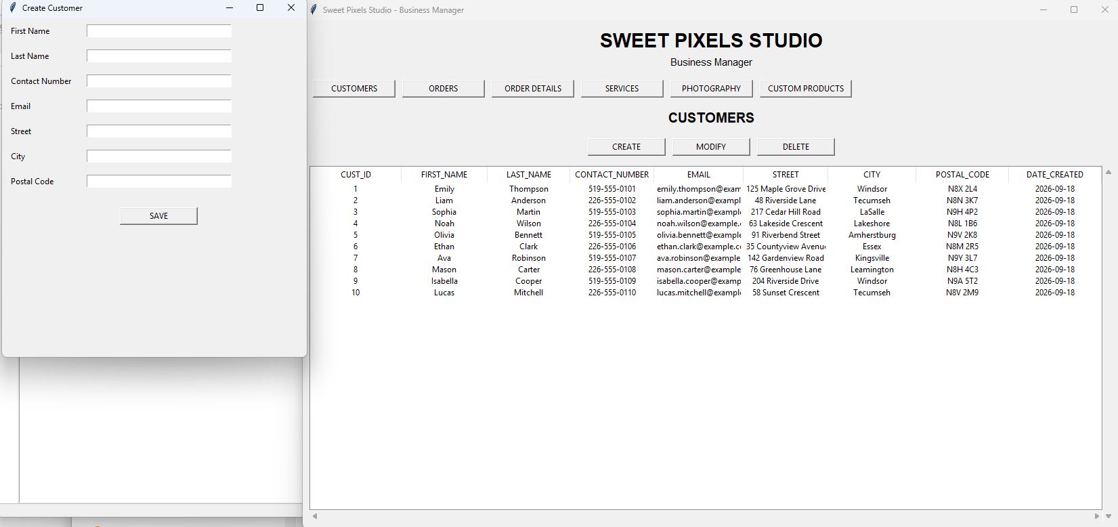
Sample View of Graphical User Interface

This was an excellent learning journey for me, and I have gained more confidence in using AI to work efficiently and progressively within a short period of time.

I feel proud of creating this program and of how AI has helped me throughout the process. This course has inspired me to learn more about programming and AI. I am especially interested in understanding how things work in the background, rather than focusing only on the finished or “fancy” screen.

