Deliverable 1: Isometric screen shot of your design with labels for understanding, and any sub-
assembly close-ups or cross-sections to show how it works should also be included as needed.
Components List:
Upper Part:
- Humidity sensor - https://projecthub.arduino.cc/rudraksh2008/temperature-and-humidity-sensor-with-arduino-1d52a6
- Microcontroller .- Adafruit V2 ESP 32 - https://github.com/adafruit/Adafruit_CAD_Parts/tree/main/5400%20ESP32%20Feather%20V2
- Mister - Pump mechanism + nozzle - (Ordered)
- Cables
- 3D-Printed Tank + Platform
- 3D Printed led

Lower Part:
- 8× upper leg (3D-printed)
- 8× lower leg (3D-printed)
- 16× ball bearings (press-fit)
- 1× chassis (3D-printed)
- 6× distance holder, M2.5, 20 mm (3D-printed)
- 6× distance holder, M2.5, 10 mm (3D-printed)
- 1× upper chassis (3D-printed, 3-part print)
- 1× battery holder (3D-printed)
- 1× motor controller holder (3D-printed)
- 8× Dynamixel RX-24F robot actuators
- 1× 12 V 5000 mAh battery
- 1× Raspberry Pi 4
- 9× Roboteck K4P
- 1× USB-C to USB-B cable
- 1× Diatone Mamba Micro 2A BEC
- 1× U2D2 (USB-to-Serial)
- 1× Arduino USB dongle
Screws & Nuts

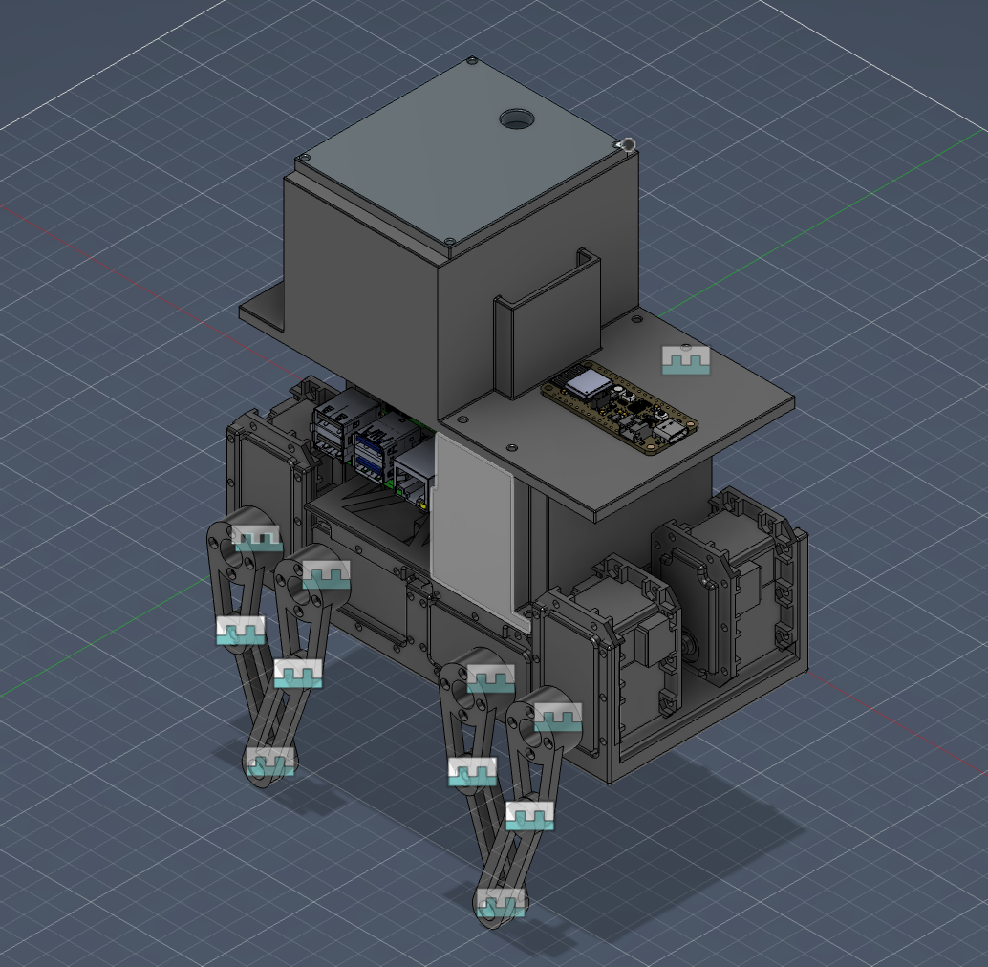
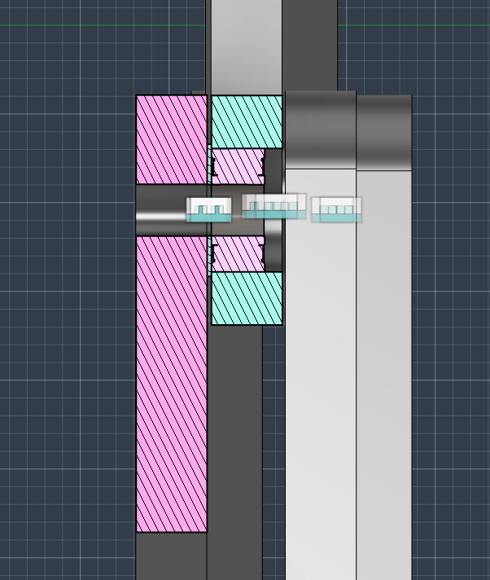
Upper Joint
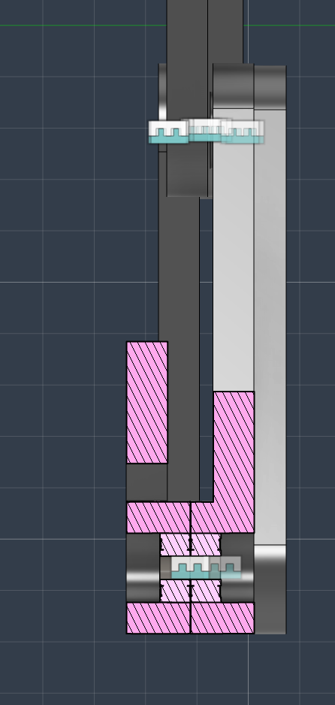
Lower joint
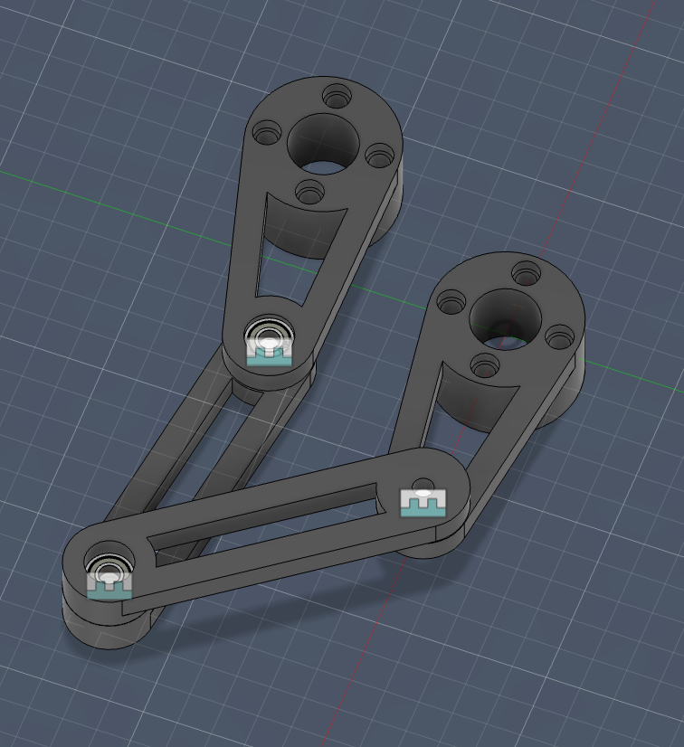

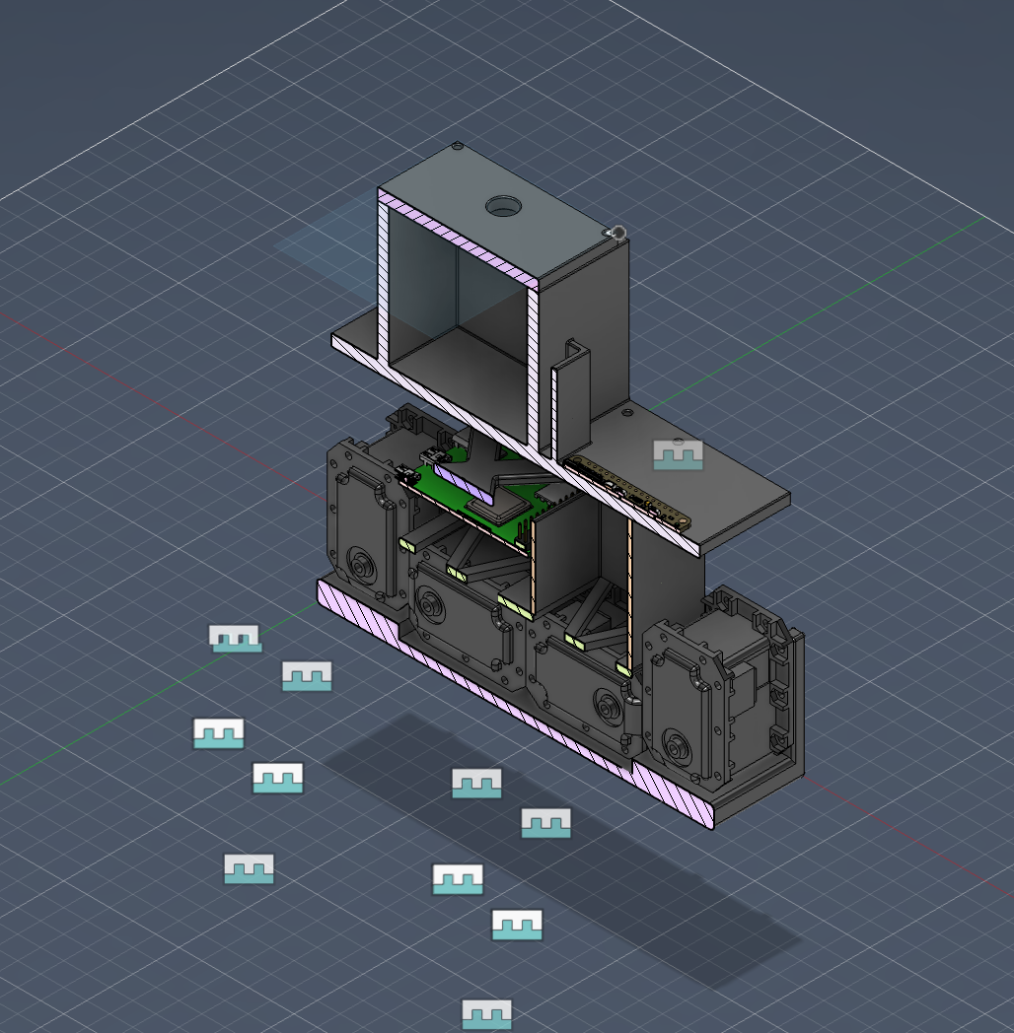

Cross sectional views

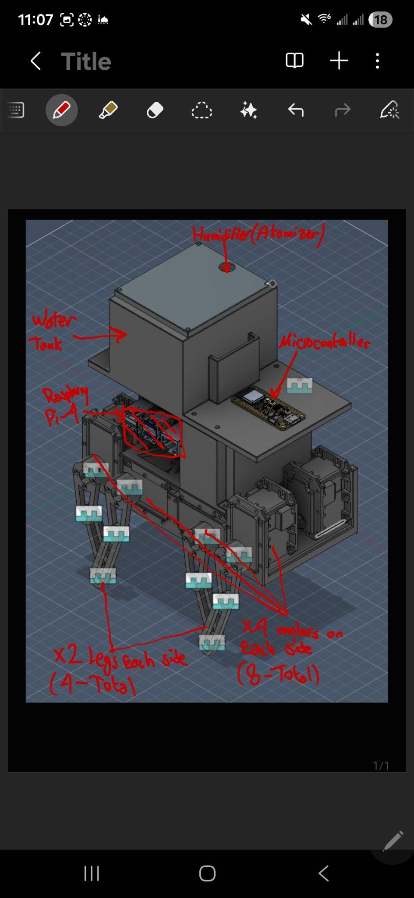

V2 Response

Deliverable 2: Function-Critical Calculations & Standards Integration
1. Mass and Load Estimations
The total mass of the quadruped robot is estimated at approximately 2 kg, which is derived from the main components. The eight Dynamixel RX-24F actuators contribute roughly 0.66 kg. The Raspberry Pi, OpenBCI Cyton board, and other electronics add about 0.1 kg, and the 12 V 5000 mAh battery weighs approximately 0.35 kg. The structural components, including the 3D-printed chassis and legs, are estimated at 0.5 kg, while the active water payload adds about 0.3 kg.
Consequently, the total weight force acting on the robot's center of mass is approximately 20 N. During locomotion, it is assumed as a worst-case scenario that only two legs support the entire weight of the robot during parts of the gait cycle. Therefore, a single active leg must support roughly 10 N of vertical static load.

2. Actuator Torque Analysis
The worst-case mechanical stress on the transmission occurs when the leg is fully extended outward. This configuration creates the largest lever arm relative to the motor axis.
- Lever Arm: The leg length is 32 mm (0.032 m).
- Maximum Torque: The 10 N vertical load produces a resultant worst-case torque at the motor of roughly 0.31 Nm.
The Dynamixel RX-24F actuator specified for the joints possesses a maximum stall torque of approximately 2.6 Nm at 12 V. Because the estimated required torque of 0.31 Nm is significantly lower than the maximum capability of the actuator, the design features a large safety margin.

3.Bearing Load Standards (ABMA)
The primary load on the robot leg acts through the structure as a lever, transmitting forces directly into the joints and bearings. The leg assembly utilizes 16 press-fit ball bearings to support the rotational joints.
To verify the reliability of the transmission, the bearing loads were evaluated using American Bearing Manufacturers Association (ABMA) standards for deep-groove ball bearings. The ABMA standard defines the effective combined bearing load using the following relationship:
Fe = (Xi · V · Fr) + (Yi · Fa)
Where:
- Fr is the radial load acting on the bearing
- Fa is the axial load
- V is a rotation factor (V = 1 when the inner ring rotates)
- Xi and Yi are radial and thrust load factors defined by the ABMA standard
In this design, the planar linkage introduces negligible axial load, therefore:
Fa = 0
The static load on a single leg is approximately 10 N. To account for dynamic walking impacts and shocks, a conservative dynamic factor of 3 is applied. This results in a maximum radial load of:
Fr = 30 N
Because Fa / C0 is below the ABMA limit value e, the standard coefficients are:
Xi = 1.00
Yi = 0
Substituting into the ABMA equation:
Fe = (1.00 · 1 · 30 N) + (0 · 0)
Fe = 30 N
Therefore, the effective bearing load is approximately 30 N in the worst-case dynamic condition where all force is assumed to act on a single bearing.
This value remains significantly lower than the rated load capacity of standard miniature deep-groove ball bearings such as the 638ZZ, confirming that the bearing operates safely within its mechanical limits according to ABMA guidelines.
Standards and Codes_v2 (1)

4. 3D-Printed Housing Tolerance Standards (ANSI)
The 16 ball bearings must be press-fit into the 3D-printed plastic upper and lower legs. To achieve proper alignment without compromising the structural integrity of the additive manufacturing layers, the interface relies on American National Standards Institute (ANSI) limits and fits.
The theoretical CAD geometry was established around an ANSI H7/k6 locational transition fit. This standardized fit is an ideal compromise between clearance and interference for accurate location. However, standard locational interference fits (such as H7/p6) are designed for rigid steel components and would cause the 3D-printed plastic to yield or delaminate under high internal bore pressure. Therefore, the upper and lower fundamental deviations of the H7/k6 specification were adopted as a baseline, but light physical dimensional offsets were applied during slicing to compensate for polymer creep and FDM resolution, ensuring a secure fit that adheres to ANSI principles adapted for plastic housings.

