P4 Part B
Team #22
Members: Bader AlKhawashki, Arunima Basu, Fritz Kuermayr, Salvador Gonzalez

Deliverable 1: Isometric screenshot of your design with labels for understanding, and any sub-
assembly close-ups or cross-sections to show how it works should also be included as needed.

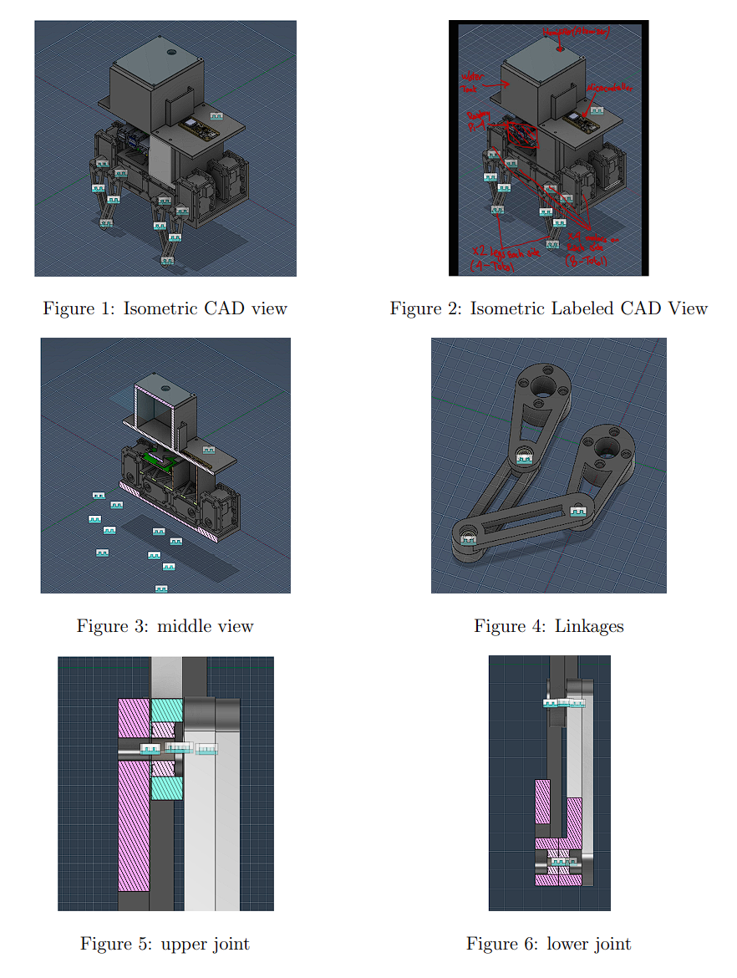
Deliverable 2: Updated function-critical back-of-the-envelope calculations regarding transmission design and/or bearing loads. You must include all major estimations for the design above, as taught in the class (e.g., if you have a custom gear transmission then you should compute resultant loads, if your motor has a radial load show that it doesn’t exceed the max spec of the motor, etc.). Note if you believe you do not have need to make any new updates from the calculations you made in P4, you can leave this part blank with a note “no new calculation updates needed”.

No new calculations needed

Deliverable 3:
Please briefly elaborate on at least one aspect of your machine design based on a specific Standard or Code (file linked in bCourse: Files à Project Assignment à P3). Your angle of elaboration could focus on either the specific dimensions and parts chosen for mechanical components (e.g., how did you choose the shaft and bearing for a slip fit), or meeting certain mechanical performance criteria in your back-of-the-envelope calculations (e.g., whether the load applied to the chosen bearing is within the rated effective load). Please mention which Standard or Code did you follow.

Note: We understand that some projects did not purchase components from sources providing technical specifications aligned with the related Standards and Codes. Additionally, some projects opted to machine their own parts using lower-cost or rapid-prototyping methods (e.g., laser-cutting gears from plywood, or non-standard wire rope for flexible transmissions). In such cases, or when there are no direct ways to apply Standards and Codes to your current project implementation, please include a brief comment: Explain which Standards and Codes you might need to reference if you were to further develop the project into a real product intended for mass production by using off-the-shelf components following industrial standards.

One aspect of our machine design that can be related to an engineering standard is the fit between the ball bearings and the upper and lower leg housings. In a conventionally machined design, this interface would be specified using a standard limits-and-fits system such as the ANSI system for hole and shaft fits. For example, a locational transition or light interference fit such as H7/k6 could be used as a starting point to ensure accurate bearing positioning while still allowing assembly.

In our actual prototype, however, the bearing seats are integrated into 3D-printed plastic parts rather than machined metal components. Because FDM printing does not provide the dimensional precision or surface quality required to reliably realize exact standardized fits, we did not implement the nominal ANSI fit values directly. Instead, we used the standard as a design reference: it informed the kind of fit relationship we wanted conceptually, namely a fit that locates the bearing securely without excessive interference. In practice, the final bore dimensions were adjusted empirically to account for print tolerances, layer-based anisotropy, polymer compliance, and the risk of cracking or delamination during press-fit assembly.

Deliverable 4: The complete Bill of Materials table of the required parts, listing name, quantity, cost and source links (including all small elements such as fasteners and washers).

Section | Item | Qty | Cost/part (USD) | Subtotal
Upper Part | Humidity sensor | 1 | $0 | $0
Upper Part | Microcontroller (ESP32 Feather V2) | 1 | $0 | $0
Upper Part | Mister (pump + nozzle) | 1 | $10 | 10
Upper Part | Cables | 30 | $0 | $0
Upper Part | 3D-Printed Tank + Platform | 1 | $2 | $2
Upper Part | 3D Printed LED | 1 | $1 | $1
Lower Part | Upper legs (3D-printed) | 8 | $0.5 | $4
Lower Part | Lower legs (3D-printed) | 8 | $0.5 | $4
Lower Part | Ball bearings | 16 | $15 | $15
Lower Part | Chassis (3D-printed) | 1 | $5 | $5
Lower Part | Distance holder M2.5 (20 mm) | 6 | $0.15 | $1
Lower Part | Distance holder M2.5 (10 mm) | 6 | $0.15 | $1
Lower Part | Upper chassis (3-part print) | 1 | $2 | $2
Lower Part | Battery holder (3D-printed) | 1 | $1 | $1
Lower Part | Motor controller holder (3D-printed) | 1 | $1 | $1
Lower Part | Dynamixel RX-24F actuators | 8 | $0 | $0
Lower Part | 12V 5000mAh battery | 2 | $30 | $60
Lower Part | Raspberry Pi 4 | 1 | $75 | $75
Lower Part | Roboteck K4P | 9 | $20 | $180
Lower Part | USB-C to USB-B cable | 1 | $5 | $5
Lower Part | Diatone Mamba Micro 2A BEC | 1 | $4 | $4
Lower Part | U2D2 (USB-to-Serial) | 1 | $35 | $35
Lower Part | Arduino USB dongle | 1 | $10 | $10
Lower Part | Screws & Nuts | 20 | $5 | $5
Upper part | Washers | 10 | $5 | $5
Upper part | Fasteners | 10 | $0 | $0
Upper part | Gaskets | 10 | $0.5 | $5

