Speech recognition failure
The speech recognition system was most likely trained exclusively on standard English (Oxford).
Dialects differ from standard English in their use of phonemes, rythm and emphasis. As a result, the meaning of spoken words changes or is lost compared to the standard English used in training.
Hypothesis: Although the characters recognized the problem, they did not use the pronunciation (standard English) with which the speech recognition system was most likely trained. This is why they are unable to give the speech recognition system an executable command (eleven).
The satirical sketch leaves it up to the viewer to determine whether the cause of this inability is a psychological or linguistic language barrier.
An Analytical Comparison of Dialect and Standard English
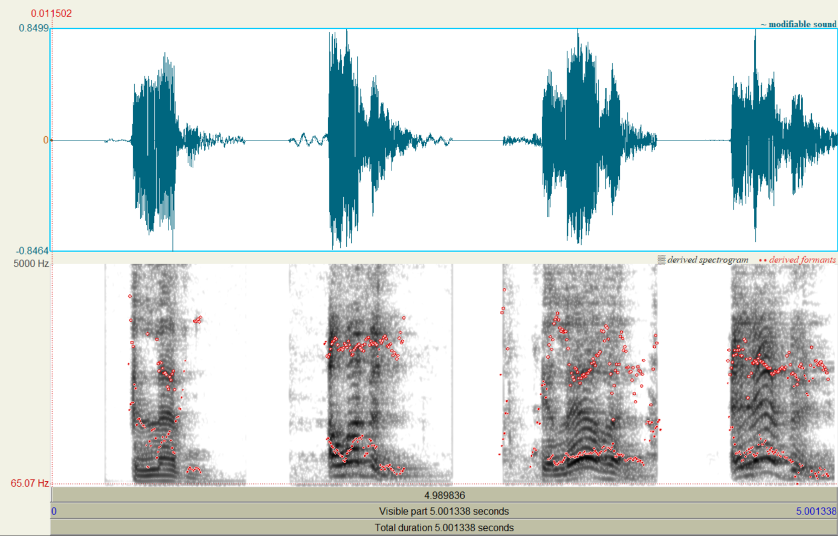
Fig. 1
- Oxford: https://www.oed.com/dictionary/eleven_adj?tl=true&tab=pronunciation
- Scotish: https://www.youtube.com/watch?v=MNuFcIRlwdc, ~ 29 s
- „American“ aus https://www.youtube.com/watch?v=MNuFcIRlwdc , ~ 53 s
- „English“ aus https://www.youtube.com/watch?v=MNuFcIRlwdc, ~ 01 m 14 s

In Fig. 1, the word “eleven” is spoken four times. The first sound wave (from the left) is standard English. To the right of it are three attempts by the characters to convey “eleven” as a command to the elevator’s speech recognition system. Both the contour (amplitude) of the sound waves over time (stress) and the arrangement of the formants F1/F2—shown as red markers in the spectrogram (vowels)—document the significant deviation in the characters’ pronunciation from standard English.
To experimentally verify the differences identified in the analysis, the speech recognition system could be tested using additional English dialects—a) Geordie (Newcastle), b) Scouse (Liverpool), and c) Yorkshire—with a defined number of different words, and a recognition rate could be determined. This would demonstrate whether and to what extent recognition depends on the individual’s pronunciation or correlates with the regional dialect.
The speech recognition system would also need to be trained on English dialects to expand the available vocabulary and improve recognition.

