Task 1
- Praat, waveforms and spectrograms

Examining the waveform of the sentence " Peter put the blue book beside the big window":
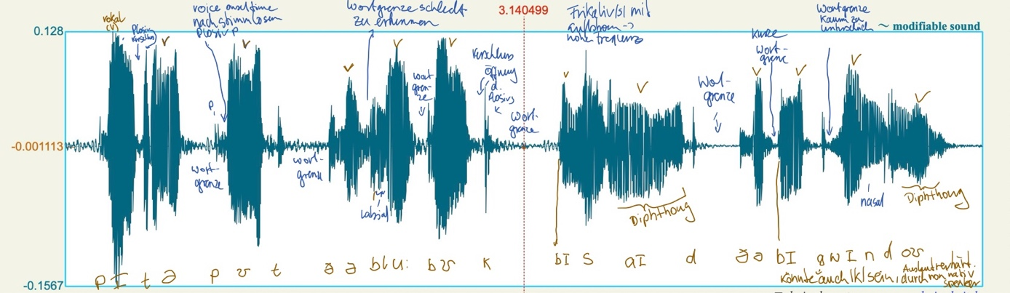
- Vowels are relatively easy to detect, although they are sometimes hard to differentiate from surrounding phonemes as in "blue" – the l and u - or "window" -ndow.
- The bi in big or beside is also hard to differentiate just visually.
- Word boundaries (very low frequency over a time period) are sometimes simple to detect (e.g., book _ beside):
- Sometimes they are less easy to differentiate (e.g., the _ big).
- Sometimes the voice onset time in a word after a voiceless plosive is easier to detect than a word boundary.
- It is very hard to describe the sentence based on the waveform alone.
-> We tried to transcribe the sentence, respectively tried to match the parts of the waveforms to the phonemes, by using the audio signal and the visual waveform representation.

Spectrograms 5, 10, 25 ms:
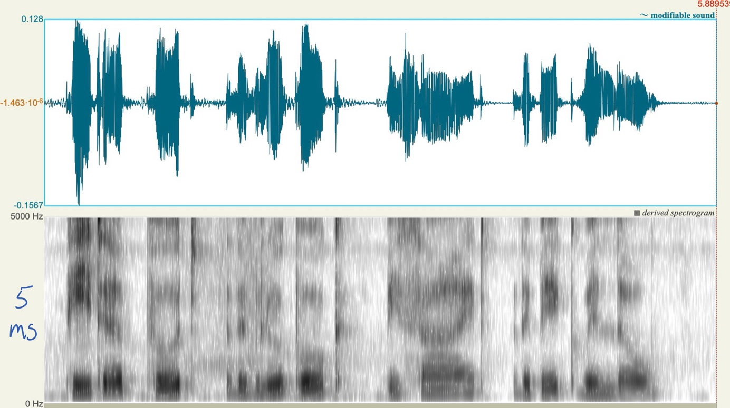
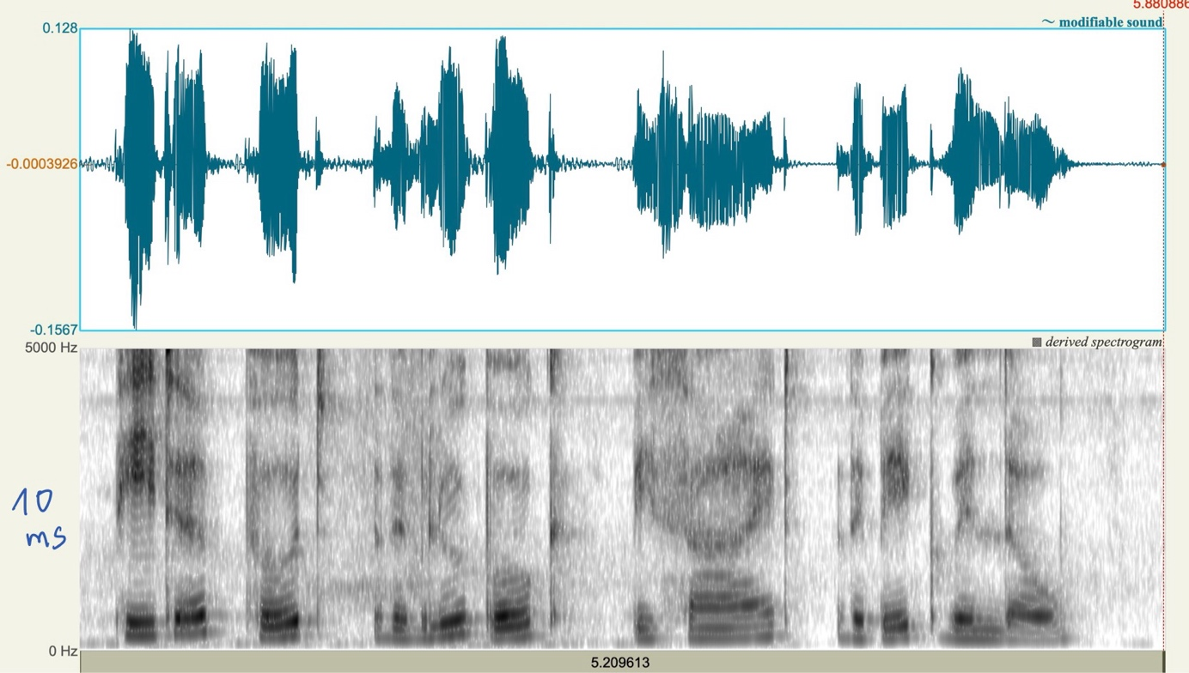
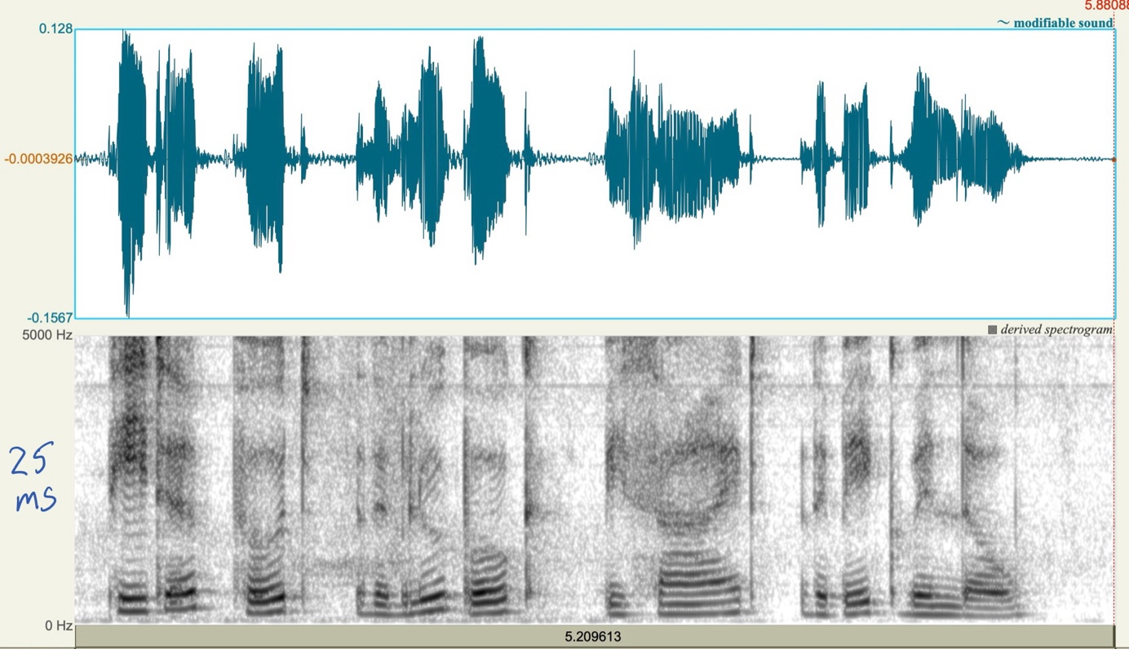

- Within the 25 ms window, the individual frequencies (harmonics) (black rings/stripes) are much more clearly visible than in the 5 ms window. This is because the 25 ms window is long enough to detect the full cycle of the tone while the 5 ms window can only detect a short uncomplete part. In the 5 ms window, the rings tend to merge with one another and are only visible as a blur. A 10 ms window fits somewhere in between.
- The 25 ms window is the best to examine the vowels. The individual frequencies can be seen more clearly allowing for optimal vowel detection based on their formants.
- In the 5 ms window you can instead see fine vertical lines. Each vertical line shows the vibration of the vocal folds – specifically the moment they close. This can be seen because of the very short window length of the spectrogram and therefore a high temporal resolution which useful to detect consonants. For example plosives are recognizable by a steady black vertical line which represents the burst of the plosive.
- So the best setting for speech analysis depends on what you want to analyze. We would use a 25ms window to analyze the vowels and a 5 ms window to analyse and detect consonants likes plosives with closures, bursts and temporal transitions.
Vowel Formants
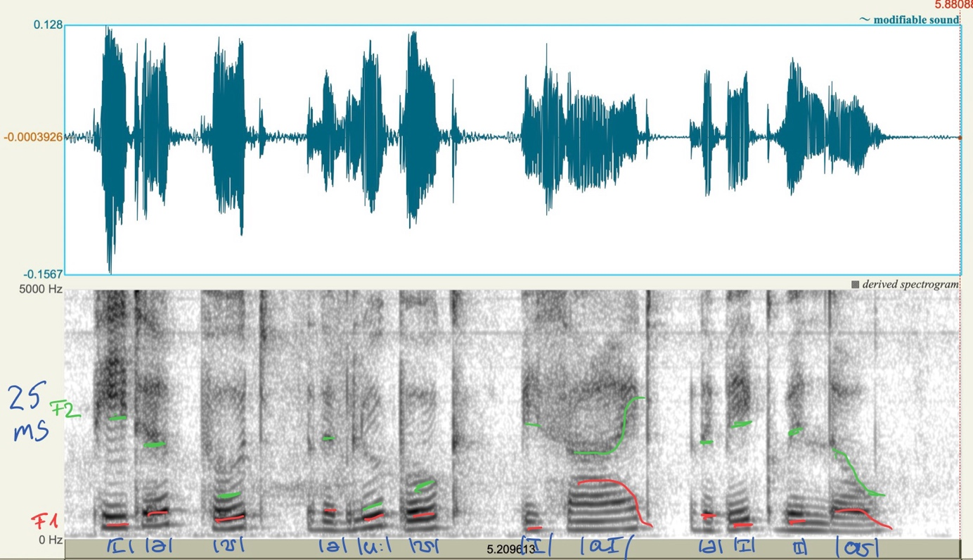
Whole transcription
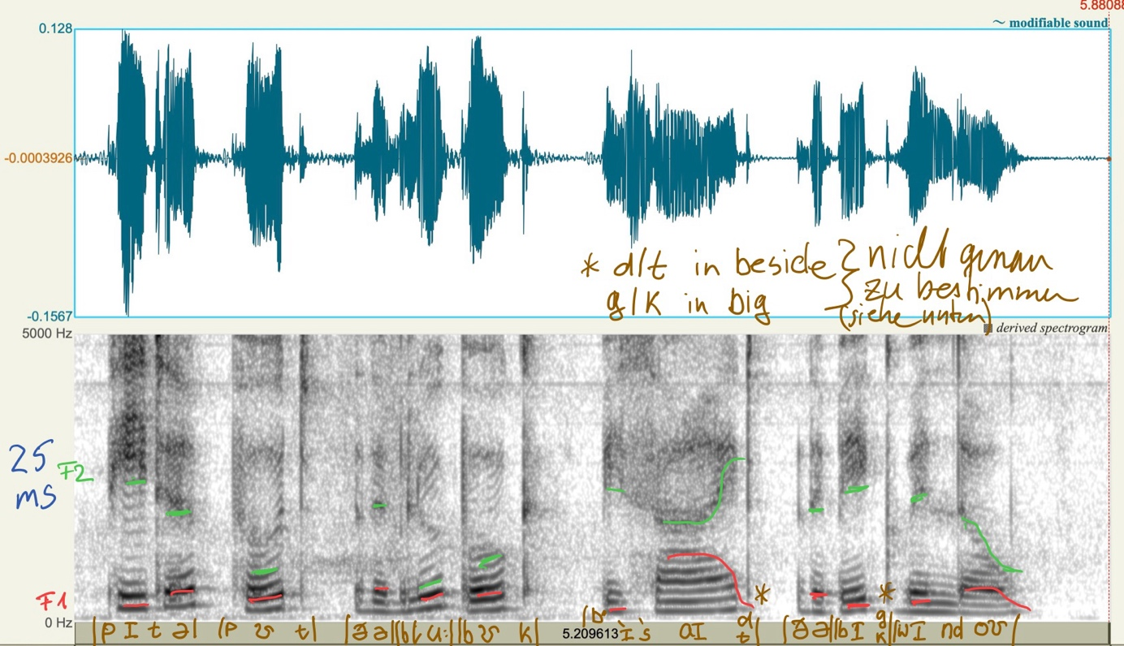
- The vowel "i" looks similar over different words, especially in Peter, big and window. The formants for the "i" are also similar in beside but the duration is a bit shorter (smaller black rings).
- The short u in put and book also looks similar in both words, as well as the "schwa" sound "e" in Peter and the word the.
- It is relatively easy to detect the plosives by the black vertical line but it is hard to differentiate which plosiv it actual is
- In the given spectrograms it is also hard to determine if a plosive is voiced or voiceless.
  - E.g. big should be pronounced with a voiced "g" at the end but as it is spoken by a native German speaker it could also be an unvoiced "g" pronounced as "k") because of the "Auslautverhärtung" in German (same with the "d" in beside). In the audio it sounds more like a "k".
- The diphthongs are both relatively long in their duration and they have a characteristic falling down or going up of the formants in the middle (like a curve)
- The fricative "s" in beside is also easy to detect because of its longer duration and its high frequency noise created by the airflow

- Speech recognition failure
The speech recognition system was most likely trained exclusively on standard English (Oxford).
Dialects differ from standard English in their use of phonemes, rythm and emphasis. As a result, the meaning of spoken words changes or is lost compared to the standard English used in training.
Hypothesis: Although the characters recognized the problem, they did not use the pronunciation (standard English) with which the speech recognition system was most likely trained. This is why they are unable to give the speech recognition system an executable command (eleven).
The satirical sketch leaves it up to the viewer to determine whether the cause of this inability is a psychological or linguistic language barrier.
An Analytical Comparison of Dialect and Standard English
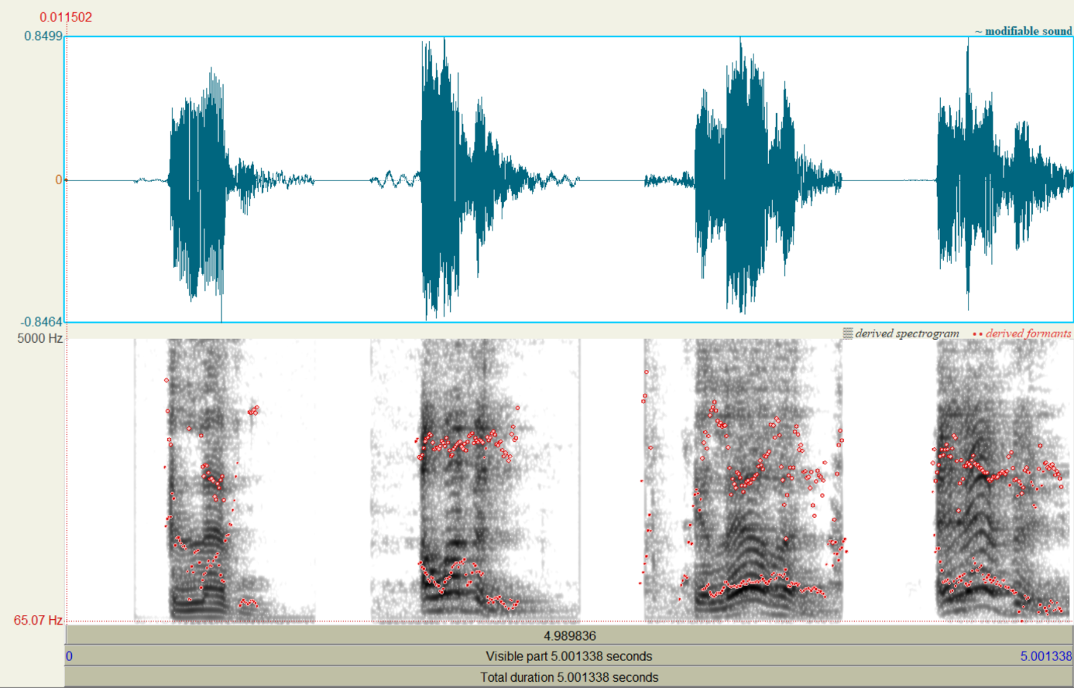
Fig. 1
- Oxford: https://www.oed.com/dictionary/eleven_adj?tl=true&tab=pronunciation
- Scottish: https://www.youtube.com/watch?v=MNuFcIRlwdc, ~ 29 s
- „American“ aus https://www.youtube.com/watch?v=MNuFcIRlwdc , ~ 53 s
- „English“ aus https://www.youtube.com/watch?v=MNuFcIRlwdc, ~ 01 m 14 s

In Fig. 1, the word “eleven” is spoken four times. The first sound wave (from the left) is standard English. To the right of it are three attempts by the characters to convey “eleven” as a command to the elevator’s speech recognition system. Both the contour (amplitude) of the sound waves over time (stress) and the arrangement of the formants F1/F2—shown as red markers in the spectrogram (vowels)—document the significant deviation in the characters’ pronunciation from standard English.
To experimentally verify the differences identified in the analysis, the speech recognition system could be tested using additional English dialects—a) Geordie (Newcastle), b) Scouse (Liverpool), and c) Yorkshire—with a defined number of different words, and a recognition rate could be determined. This would demonstrate whether and to what extent recognition depends on the individual’s pronunciation or correlates with the regional dialect.
The speech recognition system would also need to be trained on English dialects to expand the available vocabulary and improve recognition.

