Task 1 – Pen & Paper
A: Find one tagging error in each of the following sentences, which are tagged with the Penn
Treebank tagset:
1. I/PRP need/VBP a/DT flight/NN from/IN Atlanta/NN NNP
2. Does/VBZ this/DT flight/NN serve/VB dinner/NNS NN
3. I/PRP have/VBVBP a/DT friend/NN living/VBG in/IN Denver/NNP
4. Can/VBP MD you/PRP list/VB the/DT nonstop/JJ afternoon/NN flights/NNS

B: Use the Penn Treebank tagset to tag each word in the following sentences from Damon Runyon’s short stories. You may ignore punctuation.
Quelle Penn Treebank tagset: https://www.ling.upenn.edu/courses/Fall_2003/ling001/penn_treebank_pos.html (5.11.2026)
1. It/PRP is/VBZ a/DT nice/JJ night/NN.
2. This/DT crap/JJ game//NN is/VBZ over/IN a/DT garage/NN in/IN {Fifty-second Street}/NNP.
3. Nobody/NN ever/RB takes/VBZ the/DT newspapers/NNS she/PRP sells/VBZ.
# Kommentar: nobody ist eigentlicher eher ein Pronomen (im deutschen ein indefinitpronomen) aber das passt laut dem Tagset hier nicht
4. He/PRP is/VBZ a/DT tall/JJ, skinny/JJ guy/NN with/PRP a/DT long/JJ, sad/JJ, {mean-looking}/JJ kisser/NN, and/CC a/DT mournful/JJ voice/NN.
5. I/PRP am/VBP sitting/VBG in/IN Mindy/NNP ’s/POS restaurant/NN putting/VBG on/RP the/DT gefillte/JJ fish/NN, which/WDT is/VBZ a/DT dish/NN I/PRP am/VBP very/RB fond/JJ of/IN.
# Kommentar: which ist hier ein Relativpronomen und leitet keine WH-Phrase ein, trotzdem wird es als wh-Determiner getaggt.

C: Constituency parse trees
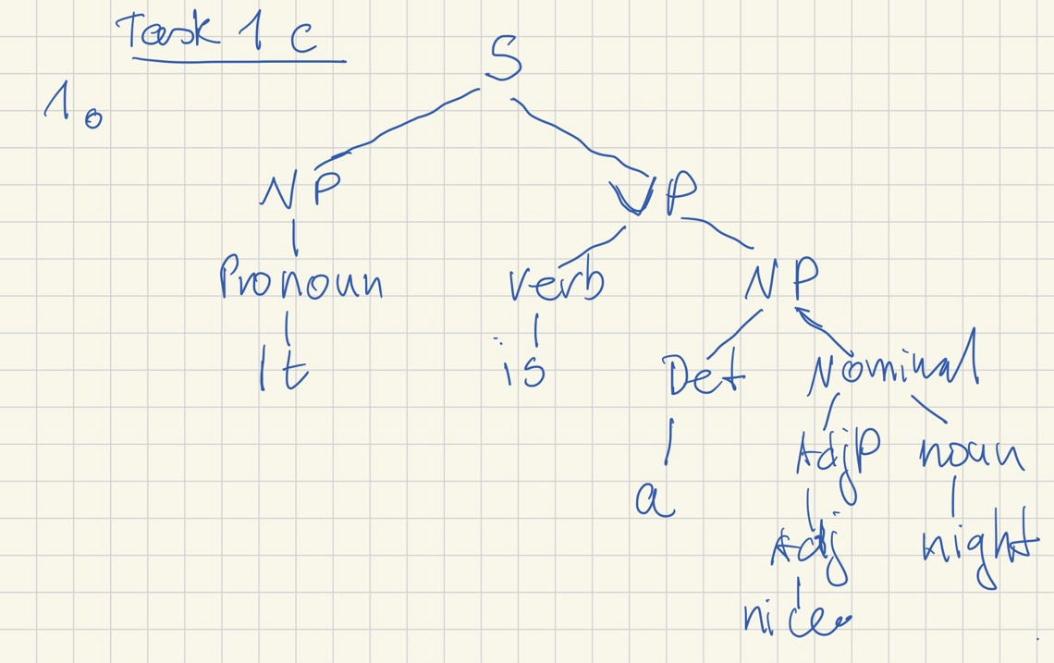

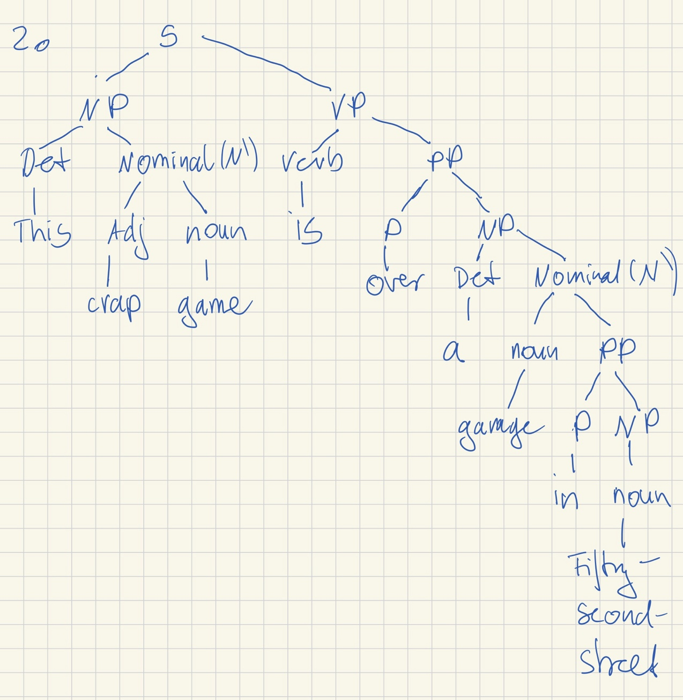
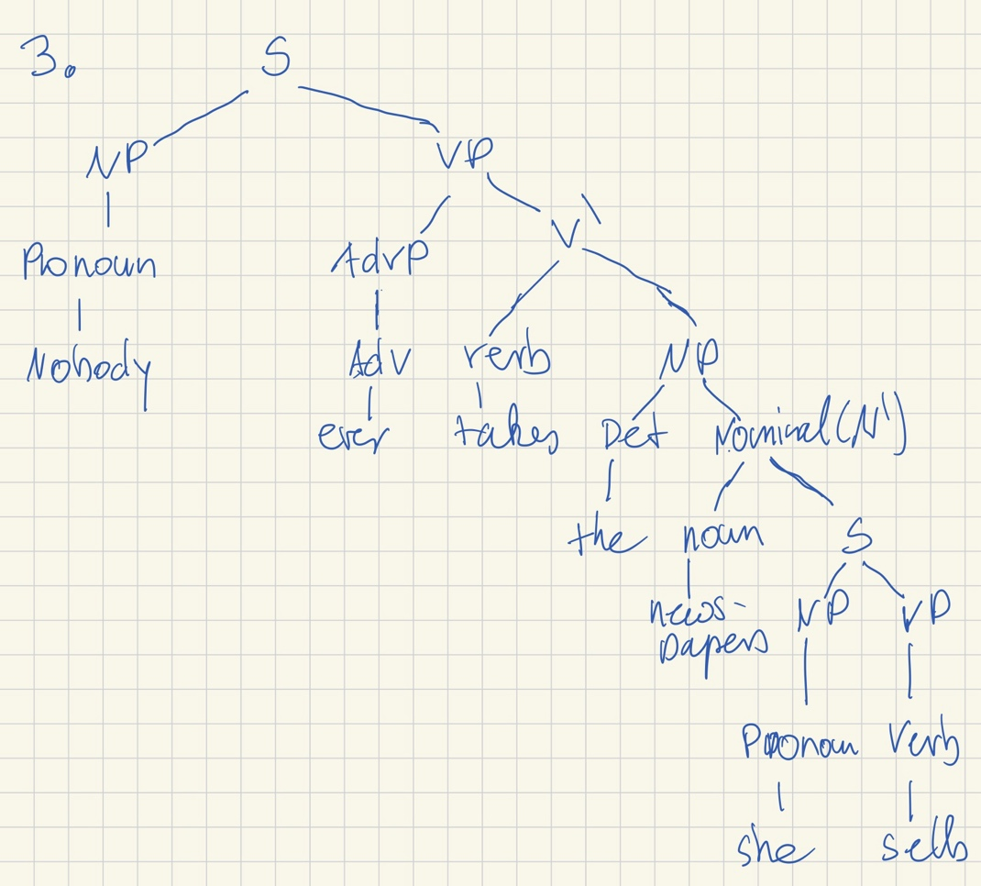
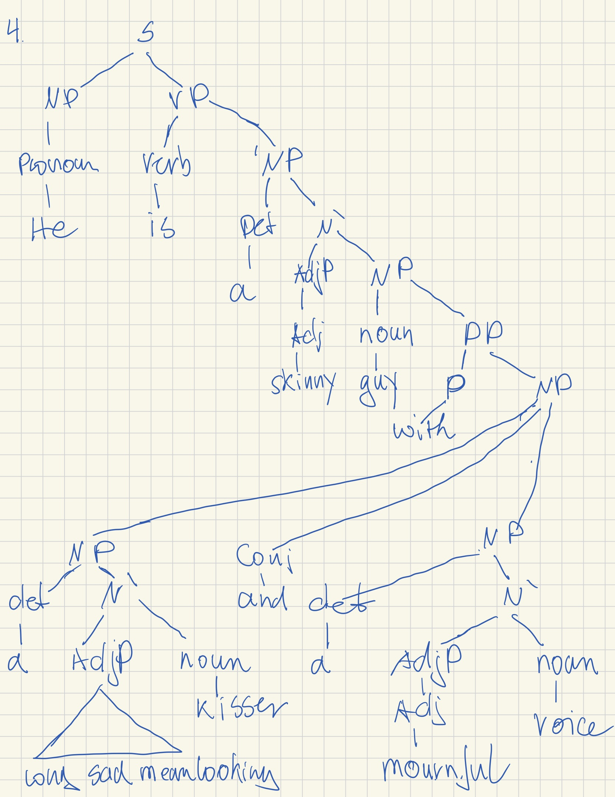
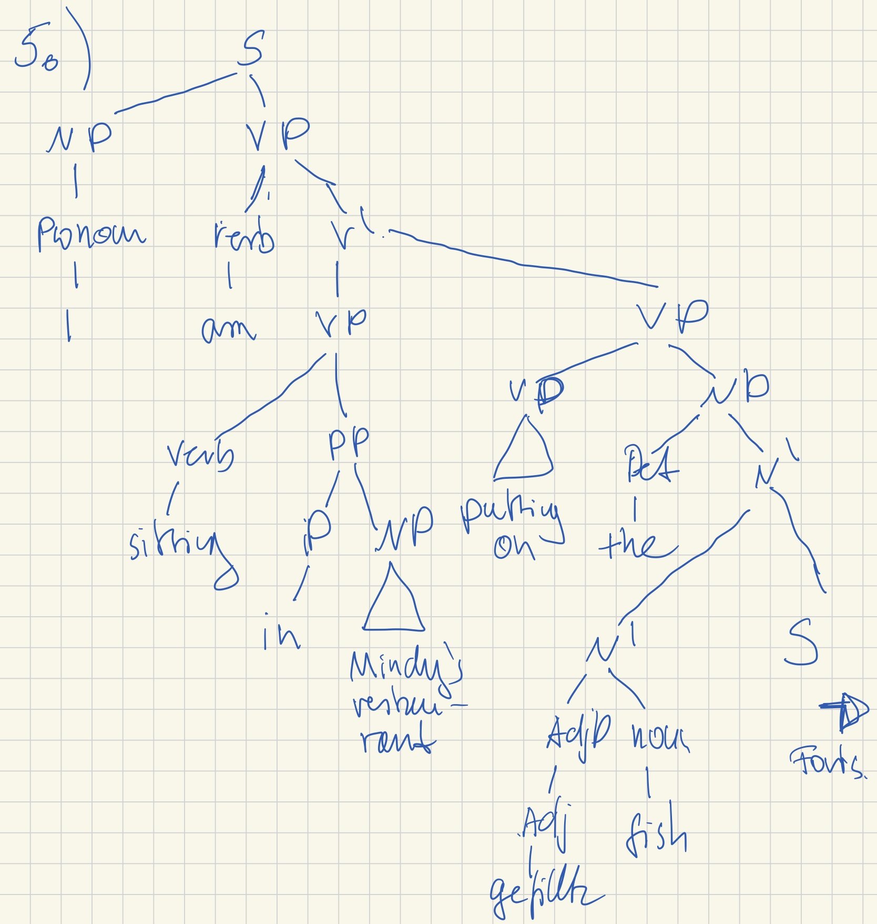
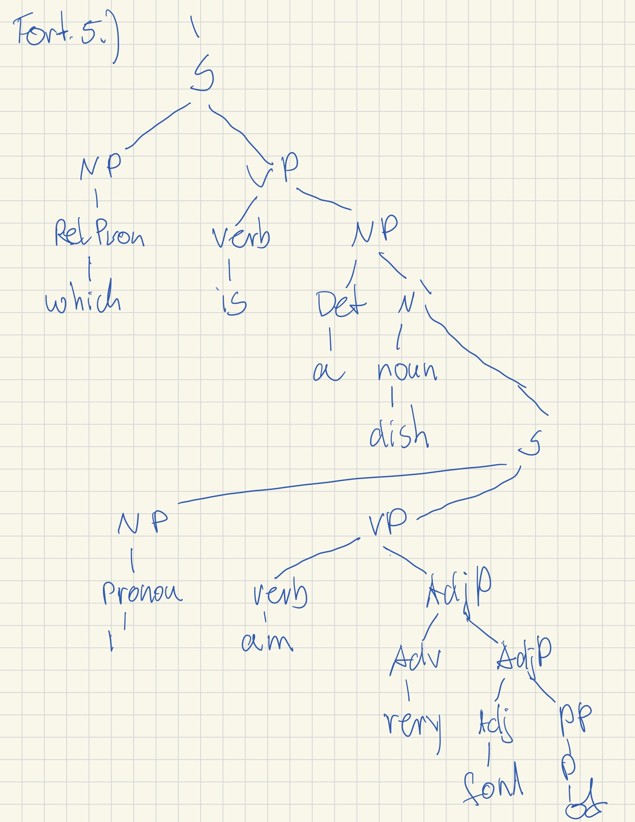

D:
- I/PRP saw/VBD the/DT man/NN with/IN a/DT telescope/NN.

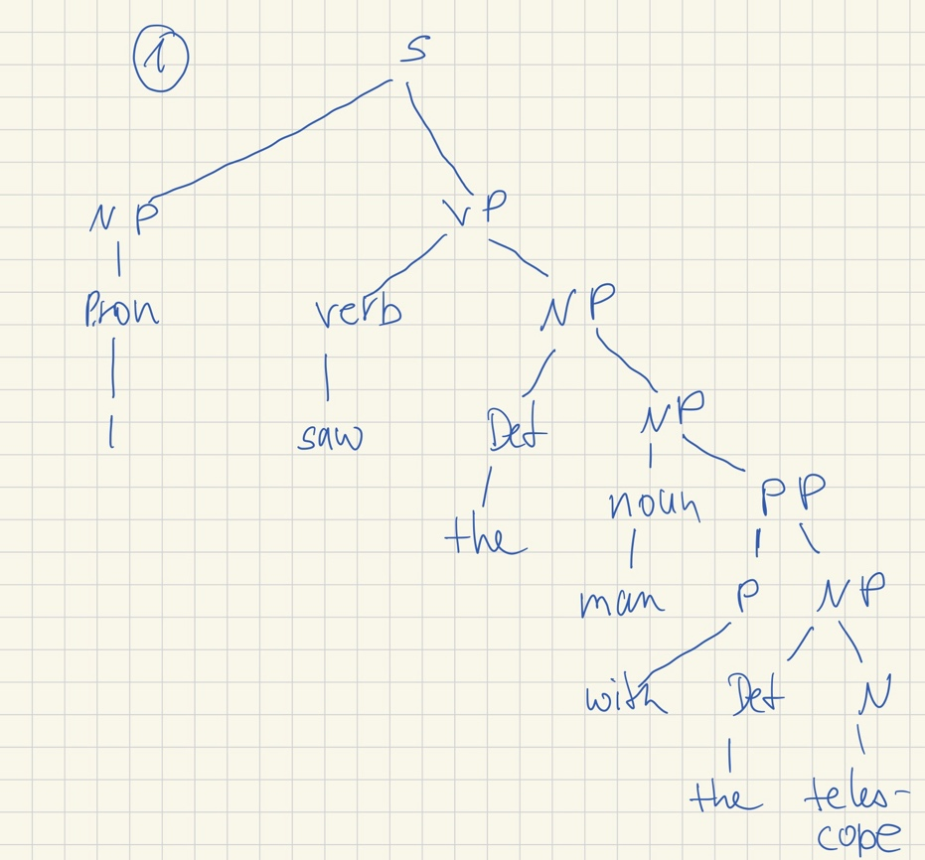
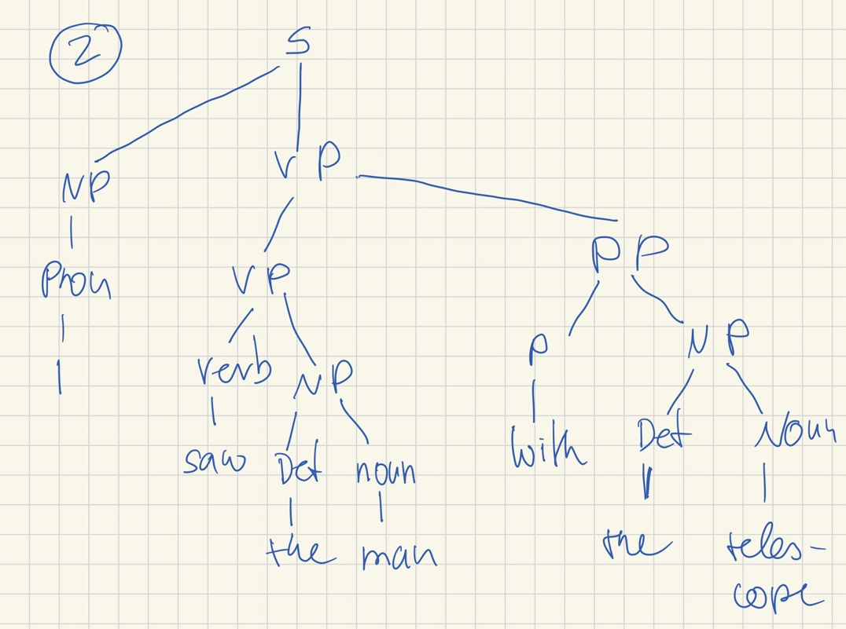
- "She took a photo of her son on the balcony."
"I was looking for the key in the room."
"I followed the woman with your red bike."
"Old man and woman love icecream."
"I saw the man with the present."

