Problem E

Nonogram
Time limit: 1 second
A Nonogram, is a popular logic puzzle where players need to fill in or Leave the cells blank to form an image. players fill cells in a grid based on number clues provided for each row and column. These clues indicate the lengths of consecutive filled blocks in each row or column.
By given the solution grid to a Nonogram puzzle as a binary matrix. Your task is to extract the number clues that would appear on the top (for columns) and on the left (for rows) of the grid.
For example, a 5×5 Nonogram solution grid be like (1 = filled, 0 = blank):
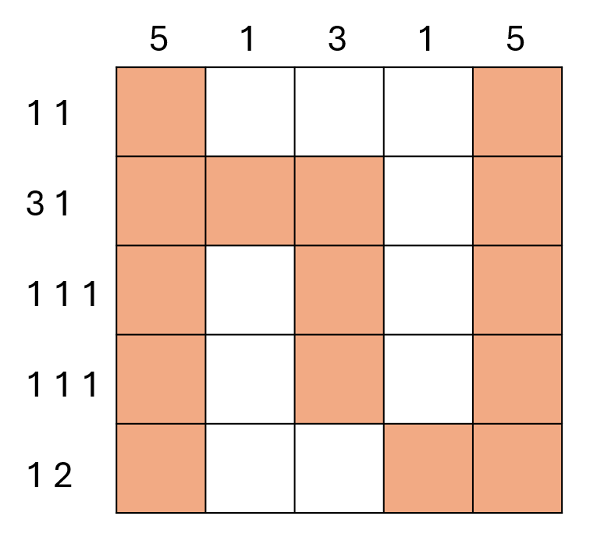

Input Format
- The first line contains a single integer n (1 ≤ n ≤ 3000) — the number of n×n Nonogram grid.
- Each of the next n lines contains n space-separated integers — either 0 or 1.

Output Format
Output 2n lines:
- The first n lines contain the clues for each column, from the first to the nth column, top to bottom.
- The next n lines contain the clues for each row, from the first to the nth row, left to right.
- For each line, print the lengths of consecutive 1s separated by a space.
- If a row or column contains no 1s, print a single 0.

Sample Input
5
1 0 0 0 1
1 1 1 0 1
1 0 1 0 1
1 0 1 0 1
1 0 0 1 1

Sample Output
5
1
3
1
5
1 1
3 1
1 1 1
1 1 1
1 2

