Headline:
Professional Cleaning You Can Trust — From Construction to Move-In Ready
Subtext:
Post-construction cleaning, pressure washing, and maintenance services delivered with precision and reliability.
Buttons:
- 🔵 Get a Quote
- ⚪ View Our Work

🏗️ Services Section
Clean icons + short descriptions

✨ Post-Construction Cleaning
- Rough, Final, and Re-cleans
- Builder-ready quality

🚿 Pressure Washing
- Driveways, siding, patios
- Safe and professional equipment

🏢 Maintenance Cleaning
- Offices, info centers
- Weekly / biweekly service

✔ Trusted by Builders
Lennar Homes, LGI Homes, DRB Homes, Ryan Homes
✔ 4+ Years Experience
Specialized in construction cleaning
✔ Reliable Crews
Always on time, ready to deliver
✔ Quality Guaranteed
We don’t leave until it’s right

📸 Before & After Section
- Slider showing:
  - Dusty construction home → spotless finish
  - Dirty driveway → pressure washed

📍 Areas We Serve
- Charlotte, NC
- Columbia, SC
- Shelby, NC

Ready to work with a team you can trust?
Buttons:
- Request a Quote
- Call Now

🧾 Footer
- Contact info
- Email: shine_brighthousecleaning@yahoo.com
- Phone (908) 462-2897
- Careers ****que esto sea un link en el cual la gente se pueda meter a llenar un formulario que luego le voy a pasar la info para el formulario
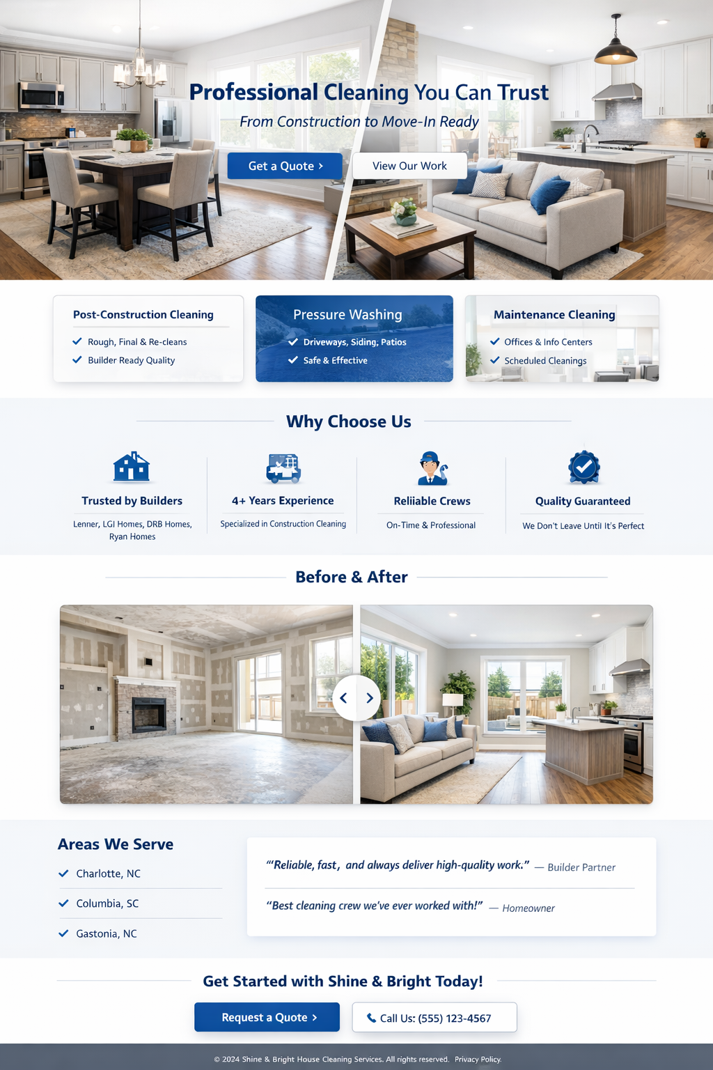
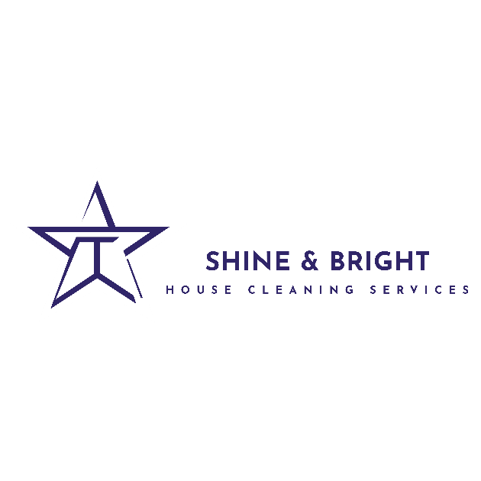
logo:

