Lab0实验报告

姓名：吴进兴

学号：519021910919

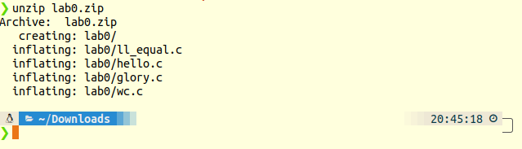

**## 练习1 gcc**

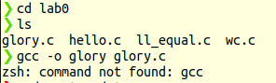

发现gcc并未安装。因此先安装gcc工具。



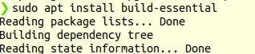

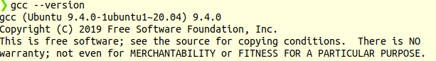

安装gcc9.4.0版本。进而练习gcc操作。

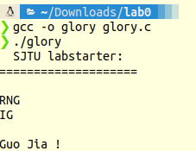

**## 练习2 GDB**

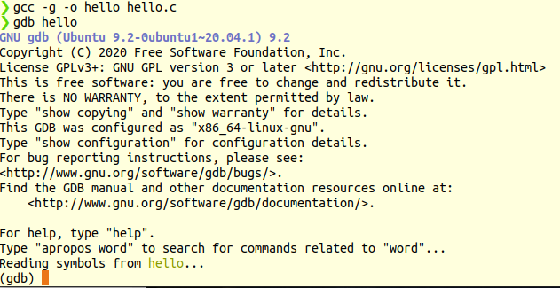

1. How do you pass command line arguments to a program when using gdb?

run+程序参数

1. How do you set a breakpoint which only occurs when a set of conditions is true (e.g. when certain variables are a certain value)?

在条件跳转到的位置设置断点

1. How do you execute the next line of C code in the program after stopping at a breakpoint?

next/n

1. If the next line of code is a function call, you'll execute the whole function call at once if you use your answer to #3. How do you tell GDB that you want to debug the code inside the function instead?

step

1. How do you resume the program after stopping at a breakpoint?

continue/c

6. How can you see the value of a variable (or even an expression like 1+2) in gdb?

print a/p a/

if want print a expression print 1+2

1. How do you configure gdb so it prints the value of a variable after every step?

8. How do you print a list of all variables and their values in the current function?

info locals

1. How do you exit out of gdb?

quit/q

**## 练习3 调试**

/* FIXME: this function is buggy. */

int ll_equal(const node* a, const node* b) {

while (a != NULL && b != NULL) {

if (a->val != b->val)

return 0;

a = a->next;

b = b->next;

}

/* lists are equal if a and b are both null */

return a == b;

}

**## 练习4 Make初步**

void wc(FILE *ofile, FILE *infile, char *inname) {

int characters, lines, words, state;

char c;

state = characters = lines = words = 0;

if(inname == NULL){

while((c = getchar()) != '0') {

characters++;

if(c == '\n') {

lines++;

state = 0;

continue;

} else if(c == ' ') {

state = 0;

continue;

} else if(c == '\t') {

state = 0;

continue;

} else {

if(state == 0) {

state = 1;

words++;

}

continue;

}

}

}

else if(inname != NULL && out_file == NULL){

fp=fopen(inname,"r");

while((c=fgetc(fp)) != '0') {

characters++;

if(c == '\n') {

lines++;

state = 0;

continue;

} else if(c == ' ') {

state = 0;

continue;

} else if(c == '\t') {

state = 0;

continue;

} else {

if(state == 0) {

state = 1;

words++;

}

continue;

}

}

fclose(fp);

}

else (inname != NULL && out_file != NULL){

fp=fopen(inname,"r");

while((c=fgetc(fp)) != '0') {

characters++;

if(c == '\n') {

lines++;

state = 0;

continue;

} else if(c == ' ') {

state = 0;

continue;

} else if(c == '\t') {

state = 0;

continue;

} else {

if(state == 0) {

state = 1;

words++;

}

continue;

}

}

fclose(fp);

fp=fopen(out_file,"w+");

fprintf(fp, "%d characters. %d words. %d lines.\n", characters, words, lines);

fclose(fp);

}

printf("%d characters. %d words. %d lines.\n", characters, words, lines);

return (0);

}