Peer review feedback

# 0x0 General information

Projection name: Websocket Based Chat Application

Code reviewed: All files in the project

Reviewer: Zhihao Cheng

Test method: White box audit, Unit test, Dynamic test, Penetration testing

Feedback Structure:

1. Summary
2. Key strengths
3. Issues, [Improvement and POC](#_0x2_Key_strengths)

# 0x1 Summary

✔ Message to person

✔ Group message

✔ Peer to Peer File Transfer

✔ Show online list

Overall, the functions basically meet the requirements, but there are some issues:

1. Incorrect package management.
2. Java script prototype override.
3. Insecure encryption design.
4. Monitor backdoor.
5. Cross-Site Scripting

The feedback will also provide the improvement and POC for code issues.

# 0x2 Program strengths

1. Clear code structure   
   Separating user interaction logic from backend processing logic to improve chat system maintainability, scalability, and flexibility.
2. Perform a filtering on received json data  
   The code checks domain of the json info and it enhances the overall robustness and reliability of the message (server.js).

# 0x3 Issues, Improvement and POC

1. **(issue)** Incorrect package management.

**Challenges of Manual Dependency Management:** The project does not adhere to NPM (Node Package Manager) standards. Manually managing dependency versions can lead to version conflicts or duplicate installations of the same package, increasing maintenance costs. Also, outdated or unmaintained dependencies can leave security vulnerabilities.

**Improvement:** Follow the best practice of NPM  
 1. npm init  
 2. npm install package(the package you need)

1. **(Potential vulnerability)** Prototype override

**Inappropriate overloading:** Overriding prototype methods can introduce unpredictable side effects because other code relying on these methods may be affected. For example, a malicious attacker uses ‘has’ as the username and ‘true’ as the password. Every time you access a ‘has’ property it always returns ‘true’, resulting in being controlled over program flow.

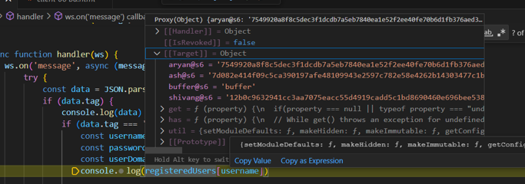

Figure 1 JavaScript prototype

**Improvement:** Disable the use of function names (e.g. ‘set’, ‘get’, ‘onload’ etc.) as usernames.

1. **(vulnerability)** Hardcode public and private key in HTML.

**Exposure Risk:** Hardcoded keys are in plaintext within the HTML client. It ruins end-to-end encryption and undermines the principles of cryptographic security.

Figure 2 client 06 bd.html line 190-197

**Improvement:** Generate keys dynamically and transmit them.  
 Example for this: [conception of S2S protocol](https://uao365-my.sharepoint.com/:w:/g/personal/a1899499_adelaide_edu_au/EW-DKxts4DFEhzo-bXsLQkEBEZii2RXYRSSa12FFT2isqg?e=NV2aoZ)

1. (**backdoor**) Keyboard Monitor.

**Privacy breach:** A function embedded in the HTML will monitor keyboard activity and send it to the server.

Figure 3 client 06 bd.html line 61-72

1. (**Vulnerability**) HTML injection (XSS)

**Cross-Site Scripting：**It allows attackers to inject and spread malicious scripts into webpages viewed by other users.

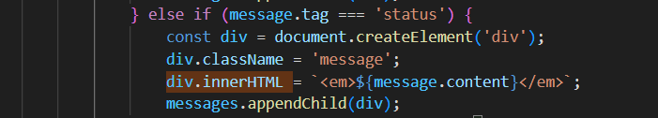

Figure 4 client 06 bd.html line 101-107

**Improvement:**

1. **Sanitization**: Remove or escape special characters from user inputs to prevent malicious scripts from being injected.
2. **Output Encoding**: While rendering user inputs to the web page, use appropriate encoding (e.g., &lt;, &gt;, &amp;) to prevent script tags from being interpreted.

**POC**:

Intercept any client WebSocket traffic and modify it to {"tag":"status","content":""}

Fill any DOM element in content.

Figure 5 Injection showcase