CAB 301

Algorithm Complexity

Assignment_1

Report

Yicong LI

N10149899

**Introduction:**

This project is aiming to implement a Tool Library System based on c#. This system allowed a registered member to view Tool set from system and make a selection for tool that they want to borrow, once a member successfully borrowed one item, the system will record member’s borrowing items. Member also allow return borrowing item to system. On the other hand, system staff is allowing to add new a tool type and revise tool’s quality. It also could delete an existing tool type or edit tool” quality.

In addition, as a user, user have to register our system and then access to authority of member’s section. I basic follow the requirement to finish all functionalities.

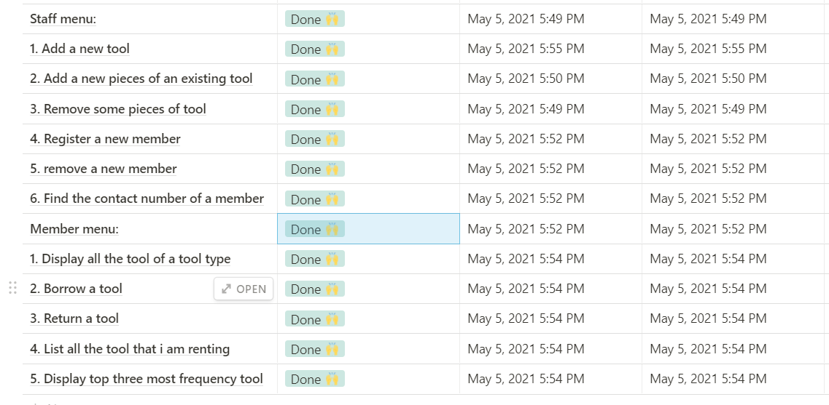

**Main Menu:**

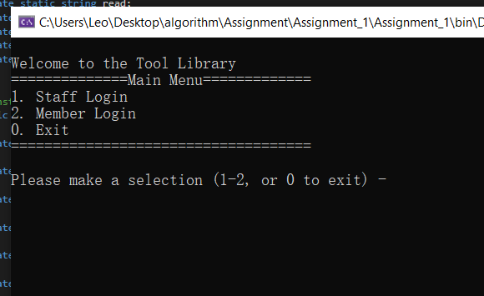

This is my main menu section. It has 3 different main functionalities, which including staff login, Member login and exit respectively. If we select invalid index number, it will invoke an alert until input a correct index number.

**Staff Menu:**

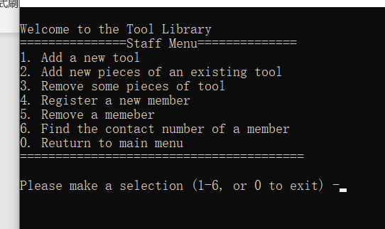

1. **Add a new tool**

**Input name:**

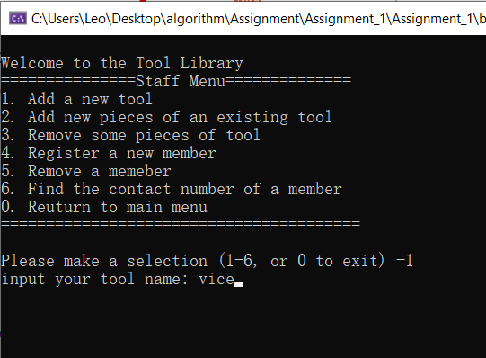

**Select a category:**

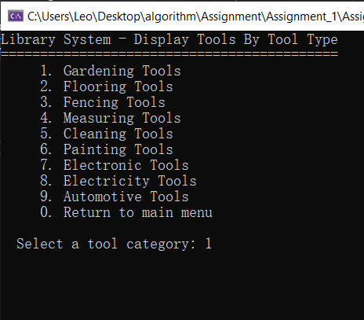

**Select tool type:**

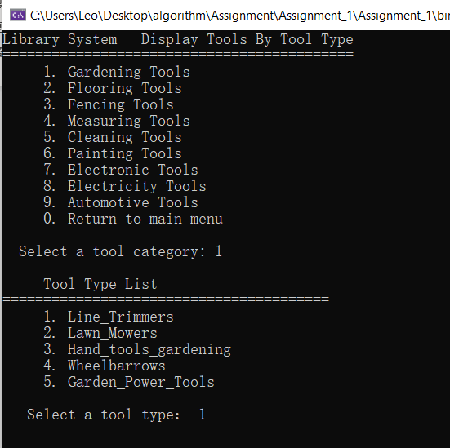

**Output:**

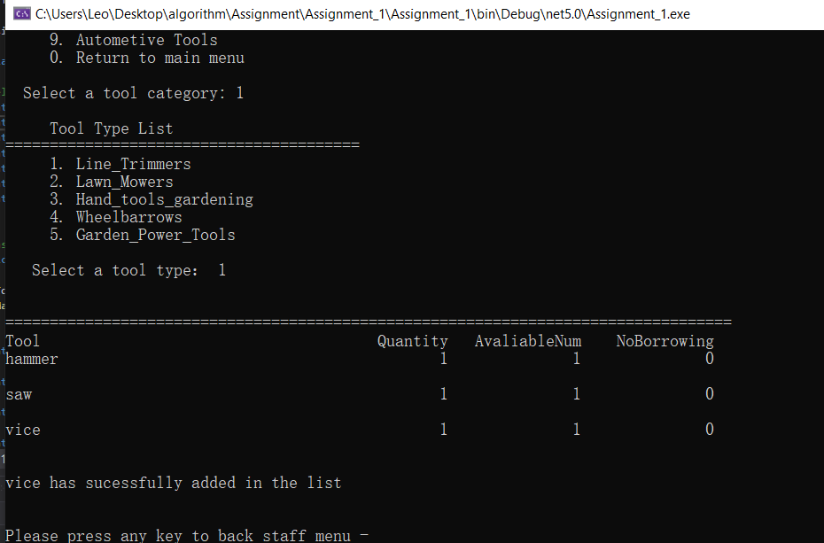

The tool whose name is vice added in the system.

1. **Add a new piece of existing tool**

Category:



Tool type:



Output:

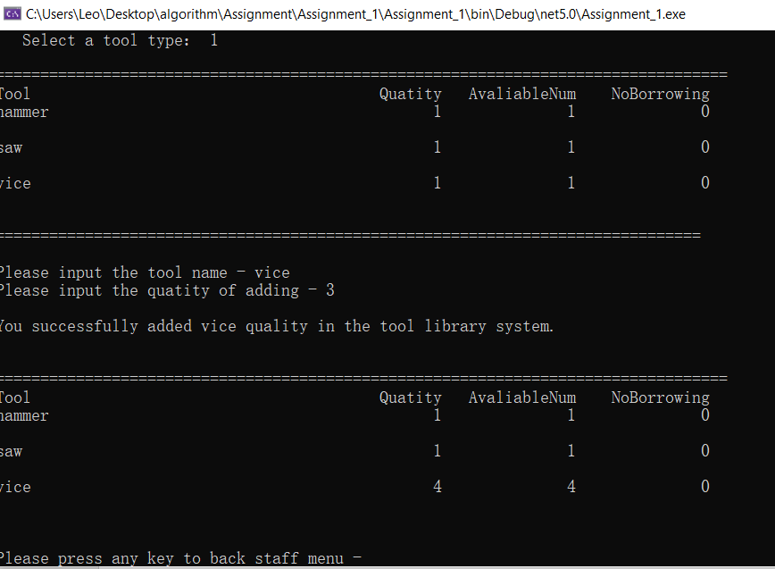

It is clear that the vice is successfully added in our system, then I input a correct vice name and increase 3 amounts, quality and available number both increase 3 amounts.

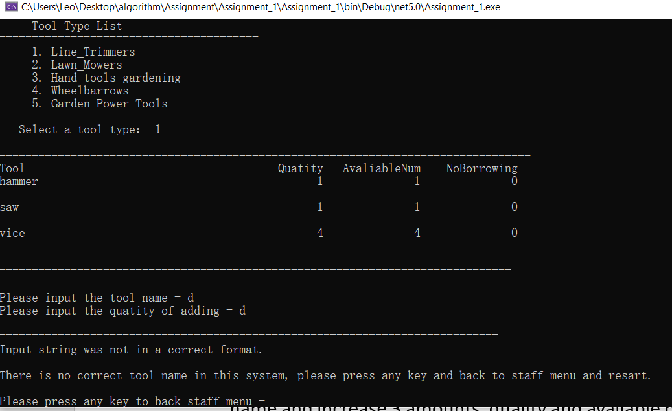

If tool name does not exist in the system, it will involve a warning, user have to back to previous page and select again.

1. **Remove some pieces of tool**

Category:



Tool type:



Output:

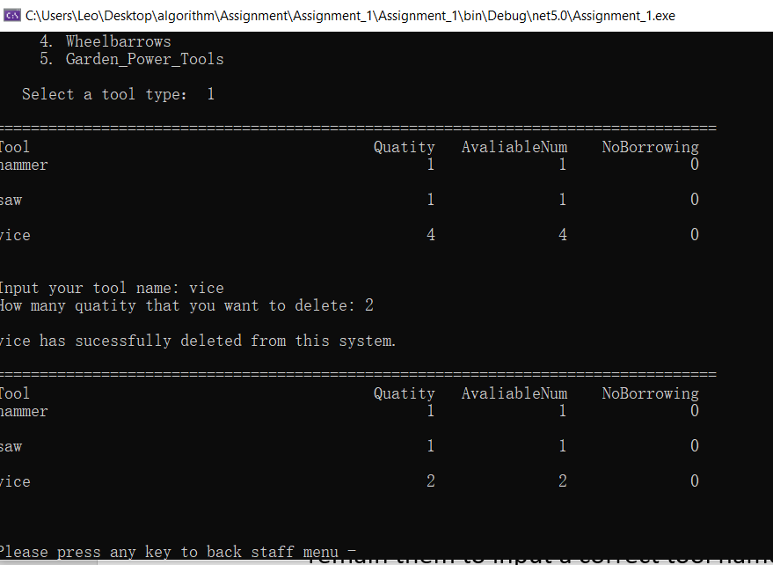

I delete 2 pieces of vice from system. It is clear that the vice has deleted from our system.

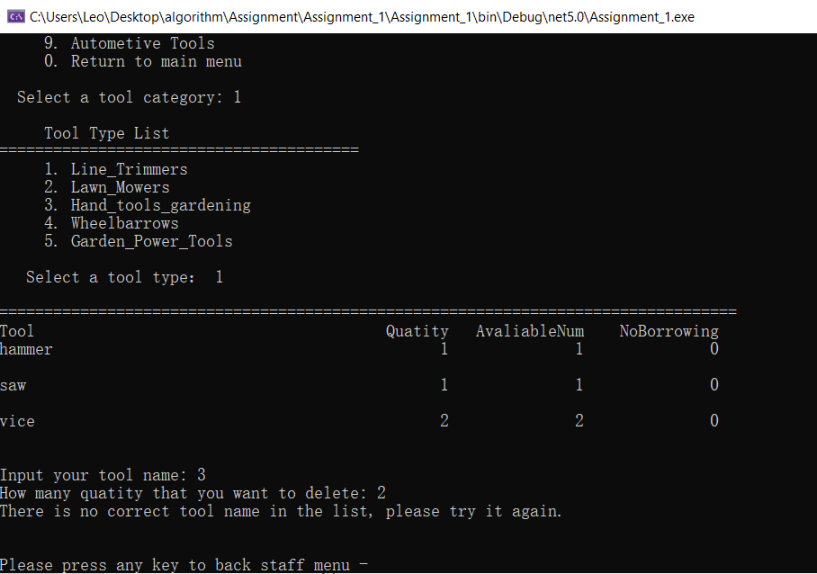

If we non-existing tool name in the console. It also involves a warning for user to remain them to input a correct tool name.

1. **Register a new member**

I initialized that lastname and firstname must fill with capital letter. If it does not, it will invoke a warning to tell user.

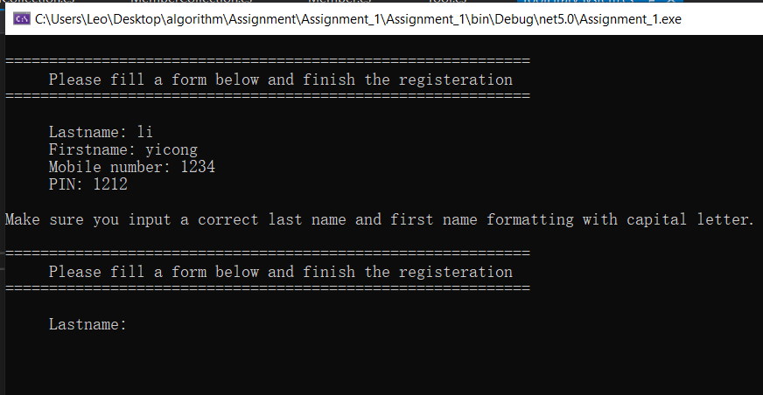

Now, I fix that problem I initialized my name with capital letter, however, if my mobile number and PIN number are not integer. It will involve a warning to tell user to fill with integer type.

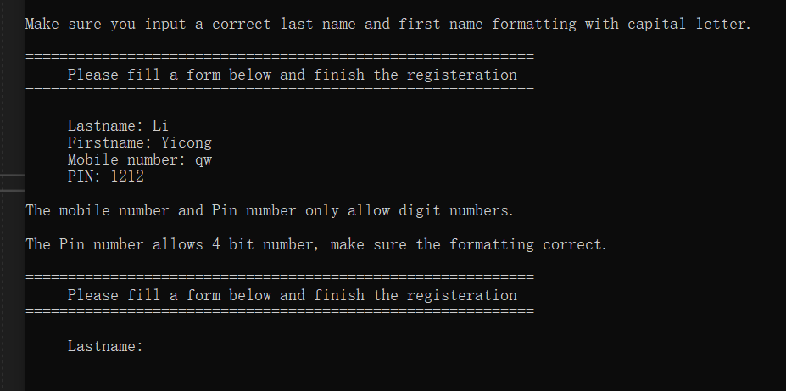

However, if I input zero to each console, it will back to previous level, which is staffmenu.

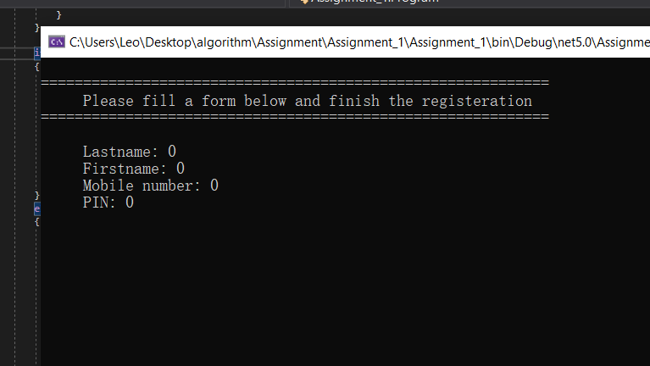

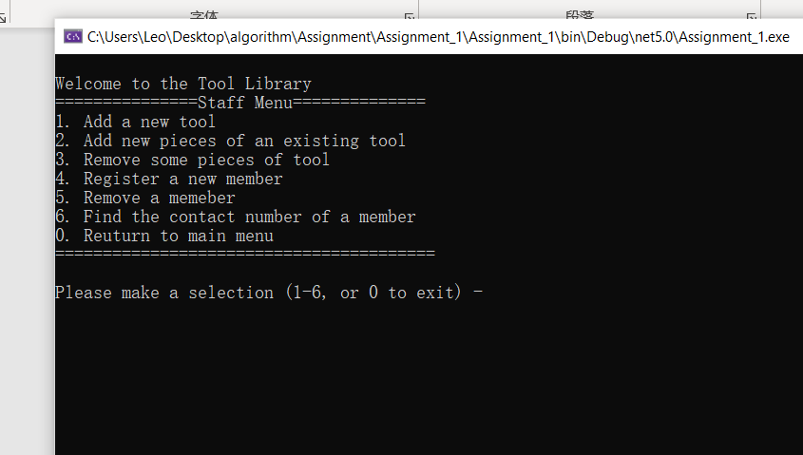

Now, I have already created a correct format account, then I will login to see what happen.

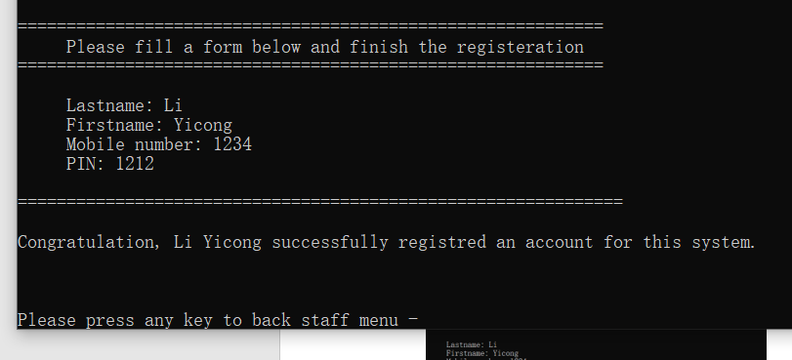

As u can see, if username is not a correct format or not a registered member. It will involve below warning to user to remain them with correct format.

Correct format: YicongLi (Firstname+Lastname) both should be capital letter.

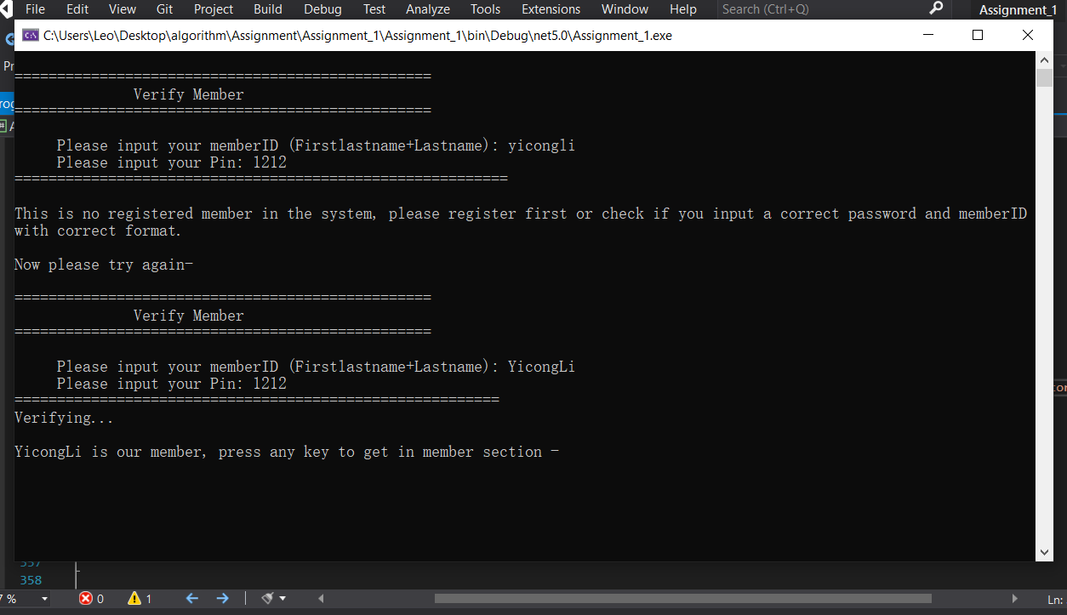

If user want to back to previous level, they have to input zero for each console. Image below, they will back to main menu.

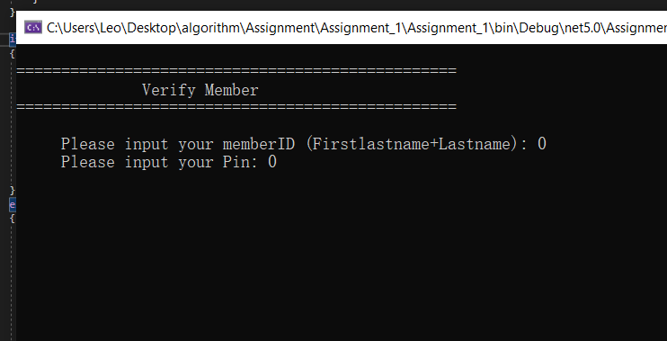

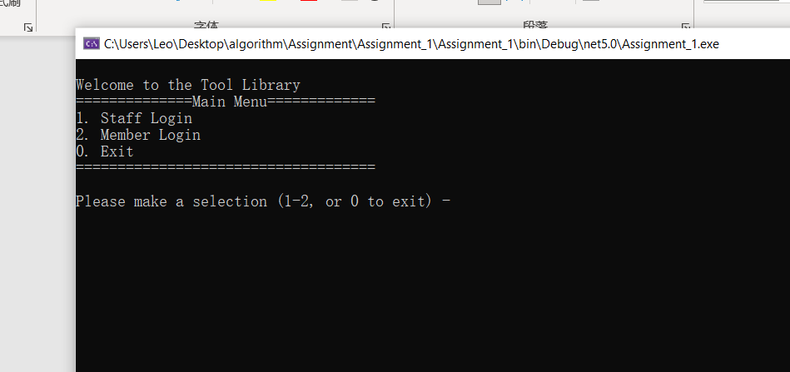

1. **Remove an existing member**

Now, in the remove an existing member, I set if user input zero, then will go back to staffmenu.

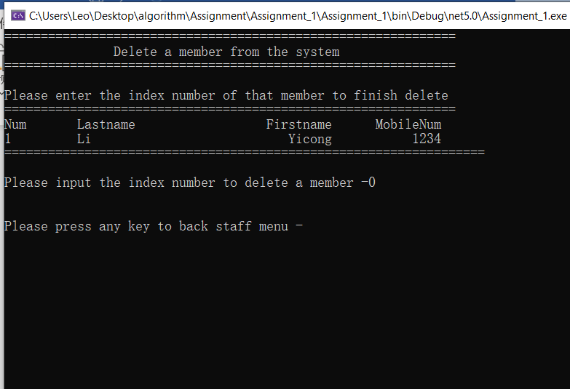

If user input an incorrect format or non-existing number, it will invoke a warning to tell user to fill a correct format.

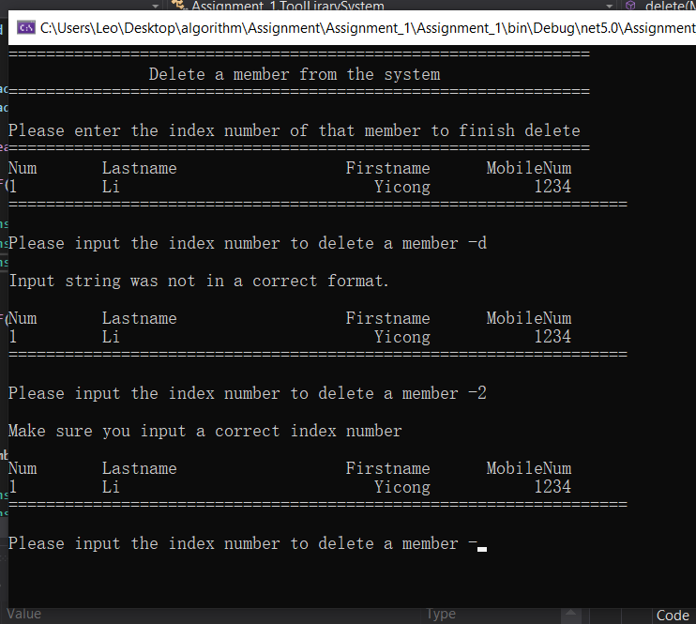

If user input correct index value, then it will delete from system, however, each staff only allow to delete once, if staff want to delete again, he have back to staffmenu and restart it.

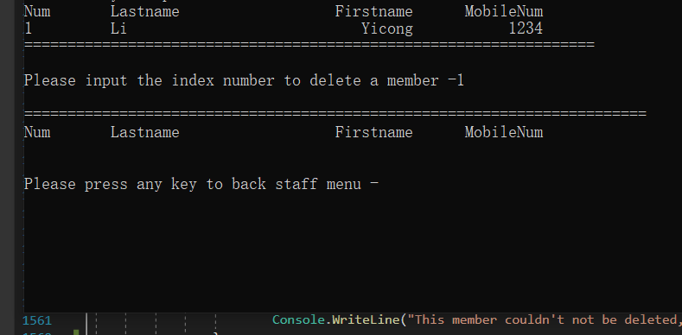

1. **Find a contact number for existing member**

I just deleted my account. Therefore, I create a random account. Now, I will input the index to check what is their mobile number. We could see that mobile number is 1234. And I set this is only check once if user want check again, then have to restart it.

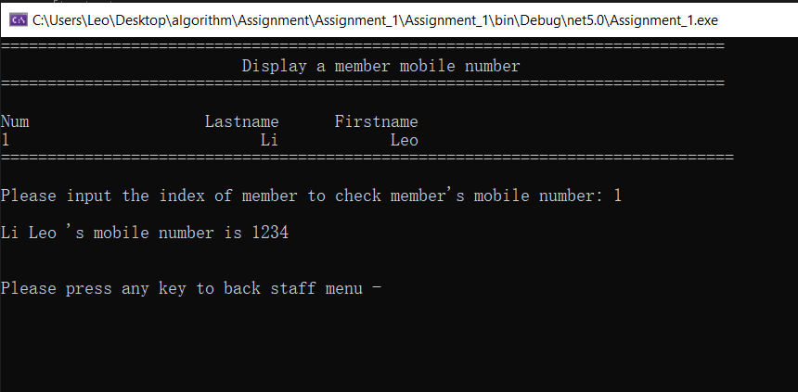

If I input zero, it will back to staffmenu. I couldn’t show the result because I set the console.clear()here, if I enter, it will back to staffmenu.

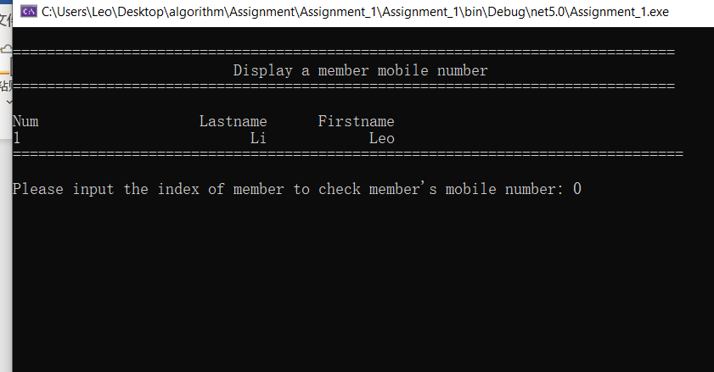

If user input a non-existing index number or incorrect format, it will invoke a warning as well.

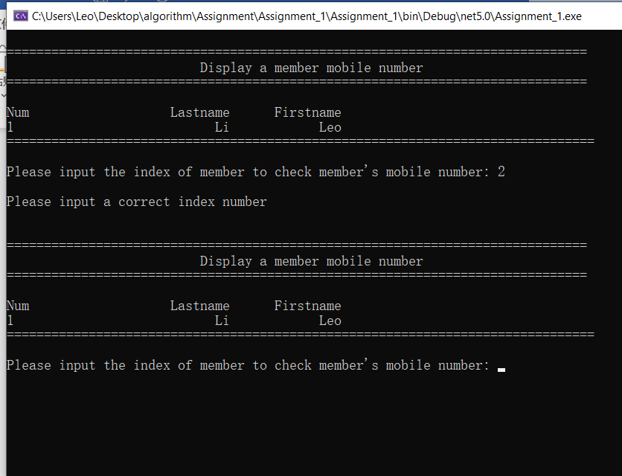

**Member Menu:**

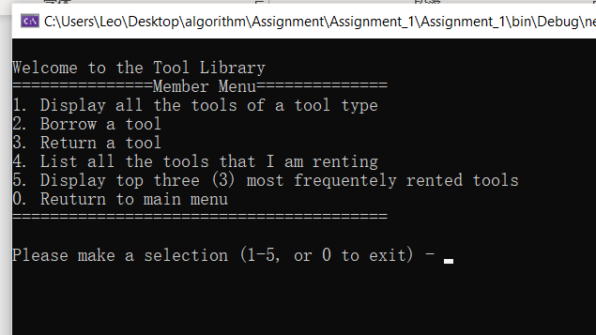

1. Display all the tools of a tool type

Category:



Tool type:



Output:

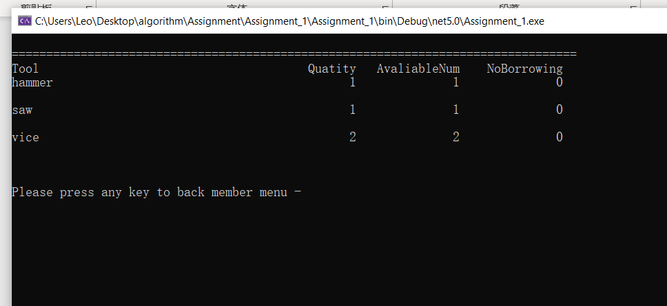

The vice that we added before is working well.

1. **Borrow a tool**

Category:



Tool type:



Output:

Now, I borrowed the tool whose name is vice from the system. Just input the tool’s name. I set that each member only borrows one item each time.

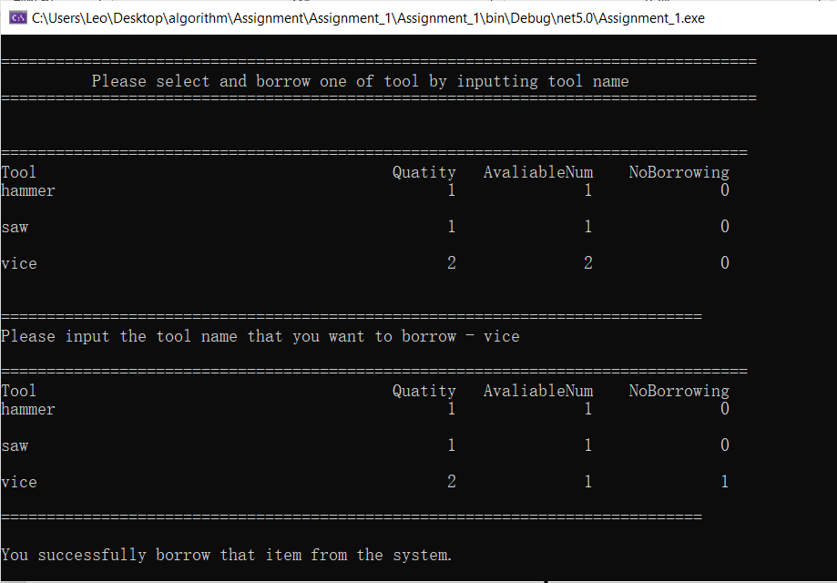

If I input a name which does not exist in the list, it will invoke a warning.

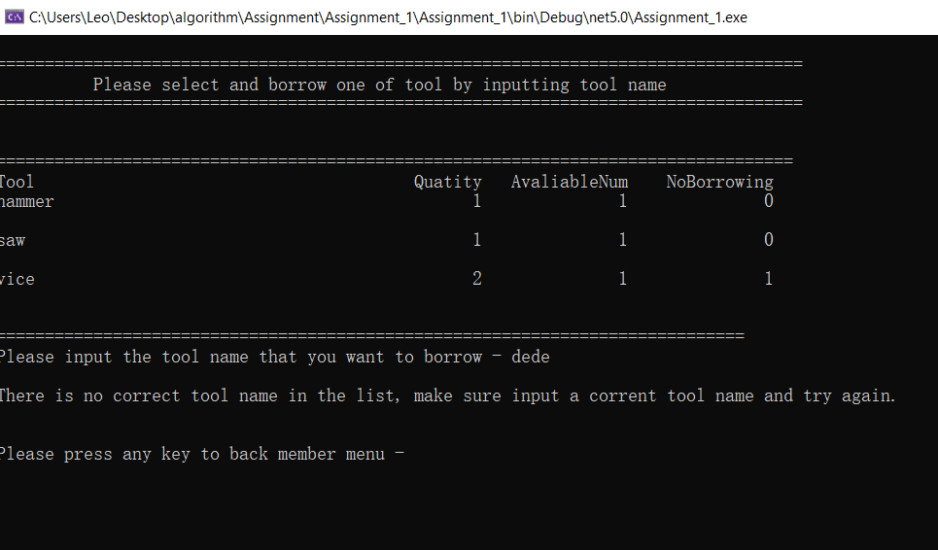

If there is no more available tool in the system.

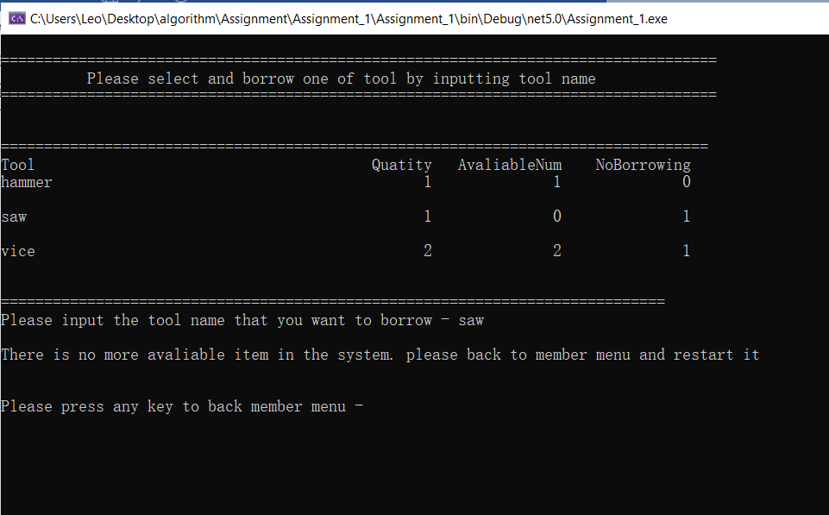

Each member only allows to borrow no more than three items

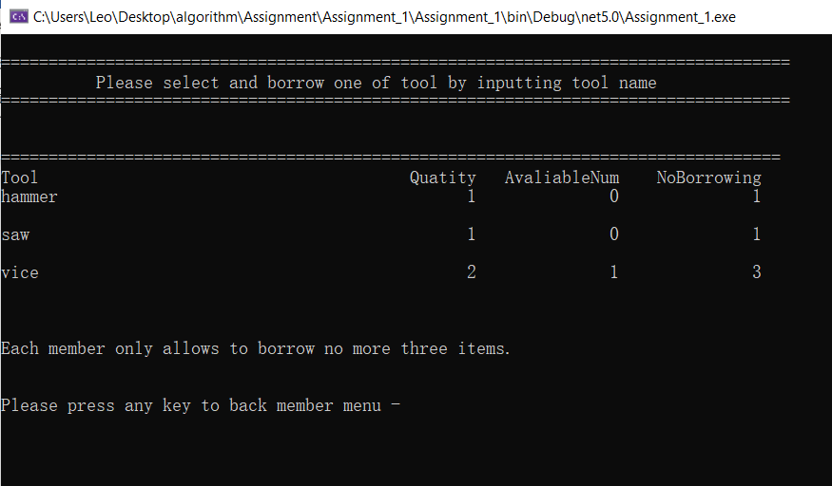

1. **Return a tool**

Category:



Tool type:



Output:

We could see that the item returned it.

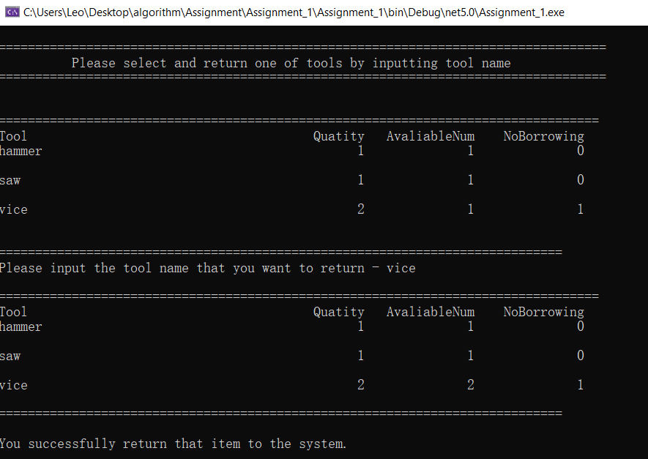

if I haven’t borrowed any tool.

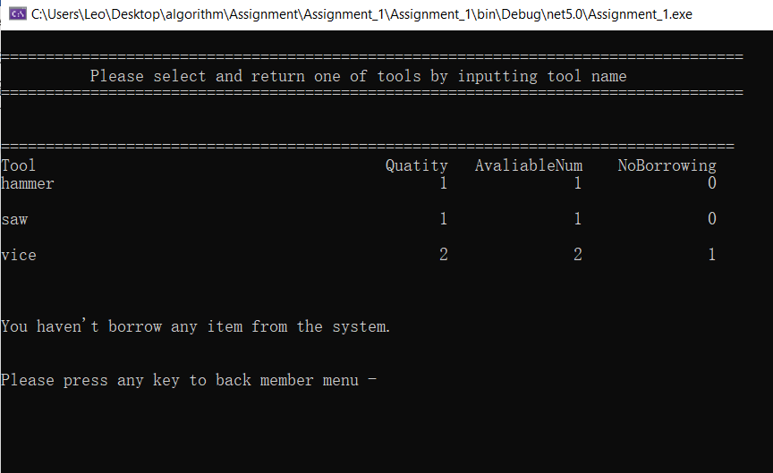

Return non-exist tool name

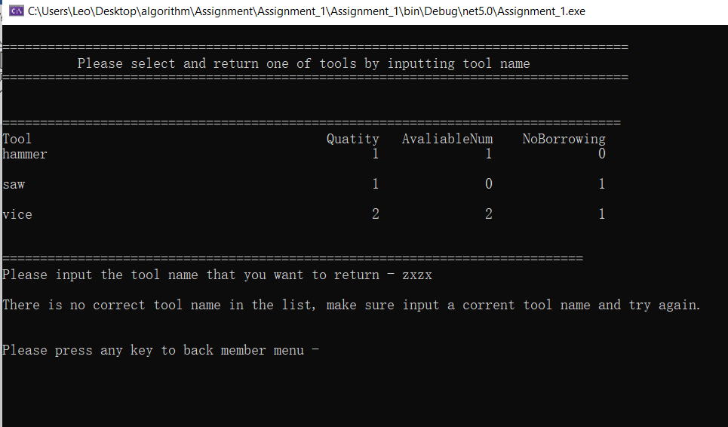

If the available quantity is full

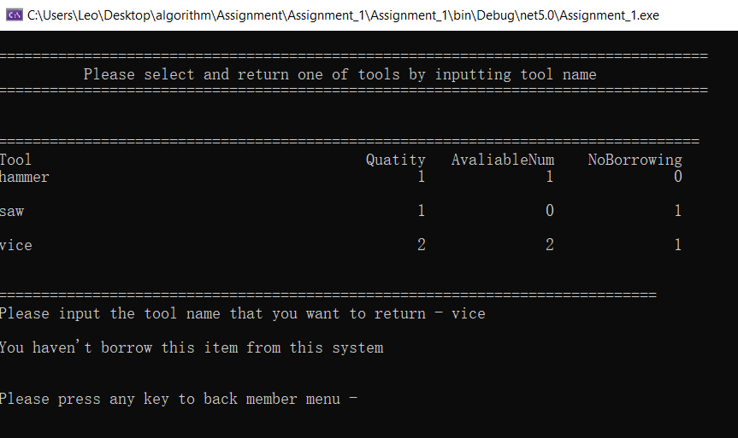

1. **List all the tools that I am renting**

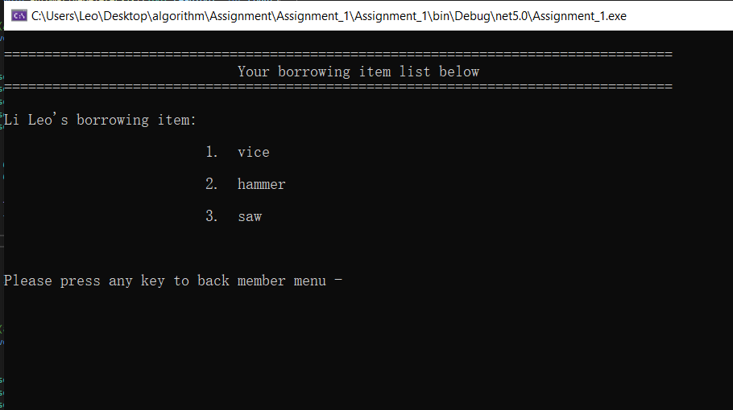

I borrow three different for test, then it will display in here.

1. **Display Top 3 frequency tool**

Output:

Now, I borrowed 3 quantity of vice, one hammer and one saw. It displays three different frequency items that borrowed in here.

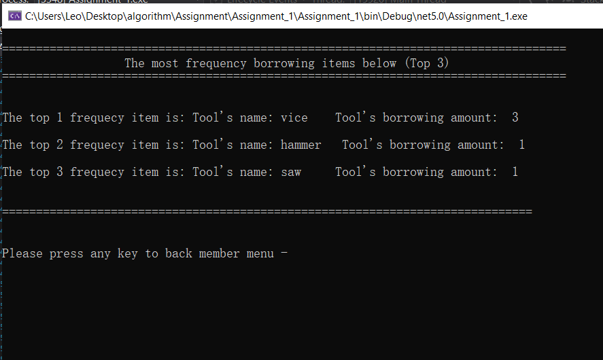

Algorithm Design:

The reason why I use list not array because I don't know how I deleted repeated objects. For example: if I borrow one item, then I return it, then I borrow it again. I will get two same objects on my list. To fix that problem I use the list to store tools. If I get same objects. Then delete it by index from the list. I will show the code image below. Now, the algorithm that I use is bubble sort, the image below. From the pseudocode below, I just use 2 for loops, compare the first value with the second value, if the second value greater than the first value, the second value goes front, then becomes the first value. If the first value greater than the second value, it will skip the second value, the first value will compare the third value and do the same thing until the for loop finished.

Pseudocode:

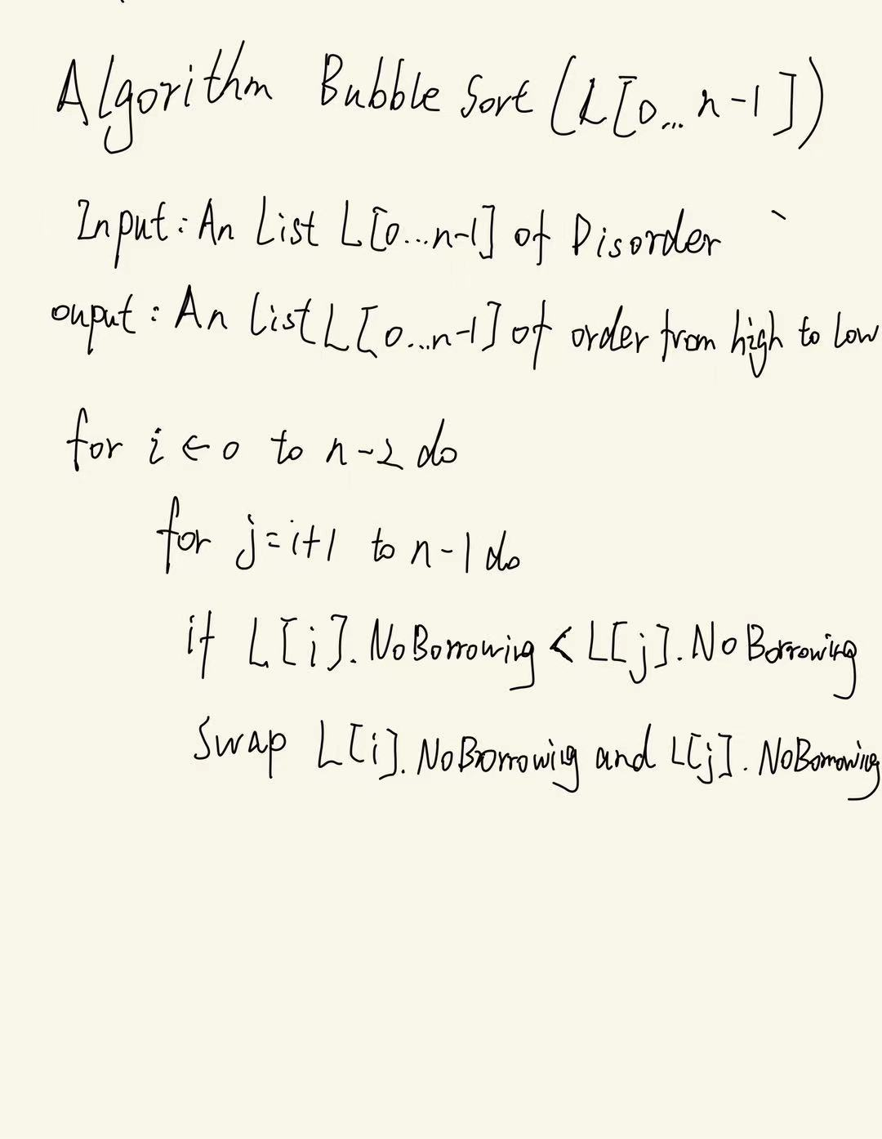

Algorithm Analysis:

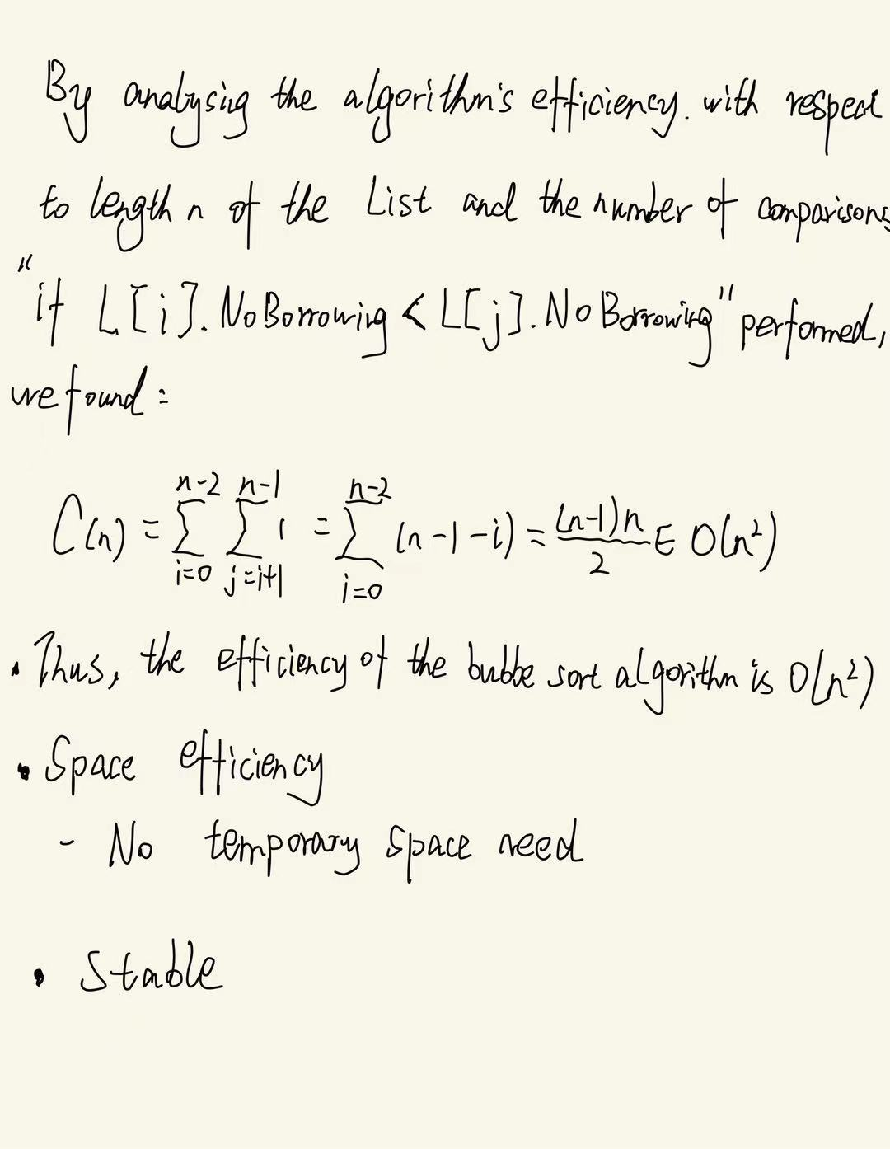

Code Explanation:

First, I use list to delete all repeated objects, which mean all objects should be unique.

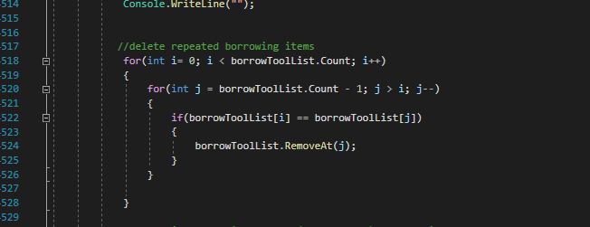

I use bubble sort to sort the list from high to low. The time complexity would be the power of N.

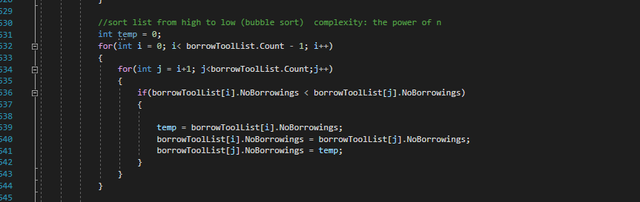

And then, output the first three as the frequency borrowing items.

