# I. Machine model switching

// 机器型号

//  #define ENDER_3S1_PLUS

#define ENDER_3S1_PRO

// #define ENDER_3S1 //配件部的需求， 将3S1Pro 刷入3S1机器并且适配触摸屏

# Second, the chip model switch

1. Configuration.h Turn on the chip switch in

// 主控芯片

//#define USER_STM32F103  1

  #define USER_STM32F401  1

1. platformio.ini Turn on the environment switch in

default_envs = STM32F401RC_creality ; STM32F401环境

; default_envs = STM32F103RET6_creality ; STM32F103环境

# 三、 Z-axis limit switch version

// 自定义Z轴限位方式   rock_20220301

#define Z_AXIS_LIMIT_MODE  0  //1 为Z轴限位开关  0 为 CRTouch

# III. Diven and Daicai1. The project (V1.0.2) which supports Diven and large color screen is modified as follows:

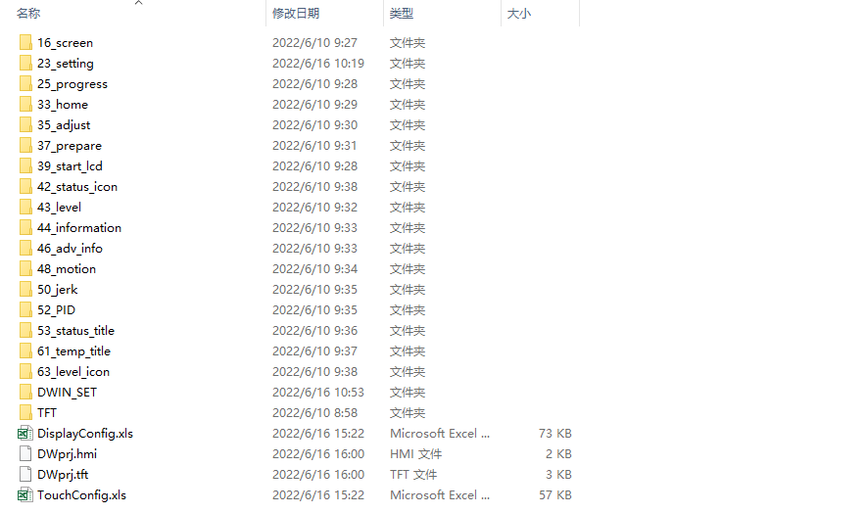

1. 1. Diven to large color screen
   1. a) Ender-3 S1 Pro and Ender-3 S1 Plus are converted to the following large colors.

