Richard Hayes Crowley
02/18/2021
CSC_157_Lab_010
SOURCE CODE:

# Richard Hayes Crowley
# 03/18/2020
# CSC_157_LAB_010
import json
from os import path
from pprint import pprint, pformat

class AncillaryException(Exception):
"""Custom exception for not entering 'y' or 'n' for ancillary CD ROM"""
pass

class Inventory(object):
# changing the structure of my class variable from a list to a dict, preload with previous JSON state if it exists
# structure will use titles as keys, since titles must be unique, and title.author, title.description, title.ancillary as properties
inventory = json.load(open("inventory.json", "r")) if path.exists(
"inventory.json") else {}

def __init__(self, title, description):
# setting title as key for another dict which will hold description as a key/value pair
Inventory.inventory[title] = {"description": description}

@staticmethod
def inventoryCheck(title):
return title in Inventory.inventory
# check if the title already exists in the list of titles

class Books(Inventory):
def __init__(self, title, description, author, ancillary=None):
# execute the parent constructor
super().__init__(title, description)
# setting author and ancillary for title in inventory
Books.inventory[title]["author"] = author
Books.inventory[title]["ancillary"] = True if ancillary == "y" else False

def get_inventory():
return Books.inventory

def __str__(self):
current_stock = json.load(open("inventory.json", "r")) if path.exists(
"inventory.json") else self.inventory
# format dict to prettified string
return pformat(current_stock)

oscar = Books("An Ideal Husband",
"Wilde's scintillating drawing-room comedy ", "Oscar Wilde")

title_to_check = input("Title to check in inventory: ")

if (Books.inventoryCheck(title_to_check)): # perform a check
print("The title already exists; it cannot be added to the inventory.")
else:
print('"' + title_to_check + '" does not exist in inventory.')
print('Enter information about "' + title_to_check + '":\n')
author = input("Author of book: ")
description = input("Description of book: ")
while True:
try:
ancillary = input(
"Does this book come with a CD-ROM? Enter y or n: ")
if ancillary != "y" and ancillary != "n":
raise AncillaryException

except AncillaryException:
print("Please enter either 'y' or 'n'")
else:
break

updated_inventory = Books(title_to_check, description, author,
ancillary if ancillary == "y" else None)

# add the updated inventory book to json
json.dump(Books.get_inventory(), open("inventory.json", "w"),
indent=4, sort_keys=True)

print('\n"' + title_to_check + '" has been added to the inventory.\n')

print(f"Inventory to date is: {updated_inventory}")

OUTPUT: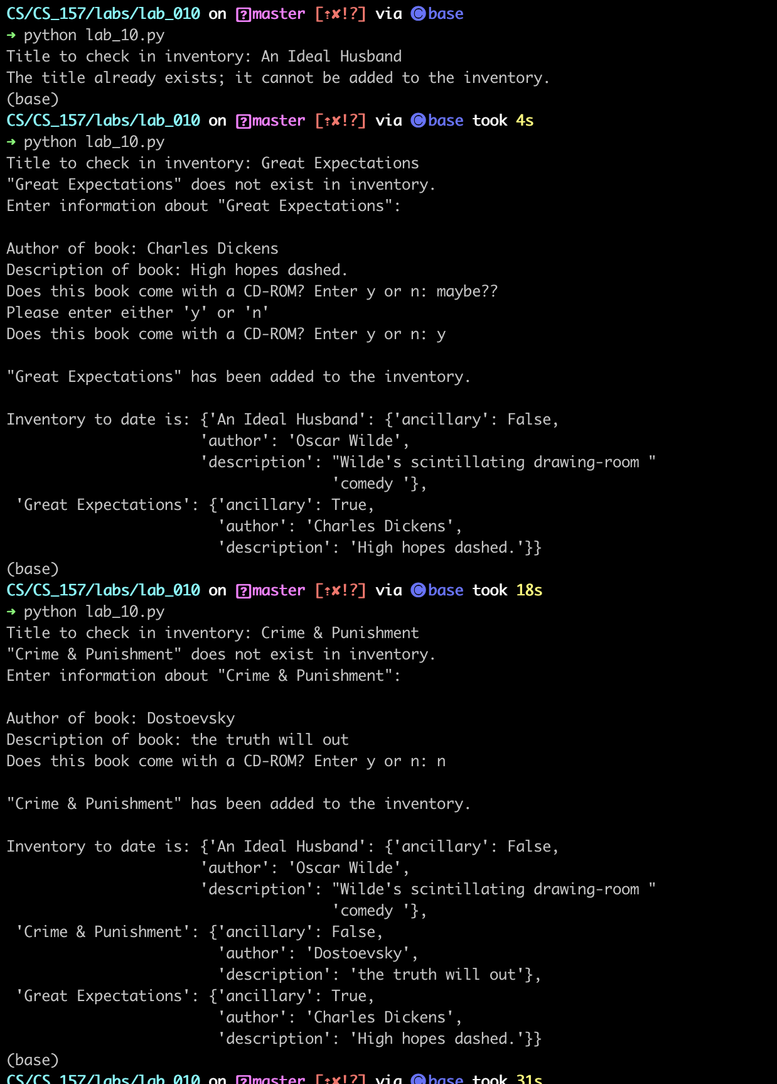

DATA PERSEVERANCE (INVENTORY.JSON SECONDARY STORAGE):

{
"An Ideal Husband": {
"ancillary": false,
"author": "Oscar Wilde",
"description": "Wilde's scintillating drawing-room comedy "
},
"Crime & Punishment": {
"ancillary": false,
"author": "Dostoevsky",
"description": "the truth will out"
},
"Great Expectations": {
"ancillary": true,
"author": "Charles Dickens",
"description": "High hopes dashed."
}
}

