Concur App Center Listing Form

Please complete the following form to populate your App Center listing. Email the completed form and graphics to your partner marketing contact for final approval. Please plan for a 1-2 week lead-time to accommodate any edits required. Any requests for updates to your App Center listing require a new form to be submitted, please send to [AppCenterMarketing@concur.com](mailto:AppCenterMarketing@concur.com).

Additionally, any partner collateral materials you would like to include in your App Center listing must be reviewed and pre-approved by Concur prior to posting or distribution. Please send all materials to your partner marketing contact and to [AppCenterMarketing@concur.com](mailto:AppCenterMarketing@concur.com).

**NOTE: All character requirements include spaces.**

|  |
| --- |
| **Listing Language** (What is the language that the following details are written in?) |
| **Listing Type** (User (Apps for Me) or Company (Apps for My Business)) |
| **Listing Name** (Company and/or specific product name.)  *32 characters* |
| **Headline** (Short heading describing the application.)  *64 characters* |
| **Short Description** (Will act as an introduction to your application and entice the reader to learn more. Briefly explain what the integration with Concur does.)  *180 characters* |
| **Long Description** (Longer descriptionof the application and Concur integration. This will appear in the details tab of your application.)  *2048 characters* |
| **Partners Listing URL** (URL to partner website.)  *256 characters* |
| **Datasheet or Collateral URL** (Speaks to Concur integration. Content hosted on partner website.) |
| **Video URL** (Speaks to the application and Concur integration.) |
| **Twitter Handle** (Provide you social handle to stay engage with @Concur.) |
| **Lead/Inquiry Report Email Address** (Only required for Apps for My Business. Lead inquires will be sent to this email address.) |
| **Lead/Inquiry IT Set Up (**Provide your IT team the following details to whitelist the Concur IP addresses and place Concur on the safe sender list.  Leads will be sent from Concur marketing automation tool Marketo. To ensure receipt of all leads complete the following:   1. Provide IT team the following details to whitelist the Concur IP address and place Concur on the safe sender list.    1. Email From Address: [appcenterreferral@concur.com](mailto:appcenterreferral@concur.com),    2. From Sender: Concur App Center Referral    3. Subject: AppCenter Inquiry Submission    4. Domain: et.concur.com, concur.com    5. Whitelist IP addresses:       1. Concur: 192.28.144.41       2. Marketo:          1. 199.15.214.45          2. 199.15.215.82          3. 199.15.214.199          4. 199.15.214.200          5. 199.15.214.201          6. 199.15.214.202          7. 199.15.215.77          8. 199.15.215.78          9. 199.15.215.79          10. 199.15.215.80          11. 199.15.215.81 |
| **Partner Name**  *256 characters* |
| **Partner Support URL** (Partner hosted page that has all of your contact information for product support.) |
| **Partner Contact Phone Number** (Provide a phone number for product support)  *32 characters* |
| **Connect URL** (Apps for Me only, URL provided must include sign in/up or sign up flows, URL must be in production and certified prior to the app launch date. |
| **Connection Workflow** (Only required for Apps for Me.) (Web flow, App Center or Auto Connection) |
| **Mobile App Center (Currently only for Apps for Me).**  **iOS App Store URL:** **(URL that takes user to the mobile page to begin the connection process. Example: https://www.partnerapp.com/concur/redirect)**  **Android Package ID and App Launch URL and Parameters: (URL that opens the app once installed on the user's mobile device. Example: me.partnername.android)**  **Any additional parameters for either mobile platform:** |
| **Keywords** (Used for key word search in the App Center**.** Available in the future and will be helpful if you name and describe your product in a way that drives traffic to your listing.)  *100 characters* |
| **App works with these Concur offerings** (Must choose at least one.)   Expense - Standard  Expense - Professional  Invoice - Standard  Invoice - Professional  Travel - Standard  Travel - Professional  Travel Request - Professional |
| **Global Capabilities**  Please read the definitions below carefully and highlight the appropriate countries with a note of the capabilities you support today. See example.  *Availability*: What countries is your app available in? (App must be fully functional)  *Language Support*: What languages is your app translated into? (Must include translation for the listing content and any other marketing assets you utilize for the app)  *Local Presence*: What countries do you have local support in? (Physical presence, offices) Please provide the address and contact number for each.  Examples:  United States – Availability/Language/Local  France – Availability/Language  **If a specific country you support is not listed below please include it separately.**   |  |  |  |  |  | | --- | --- | --- | --- | --- | | **North America**  Canada  Mexico  United States of America | **Latin America**  Argentina  Bolivia  Brazil  Chile  Colombia  Ecuador  Paraguay  Peru  Uruguay  Venezuela | **Europe, Middle East, & Africa**  Afghanistan  Armenia  Austria  Belgium  Croatia  Czech Republic  Denmark  Egypt  Ethiopia  Finland  France  Germany  Greece  Greenland  Hungary  Iceland  Iran  Iraq  Ireland  Israel  Italy  Jordan  Kenya  Netherlands  Norway  Pakistan  Poland  Portugal  Russia  South Africa  Spain  Sweden  Switzerland  Turkey  Ukraine  United Arab Emirates  United Kingdom | **Asia Pacific**  Bangladesh  Cambodia  China  Fiji  Guam  Hong Kong  India  Indonesia  Japan  Korea, South (Republic of Korea)  Malaysia  Myanmar  Nepal  New Zealand  Palestine  Singapore  Taiwan  Thailand  Vietnam | **Other**  Antarctica |   **App Center Listing Category (Highlight Closest Match(s) that align to your target audience segment). (Select all that apply.)**   * Travel Procurement * Travel Management * Traveler Services * Financial System Integration * Expense Reporting Automation * Invoice Automation * Expense Capture * Invoice Capture * Regulatory Compliance or auditing * User Management * Travel Profile Management * Sales or Service Automation * VAT Reclaim or Taxation   **Listing Category: (Highlight Functional Role):**  -Sales/Marketing  -Compliance/Audit/Legal  -Travel Management  -Finance/Accounting  -HR/Payroll  -Client/Professional Services  -IT/Operations  -General/Show All |
| **Industry** (Select an industry if the application is specific to one of the following. If application is NOT industry-specific, do not select an industry below.)   Healthcare and Life Science  Legal  Professional Services |
| **Localization**  Below, you will find a list of Concur-supported languages.  If your application is available in a country where one of the following languages is spoken, please translate your listing into that language.  Use this form, and insert translations for the short description, long description, and insert links to any localized landing pages. For example, if your listing is available in France, please translate the listing to French.  *Also, please be sure that all of the assets that your listing links to are also localized, including the inquiry link*.  **Here are several translation companies that Concur has used in the past:**  Lionbridge: <http://www.lionbridge.com/>  MotionPoint: <http://www.motionpoint.com/>  Jonckers: <http://www.jonckers.com/>  We understand that there is a cost associated with localization.  To bring that cost down, consider abbreviating the length of your listing to include only the key points about the integration with Concur and your application.  **Concur-supported languages:**  **Tier 1:**  EN-US / English US (default)  ZH / Chinese Simplified  ZH / Chinese Traditional  NL / Dutch  EN-AU / English Australian  EN-GB / English UK  FR-CA / French Canadian  FR / French  DE / German  HU /Hungarian  IT / Italian  JA / Japan  PT-BR / Portuguese Brazil  ES / Spanish European  ES / Spanish Latin America  SV / Swedish  **Tier 2:**  CS / Czech  DA /  Danish  FI / Finnish  EL /  Greek  KO / Korean  LV /  Latvian  LT / Lithuanian  NO /  Norwegian  PL / Polish  RU / Russian  SK / Slovakian  TR /  Turkish |
| **Please submit the images below for approval and include your app name and the file type in the naming. Example: Concur_Banner**  Banner: 854x315px, maximum file size 1 MB, jpg or png format  Hero: 543x307px, maximum file size 650 KB, jpg or png format  App Thumbnail: 50x50px, 8px corner radius, maximum file size 10 KB, jpg or png format  Partner Thumbnail: (Appears at bottom of details page near partner contact details. Include if different from app thumbnail) 50x50px, radius corners (rounded), maximum file size 10 KB, jpg or png format  App Logo: Partner app logo. 600x600px / 8px corner radius / max 10 KB / jpg or png  High Resolution App Logo: (Print quality logo to be used in future marketing activities.) high resolution, eps or ai format  App Screenshots (Max 5): Web: 4:3 aspect ratio minimum. 768x1024px Mobile: 16:9 minimum 640x1136 / max 650 KB, / jpg or png  **Mobile App Center images required (Apps for Me only at this time):**  Small Image (Icon): 300x300px, jpg or png format  Large Image: 600x600px, jpg or png format  Screenshots (Max 6): 920x1742px, jpg or png format  Featured App Image: 1080x576px, jpg or png format  Note: Please avoid images with very fine or small text in them as these high resolutions images will be down scaled for use on lower resolution devices. |

**Example App Center Listing**

Summary View

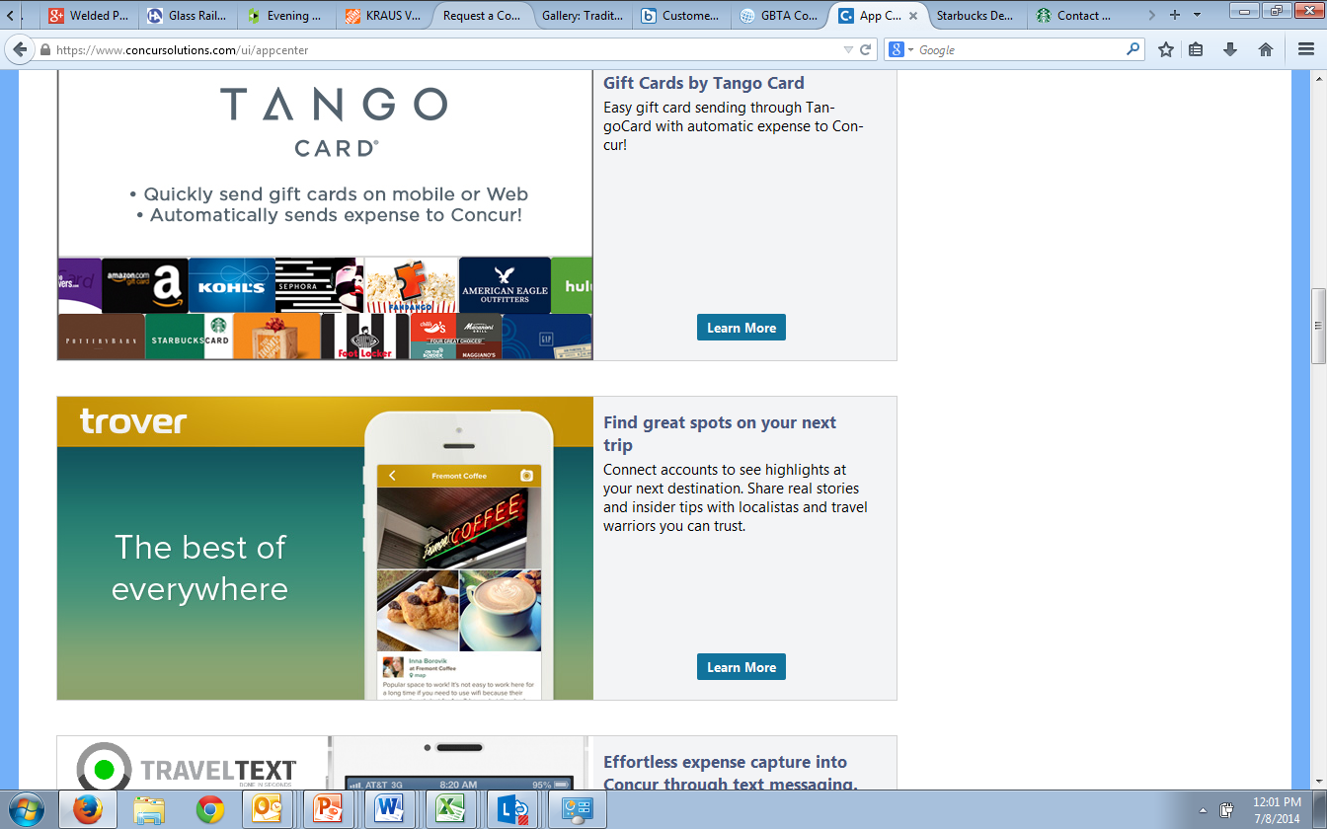

Hero Image

Short Description

Title

Detail View

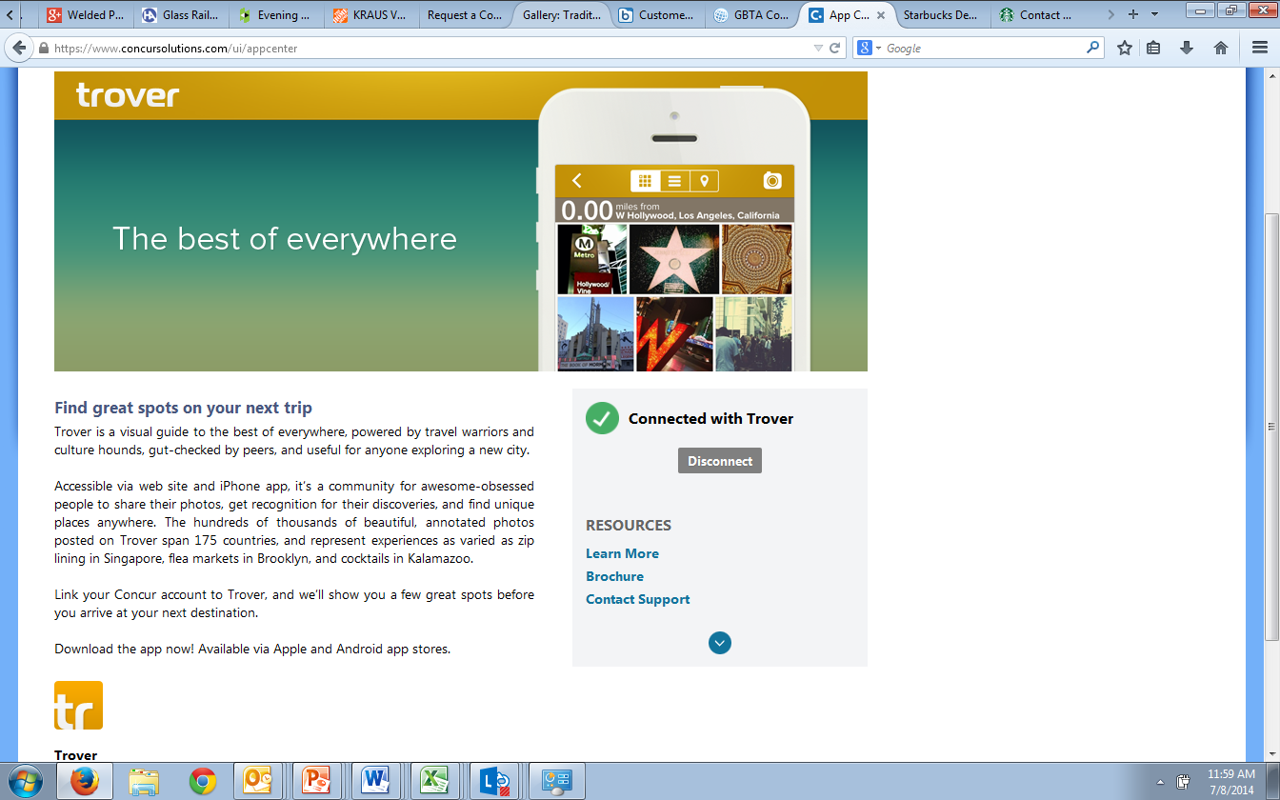

Banner

Support phone number appears here when provided

Company Name

Thumbnail

Website

Long Description

Support website