**Angel C. Buenavista**

09611667325 •[anghelusjr09.ab@gmail.com](mailto:anghelusjr09.ab@gmail.com)•Greatwoods Highlands Bacoor Cavite

**Experience**

DEPARTMENT OF HEALTH, Mandaluyong May 5 - Dec 31 2021

**Administrative Assistant III/LHSD LGU**

* Verified and Validated Requirements as per Category, Registered User Account and Updated.
* Assisted in Vaccination, Handled Database and Guided Trainees.

**Skills**

* Coding Skills for HTML and CSS
* Programming Skill in Javascript
* Programming Skill in JQuery
* Recognize Algorithms
* Design Concept
* Front End Web Development

**Education**

**Tertiary**  *Saint Bernadette College of Alabang (2018 - 2020)*

*AMA College Paranaque (2013 - 2017)*

**Secondary** *Bagumabayan National (2009 - 2013)*

**Primary** *Barangay Tanyag Elementary (2004 - 2009)*

**Participation**

* *Southville International School and Colleges* Taylor Center for Professional Development - For actively participating in the International Forum on Real Life Application of Artificial Intelligence Technology.
* *Southville International School and Colleges College* of Information Technology - In2ition 2019 Interconnected World, Interconnected Generation given this 27.
* **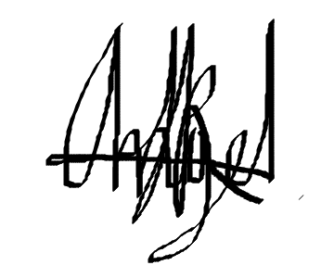***South Mansfield College* For actively participating in the C# Programming Seminar during the College O.B.E Week held on March 19, 2019 at the College Computer lab of South Mansfield College, Muntinlupa City.

Angel C. Buenavista

Signature over Printed Name