Research and Development forNext-generation Information Technology of

Ministry of Education, Culture, Sports, Science and Technology

"Research and Development of Innovative Simulation Software"

**MIT License Free Software**

FrontISTR

Ver. 3.7

Tutorial Guide

This software is the outcome of "Research and Development of Innovative Simulation Software" project supported by Research and Development forNext-generation Information Technology of Ministry of Education, Culture, Sports, Science and Technology. We assume that you agree with our license agreement of “MIT License” by using this software either for the purpose of profit-making business or for free of charge. This software is protected by the copyright law and the other related laws, regarding unspecified issues in our license agreement and contract, or the condition without either license agreement or contract.

Corresponding Clerks:

FrontISTR forum

5-1-5 Kashiwa-no-ha, Kashiwa, Chiba 277-8563 JAPAN

Tel/Fax : 04-7136-4604

E-mail : fstr_seminar@multi.k.u-tokyo.ac.jp

Contents

1. Introduction 1

2. Notes for Use in this Release 1

3. Analysis Procedure 2

3.1 Analysis by Sequential Processing 2

3.1.1 Execution Flow 2

3.1.2 Preparation of Input File 2

3.1.3 Execution Procedure 3

3.1.4 Description of Output File 4

3.2 Analysis by Parallel Processing 6

3.2.1 Execution Flow 6

3.2.2 Preparation of Input File 7

3.2.3 Execution Procedure 8

3.2.4 Description of Output File 9

4. Example of Analysis 11

4.1 Static Analysis (Elasticity) 11

4.1.1 Analysis Object 11

4.1.2 Analysis Contents 11

4.1.3 Analysis Results 12

4.2 Static Analysis (Elasticity, Parallel) 13

4.3 Static Analysis (Hyperelasticity Part 1) 13

4.3.1 Analysis Object 13

4.3.2 Analysis Content 13

4.3.3 Analysis Results 14

4.4 Static Analysis (Hyperelasticity Part 2) 15

4.4.1 Analysis Object 15

4.4.2 Analysis Content 15

4.4.3 Analysis Results 16

4.5 Static Analysis (Elastoplasticity Part 1) 18

4.5.1 Analysis Object 18

4.5.2 Analysis Content 18

4.5.3 Analysis Results 19

4.6 Static Analysis (Elastoplasticity Part 2) 20

4.6.1 Analysis Object 20

4.6.2 Analysis Content 20

4.6.3 Analysis Results 21

4.7 Static Analysis (Viscoelasticity) 23

4.7.1 Analysis Object 23

4.7.2 Analysis Content 23

4.7.3 Analysis Results 23

4.8 Static Analysis (Creep) 25

4.8.1 Analysis Object 25

4.8.2 Analysis Content 25

4.8.3 Analysis Results 25

4.9 Contact Analysis (Part 1) 27

4.9.1 Analysis Object 27

4.9.2 Analysis Content 27

4.9.3 Analysis Results 28

4.10 Contact Analysis (Part 2) 29

4.10.1 Analysis Object 29

4.10.2 Analysis Content 29

4.10.3 Analysis Results 30

4.11 Contact Analysis (Part 3) 31

4.11.1 Analysis Object 31

4.11.2 Analysis Contents 31

4.11.3 Analysis Results 32

4.12 Linear Dynamic Analysis 33

4.12.1 Analysis Object 33

4.12.2 Analysis Contents 33

4.12.3 Analysis Results 34

4.13 Nonlinear Dynamic Analysis 35

4.13.1 Analysis Object 35

4.13.2 Analysis Content 35

4.13.3 Analysis Results 35

4.14 Nonlinear Contact Dynamic Analysis 36

4.14.1 Analysis Object 36

4.14.2 Analysis Content 37

4.14.3 Analysis Results 38

4.15 Eigenvalue Analysis 39

4.15.1 Analysis Object 39

4.15.2 Analysis Content 39

4.15.3 Analysis Results 39

4.16 Heat Conduction Analysis 41

4.16.1 Analysis Object 41

4.16.2 Analysis Content 41

4.16.3 Analysis Results 42

4.17 Frequency Response Analysis 42

4.17.1 Analysis Object 43

4.17.2 Analysis Content 43

4.17.3 Analysis Results 44

# Introduction

This guide describes the analysis implementation guidelines using a large-scale structural analysis program using the finite element method FrontISTR based on examples. In addition, these exaples intend for FrontISTR Ver.3.6.

# Notes for Use in this Release

There are two versions of FrontISTR included in this release.

(1) FrontISTR Ver.3.7

All the functions of FrontISTR can be used in versions constructed with HEC-MW Ver.3.7. However, there are the following restrictions regarding the contact analysis function.

・When the MUMPS is linked, process parallel can be executed in the analysis by parallel processing. Also, when the Intel MKL is linked, thread parallel can be executed in the analysis by parallel processing. Before executing, set the environmental variables according to the computer environment being used.

　(2) FrontISTR Ver.4.5

The following functions of FrontISTR can be used in versions constructed with HEC-MW Ver.4.5.

・Elastic Static Analysis

・Nonlinear Static Analysis (except for Contact Analysis)

Each version can be executed with the execution commands which are as follows.

　(1) When executing FrontISTR Ver.3.7

　　　　　hecmw_part1、　fistr1、　hecmw_vis1

　(2) When executing FrontISTR Ver.4.5

　　　　　hecmw_part2、　fistr2、　hecmw_vis2

# Analysis Procedure

## Analysis by Sequential Processing

### Execution Flow

The execution flow by sequential processing of a single processor using FrontISTR is shown in Figure 3.1.1.

Preprocessor

REVOCAP_PrePost, etc.

Finite Element Method Structural Analysis Program

FrontISTR

*.res

*.neu

*.inp

*.bmp

*.log

*.msg

*.inp

*.bmp

*.cnt

hecmw_ctrl.dat

*.msh

hecmw_vis.ini

Visualization Program

hecmw_vis

*.neu

Post Processor

EVOCAP_PrePost, etc.

Figure 3.1.1: Execution Flow by Sequential Processing

### Preparation of Input File

(1) Overall control data (Ext. dat)

The input file and the analysis results output file of the mesh data and analysis control data are specified in this file. The fixed file name is hecmw_ctrl.dat.

An example of the overall control data is shown in the following. In this example, FrontSTR reads the single domain mesh data model.msh and analysis control data model.cnt, and writes the analysis output data model.res.0.1. Moreover, hecmw_vis reads the single domain mesh data model.msh and analysis results data model.res.0.1, and writes the model_vis_psf.0000. (Ext.) corresponding to the specified output. For details, refer to Chapter 5 of the User's Manual.

#

# for solver

#

!MESH, NAME=fstrMSH, TYPE=HECMW-ENTIRE

model.msh

!CONTROL, NAME=fstrCNT

model.cnt

!RESULT, NAME=fstrRES, IO=OUT

model.res

!RESULT, NAME=vis_out, IO=OUT

model_vis

(2) Single domain mesh data (Ext. msh)

The overall mesh configuration applicable for analysis, material data, group data used in the analysis control data and etc., are defined in this file. For details, refer to Chapter 6 of the User's Manual.

(3) Analysis control data (Ext. cnt)

The analysis classification, displacement boundary conditions, load boundary conditions and etc., are defined in this file. The solver control data and the visualizer control data are also specified in this file. An example of the analysis control data is shown in Chapter 3. For details, refer to Chapter 7 of the User's Manual.

(4) Visualization control data (Ext. ini)

The control data of hecmw_vis is specified in this file. The default file name is hecmw_vis.ini. An example of the visualization control data is shown in the following. In this example, an unstructured mesh type data for MicroAVS (Ext. inp) is output. For details, refer to Section 7.3.3 and Section 7.4.7 of the User's Manual.

!VISUAL, method=PSR, visual_start_step=1, visual_interval_step=1, visual_end_step=1

!surface_num = 1

!surface 1

!output_type = complete_avs

### Execution Procedure

Execute FrontISTR with the following command line in the directory where the input file is saved.

$ fistr1

Two methods can be used to execute the visualization. The first method is used when executing as a post process of FrontISTR. By specifying !WRITE, VISUAL in the analysis control data, the visualization will automatically be executed. In this case, it is necessary to describe the visualization control data included in the analysis control data.

When executing the visualization after the execution of FrontISTR is completed, first specify !WRITE, RESULT in the analysis control data, and then execute FrontISTR.

After the execution of FrontISTR is completed, execute hecmw_vis by the following command line in the directory where the input file and analysis results file are saved.

$ hecmw_vis1

### Description of Output File

(1) Analysis results message file (Ext. msg)

Messages, such as the analysis progression process of FrontISTR will be output in this file. One file will be created with one execution, and the fixed file name is FSTR.msg.

(2) Analysis results log file (Ext. log)

The physical quantity analysis results of each node and element of FrontISTR will be output in this file. The analysis results of the maximum, minimum and eigenvalues of the physical quantity will also be output in this file. In the case of dynamic analysis, the analysis results of all the steps will be output in this file. One file will be created with one execution, and the fixed file name is 0.log.

(3) Analysis results file (no Ext.)

The analysis results will be output in this file, when the !WRITE, RESULT option is specified.

The physical quantity analysis results of each node and element of FrontISTR will be output in this file. A file will be created for each step, and the file will be named as follows using the file header specified in the overall control data.

Naming rule: (File header specified by !RESUT).0. (Step No.)

Example: model.res.0.1

(4) Analysis results bitmap file (Ext. bmp)

The analysis results will be output in this file when specified in the visualization control data.

The visualized bitmap data will be output in this file. The file will be named using the file header specified in the overall control data. For details on the naming rules, refer to the hecmw1 document (0803_001f_hecmw_PC_cluster_201_vis.pdf).

(5) Analysis results unstructured mesh type data file (Ext. inp)

The analysis results will be output in this file when specified in the visualization control data.

The post process can be executed with REVOCAP_PrePost, MicroAVS and etc. using this file. The file will be named as follows, using the file header specified in the overall control data.

Naming rule: (File header specified by !RESUT)_psf.(Step No).inp

Example: model_vis_psf.0000.inp

(6) Analysis results neutral file (Ext. neu)

The analysis results will be output in this file when specified in the visualization control data.

The post process can be executed with Femap using this file. The file will be named as follows, using the file header specified in the overall control data.

Naming rule: (File header specified by !RESUT)_psf.(Step No.).neu

Example: model_vis_psf.0000.neu

Note: In addition to the above, the FSTR.dbg file will be output; however, since this is for debugging, it is normally not necessary to refer to this file.

## Analysis by Parallel Processing

### Execution Flow

The execution flow by parallel processing of a multiprocessor using FrontISTR is shown in Figure 3.2.1.

Preprocessor

REVOCAP_PrePost, etc.

*.msh

hecmw_part_ctrl.dat

hecmw_ctrl.dat

*.cnt

*.log

*.inp

*.0

*.0

*.0

Domain Partitioning Program

hecmw_part

Finite Element Method Structural Analysis Program

FrontISTR

*.0

*.0

*.res

*.neu

*.inp

*.bmp

*.0

*.0

*.log

*.msg

*.inp

*.bmp

hecmw_vis.ini

Visualization Program

hecmw_vis

*.neu

Post Processor

EVOCAP_PrePost, etc.

Figure 3.2.1: Execution Flow by Parallel Processing

### Preparation of Input File

(1) Overall control data (Ext. dat)

The input file and the analysis results output file of the mesh data and analysis control data are specified in this file. The fixed file name is hecmw_ctrl.dat.

An example of the overall control data is shown in the following. In this example, first, hecmw_part reads the single domain mesh data model.msh, and writes the distributed domain mesh data model_8.0~n. FrontSTR reads the distributed domain mesh data model_8.0~n and the analysis control data model.cnt, and writes the analysis results data model.res.0~n.1. Moreover, hecmw_vis reads the distributed domain mesh data model_8.0~n and the analysis results data model.res.0~n.1, and writes the model_vis_psf.0000. (Ext.) corresponding to the specified output. For details, refer to Chapter 5 of the User's Manual.

#

# for partitioner

#

!MESH, NAME=part_in, TYPE=HECMW-ENTIRE

model.msh

!MESH, NAME=part_out, TYPE=HECMW-DIST

model_8

#

# for solver

#

!MESH, NAME=fstrMSH, TYPE=HECMW-DIST

Model_8

!CONTROL, NAME=fstrCNT

model.cnt

!RESULT, NAME=fstrRES, IO=OUT

model.res

!RESULT, NAME=vis_out, IO=OUT

model_vis

(2) Single domain mesh data (Ext. msh)

The overall mesh configuration applicable for analysis, material data, group data used in the analysis control data and etc., are defined in this file. For details, refer to Chapter 6 of the User's Manual.

(3) Analysis control data (Ext. cnt)

The analysis classification, displacement boundary conditions, load boundary conditions and etc., are defined in this file. The solver control data and the visualizer control data are also specified in this file. An example of the analysis control data is shown in Chapter 3. For details, refer to Chapter 7 of the User's Manual.

(4) Domain partitioning utility control data (Ext. dat)

The control data of hecmw_part is specified in this file. The fixed file name is hecmw_part_ctrl.dat. An example of the domain partitioning utility control data is shown in the following. In this example, a single domain is partitioned into 8 domains by the domain decomposition method PMETIS. Moreover, file model_8.inp will be output to display the mesh after the domains are partitioned. For details, refer to the hecmw1 document (0803_001x_hecmw_part_201_users.pdf).

!PARTITION,TYPE=NODE-BASED,METHOD=PMETIS,DOMAIN=8,UCD=model_8.inp

(5) Visualization control data (Ext. ini)

The control data of hecmw_vis is specified in this file. The default file name is hecmw_vis.ini. An example of the visualization control data is shown in the following. In this example, an unstructured mesh type data for MicroAVS (Ext. inp) is output. For details, refer to Section 7.3.3 and Section 7.4.7 of the User's Manual.

!VISUAL, method=PSR, visual_start_step=1, visual_interval_step=1, visual_end_step=1

!surface_num = 1

!surface 1

!output_type = complete_avs

### Execution Procedure

Execute hecmw_part with the following command line in the directory where the input file is saved.

$ hecmw_part1

Execute FrontISTR with the following command line in the directory where the input file is saved. In addition, in the execution procedure of the MPI process, it is necessary to make corrections according to each environment.

$ mpirun –np 8 fistr1

Two methods can be used to execute the visualization. The first method is used when executing as a post process of FrontISTR. By specifying !WRITE, VISUAL in the analysis control data, the visualization will automatically be executed. In this case, it is necessary to describe the visualization control data included in the analysis control data.

When executing the visualization after the execution of FrontISTR is completed, first specify !WRITE, RESULT in the analysis control data, and then execute FrontISTR.

After the execution of FrontISTR is completed, execute hecmw_vis by the following command line in the directory where the input file and analysis results file are saved. In addition, in the execution procedure of the MPI process, it is necessary to make corrections according to each environment.

$ mpirun –np 8 hecmw_vis1

### Description of Output File

(1) Domain partitioning utility log file (Ext. log)

Messages, such as the analysis progression process of hecmw_part will be output in this file. The fixed file name is hecmw_part.log.

(2) Distributed domain mesh file (no Ext.)

The mesh configuration partitioned into domains, material data, group data used in the analysis control data and etc, will be output in this file. A file will be created for each distributed domains, and the file will be named as follows using the file header specified in the overall control data.

Naming rule: (File header specified by !MESH).(Distributed domain number)

Example: model_8.0　～　model_8.7

(3) File for domain partitioning mesh display (Ext. inp)

The unstructured mesh type data to display the mesh partitioned into domains will be output in this file. This can be displayed by MicroAVS, etc.

(4) Analysis results message file (Ext. msg)

Messages, such as the analysis progression process of FrontISTR will be output in this file. One file will be created with one execution, and the fixed file name is FSTR.msg.

(5) Analysis results log file (Ext. log)

The physical quantity analysis results of each node and element of FrontISTR will be output in this file. The analysis results of the maximum, minimum and eigenvalues of the physical quantity will also be output in this file. In the case of dynamic analysis, the analysis results of all the steps will be output in this file. A file will be created for each distributed domain, and the fixed file name is n.log (n is the distributed domain number).

(6) Analysis results file (no Ext.)

The analysis results will be output in this file, when the !WRITE, RESULT option is specified.

The physical quantity analysis results of each node and element of FrontISTR will be output in this file. A file will be created for each distributed domain and step, and the file will be named as follows using the file header specified in the overall control data.

Naming rule: (File header specified by !RESUT).(Distributed domain number).(Step number)

Example: model_8.res.0.1　～　model_8.res.7.1

(7) Analysis results bitmap file (Ext. bmp)

The analysis results will be output in this file when specified in the visualization control data.

The visualized bitmap data will be output in this file. The file will be named using the file header specified in the overall control data. For details on the naming rules, refer to the hecmw1 document (0803_001f_hecmw_PC_cluster_201_vis.pdf).

(8) Analysis results unstructured mesh type data file (Ext. inp)

The analysis results will be output in this file when specified in the visualization control data.

The post process can be executed with REVOCAP_PrePost, MicroAVS and etc. using this file. The file will be named as follows, using the file header specified in the overall control data.

Naming rule: (File header specified by !RESUT)_psf.(Step No.).inp

Example: model_vis_psf.0000.inp

(9) Analysis results neutral file (Ext. neu)

The analysis results will be output in this file when specified in the visualization control data.

The post process can be executed with Femap using this file. The file will be named as follows, using the file header specified in the overall control data.

Naming rule: (File header specified by !RESUT)_psf.(Step No).neu

Example: model_vis_psf.0000.neu

Note: In addition to the above, the FSTR.dbg.0 ~ n files will be output; however, since these are for debugging, it is normally not necessary to refer to these files.

# Example of Analysis

## Static Analysis (Elasticity)

Data of tutorial/01_elastic_hinge/ is used for the implementation of this analysis.

### Analysis Object

A hinge component is the object of the analysis. The shape is shown in Figure 4.1.1, and the mesh data is shown in Figure 4.1.2. Quadratic tetrahedral elements are used for the mesh, and the scale of the mesh consists of 49,871 elements and 84,056 nodes.

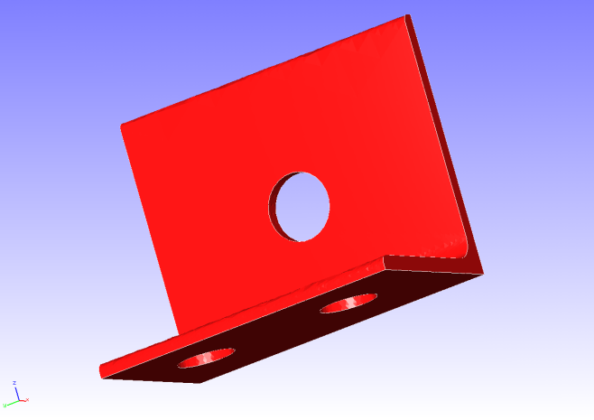 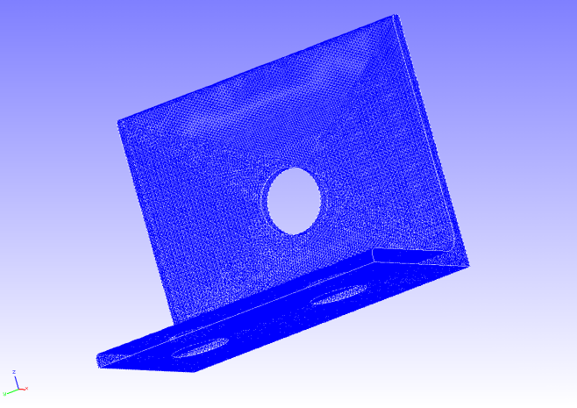

Restrained

Surface

Forced

Surface

Figure 4.1.1: Shape of Hinge Component Figure 4.1.2: Mesh Data of Hinge Component

### Analysis Contents

A stress analysis is implemented, where the displacement of the restrained surface shown in Figure 4.1.1 is restrained, and a concentrated load is applied to the forced surface. The analysis control data is shown in the following.

# Control File for FISTR

## Analysis Control

!VERSION

3

!SOLUTION, TYPE=STATIC

!WRITE,RESULT

!WRITE,VISUAL

## Solver Control

### Boundary Conditon

!BOUNDARY

BND0, 1, 3, 0.000000

!BOUNDARY

BND1, 1, 3, 0.000000

!CLOAD

CL0, 1, 1.00000

### Material

!MATERIAL, NAME=STEEL

!ELASTIC

210000.0, 0.3

!DENSITY

7.85e-6

### Solver Setting

!SOLVER,METHOD=CG,PRECOND=1,ITERLOG=YES,TIMELOG=YES

10000, 2

1.0e-8, 1.0, 0.0

### Analysis Results

A contour figure of the Mises stress was created by REVOCAP_PrePost, and is shown in Figure 4.1.3. Moreover, a portion of the analysis results log file is shown in the following as numeric data of the analysis results.

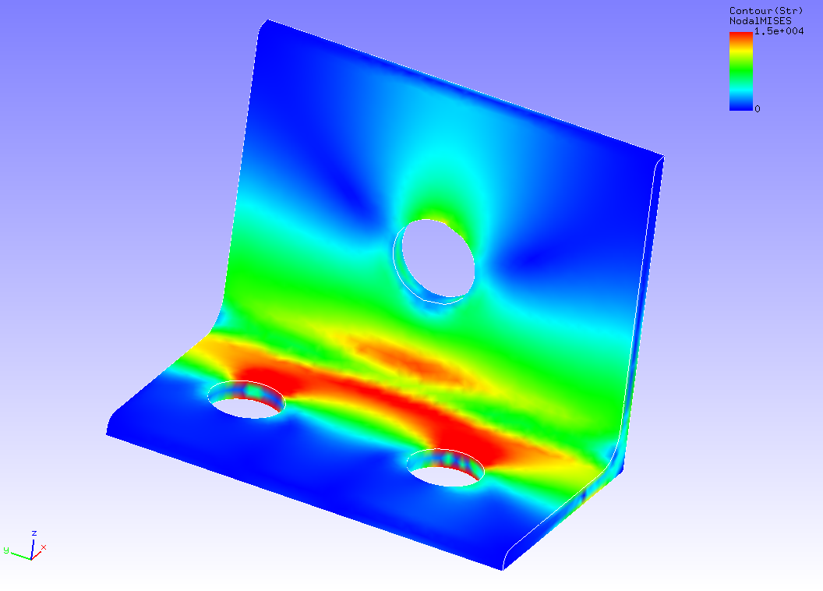

Figure 4.1.3: Analysis Results of Mises Stress

#### Result step= 1

##### Local Summary :Max/IdMax/Min/IdMin####

//U1 3.9115E+00 82452 -7.1083E-02 65233

//U2 7.4504E-03 354 -5.8813E-02 696

//U3 5.9493E-02 84 -5.8751E-01 61080

//E11 1.3777E-01 130 -1.3653E-01 77625

//E22 4.9199E-02 61 -5.4370E-02 102

//E33 6.8634E-02 51036 -6.1176E-02 30070

//E12 7.1556E-02 27808 -6.8093E-02 27863

//E23 5.3666E-02 56 -5.4347E-02 82

//E13 7.2396E-02 36168 -9.6621E-02 130

//S11 3.8626E+04 130 -3.6387E+04 28580

//S22 1.6628E+04 130 -1.5743E+04 28580

//S33 1.6502E+04 30033 -1.5643E+04 28580

//S12 5.7795E+03 27808 -5.4998E+03 27863

//S23 4.3345E+03 56 -4.3896E+03 82

//S13 5.8474E+03 36168 -7.8040E+03 130

//SMS 2.8195E+04 77625 1.2755E+00 75112

## Static Analysis (Elasticity, Parallel)

Data of tutorial/02_elastic_hinge_parallel/ is used to implement the analysis of Section 4.1 in four-parallel.

## Static Analysis (Hyperelasticity Part 1)

Data of tutorial/ 03_hyperelastic_cylinder/ is used to implement this analysis.

### Analysis Object

The object for analysis is a 1/8 model of a cylinder. The shape is shown in Figure 4.3.1, and the mesh data is shown in Figure 4.3.2. Hexahedral linear elements are used for the mesh, and the scale of the mesh consists of 432 elements and 629 nodes.

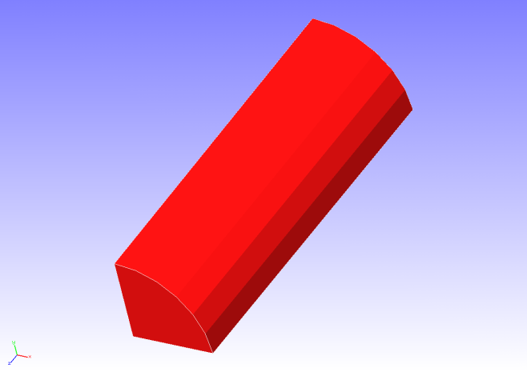 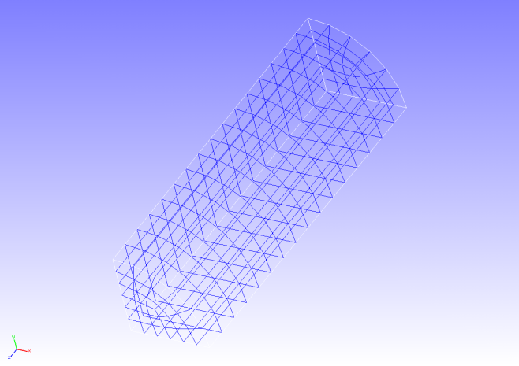

Figure 4.3.1: Shape of Cylinder (1/8 Model) Figure 4.3.2: Mesh Data of Cylinder (1/8 model)

### Analysis Content

Stress analysis is implemented where tension displacement is applied to the cylinder in the axial direction. The Mooney-Rivlin model is used for the constitutive equation of the material of the hyperelasticity. The analysis control data is shown in the following.

# Control File for FISTR

## Analysis Control

!VERSION

3

!SOLUTION, TYPE=NLSTATIC

!WRITE,RESULT

!WRITE,VISUAL

## Solver Control

### Boundary Conditon

!BOUNDARY, GRPID=1

LOADS, 3, 3, -7.0

FIX, 3, 3, 0.0

XSYMM, 1, 1, 0.0

YSYMM, 2, 2, 0.0

### STEP

!STEP, SUBSTEPS=5, CONVERG=1.0e-5

BOUNDARY, 1

### Material

!MATERIAL, NAME=MAT1

!HYPERELASTIC, TYPE=MOONEY-RIVLIN

0.1486, 0.4849, 0.0789

### Solver Setting

!SOLVER,METHOD=CG,PRECOND=1,ITERLOG=YES,TIMELOG=YES

10000, 2

1.0e-8, 1.0, 0.0

### Analysis Results

As analysis results of the 5th sub step, a deformed figure applied with a contour of the Mises stress was created by REVOCAP_PrePost, and is shown in Figure 4.3.3. Moreover, a portion of the analysis results log file is shown in the following as numeric data of the analysis results.

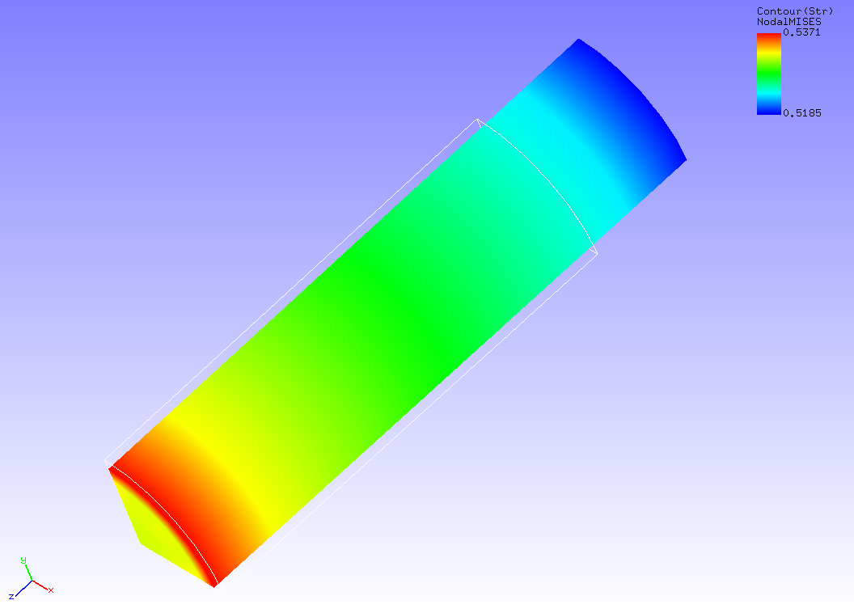

Figure 4.3.3: Analysis Results of Deformation and Mises Stress

#### Result step= 5

##### Local Summary :Max/IdMax/Min/IdMin####

//U1 0.0000E+00 1 -6.7543E-01 7

//U2 0.0000E+00 1 -6.7543E-01 13

//U3 0.0000E+00 1 -7.0000E+00 38

//E11 -9.6960E-02 38 -1.0234E-01 7

//E22 -9.6960E-02 50 -1.0234E-01 13

//E33 3.0653E-01 13 2.8767E-01 38

//E12 6.9417E-04 53 -7.0552E-04 10

//E23 5.8123E-08 39 -3.2652E-03 86

//E13 5.8123E-08 49 -3.2652E-03 93

//S11 5.8544E-03 38 -6.3700E-03 7

//S22 5.8544E-03 50 -6.3701E-03 13

//S33 5.3515E-01 35 5.2022E-01 64

//S12 1.5492E-03 53 -1.6314E-03 10

//S23 1.7965E-07 38 -2.1555E-03 86

//S13 1.7965E-07 50 -2.1555E-03 93

//SMS 5.3711E-01 10 5.1849E-01 53

## Static Analysis (Hyperelasticity Part 2)

Data of tutorial/ 04_hyperelastic_spring/ is used to implement this analysis.

### Analysis Object

A spring is the object of the analysis. The shape is shown in Figure 4.4.1, and the mesh data is shown in Figure 4.4.2. Quadratic tetrahedral elements are used for the mesh, and the scale of the mesh consists of 46,454 elements and 78,771 nodes.

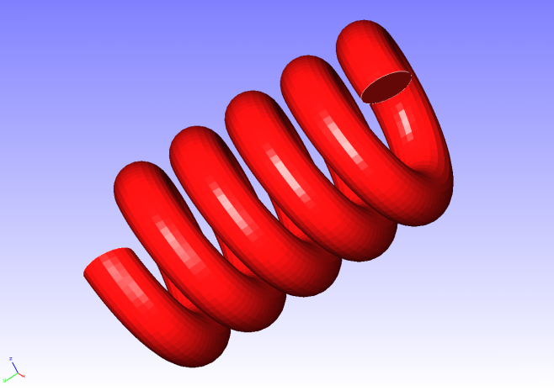 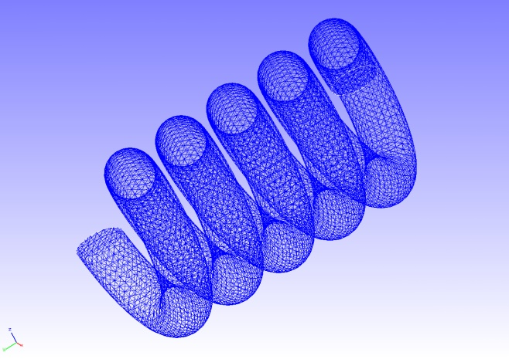

Restrained

Surface

Forced

Surface

Figure 4.4.1: Shape of Spring Figure 4.4.2: Mesh Data of Spring

### Analysis Content

A stress analysis is implemented, where the displacement of the restrained surface shown in Figure 4.4.1 is restrained, and a displacement is applied to the forced surface. The Arruda-Boyce model is used for the constitutive equation of the material of the hyperelasticity. The analysis control data is shown in the following.

# Control File for FISTR

## Analysis Control

!VERSION

3

!SOLUTION, TYPE=NLSTATIC

!WRITE,RESULT

!WRITE,VISUAL

## Solver Control

### Boundary Conditon

!BOUNDARY, GRPID=1

LOADS, 2, 2, -5.0

FIX, 1, 3, 0.0

### STEP

!STEP, SUBSTEPS=1, CONVERG=1.0e-5

BOUNDARY, 1

### Material

!MATERIAL, NAME=MAT1

!HYPERELASTIC, TYPE=ARRUDA-BOYCE

0.71, 1.7029, 0.1408

### Solver Setting

!SOLVER,METHOD=CG,PRECOND=1,ITERLOG=YES,TIMELOG=YES

10000, 2

1.0e-8, 1.0, 0.0

### Analysis Results

A deformed figure applied with a displacement contour was created by REVOCAP_PrePost, and is shown in Figure 4.4.3. Moreover, a portion of the analysis results log file is shown in the following as numeric data of the analysis results.

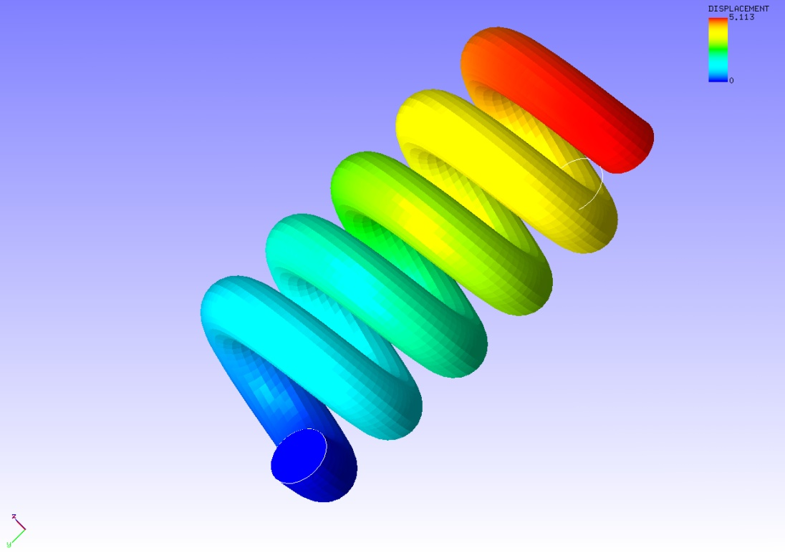

Figure 4.4.3: Analysis Results of Deformation and Displacement

#### Result step= 1

##### Local Summary :Max/IdMax/Min/IdMin####

//U1 2.8588E-01 42179 -2.6512E-01 22274

//U2 2.2657E-02 6381 -5.0291E+00 22825

//U3 7.4573E-02 7058 -9.5095E-01 48324

//E11 4.8291E-03 2851 -4.2788E-03 3429

//E22 2.4161E-03 55960 -1.4539E-03 44761

//E33 5.3256E-03 25260 -4.6858E-03 27938

//E12 1.3574E-02 56003 -1.3081E-02 45120

//E23 2.8679E-02 48353 -1.8970E-02 48322

//E13 1.0897E-02 47938 -9.1054E-03 27344

//S11 5.1605E-02 2814 -5.0895E-03 10408

//S22 5.0635E-02 55965 -3.6174E-03 45307

//S33 4.9662E-02 39836 -5.1017E-03 4949

//S12 1.2059E-02 56003 -1.1865E-02 45120

//S23 2.6123E-02 48353 -1.7281E-02 56868

//S13 1.0133E-02 47938 -8.2330E-03 27344

//SMS 4.9365E-02 48353 3.2148E-04 64553

## Static Analysis (Elastoplasticity Part 1)

Data of tutorial/ 05_plastic_cylinder / is used to implement this analysis.

### Analysis Object

The same 1/8 model cylinder as the static analysis (hyperelasticity part 1) in Section 4.3 is the object of the analysis.

### Analysis Content

The necking phenomenon of the cylinder by plastic deformation is analyzed. The Mises model is used for the yield function. The analysis control data is shown in the following.

# Control File for FISTR

## Analysis Control

!VERSION

3

!SOLUTION, TYPE=NLSTATIC

!WRITE,RESULT,FREQUENCY=10

!WRITE,VISUAL,FREQUENCY=10

## Solver Control

### Boundary Conditon

!BOUNDARY, GRPID=1

LOADS, 3, 3, -7.0

FIX, 3, 3, 0.0

XSYMM, 1, 1, 0.0

YSYMM, 2, 2, 0.0

### STEP

!STEP, SUBSTEPS=40, CONVERG=1.0e-3

BOUNDARY, 1

### Material

!MATERIAL, NAME=MAT1

!ELASTIC

206900.0, 0.29

!PLASTIC, YIELD=MISES, HARDEN=MULTILINEAR

450.0, 0.0

608.0, 0.05

679.0, 0.1

732.0, 0.2

752.0, 0.3

766.0, 0.4

780.0, 0.5

### Output

!OUTPUT_VIS

NSTRAIN, ON

!OUTPUT_RES

ISTRESS, ON

### Solver Setting

!SOLVER,METHOD=CG,PRECOND=1,ITERLOG=NO,TIMELOG=YES

2000, 2

1.0e-8, 1.0, 0.0

### Analysis Results

As analysis results of the 35th sub step, a deformed figure applied with a contour of the Mises stress was created by REVOCAP_PrePost, and is shown in Figure 4.5.1. Moreover, a portion of the analysis results log file is shown in the following as numeric data of the analysis results.

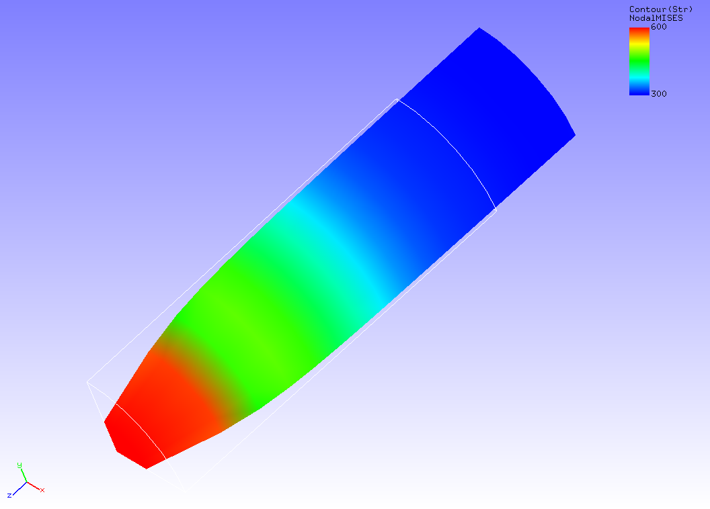

Figure 4.5.1: Analysis Results of Deformation and Mises Stress

#### Result step= 40

##### Local Summary :Max/IdMax/Min/IdMin####

//U1 0.0000E+00 1 -3.5930E+00 7

//U2 0.0000E+00 1 -3.5930E+00 13

//U3 0.0000E+00 1 -7.0000E+00 38

//E11 -3.9417E-02 38 -6.5298E-01 16

//E22 -3.9417E-02 50 -6.5298E-01 4

//E33 1.3083E+00 1 7.9614E-02 50

//E12 6.9553E-02 10 -1.7556E-02 368

//E23 1.5953E-02 90 -7.1473E-01 13

//E13 1.5954E-02 89 -7.1473E-01 7

//S11 1.9746E+02 86 -3.6807E+02 192

//S22 1.9746E+02 93 -3.6807E+02 192

//S33 9.1649E+02 1 -6.4716E+01 191

//S12 6.3257E-01 53 -1.2521E+02 406

//S23 5.7963E+01 191 -2.0766E+02 89

//S13 5.7963E+01 191 -2.0766E+02 90

//SMS 7.9001E+02 13 2.1264E+02 189

## Static Analysis (Elastoplasticity Part 2)

Data of tutorial/ 06_plastic_can / is used to implement this analysis.

### Analysis Object

The object for analysis is a 1/2 model of a can. The shape is shown in Figure 4.6.1, and the mesh data is shown in Figure 4.6.2. Quadratic tetrahedral elements are used for the mesh, and the scale of the mesh consists of 7,236 elements and 14,119 nodes.

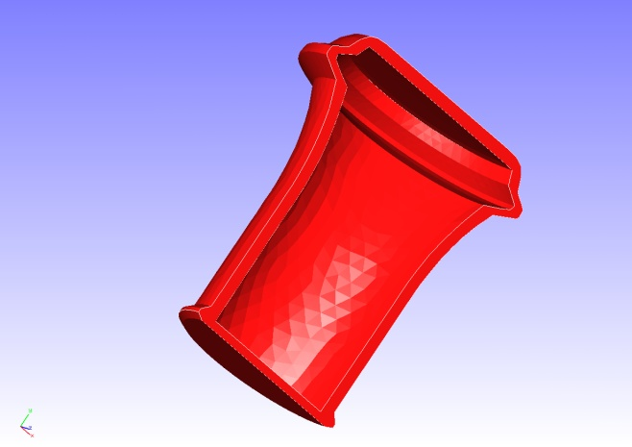　 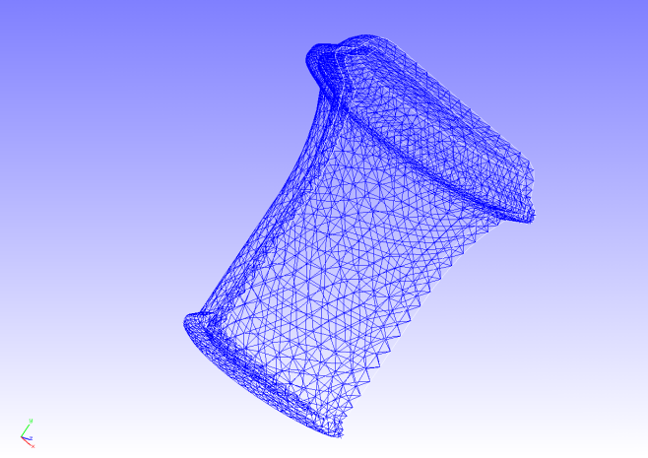

Forced Surface

(Internal Pressure)

Restrained Surface

Restrained Surface

Figure 4.6.1: Shape of Can Figure 4.6.2: Mesh Data of Can

### Analysis Content

A stress analysis is implemented, where the displacement of the restrained surface shown in Figure 4.6.1 is restrained, and a distributed load was applied to the forced surface inside of the can. The Drucker-Prager model is used for the yield function. The analysis control data is shown in the following.

# Control File for FISTR

## Analysis Control

!VERSION

3

!SOLUTION, TYPE=NLSTATIC

## Solver Control

### Boundary Conditon

!BOUNDARY, GRPID=1

BND0, 3, 3, 0.000000

!BOUNDARY, GRPID=1

BND1, 1, 1, 0.000000

BND1, 2, 2, 0.000000

BND1, 3, 3, 0.000000

!DLOAD,GRPID=1

DL0, S, 1.0

!DLOAD,GRPID=1

DL1, S, 1.0

!DLOAD,GRPID=1

DL2, S, 0.5

### STEP

!STEP, SUBSTEPS=10, CONVERG=1.0e-5

BOUNDARY, 1

LOAD, 1

### Material

!MATERIAL, NAME=M1

!ELASTIC

24000.0, 0.2

!PLASTIC, YIELD = DRUCKER-PRAGER

500.0, 20.0, 0.0

### Solver Setting

!SOLVER,METHOD=CG,PRECOND=1,ITERLOG=NO,TIMELOG=YES

20000, 2

1.0e-8, 1.0, 0.0

### Analysis Results

As analysis results of the 10th sub step, a deformed figure applied with a contour of the Mises stress was created by REVOCAP_PrePost, and is shown in Figure 4.6.3. The deformation magnification is set to 30. Moreover, a portion of the analysis results log file is shown in the following as numeric data of the analysis results.

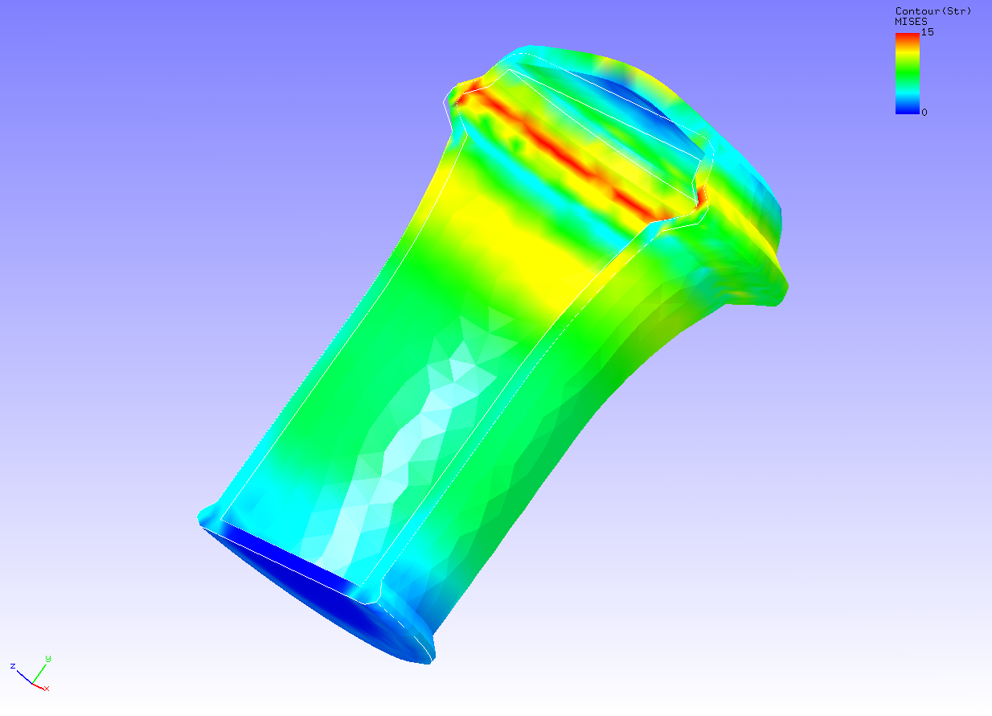

Figure 4.6.3: Analysis Results of Deformation and Mises Stress

#### Result step= 10

##### Local Summary :Max/IdMax/Min/IdMin####

//U1 1.6235E+00 1600 -1.6188E+00 11901

//U2 1.9319E+01 6877 -4.5377E-01 7096

//U3 1.6152E+00 7016 -1.5121E+00 6934

//E11 9.9346E-04 11242 -6.5987E-04 1404

//E22 1.5038E-03 13972 -5.4264E-04 2367

//E33 9.8561E-04 6833 -6.4870E-04 7000

//E12 1.6845E-03 2698 -1.7200E-03 11906

//E23 1.7107E-03 6749 -1.4474E-03 13509

//E13 1.2130E-03 12475 -1.1219E-03 11342

//S11 2.7825E+01 1086 -1.9473E+01 2363

//S22 3.7931E+01 13972 -1.4575E+01 2367

//S33 2.7377E+01 1086 -1.9776E+01 13082

//S12 1.6847E+01 2698 -1.7201E+01 11906

//S23 1.7109E+01 6749 -1.4474E+01 13509

//S13 1.2124E+01 12475 -1.1214E+01 11342

//SMS 3.7533E+01 2834 2.7585E-04 7333

## Static Analysis (Viscoelasticity)

Data of tutorial/ 07_viscoelastic_cylinder / is used to implement this analysis.

### Analysis Object

The same 1/8 model cylinder as in the static analysis (hyperelasticity part 1) in Section 4.3 is the object of the analysis.

### Analysis Content

Stress relaxation analysis is implemented where tension displacement is applied to the cylinder in the axial direction. The analysis control data is shown in the following.

# Control File for FISTR

## Analysis Control

!VERSION

3

!SOLUTION, TYPE=NLSTATIC

!WRITE,VISUAL

!WRITE,RESULT

## Solver Control

### Boundary Conditon

!BOUNDARY, GRPID=1

LOADS, 3, 3, -7.0

FIX, 3, 3, 0.0

XSYMM, 1, 1, 0.0

YSYMM, 2, 2, 0.0

### STEP

!STEP, TYPE=VISCO, CONVERG=1.0e-5

0.2, 2.0

BOUNDARY, 1

### Material

!MATERIAL, NAME=MAT1

!ELASTIC

206900.0, 0.29

!VISCOELASTIC

0.5, 1.0

### Solver Setting

!SOLVER,METHOD=CG,PRECOND=1,ITERLOG=YES,TIMELOG=YES

10000, 2

1.0e-8, 1.0, 0.0

### Analysis Results

A deformed figure applied with a contour of the Mises stress was created by REVOCAP_PrePost, and is shown in Figure 4.7.1. This is the analysis results after 2 seconds (10th step). Moreover, a portion of the analysis results log file is shown in the following as numeric data of the analysis results.

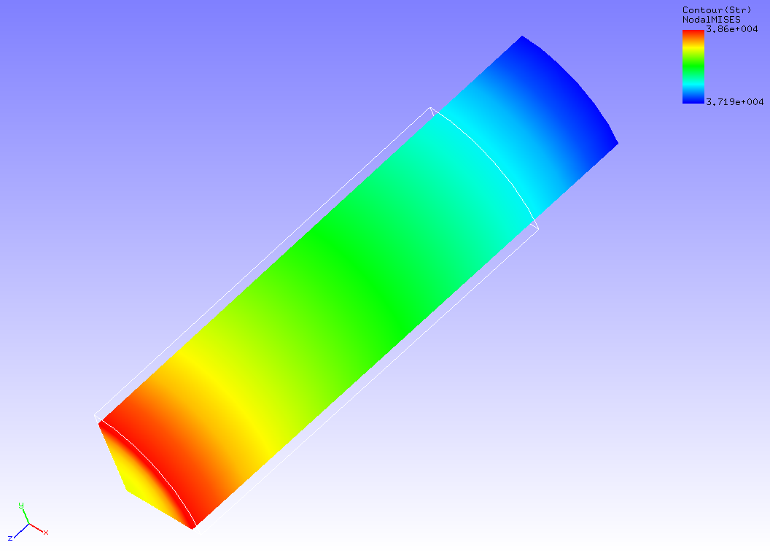

Figure 4.7.1: Analysis Results of Deformation and Mises Stress

#### Result step= 10

##### Local Summary :Max/IdMax/Min/IdMin####

//U1 0.0000E+00 1 -7.4531E-01 91

//U2 0.0000E+00 1 -7.4531E-01 88

//U3 0.0000E+00 1 -7.0000E+00 38

//E11 -1.0763E-01 38 -1.1244E-01 7

//E22 -1.0763E-01 50 -1.1244E-01 13

//E33 3.0270E-01 13 2.9129E-01 50

//E12 9.8113E-04 53 -9.9997E-04 10

//E23 1.1878E-04 72 -3.2869E-03 84

//E13 1.1878E-04 64 -3.2869E-03 95

//S11 1.4135E+02 13 -1.3699E+02 50

//S22 1.4135E+02 7 -1.3699E+02 38

//S33 3.8691E+04 13 3.7107E+04 50

//S12 4.6701E+01 53 -4.7594E+01 10

//S23 5.2254E+00 72 -1.5313E+02 84

//S13 5.2254E+00 64 -1.5313E+02 95

//SMS 3.8602E+04 13 3.7194E+04 50

## Static Analysis (Creep)

Data of tutorial/ 08_creep_cylinder / is used to implement this analysis.

### Analysis Object

The same 1/8 model cylinder as in the static analysis (hyperelasticity part 1) in Section 4.3 is the object of the analysis.

### Analysis Content

Creep behavioral analysis is implemented where tension displacement is applied to the cylinder in the axial direction. The analysis control data is shown in the following.

# Control File for FISTR

## Analysis Control

!VERSION

3

!SOLUTION, TYPE=NLSTATIC

!WRITE,RESULT

!WRITE,VISUAL

## Solver Control

### Boundary Conditon

!BOUNDARY, GRPID=1

LOADS, 3, 3, -7.0

FIX, 3, 3, 0.0

XSYMM, 1, 1, 0.0

YSYMM, 2, 2, 0.0

### STEP

!STEP, SUBSTEPS=5, CONVERG=1.0e-5

BOUNDARY, 1

### Material

!MATERIAL, NAME=MAT1

!ELASTIC

206900.0, 0.29

!CREEP, TYPE=NORTON

1.e-10, 5.0, 0.0

### Solver Setting

!SOLVER,METHOD=CG,PRECOND=1,ITERLOG=YES,TIMELOG=YES

10000, 2

1.0e-8, 1.0, 0.0

### Analysis Results

As analysis results of the 5th sub step, a deformed figure applied with a contour of the Mises stress was created by REVOCAP_PrePost, and is shown in Figure 4.8.1. Moreover, a portion of the analysis results log file is shown in the following as numeric data of the analysis results.

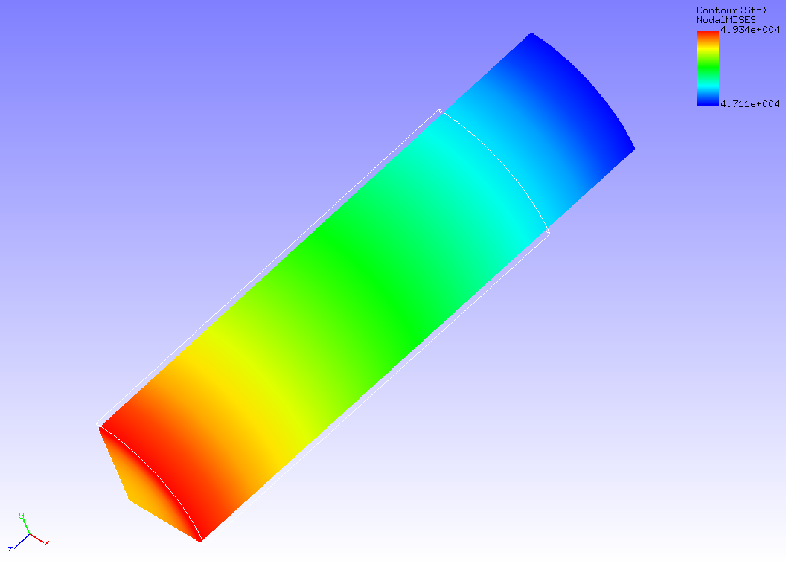

Figure 4.8.1: Analysis Results of Deformation and Mises Stress

#### Result step= 5

##### Local Summary :Max/IdMax/Min/IdMin####

//U1 0.0000E+00 1 -4.1832E-01 91

//U2 0.0000E+00 1 -4.1832E-01 88

//U3 0.0000E+00 1 -7.0000E+00 38

//E11 -6.5815E-02 38 -6.9387E-02 7

//E22 -6.5815E-02 50 -6.9387E-02 13

//E33 2.3854E-01 13 2.2765E-01 38

//E12 5.4317E-04 53 -5.5746E-04 10

//E23 8.9875E-05 72 -2.2085E-03 84

//E13 8.9875E-05 64 -2.2085E-03 95

//S11 1.1317E+02 14 -1.1102E+02 49

//S22 1.1317E+02 6 -1.1102E+02 39

//S33 4.9374E+04 13 4.7081E+04 38

//S12 4.3566E+01 53 -4.4697E+01 10

//S23 7.6408E+00 72 -1.6768E+02 84

//S13 7.6408E+00 64 -1.6768E+02 95

//SMS 4.9340E+04 13 4.7114E+04 38

## Contact Analysis (Part 1)

Data of tutorial/ 09_contact_hertz / is used to implement this analysis.

### Analysis Object

The Hertz contact problem was applied in this analysis. The shape of the analysis object is shown in Figure 4.9.1, and the mesh data is shown in Figure 4.9.2. Hexahedral linear elements are used for the mesh, and the scale of the mesh consists of 168 elements and 408 nodes.

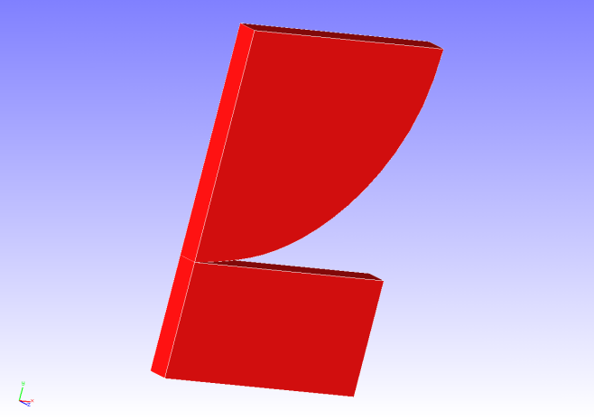 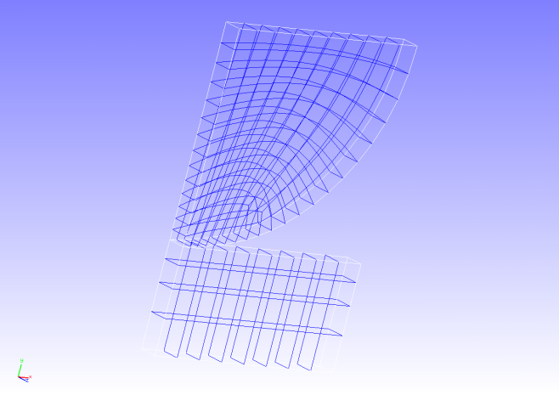

Forced Surface

Figure 4.9.1: Shape of Analysis Object Figure 4.9.2: Mesh Data of Analysis Object

### Analysis Content

An extended Lagrange multiplier method is used to implement the contact analysis where forced displacement is applied to the upper surface of a 1/4 model disc in the compression direction. The analysis control data is shown in the following.

# Control File for FISTR

## Analysis Control

!VERSION

3

!SOLUTION, TYPE=NLSTATIC

!WRITE,RESULT

!WRITE,VISUAL

## Solver Control

### Boundary Conditon

!BOUNDARY, GRPID=1

ALL, 3, 3, 0.0

BOTTOM, 2, 2, 0.0

CENTER, 1, 1, 0.0

UPPER, 2, 2, -0.306

!CONTACT_ALGO, TYPE=ALAGRANGE

!CONTACT, GRPID=1

CP1, 0.0

### STEP

!STEP, SUBSTEPS=5, CONVERG=1.0e-5

BOUNDARY, 1

CONTACT, 1

### Material

!MATERIAL, NAME=MAT1

!ELASTIC

1100.0, 0.0

### Solver Setting

### Solver Setting

!SOLVER, METHOD=CG, PRECOND=1, ITERLOG=YES, TIMELOG=YES

1000, 2

1.0e-10, 1.0, 0.0

### Analysis Results

As analysis results of the 5th sub step, a deformed figure applied with a contour of the displacement in the y direction was created by REVOCAP_PrePost, and is shown in Figure 4.9.3. Moreover, a portion of the analysis results log file is shown in the following as numeric data of the analysis results.

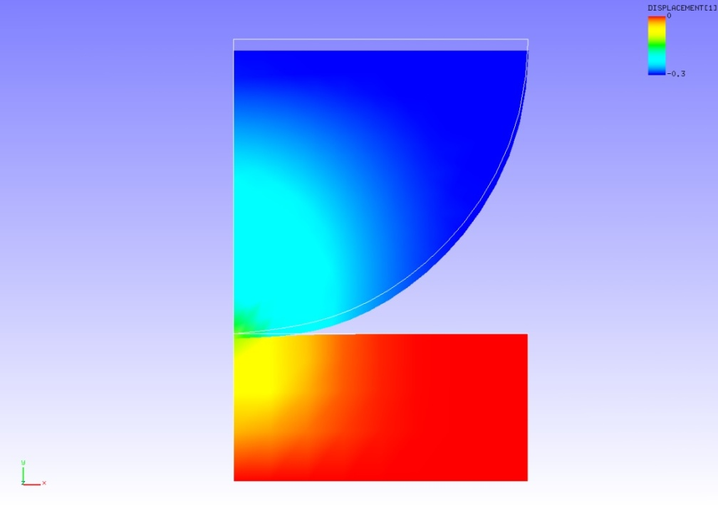

Figure 4.9.3: Analysis Results of Deformation and y Direction Displacement

#### Result step= 5

##### Local Summary :Max/IdMax/Min/IdMin####

//U1 1.1912E-02 70 -3.7167E-02 47

//U2 4.4886E-03 1008 -3.0603E-01 32

//U3 0.0000E+00 1 0.0000E+00 1

//E11 6.4120E-03 1003 -4.1075E-02 50

//E22 1.8765E-03 1012 -5.8752E-02 29

//E33 1.1012E-02 1046 -3.2153E-03 47

//E12 4.9036E-02 1046 -3.9706E-02 30

//E23 1.4957E-15 1047 -8.5554E-15 1000

//E13 7.5696E-15 50 -1.4571E-15 1047

//S11 7.0532E+00 1003 -4.5183E+01 50

//S22 2.0641E+00 1012 -6.4627E+01 29

//S33 1.2113E+01 1046 -3.5369E+00 47

//S12 2.6970E+01 1046 -2.1838E+01 30

//S23 8.2263E-13 1047 -4.7055E-12 1000

//S13 4.1633E-12 50 -8.0141E-13 1047

//SMS 7.6836E+01 30 8.8599E-02 69

## Contact Analysis (Part 2)

Data of tutorial/ 10_contact_2tubes/ is used to implement this analysis.

### Analysis Object

A pinched cylindrical problem was applied in this analysis. The shape of the analysis object is shown in Figure 4.10.1, and the mesh data is shown in Figure 4.10.2. Hexahedral linear elements are used for the mesh, and the scale of the mesh consists of 2,888 elements and 4,000 nodes.

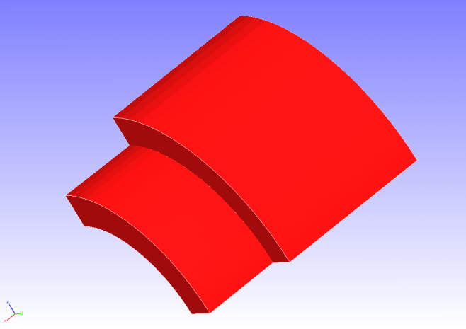 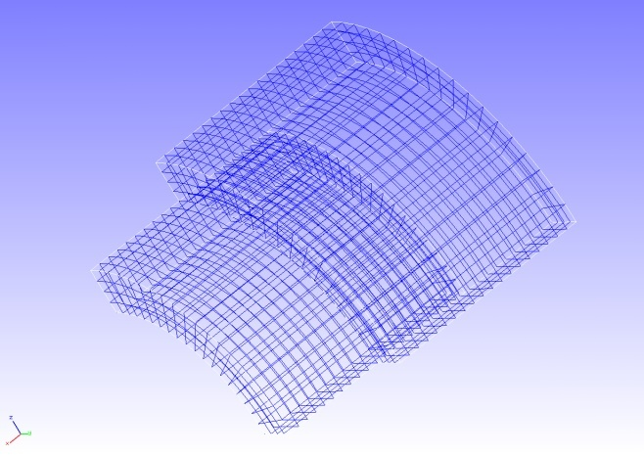

Forced Surface

Figure 4.10.1: Shape of Analysis Object Figure 4.10.2: Mesh Data of Analysis Object

### Analysis Content

The Lagrange multiplier method is used to implement the contact analysis where forced displacement is applied to the forced surface shown in Figure 4.10.1 in the pinched direction. The analysis control data is shown in the following.

# Control File for FISTR

## Analysis Control

!VERSION

3

!SOLUTION, TYPE=NLSTATIC

!WRITE,RESULT

!WRITE,VISUAL

## Solver Control

### Boundary Conditon

!BOUNDARY, GRPID=1

X0, 1, 3, 0.0

Y0, 2, 2, 0.0

Z0, 3, 3, 0.0

!BOUNDARY, GRPID=2

X1, 1, 1, 0.0

!BOUNDARY, GRPID=3

X1, 1, 1, -1.0

!CONTACT_ALGO, TYPE=SLAGRANGE

!CONTACT, GRPID=1, INTERACTION=FSLID, NPENALTY=1.0e+2

CP1, 0.0, 1.0e+5

### STEP

!STEP, SUBSTEPS=4, CONVERG=1.0e-5

BOUNDARY, 1

BOUNDARY, 3

CONTACT, 1

### Material

!MATERIAL, NAME=M1

!ELASTIC

2.1e+5, 0.3

### Solver Setting

!SOLVER,METHOD=DIRECTmkl

### Analysis Results

As analysis results of the 4th sub step, a deformed figure applied with a contour of the Mises stress was created by REVOCAP_PrePost, and is shown in Figure 4.10.3. Moreover, a portion of the analysis results log file is shown in the following as numeric data of the analysis results.

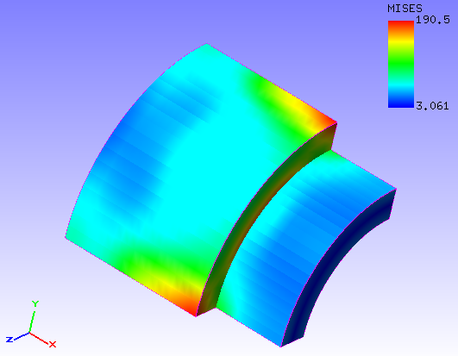

Figure 4.10.3: Analysis Results of Deformation and Mises Stress

#### Result step= 4

##### Local Summary :Max/IdMax/Min/IdMin####

//U1 8.6939E-04 32 -1.0021E+00 2006

//U2 8.7641E-03 104 -7.0519E-03 2006

//U3 8.7641E-03 4 -7.0519E-03 1901

//E11 7.5301E-04 1901 -4.1253E-04 105

//E22 9.8422E-04 2 -9.2887E-04 2058

//E33 9.8423E-04 102 -9.2880E-04 3843

//E12 5.3508E-04 133 -2.8307E-04 278

//E23 1.2482E-03 1901 -1.4180E-03 4

//E13 5.3519E-04 33 -2.8312E-04 1678

//S11 7.7141E+01 103 -9.0007E+01 101

//S22 2.0117E+02 2 -2.2938E+02 1905

//S33 2.0117E+02 102 -2.2941E+02 2010

//S12 4.3218E+01 133 -2.2863E+01 278

//S23 1.0082E+02 1901 -1.1453E+02 4

//S13 4.3227E+01 33 -2.2867E+01 1678

//SMS 2.9968E+02 1901 3.1610E+00 2454

## Contact Analysis (Part 3)

Data of tutorial/ 11_contact_2beam/ is used to implement this analysis.

### Analysis Object

A two beam contact problem is applied in this analysis. The outline of the analysis model is shown in Figure 4.11.1. Hexahedral linear elements are used for the mesh, and the scale of the mesh consists of 80 elements and 252 nodes.

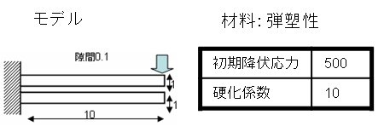

Model

Material: Elastoplasticity

Clearance 0.1

Initial Yield Stress

Hardening Factor

Figure 4.11.1 Outline of Analysis Model

### Analysis Contents

The Lagrange multiplier method is used to implement the contact analysis where forced displacement is applied to the front edge surface of the upper beam. The analysis control data is shown in the following.

!!

!! Control File for FISTR

!!

!VERSION

3

!SOLUTION, TYPE=NLSTATIC

!WRITE,RESULT

!WRITE,VISUAL

!BOUNDARY, GRPID=1

ng1, 1, 3, 0.0

ng2, 1, 3, 0.0

ng3, 3, 3, -3.0

!CONTACT_ALGO, TYPE=SLAGRANGE

!CONTACT, GRPID=1, INTERACTION=FSLID

CP1, 0.0, 1.0e+5

!STEP, SUBSTEPS=100, CONVERG=1.0e-4

BOUNDARY, 1

CONTACT, 1

!MATERIAL, NAME=M1

!ELASTIC

2.1e+5, 0.3

!PLASTIC,YIELD=MISES

500.0, 10.0

!SOLVER,METHOD=MUMPS

### Analysis Results

As analysis results of the 100th sub step, a deformed figure applied with a contour of the Mises stress was created by REVOCAP_PrePost, and is shown in Figure 4.11.2. Moreover, a portion of the analysis results log file is shown in the following as numeric data of the analysis results.

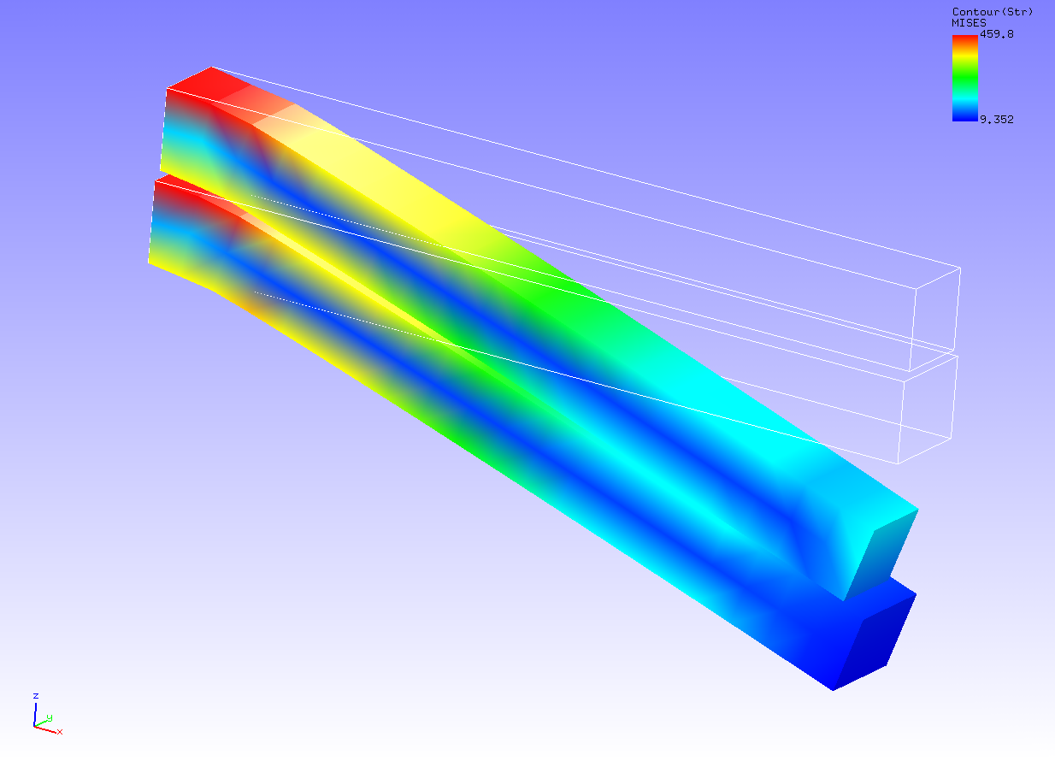

Figure 4.11.2: Analysis Results of Deformation and Mises Stress

#### Result step= 100

##### Local Summary :Max/IdMax/Min/IdMin####

//U1 1.4102E-01 196 -6.1103E-01 6

//U2 4.5722E-02 11 -4.5722E-02 195

//U3 0.0000E+00 1 -3.0000E+00 8

//E11 1.6030E-01 195 -1.3024E-01 49

//E22 5.9705E-02 49 -7.5459E-02 195

//E33 7.3924E-02 152 -8.7395E-02 30

//E12 8.6186E-02 7 -8.6186E-02 192

//E23 9.9009E-02 11 -9.9009E-02 195

//E13 6.0657E-02 90 -1.2889E-01 192

//S11 5.7685E+02 132 -6.3641E+02 152

//S22 1.2740E+02 3 -1.2727E+02 10

//S33 1.4933E+02 3 -1.4146E+02 127

//S12 1.4676E+02 70 -1.4676E+02 235

//S23 1.7885E+02 109 -1.7885E+02 172

//S13 1.6202E+02 90 -2.4814E+02 194

//SMS 6.2476E+02 89 8.3117E+00 2

## Linear Dynamic Analysis

Data of tutorial/ 12_dynamic_beam/ is used to implement this analysis.

### Analysis Object

A cantilever beam is the object of the analysis. The shape is shown in Figure 4.12.1, and the mesh data is shown in Figure 4.12.2. Quadratic tetrahedral elements are used for the mesh, and the scale of the mesh consists of 240 elements and 525 nodes.

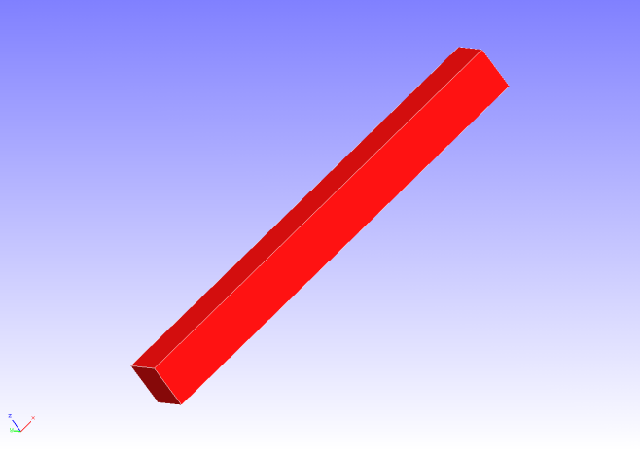 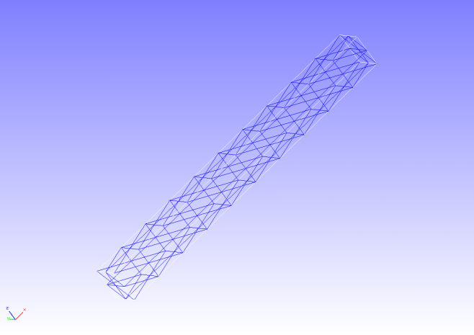

Load Mode

Restrained Surface

Figure 4.12.1: Shape of Cantilever Beam Figure 4.12.2: Mesh Data of Cantilever Beam

### Analysis Contents

A linear dynamic analysis is implemented, after the displacement of the restrained surface shown in Figure 4.12.1 is restrained, and a concentrated load is applied to the load node. The analysis control data is shown in the following.

# Control File for FISTR

## Analysis Control

!VERSION

3

!WRITE,LOG,FREQUENCY=5000

!WRITE,RESULT,FREQUENCY=5000

!SOLUTION, TYPE=DYNAMIC

!DYNAMIC, TYPE=LINEAR

11 , 1

0.0, 1.0, 500000, 1.0000e-8

0.5, 0.25

1, 1, 0.0, 0.0

100000, 3121, 500

1, 1, 1, 1, 1, 1

## Solver Control

### Boundary Conditon

!BOUNDARY, AMP=AMP1

FIX, 1, 3, 0.0

!CLOAD, AMP=AMP1

CL1, 3, -1.0

### Solver Setting

!SOLVER,METHOD=CG,PRECOND=1,ITERLOG=NO,TIMELOG=NO

10000, 2

1.0e-06, 1.0, 0.0

### Analysis Results

A time sequence display of the displacement of the monitoring node (load node, node number 3121) specified by the analysis control data was created in Microsoft Excel, and is shown in Figure 4.12.3. A portion of the displacement output file (dyna_disp_p1.out) of the monitoring node is shown in the following as numeric data of the analysis results.

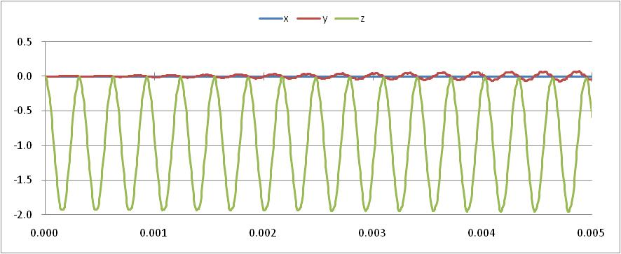

Displacement (mm)

Time (sec)

Figure 4.12.3: Displacement Time Sequence of Monitoring Node

0 0.0000E+000 3121 0.0000E+000 0.0000E+000 0.0000E+000

500 5.0000E-006 3121 5.5959E-005 -2.0679E-006 -1.5563E-002

1000 1.0000E-005 3121 5.3913E-005 2.0947E-005 -4.3950E-002

1500 1.5000E-005 3121 7.6105E-005 5.8799E-005 -8.0795E-002

2000 2.0000E-005 3121 6.8543E-006 4.0956E-005 -1.2329E-001

2500 2.5000E-005 3121 5.4725E-005 7.0881E-005 -1.7742E-001

3000 3.0000E-005 3121 6.8226E-005 1.7597E-004 -2.2801E-001

3500 3.5000E-005 3121 4.2923E-005 1.1791E-004 -2.7290E-001

4000 4.0000E-005 3121 -1.2087E-005 1.2552E-004 -3.2393E-001

4500 4.5000E-005 3121 3.4969E-005 -3.4512E-005 -3.8844E-001

5000 5.0000E-005 3121 6.1592E-005 1.2820E-004 -4.6425E-001

5500 5.5000E-005 3121 1.3188E-005 1.9002E-005 -5.4590E-001

6000 6.0000E-005 3121 3.1393E-005 -7.4604E-005 -6.4556E-001

6500 6.5000E-005 3121 9.8931E-005 -1.9078E-004 -7.5561E-001

7000 7.0000E-005 3121 4.2308E-005 1.1593E-004 -8.6826E-001

7500 7.5000E-005 3121 -2.7019E-005 3.0277E-004 -9.6826E-001

## Nonlinear Dynamic Analysis

Data of tutorial/ 13_dynamic_beam_nonlinear / is used to implement this analysis.

### Analysis Object

The same cantilever beam as in the linear dynamic analysis in Section 4.12 is the object of the analysis.

### Analysis Content

A nonlinear dynamic analysis is implemented, after the displacement of the restrained surface shown in Figure 4.12.1 is restrained, and a concentrated load is applied to the load node. The analysis control data is shown in the following.

# Control File for FISTR

## Analysis Control

!VERSION

3

!WRITE,RESULT,FREQUENCY=100

!SOLUTION, TYPE=DYNAMIC

!DYNAMIC, TYPE=NONLINEAR

1 , 1

0.0, 0.1, 100000, 1.0000e-8

0.5, 0.25

1, 1, 0.0, 0.0

1000, 3121, 100

1, 1, 1, 1, 1, 1

## Solver Control

### Boundary Conditon

!BOUNDARY, GRPID=1, AMP=AMP1

FIX, 1, 3, 0.0

!CLOAD, GRPID=1, AMP=AMP1

CL1, 3, -1.0

### STEP

!STEP, CONVERG=1.0e-3

BOUNDARY, 1

LOAD, 1

### Material

!DENSITY

1.0e-8

!HYPERELASTIC, TYPE=NEOHOOKE

1000.0, 0.00005

### Solver Setting

!SOLVER,METHOD=CG,PRECOND=1,ITERLOG=NO,TIMELOG=NO

10000, 2

1.0e-06, 1.0, 0.0

### Analysis Results

A time sequence display of the displacement of the monitoring node (load node, node number 3121) specified by the analysis control data was created in Microsoft Excel, and is shown in Figure 4.13.1. A portion of the displacement output file (dyna_disp_p1.out) of the monitoring node is shown in the following as numeric data of the analysis results.



Time (sec)

Displacement (mm)

Figure 4.13.1: Displacement Time Sequence of Monitoring Node

0 0.0000E+000 3121 0.0000E+000 0.0000E+000 0.0000E+000

100 1.0000E-006 3121 9.6353E-005 -5.1095E-005 -1.3238E-003

200 2.0000E-006 3121 9.0012E-005 -3.6471E-005 -3.6634E-003

300 3.0000E-006 3121 8.9091E-005 -5.9391E-007 -6.5111E-003

400 4.0000E-006 3121 1.8224E-005 1.8912E-006 -1.0037E-002

500 5.0000E-006 3121 5.1827E-005 -2.5069E-005 -1.4121E-002

600 6.0000E-006 3121 3.6671E-005 2.1807E-005 -1.8473E-002

700 7.0000E-006 3121 -1.7546E-005 6.9216E-006 -2.3308E-002

800 8.0000E-006 3121 -5.2440E-005 1.6820E-006 -2.8491E-002

900 9.0000E-006 3121 -8.5845E-005 3.4707E-005 -3.4008E-002

1000 1.0000E-005 3121 -1.4183E-004 3.5653E-005 -3.9828E-002

1100 1.1000E-005 3121 -2.0256E-004 1.7437E-005 -4.5995E-002

1200 1.2000E-005 3121 -2.3574E-004 3.3228E-005 -5.2387E-002

1300 1.3000E-005 3121 -3.3244E-004 2.3837E-005 -5.9080E-002

1400 1.4000E-005 3121 -4.3976E-004 4.6942E-005 -6.6266E-002

1500 1.5000E-005 3121 -5.2678E-004 1.6307E-004 -7.3148E-002

## Nonlinear Contact Dynamic Analysis

Data of tutorial/ 14_dynamic_plate_contact/ is used to implement this analysis.

### Analysis Object

A drop impact analysis of a square plate on a floor is the subject of the analysis. The shape is shown in Figure 4.14.1, and the mesh data is shown in Figure 4.14.2. Hexahedral linear elements are used for the mesh, and the scale of the mesh consists of 8,232 elements and 10,712 nodes.

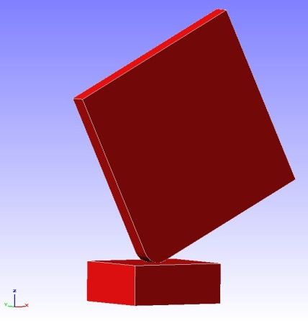　　　　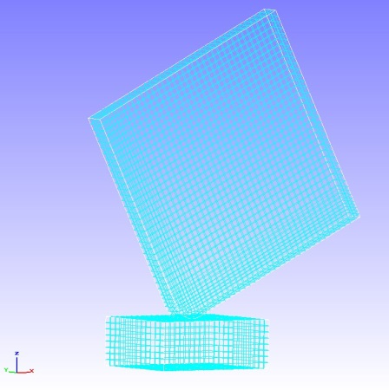

Restrained Surface

Initial Velocity

Figure 4.14.1: Shape of Floor and Figure 4.14.2: Mesh Data of Floor and

Square Plate Square Plate

### Analysis Content

An initial velocity of 4,427 mm/s is set for the square plate of the analysis object, to implement the contact dynamic analysis. The analysis control data is shown in the following.

!! Control File for FISTR

!VERSION

3

!WRITE,LOG,FREQUENCY=20

!WRITE,RESULT,FREQUENCY=20

!SOLUTION, TYPE=DYNAMIC

!DYNAMIC, TYPE=NONLINEAR

1 , 1

0.0, 1.0, 200, 1.0000e-8

0.65, 0.330625

1, 1, 0.0, 0.0

20, 2621, 1

1, 1, 1, 1, 1, 1

!BOUNDARY, GRPID = 1

bottom, 1, 3, 0.0

!VELOCITY, TYPE = INITIAL

plate, 3, 3, -4427.0

!CONTACT_ALGO, TYPE=SLAGRANGE

!CONTACT, GRPID=1, INTERACTION=FSLID

CP1, 0.0, 1.0e+5

!STEP, CONVERG=1.0e-8, ITMAX=100

BOUNDARY, 1

CONTACT, 1

!MATERIAL, NAME = M1

!ELASTIC

2.00000e+5, 0.3

!PLASTIC

1.0e+8, 0.0

!MATERIAL, NAME = M2

!ELASTIC

1.16992e+5, 0.3

!PLASTIC

70.0, 0.0

!SOLVER,METHOD=MUMPS

### Analysis Results

The contour figure of the Mises stress at the time of the drop impact is shown in Figure 4.14.3. A portion of the energy output file (dyna_energy.txt) of the monitoring node is shown in the following as numeric data of the analysis results.

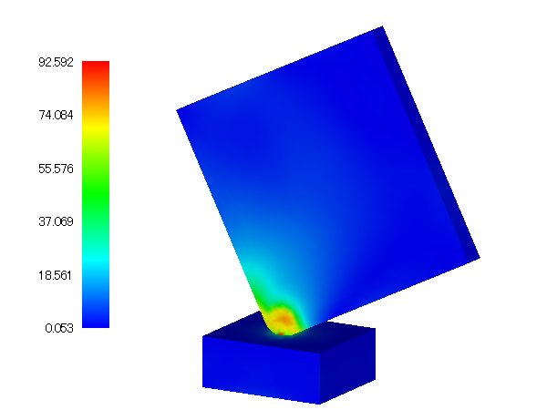

Figure 4.14.3: Mises Stress at time of Drop Impact

time step time kinetic energy strain energy total energy

0 0.0000E+000 9.7816E-003 0.0000E+000 9.7816E-003

1 1.0000E-008 9.7756E-003 4.9520E-006 9.7806E-003

2 2.0000E-008 9.7653E-003 1.4640E-005 9.7800E-003

3 3.0000E-008 9.7535E-003 2.5204E-005 9.7787E-003

4 4.0000E-008 9.7408E-003 3.7426E-005 9.7782E-003

5 5.0000E-008 9.7278E-003 5.0061E-005 9.7779E-003

6 6.0000E-008 9.7147E-003 6.2937E-005 9.7776E-003

7 7.0000E-008 9.7015E-003 7.5913E-005 9.7774E-003

8 8.0000E-008 9.6883E-003 8.8933E-005 9.7772E-003

9 9.0000E-008 9.6751E-003 1.0199E-004 9.7771E-003

10 1.0000E-007 9.6619E-003 1.1508E-004 9.7769E-003

11 1.1000E-007 9.6486E-003 1.2823E-004 9.7768E-003

12 1.2000E-007 9.6353E-003 1.4139E-004 9.7767E-003

## Eigenvalue Analysis

Data of tutorial/ 15_eigen_spring/ is used to implement this analysis.

### Analysis Object

The same spring as in the static analysis (hyperelasticity part 2) in Section 4.4 is the object of the analysis.

### Analysis Content

The displacement of the restrained surface shown in Figure 4.4.1 is restrained, and an eigenvalue analysis is implemented up to the 5th mode. The analysis control data is shown in the following.

# Control File for FISTR

## Analysis Control

!VERSION

3

!SOLUTION, TYPE=EIGEN

!EIGEN

5, 1.0E-8, 60

!WRITE,RESULT

!WRITE,VISUAL

## Solver Control

### Boundary Conditon

!BOUNDARY

XFIX, 1, 1, 0.0

YFIX, 2, 2, 0.0

ZFIX, 3, 3, 0.0

### Material

# define in mesh file

### Solver Setting

!SOLVER,METHOD=DIRECT

### Analysis Results

Analysis results data file spring.res.0.3 is used, and a 3rd oscillation mode (compression extension of the spring in y direction) was created by REVOCAP_PrePost, and is shown in Figure 4.15.1. The deformation magnification is set to 1,000. The character frequency list output to the analysis results log file is shown in the following as numeric data of the analysis results.

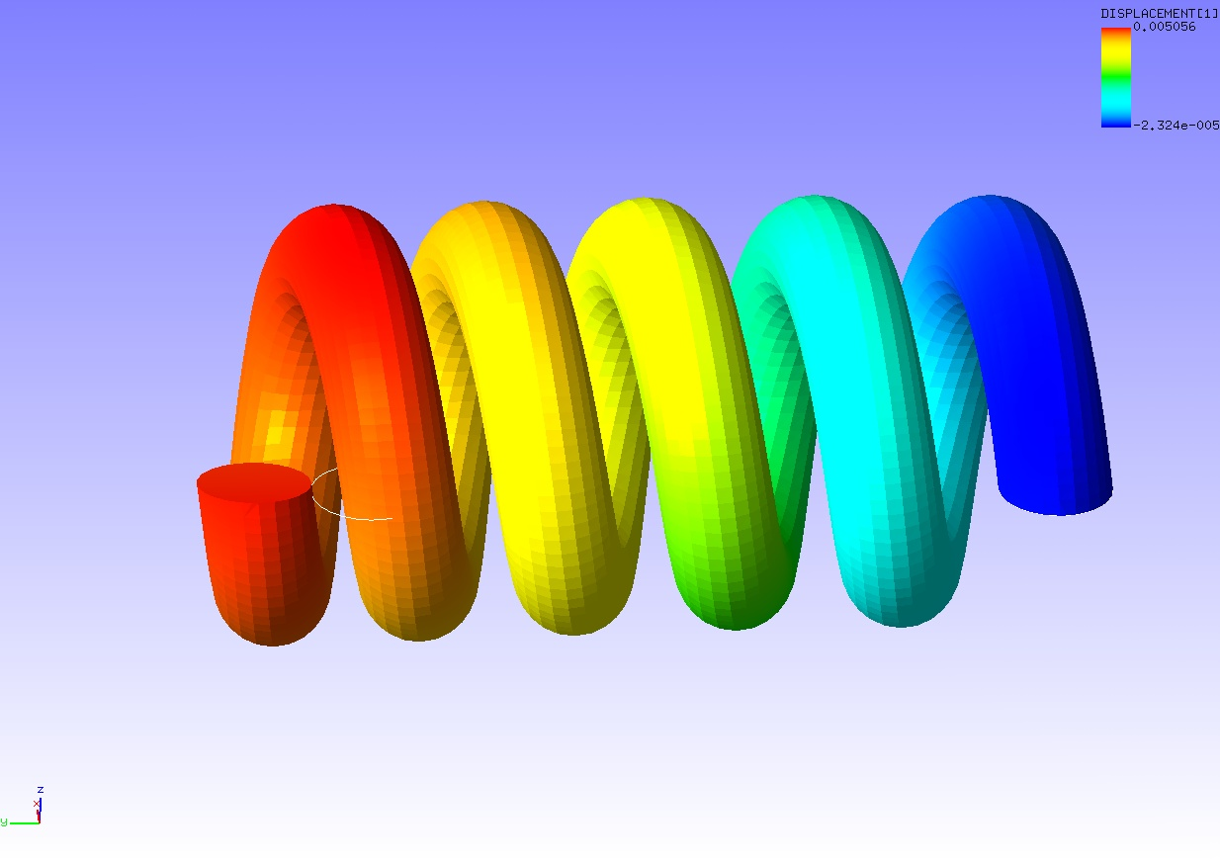

Figure 4.15.1: 3rd Oscillation Mode of Spring

********************************

*RESULT OF EIGEN VALUE ANALYSIS*

********************************

NUMBER OF ITERATIONS = 26

NO. EIGENVALUE ANGL.FREQUENCY FREQUENCY(HZ)

--- ---------- -------------- -------------

1 0.783085E+07 0.279837E+04 0.445374E+03

2 0.787176E+07 0.280567E+04 0.446536E+03

3 0.326006E+08 0.570969E+04 0.908726E+03

4 0.383712E+08 0.619445E+04 0.985877E+03

5 0.129322E+09 0.113720E+05 0.180991E+04

## Heat Conduction Analysis

Data of tutorial/ 16_heat_block/ is used to implement this analysis.

### Analysis Object

A block with a hole is the object of the analysis. The shape is shown in Figure 4.16.1, and the mesh data is shown in Figure 4.16.2. Hexahedral linear elements are used for the mesh, and the scale of the mesh consists of 32,160 elements and 37,386 nodes.

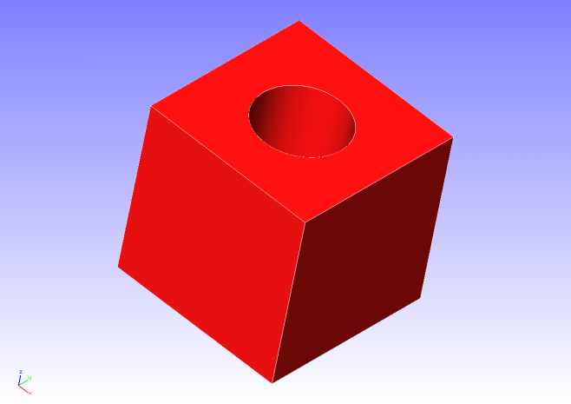 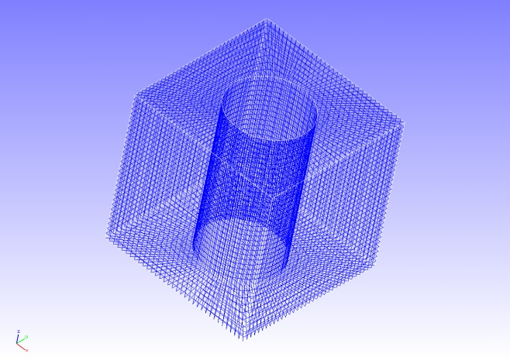

Figure 4.16.1: Shape of Block with Hole Figure 4.16.2: Mesh Data of Block with Hole

### Analysis Content

A steady heat conduction analysis is implemented, where a heat source is applied to the cylindrical inner surface of the analysis object. The analysis control data is shown in the following.

# Control File for FISTR

## Analysis Control

!VERSION

3

!SOLUTION, TYPE=HEAT

!HEAT

0.0

!WRITE,RESULT

!WRITE,VISUAL

## Solver Control

### Boundary Conditon

!FIXTEMP

FTMPC, 100.0

FTMPS1, 20.0

FTMPS2, 20.0

FTMPS3, 20.0

FTMPS4, 20.0

### Solver Setting

!SOLVER,METHOD=CG,PRECOND=2,ITERLOG=YES,TIMELOG=YES

100, 2

1.0e-8, 1.0, 0.0

### Analysis Results

A temperature contour figure was created by REVOCAP_PrePost, and is shown in Figure 4.16.3. Moreover, a portion of the analysis results log file is shown in the following as numeric data of the analysis results.

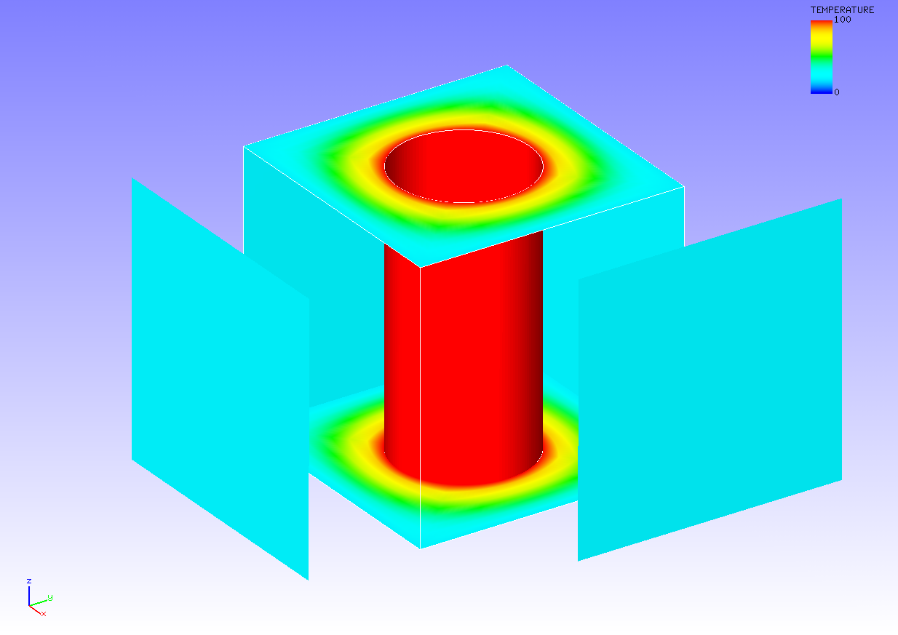

Figure 4.16.3: Temperature Analysis Results

ISTEP = 1

Time = 0.000

Maximum Temperature : 100.000

Maximum Node No. : 9

Minimum Temperature : 20.000

Minimum Node No. : 85

## Frequency Response Analysis

Use the files in the directory, tutorial/ 17_freq_beam/, in order to reproduce the test. The analysis consists of two steps; 1st Eigenvalue analysis, 2nd Frequency response analysis. For the 1s step, the following name change is required.

hecmw_ctrl_eigen.dat -> hecmw_ctrl.dat

After changing the name of file, eigenvalues analysis should be executed. You will get 0.log as the result of eigenvalue analysis. The file name should be changed as follows.

0.log -> eigen_0.log

Then start frequency response analysis.

### Analysis Object

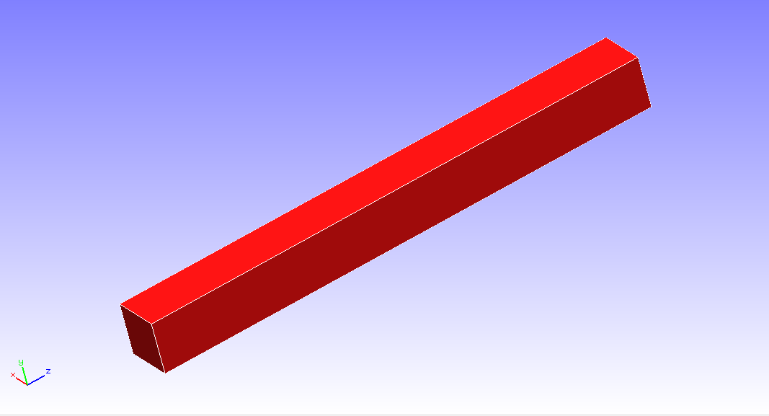The analysis model is shown in Fig. 4.17.1 and the discretized mesh is shown in Fig.4.17.2. The model is mesh with Element Type 341 (Number of Elements: 126, Number of Nodes: 55).

Constraints

Load

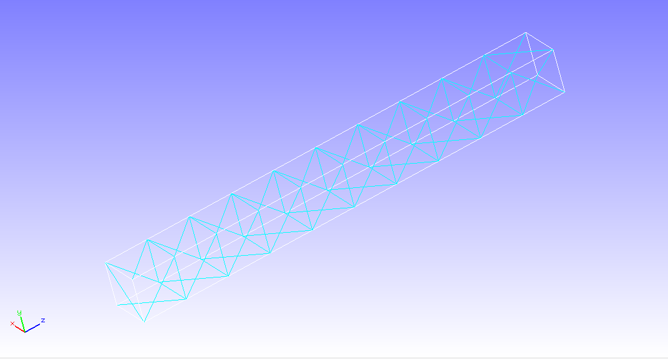

　　　Fig. 4.17.1　The analysis model　　　　 　　Fig. 4.17.2　The mesh

### Analysis Content

　One of the cantilever beam end was fixed and the other is applied load as nodal force on two nodes. The eigenvalues up to 10th mode are computed and the resulting eigenvalues and eigenvectors up to 5th mode are used for frequency response analysis。The analysis control data shown below.

# Control File for FISTR

!VERSION

3

!WRITE,RESULT

!WRITE,VISUAL

!SOLUTION, TYPE=DYNAMIC

!DYNAMIC

11 , 2

14000, 16000, 20, 15000.0

0.0, 6.6e-5

1, 1, 0.0, 7.2E-7

10, 2, 1

1, 1, 1, 1, 1, 1

!EIGENREAD

eigen_0.log

1, 5

!BOUNDARY

_PickedSet4, 1, 3, 0.0

!FLOAD, LOAD CASE=2

_PickedSet5, 2, 1.

!FLOAD, LOAD CASE=2

_PickedSet6, 2, 1.

!SOLVER,METHOD=CG,PRECOND=1,ITERLOG=NO,TIMELOG=YES

10000, 2

1.0e-8, 1.0, 0.0

### Analysis Results

　The frequency dependency of amplitude of displacement at a monitoring node（Node ID 1）specified in the analysis control data is shown in Fig. 4.17.3. A portion of a log file is shown below to show the numerical data obtained by the frequency response analysis.

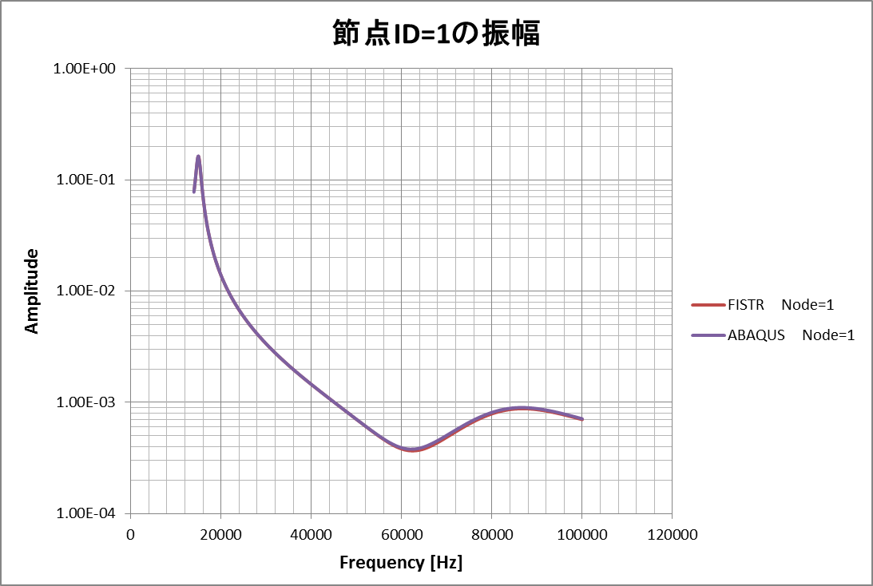

Amplitude if displacement at a monitoring node

Fig.4.17.3　Frequency dependency of amplitude of displacement at a monitoring node

Rayleigh alpha: 0.000000000000000E+000

Rayleigh beta: 7.200000000000000E-007

read from=eigen_0.log

start mode= 1

end mode= 5

start frequency: 14000.0000000000

end frequency: 16000.0000000000

number of the sampling points 20

monitor nodeid= 1

14100.0000000000 [Hz] : 8.395286141741409E-002

14100.0000000000 [Hz] : 1 .res

14200.0000000000 [Hz] : 9.123156781733653E-002

14200.0000000000 [Hz] : 2 .res

14300.0000000000 [Hz] : 9.960390920903195E-002

14300.0000000000 [Hz] : 3 .res

14400.0000000000 [Hz] : 0.109177752620282

14400.0000000000 [Hz] : 4 .res

14500.0000000000 [Hz] : 0.119954048088759

14500.0000000000 [Hz] : 5 .res

14600.0000000000 [Hz] : 0.131684042912029

14600.0000000000 [Hz] : 6 .res

14700.0000000000 [Hz] : 0.143642576374702

14700.0000000000 [Hz] : 7 .res

14800.0000000000 [Hz] : 0.154391186635728

14800.0000000000 [Hz] : 8 .res

End