NatWest Code Test

We appreciate you taking the time to complete this test, hopefully you'll find it interesting too. You can choose the coding language of your choice to provide the solution between JavaScript, Python and Java.

Problem Statement

A video player plays a game in which the character competes in a hurdle race. Hurdles are of varying heights, and the characters have a maximum height they can jump. There is a magic potion they can take that will increase their maximum jump height by ***1*** unit for each dose. How many doses of the potion must the character take to be able to jump all of the hurdles. If the character can already clear all of the hurdles, return ***0***.

**Example**  
height = [1, 2, 3, 3, 2]

k = 1

The character can jump ***1*** unit high initially and must take ***3-1 = 2*** doses of potion to be able to jump all of the hurdles.

**Function Description**

Complete the hurdleRace function in the editor below.

hurdleRace has the following parameter(s):

* int k: the height the character can jump naturally
* int height[n]: the heights of each hurdle

**Returns**

* int: the minimum number of doses required, always  or more

**Input Format**

The first line contains two space-separated integers ***n*** and ***k*** , the number of hurdles and the maximum height the character can jump naturally.  
The second line contains  space-separated integers ***height[i]***  where ***0 <= i < n***.

**Sample Input 0**

5 4

1 6 3 5 2

**Sample Output 0**

2

**Explanation 0**

Dan's character can jump a maximum of **k = 4** units, but the tallest hurdle has a height of h1 = 6:

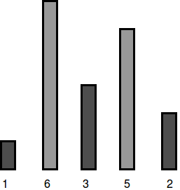

To be able to jump all the hurdles, Dan must drink  doses.

**Sample Input 1**

5 7

2 5 4 5 2

**Sample Output 1**

0

**Explanation 1**

Dan's character can jump a maximum of  units, which is enough to cross all the hurdles:

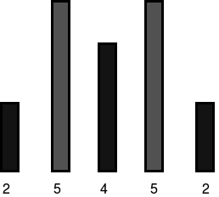

Because he can already jump all the hurdles, Dan needs to drink  doses.

|  |
| --- |
| Deliverables  • Project containing source code for your solution.  • Any instructions to run the solution.  • A short description of what you have implemented.  Please check-in your code to a GitHub repository, add a detailed readme file and provide details and access. |