# ODD Protocol

The model description follows the ODD protocol for describing agent-based models by Grimm et al. (2006) and updated (Grimm et al. 2020). The model was implemented in Python version 3.10 and all model outputs were analysed in R version 4.1.0 with the user interface R-Studio version 1.4.1717.

1. Purpose and patterns

The purpose of this simulation model is to reproduce realistic movement of interacting animals. The movement data simulated with this model is then used to assess how well the statistical methods can infer such animal interactions.

1. Entities, state variables and scales

The model contains two types of mobile agents. The first agents are defined as individuals of prey species which can flee from the predator agents. The second agent represent individuals of a solitary predator species chasing the prey. State variables can be seen in Table 1.

|  |  |  |  |
| --- | --- | --- | --- |
| **Agent** | **Variables** | **Details** | **Unit** |
| Predator & Prey species | Location | Current X,Y Coordinates of agents in gridded landscape | [X,Y] |
|  | Facing direction | Direction of the next movement step | rad |
|  | Step length | Distance of the next movement step | cells |
|  | Step | Movement step performed each time step defined by step length and facing direction | [X,Y] |
|  | Perceptual range | Circular range around current position of agent with a defined radius | cells |
|  | Perceived agents | List of all other agents within perceptual range |  |
| Predator species | Chasing behaviour | Time during which the predator is performing a chasing behaviour | steps |

**Table 1**: State variables of the two different mobile agents within the gridded landscape

The prey agents were designed to mimic animals expressing anti-predator behaviours in response to perceiving predator species (Lima and Dill 1990). In this simulation model, the individuals of the prey species express a fleeing behaviour and run away from individuals of the predator species. The prey agents are characterized by their coordinates, facing direction, step length, movement velocity (Euclidean 2D vector) and perceptual range. The predator agent imitates the behaviour of a predator species chasing prey species and runs towards them. The predator agents are characterized by their coordinates, facing direction, step length, movement velocity (Euclidean 2D vector), perceptual range and chasing time.

The environment has closed borders and consists of 1000 x 1000 cells, each having a length and width of 2 m. Thus, the whole environment covers an area of 16 km2. Every cell has the same characteristics, i.e. we represent a homogenous landscape.

1. Process overview and scheduling

The process overview is depicted in Figure 1. Each time step both agent types move a certain distance defined by a specific step length and facing direction. In this model the movement is modelled according to two different behavioural states determining the persistency of the movement. During one state the movement direction is independent of the previous one resulting in a random walk, also called Brownian walk (Pearson 1905). During the second state the movement is described by a correlated random walk (Patlak 1953), meaning that the movement direction has a strong tendency to point in the same direction as the previous one resulting in the agents moving in rather straight lines (persistence). The facing direction during the correlated random walk at each time step is selected from Von Mises distribution. Adding such directional persistence within random walk models reproduces realistic animal movement (Kareiva and Shigesada 1983). The switch between two states is based on a Markov chain process (Howard 1972). If the agents reach the border of the landscape, they set their facing direction away from the landscape border. The step length during each time step is selected from an exponentiated Weibull distribution.

A fleeing behaviour of the prey agent commences as soon as a predator agent enters the perceptual range of the prey. The prey agent flees from the predator agent by facing the opposite direction of the predator agent´s current location and moving with a maximum step length. This fleeing behaviour stops as soon as the predator is not anymore within the perceptual range of the prey. Similarly, the predator agent steers towards the nearest prey agent and moves with the step length set to the maximum value once the prey enters the predator´s perceptual range. The chasing behaviour is limited and only expressed by the predator during a defined time period, the duration of which is drawn from the uniform distribution. Reaching the prey or not does not have any effect on this period spend in chasing behaviour. After each chasing event, the predator does not express a chasing behaviour anymore again for a certain period of time (a so-called “resting behaviour”, the duration of which is drawn from the uniform distribution), even if the prey enters its perceptual range.

1. Design Concepts

*Basic principles*. Movement patterns are strongly shaped by individual decisions which, in return, are influenced by their environment with its dynamic risks and rewards but also complex internal state (Nathan et al. 2008). The current version of the model rests on the basic assumption, that the presence of other con- or heterospecific agents around the individual´s location influences its decision about the next movement (Cote and Clobert 2007; Clobert et al. 2009).

*Emergence*. Since the purpose of the model is to simulate movement data, on which statistical methods will be applied, the output of this model are movement trajectories that result from decisions of moving interacting individuals.

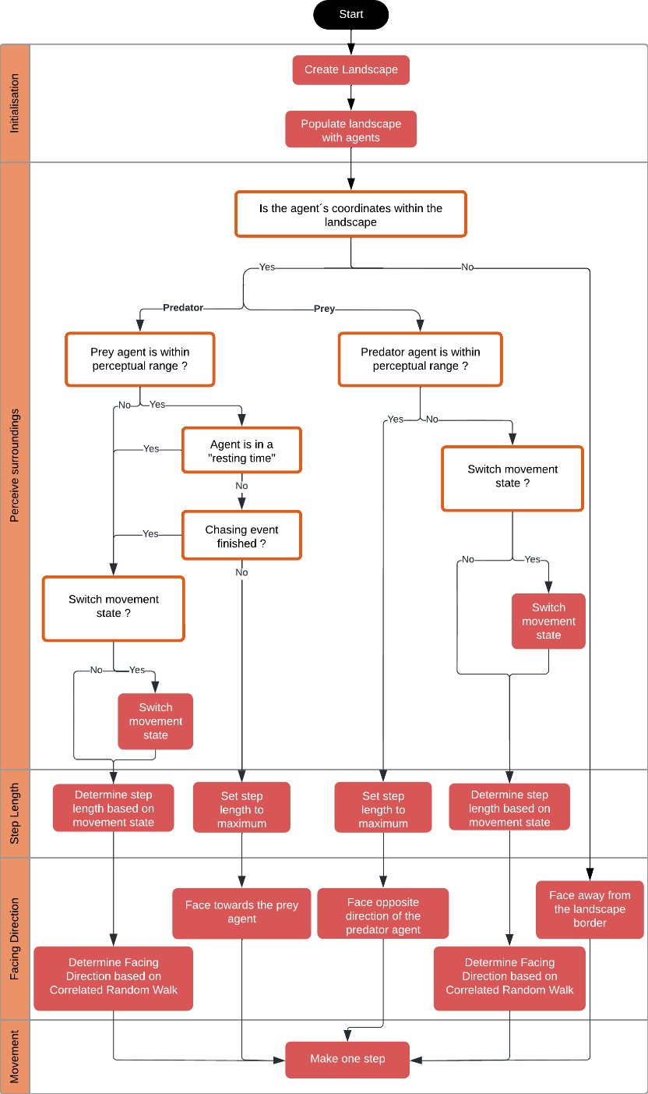

**Figure 1**: Flow chart showing the initialisation and the processes that take place every time step. Boxes filled with red are actions and orange encircled boxes are conditions.

**Table 2**: Parameter table of the Correlated Random Walk performed by the prey and predator agent in this model

|  |  |  |  |  |
| --- | --- | --- | --- | --- |
| **Description** | **Distribution** | **States** | **Parameters** | **Value** |
| **Correlated Random Walk** |  |  |  |  |
| Persistency time period | Uniform distribution | Persistent time period | time steps (t) | 100 - 200 |
| Uniform distribution | Non-persistent time period | time steps (t) | 300 - 400 |
| Facing Direction | Von Mises | Non-persistent | exponentiation parameter (α) | 0.7 |
| shape (ϰ) | 1.7 |
| scale (λ) | 1.5 |
| Persistent | exponentiation parameter (α) | 0.5 |
| shape (ϰ) | 6.7 |
| scale (λ) | 3 |
| Step Length | Exponentiated Weibull Distribution | Non-persistent | location (μ) | 0 |
| measure of concentration (ϰ) | 2 |
| Persistent | location (μ) | 0 |
| measure of concentration (ϰ) | 50 |
| **Turning angle at Border** | Circular uniform distribution | / | angle (°) | 0° - 180 ° |
| **Chasing time period** | Uniform distribution | Chasing time period | time steps (t) | 200 - 300 |
| Uniform distribution | Resting time period | time steps (t) | 500 - 700 |

*Adaption, Objectives, Learning, and Prediction*. None of these design concepts have been used.

*Sensing*. Both prey and predator agents sense other agents within their circular perceptual range. The agent will adjust their movement based on the type of the nearby agents.

*Interaction*. Prey agents flee from the predator agent that come within their perceptual range. The predator agent, on contrary, chases prey agents if they are within its perceptual range.

*Stochasticity*. Randomness is introduced by the initial random location of the prey and predator agents, as well as during their correlated random walk. Indeed, for the correlated random walk at each time step both the facing direction and the step length are randomly drawn from the predefined distributions. The chasing behaviour as well as the “resting time” of the predator is randomly drawn from a uniform distribution.

*Collectives*. No social traits have been introduced to the agents.

*Observation*. To imitate what can be observed in an empirical study relying on telemetry methods for collecting the movement data, we use “virtual ecologist approach” (Zurell et al. 2010), i.e. we sample the coordinates of each individual species and individual IDs at each time step

1. Initialization

Position of prey and predator agents are chosen randomly within the landscape. Time is modelled as discrete steps, with one step being equivalent to one second. Both prey and predator agents are also given an initial movement velocity, characterized by a random step length, following an exponentiated Weibull distribution, and a random facing direction extracted from an uniform distribution between 0° and 359°.

At the beginning of each model run we set up the homogeneous landscape consisting of 2000 x 2000 cells. Either one, two, three, five or 10 preys (depends on the scenario used, see Methods) and 1 predator agent are initialised. The initial coordinates of the prey and predator agents are chosen randomly on the landscape. For the first move of both prey and predator agents we draw a step length randomly from the exponential Weibull distribution and facing direction from Von Mises distribution, respectively (Table 2). The perceptual range of the prey is determined by the simulated scenario (see 0.i) and is either 0 or 150 cells and the predator agent´s perceptual range is set to a value of 0, 150, 300, 600 or 1500 cells.

1. Input data

The model does not use any input data.

1. Sub models

## Movement

Both prey and predator agents perform an exploring movement characterized by a correlated random walk defined by their facing direction and step length. The turning angle of the facing direction follows the Von Mises distribution (Codling et al. 2010). The step length is randomly drawn from the exponentiated Weibull distribution (Table 2). The parameters for these two distributions depend on the current movement state of the individual (Table 2). The closer the measure of concentration of the Von Mises distribution (ϰ) to zero, the more uniform is the Von Mises distribution, resulting in a completely random movement referred to as a Brownian motion. The larger ϰ gets, the more the Von Mises distribution approaches a normal distribution concentrated around the mean (0°), which results in a tendency to move straight forward (Mardia and Jupp 2010). The step length lies between 0 and 4. In the case agents of either prey or predator come in contact with the edge of the landscape, it will rotate its facing direction away from the landscape border. The angle is drawn from an uniform distribution between 0° and 180° facing towards the direction of the landscape.

## Interactions with other agents

A fleeing behaviour of the prey agent commences as soon as a predator agent enters their perceptual range. The prey agent flees from the predator agent by facing towards the opposite direction of the predator´s current location at maximum step length of 4 cells per time step. On contrary, the predator agent goes into a chasing behaviour once a prey enters its perceptual range, in which case they move straight towards the nearest prey agent. While chasing, the step length of predators is set to its maximum value of 4 cells. This chasing behaviour is only expressed for a specific time period, the duration of which is randomly drawn from a uniform distribution (minimum 100 steps and maximum 300 steps). After each period of a chasing behaviour the predator agent performs “resting behaviour” during which the agent moves independently of the prey agents. The duration for the resting behaviour is drawn from the uniform distribution (minimum 400-time steps and maximum 700-time steps). In the case where simulations are run with agents having a perceptual range of 0, they do not interact with other agents and only perform a correlated random walk.