Two Algorithms: A Chemotaxis Model and a Statistical Mechanics Approach to Machine Learning for Stochastic Optimization
Michael Frood^{1, b)} and Apichart Linhananta^{1, a)}
¹Department of Physics, Lakehead University, Thunder Bay, Ontario, Canada, P7B 5E1
^{a)} Corresponding author: alinhana@lakeheadu.ca
^{b)} dmfrood@lakeheadu.ca
Abstract.
Incorporating chemotaxis into the Keller-Segel equation is a major undertaking. We present a stochastic model where the run-and-tumble motion of Escherichia coli (E. Coli) is modeled using a Poisson Process tumble distribution function. The drift velocity of motion is also a stochastic function that is proportional to the tumble rate function parameters. The parameters of the distribution function were solved by a machine learning algorithm which optimizes functions with a stochastic output. Inspired by the biological and statistical mechanics of population gene pools in demes, for this paper the algorithm is shortened to D-DEME, (Dynamic Data Evolving Mean Estimator). The technique avoids microstate-level tracking by aggregating large batches of continuously generated data points utilizing the Central Limit Theorem in order to record the macroscopic parameters, then discard the points before moving to the next iteration. D-DEME focuses on the overall trend of the aggregated data to reduce sensitivity to noise and optimize parameters for non-explicit, stochastic, non-differentiable functions. This ensemble-based method is also useful for non-monotonic expectation functions, and bypasses the need for direct gradient calculations of each data point where standard chain-rule practices fail. It allows for gradient descent convergence under heteroskedastic noise without the need for explicit step sizes. The algorithm utilizes ensemble level statistics to calculate a Polyak–Ruppert slope estimation to stabilize the effective learning rate, and a measured noise confidence interval as a signal of when to being an adaptive phase transition to a Robbins–Monro style decay, allowing the system to self-regulate purely through observed statistics. This paper therefore provides two novel models that integrate existing mathematical frameworks: (1) D-DEME, an algorithm to complement ML models to aid with stochastic optimization, and (2) a run-and-tumble simulation which is able to accurately recreate experimental drift velocities of bacteria, adding to pre-existing run-and-tumble algorithms which have previously been shown to break down at high drift velocities. Using D-DEME and the run-and-tumble model, we recover a receptor occupancy filter equation and calculate its values to recreate tumble rates to match theoretical drift velocities.

Introduction
The mechanics of how bacteria propel themselves in response to environmental signals has been studied for decades [1]. The bacteria, Escherichia coli (E. Coli), respond to various environmental gradients by alternating their motility to locate favorable niches and avoid dangerous locations, a process called chemotaxis [2, 3, 4, 5]. Understanding the effect of chemotaxis on the evolution of antibiotic resistance in bacteria is an important field of research. There is a need to develop an accurate algorithm to simulate chemotaxis, which can then be incorporated in bacterial growth models. There are complex simulations with algorithms that accurately reproduce the chemotactic motion of E. Coli [2, 6]. But these algorithms are not easily incorporated into complicated models of cell growth in heterogeneous environments. The focus of this paper is to solve the chemotaxis problem and to develop a new type of machine learning (ML) algorithm to determine the parameters of a for a chemotactic tumble probability function that represents E. Coli swimming in a chemical gradient. The probability function is based on the function by Brown and Berg from their work modelling temporal simulation of E. Coli’s chemotaxis [7]. The parameters are optimized by a novel ML algorithm to accurately recreate the theoretical drift velocity, $v_{d}$, of the bacteria as observed in experiments.
It is well established that E. Coli utilize their flagella to propel themselves using a run-and-tumble mechanism [2, 8, 9]. During the run-and-tumble motion, an E. Coli propels itself by the counterclockwise (CCW) rotation of its flagellar motor. In a uniform chemical environment, it moves at constant speed in a straight line for $\sim 10s$, until its flagellar motor switched to a clockwise (CW) rotation, causing the E. Coli to tumble for $\sim 0.1s$, and reorient itself by rotational diffusion. After which the flagellar motor switches back to a CCW rotation, and it moves off in a new direction [2, 8, 9]. In effect, the E. Coli is a perfect random walker. It is well established that the E. Coli’s flagellar motor is controlled by multi-protein receptor complexes that sense changes in the concentration of ligands associated with nutrients [8]. The receptors are either inactive (methylated) or active (demethylated), with the overall methylation level, $m$, of an E. Coli determined by a complex sensory system. The standard chemotaxis theory includes feedback control equations relating the overall receptor activity, $a\left(m,c_{F}\right)$, the receptor free energy, $F\left(m,c_{F}\right)$, and the methylation dynamic equation, $\frac{dm}{dt}=k_{R}\left(1-a\left(t\right)\right)-k_{B}{a\left(t\right)}^{3}$, with $k_{R}$ and $k_{B}$ being methylation constants [1]. The methylation level, $m\left(t\right)$, and the nutrient concentration, $c_{F}\left(t\right)$, are both functions of time.
When an E. Coli swims downstream (away from a nutrient), $∇c_{F}<0$, the methylation level, $m$, decreases along with the overall activation, $A$, which increases the tumbling rate, $k_{ccw→cw}>{0.1s}^{-1}$. When it swims upstream, $∇c_{F}>0$, the tumbling rate remains at about $k_{ccw→cw}\sim 0.1s^{-1}$ [1]. Consequently, E. Coli immersed in a nutrient gradient are observed to be randomly biased to move upstream towards regions with higher food concentration, as observed in the experiments of Austin et al. [10, 11]. Chemotaxis has been extensively studied by Brown and Berg [7]. They observed an increase in the tumbling rate of E. Coli ($>0.1s^{-1}$) moving downstream from a food gradient, while the tumbling rate remains relatively constant ($\sim 1s^{-1}$) for E. Coli moving upstream. However, other works found that, bacteria swimming up the gradient find that the duration of reorientation is reduced so as a consequence bacteria tumble less frequently if they are swimming up the gradient and more frequently if they swim away [1, 3, 7, 12, 13, 14]. This is the opposite case for repellants, with bacteria increasing the frequency of tumbling swimming up the gradient, and decreasing swimming down [14]. This results in an upstream drift velocity, $v_{d}$, directed up along a food gradient, and down from a repellent gradient. The drift velocity can be calculated given a ratio between the time spent running up the gradient minus the time spent running down the gradient divided by the total time spent running and tumbling [1, 2, 13]. In the presence of a nutrient gradient, $∇c$, the drift velocity has a magnitude of $v_{d}=K\left(〈a\left(t\right)〉\right)\frac{∂F}{∂c}∇c$, where the coefficient $K\left(〈a\left(t\right)〉\right)$ is a function of the mean overall receptor activity, $〈a\left(t\right)〉$.
The tumble probability function based on the work by Brown and Berg is expressed as $η_{±}=$
$exp \left(-r_{o}∓α\left(\frac{dP_{b}(t)}{dt}\right)\right)$, where $η_{+}$ describes the decrease in tumble rate as the bacteria moves up the gradient and $η_{-}$ describes the increase moving down. The function can be a basis for an efficient simulation algorithm that accurately mimics the motility of E. Coli, including its use in a Gillespie simulation [15]. While the theoretical drift velocity is accurately modeled for observations in shallow gradients through various chemotaxis simulations, in steep gradients previous models show a failure to capture the velocity due to limitations of responses including finite methylation sites reaching a threshold, and linear responses of methylation and demethylation [2, 6]. Simulations of chemotaxis produce a drift speed lower than theory due to oversaturation of the E. Coli sensory system at high gradients, leading to an unphysical state of non-stop running [2]. This paper uses the tumble probability functions in a new run-and-tumble algorithm that generalizes these responses into the function $\frac{dP_{b}(t)}{dt}$ modeled after the works of Sourjik et al. and Tu et al [2, 6]. This function describes the activity of receptors due to protein bound to replicate chemotaxis in gradients, where the drift velocity is predicted to reach a value as high as 8 μm/s in magnitude. The parameter α represents a filter for $\frac{dP_{b}(t)}{dt}$ to control the frequency signals of responses in gradients and to represent non-linear effects to help the model replicate the theoretical drift velocity even in steep gradients.
The proposed chemotactic algorithm requires the determination of the parameters $r_{0}$ and $α$ in the distribution function $η_{±}$. The paper accomplishes this optimization problem by using a novel machine learning (ML) algorithm. The algorithm is called D-DEME because of the overlap between the model’s optimization of continuously dynamic data and its analogy to the statistical mechanics to evolutionary concept of demes [16]. The ML model optimizes parameters from stochastic function outputs to theoretical optimal means by utilizing the Central Limit Theorem (CLT). The use of ML in science, engineering and physics is widespread [17, 18]. Recently, Karniadakis et al. developed a physics-informed neural network (PINN) method for solving forward and inverse non-linear partial differential equations [19]. The task at hand is not to solve a PDE, but to develop a ML method to determine the parameters of $η_{±}$ that produce accurate chemotactic motions without knowing the system, and results in a drift velocity, $v_{d}$, predicted by the theory of Tu et al. and Sourjick el al. [2, 6]. No differential equation and assumed solution are calculated. This is a self-consistent ML method where the input data is stochastically produced by using the initial distribution functions $η_{±}$ to output a mean drift velocity $v_{d}$ that is comparable to the theoretical drift velocity recorded in experiment. The chemotaxis tumble rates can then be used to quantify the E. Coli motility through the use of chemotaxis diffusion coefficients in a Gillespie algorithm for populations of bacteria, with $D_{+}$ and $D_{-}$, being the diffusion coefficient for motion upstream ($+$) and downstream ($-$), respectively.

Theory and Method

Part I: FKPP Diffusion Reaction Equation
Bacteria respond to various environmental gradients by alternating their motility to locate favorable niches and avoid dangerous locations called chemotaxis, while the drift velocity is the bacteria’s velocity component in the direction up or down the gradient [2, 4, 8]. Most of the knowledge of bacteria chemotaxis comes from the study of E. coli, which swims using multiple flagella. E. coli use their multiple flagella in a run and tumble like motion to propel the cell forward and then reorient the direction of the cell for the next run. An algorithm to describe this motion is discussed in Part II. Part I will model how the external attractant chemicals (ligands) are detected by membrane-bound chemoreceptors on a flagellar motor. The receptors use enzymes to add/remove methyl groups (methylation and demethylation), a process which depend on the receptor kinase activity [2, 4, 20]. This process of the flagellar motor will change its rotation from counterclockwise (CCW) to clockwise (CW), which in turn causes the motion of the E. coli cell to change from run to tumble [2, 4, 5, 6, 20].
Analytical calculations of average drift velocity are limited to shallow gradients due to the sensitivity of receptors [2, 4]. In steeper gradients, including exponential gradients, the large change in concentration results in large changes to the methylation level and a gradual saturation of receptor methylation sites at high levels of stimulation. This invalidates memoryless adaptation because the bacterium can no longer adapt to higher ligand concentrations due to receptor inhibition, which therefore causes the bacteria’s chemotactic motion to slow [2, 4, 6]. Chemotaxis at steep gradients is modeled by the receptor free energy that includes methylation and ligand binding [1, 2, 21]:
 | $$F\left(m,c_{F}\right)=-m\left(t\right)+\sum_{j∈\left\{a,s\right\}}{ν_{j}\frac{1+{c_{F}}/{K_{j}^{off}}}{1+{c_{F}}/{K_{j}^{on}}}}=-m\left(t\right)+f_{o}\left(c_{F}\right)$$ | (1)
with $c_{F}$ being the concentration of the attractant, $ν_{i}$, as the fraction of receptor type j for the most abundant receptor types Tar and Tsr (represented by “a” and “s” in the summation operator). The range of adaptation for the Tar receptor can vary with different strains but it can be approximated to be around $K_{a}^{off}<c_{F}<K_{a}^{on}$ with $K_{a}^{off}=20 µM$ and $K_{a}^{on}=500 µM$ [4, 22]. The receptor fractions are $ν_{a}=1/3$ and $ν_{s}=2/3$. Above this range the Tsr receptor continues to respond in the range of $K_{s}^{off}<c_{F}<K_{s}^{on}$, with $K_{s}^{off}=10000 µM$ and $K_{s}^{on}$ being less specific but still $K_{s}^{on}≫K_{s}^{off}$ [2, 22, 23]. The ligand binding free energy equation leads to two saturation peaks independent of methylation [2]. For this equation, the methylation free energy of the receptor is approximated to be around, $m\left(t\right)=1.7$ [4, 6, 20].
To derive a relation for the drift velocity, $v_{d}$, we follow the method of Tu et al. which considers the 1D Keller Segal (KS) chemotaxis equation of $N\left(x,t\right)$ E. Coli cells [4, 6]:
 | $$\frac{∂N}{∂t}=-\frac{∂}{∂x}\left(-D\frac{∂N}{∂x}+Nχ_{o}\frac{∂f_{o}}{∂x}\right)$$ | (2)
where $f_{o}\left(c_{F}\right)$ is the methylation-independent ligand binding contribution to free energy that is derived with respect to the food concentration and is a dimensionless sensitivity function. The food concentration is exponential, $c_{F}\left(x\right)=\frac{c_{F0}}{e^{Gx_{l}}}e^{Gx}$, where $x_{l}$ is the maximal domain position $x$ increases to, while the exponent in the denominator ensures that the function increases to a maximum concentration of $c_{F0}$ = 60000 µM. The constant relative gradient is $G=\frac{1}{c_{F}}\frac{dc_{F}}{dx}$ with units in $\left[{µm}^{-1}\right]$. The gradient of the ligand receptor binding site on the RHS of Eq. (2) can then be described as [2, 6, 24]:
 | $$\frac{∂f_{o}}{∂x}=\frac{df_{o}}{dc_{F}}∙\frac{dc_{F}}{dx}=c_{F}∙\left(\frac{1}{c_{F}}\frac{dc_{F}}{dx}\right)\left[\sum_{j∈\{a,s\}}{ν_{j}\frac{\left(K_{j}^{on}-K_{j}^{off}\right)}{\left(c_{F}+K_{j}^{off}\right)\left(c_{F}+K_{j}^{on}\right)}}\right]=c_{F}G\left[\sum_{j∈\{a,s\}}{ν_{j}\frac{\left(K_{j}^{on}-K_{j}^{off}\right)}{\left(c_{F}+K_{j}^{off}\right)\left(c_{F}+K_{j}^{on}\right)}}\right]$$ | (3)
the receptor sensitivity multiplied by the local relative gradient $\frac{∂f_{o}}{∂c_{F}}\frac{dc_{F}}{dx}$ exhibits two peaks. This due to the sensitivity of the high and low affinity of the most abundant receptor types Tar and Tsr, and how they control the net binding rate through differences in ligand concentrations, $\left(K_{j}^{on}-K_{j}^{off}\right)$, in exponential gradients [2]. Comparison of Eqs. (2) and (3) show that the drift velocity is given by:
$$v_{d}\left(c_{F}\right)=χ_{o}\frac{∂f_{o}}{∂x}=c_{F}Gχ_{o}\left[\sum_{j∈\{a,s\}}{ν_{j}\frac{\left(K_{j}^{on}-K_{j}^{off}\right)}{\left(c_{F}+K_{j}^{off}\right)\left(c_{F}+K_{j}^{on}\right)}}\right]=c_{F}Gχ_{o}\sum_{j∈\{a,s\}}{S_{j}(c_{F})}$$ | (4)
where $χ_{o}$ is the chemotaxis mobility coefficient in units of $\left[\frac{{µm}^{2}}{s}\right]$. Unlike previous models referenced [2, 6], the chemotaxis mobility coefficient in this model is constant and does not depend on the receptor activity or methylation. The system is separated by bacterial microhabitats which are called demes. Demes are subpopulations of organisms which exchange genetic information within a common gene pool to evolve to local environmental conditions [25]. A plot of the theoretical drift velocity in equation 4 vs. the concentration of attractant is displayed in Figure 1.
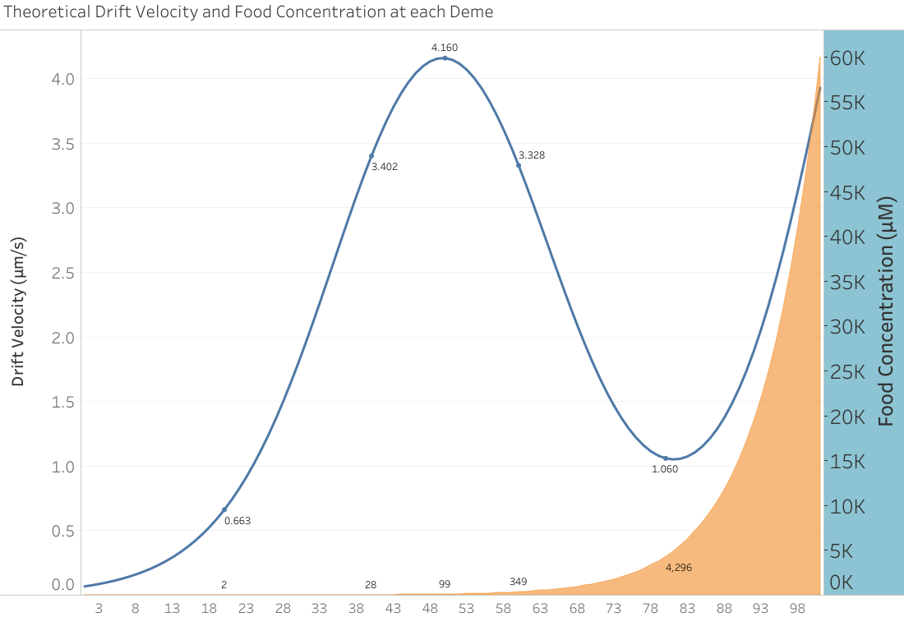
Figure 1 – Dual-axis plot shows the theoretical drift velocity, $v_{d}$, (blue line) caused by the LB concentration (orange area). Motility coefficient, $χ_{o}=7500\frac{{µm}^{2}}{s}$, maximum food concentration, $c_{F0}$ = 60000 µM, max drift velocity along x-axis, $v_{d}^{Max}=4.16$ µm/s. The x-axis values represent the microhabitats called demes ($i$).
The change in the ligand binding sensitivity function with respect to position from Eq. (3) can be described as the time rate of change of the fractional amount of receptor (protein) bound [7]:
$$\frac{dP_{b}}{dt}=\frac{df_{o}}{dc_{F}}∙\frac{dc_{F}}{dt}=\frac{c_{F}}{c_{F}}∙\frac{df_{o}}{dc_{F}}∙\frac{dc_{F}}{dx}∙\frac{dx}{dt}=χ_{o}{\left(c_{F}G\frac{df_{o}}{dc_{F}}\right)}^{2}$$ | (5)
which helps to guide the bacteria to determine if a tumble is to occur.
The purpose of this work is to construct an efficient and accurate algorithm for the chemotaxis motion of E. Coli, similar to the metropolis algorithm for the Ising Model [26, 27]. The chemotactic motions are biased Poisson processes that can be represented by the rate of tumbling located at each deme position $i$ [7]:
$$η_{±}^{i}=Aexp\left(-r_{o}∓α^{i}\left(\frac{dP_{b}^{i}(t)}{dt}\right)\right)$$ | (6)
with the rate of tumbling going up a gradient given by $η_{+}$, and going down $η_{-}$. The value $A$ is the normalization coefficient. The rate of tumbling is a product of the timed rate of change of receptor protein bound and the constant, $α$. The factor, $α\left(\frac{dP_{b}}{dt}\right)$, helps determine the decrease or increase in the rate of tumbling when moving up or down the deme’s, $\left(i\right)$, local food gradient. The difference in tumbling is the factor that contributes to the drift velocity. The run-and-tumble simulation, which will be discussed in Part II, and the tumble rate from Eq. (6) are based on the classical model by Brown and Berg. However, the tumble rates from within their model lacks normalization and is not physically realizable [7]. In their model, the constant for Eq. (6) was set to $A=1s^{-1}$ and had not been normalized. The tumble rates and drift velocity have an exact analytic solution which can be solved separate from the model by Brown and Berg (see appendix).

Part II: Run-and-Tumble Algorithm
To compute the tumble rate of bacteria, an algorithm similar to the one by Brown and Berg is used as seen in Figure 2 [7]. Bacteria starting from rest swim for a time $(∆t=0.1s)$ in a direction chosen at random. The run speed of the bacteria is around $V_{o}=12.52\frac{µm}{s}$ [1, 2, 5, 6]. The values of $r_{o}$ and $α\left(\frac{dP_{b}}{dt}\right)$ are selected. The probability that the bacteria will tumble during the time interval is determined from $η^{i}∆t$. A random number between 0 and 1 is drawn. If the number is less than the probability, the bacteria tumbles. During a tumble the bacteria stops while drawing from a probability distribution, ($T\left(θ\right)$), to select a new angle to run along. If the random number generated is greater than the probability of tumbling, the bacterium continues to run along the direction it is oriented towards. This process is repeated until the bacteria crosses a marker, then its drift velocity is recorded. The simulation takes the dot product between the run vector and the unit displacement along the axis of motion.

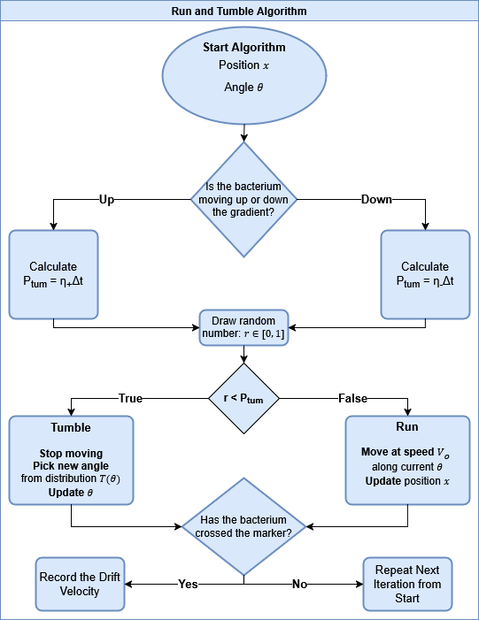
Figure 2 – The run-and-tumble algorithm by Brown and Berg [7].
The tumbling angle is calculated using a probability density function with a distribution given by:
$$T\left(θ\right)=0.5\left(1+cos θ \right)sin θ , 0<θ<π$$ | (7)
with a mean of around $θ=67.5°$. This distribution is close to the experimental measurements obtained from Berg and Brown [13, 24, 28]. In the absence of a food gradient or chemotaxis mechanism, $\frac{dP_{b}}{dt}=0$, then there is no tumble bias, and $η_{±}=exp \left(-r_{o}\right)$. A realistic diffusion constant for E. coli is $D=112 \frac{{µm}^{2}}{s}$ [9, 13, 28]. The diffusion section of the Keller Segal equation is $\frac{dN}{dt}=D\frac{d^{2}N}{{dx}^{2}}$. Using the Fourier Transform, the solution to the differential equation for population $N$ is a Gaussian distribution [29]:
$$N\left(x,t\right)=\int_{-∞}^{∞}{\hat{N}\left(k,0\right)e^{-Dk^{2}t}e^{ikx}dk=\frac{1}{\sqrt{2πσ^{2}}}e^{- \frac{{(x-x_{o})}^{2}}{2σ^{2}}}}$$ | (8)
where the population distribution $N\left(x,t\right)$ has a variance $σ^{2}=2Dt$. A Shapiro-Wilk test for normal distribution with the Bhattacharyya distance for overlap the distribution calculated the constant closest to the theoretical in Eq. (6) to be $r_{o}=1.16$.

Part III: Machine Learning D-DEME Algorithm

The technique continuously draws individual data points, $j$, randomly generated through a function, $v$, dependent on an independent variable, $α$, (i.e. $v_{j}\left(α\right)$). The function utilized to generate data points was the run-and-tumble chemotaxis loop by Brown and Berg in Part II to record drift velocity as a function of α [10]. Because the drift velocity is dependent on the probability distribution of the tumble rate from Eq. (6), it is then a function of the food concentration gradient at deme $i$ as outlined in part I: $v\left(α^{i}\right)∝η\left(α^{i}\left(\frac{dP_{b}^{i}(t)}{dt}\right)\right)$ where $\frac{dP_{b}^{i}(t)}{dt}∝c_{F}\left(x_{i}\right)=\frac{c_{F0}}{e^{Gx_{l}}}e^{Gx_{i}}$. The target of the machine learning algorithm is to identify a value, ($α^{*}$), in order to for the mean of the drift velocity proportional to the tumble rate to equal the theoretical value of $v_{d}$ as seen in Figure 1, ($v\left(α^{*}\right)=v_{d}$).
For a sample size of $n$ data points, starting with a mean square error (MSE) loss function it is decomposed into mean and variance components [See appendix for derivation]. The function decomposition is generalized by introducing a variance weighting coefficient λ:
$$L\left(α\right)=\frac{1}{n}\sum_{j=1}^{n}{{‖v_{j}\left(α\right)-v_{d}‖}^{2}}+\left(λ-1\right)\frac{n-1}{n}s^{2}\left(α\right)={\left(\overline{v}\left(α\right)-v_{d}\right)}^{2}+λ\frac{n-1}{n}s^{2}\left(α\right)$$ | (9)
where $j$ represents a run, $v_{j}\left(α\right)$ represents a drift velocity data point collected from the full loop of the run and tumble algorithm in Part II for a total of $n$ data points, $v_{d}$ is the theoretical drift velocity, $\overline{v}\left(α\right)=\frac{1}{n}\sum_{j=1}^{n}{v_{j}\left(α\right)}$ is the sample mean, $s^{2}\left(α\right)=\frac{1}{n-1}\sum_{j=1}^{n}{{\left[v_{j}\left(α\right)-\overline{v}\left(α\right)\right]}^{2}}$ is the unbiased variance of the sample [30, 31, 32]. When $λ=1$ Eq. (9) reverts back to a standard mean squared error loss function, and when $0≤λ≤1$, the equation down-weighs variance relative to the mean squared error, with $λ=0$ completely ignoring heteroskedasticity. Instead of calculating the mean of a fixed cluster, like in k-means clustering, this technique calculates a new mean repeatedly by using the data generated per iteration to compare and optimize against a theoretical value [33]. The data is dynamic as a new sample set is continuously generated into a tensor for each iteration, then discarded before the next iteration. Only the aggregate data of the samples ($μ\left(α\right)$,$\frac{dμ\left(α\right)}{dα}, s^{2}\left(α\right), \frac{ds^{2}}{dα}, etc.$) are recorded. With a large enough batch of randomly drawn individual samples from a fixed distribution, $\sum_{j=1}^{n}{v_{j}\left(α\right)}$, the distribution of the mean eventually approaches a Gaussian distribution due to the Central Limit Theorem [30, 31]. The sampling process removes the necessity for the function $v\left(α\right)$ to be explicit, since the function’s population distribution mean is what is approximated, and the expectation of the population distribution is what is optimized [30, 31]. This relationship is shown visually in Figure 3. This algorithm’s goal of expectation-level optimization to a theoretical value to find a unique value of an input parameter which optimizes the ensemble mean of a function, ($\overline{v}\left(α^{*}\right)≅μ\left(α^{*}\right)=v_{d}$), where the unknown population mean is represented by $μ$, while $α^{*}$ is the optimal value for the population mean to equal $v_{d}$. This technique uses batch sampling instead of inputting one parameter at a time.

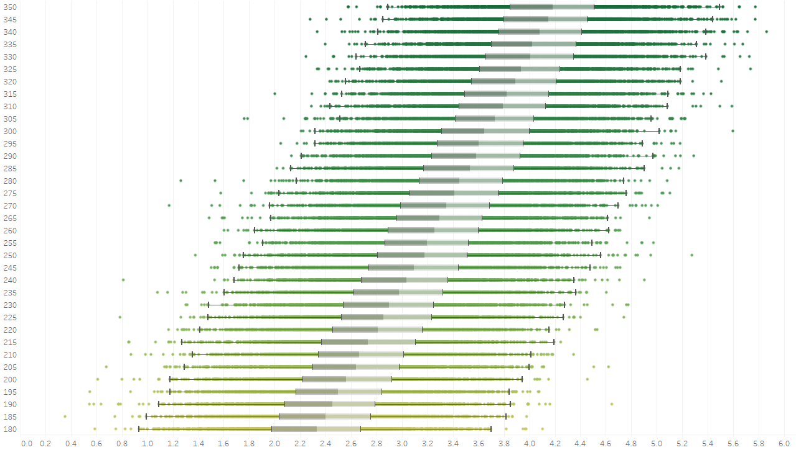
Figure 3 – Boxplots of Gaussian distributions of $v\left(α\right) \left[\frac{μm}{s}\right]$ on the x-axis per $α$ on the y-axis show the CLT sample mean dynamically shifting with respect to alpha: $\overline{v}\left(α\right)=\frac{1}{n}\sum_{j=1}^{n}{v_{j}\left(α\right)}$. The grey bars represent the inner quartile range of the normal distributions. Each layer along the y-axis contains the normal distribution of data points generated then discarded for each training iteration.
The derivative of the loss function with respect to $α$ will have the form:
$$\frac{∂L}{∂α}=\frac{2}{n}\sum_{j=1}^{n}{\left(v_{j}\left(α\right)-v_{d}\right)\frac{dv_{j}\left(α\right)}{dα}}+\left(λ-1\right)\frac{n-1}{n}\frac{ds^{2}}{dα}=2\left(\overline{v}\left(α\right)-v_{d}\right)\frac{d\overline{v}\left(α\right)}{dα}+λ\frac{n-1}{n}\frac{ds^{2}}{dα}$$ | (10)
With the derivative of the sample variance with respect to alpha being:
$$\frac{ds^{2}\left(α\right)}{dα}=\frac{2}{n-1}\sum_{j=1}^{n}{\left[ v_{j}\left(α\right)-\overline{v}\left(α\right) \right]\left(\frac{dv_{j}\left(α\right)}{dα}-\frac{d\overline{v}\left(α\right)}{dα}\right)}$$  $$=2∙{Cov}_{n}\left(v_{j}\left(α\right),\frac{dv_{j}\left(α\right)}{dα}\right)=2∙{Cov}_{n}\left(ϵ_{j}\left(α\right),\frac{dϵ_{j}\left(α\right)}{dα}\right)$$ | (11)
where $\left(ϵ_{j}\left(α\right)=v_{j}\left(α\right)-\overline{v}\left(α\right)\right)$ is the residual for sample$j$, and $\left(\frac{dϵ_{j}}{dα}=\frac{dv_{j}}{dα}-\frac{d\overline{v}}{dα}\right)$ gives the residual rate of change with respect to α, while ${Cov}_{n}(⋅,⋅)$ represents the sample covariance normalized by $1/(n-1)$. The gradient is used to determine the next k^{th} iteration of 𝛼:
$$α_{k+1}=α_{k}-γ_{k}\frac{∂L\left(α_{k}\right)}{∂α_{k}}$$ | (12)
where $γ_{k}$ is the learning rate. The algorithm functions are separated into sections and are as summarized:
Section 1 – Initialize a Starting Value for $α$
The landscape for the expectation function of $α$ is sampled to record multiple values of $\overline{v}\left(α\right)=\frac{1}{n}\sum_{j=1}^{n}{v_{j}\left(α\right)}$. During this time the variance $s^{2}\left(α\right)=\frac{1}{n-1}\sum_{j=1}^{n}{{\left[v_{j}\left(α\right)-\overline{v}\left(α\right)\right]}^{2}}$ is also recorded. The sampled landscape is used to define a window where a sign transition of $μ(α)-v_{d}$ has occurred. This location guides the algorithm into a window $\left[α_{min},α_{max}\right]$ that contains a valid solution based on the nearest sampled positions: $α^{*}∈\left[α_{min},α_{max}\right]$. The window also defines where the algorithm will collect and store all sample aggregate statistical information ($\overline{v}\left(α\right)$,$\frac{d\overline{v}\left(α\right)}{dα}, s^{2}\left(α\right), \frac{ds^{2}}{dα}, etc$.)
Section 2 – The Intrinsic Error and Uncertainty Measurement
The sampling error of the mean is represented by $δ_{n}\left(α\right)=\frac{1}{n}\sum_{j=1}^{n}{δ_{j}\left(α\right)}=\frac{1}{n}\sum_{j=1}^{n}{\left(v_{j}\left(α\right)-μ\left(α\right)\right)}=\overline{v}\left(α\right)-μ\left(α\right)$, and satisfies $\frac{1}{N}\sum_{k}^{N}{δ_{n}^{(k)}\left(α\right)}→0$ as $N→∞$, where $k$ are repeated independent sample observations with size $n$ [30]. By the Central Limit Theorem, $δ_{n}(α)$ is a random variable with an approximately normal distribution and population standard deviation $σ(α)/\sqrt{n}$ [30, 31]. In practice, this algorithm’s population standard deviation is estimated using the sample variance from Eq. (11), $s\left(α\right)=\sqrt{s^{2}\left(α\right)}$, for a very large sample batch size since $s\left(α\right)→σ\left(α\right)$ as $n→∞$. A two-sided $≈95\%$ measured confidence interval for a given sample mean is $±2s(α)/\sqrt{n}$, (with 1.96 rounded to 2 as a conservative estimate) [30, 31]. This is what is used as a diagnostic intrinsic noise gate surrounding $\overline{v}\left(α\right)$ so that under repeated sampling around 95% of the intervals would capture the population mean [31, 34]. The confidence interval is recorded as another aggregate data point for a given value of $α$, and its width is minimized by increasing the batch size $n$.
Section 3 – Finite Difference Approximation
The ML technique provides a chain rule free way to optimize the parameter α because the function is not explicit and its derivative, ($\frac{v_{j}\left(α\right)}{dα}$), is unknown, and so standard chain rule practices are not applicable. The derivative of the expectation is also unknown, and so instead, a finite difference tracker computes the slope $\frac{∆\overline{v}}{∆α}=\frac{\overline{v}\left(α_{k+1}\right)-\overline{v}\left(α_{k}\right)}{α_{k+1}-α_{k}}$ and $\frac{∆s^{2}}{∆α}=\frac{s^{2}\left(α_{k+1}\right)-s^{2}\left(α_{k}\right)}{α_{k+1}-α_{k}}$ over the window $\left[α_{min},α_{max}\right]$. The conditional check $\left|α_{k+1}-α_{k}\right|>ε$ (where $ε$ is a tolerance value) is used to prevent division by extremely small $α$-differences in order to prevent both noise amplification and finite-difference slopes from blowing up. As mentioned before, only the aggregate data of the population are recorded. This aggregate data includes the finite difference approximations over the alpha window in order to obtain meaningful local slope estimates, (excluding the slopes that do not pass the conditional check).
Section 4 – Polyak-Ruppert (PR) Weighted Slope Estimation
Over the alpha window, the expectation function can be treated as a linear estimate
$μ\left(α\right)=mα+b$, where $m$ denotes the population secant slope of the alpha window between $μ\left(α_{min}\right)$ and $μ\left(α_{max}\right)$. As the window shrinks, the secant approaches the tangent of the underlying expectation function $\frac{∆μ\left(α\right)}{∆α}→m$, which denotes the population secant slope of the alpha window $\left[α_{min},α_{max}\right]$. A local linear approximation of $m$ located in the window is computed using the finite difference aggregate data mentioned in Section 3 as input into a centered least-squares Polyak–Ruppert (PR) style slope estimator [35, 36, 37]:
$$m_{k}=\frac{\sum_{i}{\left(α_{i}-{〈α〉}_{w}\right)\left(\overline{v}\left(α_{i}\right)-{〈\overline{v}\left(α\right)〉}_{w}\right)}}{\sum_{i}{{\left(α_{i}-{〈α〉}_{w}\right)}^{2}}+ϵ}$$ | (13)
where $ϵ$ is a small positive value to prevent division by zero, $α_{i}$ is the $i$-th value of $α$ inside the alpha window, $μ\left(α_{i}\right)$ is the sample mean at $α_{i}$, ${〈α〉}_{w}=\frac{\sum_{i=1}^{K}{w_{i}α_{i}}}{\sum_{i=1}^{K}{w_{i}}}$ is the weighted average of the $α$-values, ${〈\overline{v}\left(α\right)〉}_{w}=\frac{\sum_{i=1}^{K}{w_{i}\overline{v}\left(α_{i}\right)}}{\sum_{i=1}^{K}{w_{i}}}$ is the weighted average of the sample means, and $w_{i}$ is the weight calculated at point $i$, while $K$ is the total number of $α$ points within the window. When the stochastic noise between samples is heteroskedastic (finite-difference variance differs between α points), or when the sample standard deviation exceeds one, regression for $m_{k}$ becomes unreliable because high variance samples dominate the slope [32, 38, 39]. Under heteroskedasticity, the Gauss–Markov theorem implies that setting the Weighted Least Squares (WLS) weight proportional to the inverse variance produces the best linear unbiased estimator when variances are known [32, 38, 39]. For sufficiently large $n_{i}$, the unbiased sample variance provides an estimation of the population variance of the individual samples so that $Var(μ\left(α_{i}\right))≈\frac{s_{i}^{2}}{n_{i}}$ [30, 31, 32]. This is why the PR slope is computed using a WLS method whereby each point is given the weight proportional to the invers variance: $w_{i}=\frac{n_{i}}{s_{i}^{2}}$. Even when heteroskedasticity is large weighing by the inverse of the variance both boosts $α$ points with more samples $\left(n_{i}\right)$ and penalizes points with greater variance $\left(s_{i}^{2}\right)$.
Section 5 – Slope Stabilization Check
The WLS average of the $α$-values lies within the window. [40, 41]. If the secant line has a non-zero intercept, then the residual relative to the secant contains a constant offset [37].
The residual error including the sampling error and regression model approximate error is represented by the centered residual:
$$r_{\text{cent}}\left(α\right)=\overline{v}\left(α\right)-{〈\overline{v}\left(α\right)〉}_{w}-m_{k}\left(α-{〈α〉}_{w}\right)$$ | (14)
Where ${〈\overline{v}\left(α\right)〉}_{w}+m_{k}\left(α-{〈α〉}_{w}\right)$ is the centered weighted least-squares regression line over the alpha window. The centered residual should approach zero if the underlying expectation function is exactly linear and the weighing is symmetric in the window. However, Eq. (14) also carries a stochastic component caused by sampling noise, and an approximation error within the window caused by a possible non-linear expectation function and its difference with the weighted least-squares regression secant. This prevents the residual from fully vanishing. If the observed sample mean at $α$ stays close to the regression secant, then the residual is comparable or smaller than the intrinsic noise represented by a two-sided $≈95\%$ measured confidence interval as described in Section 2:
$$\left|r_{\text{cent}}\left(α\right)\right|≤κ\frac{2s(α)}{\sqrt{n}}$$ | (15)
where $κ$ is a small multiplier coefficient as an option to widen tolerance but tested to still guarantee convergence. When this check is passed, the residual does not exceed the confidence interval, meaning the magnitude of residual error is too weak to be distinguished from sampling noise so the ML model perceives the region as effectively linear for computation. As the sample size increases and measurements become more precise, the check requires a more accurate local linear approximation as the tolerance window is decreased unless it is compensated for by $κ$.
A second check for to diagnose the secant behaves linearly is to require the PR slope between iteration $k$ and $k+1$: $\left|m_{k+1}-m_{k}\right|<τ$, where $τ$ is a conditional tolerance. The change in slope between iterations is expected to be below the tolerance to pass the check to ensure that while the population secant slope $m$ is unknown, $m_{k}$ will be able to be used as a practical proxy for the secant to aid convergence.
If the linear checks are not passed, the algorithm reverts back to the local finite difference approximation $\frac{∆\overline{v}}{∆α}=\frac{\overline{v}\left(α_{k+1}\right)-\overline{v}\left(α_{k}\right)}{α_{k+1}-α_{k}}$. If the conditional check $\left|α_{k+1}-α_{k}\right|>ε$ in Section 3 is not passed, the algorithm reverts to using finite step sizes of $γ_{k}$ without slope information and not the gradient descent update in Eq. (12).
Section 6 – Gradient Approximation and Parameter Update
The population mean $μ\left(α\right)=\overline{v}\left(α\right)+δ_{n}\left(α\right)$, where $δ_{n}\left(α\right)$ is the sampling error defined in Section 2. After the checks from Sections 3 and 5 are passed, PR secant slope approximation $m_{k}$ can be inserted into Eq. (12). If $λ=0$, the update rule is no longer a standard MSE function, however, convergence depends on if the learning rate following a Lyapunov contraction condition proposed in the next Section 7. If $\frac{ds^{2}}{dα}=0$ or if $λ=0$, Eq. (12) can be written as:
$$α_{k+1}≅α_{k}-γ_{k}∙2\left(\overline{v}\left(α_{k}\right)-v_{d}\right)m_{k}$$ | (16)

Section 7 – Empirical Lyapunov Stability and Learning Rate Cap
After the centered residual check of Eq. (15) in Section 5 is passed, any curvature deviations from the secant line are too small to be distinguished from noise within the alpha window. Therefore, when $a_{k},α^{*}∈\left[α_{min},α_{max}\right]$ the local linear approximation is valid: $\overline{v}\left(α_{k}\right)≅m_{k}α+b+\overline{ζ}\left(a\right)$, and $v_{d}≅m_{k}α^{*}+b+ζ_{d}\left(a\right)$, where $ζ\left(a\right)$ and $ζ_{d}\left(a\right)$ are errors that can potentially include mismatches from the alpha window secant due to curvature. If the centered residual check of Eq. (15) is passed, this approximation can be inserted into a recursive form of Eq. (16):
$$α_{k+1}≅α_{k}-γ_{k}∙2\left(\overline{v}\left(α_{k}\right)-v_{d}\right)m_{k}$$
$$α_{k+1}-α^{*}≅(α_{k}-α^{*})-γ_{k}∙2\left(m_{k}α_{k}-m_{k}α^{*}+\overline{ζ}\left(α\right)-ζ_{d}\left(α\right)\right)m_{k}$$
$$e_{k+1}≅\left(1-2γ_{k}m_{k}^{2}\right) e_{k}- 2γ_{k}m_{k}\left(m_{k}∙e_{k}+\overline{ζ}\left(α\right)-ζ_{d}\left(α\right)\right)$$
$$e_{k+1}≅\left(1-4γ_{k}m_{k}^{2}\right) e_{k}+ζ(a,γ_{k},m_{k})$$
where $e_{k}=α_{k}-α^{*}$, and $ζ(α,γ_{k},m_{k})=2γ_{k}m_{k}\left(\overline{ζ}\left(α\right)-ζ_{d}\left(α\right)\right)$ is the error mismatch between $α_{k}$ and $α^{*}$.
When the checks in Section 5 are satisfied, all noise terms within $ζ$ are bounded by the centered residual in the alpha window. When the stochastic noise behaves as a bounded disturbance, the recursive equation is analyzed using a one-dimensional Lyapunov contraction condition [40, 41], and for the condition to be true:
$$e_{k+1}=qe_{k}+ζ⟺\left|e_{k}\right| ≤ {\left|q\right|}^{k} \left|e_{0}\right|+\max_{0≤i<k}\left|ζ_{i}\right|\frac{1-{\left|q\right|}^{k}}{1-\left|q\right|}$$
where $q=1-4γ_{k}m_{k}^{2}$. The inequality noise term on the right is bounded proportional to the maximum noise magnitude over all previous iterations in the alpha window: $\max_{0≤i<k}\left|ζ_{i}\right|$, from $i=0$ to $i=k-1$. If $\left|q\right|<1$ and as $k →∞$ the term is scaled by $\frac{1-{\left|q\right|}^{k}}{1-\left|q\right|}≤\frac{1}{1-\left|q\right|}$ [40, 41]. The left term, (${\left|q\right|}^{k} \left|e_{0}\right|$), represents exponential decay of the initial error $e_{0}$. Contraction towards a noise bounded region surrounding $α^{*}$, ($\frac{\left|ζ_{k}\right|}{1-\left|q\right|}≤\frac{\max_{0≤i<k}\left|ζ_{i}\right|}{1-\left|q\right|}$), as $k →∞$ requires $\left|q\right|<1$ to guarantee decay [40, 41]. The secant is not only used as a gradient estimate, but also to derive an upper bound on the learning rate, ($\left|1-4γ_{k}m_{k}^{2}\right|<1⇔0<γ_{k}<\frac{1}{2m_{k}^{2}}$), to utilize a step size for more rapid convergence without overshooting or oscillations despite intrinsic stochastic noise. Maximum convergence for the local linear model occurs when $\left|q\right|$ is minimized: $q=0=1-4γ_{k}m_{k}^{2}$, making the learning rate $γ_{k}=\frac{1}{4m_{k}^{2}}$, and allowing for the most rapid convergence to the local optimal region. This would mean that each step converges towards the asymptotic noise bounded region surrounding $α^{*}$ with radius: $α_{k+1}-α^{*}≈\frac{\left|ζ_{k}\right|}{1-\left|q\right|}$.

Section 8 – Phase Transition Between Signal and Noise Regimes
The two-sided $≈95\%$ measured confidence interval for a given sample mean from Section 2 is an observable noise floor surrounding $\overline{v}\left(α_{k}\right)$, and so therefore used as a gauge to determine when the remaining error is indistinguishable from sampling noise. The absolute drift velocity difference $|\overline{v}\left(α_{k}\right)-v_{d}|$ is compared against intrinsic sample noise:
$$\left|\overline{v}\left(α_{k}\right)-v_{d}\right|≤C\frac{2s\left(α\right)}{\sqrt{n}}$$ | (18)
Where $C$ is a small multiplier coefficient as an option to alter the confidence interval tolerance but still ensure contraction. The error mismatch can be expressed as $\left|ζ_{k}\right|=\left|2γ_{k}m_{k}\left(\overline{ζ}\left(a\right)-ζ_{d}\left(a\right)\right)\right|$ from Section 7. Setting $γ_{k}=\frac{1}{4m_{k}^{2}}$, the noise bound region per iteration $k$ is calculated to be:
$$\frac{\left|ζ_{k}\right|}{1-\left|q\right|}=\frac{\left|2γ_{k}m_{k}\left({\overline{ζ}}_{k}\left(a\right)-ζ_{d,k}\left(a\right)\right)\right|}{1-\left|1-4γ_{k}m_{k}^{2}\right|}≈\frac{\left|{\overline{ζ}}_{k}\left(a\right)-ζ_{d,k}\left(a\right)\right|}{2\left|m_{k}\right|}$$ | (19)
This is the approximate noise bounded region surrounding $α^{*}$ established in Section 7 that $\left|e_{k}\right|$ converges towards when $γ_{k}=\frac{1}{4m_{k}^{2}}$ causing $q=0$. Thus, the constant $C$ from Eq. (18) acts as a hyperparameter manually set before training and chosen to relate the noise bound region containing the unknown residual error, (${\overline{ζ}}_{k}\left(a\right)-ζ_{d,k}\left(a\right))$, with the confidence interval. During training the conditional threshold of Eq. (18) allows the learning rate to dynamically adapt to the environment using a phase-like transition from a stable low noise to high noise asymptotic convergence:
$$γ_{k}=\left\{\begin{aligned}\begin{matrix}\frac{1}{4m_{k}^{2}}, & \begin{matrix}\left|\overline{v}\left(α_{k}\right)-v_{d}\right|>C\frac{2s\left(α\right)}{\sqrt{n}}, & (Low Noise)\end{matrix}\end{matrix} \\ \begin{matrix}\frac{lr_{scale}}{4m_{k}^{2}}, & \begin{matrix}\left|\overline{v}\left(α_{k}\right)-v_{d}\right|≤C\frac{2s\left(α\right)}{\sqrt{n}}, & (High Noise)\end{matrix}\end{matrix}\end{aligned}\right.$$ | (20)
where $lr_{scale}$ is a scheduler-controlled learning rate decay. If $m_{k}$ is unknown and not yet stabilized, then the learning rate cap from Section 7 is not applied to $γ_{k}$ in Eq. (20) and the algorithm uses a stable uncapped learning rate instead. The noise limit signal can still be used because $s\left(α\right)$ is measured in real time, which allows the algorithm to signal the phase shift dynamically. The algorithm transitions to the high noise phase limit when the absolute drift velocity difference is below the confidence interval in Eq. (20). This signals the algorithm to start asymptotic convergence by applying a Robbins–Monro (RM) decay to the learning rate $γ_{k}$using the iteration scheduler-controlled learning rate multiplicative decay factor $lr_{scale}$ following RM conditions, ($\sum{γ_{k}}=∞, \sum{{γ_{k}}^{2}}<∞$) [42]. The phase shift prevents the asymptotic decrease of $γ_{k}$ from prematurely slowing convergence by using the learning rate $γ_{k}$ in Eq. (20) during the low noise phase at the beginning of training.
Combining the asymptotic RM technique along with using larger batch sizes $n$ to shrink the noise confidence interval in Eq. (20) can allow the algorithm to compensate for increasing variance towards convergence [30, 42]. In cases where single finite difference slope estimations are used per iteration in place of $m_{k}$, the measurements may be safe to use in the low noise phase when signal dominates, but not when they are dominated by stochastic fluctuations with high noise [32, 38, 39]. Therefore, for cases when $m_{k}$ is not calculated or the finite difference gradient calculations from Section 3 are not reliable, (e.g. in the high noise phase), the algorithm can revert to RM style updates, and as discussed in Section 5, using finite step sizes of $γ_{k}$. These updates however use batch sampling instead of a single data point per iteration and use the error between $\overline{v}\left(α_{k}\right)$ and $v_{d}$ to guide convergence when finite difference is unavailable: $α_{k+1}=α_{k}-γ_{k}\left(\overline{v}\left(α_{k}\right)-v_{d}\right)$ [42]. Using these methods the machine learning model will continue updating until a maximum number of iterations is reached or until the loss function in Eq. (9) computes a value below a suitable error level.

Results and DISCUSSION
Numerical optimization on solvable systems is common in physics, like how Monte Carlo methods are frequently applied to systems like the Ising Model to test algorithms, study noise, or explore more complex models than what the exact solution provides [26]. In this situation, however, the tumble rates to reproduce drift velocity, ($η\left(α\right)$ and $v\left(α\right)$), from Brown and Berg’s model have not been normalized and only represent an empirical measurement of chemotactic behavior, (i.e. for the tumble rate in Eq. (6) the the coefficient $A=1s^{-1}$ instead of being normalized) [7].
This problem provided an opportunity to offer a new approach to optimize parameters from ensemble-level outputs while avoiding explicit functions, (in this case the tumble rate from Brown and Berg lacked an explicit function linking $v\left(α\right)$ to $α$). Even though ${dP_{b}}/{dt}$ from the tumble rate equation in the Brown and Berg model has been developed with the calculations of receptor activity by Tu and Sourjik, the historical significance of the Brown and Berg model to measure chemotaxis makes it a useful test case for optimization [2, 7, 28, 43]. The purpose of the test is to not optimize the parameters of a normalized equation with a solution, but to instead fit a chemotaxis model so that its outputs reproduce known theoretical values for it to become operationally physically meaningful, despite the Brown and Berg equation being physically incorrect [7]. The values of α are adjusted to compensate for $A=1s^{-1}$ in Eq. (6), as shown in Figures 4 and 5. The test was able to recover the correct macroscopic behaviour when applied to a model lacking a physical solution, which can be useful for real-world modeling where theoretical solutions and explicit functions may often be inaccessible. Because the non-physical equation with $A=1s^{-1}$ alters the normalization constant of the physical model, the values of α are altered to reproduce the same ensemble mean as the physical solution.
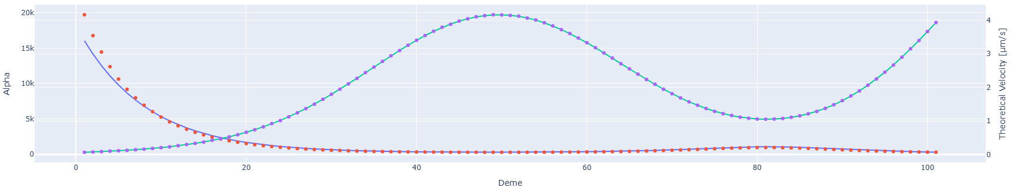
Figure 4 – Theoretical drift velocity (green line) and D-DEME calculated run-and-tumble drift velocity distribution mean (purple dot). Theoretical alpha values calculated (blue line) and the fitted alpha values for the non-physical solution (red dot). Values calculated for each microhabitat location (deme) on x-axis.
After finding the $α$ for each microhabitat location (deme), the optimized mean fitted drift velocity distribution, ($\overline{v}\left(α\right)$), is represented by a purple dot in Figure 4, while the theoretical velocity, ($v_{d}$), is represented by a green line. The percent standard error of the mean fitted velocity distribution compared to the theoretical drift velocity calculated averaged across all demes is 0.28%, with a median error of 0.095% and a standard deviation of 0.52%. In addition, of the 101 demes 95% of all demes contained errors below 1.32%, with the maximum observed error 2.99%. The non-absolute percent error by deme is shown in Figure 5. What the median indicates is that half of all demes have an error below 0.095% demonstrating that the fitted model has very high accuracy. However, a small number of demes contribute to the upper end of the error distribution. What should be noted is that the largest relative errors are situated in the low-food concentration gradient region of the demes where receptor occupancy, $\frac{dP_{b}}{dt}$, and theoretical drift velocity are all smallest. These locations are where the $α$ parameter remains largest corresponding to the low receptor occupancy regions as the as shown in the initial demes of Figure 4. Because of the small velocity values, the absolute deviations between the optimized and theoretical drift velocities correspond to relatively larger percentage errors, $\frac{\left|\overline{v}\left(α\right)-v_{d}\right|}{v_{d}}$. This is what accounts for the increase in relative errors with the maximum being 2.99%. The model calculates a drift velocity close to the theoretical throughout each deme including the locations containing a steep-gradient.
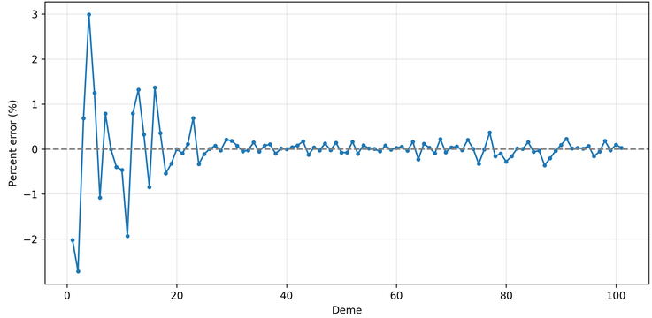
Figure 5 - Non-absolute Percent Error by Deme. The largest relative errors are situated in the low-food concentration gradient region of the demes.
Statistical Mechanics Analogy
The mathematical process is shortened to Dynamic Data Evolving Mean Estimator (D-DEME). This is because of the model’s optimization process of an evolving mean from continuously dynamic data under the CLT forming a computational analogue to the evolutionary population dynamics of demes and the statistical mechanics used to describe them [16]. D-DEME must adapt systems with continuously shifting noisy stochastic outputs, like how populations in demes must find relatively optimal genotypes on ever-changing genetic fitness landscapes. Each point on the landscape represents a combination of genes, (genotype, $\vec{g}$), and its associated positive fitness value $ϕ\left(\vec{g}\right)$). The equilibrium probability distribution that a population will have a particular genotype on the landscape is proportional to the Wright evolutionary potential expressed as $P∝\frac{e^{-\frac{ϕ\left(\vec{g}\right)}{δ}}}{Z}$ [16, 44]. Here, the equilibrium probability distribution is proportional to the stochastic drive ($δ$), and the partition function, $\left(Z\right)$, which sums over all the states to normalize the probability distribution. The stochastic drive is inversely related to population, as random changes have a larger effect when there are fewer individuals present, narrowing genetic variation, and in larger populations random changes are averaged out creating a wider genetic distribution [16]. Both systems iterate over generations of populations, (i.e. the past generations of data points are discarded). For evolutionary biology, this involves a population evolving towards an equilibrium probability distribution which provides a combination of genotypes most optimal for survival in their environment [16]. Similarly, D-DEME evolves a parameter over iterations to reach a desired optimal value as a whole for a particular function. Since biological evolution must respond to changing environmental pressures, and D-DEME must continuously update its collective parameters under a continuously evolving solution space.
In a lot of machine learning methods, samples are drawn from a fixed dataset where the overall distribution of data is assumed static as the models are updated using minibatches to find a local minimum in the solution space within a static loss landscape [17, 45]. The purpose of D-DEME is to optimize the macroscopic parameters of a black box stochastic function towards a target value without an explicit gradient. This is why D-DEME aligns closer to principles of statistical mechanics for population evolutionary dynamics than individual based evolution. In this sense, the optimization is more like how the canonical ensemble is used to describe the statistical aggregate behavior of a thermodynamic system moving to equilibrium without tracking the individual particles, (the microstates) [16, 46]. The model navigates a macroscopic solution space using the aggregate values of the function.
Apart from fitting values for solving a chemotaxis equation, D-DEME can help fit variables to optimize many types of functions that have inherent stochastic outputs, including functions with non-Gaussian distributions if enough samples are drawn for the CTL to converge a normal distribution to the population mean [30, 31]. In practice, quantities measured in physics and biological systems may not be explicit and are inherently noisy [16, 27, 46]. This technique offers a way to optimize black-box outputs that are stochastic by nature.

Biological Fold-Change Detection Filter and Drift Velocity Receptor Dynamics
As a consequence of Eq. (3), chemotaxis depends on relative changes in in food concentration as opposed to absolute changes. Fold-change detection (FCD) by Goentoro et al. [47] was made as a general sensory law for biological systems. This was experimentally verified in E. coli chemotaxis by Tu et al. which showed that E. coli chemotaxis depends on the relative rate of receptor stimulation through biochemical methylation feedback [20]. A mathematical way to extending this to a relative rate of the time rate of change of the fractional amount of receptor (protein) bound in Eq. (5) is:
$$\frac{1}{P_{b}}\frac{dP_{b}}{dt}=\frac{d}{dt}\left(ln P_{b}\right)$$ | (22)
From Eq. (6) this can imply that $α\frac{dP_{b}}{dt}∝\frac{1}{P_{b}}\frac{dP_{b}}{dt}⟹α∝\frac{1}{P_{b}}$. The bacterial receptor can bind or unbind attractant molecules, producing a fractional occupancy [43]:
$$P_{b}=\frac{N_{\text{bound}}}{N_{\text{total}}}$$ | (23)
where $N_{\text{bound}}$ is the number of ligand-bound receptors and $N_{\text{total}}$ is the total number of receptor sites. Therefore, $α$ acts as a placeholder function to describes the feedback from methylation and depends on receptor occupancy. If Methylation (CheR/CheB) works on receptor activity to bring it back toward an adapted value [1, 2, 21], then $α$ in this model is a nonlinear filter that rescales how sensitive the bacterial system adapts to the concentration gradient.
At low gradients where receptor occupancy is low, $\left(P_{b}≪1\right)$, methylation can adapt to the concentration, and $α$ represents a high-pass filter to amplify low-frequency gradient signals. The filter $α$ gets larger when methylation can easily compensate so the bacterial system can track environmental changes closely. In steep gradients at high occupancy, $\left(P_{b}→1\right)$, methylation cannot keep up with the rapid changes in concentration, so $α$ represents a low-pass filter to prevent the model from overreacting to noise by filtering out high-frequency gradient signals. It becomes smaller when receptors saturate and methylation falls behind so bacteria cannot “see” further up the gradient. Instead of filtering methylation adaptation as a frequency filter [43], this instead is an orthogonal nonlinear amplitude filter to control the magnitude of the signal based on receptor occupancy. Previous methylation models show a failure to reproduce the theoretical drift velocity in steep gradients due to finite methylation sites saturating and no longer bringing receptor activity to baseline, causing adaptation to fail and chemotaxis to collapse into nonstop runs [2, 6]. While the methylation model is more complex, fitting the placeholder alpha constants, (not a replacement for methylation dynamics), in this model helps to provide accurate tumble times to replicate the theoretical drift velocity per deme and prevents adaptation collapse. By simplifying the biological mechanisms using aggregate placeholders, the α-model can replicate the theoretical drift velocity in steep gradients.
The data collected shows the relation between mean drift velocity and the receptor response are proportional, as can be seen in Figure 6. This relationship between the fitted slope and time rate of change of receptor protein bound can be represented by:
$$m_{k}=\frac{dv}{dα}=k\frac{dP_{b}}{dt}$$ | (24)
where $k$ is a proportional coefficient. Solving the differential equation with $α∝\frac{1}{P_{b}}$ gives a linear solution:
$$v\left(α\right)=kα\frac{dP_{b}}{dt}+v_{o}\left(α\right)=k^{'}\frac{d\left(ln P_{b}\right)}{dt}+v_{o}\left(α\right)$$ | (25)
where $k^{'}$ is the linear constant to convert molecular receptor changes (s⁻¹) into changes in velocity (m·s⁻¹). The velocity function in Eq. (25) arrives at the same FCD principle as Goentoro et al. due to the $α$-filter, and reproduces the logarithmic sensing behavior by Tu et al. to ensure the velocity with respect to $\frac{dP_{b}}{dt}$ is locally linear at lower speeds [20, 47]. However, the physical limitation of the flagellar motor producing a maximum run speed, ($V_{o}$), and the indirect horizontal movement along the axis, ($V_{o}cosθ$), causes the maximum drift velocity along the axis to saturate. The linear relation of $\frac{dv}{dα}$ then breaks down to no longer be proportional to the constant $m_{k}$, as can be seen in in the high velocity deme locations in Figure 6. The saturation of the horizontal axis drift velocity can be seen in Figure 7, whereby the velocity as a function of filter $α$ at deme 51 and $\frac{dP_{b}}{dt}=0.00228$ $s^{-1}$ saturates to $v\left(α\right)≈8.1 μm/s$. While the physical limitation still exists, the FCD property of the model still prevents adaptation from failing in steep gradients and will replicate the theoretical drift velocity.
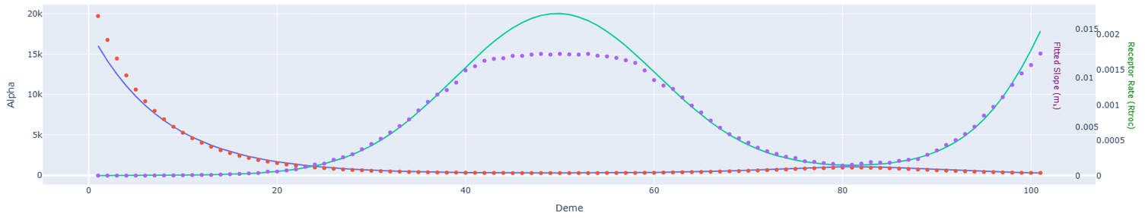
Figure 6 – Alpha value $\left(α\right)$ and Time Rate of Change of Receptor Protein Bound $\left(\frac{dP_{b}}{dt}\right)$ vs. position (Deme). At high receptor occupancy $\left(P_{b}→1\right)$, the physical response of the flagellar motor saturates and the linear proportionality between $v$ and α breaks down, as can be seen in the fitted slope $m_{k}$ (purple dot) vs $\frac{dP_{b}}{dt}$ (green line). The fitted alpha value for the non-physical model (red dot) breaks from the physical model solution (blue line) at low concentrations of $\frac{dP_{b}}{dt}$.
By measuring the gradient of the mean with the gradient of the variance from Eq. (10) and (11), as well as detecting if $\left|\overline{v}\left(α_{k}\right)-v_{d}\right|$ is actually converging, the algorithm can detect if the drift velocity sample mean remains far from the target but the slope is negligible ($\frac{d\overline{v}\left(α\right)}{dα}≈0$). In this case, the variance gradient can aid with identifying directions along the functional landscape to update via gradient descent: $α_{k+1}≅α_{k}-γ_{k}\left(λ\frac{n-1}{n}\frac{ds^{2}}{dα}\right)$. These changes in variance can also aid in optimizing the drift velocity sample mean. The sign of $λ≠0$ and the covariance of the residuals ($\frac{ds^{2}}{dα}$) together help with convergence towards stable regions (minimizing variance) or towards areas with greater spread (maximizing variance).
Values for $v, s^{2},\frac{dv}{dα},$ and $\frac{ds^{2}}{dα}$ were recorded varying alpha values when isolating location deme 51 in the model. These values are shown in Figure 7. Calculations were done using constant $\frac{dP_{b}}{dt}=0.00228$ [$s^{-1}$] and run speed $V_{o}=12.52$ [$μm/s$]. At high alpha values the slope of the drift velocity with respect to $α$ saturates and goes to zero as it becomes insensitive, but the $\frac{ds^{2}}{dα}$ continues to increase as it becomes more sensitive. The variance can therefore help optimize solutions along plateaus where the drift velocity gradient has effectively vanished, thereby optimizing stochastic variance parameters.
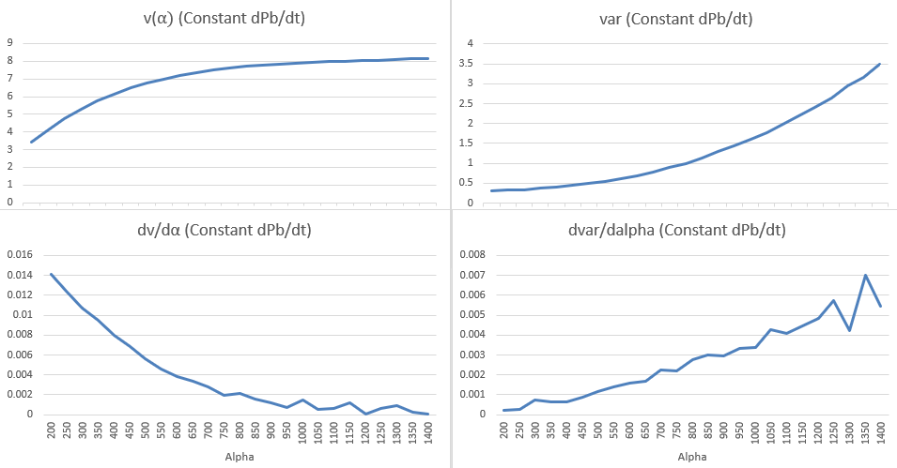
Figure 7 – Values recorded using the location of Deme 51 in the model. Calculations were done using constant $\frac{dP_{b}}{dt}=0.00228$ [$s^{-1}$] and run speed $V_{o}=12.52$ [$μm/s$]. Drift velocity [$μm/s$] (top left), variance ($s^{2}\left(α\right)$) [$m^{2}s^{-2}$] (top right), drift velocity w.r.t. alpha (bottom left), variance w.r.t. alpha (bottom right) vs. alpha. The drift velocity saturates to $v\left(α\right)≈8.1 μm/s$.
In regions where the gradient descent can fail the variance gradient can still provide directional information. These regions may include local minima/maxima, plateaus, or saddle points, which can come from black box functions [48]. Unlike standard RM this framework can be more robust to noise and non-monotonic environments allowing the algorithm to escape and adapt towards the correct solution [42].
As mentioned in Section 1 in Theory and Method, the landscape for the expectation function of $α$ is sampled to record multiple values of $\overline{v}\left(α\right)$ in order to define a window where a sign transition of $μ(α)-v_{d}$ has occurred. Multiple initialization locations for α could also benefit D-DEME, as seen in evolutionary algorithms (EAs) [49]. Like D-DEME, EAs are used to optimize noisy, non-differentiable functions. EAs simulate natural evolution by optimizing functions on a fitness landscape through iterative improvements to a population of possible function solutions, $\left\{v_{1}\left(α\right),…v_{n}\left(α\right)\right\}$. The algorithm does this through use of mutation, recombination, and selection operators, and then after several iterations the population is evaluated to determine the most optimal solution [49]. Both EAs and D-DEME can be computationally intensive. D-DEME however records the macroscopic parameters of the overall fitness distribution of data points per iteration instead of supervising a population of individual functions on a fitness landscape (i.e. recording the gene pool of the deme instead of each individual’s genetics). It discards the data immediately after use for the next iteration while still retaining some values, for instance $α_{k}$ and $μ\left(α_{k}\right)$, (k being the current iteration). This helps to avoid potential problems regarding long term memory storage while still optimizing a sample population.
These examples demonstrate this method’s ability to optimize macroscopic ensemble behaviors for black-box systems in various scientific domains ranging from computational biology to engineering. For this experiment the theoretical value was $v_{d}$, however this can also include other types of stochastic systems:
Thermodynamics could optimize energy for ensemble systems: $L\left(E\left(P,V,T\right)-E_{t}\right)$, with $E_{t}$ being the theoretical target energy value.
Evolutionary Biology could involve a gene probability distribution of a population in on a Wright evolutionary fitness landscape: $L\left(P\left(ϕ\left(\vec{g}\right)\right)-ϕ_{t}\right)$, where $ϕ_{t}$ is the theoretical target fitness value.

Conclusion
The purpose of this paper was to complete two goals: construct a new run-and-tumble chemotaxis model of bacteria by synthesizing existing frameworks, and then identify the parameters of said model to accurately recreate theoretical drift velocities by utilizing D-DEME built from existing mathematical frameworks.

To summarize, D-DEME focuses on optimizing parameters of a stochastic function within a shifting solution space, leveraging existing concepts including Robbins–Monro theory, batch dynamic sampling, and statistical mechanics of canonical ensembles to account for high stochasticity which can make it well suited for solving black-box problems (the Brown and Berg model) [16, 42, 46]. The model records aggregated statistical parameters from large populations of dynamic generated data per iteration that are then discarded, reducing long term memory requirements. Static datasets or fixed solution spaces are not feasible as data is continuously drawn from changing probability distributions. D-DEME can therefore reduce dimensionality of multiple data points by focusing on their systemic properties to optimize stochastic non-differentiable functions, bypassing the need for direct gradient calculations of the output for each data point where standard chain-rule practices fail. This technique can utilize the CLT to identify the dependence the expectation value has with the optimization parameter(s), $μ\left(α\right)$. The derivative of the ensemble mean can influence training by being integrated into the learning rate (e.g. $\frac{E\left[v\left(α\right)\right]}{dα}=m→2mγ=γ^{'}$). In cases where the direct expectation relation is unknown, finite difference approximations can be used for gradient estimation instead, ($Δ_{α}^{2}μ\left(α_{k}\right)$). Recording only the expectation value of the probability distribution is analogous to avoiding microstate-level tracking in statistical mechanics, as the macroscopic ensemble properties can guide optimization while naturally smoothing out noise. The function itself does not need to be explicit or deterministic because convergence occurs for the underlying probability distribution, instead of for an optimal location within a fixed landscape. This can be useful for optimizing black-box stochastic systems with evolving emergent behavior, where explicit gradients are unavailable or inaccessible. Although the application in this paper was for chemotaxis, the algorithm has broader applications for parameter optimization for aligning noisy collective outputs of theoretical models with experimental data across various scientific applications with reliable precision. The ensemble inspired approach provides a mathematical advantage to complement existing ML models to see the forest, not just the trees, while reducing sensitivity to noise.

Acknowledgments
(Use the Microsoft Word template style: Heading 1) or (Use Times New Roman Font: 12 pt, Bold, ALL CAPS, Centered)
If desired, in this section we welcome you to include thank your comments for those who have supported your research. Font should be Times New Roman, 10 pt.

References

[1] | Y. Liu, T. Lehnert and M. A. M. Gijs, "Effect of inoculum size and antibiotics on bacterial traveling bands in a thin microchannel defined by optical adhesive," Microsystems & Nanoengineering, vol. 7, no. 86, 2021.
[2] | G. Micali, R. Colin, V. Sourjik and R. G. Endres, "Drift and Behavior of E. coli Cells," Biophysical Journal, vol. 113, p. 2321–2325, 2017.
[3] | J. D. Murray, Mathematical Biology: I. An Introduction, New York: Springer, 2000.
[4] | G. Si, T. Wu, Q. Ouyang and Y. H. Tu, "Quantitative Modeling of Escherichia coli Chemotactic Motion in Environments Varying in Space and Time," PLoS Comput Biol, vol. 6, no. 4, p. 1000735, 2010.
[5] | K. Sona, F. Menolascinac and R. Stocker, "Speed-dependent chemotactic precision in marine bacteria," Proc. Nat. Acad. Sci., vol. 113, no. 31, p. 8624–8629, 2016.
[6] | G. Si, T. Wu, Q. Ouyang and Y. H. Tu, "A Pathway-based Mean-field Model for Escherichia coli Chemotaxis," Phys Rev Lett., vol. 109, no. 4, 2012.
[7] | D. A. Brown and H. C. Berg, "Temporal Stimulation of Chemotaxis in Escherichia Coli," Proc. Nat. Acad. Sci., vol. 71, no. 4, p. 1786–1791, 1974.
[8] | V. Sourjik and N. S. Wingreen, "Responding to chemical gradients: bacterial chemotaxis," Current Opinion in Cell Biology, vol. 24, pp. 262-268, 2012.
[9] | J. Tatikos, H. Stark and V. Zaburdaev, "How the Motility Pattern of Bacteria Affects Their Dispersal and Chemotaxis," PLOS ONE, vol. 8, no. 12, p. e81936, 2013.
[10] | Q. Zhang, G. Lambert, D. Liao, H. Kim, K. Robin, C. K. Tung, N. Pourmand and R. H. Austin, "Acceleration of emergence of bacterial antibiotic resistance in connected microenvironments," Science, vol. 333, no. 6050, pp. 1764-1767, 2011.
[11] | Q. Zhang, K. Robin, D. Liao, G. Lambert and R. H. Austin, "The Goldilocks Principle and Antibiotic Resistance in Bacteria," Molecular Pharmaceutics, vol. 8, pp. 2063-2068, 2011.
[12] | G. Nadin, B. Perthame and L. Ryzhik, "Traveling waves for the Keller-Segel system with Fisher birth terms," Interfaces and Free Boundaries, vol. 9, pp. 477 - 495, 2007.
[13] | J. Saragosti, P. Silberzan and A. Buguin, "Modeling E. coli Tumbles by Rotational Diffusion. Implications for Chemotaxis," PLoS ONE, vol. 7, no. 4, p. e35412, 2012.
[14] | W. Tso and J. Adler, "Negative Chemotaxis in Escherichia coli," Journal of Bacteriology, vol. 118, no. 2, p. 560 – 576, 1974.
[15] | P. Greulich, B. Waclaw and R. J. Allen, "Mutational pathway determines whether drug gradients accelerate evolution of drug-resistant cells," Phys. Rev. Lett., vol. 109, no. 8, p. 088101, 2012.
[16] | G. Sella and A. E. Hirsh, "The application of statistical physics to evolutionary biology," PNAS, vol. 102, no. 27, p. 9541–9546, 2005.
[17] | H. Levine and Y. H. Tu, "Machine learning meets physics: A two-way street," Biophysics and Computational Biology, vol. 121, no. 27, p. e2403580121, 2024.
[18] | F. Cichos, K. Gustavsson, B. Mehlig and G. Volpe, "Machine learning for active matter," Nature Machine Intelligence, vol. 2, no. 2, p. 94–103, 2020.
[19] | M. Raissi, P. Perdikaris and G. E. Karniadakis, "Physics-informed neural networks: A deep learning framework for solving forward and inverse problems involving nonlinear partial differential equations," Journal of Computational Physics, vol. 378, pp. 687-707, 2019.
[20] | Y. V. Kalinin, L. Jiang, Y. H. Tu and M. Wu, "Logarithmic Sensing in Escherichia coli Bacterial Chemotaxis," Biophysical Journal, vol. 96, p. 2439–2448, 2009.
[21] | G. Liu, K. Bogaj, V. Bortolaia, J. E. Olsen and L. E. Thomsen, "Antibiotic-Induced, Increased Conjugative Transfer Is Common to Diverse Naturally Occurring ESBL Plasmids in Escherichia coli," Front Microbiol, vol. 10, no. 2119, 2019.
[22] | J. E. Keymer, R. G. Endres, M. Skoge, Y. Meir and N. S. Wingreen, "Chemosensing in Escherichia coli: Two regimes of two-state receptors," PNAS, vol. 103, no. 6, p. 1786–1791, 2006.
[23] | Y. Yang, A. M. Pollard, C. Höfler, G. Poschet, M. Wirtz, R. Hell and V. Sourjik, "Relation between chemotaxis and consumption of amino acids in bacteria," Molecular Microbiology, vol. 96, no. 6, p. 1272–1282, 2015.
[24] | N. Vladimirov, L. Løvdok, D. Lebiedz and V. Sourjik, "Dependence of Bacterial Chemotaxis on Gradient Shape and Adaptation Rate," PLOS Computational Biology, vol. 4, no. 12, p. e1000242, 2008.
[25] | J. S. L. Gilmour and J. W. Gregor, "Demes: A Suggested New Terminology," Nature, vol. 144, p. 333, 1939.
[26] | E. Carlon, Computational Physics, Flanders, Belgium: KU Leuven, 2012.
[27] | R. K. Pathria and P. D. Beale, Statistical Mechanics: Third Edition, Oxford: Elsevier Ltd., 2011.
[28] | H. C. Berg and D. A. Brown, "Chemotaxis in Escherichia coli analysed by three-dimensional tracking," Nature, vol. 239, pp. 500-504, 1972.
[29] | M. Descerno, One-dimensional diffusion on a finite region, UCLA: Department of Chemistry and Biochemistry, 2004.
[30] | P. Billingsley, Probability and Measure, 3rd ed., New York, NY, USA: Wiley, 1995.
[31] | S. M. Ross, A First Course in Probability, Upper Saddle River, NJ, USA: Pearson, 2012.
[32] | N. R. Draper and H. Smith, Applied Regression Analysis, 3rd ed., New York, NY, USA: Wiley, 1998.
[33] | T. Kanungo, D. M. Mount, N. S. Netanyahu, C. D. Piatko, R. Silverman and A. Y. Wu, "An efficient k-means clustering algorithm: Analysis and implementation," IEEE Transactions on Pattern Analysis and Machine Intelligence, vol. 24, no. 7, p. 881–892, 2002.
[34] | F. M. Dekking, C. Kraaikamp, H. P. Lopuhaä and L. E. Meester, A Modern Introduction to Probability and Statistics, London, UK: Springer, 2005.
[35] | B. T. Polyak and A. B. Juditsky, "Acceleration of Stochastic Approximation by Averaging," SIAM Journal on Control and Optimization, vol. 30, no. 4, pp. 838-855, 1992.
[36] | D. Ruppert, "Efficient Estimates from a Slowly Convergent Robbins–Monro Process," Dept. Statistics, Cornell Univ., Ithaca, NY, USA, 1988.
[37] | G. A. F. Seber and A. J. Lee, Linear Regression Analysis, Hoboken, NJ, USA: Wiley-Interscience, 2003.
[38] | J. Johnston and J. DiNardo, Econometric Methods, 4th ed., New York, NY, USA: McGraw–Hill, 1997.
[39] | S. Weisberg, Applied Linear Regression, 3rd ed., Hoboken, NJ, USA: Wiley, 2005.
[40] | H. K. Khalil, Nonlinear Systems, 3rd ed., Upper Saddle River, NJ, USA: Prentice Hall, 2002.
[41] | S. Elaydi, An Introduction to Difference Equations, 3rd ed., New York, NY, USA: Springer, 2005.
[42] | H. Robbins and S. Monro, "A Stochastic Approximation Method," The Annals of Mathematical Statistics, vol. 22, no. 3, pp. 400 - 407, 1951.
[43] | Y. Tu, T. S. Shimizu and H. C. Berg, "Modeling the chemotactic response of Escherichia coli to time-varying stimuli," Proc. Natl. Acad. Sci., vol. 105, no. 39, pp. 14855-14860, 2008.
[44] | P. Ao, "Laws in Darwinian evolutionary theory," Physics of Life Reviews, vol. 2, no. 2, pp. 117-156, 2005.
[45] | S. Shwartz and B. David, Understanding Machine Learning: From Theory to Algorithms, Cambridge, England: Cambridge University Press, 2014.
[46] | D. A. McQuarrie, Statistical Mechanics, Sausalito, CA: University Science Books, 2000.
[47] | L. Gorentoro, O. Shoval, M. Kirkegaard, Y. Hart, E. Mayo and U. Alon, "The incoherent feedforward loop can provide fold-change detection in gene regulation," Molecular Cell, vol. 36, no. 6, p. 894–899, 2009.
[48] | F. E. Bottou, F. E. Curtis and J. Nocedal, "Optimization Methods for Large-Scale Machine Learning," SIAM Review, vol. 60, no. 2, pp. 223 - 311, 2018.
[49] | H.-G. Beyer and H.-P. Schwefel, "An Overview of Evolutionary Algorithms for Parameter Optimization," Evolutionary Computation, vol. 1, no. 1, pp. 1-23, 1995.
[50] | D. P. Kingma and J. L. Ba, "Adam: A Method For Stochastic Optimization," in 3rd International Conference on Learning Representations (ICLR), San Diego, CA, USA, 2015.
[51] | M. Klann, A. Ganguly and H. Köpp, "Hybrid spatial Gillespie and particle tracking simulation," Bioinformatics, vol. 28, no. 18, pp. i549 - i555, 2012.

Where to Find Further Information
We warmly invite you to visit our online platform, Scitation, where you can find further help/advice and publishing policies for AIP Conference Proceedings:
- For authors: https://aip.scitation.org/apc/authors/preppapers
- For conference organizers: https://aip.scitation.org/apc/organizers/abstracts

Summary: Points to Consider when Preparing Your Paper

- Articles should use 8.5 x 11 single column template.
- Use Times New Roman font, the point size will vary by section.
- DO NOT alter the margins of our templates. They are carefully designed for AIP’s production process: Altering them can cause significant delays. Paper size should be 8 ½ x 11 with margins set at:Top – 1 inch, Left – 1 inch, Bottom – 1.18 inch, Right – 1 inch.
- DO NOT display the title in ALL CAPS (initial cap only)
- DO NOT include any headers, footers, or page numbers in your document. They will be added to your article PDF by AIP Publishing, so please do not amend this template to add them to your paper.
- Line spacing should be 1.0 throughout the entire article, no double spacing.
- Make sure all author affiliation associations are correct. This means author vs. affiliation and author vs. email address. If there is only one affiliation for all authors, association is not needed. Author names should be listed in First name Surname format.
- Use clear, legible graphics and diagrams. Readers of your paper will be grateful. If they cannot read it, they are unlikely to cite it.
- DO NOT use copyrighted material without permission. Papers using copyrighted material without appropriate permission and acknowledgment will be excluded from the proceedings.
- No 1-page papers please. 1-page, abstract-only contributions are not acceptable and will be excluded from the proceedings.
- Prepare and format references with care. References should be numbered using Arabic numerals followed by a period (.).
- Embed all fonts into your article PDF. The importance of font embedding is discussed in the section Font Embedding (above). PDFs supplied without embedded fonts are often completely unusable for printing or publication purposes. In such cases, we must return those PDFs to the proceedings editors for font embedding. Failure to embed fonts can cause unnecessary inconvenience to your proceedings editor(s) and publication delays for other authors. Failure to provide a replacement paper in a timely fashion may result in an article being removed from the proceedings.
- Check your article PDF file! It is not uncommon for errors to appear in PDFs generated from Microsoft Word – corrupted math, figures reflowing, etc. It is essential to very carefully check your article PDF file before sending it to the proceedings editor(s).
- Avoid large PDF files (10 MB maximum, ideally). For the benefit of your readers, we recommend keeping your article PDF file below 10 MB. This is a recommendation, not a requirement.

