Two Algorithms: A Chemotaxis Model and a Statistical Mechanics Approach to Machine Learning for Stochastic Optimization
Michael Frood^{1, b)} and Apichart Linhananta^{1, a)}
¹Department of Physics, Lakehead University, Thunder Bay, Ontario, Canada, P7B 5E1
^{a)} Corresponding author: alinhana@lakeheadu.ca
^{b)} dmfrood@lakeheadu.ca
Abstract.
Incorporating chemotaxis into the Keller-Segel equation is a major undertaking. We present a stochastic model where the run-and-tumble motion of Escherichia coli (E. Coli) is modeled using a Poisson Process tumble distribution function. The drift velocity of motion is also a stochastic function that is a product of the tumble rate function, and therefore a product of the function’s parameters. The parameters of the distribution function were solved by a machine learning algorithm which optimizes functions with a stochastic output. Inspired by the biological and statistical mechanics of population gene pools in demes, for this paper the algorithm is referred to as D-DEME, (Dynamic Data Evolving Mean Estimator). The technique avoids microstate-level tracking by aggregating large groups of continuously generated then discarded data into ensemble-level values utilizing the Central Limit Theorem to treat a batch of data points as a macroscopic entity, thereby reducing sensitivity to noise. D-DEME can focus on the overall trend of the aggregated data to optimize parameters for non-explicit, stochastic, non-differentiable functions by embedding the calculated slope of the mean function directly into the learning rate or using finite difference approximations. This memoryless, expectation-based method is also robust to non-convexity and non-monotonicity, while bypassing the need for direct gradient calculations for each data point where standard chain-rule practices fail. This paper therefore provides two novel models built from existing mathematical frameworks: (1) D-DEME the algorithm to complement ML models by unifying existing concepts including Robbins–Monro theory, batch dynamic sampling, and ensemble-level modeling, and (2) a run-and-tumble simulation which is able to accurately recreate theoretical drift velocities of bacteria by combining existing run-and-tumble algorithms. Using D-DEME, we efficiently recover stochastic tumble rates to recreate these drift velocities in a biologically accurate run-and-tumble simulation.

Introduction
The mechanics of how bacteria propel themselves in response to environmental signals has been studied for decades [1]. The bacteria, Escherichia coli (E. Coli), respond to various environmental gradients by alternating their motility to locate favorable niches and avoid dangerous locations, a process called chemotaxis [2, 3, 4, 5]. Understanding the effect of chemotaxis on the evolution of antibiotic resistance in bacteria is an important field of research. There is a need to develop an accurate algorithm to simulate chemotaxis, which can then be incorporated in bacterial growth models. There are complex simulations with algorithms that accurately reproduce the chemotactic motion of E. Coli [2, 6]. But these algorithms are not easily incorporated into complicated models of cell growth in heterogeneous environments. The focus of this paper is to solve the chemotaxis problem and to develop a new type of machine learning (ML) algorithm to determine the parameters of a for a chemotactic tumble probability function that represents E. Coli swimming in a chemical gradient. The probability function is based on the function by Brown and Berg from their work modelling temporal simulation of E. Coli’s chemotaxis [7]. The parameters are optimized by a novel ML algorithm to accurately recreate the theoretical drift velocity, $v_{d}$, of the bacteria as observed in experiments.
It is well established that E. Coli utilize their flagella to propel themselves using a run-and-tumble mechanism [2, 8, 9]. During the run-and-tumble motion, an E. Coli propels itself by the counterclockwise (CCW) rotation of its flagellar motor. In a uniform chemical environment, it moves at constant speed in a straight line for $\sim 10s$, until its flagellar motor switched to a clockwise (CW) rotation, causing the E. Coli to tumble for $\sim 0.1s$, and reorient itself by rotational diffusion. After which the flagellar motor switches back to a CCW rotation, and it moves off in a new direction [2, 8, 9]. In effect, the E. Coli is a perfect random walker. It is well established that the E. Coli’s flagellar motor is controlled by multi-protein receptor complexes that sense changes in the concentration of ligands associated with nutrients [8]. The receptors are either inactive (methylated) or active (demethylated), with the overall methylation level, $m$, of an E. Coli determined by a complex sensory system. The standard chemotaxis theory includes feedback control equations relating the overall receptor activity, $a\left(m,c_{F}\right)$, the receptor free energy, $F\left(m,c_{F}\right)$, and the methylation dynamic equation, $\frac{dm}{dt}=k_{R}\left(1-a\left(t\right)\right)-k_{B}{a\left(t\right)}^{3}$, with $k_{R}$ and $k_{B}$ being methylation constants [1]. The methylation level, $m\left(t\right)$, and the nutrient concentration, $c_{F}\left(t\right)$, are both functions of time.
When an E. Coli swims downstream (away from a nutrient), $∇c_{F}<0$, the methylation level, $m$, decreases along with the overall activation, $A$, which increases the tumbling rate, $k_{ccw→cw}>{0.1s}^{-1}$. When it swims upstream, $∇c_{F}>0$, the tumbling rate remains at about $k_{ccw→cw}\sim 0.1s^{-1}$ [1]. Consequently, E. Coli immersed in a nutrient gradient are observed to be randomly biased to move upstream towards regions with higher food concentration, as observed in the experiments of Austin et al. [10, 11]. Chemotaxis has been extensively studied by Brown and Berg [7]. They observed an increase in the tumbling rate of E. Coli ($>0.1s^{-1}$) moving downstream from a food gradient, while the tumbling rate remains relatively constant ($\sim 1s^{-1}$) for E. Coli moving upstream. However, other works found that, bacteria swimming up the gradient find that the duration of reorientation is reduced so as a consequence bacteria tumble less frequently if they are swimming up the gradient and more frequently if they swim away [1, 3, 7, 12, 13, 14]. This is the opposite case for repellants, with bacteria increasing the frequency of tumbling swimming up the gradient, and decreasing swimming down [14]. This results in an upstream drift velocity, $v_{d}$, directed up along a food gradient, and down from a repellent gradient. The drift velocity can be calculated given a ratio between the time spent running up the gradient minus the time spent running down the gradient divided by the total time spent running and tumbling [1, 2, 13]. In the presence of a nutrient gradient, $∇c$, the drift velocity has a magnitude of $v_{d}=K\left(〈a\left(t\right)〉\right)\frac{∂F}{∂c}∇c$, where the coefficient $K\left(〈a\left(t\right)〉\right)$ is a function of the mean overall receptor activity, $〈a\left(t\right)〉$.
The tumble probability function based on the work by Brown and Berg is expressed as $η_{±}=$
$exp \left(-r_{o}∓α\left(\frac{dP_{b}(t)}{dt}\right)\right)$, where $η_{+}$ describes the decrease in tumble rate as the bacteria moves up the gradient and $η_{-}$ describes the increase moving down. The function can be a basis for an efficient simulation algorithm that accurately mimics the motility of E. Coli, including its use in a Gillespie simulation [15]. While the theoretical drift velocity is accurately modeled for observations in shallow gradients through various chemotaxis simulations, in steep gradients previous models show a failure to capture the velocity due to limitations of responses including finite methylation sites reaching a threshold, and linear responses of methylation and demethylation [2, 6]. Simulations of chemotaxis produce a drift speed lower than theory due to oversaturation of the E. Coli sensory system at high gradients, leading to an unphysical state of non-stop running [2]. This paper uses the tumble probability functions in a new run-and-tumble algorithm that generalizes these responses into the function $\frac{dP_{b}(t)}{dt}$ modeled after the works of Sourjik et al. and Tu et al [2, 6]. This function describes the activity of receptors due to protein bound to replicate chemotaxis in gradients, where the drift velocity is predicted to reach a value as high as 8 μm/s in magnitude. The parameter α represents a filter for $\frac{dP_{b}(t)}{dt}$ to control the frequency signals of responses in gradients and to represent non-linear effects to help the model replicate the theoretical drift velocity even in steep gradients.
The proposed chemotactic algorithm requires the determination of the parameters $r_{0}$ and $α$ in the distribution function $η_{±}$. The paper accomplishes this optimization problem by using a novel machine learning (ML) algorithm. The algorithm is called D-DEME because of the overlap between the model’s optimization of continuously dynamic data and its analogy to the statistical mechanics to evolutionary concept of demes [16]. The ML model optimizes parameters from stochastic function outputs to theoretical optimal means by utilizing the Central Limit Theorem (CLT). The use of ML in science, engineering and physics is widespread [17, 18]. Recently, Karniadakis et al. developed a physics-informed neural network (PINN) method for solving forward and inverse non-linear partial differential equations [19]. The task at hand is not to solve a PDE, but to develop a ML method to determine the parameters of $η_{±}$ that produce accurate chemotactic motions, which results in a drift velocity, $v_{d}$, predicted by the theory of Tu et al. and Sourjick el al. [2, 6]. This is a self-consistent ML method where the input data is stochastically produced by using the initial distribution functions $η_{±}$ to output a mean drift velocity $v_{d}$ that is comparable to the theoretical drift velocity recorded in experiment. The chemotaxis tumble rates can then be used to quantify the E. Coli motility through the use of chemotaxis diffusion coefficients in a Gillespie algorithm for populations of bacteria, with $D_{+}$ and $D_{-}$, being the diffusion coefficient for motion upstream ($+$) and downstream ($-$), respectively.

Theory and Method

Part I: FKPP Diffusion Reaction Equation
Bacteria respond to various environmental gradients by alternating their motility to locate favorable niches and avoid dangerous locations called chemotaxis, while the drift velocity is the bacteria’s velocity component in the direction up or down the gradient [2, 4, 8]. Most of the knowledge of bacteria chemotaxis comes from the study of E. coli, which swims using multiple flagella. E. coli use their multiple flagella in a run and tumble like motion to propel the cell forward and then reorient the direction of the cell for the next run. An algorithm to describe this motion is discussed in Part II. Part I will model how the external attractant chemicals (ligands) are detected by membrane-bound chemoreceptors on a flagellar motor. The receptors use enzymes to add/remove methyl groups (methylation and demethylation), a process which depend on the receptor kinase activity [2, 4, 20]. This process of the flagellar motor will change its rotation from counterclockwise (CCW) to clockwise (CW), which in turn causes the motion of the E. coli cell to change from run to tumble [2, 4, 5, 6, 20].
Analytical calculations of average drift velocity are limited to shallow gradients due to the sensitivity of receptors [2, 4]. In steeper gradients, including exponential gradients, the large change in concentration results in large changes to the methylation level and a gradual saturation of receptor methylation sites at high levels of stimulation. This invalidates memoryless adaptation because the bacterium can no longer adapt to higher ligand concentrations due to receptor inhibition, which therefore causes the bacteria’s chemotactic motion to slow [2, 4, 6]. Chemotaxis at steep gradients is modeled by the receptor free energy that includes methylation and ligand binding [1, 2, 21]:
 | $$F\left(m,c_{F}\right)=-m\left(t\right)+\sum_{j∈\left\{a,s\right\}}{ν_{j}\frac{1+{c_{F}}/{K_{i}^{off}}}{1+{c_{F}}/{K_{i}^{on}}}}=-m\left(t\right)+f_{o}\left(c_{F}\right)$$ | (1)
with $c_{F}$ being the concentration of the attractant, $ν_{i}$, as the fraction of receptor type j for the most abundant receptor types Tar and Tsr (represented by “a” and “s” in the summation operator). The range of adaptation for the Tar receptor can vary with different strains but it can be approximated to be around $K_{a}^{off}<c_{F}<K_{a}^{on}$ with $K_{a}^{off}=20 µM$ and $K_{a}^{off}=500 µM$ [4, 22]. The receptor fractions are $ν_{a}=1/3$ and $ν_{s}=2/3$. Above this range the Tsr receptor continues to respond in the range of $K_{s}^{off}<c_{F}<K_{s}^{on}$, with $K_{s}^{off}=10000 µM$ and $K_{s}^{on}$ being less specific but still $K_{s}^{on}≫K_{s}^{off}$ [2, 22, 23]. The ligand binding free energy equation leads to two saturation peaks independent of methylation [2]. For this equation, the methylation free energy of the receptor is approximated to be around, $m\left(t\right)=1.7$ [4, 6, 20].
To derive a relation for the drift velocity, $v_{d}$, we follow the method of Tu et al. which considers the 1D Keller Segal (KS) chemotaxis equation of $N\left(x,t\right)$ E. Coli cells [4, 6]:
 | $$\frac{∂N}{∂t}=-\frac{∂}{∂x}\left(-D\frac{∂N}{∂x}+Nχ_{o}\frac{∂f_{o}}{∂x}\right)$$ | (2)
where $f_{o}\left(c_{F}\right)$ is the methylation-independent ligand binding contribution to free energy, and a dimensionless sensitivity function which depends on the concentration of food. The food concentration is exponential, $c_{F}\left(x\right)=\frac{c_{F0}}{e^{Gx_{l}}}e^{Gx}$, where $x_{l}$ is the maximal domain position $x$ increases to, while the exponent in the denominator ensures that the function increases to a maximum concentration of $c_{F0}$ = 60000 µM. The constant relative gradient is $G=\frac{1}{c_{F}}\frac{dc_{F}}{dx}$ with units in $\left[{µm}^{-1}\right]$. The gradient of the ligand receptor binding site on the RHS of Eq. (2) can then be described as [2, 6, 24]:
 | $$\frac{∂f_{o}}{∂x}=\frac{c_{F}}{c_{F}}∙\frac{df_{o}}{dc_{F}}∙\frac{dc_{F}}{dx}=c_{F}\frac{{dc_{F}}/{dx}}{c_{F}}\left[\sum_{j∈\{a,s\}}{ν_{j}\frac{\left(K_{j}^{on}-K_{j}^{off}\right)}{\left(c_{F}+K_{j}^{off}\right)\left(c_{F}+K_{j}^{on}\right)}}\right]=c_{F}G\left[\sum_{j∈\{a,s\}}{ν_{j}\frac{\left(K_{j}^{on}-K_{j}^{off}\right)}{\left(c_{F}+K_{j}^{off}\right)\left(c_{F}+K_{j}^{on}\right)}}\right]$$ | (3)
the receptor sensitivity multiplied by the local relative gradient $\frac{∂f_{o}}{∂c_{F}}\frac{dc_{F}}{dx}$ exhibits two peaks. This due to the sensitivity of the high and low affinity of the most abundant receptor types Tar and Tsr, and how they control the net binding rate through differences in ligand concentrations, $\left(K_{j}^{on}-K_{j}^{off}\right)$, in exponential gradients [2]. Comparison of Eqs. (2) and (3) show that the drift velocity is given by:
$$v_{d}\left(c_{F}\right)=χ_{o}\frac{∂f_{o}}{∂x}=c_{F}Gχ_{o}\left[\sum_{j∈\{a,s\}}{ν_{j}\frac{\left(K_{j}^{on}-K_{j}^{off}\right)}{\left(c_{F}+K_{j}^{off}\right)\left(c_{F}+K_{j}^{on}\right)}}\right]=c_{F}Gχ_{o}\sum_{j∈\{a,s\}}{S_{j}(c_{F})}$$ | (4)
where $χ_{o}$ is the chemotaxis mobility coefficient in units of $\left[\frac{{µm}^{2}}{s}\right]$. Unlike previous models referenced [2, 6], the chemotaxis mobility coefficient in this model is constant and does not depend on the receptor activity or methylation. The system is separated by bacterial microhabitats which are called demes. Demes are subpopulations of organisms which exchange genetic information within a common gene pool to evolve to local environmental conditions [25]. A plot of the theoretical drift velocity in equation 4 vs. the concentration of attractant is displayed in Figure 1.
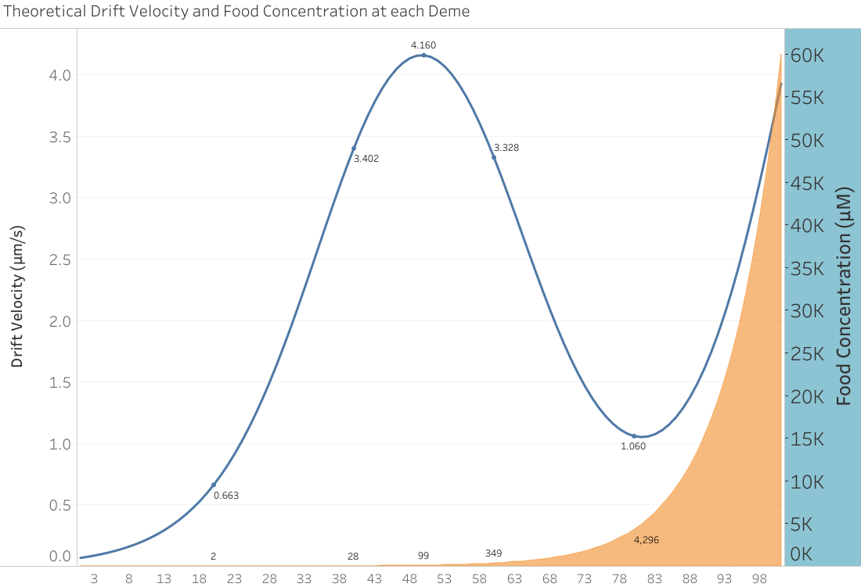
Figure 1 – Dual-axis plot shows the theoretical drift velocity, $v_{d}$, (blue line) caused by the LB concentration (orange area). Motility coefficient, $χ_{o}=7500\frac{{µm}^{2}}{s}$, maximum food concentration, $c_{F0}$ = 60000 µM, max drift velocity along x-axis, $v_{d}^{Max}=4.16$ µm/s. The x-axis values represent the microhabitats called demes ($i$).
The change in the ligand binding sensitivity function with respect to position from Eq. (3) can be described as the time rate of change of the fractional amount of receptor (protein) bound [7]:
$$\frac{dP_{b}}{dt}=\frac{df_{o}}{dc_{F}}∙\frac{dc_{F}}{dt}=\frac{c_{F}}{c_{F}}∙\frac{df_{o}}{dc_{F}}∙\frac{dc_{F}}{dx}∙\frac{dx}{dt}=χ_{o}{\left(c_{F}G\frac{df_{o}}{dc_{F}}\right)}^{2}$$ | (5)
which helps to guide the bacteria to determine if a tumble is to occur.
The purpose of this work is to construct an efficient and accurate algorithm for the chemotaxis motion of E. Coli, similar to the metropolis algorithm for the Ising Model [26, 27]. The chemotactic motions are biased Poisson processes that can be represented by the probability of tumbling located at each deme position $i$ [7]:
$$η_{±}^{i}=Aexp\left(-r_{o}∓α^{i}\left(\frac{dP_{b}^{i}(t)}{dt}\right)\right)$$ | (6)
with the rate of tumbling going up a gradient given by $η_{+}$, and going down $η_{-}$. The value $A$ is the normalization coefficient. The rate of tumbling is a product of the timed rate of change of receptor protein bound and the constant, $α$. The constant is the activation time which determines how quickly bacteria can adjust their tumbling rate based on the deme’s, $\left(i\right)$, local attractant concentration. The factor, $α\left(\frac{dP_{b}}{dt}\right)$, helps determine the decrease or increase in the rate of tumbling when moving up or down the food gradient, while the difference in tumbling is the major factor that contributes to the drift velocity. The run-and-tumble simulation, which will be discussed in Part II, and the tumble rate from Eq. (6) are based on the classical model by Brown and Berg. However, the tumble rates from within their model lacks normalization and is not physically realizable [7]. In their model, the constant for Eq. (6) was set to $A=1s^{-1}$ and had not been normalized. The tumble rates and drift velocity have an exact analytic solution which can be solved separate from the model by Brown and Berg (see appendix).

Part II: Run-and-Tumble Algorithm
To compute the tumble rate of bacteria, an algorithm similar to the one by Brown and Berg is used as seen in Figure 2 [7]. Bacteria starting from rest swim for a time $(∆t=0.1s)$ in a direction chosen at random. The run speed of the bacteria is around $V_{o}=12.5\frac{µm}{s}$ [1, 2, 5, 6]. The values of $r_{o}$ and $α\left(\frac{dP_{b}}{dt}\right)$ are selected. The probability that the bacteria will tumble during the time interval is determined from $η^{i}∆t$. A random number between 0 and 1 is drawn. If the number is less than the probability, the bacteria tumbles. During a tumble the bacteria stops while drawing from a probability distribution, ($T\left(θ\right)$), to select a new angle to run along. If the random number generated is greater than the probability of tumbling, the bacterium continues to run along the direction it is oriented towards. This process is repeated until the bacteria crosses a marker, then its drift velocity is recorded. The simulation takes the dot product between the run vector and the unit displacement along the axis of motion.

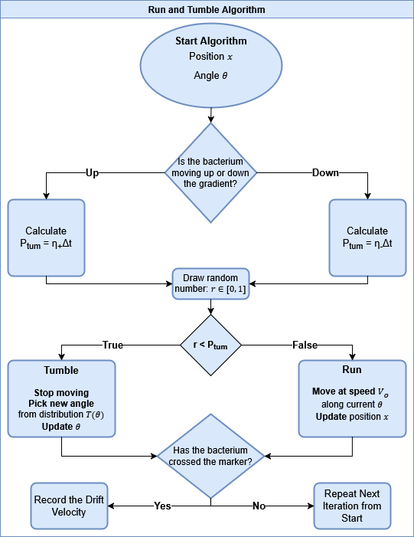
Figure 2 – The run-and-tumble algorithm by Brown and Berg [7].
The tumbling angle is calculated using a probability density function with a distribution given by:
$$T\left(θ\right)=0.5\left(1+cos θ \right)sin θ , 0<θ<π$$ | (7)
with a mean of around $θ=67.5°$. This distribution is close to the experimental measurements obtained from Berg and Brown [13, 24, 28]. In the absence of a food gradient or chemotaxis mechanism, $\frac{dP_{b}}{dt}=0$, then there is no tumble bias, and $η_{±}=exp \left(-r_{o}\right)$. A realistic diffusion constant for E. coli is $D=112 \frac{{µm}^{2}}{s}$ [9, 13, 28]. The diffusion section of the Keller Segal equation is $\frac{dN}{dt}=D\frac{d^{2}N}{{dx}^{2}}$. Using the Fourier Transform, the solution to the differential equation for population $N$ is a Gaussian distribution [29]:
$$N\left(x,t\right)=\int_{-∞}^{∞}{\hat{N}\left(k,0\right)e^{-Dk^{2}t}e^{ikx}dk=\frac{1}{\sqrt{2πσ^{2}}}e^{- \frac{{(x-x_{o})}^{2}}{2σ^{2}}}}$$ | (8)
where the population distribution $N\left(x,t\right)$ has a variance $σ^{2}=2Dt$.

Part III: Machine Learning D-DEME Algorithm

The function utilized was the run-and-tumble chemotaxis loop by Brown and Berg, discussed above [10]. The ML algorithm seeks to determine the value of the parameter, α, from the distribution function of Eq. (6), $η_{±}^{i}\left(α^{i}\right)$, for each deme location $i$ on the gradient. Because the drift velocity is dependent on the probability distribution of the tumble rate, the drift velocity is then a function of the food concentration gradient at deme $i$ as outlined in part I: $v_{d}^{i}\left(α^{i}\right)∝Aexp\left(-r_{o}∓α^{i}\left(\frac{dP_{b}^{i}(t)}{dt}\right)\right)$ where $\frac{dP_{b}^{i}(t)}{dt}∝c_{F}\left(x_{i}\right)=\frac{c_{F0}}{e^{Gx_{l}}}e^{Gx_{i}}$. The target of the machine learning algorithm is to identify a value of $α^{i}$ in order to for the mean of the drift velocity built by the tumble rate to equal the theoretical value of $v_{d}$ as seen in Figure 1.
The technique uses dynamic data drawn from a stochastic function every iteration, in this case the drift velocity, which is dependent on the probability distributions of the tumble rate, $v\left(α\right)∝η\left(α\right)$. First, multiple displacement histograms with no chemotaxis were collected for different values of $r_{o}$ using the tumble rate $η=exp \left(-r_{o}\right)$. A Shapiro-Wilk test for normal distribution with the Bhattacharyya distance for overlap the distribution calculated the constant closest to the theoretical in Eq. (8) to be $r_{o}=1.16$. Next, histograms were generated by applying multiple iterations of the run-and-tumble algorithm in Part II to simulate bacterial chemotaxis using displacement measurements to gather data points of drift velocity as a function of α. All data are recorded into a tensor for each iteration. In this technique, instead of calculating the mean of a fixed cluster, like in k-means clustering, a new mean is repeatedly generated by the data collected per iteration to compare and optimize against a theoretical value [30]. For a sample size of $n$ data points, the mean square error loss function is calculated:
$$L\left(α\right)=\frac{1}{n}\sum_{j=1}^{n}{{‖v_{j}\left(α\right)-v_{d}‖}^{2}}$$ | (9)
where $j$ represents a run, $v_{j}\left(α\right)$ represents a drift velocity data point collected from the full loop of the run and tumble algorithm in Part II, and $v_{d}$ is the theoretical drift velocity. In this case, the derivative of the training function with respect to $α$ will have the form:
$$-γ\frac{∂L_{α}}{∂α}=-γ\frac{2}{n}\sum_{j=1}^{n}{\left(v_{j}\left(α\right)-v_{d}\right)\frac{dv_{j}\left(α\right)}{dα}}$$ | (10)
where $γ$is the learning rate. The gradient is used to determine the 𝑘 + 1 iteration of 𝛼:
$$α_{k+1}=α_{k}-γ\frac{∂L\left(α_{k}\right)}{∂α_{k}}$$ | (11)
The mathematical ML model displays the following characteristics:
- Randomly Generated Data: The technique continuously draws and stores individual data points in parallel, $j$, randomly generated through a function, $v$, dependent on an independent variable, $α$, (i.e. $v_{j}\left(α\right)$). The function is not explicit and inherently stochastic. The data is dynamic as a new sample set is continuously generated each iteration and then discarded before the next, not relying on a fixed dataset or a functional space.
- Normal Distribution: The randomly drawn individual samples, $\sum_{j=1}^{n}{v_{j}\left(α\right)}$, must eventually approximate a Gaussian distribution due to the Central Limit Theorem [31, 32]. This removes the necessity for the function $v\left(α\right)$ to be known as the function’s population distribution mean is identified provided there is a large enough sample size, $n$, taken from individual independent samples.
- The Mean as a Function of the Parameters: The expectation value of the overall distribution is dependent on the variable to be optimized, and the function of the expectation is monotonic. For this case the mean has a linear relationship, $μ\left(α\right)=\frac{1}{n}\sum_{j=1}^{n}{v_{j}\left(α\right)}=\overline{v}\left(α\right)±ϵ=mα±ϵ$. Here the true mean, $\overline{v}\left(α\right)=mα$ as seen in Figure 3 below, while $ϵ$ is the standard error. The derivative of the expectation value is then $\frac{1}{n}\sum_{j=1}^{n}{\frac{dv_{j}\left(α\right)}{dα}}=m$, as the variance and standard error with respect to $α$ is unchanged (see appendix).
- Chain Rule Free Optimization: The algorithm provides a way to optimize the parameter α when the function is not explicit and the true derivative, $\frac{v_{j}\left(α\right)}{dα}$, is unknown or impractical to compute. The relation between the mean as a function of the variable allows for the unknown gradient to be incorporated into the learning rate, $\frac{μ\left(α\right)}{dα}=m→\frac{2}{n}\sum_{j=1}^{n}{\frac{dv_{j}\left(α\right)}{dα}}γ=2mγ=γ^{'}$. In cases where the explicit relation between the expectation value and variables are unknown, finite difference approximations for the linear slope, $m$, can be applied instead. This is further discussed in the algorithm steps below and in the discussion section.
- The use of Existing Frameworks: While this algorithm shares Robbins–Monro (RM) algorithm’s goal of expectation-level optimization to a theoretical value, ($v_{d}$), to find a unique value of an input parameter ($α^{*}$) which optimizes the ensemble mean of a function, ($μ\left(α\right)=E\left[v\left(α^{*}\right)\right]=v_{d}$), this technique of uses a batch sampling instead of inputting one parameter at a time from the classic RM algorithm [33]. The sample utilizes the CLT to identify $μ\left(α\right)$ in a memoryless manner as samples are discarded after each iteration and not accumulated, with only the ensemble mean recorded. This structure allows for the utilizing of the slope of the mean ($\frac{μ\left(α\right)}{dα}$) instead of the non-explicit function $v\left(α\right)$, through it either being empirically estimated or directly calculated. Because noise is controlled through batch-level averaging rather than per-iteration decay, this method can optionally utilize RM step-size conditions (i.e. step size being the learning rate for iteration $k$, $\sum{γ_{k}}=∞, \sum{{γ_{k}}^{2}}<∞$), which are there for convergence control [33]. However, unlike the RM algorithm which assumes the user does not know $\frac{μ\left(α\right)}{dα}$ [33], this method can, in addition, fold the slope of the expectation gradient directly into an adaptive learning rate, and can allow for existing second-order optimization techniques to be applied to the gradient of the expectation function itself [34]. This gradient combined with the memorylessness of data points utilizing the CLT allows for an evolving value of $E\left[v\left(α\right)\right]$, and can include cases where the expectation function itself changes over iterations, ($μ_{k}\left(α\right)≠μ_{k+1}\left(α\right)$), unlike standard RM algorithms which assumes that $E\left[v\left(α\right)\right]$ is fixed [33]. Under fixed expectation and unknown slope, the technique is functionally equivalent to RM, however by unifying existing batch sampling and learning rate adaptation techniques this framework can better generalize EM algorithms to be more robust to noise, non-convex, and non-monotonicity which can come from black box functions [33, 34].

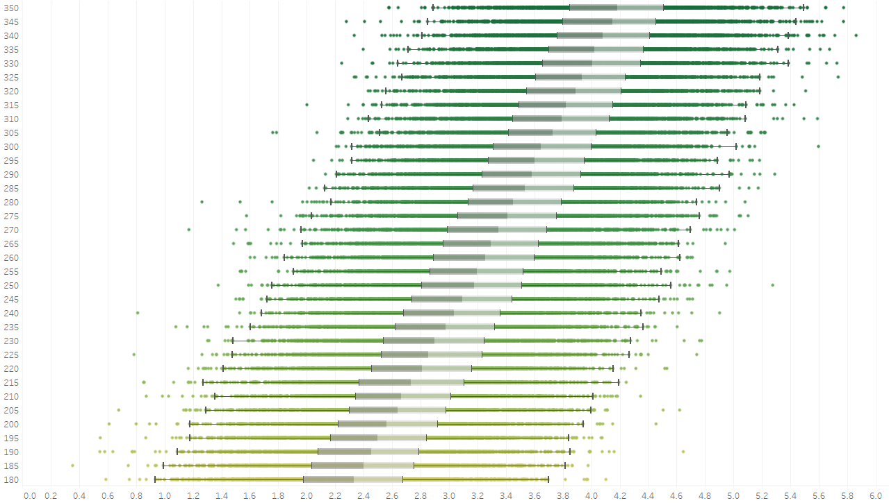
Figure 3 – Boxplots of Gaussian distributions of $v\left(α\right) \left[\frac{μm}{s}\right]$ on the x-axis per $α \left[s\right]$ on the y-axis show a linear relationship of the mean: $μ\left(α\right)=\frac{1}{n}\sum_{j=1}^{n}{v_{j}\left(α\right)=\overline{v}\left(α\right)±ϵ=mα±ϵ}$, where $ϵ$ is the standard error of the mean. The grey bars represent the inner quartile range of the normal distributions. Each layer along the y-axis contains the normal distribution of data points generated in parallel then discarded for each training iteration. The overall functional distribution for each iteration is dynamic, and so the CLT is utilized to determine the new mean. The collective epoch of data progresses a functional space towards the optimal value of $α$.
Taking the derivative of the loss function from Eq. (10), $L\left(α\right)$:
$$\frac{dL}{dα}=\frac{2}{n}\sum_{j=1}^{n}{\left(v_{j}\left(α\right)-v_{d}\right)}∙\frac{dv_{j}\left(α\right)}{dα}$$
$$=\frac{d}{dα}\frac{2}{n}\sum_{j=1}^{n}{\frac{1}{2}{\left(v_{j}\left(α\right)\right)}^{2}}-2v_{d}\left(m\right)$$
$$=\frac{d}{dα}{\left(ma±ϵ\right)}^{2}-2v_{d}m$$
The iteration of Eq. (11) is then described as:
$$α_{k+1}=α_{k}-γ^{'}\left[\overline{v}\left(α\right)-v_{d}\right]∓γ^{'}ϵ$$ | (12)
where $γ^{'}=2mγ$ and $\overline{v}\left(α\right)=mα$.
The algorithm steps are as summarized:
- A starting value, α, is initialized.
- For each iteration in the ML algorithm:
  - Parallel computing is utilized to generate $n$ datapoints from the function with a stochastic output simultaneously: $\sum_{j=1}^{n}{v_{j}\left(α\right)}$.
  - Each iteration of the training loop generates a new epoch of data with a mean: $μ\left(α\right)=\frac{1}{n}\sum_{j=1}^{n}{v_{j}\left(α\right)}=mα±ϵ$.
  - Update $α_{k}$ via “gradient descent”:
    - Residuals are calculated: $\frac{1}{n}\sum_{j=1}^{n}{\left(v_{j}\left(α\right)-v_{d}\right)}$.
    - The true derivative, $\frac{v_{j}\left(α\right)}{dα}$, is unknown. The chain rule for the derivative of a mean squared error (MSE) function is not computed, as the slope of the mean with respect to α can be incorporated into the learning rate: $\frac{2}{n}\sum_{j=1}^{n}{\frac{dv_{j}\left(α\right)}{dα}}γ=2mγ=γ^{'}$.
    - Finite difference approximation is optional instead of integrating into the learning rate: $\sum_{j=1}^{n}{\frac{∆v_{j}\left(α\right)}{∆α}}=\frac{μ\left(α_{k+1}\right)-μ\left(α_{k}\right)}{α_{k+1}-α_{k}}≈m→2mγ$.
- Update $α$ by subtracting the product of the residuals and the integrated learning rate using Eq. (12).
- Adjust Learning Rate and Epoch Size:
  - As the equation moves closer to the optimal value, $\left(\overline{v}\left(α\right)-v_{d}\sim 0\right)$, there is still an intrinsic standard error in Eq. (12), $ϵ$, from the random distribution which will prevent the algorithm from reaching the most optimal value due to less stable convergence: $α_{k+1}≅α_{k}∓γ^{'}ϵ$.
  - Two methods are used to help convergence on two fronts, $\left(γ^{'} and ϵ\right)$:
    - After a fractional interval of the training loop with $i$ iterations, implement an adaptive learning rate through reducing the rate, γ′, by: ${γ^{'}}_{i+1}=\frac{{γ^{'}}_{i}}{i+1}$. E.g. in this case, every 20 iterations the training value is decreased by 1/2, 1/3, etc. as it arrives closer to the local minimum. This follows from the step size requirements of the Robbins–Monro algorithm [33].
    - Within the same interval of the training loop, increase the full-batch (epoch) of data to reduce the standard error by the scaling $Ο\left(\frac{1}{\sqrt{n}}\right)$ with increasing sample size. E.g. in this case, every 20 iterations the number of data points recorded is doubled to reduce the standard error by $\frac{1}{\sqrt{2}}$.
- Continue updating until maximum number of iterations is reached or until the loss function minimizes a computed MSE below a suitable error level, $Ε$:
$$L\left(α\right)=\frac{1}{n}\sum_{j=1}^{n}{{‖v_{j}\left(α\right)-v_{d}‖}^{2}}<E$$ | (13)
The mathematical process is shortened to Dynamic Data Evolving Mean Estimator (D-DEME). This is because of the overlap between the model’s optimization of an evolving mean from continuously dynamic data and its analogy to the evolutionary concept of demes and the statistical mechanics used to describe them [16]. D-DEME must adapt systems with continuously shifting noisy stochastic outputs, like how populations in demes must find relatively optimal genotypes on ever-changing genetic fitness landscapes. Each point on the landscape represents a combination of genes, (genotype, $\vec{g}$), and its associated positive fitness value $ϕ\left(\vec{g}\right)$). The equilibrium probability distribution that a population will have a particular genotype on the landscape is proportional to the Wright evolutionary potential expressed as $P∝\frac{e^{-\frac{ϕ\left(\vec{g}\right)}{δ}}}{Z}$ [16, 35]. Here, the equilibrium probability distribution is proportional to the stochastic drive ($δ$), and the partition function, $\left(Z\right)$, which sums over all the states to normalize the probability distribution. The stochastic drive is inversely related to population, as random changes have a larger effect when there are fewer individuals present, narrowing genetic variation, and in larger populations random changes are averaged out creating a wider genetic distribution [16].
Both systems iterate over generations of populations where the previous ones are no longer retained, (i.e. the past population of data points are discarded), to move system towards a relatively optimal state. For evolutionary biology, this involves a population evolving towards an equilibrium probability distribution which provides a combination of genotypes most optimal for survival in their environment [16]. Similarly, D-DEME identifies the necessary parameters to reach an optimal value as a whole from a population of data points in a stochastic function. Since biological evolution must respond to changing environmental pressures, and D-DEME must continuously update its collective parameters to a continuously evolving solution space.
In gradient-based ML, (including SGD, Adam, deep learning, etc.), samples are drawn from a fixed dataset where the overall distribution of data is assumed static as the models are updated using the explicit gradient calculations from these minibatches to find a local minimum in the solution space within a static loss landscape [17, 36]. D-DEME doesn't just resample from a static distribution; it dynamically generates new data from a stochastic function with an assumed shift in the overall population distribution. This shifting population distribution allows D-DEME to optimize its expectation value without requiring an explicit chain rule for the function itself. Some conceptual distributions not associated with this current experiment are provided as examples in Figure 4 to show the difference in drawing from a fixed distribution and evolving the distribution between iterations.
The purpose of D-DEME is not to explore an unknown potential landscape; it is to optimize the macroscopic parameters of a black box stochastic function towards a target value. This is why D-DEME aligns closer to principles of statistical mechanics for population dynamics than individual based evolution. In this sense, the application is more like how the canonical ensemble is used to describe the statistical behavior of a thermodynamic system [16, 37]. In statistical mechanics, the canonical ensemble describes the system in thermal equilibrium without tracking the individual particles of a population, (the microstates). As with the canonical ensemble, the mathematics focuses on the overall distribution of the macroscopic function outputs, where the collective ensemble behaves as a single-agent optimizer moving to equilibrium, (or in this case the minimization of the loss function).
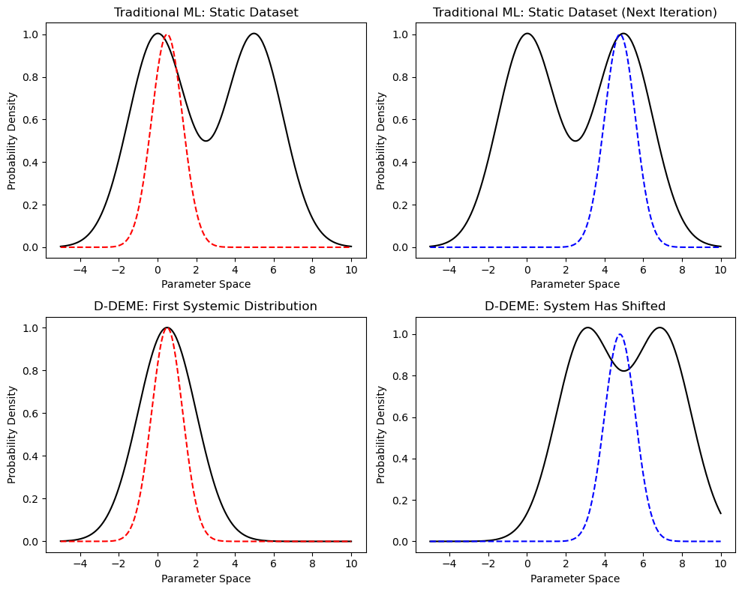
Figure 4 – These are conceptual distributions not associated with this current experiment. Top: the static distribution (solid black line) over the solution space with batch samples being taken from each iteration (red/blue dashed lines) to train a model. The top systemic distributions remain the same from iteration to iteration. The sample iterations contain their own mean. Bottom: The overall systemic distributions (solid black line) are different on the first and second iteration for D-DEME. Enough samples are drawn for the distribution to follow the CLT and gives the mean of the overall population distribution (red/blue dashed lines) for each iteration. The solution space itself is optimized and the data is discarded in the next iteration.
Apart from fitting values for solving a chemotaxis equation, D-DEME can help fit variables which optimize many types of functions that have inherent stochastic outputs, including functions with non-Gaussian distributions, because enough samples are drawn the CTL guarantees a normal distribution with an expectation value centered on the mean of the entire population regardless of the type of distribution [31, 32]. The loss function optimizing a mean of a solution space instead of a local minimum within one offers a relatively more directed convergence towards a theoretical target. In this test the variance of the function used is constant with each iteration. However, the techniques of gradually reducing the learning rate, and increasing the size of data points gathered can still help the algorithm to converge in other cases with increasing variance towards convergence, as long as the techniques compensate for the increase. In practice, quantities like $r_{0}$, α, and ${dP_{b}}/{dt}$ may not be directly measurable, as biological systems are inherently noisy. This technique offers a way to optimize function outputs that are noisy and non-deterministic by nature without requiring calculating the function derivative to determine its gradient.

Results and DISCUSSION
Numerical optimization on solvable systems is common in physics, like how Monte Carlo methods are frequently applied to systems like the Ising Model to test algorithms, study noise, or explore more complex models than what the exact solution provides [26]. In this situation, however, the tumble rates to reproduce drift velocity, ($η\left(α\right)$ and $v\left(α\right)$), from Brown and Berg’s model have not been normalized and only represent an empirical measurement of chemotactic behavior, (i.e. for the tumble rate in Eq. (6) the the coefficient $A=1s^{-1}$ instead of being normalized) [7].
This problem provided an opportunity to offer a new approach to optimize parameters from ensemble-level outputs while avoiding explicit functions, (in this case the tumble rate from Brown and Berg lacked an explicit function linking $v\left(α\right)$ to $α$). Even though ${dP_{b}}/{dt}$ from the tumble rate equation in the Brown and Berg model has been developed with the calculations of receptor activity by Tu and Sourjik, the historical significance of the Brown and Berg model to measure chemotaxis makes it a useful test case for optimization. The purpose of the test is to not optimize the parameters of a normalized equation with a solution, but to instead fit a chemotaxis model so that its outputs reproduce known theoretical values for it to become operationally physically meaningful, despite its inherent equation being physically incorrect. The values of α are adjusted to compensate for $A=1s^{-1}$ in Eq. (6), as shown in Figure 5. The test was able to recover the correct macroscopic behaviour when applied to a model lacking a physical solution, which can be useful for real-world modeling where theoretical solutions and explicit functions may often be inaccessible.
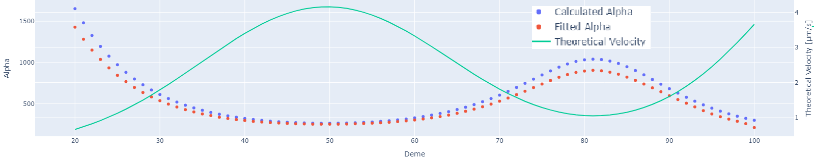
Figure 5 – On the LH y-axis are alpha values, ($α \left[s\right]$, dotted lines), on RH y-axis is drift velocity, ($v\left(α\right) \left[\frac{μm}{s}\right]$, solid green line), and on the x-axis are the Deme positions (Starting at 20 to zoom in on difference between $α$). The values of α are adjusted to compensate for $A=1s^{-1}$ in Eq. (6) (Fitted Alpha), while the normalization constant at deme $i$ is $A=-r_{o}∓α^{i}\left(\frac{dP_{b}^{i}\left(t\right)}{dt}\right) [s^{-1}]$ (Calculated Alpha).
Fitting the alpha constants help provide accurate tumble times to replicate the theoretical drift velocity per deme through a stochastic process that depends on the gradient, and not the methylation-dependent receptor activity. Previous methylation models show a failure to capture the theoretical drift velocity in steep gradients due to finite methylation sites reaching a threshold along with limitations due to a linear response for methylation and demethylation [2, 6]. While the methylation model is more complex, the temporal stimulation α-based model avoids the methylation model’s pitfalls by calculating the methylation independent tumble rates to replicate the theoretical drift velocity through a stochastic process. By simplifying the biological processes into a net behavior instead of modelling instantaneous reactions, the α-based model can include replicating the theoretical drift velocity in steep gradients. The biological feedback loops involved in methylation, demethylation and gradient sensing of the receptors are generalized to achieve non-linear responses as the temporal stimulus fluctuates continuously over time [38]. In shallow gradients, methylation can adapt to the concentration, and α represents a high-pass filter to amplify low-frequency gradient signals. In steep gradients, methylation cannot keep up with the rapid changes in concentration, so α represents a low-pass filter to prevent the model from overreacting to noise by filtering out high-frequency gradient signals. The α parameter can be utilized to effectively identify the biological filters within the bacteria’s run-and-tumble system.
The run-and-tumble mechanics follow diffusive behavior which results in a mean square displacement $〈x^{2}〉$, and this behavior can be extended for Gillespie models without keeping track of individual particles [39]. Over time, $t$, the particle goes through $η_{±}t$ runs, with a run speed of $V_{o}$. Bacteria moving up the gradient undergo super-diffusive motion, while bacteria moving down undergo sub-diffusive:
$$D_{±}=\frac{〈x^{2}〉}{2t}=\frac{1}{2t}〈{\left(\frac{V_{o}}{η_{±}}\right)}^{2}〉\left(η_{±}t\right)=\frac{\left(η_{±}t\right)}{2t}\left[\frac{\left(\frac{1}{2π}\int_{0}^{2π}{{\left(V_{o}cosθ\right)}^{2}}dθ\right)}{{η_{±}}^{2}}\right]=\frac{{V_{o}}^{2}}{4η_{±}}$$ | (14)
The key feature is that when the tumble rate, $η_{±}$, is fitted correctly, it can be used by anomalous
diffusion coefficients as a way to represent diffusion with drift velocity from the Keller Segal equation in cartesian coordinates. Direction of reorientation is averaged out over time and is not a factor in Eq. (11). The diffusion coefficient, $D_{±}$, reverts back to the theoretical random
diffusion rate, $D$, when the gradient is removed or chemotaxis is not a factor.
Plugging Eq. (11) back into Eq. (2) the 1D KS chemotaxis equation can now be expressed using the relative unitless diffusion asymmetry [4, 6]:
$$\frac{∂N}{∂t}=-\frac{∂}{∂x}\left(-D\frac{∂N}{∂x}+V_{o}\frac{D_{+}-D_{-}}{D_{+}+D_{-}}N\right)=\frac{{V_{o}}^{2}e^{r_{o}}}{4}\frac{∂^{2}N}{∂x^{2}}-V_{o}tanh\left(α\frac{dP_{b}(t)}{dt}\right) \frac{∂N}{∂x}$$ | (12)

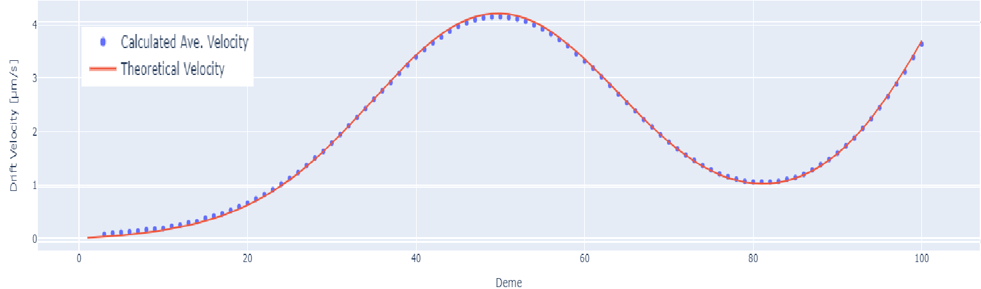
Figure 5 – Theoretical drift velocity (red) and D-DEME calculated run-and-tumble drift velocity distribution mean (blue). Values calculated for each microhabitat location (deme) on x-axis.
After finding the $α$ for each microhabitat location (deme), the percent standard error of the mean velocity distribution compared to the theoretical averaged for all demes is 0.64%.
The example used in this case calculated mean of a sample distribution from the function to have a linear relationship with input variables, but other techniques could broaden D-DEME’s applicability to optimize complex non-deterministic functions with means that have a non-linear relationship with input variables as well. Instead of directly calculating the gradient of the function, calculating the gradient of the expected value in relation to the variable to be optimized, $\frac{1}{n}\sum_{j=1}^{n}{\frac{∆v_{j}\left(α\right)}{∆α}}=\frac{μ\left(α_{k+1}\right)-μ\left(α_{k}\right)}{α_{k+1}-α_{k}}=Δ_{α}^{2}μ\left(α_{k}\right)$, if known, can smooth out the noise from the combined data points and provide an interpretable gradient path instead. This finite difference approximation may make optimizing other functions with non-linear means possible as well, in cases where the expected value’s relation to α is unknown. This process still does not require the derivation of the function itself, and could help focus on optimizing non-deterministic systems with systemic trends, including expectation values that have non-linear relationships with α.
Other machine learning techniques have been created to optimize stochastic objective functions by minimizing the expected value, an example includes Adam [34, 40]. Like D-DEME, random subsamples (minibatches) of datapoints or inherent function noise may cause stochasticity. However, Adam performs first order gradient-based optimizations of the stochastic objective function. This requires direct calculations of the gradient for each data point, $∇_{α}v\left(α\right)$, to guide its search [40]. In contrast, D-DEME can calculate the derivative of the function’s mean with a linear or non-linear relationship, ($\frac{d^{2}μ}{dα^{2}}$), and can avoid direct gradient calculations if one were to find either a function of the expectation value or use finite difference approximations of the batch mean, ($Δ_{α}^{2}μ\left(α_{k}\right)$). In cases with a non-linear expectation value in relation to the variable, a second order Taylor series expansion can improve convergence by approximating curvature:
 | $$μ\left(α+∆α\right)=μ\left(α_{k}\right)+∆α\frac{dμ}{dα_{k}}+\frac{{∆α}^{2}}{2}∙\frac{d^{2}μ}{dα_{k}^{2}}+…≈μ\left(α_{k}\right)+∆α∙∆_{α}μ\left(α_{k}\right)+\frac{{∆α}^{2}}{2}∙Δ_{α}^{2}μ\left(α_{k}\right)$$ | (15)
where $μ\left(α_{k}\right)$ is the expectation value of $v\left(α\right)$ at iteration $k$, and the approximations are scaled by the step size between iterations, $∆α$. The methods used in Adam or existing second-order optimization techniques could be applied to gradient of the mean to improve D-DEME’s accuracy and performance [34, 40].
Multiple initialization locations for α could also benefit D-DEME, as seen in evolutionary algorithms (EAs) [41]. Like D-DEME, EAs are used to optimize noisy, non-differentiable functions. EAs simulate natural evolution by optimizing functions on a fitness landscape through iterative improvements to a population of possible function solutions, $\left\{v_{1}\left(α\right),…v_{n}\left(α\right)\right\}$. The algorithm does this through use of mutation, recombination, and selection operators, and then after several iterations the population is evaluated to determine the most optimal solution [41]. Both EAs and D-DEME can be computationally intensive due to parallel computing. D-DEME however records the macroscopic parameters of the overall fitness distribution of data points per iteration instead of supervising a population of individual functions on a fitness landscape (i.e. recording the gene pool of the deme instead of each individual’s genetics). It discards the data immediately after use for the next iteration while still retaining some values, for instance $α_{k}$ and $μ\left(α_{k}\right)$, (k being the current iteration). This helps to avoid potential problems regarding long term memory storage while still optimizing a sample population.
These examples demonstrate this method’s ability to optimize macroscopic ensemble behaviors for black-box systems in various scientific domains ranging from computational biology to engineering. For this experiment the theoretical value was $v_{d}$, however this can also include other types of stochastic systems:
Thermodynamics could optimize energy for ensemble systems: $L\left(E\left(P,V,T\right)-E_{t}\right)$, with $E_{t}$ being the theoretical target energy value.
Evolutionary Biology could involve a gene probability distribution of a population in on a Wright evolutionary fitness landscape: $L\left(P\left(ϕ\left(\vec{g}\right)\right)-ϕ_{t}\right)$, where $ϕ_{t}$ is the theoretical target fitness value. The convergence of the stochastic function’s normal distribution can be thought of as evolving the fitness distribution of the population’s gene pool, (the deme’s fitness distribution), as opposed to evolving the individual entities separately.

Conclusion
The purpose of this paper was to complete two goals: construct a new run-and-tumble chemotaxis model of bacteria by synthesizing existing frameworks, and then identify the parameters of said model to accurately recreate theoretical drift velocities by utilizing D-DEME built from existing mathematical frameworks.

To summarize, D-DEME focuses on optimizing parameters of a stochastic function within a shifting solution space, leveraging existing concepts including Robbins–Monro theory, batch dynamic sampling, and statistical mechanics of canonical ensembles to account for high stochasticity which can make it well suited for solving black-box problems (the Brown and Berg model) [16, 33, 37]. The model records aggregated statistical parameters from large populations of dynamic generated data, which are processed in parallel then discarded, reducing long term memory requirements. Static datasets or fixed solution spaces are not feasible as data is continuously drawn from changing probability distributions. D-DEME can therefore reduce dimensionality of multiple data points by focusing on their systemic properties to optimize stochastic non-differentiable functions, bypassing the need for direct gradient calculations of the output for each data point where standard chain-rule practices fail. This technique can utilize the CLT to identify the dependence the expectation value has with the optimization parameter(s), $μ\left(α\right)$. The derivative of the ensemble mean can influence training by being integrated into the learning rate (e.g. $\frac{E\left[v\left(α\right)\right]}{dα}=m→2mγ=γ^{'}$). In cases where the direct expectation relation is unknown, finite difference approximations can be used for gradient estimation instead, ($Δ_{α}^{2}μ\left(α_{k}\right)$). Recording only the expectation value of the probability distribution is analogous to avoiding microstate-level tracking in statistical mechanics, as the macroscopic ensemble properties can guide optimization while naturally smoothing out noise. The function itself does not need to be explicit or deterministic because convergence occurs for the underlying probability distribution, instead of for an optimal location within a fixed landscape. This can be useful for optimizing black-box stochastic systems with evolving emergent behavior, where explicit gradients are unavailable or inaccessible. Although the application in this paper was for chemotaxis, the algorithm has broader applications for parameter optimization for aligning noisy collective outputs of theoretical models with experimental data across various scientific applications with reliable precision. The ensemble inspired approach provides a mathematical advantage to complement existing ML models to see the forest, not just the trees, while reducing sensitivity to noise.

Acknowledgments
(Use the Microsoft Word template style: Heading 1) or (Use Times New Roman Font: 12 pt, Bold, ALL CAPS, Centered)
If desired, in this section we welcome you to include thank your comments for those who have supported your research. Font should be Times New Roman, 10 pt.

References

[1] | Y. Liu, T. Lehnert and M. A. M. Gijs, "Effect of inoculum size and antibiotics on bacterial traveling bands in a thin microchannel defined by optical adhesive," Microsystems & Nanoengineering, vol. 7, no. 86, 2021.
[2] | G. Micali, R. Colin, V. Sourjik and R. G. Endres, "Drift and Behavior of E. coli Cells," Biophysical Journal, vol. 113, p. 2321–2325, 2017.
[3] | J. D. Murray, Mathematical Biology: I. An Introduction, New York: Springer, 2000.
[4] | G. Si, T. Wu, Q. Ouyang and Y. H. Tu, "Quantitative Modeling of Escherichia coli Chemotactic Motion in Environments Varying in Space and Time," PLoS Comput Biol, vol. 6, no. 4, p. 1000735, 2010.
[5] | K. Sona, F. Menolascinac and R. Stocker, "Speed-dependent chemotactic precision in marine bacteria," Proc. Nat. Acad. Sci., vol. 113, no. 31, p. 8624–8629, 2016.
[6] | G. Si, T. Wu, Q. Ouyang and Y. H. Tu, "A Pathway-based Mean-field Model for Escherichia coli Chemotaxis," Phys Rev Lett., vol. 109, no. 4, 2012.
[7] | D. A. Brown and H. C. Berg, "Temporal Stimulation of Chemotaxis in Escherichia Coli," Proc. Nat. Acad. Sci., vol. 71, no. 4, p. 1786–1791, 1974.
[8] | V. Sourjik and N. S. Wingreen, "Responding to chemical gradients: bacterial chemotaxis," Current Opinion in Cell Biology, vol. 24, pp. 262-268, 2012.
[9] | J. Tatikos, H. Stark and V. Zaburdaev, "How the Motility Pattern of Bacteria Affects Their Dispersal and Chemotaxis," PLOS ONE, vol. 8, no. 12, p. e81936, 2013.
[10] | Q. Zhang, G. Lambert, D. Liao, H. Kim, K. Robin, C. K. Tung, N. Pourmand and R. H. Austin, "Acceleration of emergence of bacterial antibiotic resistance in connected microenvironments," Science, vol. 333, no. 6050, pp. 1764-1767, 2011.
[11] | Q. Zhang, K. Robin, D. Liao, G. Lambert and R. H. Austin, "The Goldilocks Principle and Antibiotic Resistance in Bacteria," Molecular Pharmaceutics, vol. 8, pp. 2063-2068, 2011.
[12] | G. Nadin, B. Perthame and L. Ryzhik, "Traveling waves for the Keller-Segel system with Fisher birth terms," Interfaces and Free Boundaries, vol. 9, pp. 477 - 495, 2007.
[13] | J. Saragosti, P. Silberzan and A. Buguin, "Modeling E. coli Tumbles by Rotational Diffusion. Implications for Chemotaxis," PLoS ONE, vol. 7, no. 4, p. e35412, 2012.
[14] | W. Tso and J. Adler, "Negative Chemotaxis in Escherichia coli," Journal of Bacteriology, vol. 118, no. 2, p. 560 – 576, 1974.
[15] | P. Greulich, B. Waclaw and R. J. Allen, "Mutational pathway determines whether drug gradients accelerate evolution of drug-resistant cells," Phys. Rev. Lett., vol. 109, no. 8, p. 088101, 2012.
[16] | G. Sella and A. E. Hirsh, "The application of statistical physics to evolutionary biology," PNAS, vol. 102, no. 27, p. 9541–9546, 2005.
[17] | H. Levine and Y. H. Tu, "Machine learning meets physics: A two-way street," Biophysics and Computational Biology, vol. 121, no. 27, p. e2403580121, 2024.
[18] | F. Cichos, K. Gustavsson, B. Mehlig and G. Volpe, "Machine learning for active matter," Nature Machine Intelligence, vol. 2, no. 2, p. 94–103, 2020.
[19] | M. Raissi, P. Perdikaris and G. E. Karniadakis, "hysics-informed neural networks: A deep learning framework for solving forward and inverse problems involving nonlinear partial differential equations," Journal of Computational Physics, vol. 378, pp. 687-707, 2019.
[20] | Y. V. Kalinin, L. Jiang, Y. H. Tu and M. Wu, "Logarithmic Sensing in Escherichia coli Bacterial Chemotaxis," Biophysical Journal, vol. 96, p. 2439–2448, 2009.
[21] | G. Liu, K. Bogaj, V. Bortolaia, J. E. Olsen and L. E. Thomsen, "Antibiotic-Induced, Increased Conjugative Transfer Is Common to Diverse Naturally Occurring ESBL Plasmids in Escherichia coli," Front Microbiol, vol. 10, no. 2119, 2019.
[22] | J. E. Keymer, R. G. Endres, M. Skoge, Y. Meir and N. S. Wingreen, "Chemosensing in Escherichia coli: Two regimes of two-state receptors," PNAS, vol. 103, no. 6, p. 1786–1791, 2006.
[23] | Y. Yang, A. M. Pollard, C. Höfler, G. Poschet, M. Wirtz, R. Hell and V. Sourjik, "Relation between chemotaxis and consumption of amino acids in bacteria," Molecular Microbiology, vol. 96, no. 6, p. 1272–1282, 2015.
[24] | N. Vladimirov, L. Løvdok, D. Lebiedz and V. Sourjik, "Dependence of Bacterial Chemotaxis on Gradient Shape and Adaptation Rate," PLOS Computational Biology, vol. 4, no. 12, p. e1000242, 2008.
[25] | J. S. L. Gilmour and J. W. Gregor, "Demes: A Suggested New Terminology," Nature, vol. 144, p. 333, 1939.
[26] | E. Carlon, Computational Physics, Flanders, Belgium: KU Leuven, 2012.
[27] | R. K. Pathria and P. D. Beale, Statistical Mechanics: Third Edition, Oxford: Elsevier Ltd., 2011.
[28] | H. C. Berg and D. A. Brown, "Chemotaxis in Escherichia coli analysed by three-dimensional tracking," Nature, vol. 239, pp. 500-504, 1972.
[29] | M. Descerno, One-dimensional diffusion on a finite region, UCLA: Department of Chemistry and Biochemistry, 2004.
[30] | T. Kanungo, D. M. Mount, N. S. Netanyahu, C. D. Piatko, R. Silverman and A. Y. Wu, "An efficient k-means clustering algorithm: Analysis and implementation," IEEE Transactions on Pattern Analysis and Machine Intelligence, vol. 24, no. 7, p. 881–892, 2002.
[31] | P. Billingsley, Probability and Measure, 3rd ed., New York, NY, USA: Wiley, 1995.
[32] | S. M. Ross, A First Course in Probability, Upper Saddle River, NJ, USA: Pearson, 2012.
[33] | H. Robbins and S. Monro, "A Stochastic Approximation Method," The Annals of Mathematical Statistics, vol. 22, no. 3, pp. 400 - 407, 1951.
[34] | F. E. Bottou, F. E. Curtis and J. Nocedal, "Optimization Methods for Large-Scale Machine Learning," SIAM Review, vol. 60, no. 2, pp. 223 - 311, 2018.
[35] | P. Ao, "Laws in Darwinian evolutionary theory," Physics of Life Reviews, vol. 2, no. 2, pp. 117-156, 2005.
[36] | S. Shwartz and B. David, Understanding Machine Learning: From Theory to Algorithms, Cambridge, England: Cambridge University Press, 2014.
[37] | D. A. McQuarrie, Statistical Mechanics, Sausalito, CA: University Science Books, 2000.
[38] | Y. Tu, T. S. Shimizu and H. C. Berg, "Modeling the chemotactic response of Escherichia coli to time-varying stimuli," Proc. Natl. Acad. Sci., vol. 105, no. 39, pp. 14855-14860, 2008.
[39] | M. Klann, A. Ganguly and H. Köpp, "Hybrid spatial Gillespie and particle tracking simulation," Bioinformatics, vol. 28, no. 18, pp. i549 - i555, 2012.
[40] | D. P. Kingma and J. L. Ba, "Adam: A Method For Stochastic Optimization," in 3rd International Conference on Learning Representations (ICLR), San Diego, CA, USA, 2015.
[41] | H.-G. Beyer and H.-P. Schwefel, "An Overview of Evolutionary Algorithms for Parameter Optimization," Evolutionary Computation, vol. 1, no. 1, pp. 1-23, 1995.

Where to Find Further Information
We warmly invite you to visit our online platform, Scitation, where you can find further help/advice and publishing policies for AIP Conference Proceedings:
- For authors: https://aip.scitation.org/apc/authors/preppapers
- For conference organizers: https://aip.scitation.org/apc/organizers/abstracts

Summary: Points to Consider when Preparing Your Paper

- Articles should use 8.5 x 11 single column template.
- Use Times New Roman font, the point size will vary by section.
- DO NOT alter the margins of our templates. They are carefully designed for AIP’s production process: Altering them can cause significant delays. Paper size should be 8 ½ x 11 with margins set at:Top – 1 inch, Left – 1 inch, Bottom – 1.18 inch, Right – 1 inch.
- DO NOT display the title in ALL CAPS (initial cap only)
- DO NOT include any headers, footers, or page numbers in your document. They will be added to your article PDF by AIP Publishing, so please do not amend this template to add them to your paper.
- Line spacing should be 1.0 throughout the entire article, no double spacing.
- Make sure all author affiliation associations are correct. This means author vs. affiliation and author vs. email address. If there is only one affiliation for all authors, association is not needed. Author names should be listed in First name Surname format.
- Use clear, legible graphics and diagrams. Readers of your paper will be grateful. If they cannot read it, they are unlikely to cite it.
- DO NOT use copyrighted material without permission. Papers using copyrighted material without appropriate permission and acknowledgment will be excluded from the proceedings.
- No 1-page papers please. 1-page, abstract-only contributions are not acceptable and will be excluded from the proceedings.
- Prepare and format references with care. References should be numbered using Arabic numerals followed by a period (.).
- Embed all fonts into your article PDF. The importance of font embedding is discussed in the section Font Embedding (above). PDFs supplied without embedded fonts are often completely unusable for printing or publication purposes. In such cases, we must return those PDFs to the proceedings editors for font embedding. Failure to embed fonts can cause unnecessary inconvenience to your proceedings editor(s) and publication delays for other authors. Failure to provide a replacement paper in a timely fashion may result in an article being removed from the proceedings.
- Check your article PDF file! It is not uncommon for errors to appear in PDFs generated from Microsoft Word – corrupted math, figures reflowing, etc. It is essential to very carefully check your article PDF file before sending it to the proceedings editor(s).
- Avoid large PDF files (10 MB maximum, ideally). For the benefit of your readers, we recommend keeping your article PDF file below 10 MB. This is a recommendation, not a requirement.

