Name: Firas Saadeddin S23208870
Part 1 answers:
The name of the city I added (TODO 2):
City name: Alkhobar
It is connected to: Damam

Fill in the blanks using what you saw in the terminal output.
a. BFS started at: Makkah
b. BFS was looking for: Alkhobar
The path BFS found was: Makkah→Jeddah → Riyadh→Dammam-> Alkobar
d. The path had steps (hops) in total. 4
e. Did BFS visit any cities that were NOT on the final path? Yes
If yes, name one: f. Why does BFS visit extra cities that are not on the final path?
Taif, Abha
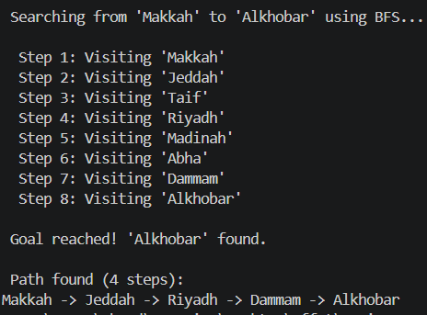

f. Why does BFS visit extra cities that are not on the final path?
Because it explore all the possible paths from the starting point going level by level

Part2:

a. Query 1 – Is Lina guilty? Program answered: YES
b. Query 2 – Is Nora suspicious? Program answered: NO
c. Query 3 – Does Sara have a key? Program answered: NO
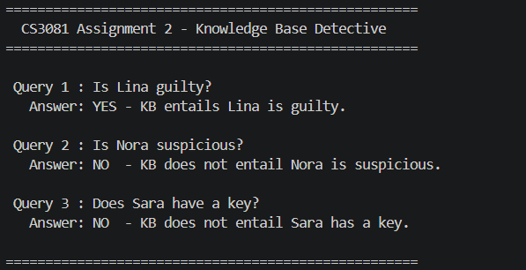
Why is Lina guilty according to the KB? (Trace the clues: which clues lead to this conclusion?)

Clue 3: Lina was seen near the lab
Clue 4: If seen → she has a key → so Lina has a key
Clue 1: If she has a key → she is guilty
Therefore, Lina is guilty

b. Clue 5 says Nora HAS an alibi. Yet Query 2 asks if she is suspicious. Based on the program’s answer – is she suspicious? In your own words, why?

Because Clue 5 says she has an alibi, and Clue 6 says only people without an alibi are suspicious.
So she is not suspicious

c. Complete this sentence in your own words: “The Knowledge Base cannot prove a statement unless it can logically derive it from the given facts and rules.”

Reflection questions:
In Part 1, BFS searched for a path. In Part 2, the KB deduced a fact. What is the difference between what BFS does and what the KB does? Think about: What is the input? What is the output? What kind of problem does each solve?

BFS takes a map with a start and goal and searches to find a path between them, so its output is a sequence of steps. It solves a search problem. On the other hand, the Knowledge Base takes facts and logical rules and uses them to determine whether a statement is true or false. It solves a reasoning problem. The main difference is that BFS finds a path, while the KB proves a fact.

BFS:
- Input: map + start + goal
- Output: path
- Problem: search
KB:
- Input: facts + rules
- Output: true/false
- Problem: reasoning
Difference:
- BFS finds a path
- KB proves a fact

